ACADEMIC PROJECT REPORT
HarmonyHub
A Digital Learning Platform for Universal Human Values (UHV) & Professional Ethics
"Understand Yourself. Build Better Relationships. Live in Harmony."
Course / Subject: | Universal Human Values & Professional Ethics (UHV)
Project Type: | Full-Stack Web Educational Application
Technology Stack: | React 19, TypeScript, Vite, Tailwind CSS v4, Supabase
Status: | Phase 1 Completed (Responsive UI, Interactive Modules, Dashboard)
Academic Year: | 2025 – 2026

1. Executive Summary
Universal Human Values (UHV) and Professional Ethics forms a cornerstone in contemporary higher technical education, emphasizing the holistic development of students beyond pure technical competencies. HarmonyHub is an interactive, digital educational web application engineered specifically to make UHV concepts accessible, engaging, and practically applicable.
The platform guides students through self-exploration, emotional intelligence, interpersonal harmony, ecological coexistence, and professional integrity. Designed with a calming natural color palette (forest green, warm cream, clean whites) and a contemporary glassmorphism aesthetic, HarmonyHub provides structured modules, micro-learning topics, reflective exercises, and personalized progress tracking.
2. Project Objectives & Motivation
- Self-Awareness: Facilitate Continuous Self-Exploration
- Social Harmony: Strengthen Interpersonal Relationships and Trust
- Ecological Balance: Foster Environmental Consciousness and Mutual Fulfillment with Nature
- Professional Ethics: Promote Ethical Competence in Professional Careers
- Pedagogical Modernization: Provide Modern, Accessible Digital Learning Tools
3. System Architecture & Technology Stack
HarmonyHub was built using modern front-end engineering standards to guarantee blazingly fast load times, rock-solid type safety, and seamless responsive design across all devices.
Layer / Domain | Technology Selected | Purpose & Architectural Role
Core UI Framework | React 19 + TypeScript | Component-driven declarative architecture with strict static typing preventing runtime bugs.
Build Tooling | Vite 6.x | Instant Hot Module Replacement (HMR) and optimized Rollup-based production bundling.
Styling System | Tailwind CSS v4 + @tailwindcss/vite | Modern utility-first CSS engine with custom @theme tokens for serene earth-toned aesthetics.
Navigation & Routing | React Router v7 | Single Page Application (SPA) routing with dynamic URL parameters for modules and subpages.
Iconography | Lucide React | Lightweight, visually consistent vector icons for intuitive user navigation.
Backend & Auth (Ready) | Supabase Client (@supabase/supabase-js) | Cloud PostgreSQL database, Row Level Security, and JWT user authentication pipeline.
4. UHV Curriculum & Module Breakdown
The platform is structured strictly around the four universally recognized pillars of Harmony in human life, providing 32 distinct interactive learning topics:
Module 1: Harmony in the Human Being
Module Scope: 8 Topics | Self-Exploration, Desire vs Need, Body-Self Synergy
- Introduction to Self-Exploration: Natural Acceptance and Experiential Validation
- Continuous Happiness and Prosperity: The Basic Human Aspirations
- The Human Being as Co-existence of the Self ('I') and the Body
- Needs of the Self ('I') and 'Body' - Sukh and Suvidha
- Activities of the Self: Imaging, Analyzing, Selecting/Desiring
- Harmony in the Self: Realization and Understanding
- Harmony of the Self with the Body: Sanyama and Swasthya
- Programs to Ensure Sanyama and Health in Daily Life
Module 2: Harmony in Family and Society
Module Scope: 8 Topics | Trust, Respect, Justice, Undivided Society
- Harmony in the Family: The Basic Unit of Human Interaction
- Trust (Vishwas): The Foundational Value in Relationships
- Respect (Samman): Distinction vs Differentiation
- Affection, Care, and Guidance: Nurturing Mutual Trust
- Reverence, Glory, Gratitude, and Love: Complete Value Fulfillment
- Harmony in the Society: From Family Order to World Family
- Comprehensive Human Goals: Right Understanding, Prosperity, Fearlessness, Co-existence
- Universal Human Order (Sarvabhauma Vyavastha)
Module 3: Harmony in Nature and Existence
Module Scope: 8 Topics | Four Orders of Nature, Cyclic Processes, Co-existence
- Understanding Harmony in Nature: The Four Orders
- Physical Order (Padartha Avastha): Soil, Water, Metals, and Minerals
- Bio Order (Prana Avastha): Plants, Trees, and Microorganisms
- Animal Order (Jeeva Avastha): Animals and Birds
- Human Order (Gyana Avastha): Self-Conscious Entities
- Interconnectedness and Mutual Fulfillment (Parasparta)
- Recyclability and Self-Regulation in Nature
- Existence as Co-existence (Sah-astitva) in Space
Module 4: Professional Ethics
Module Scope: 8 Topics | Ethical Competence, Holistic Technologies, Sustainable Living
- Definitiveness of Ethical Human Conduct
- Basis for Humanistic Education, Constitution, and Universal Order
- Competence in Professional Ethics: Clarity, Confidence, and Integrity
- Issues in Professional Ethics: Exploitation, Corruption, and Unethical Practices
- Holistic Technologies and Production Systems: Eco-Friendly Criteria
- Management Models for Mutual Fulfillment and Long-term Sustainability
- Case Studies of Typical Ethical Dilemmas in Engineering and Management
- Vision for a Holistic and Sustainable Alternative Way of Living
5. Implemented Features & Application Pages
The initial release (Phase 1) delivers a complete, highly polished frontend user journey with comprehensive educational content, dynamic statistics, interactive navigation, and full responsiveness.
Landing Page (Home) Features an attention-grabbing hero section, student impact metrics, 4 module overview cards with smooth hover micro-animations, core values highlights, student testimonials, and call-to-action sections.
About HarmonyHub Page Presents the academic mission, pedagogical vision, the AICTE/UGC UHV framework context, teaching methodology, and project stewardship values.
Student Learning Dashboard A personalized hub showcasing enrolled courses, real-time progress calculations, overall completion ring (SVG circular indicator), active streak counter, and recent learning activity feed.
Module Detail View Deep dive page for each UHV pillar featuring detailed curriculum listings, estimated completion times, difficulty levels, prerequisite indicators, and completion checkoffs.
Authentication Gateway Dedicated Login and Registration interfaces featuring responsive form controls, password toggles, and seamless integration hooks for Supabase Auth.
6. Visual Walkthrough & Interface Screenshots
Below are verified high-resolution interface captures demonstrating the aesthetic design and functional layouts created for HarmonyHub:

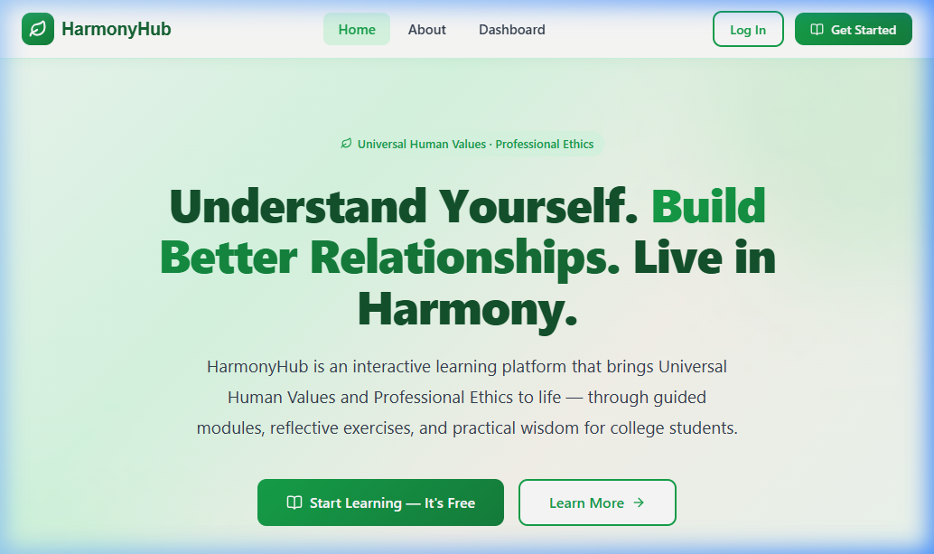
Figure 1: HarmonyHub Landing Page with Hero & Module Cards

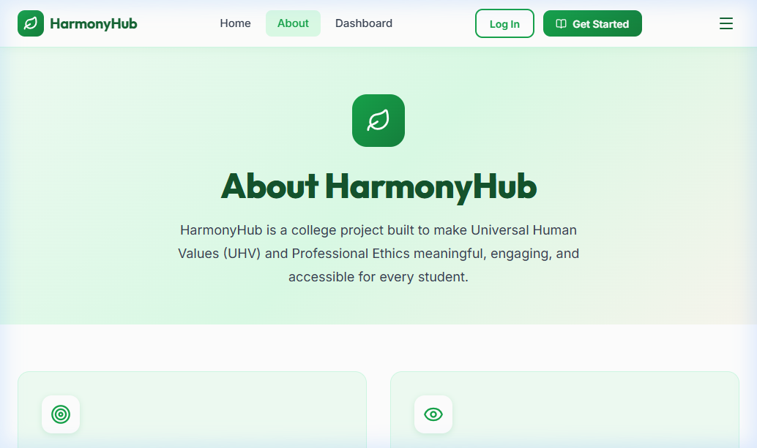
Figure 2: About Page - Mission, Vision & Curriculum Pillars

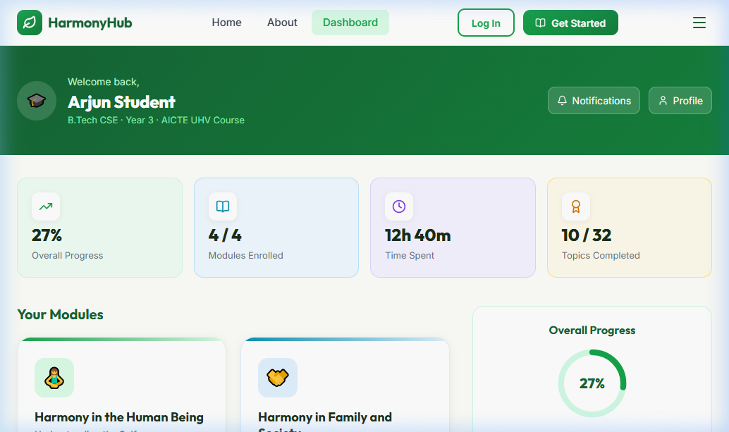
Figure 3: Student Learning Dashboard with Interactive Progress Tracking

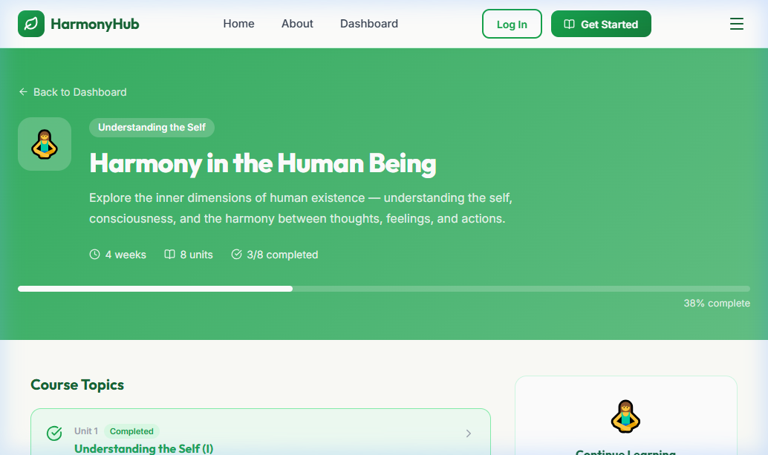
Figure 4: Module Detail View - Human Being & 8 Detailed Topics

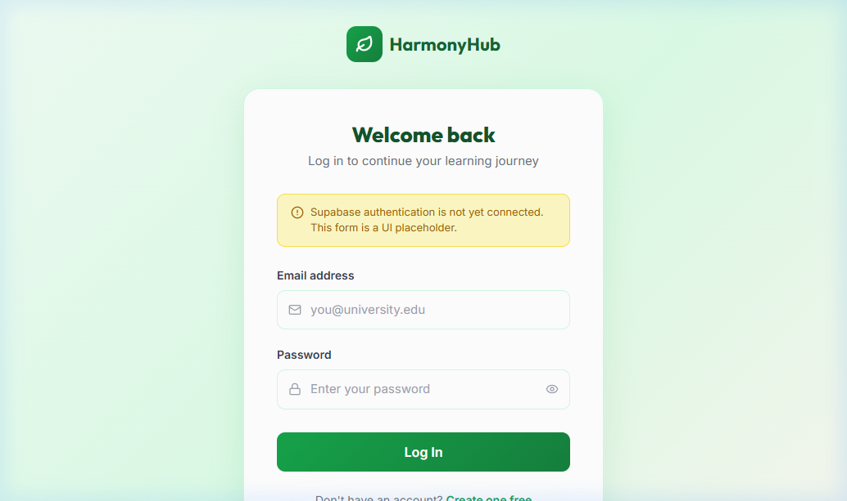
Figure 5: Student Authentication Portal with Clean Security UI
7. Repository Organization & File Structure
The project codebase maintains clean separation of concerns, modular components, and strict TypeScript types:
HarmonyHub/
├── index.html # HTML entry point with Google Fonts (Inter, Outfit)
├── package.json # Project dependencies and npm scripts
├── vite.config.ts # Vite configuration with @tailwindcss/vite plugin
├── tsconfig.json # TypeScript compiler configuration
├── .env.example # Template for Supabase URL and Anon Key
├── src/
│ ├── main.tsx # React application mounting point
│ ├── App.tsx # BrowserRouter and route mapping
│ ├── index.css # Global Tailwind v4 styles, custom tokens & utilities
│ ├── types/
│ │ └── index.ts # TypeScript interfaces (Module, Topic, User)
│ ├── data/
│ │ └── modules.ts # 4 UHV Modules and 32 learning topics dataset
│ ├── lib/
│ │ └── supabase.ts # Supabase client initialization & connection status
│ ├── components/
│ │ ├── layout/
│ │ │ ├── Navbar.tsx # Glassmorphism header with responsive mobile drawer
│ │ │ └── Footer.tsx # Dark green footer with quick links and copyright
│ │ └── ui/
│ │ └── ModuleCard.tsx # Color-themed card component with progress badges
│ └── pages/
│ ├── LandingPage.tsx # Landing hero, stats, cards, testimonials
│ ├── AboutPage.tsx # Mission, pedagogical approach, UHV values
│ ├── DashboardPage.tsx # Enrolled courses, circular progress, streak
│ ├── ModuleDetailPage.tsx # Topic breakdown, prerequisites, start button
│ ├── LoginPage.tsx # Student login form with security validation
│ └── RegisterPage.tsx # Student registration form
8. Supabase Database Schema & Security Design
HarmonyHub is architected for turnkey integration with Supabase (PostgreSQL with Row Level Security). Below is the recommended database schema for user profiles, module tracking, and reflective journal submissions:
-- 1. User Profiles linked to Supabase Auth
CREATE TABLE public.profiles (
id UUID REFERENCES auth.users ON DELETE CASCADE PRIMARY KEY,
full_name TEXT NOT NULL,
email TEXT UNIQUE NOT NULL,
role TEXT DEFAULT 'student',
avatar_url TEXT,
created_at TIMESTAMPTZ DEFAULT NOW()
);
-- 2. Student Topic Progress Tracking
CREATE TABLE public.user_progress (
id UUID DEFAULT gen_random_uuid() PRIMARY KEY,
user_id UUID REFERENCES public.profiles(id) ON DELETE CASCADE,
module_id TEXT NOT NULL,
topic_id TEXT NOT NULL,
completed BOOLEAN DEFAULT FALSE,
completed_at TIMESTAMPTZ,
UNIQUE(user_id, topic_id)
);
-- 3. Self-Exploration Reflective Journal
CREATE TABLE public.reflections (
id UUID DEFAULT gen_random_uuid() PRIMARY KEY,
user_id UUID REFERENCES public.profiles(id) ON DELETE CASCADE,
topic_id TEXT NOT NULL,
reflection_text TEXT NOT NULL,
created_at TIMESTAMPTZ DEFAULT NOW()
);
9. Setup & Local Execution Guide
- Step 1: Clone Repository: git clone <repository_url> && cd HarmonyHub
- Step 2: Install Node Dependencies: npm install
- Step 3: Setup Environment Variables: cp .env.example .env.local (configure Supabase URL & Key)
- Step 4: Launch Development Server: npm run dev (launches Vite HMR on http://localhost:5173)
- Step 5: Production Build: npm run build (verifies strict TypeScript compilation and asset bundling)
10. Conclusion & Roadmap
HarmonyHub successfully demonstrates how contemporary web engineering and human-centered design can elevate ethical education. By transforming passive theoretical reading into an engaging, structured, and reflective digital journey, students cultivate genuine self-awareness, social responsibility, and ethical leadership.
Future enhancements scheduled for Phase 2 include live Supabase authentication, interactive topic reading panes with self-assessment quizzes, AI-assisted reflective journal prompts, and faculty grading dashboards.

