Vuforia With Unity
Steps to import Vuforia SDK in unity and to deploy a simple Image Target application using it :-

Step 1: Go to Vuforia Developer Portal and Sign up/ Login ( Existing user )
https://developer.vuforia.com/

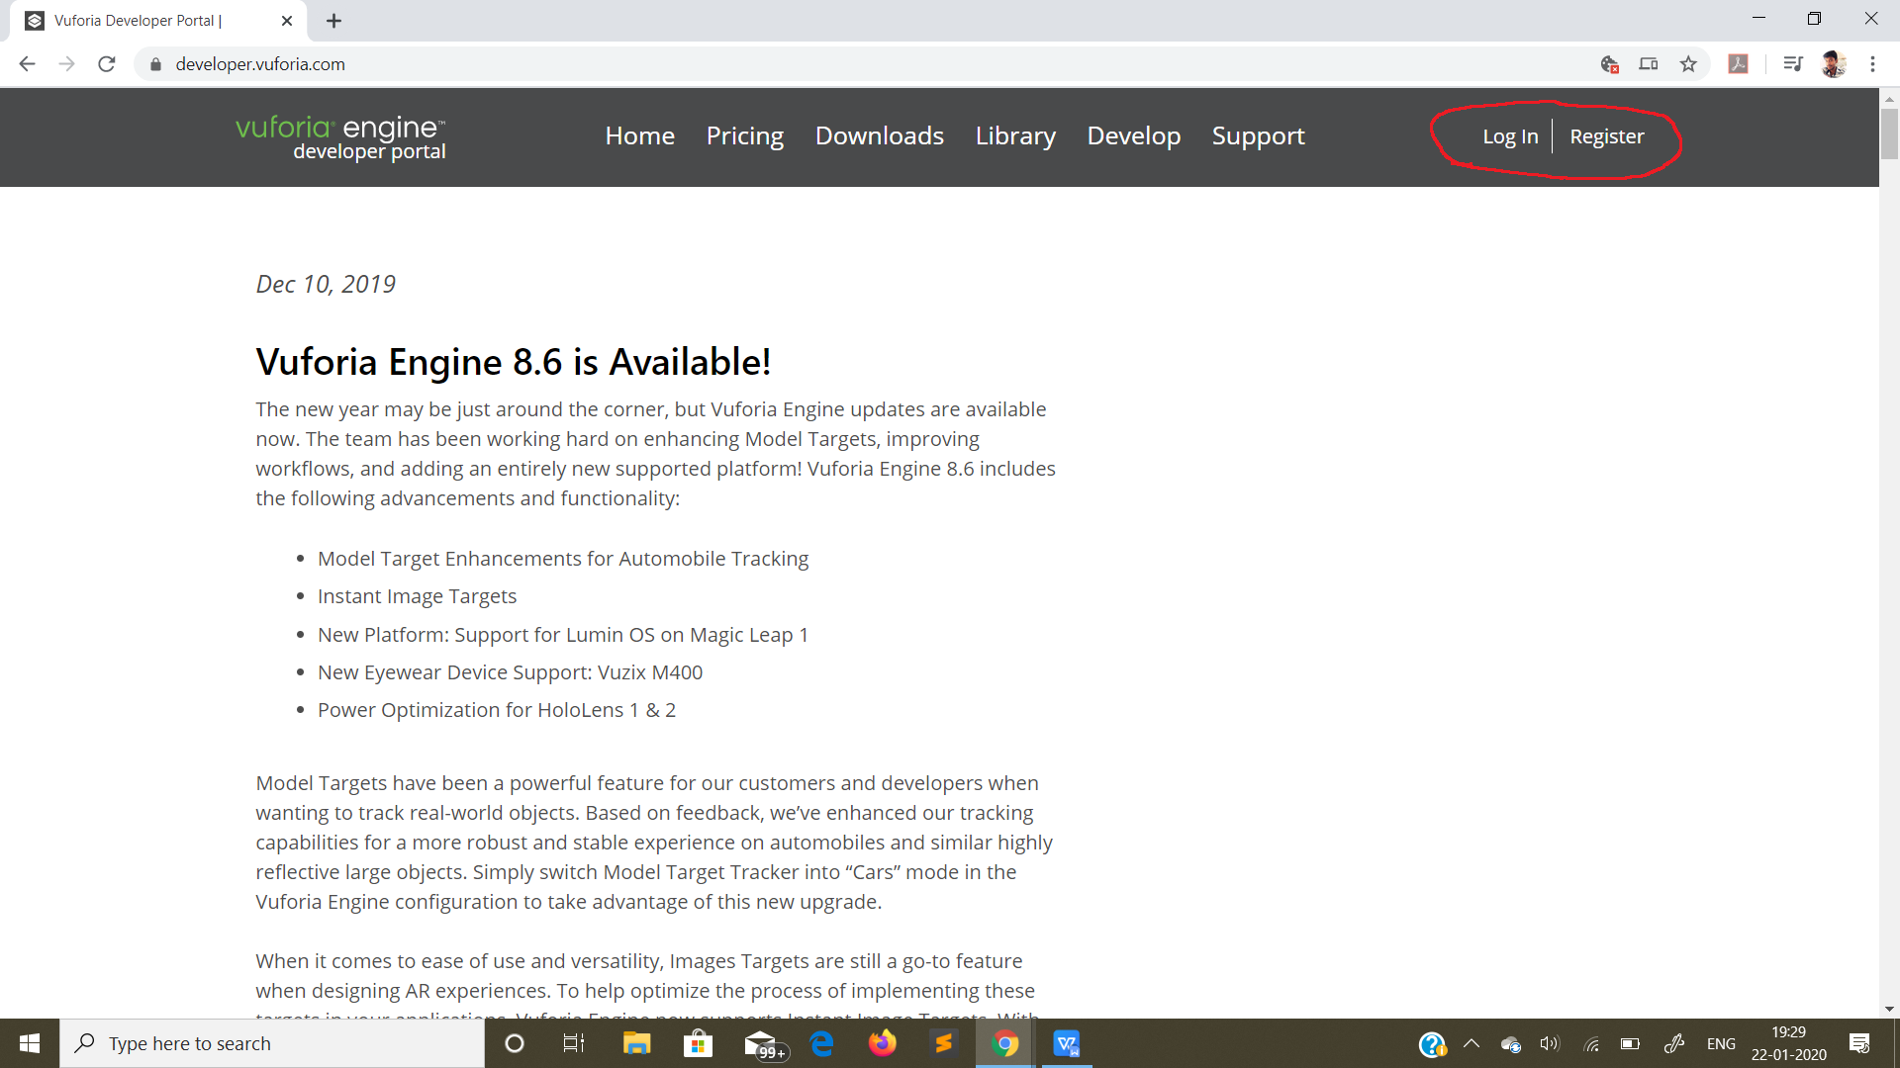

Step 2: Login in to Vuforia with your credentials

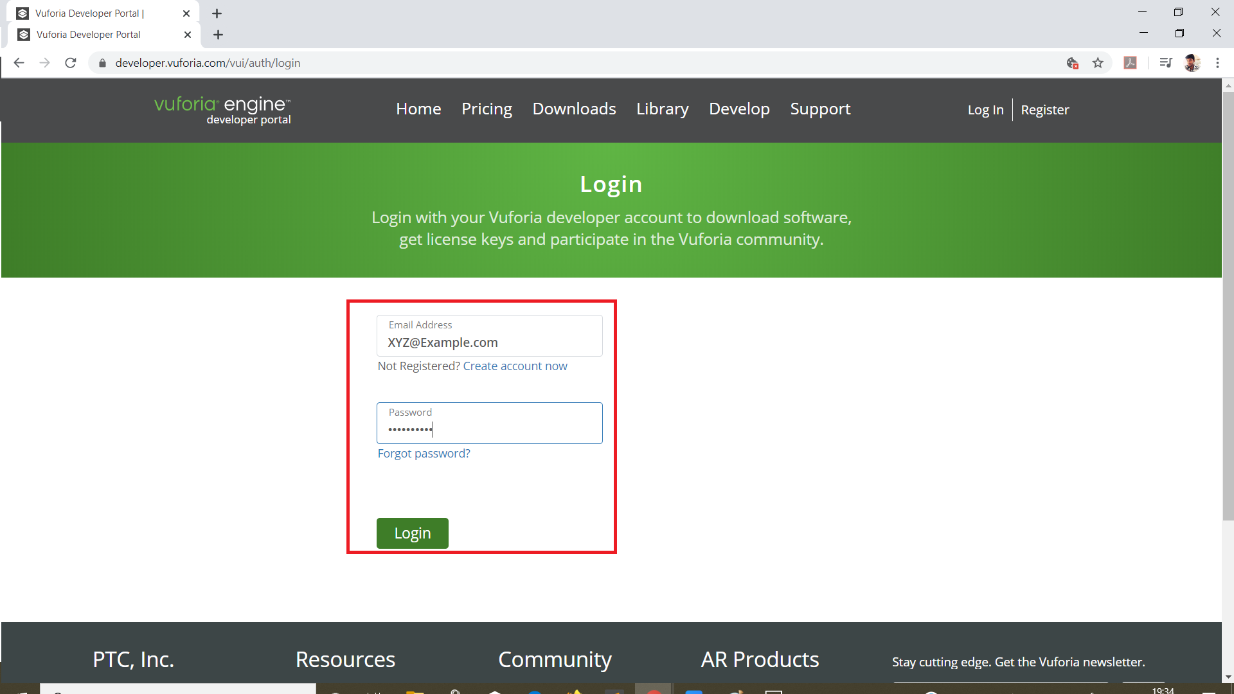

Step 3: Click on Get Development Key to make a new License name.

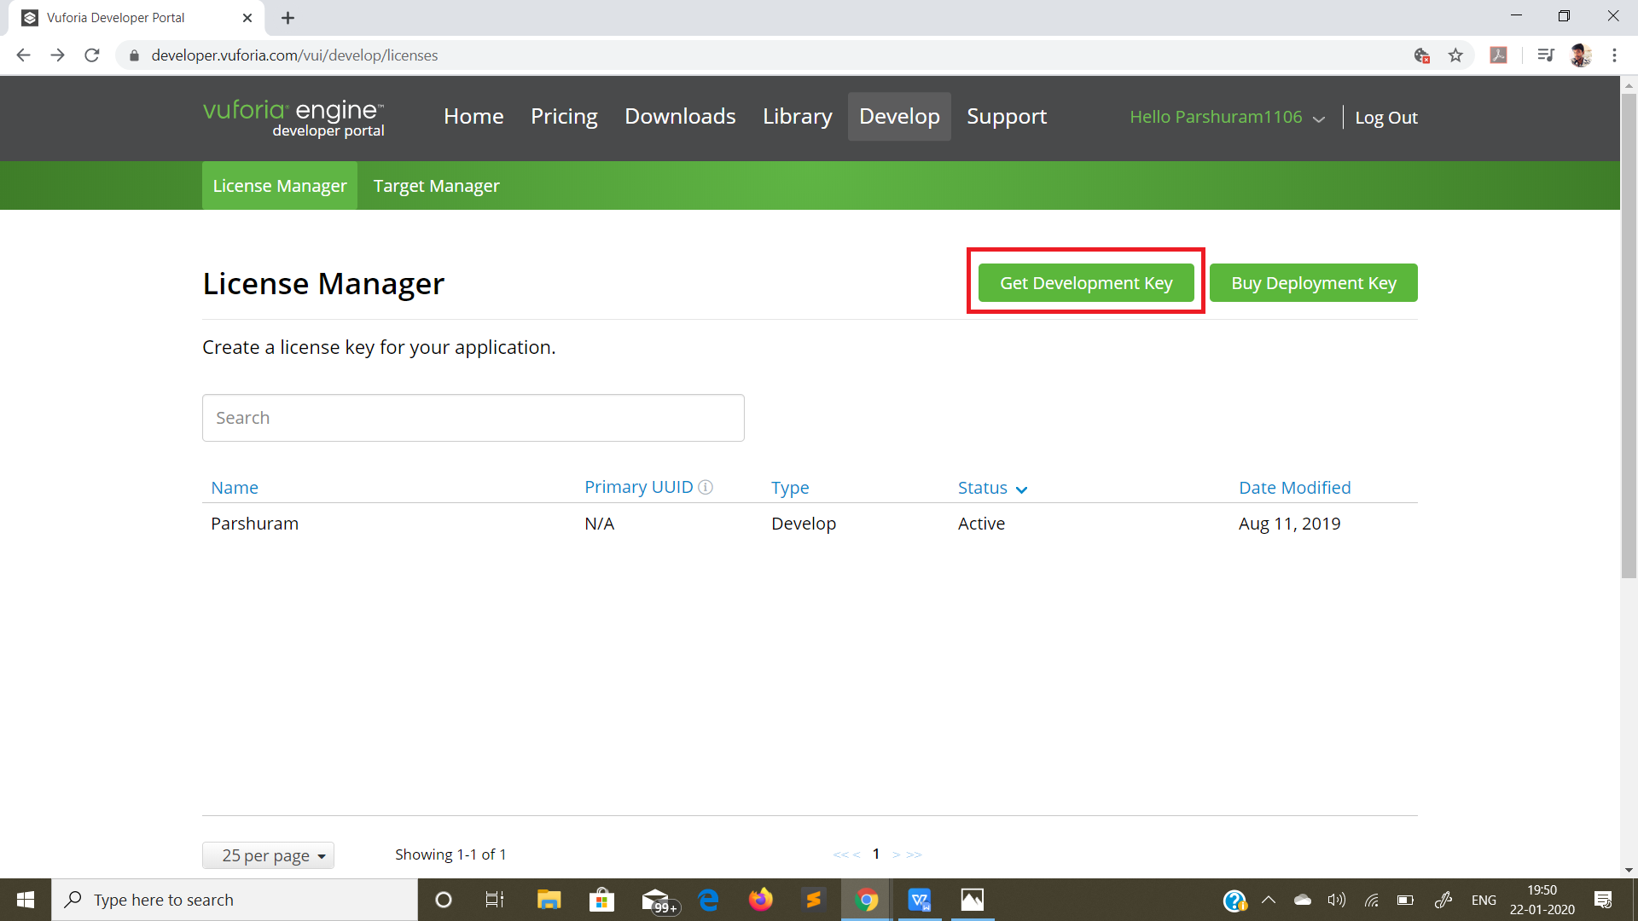

Give a name to your License and click confirm

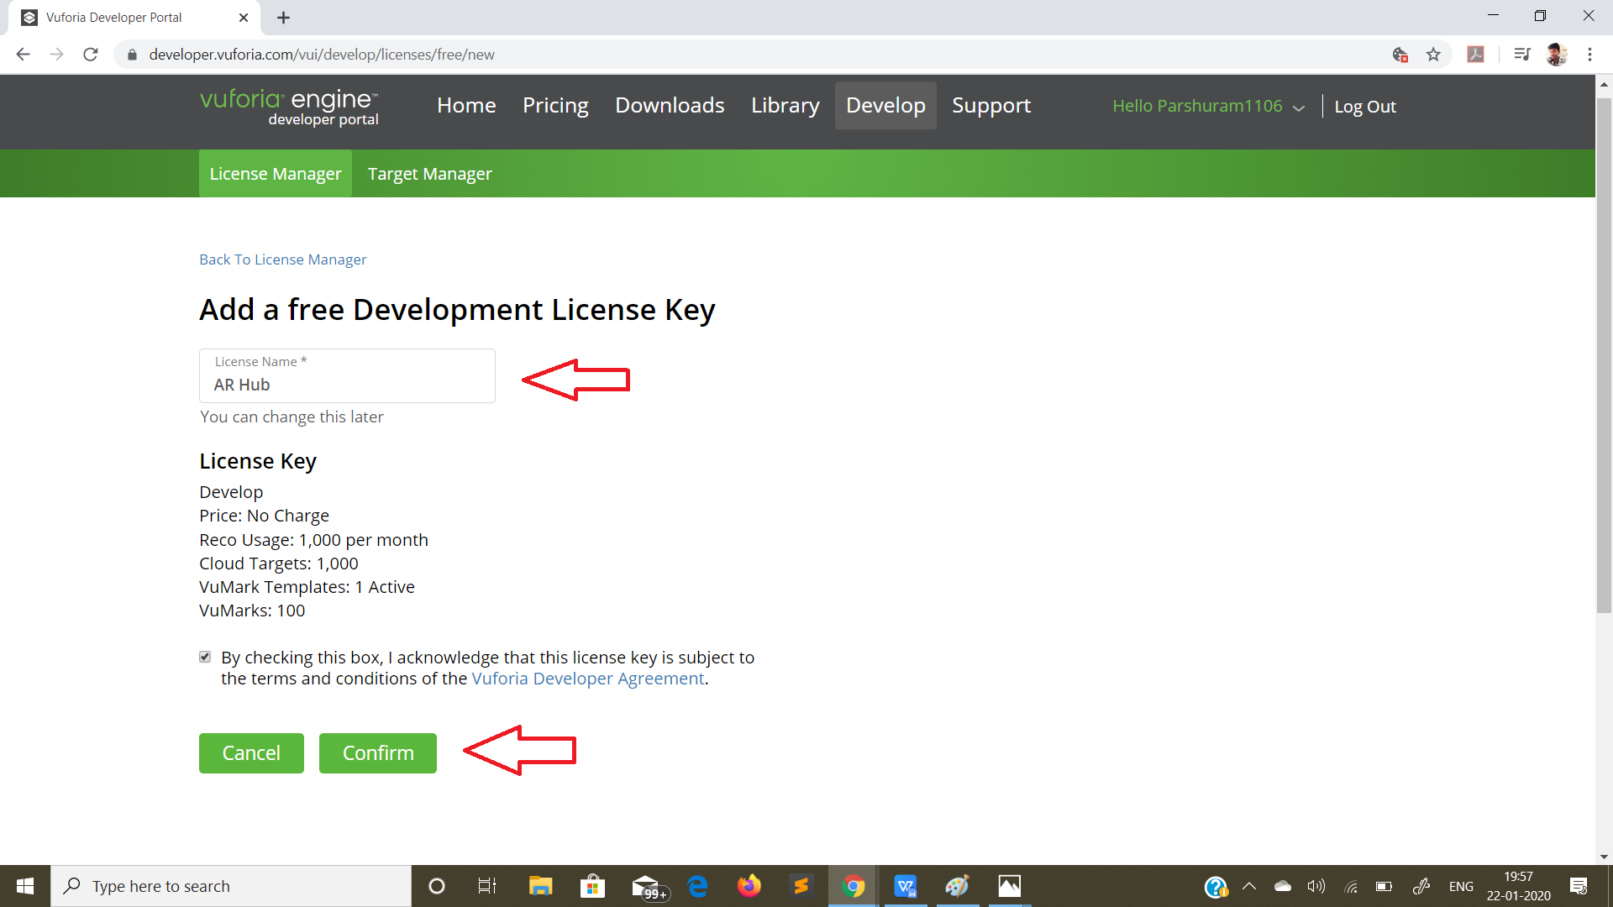

Step 4: After your license is made you will be able to see the License key in the license manager and all the details regarding your license.

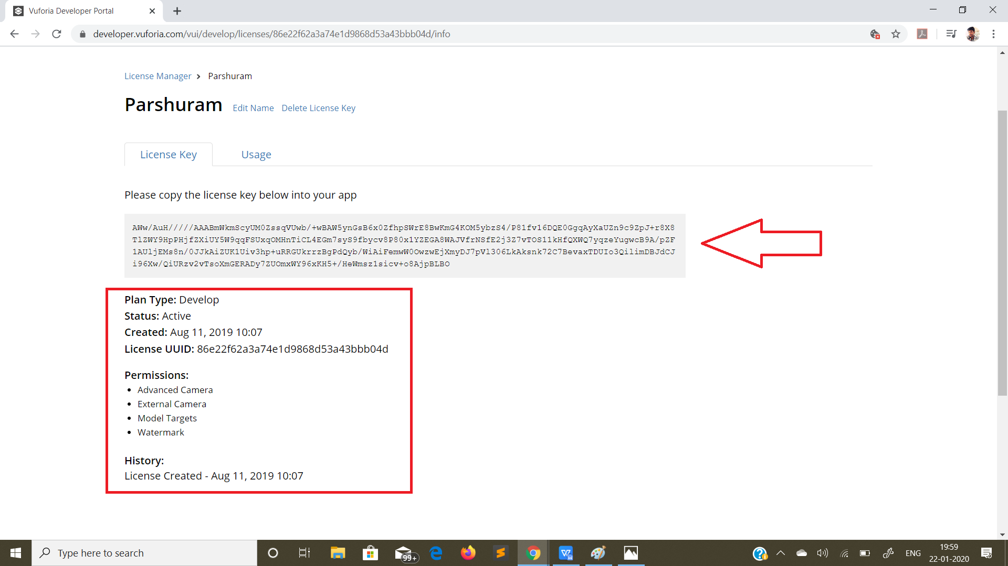

Step 5: Go to Target Manager and click on “Add Database”. Database is basically a folder that contains all the Image-Targets that you upload to Vuforia. The red box contains all the Databases that you create.

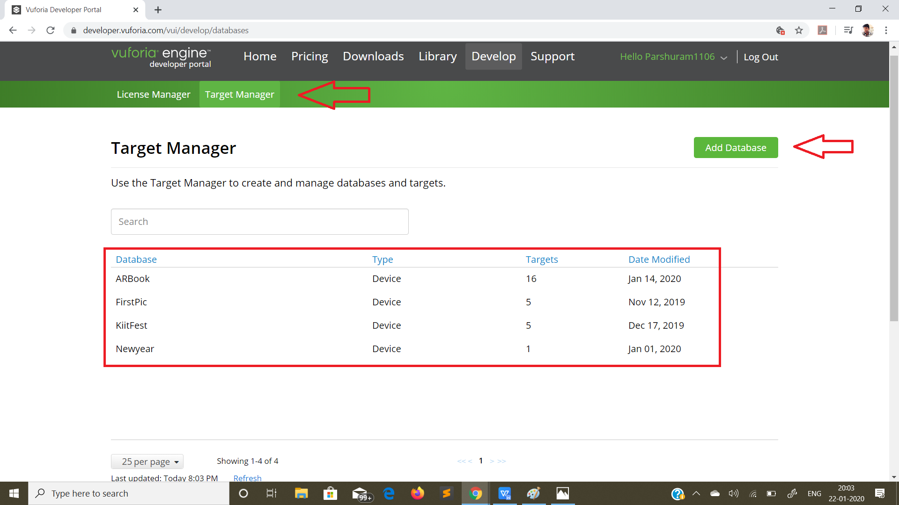

Targets define the number of image targets that are contained in respective Database.
Step 6: Click on “Add Target” and search for your image target by clicking on “Browse”and upload it using“Add”. Vuforia will scan the image and rate it.

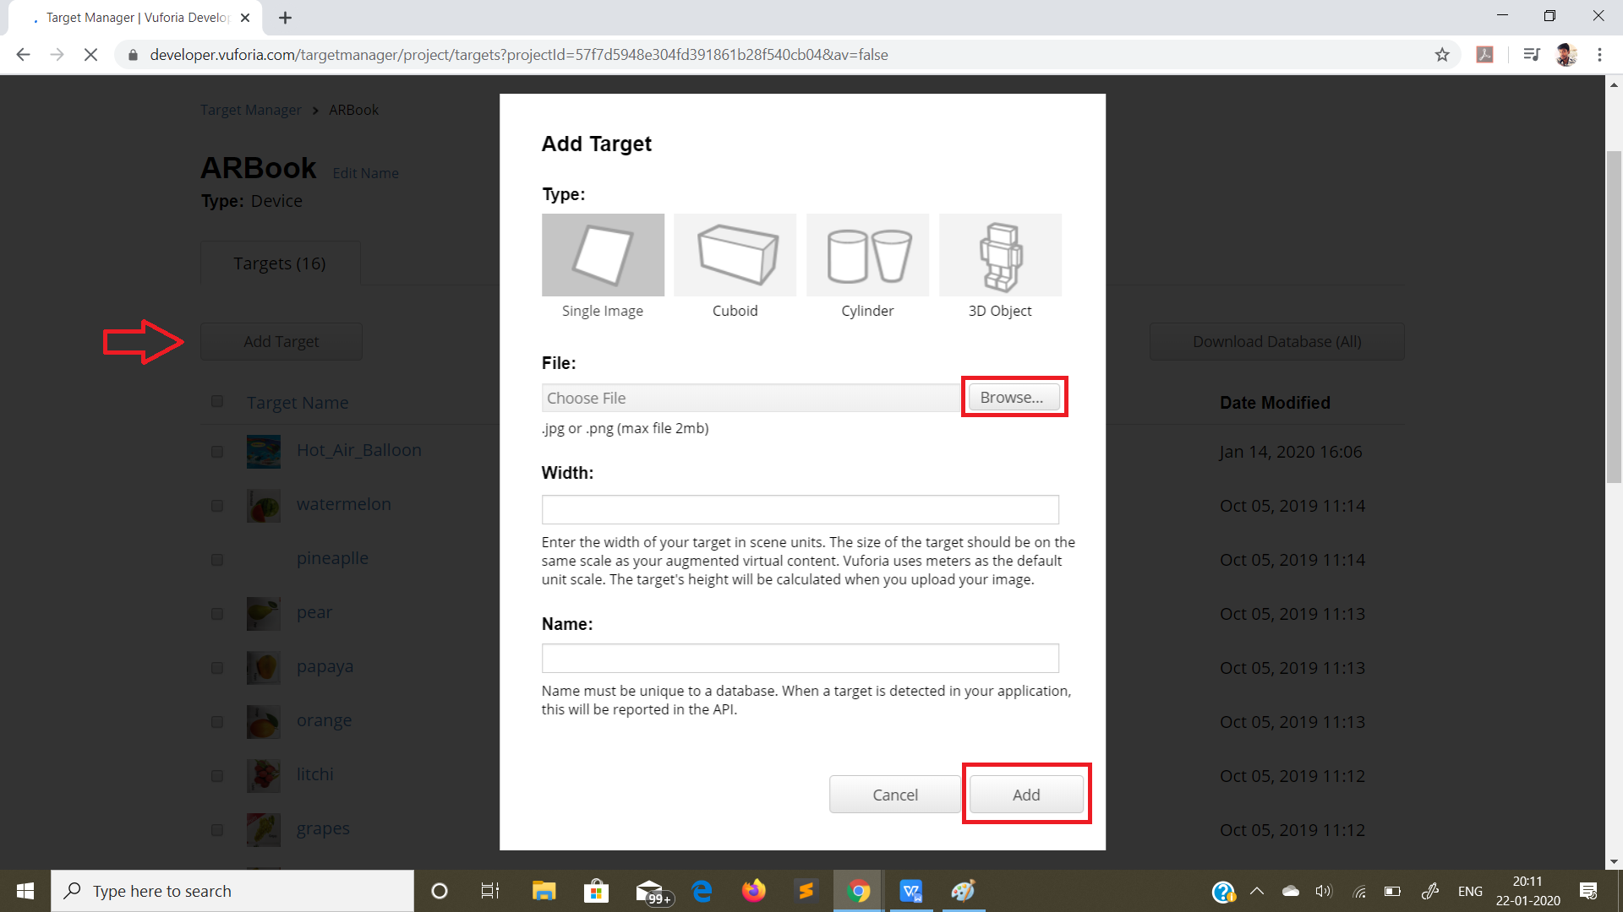

Step 7: Select one of the image targets and click on “Download Database”.

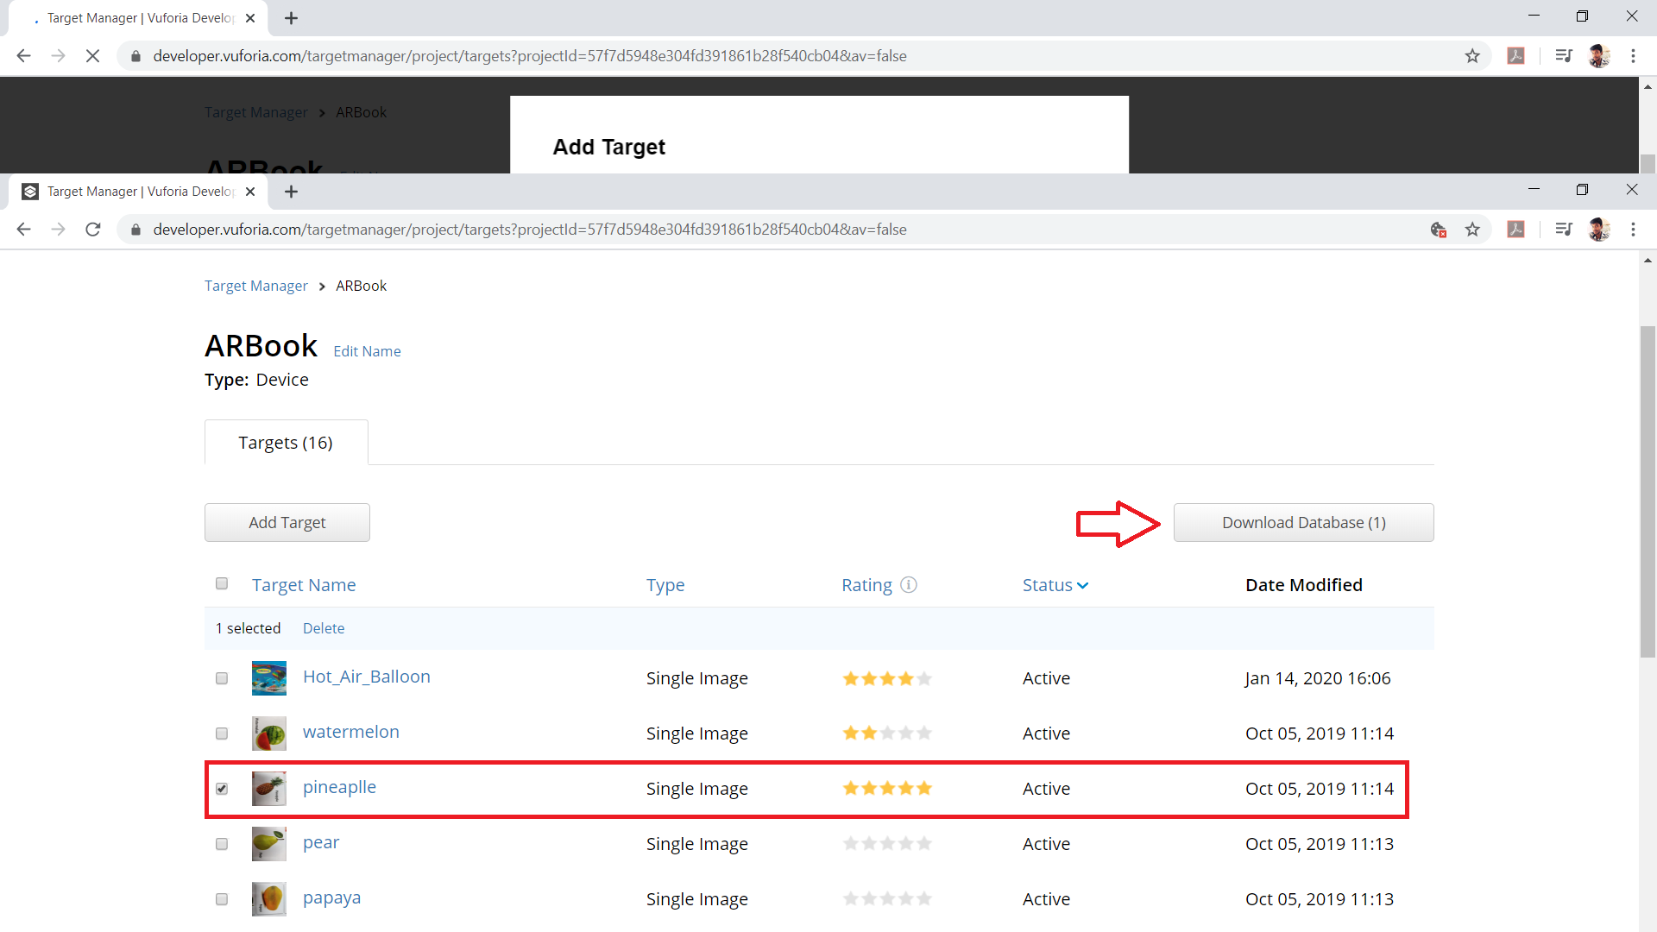

Step 8: Select “Unity Editor”and click download.

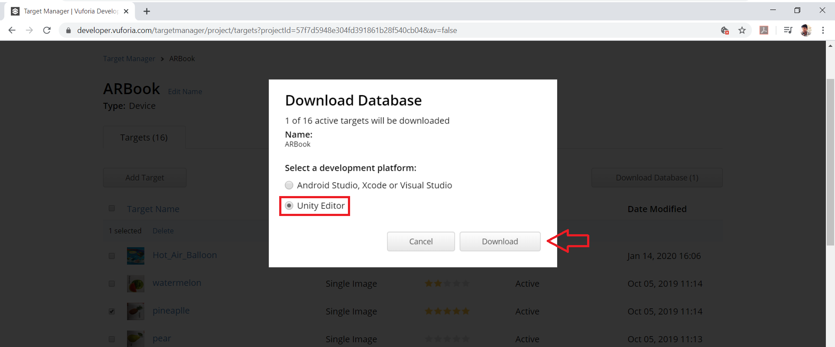

Step 9: Open Unity (2018.3.14f1)

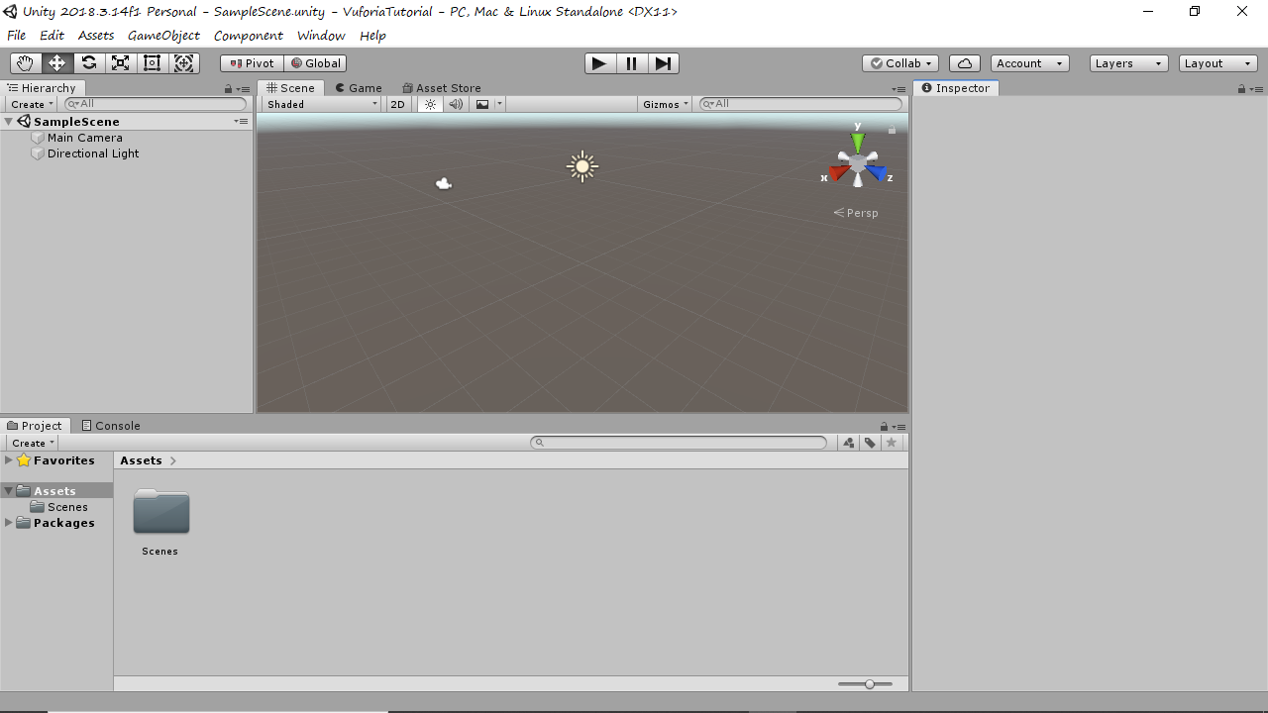

Step 10: Go to “Build Settings”

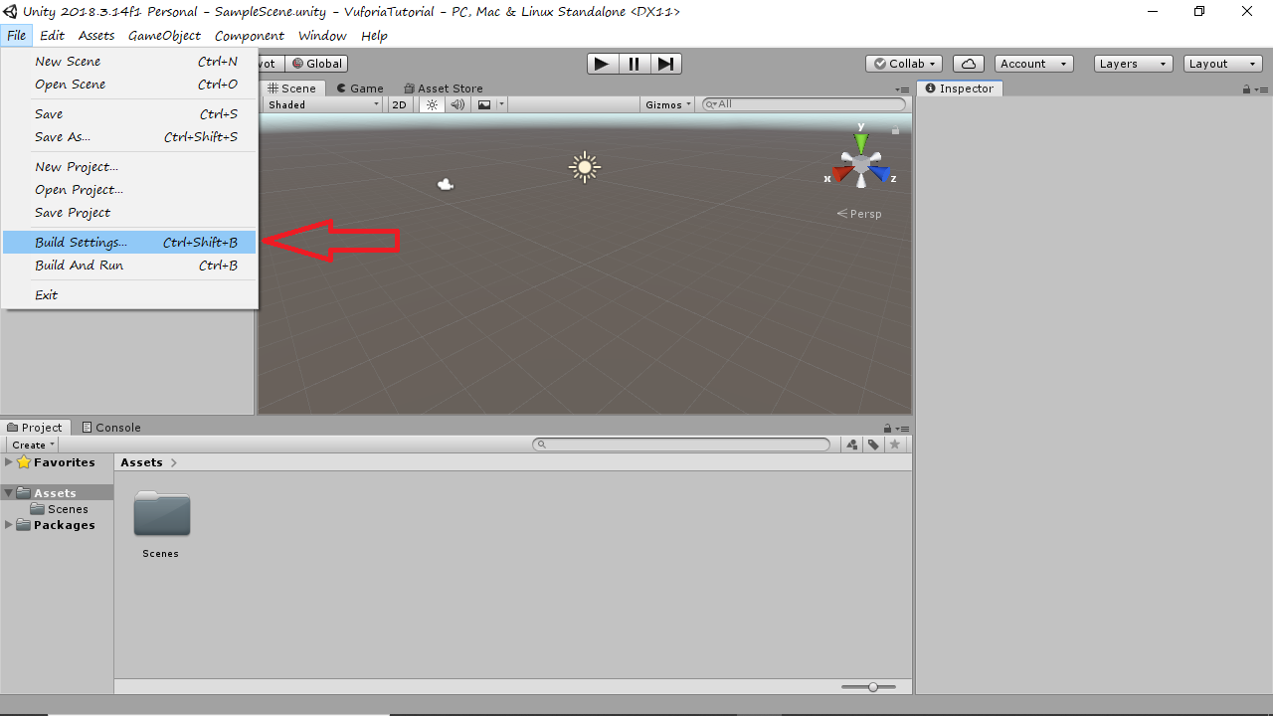

Step 11: Go to player settings and type your “Company Name”and “Product Name”in the package settings

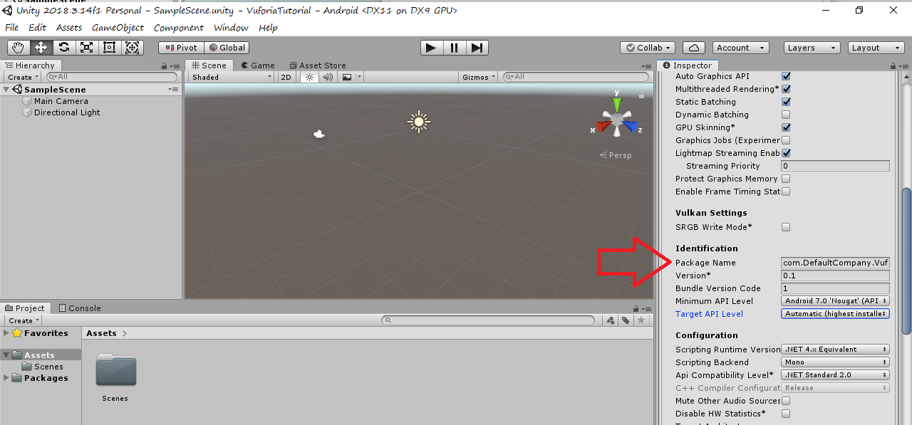

Step 12: Go to XR Settings and enable Vuforia Augmented Reality supported.

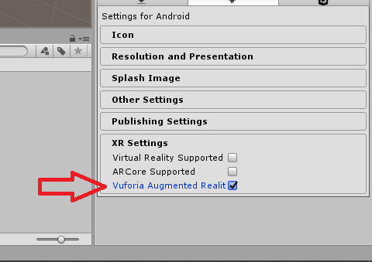

Step 13: Delete Main Camera and import Vuforia AR camera.

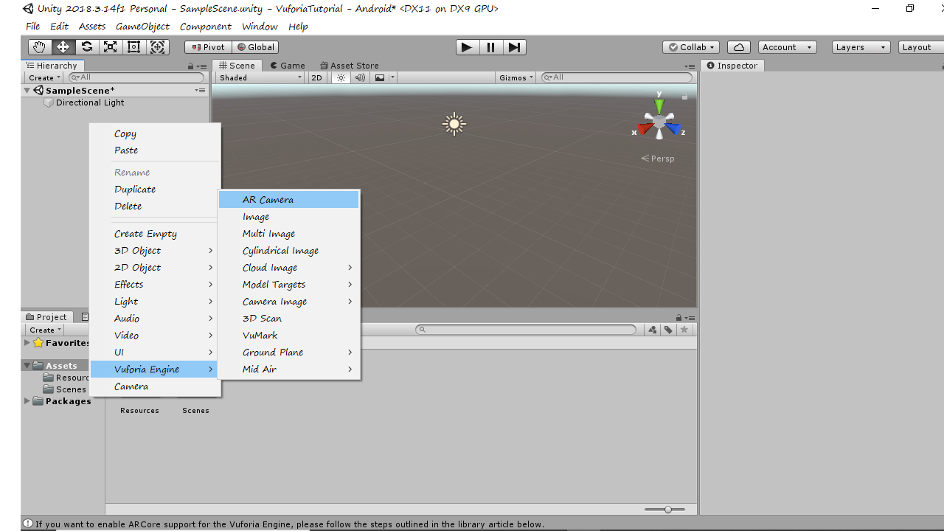

Step 14: Click on the AR camera and click on “Open Vuforia Engine Configuration”

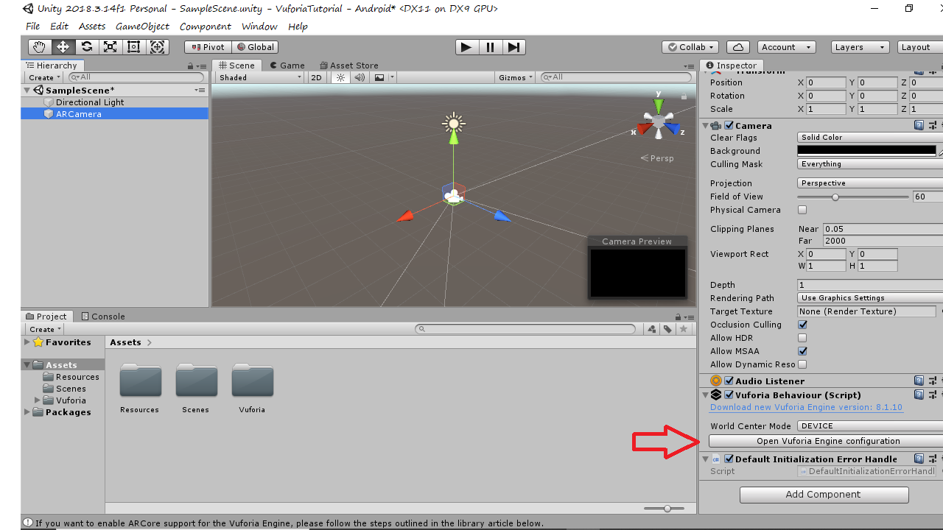

Step 15: Paste the license in this column.

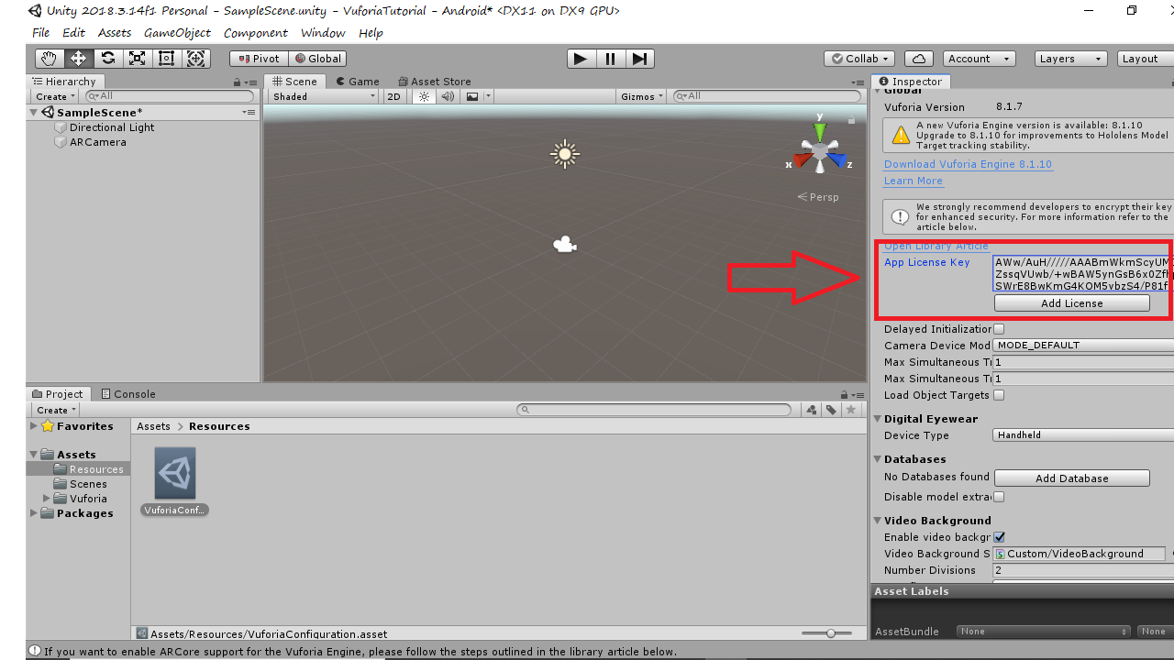

Step 16: Add an image target as a child to AR camera.

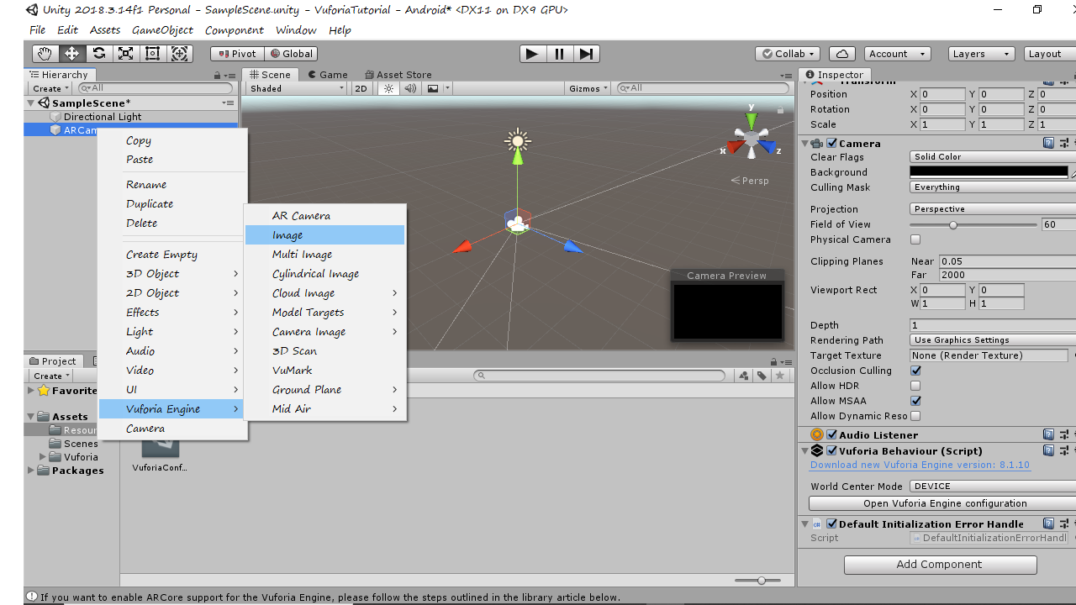

Step 17: Import the database in Unity which we downloaded in step 8.

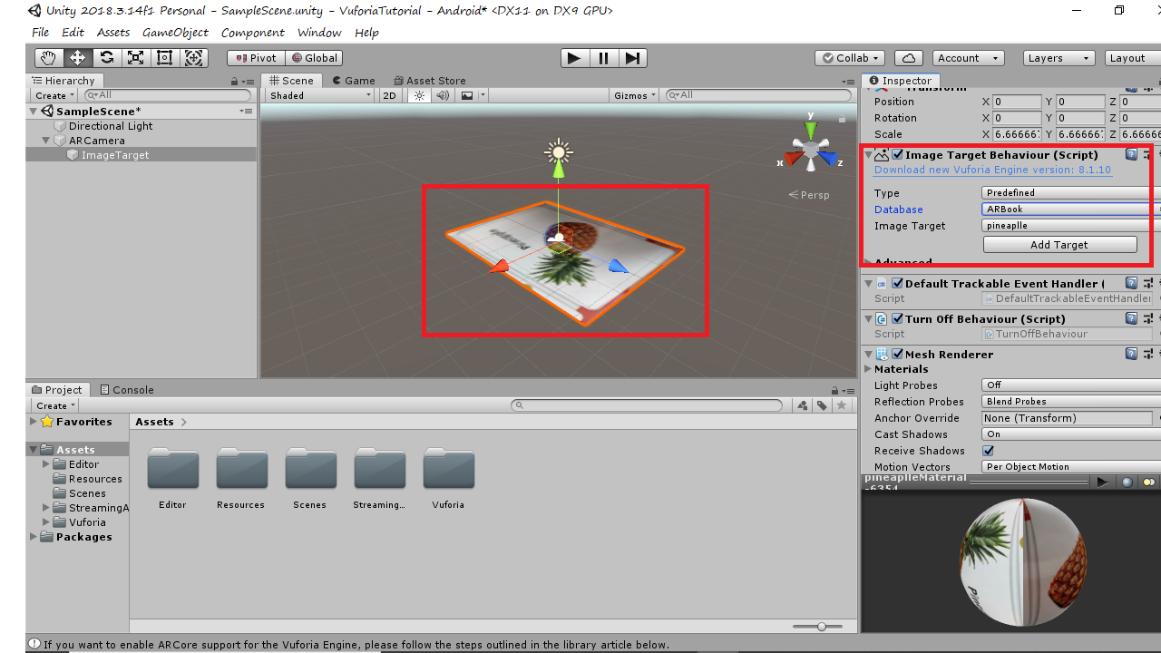

Step 18: Select any 3D object of your choice and make it a child to the image target. Then click on play bottom at the top centre.

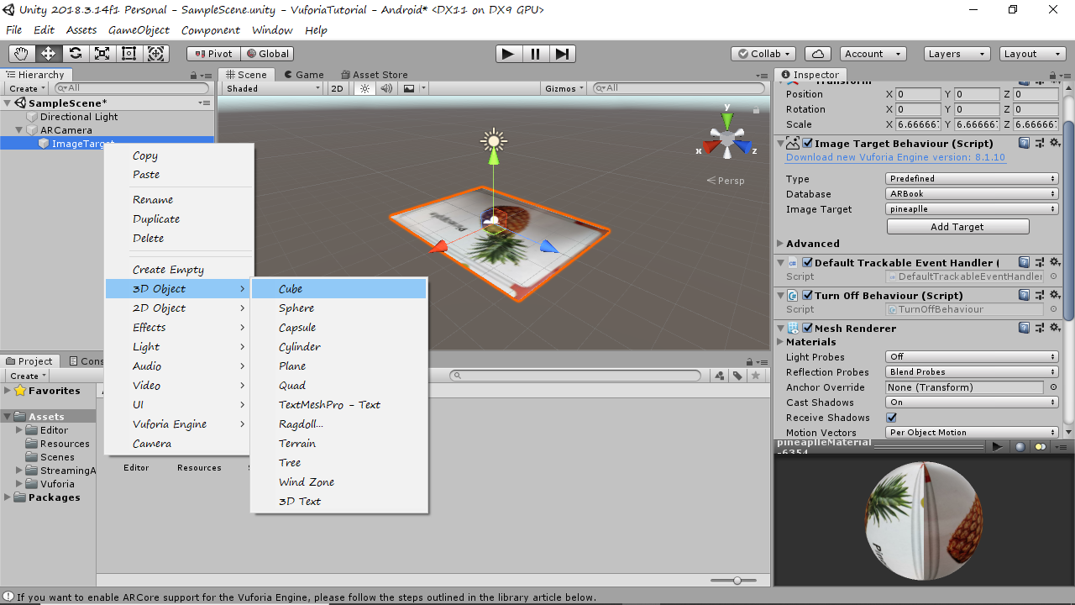

Bingo!! Your first Vuforia app is ready to be deployed.

