UNIVERSITY OF WEST LONDON
The Career University

CrustLoop Consultancy
A Business Proposal for a Circular Economy Consultancy
Redirecting Surplus Baked Goods Waste into Value-Added Circular Outputs

Module Title | Circular Economy and Food Security
Module Code | CA70022E
Module Leader | Dr Szymon Lara
Student Name | Surendra
Student Number | 34143280
Assessment | Summative Assessment 2 – Written Business Plan Report
Submission Date | 20 May 2026
Academic Year | 2025–26

External Examiner: Dr Athina Tziboula-Clarke, Abertay University

Table of Contents
Executive Summary 3
1. Introduction 4
1.1 Aims and Objectives of the Report 4
1.2 Originality, Creativity, and Innovative Aspects of the Proposal 4
2. Business Idea Description 5
2.1 The Problem: A System Designed to Waste 5
2.2 The Solution: CrustLoop Consultancy 6
2.3 Unique Selling Proposition 7
3. Market Analysis and Strategy 9
3.1 Market Context and Scale of Opportunity 9
3.2 Competitive Landscape 9
3.3 Marketing Strategy: The 7Ps Framework 10
3.4 SWOT Analysis 11
3.5 Target Market and Stakeholder Mapping 11
4. Barriers and Facilitators 13
4.1 Barriers to Implementation 13
4.1.1 Supply Chain Inconsistency and Volume Variability 13
4.1.2 Logistics Complexity and Cold-Chain Management 13
4.1.3 Cultural Resistance and SME Awareness Deficit 13
4.1.4 Impact Measurement Standardisation 14
4.1.5 Regulatory and Classification Uncertainty 14
4.2 Facilitators of Implementation 14
4.2.1 UK Government Food Waste Policy Mandates 14
4.2.2 ESG Investment and Procurement Criteria 15
4.2.3 Established Circular Economy Infrastructure and Networks 15
4.2.4 Proven Proof-of-Concept Models 15
4.2.5 Digital Impact Measurement Technology 16
5. Conclusions and Recommendations 17
References 18
Appendices 22
Appendix A: CrustLoop Circular Economy Pathway Mapping 22
Appendix B: CrustLoop Indicative Revenue Model (Years 1–3) 22

Executive Summary
CrustLoop Consultancy is a future envisioned circular economy consultancy that will assist food businesses across the UK, such as bakeries, cafes, supermarkets and sandwich manufacturers, in converting their surplus bread and baked goods waste into a viable, sustainable business output. The consultancy tackles a vital and proven need in the market: Around 900,000 tonnes of bread are thrown away in the UK each year (WRAP, 2022), with a significant portion of the value remaining untapped by food businesses under pressure to prove strong Environmental, Social and Governance (ESG) credentials.
CrustLoop is built on the principles of the circular economy as put forth by the Ellen MacArthur Foundation (2021), and provides a holistic advisory service, comprising waste diagnostics, supply chain partnership brokering, circular strategy implementation, and verified impact reporting. The four main pathways to waste diversion for its craft brewing partnerships, animal feed supply agreements, anaerobic digestion contracts and urban composting networks are informed by successful precedents such as the bread-to-beer model with Stuart (2009), and is aligned with the UK Food Waste Reduction Roadmap (HM Government, 2021).
The business is based on a careful analysis of the competitive environment, using the 7Ps Marketing Mix (Kotler and Keller, 2016) and SWOT matrix has identified strategic positioning opportunities. Most importantly, the proposal lists five key barriers to the supply chain inconsistency, logistics complexity, cultural resistance, impact measurement challenges, and regulatory uncertainty that shape the risk and opportunity landscape of this endeavour, and five structural facilitators (policy imperatives, ESG investment demand, existing CE networks, proof-of-concept models, and digital measurement technologies).
CrustLoop is a strategic asset that is both commercially viable and socially beneficial, and scales with food waste reduction, showing that sustainability and profitability are mutually reinforcing strategic assets (Lacy and Rosqvist, 2015).

1.Introduction

1.1 Aims and Objectives of the Report
This report is a business proposal to be presented to CrustLoop Consultancy which is an advisory company specializing in the UK food system with a focus on the circular economy. The goal of the report is to illustrate how circular economy principles can be put into practice to overcome the ongoing and expensive issue of surplus bread and baked goods waste. The report describes the business concept, a thorough market analysis, a critical analysis of the barriers and facilitators to implementation and a strategic recommendation. In so doing, it goes beyond the analysis of the available case studies and provides a feasible and innovative plan for implementing a circular economy in the food system, aligning with the needs of Assessment 2.

1.2 Originality, Creativity, and Innovative Aspects of the Proposal
CrustLoop's uniqueness stems from its narrow, yet largely overlooked specialisation, and focus on baked goods waste, which is a focused, high-volume waste stream that is relatively easy to manage and is largely underutilised by existing market players. The proposal in three ways is innovative. First, it takes a partnership-brokering approach, which links food businesses to a network of pre-vetted food businesses for circular diversion (craft breweries, animal feed producers, anaerobic digestion plants, and composting networks), based on the successful model of Toast Ale (Stuart, 2009). Second, it integrates the concept of independent verification of impact measurement into its core value proposition, tackling the greenwashing risk that is prevalent in many sustainability consultancies (Bocken et al., 2016). Third, it adapts its business model to the regulatory needs, taking the UK Food Waste Reduction Roadmap (HM Government, 2021) from a client requirement to a long-term driver of demand.

2. Business Idea Description

2.1 The Problem: A System Designed to Waste
The UK food system is highly structurally inefficient and generates unprecedented waste. One-third of all the food produced worldwide for human consumption is lost or wasted and accounts for 8-10 per cent of global greenhouse gas emissions (Food and Agriculture Organisation, 2019). The food and drink industry contributes about 10.7 million tonnes of food waste per year in the UK, with a large proportion (6.4 million tonnes) being avoidable food waste that was edible at the time of disposal (DEFRA, 2021). The majority of this waste is bread and baked goods, where WRAP (2022) estimates the UK alone loses around 900,000 tonnes of bread every year.
Figure 1 below shows the volume of food waste by category in the UK, with bakery and bread waste in its wider context. The absolute quantity of avoidable waste from fresh vegetables is high, whereas bread and bakery products are a concentrated, logistically manageable waste stream, with a consistent composition, predictable waste volumes and suitable diversion markets, including craft brewing and anaerobic digestion.
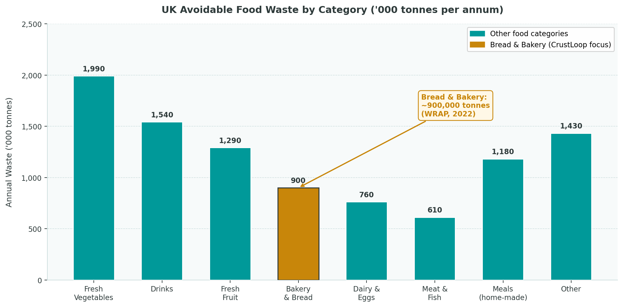
Figure 1: UK Avoidable Food Waste by Category ('000 tonnes per annum). Sources: WRAP (2022); DEFRA (2021).
This is not a waste of time, it's a waste of structure. According to Papargyropoulou et al. (2014), food waste is the result of a system of misalignments between the production schedule, the demand predicted by the retailers, consumer behaviour and logistics of the supply chain. Surplus is viewed as a by-product of the dominant linear economic model, described by Stahel (2016) as 'take-make-waste'. Methane is produced when bread decomposes in landfill, a greenhouse gas that is around 28 times more effective than CO₂ over 100 years (IPCC, 2021), so it's important to note that the diversion of bread makes a significant environmental impact..

2.2 The Solution: CrustLoop Consultancy
CrustLoop Consultancy is designed to be a circular economy specialist consultancy service, which fits into the day-to-day working of food businesses and transforms their waste into assets. The business is based on the core principles of the circular economy as stated by the Ellen MacArthur Foundation (2021): An economic model which seeks to prevent waste from occurring as a result of the design, rather than the operation, of products, components and materials.
The consultancy will provide four integrated services: Waste Audit, Partnership Brokering, Strategy and Implementation and Impact Reporting. The distribution of CrustLoop's client surplus over its four main diversion pathways is shown in figure 2. Craft brewing partnerships are the most valuable diversion channel and play the biggest role in the earliest-stage client proposals, compared to those that can be met through an anaerobic digestion channel, which is the base channel for volumes that do not fit into brewing or feed contracts over a specific period.
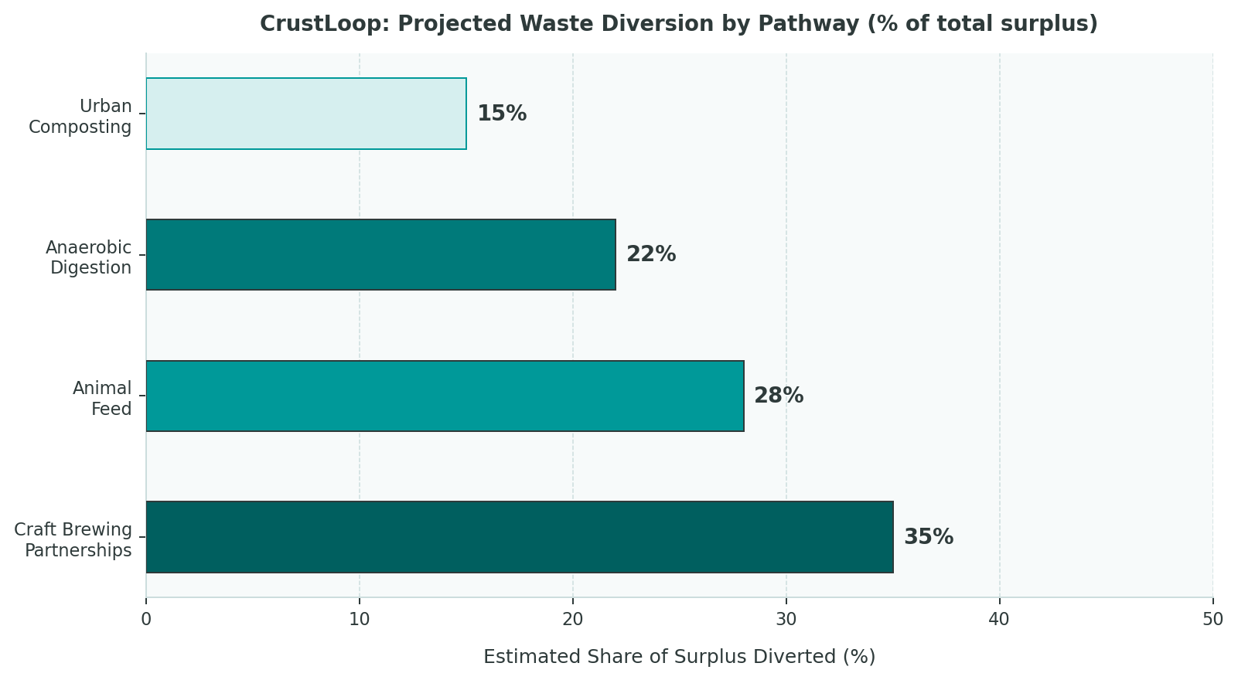
Figure 2: CrustLoop Projected Waste Diversion by Pathway (% of total client surplus). Sources: Author's own projections; Ellen MacArthur Foundation (2021); ADBA (2022).
- Key Statistic: Anaerobic digestion of one tonne of food waste can generate sufficient biogas to power an
- average UK household for approximately two months, whilst simultaneously producing digestate as a
- natural fertiliser substitute (Zero Waste Scotland, 2022).

2.3 Unique Selling Proposition
CrustLoop's USP rests on three differentiated pillars. First, genuine sector specialisation: unlike generalist sustainability consultants, CrustLoop focuses exclusively on baked goods waste, enabling depth of expertise in relevant legislation, supply chain logistics, and viable diversion markets that broad advisory firms cannot replicate (Porter, 2008). Second, a partnership-led, outcomes-focused commercial model: CrustLoop generates revenue through retainer contracts and a percentage share of verified cost savings, aligning the consultancy's commercial incentives directly with client outcomes. Third, a measurable impact reporting framework: at a time when greenwashing accusations present significant reputational risks (Bocken et al., 2016), CrustLoop's commitment to independently verifiable impact data provides clients with genuine, auditable sustainability credentials that create competitive advantage in procurement processes and investor relations.
Target clients include national food retail chains such as Greggs and Pret A Manger, regional sandwich manufacturers, contract catering firms in healthcare and education, and independent high street bakeries served through a standardised, lower-cost diagnostic package.

3. Market Analysis and Strategy

3.1 Market Context and Scale of Opportunity
The circular economy consulting market represents one of the fastest-growing segments within professional services globally. According to the European Commission (2021), the full implementation of circular economy principles could generate EUR 1.8 trillion in economic value across Europe by 2030, with the agri-food sector identified as among the highest-priority areas for intervention. In the UK, the Food Waste Reduction Roadmap mandates all food businesses with a turnover above GBP 10 million to measure, report, and act on food waste by 2026 (HM Government, 2021), creating compliance-driven demand for specialist advisory services.
Kirchherr et al. (2017), in a systematic review of 114 circular economy definitions, identify three recurring dimensions: the technical cycle (material recovery and recycling), the biological cycle (organic material return to the biosphere), and the value creation logic. CrustLoop operates primarily across the biological cycle and value creation logic positioning it within the emerging 'circular food economy' sub-sector that Geissdoerfer et al. (2017) identify as one of the most commercially promising frontiers of circular economy application.

Metric | Value | Source
UK annual bread & bakery waste | ~900,000 tonnes | WRAP (2022)
UK total avoidable food waste | 6.4 million t/yr | DEFRA (2021)
UK food sector waste cost to business | £19 billion/yr | WRAP (2022)
Global food wasted annually | 1.3 billion tonnes | FAO (2019)
UK AD plants operational (2022) | Over 650 | ADBA (2022)
UK CE consulting market growth (CAGR) | ~14% per annum | European Commission (2021)
Table 1: Key Market Context Statistics for CrustLoop's Operating Environment

3.2 Competitive Landscape
A critical evaluation of CrustLoop's competitive environment reveals that whilst the sustainability consulting market is populated by numerous players, none directly occupies the specialist baked goods circular economy advisory niche. Winnow Solutions deploys AI-powered food waste measurement technology targeted at commercial hospitality kitchens a potential technology partner rather than a direct competitor. Too Good To Go operates a consumer-facing surplus food marketplace limited to consumer redistribution rather than industrial-scale circular valorisation. WRAP's advisory programmes offer sector-wide benchmarking data but lack the bespoke implementation-intensive support that CrustLoop will provide.
Porter's (2008) five forces framework illuminates CrustLoop's competitive position favourably: supplier power is low (surplus bread is effectively free at point of collection), buyer power is moderate, the threat of new entrants is limited in the near term by the knowledge barrier of sector-specific expertise, substitute services lack CrustLoop's depth of focus, and competitive rivalry is currently low due to the novelty of the niche.

3.3 Marketing Strategy: The 7Ps Framework
The 7Ps Marketing Mix, as extended by Kotler and Keller (2016) beyond McCarthy's (1964) original 4Ps to incorporate People, Process, and Physical Evidence, provides the analytical structure for CrustLoop's go-to-market strategy.

Marketing P | CrustLoop Strategic Application
Product | Four integrated service lines: Waste Audit, Partnership Brokering, Circular Strategy and Implementation, and Impact Reporting. Services are modular clients may engage with one or all. The core product is bespoke intellectual capital applied to specific operational waste contexts.
Price | Tiered pricing: (i) Diagnostic Audit fixed-fee entry point; (ii) Monthly Advisory Retainer recurring revenue model; (iii) Performance Share percentage of verified cost savings, aligning CrustLoop's income with client value creation.
Place | London-headquartered with nationwide remote consulting capability. On-site visits for audits and partnership inception. Client-facing digital impact dashboard. National coverage by Year 2.
Promotion | B2B marketing via LinkedIn, trade press editorial (The Grocer, Footprint), and industry forums (Bread & Jam Festival, WRAP Circular Economy Conference). Co-publication with Ellen MacArthur Foundation CE100 network.
People | Founder-led in Year 1. Year 2: Partnerships and Logistics Manager. Year 3: Impact Measurement Analyst with LCA background.
Process | Standardised four-stage methodology: (1) Waste Audit; (2) Pathway Design; (3) Partnership Implementation; (4) Impact Monitoring.
Physical Evidence | Branded impact reports with independent verification; published client case studies; B Corp certification target (Year 3); conference thought leadership.
Table 2: CrustLoop 7Ps Marketing Mix Analysis (Kotler and Keller, 2016)

3.4 SWOT Analysis
A SWOT analysis synthesises the internal and external strategic environment facing CrustLoop at launch (Hill and Westbrook, 1997).
 | Helpful | Harmful
Internal | STRENGTHS: Deep sector specialisation first-mover advantage Low capital overhead knowledge and relationship-based Measurable client outcomes drive retention and referrals Strong alignment with UK food waste regulation Scalable standardised methodology Social purpose narrative resonates with ESG procurement | WEAKNESSES: Small founding team limits capacity Limited brand recognition at launch Revenue dependent on client willingness to invest Reliance on third-party diversion partners Impact measurement not yet standardised Cash flow risk before retainers are established
External | OPPORTUNITIES: UK Food Waste Roadmap mandatory reporting by 2026 Growing ESG criteria from retailers and investors Expansion into dairy, produce, other waste categories Potential to license proprietary measurement methodology Innovate UK grant funding for CE innovation | THREATS: Economic downturn reducing sustainability spend Larger consultancies entering the CE food niche Supply chain volatility affecting diversion partners Regulatory changes in organic waste classification Greenwashing accusations if impact claims not verified
Table 3: CrustLoop SWOT Analysis (Hill and Westbrook, 1997)

3.5 Target Market and Stakeholder Mapping
CrustLoop's stakeholder ecosystem spans three tiers of client. Tier 1 National Chains (Greggs, Pret A Manger, supermarket bakeries): highest volume waste generators, greatest regulatory scrutiny, and largest budgets. Tier 2 Regional and Contract Catering Operations: mid-volume clients requiring a balance of standardisation and bespoke advisory. Tier 3 Independent Bakeries and Cafes: served through a lower-cost standardised package, important for building a democratising reputation in sustainable food practice.
Murray et al. (2017) emphasise that circular economy implementation requires the active participation of multiple stakeholders across value chains; CrustLoop's brokering function is therefore central to its value creation logic. Secondary stakeholders include craft brewery partners, anaerobic digestion operators, local authorities, food waste charities, DEFRA, and the Environment Agency.

4.1 Barriers to Implementation

4.1.1 Supply Chain Inconsistency and Volume Variability
One of the most operationally significant barriers facing CrustLoop is the inherent unpredictability of surplus baked goods supply. Unlike commodity raw materials, bakery surplus is generated in response to daily sales performance, seasonal demand fluctuations, and product range decisions factors largely outside CrustLoop's or its clients' control. Stuart (2009) documents similar challenges in the context of wider food system waste, noting that the 'lumpy' nature of surplus generation complicates the design of reliable circular loops. For diversion partners particularly craft breweries with batch production schedules and AD plants with minimum feedstock requirements volume unpredictability creates contractual risk. Mitigating this requires flexible, volume-variable partnership agreements and the aggregation of multiple client surplus streams to provide consistent supply to diversion partners.

4.1.2 Logistics Complexity and Cold-Chain Management
Baked goods are time-sensitive materials. Surplus bread must be collected and redirected rapidly to avoid secondary decomposition, which would undermine the environmental case for circular diversion. Establishing cost-effective collection logistics across dispersed client networks, particularly for small independent bakeries in dense urban environments, presents a significant operational challenge. The carbon cost of additional vehicle movements for collection must be rigorously assessed against the benefit of diversion from landfill to ensure the net environmental case remains positive (Silvennoinen et al., 2015). Partnering with established food redistribution logistics networks such as FareShare could reduce this barrier whilst generating social co-benefit.

4.1.3 Cultural Resistance and SME Awareness Deficit
Research by the Ellen MacArthur Foundation (2021) consistently demonstrates that SME uptake of circular economy practices lags significantly behind large corporations, driven by resource constraints, short-term financial horizons, and a cultural disposition to treat waste as an inevitable operational cost rather than a recoverable asset. Korhonen et al. (2018) note that the circular economy remains an 'essentially contested concept' in business practice. For CrustLoop, overcoming cultural inertia requires a deliberate education-led marketing strategy that leads with financial return rather than environmental aspiration demonstrating that circular practice reduces disposal costs and strengthens procurement relationships within the client's existing commercial logic.

4.1.4 Impact Measurement Standardisation
A persistent challenge in the sustainability consultancy sector is the absence of universally accepted, auditable methodologies for quantifying the environmental and social impact of circular interventions. Without credible measurement frameworks, CrustLoop's impact reports are vulnerable to accusations of greenwashing a critical reputational risk (Bocken et al., 2016). The complexity of life cycle assessment (LCA) for organic waste diversion means that CrustLoop will need to invest in a rigorous, independently verified impact methodology drawing on WRAP's Food Waste Impact Calculator and the Carbon Trust's carbon footprinting protocols to establish the credibility its value proposition demands.

4.1.5 Regulatory and Classification Uncertainty
UK waste legislation imposes specific regulatory requirements on the diversion of organic waste to different end uses. Surplus bread redirected to animal feed is subject to the Animal Feed Regulations 2010, whilst anaerobic digestion requires compliance with the Environmental Permitting (England and Wales) Regulations 2016. Post-Brexit, the UK has diverged incrementally from EU circular economy directives, introducing additional uncertainty for businesses with pan-European diversion ambitions (European Commission, 2021). CrustLoop must maintain ongoing regulatory monitoring and engage specialist environmental law counsel to protect clients from compliance risk.

4.2 Facilitators of Implementation

4.2.1 UK Government Food Waste Policy Mandates
The most powerful structural facilitator for CrustLoop is the increasingly mandatory nature of UK food waste reporting and reduction. The Food Waste Reduction Roadmap (HM Government, 2021) requires food businesses with turnover exceeding GBP 10 million to measure, publish, and act on food waste data by 2026. This regulatory imperative transforms circular economy advisory from an optional improvement activity into a compliance necessity for a substantial portion of CrustLoop's target client base, creating durable commercial demand aligned with the UK's commitment to halving food waste by 2030 in line with SDG 12.3 (Godfray et al., 2010).

4.2.2 ESG Investment and Procurement Criteria
The integration of ESG criteria into the investment and procurement decisions of major retailers and institutional investors has created powerful commercial incentives for food businesses to demonstrate genuine sustainability performance. Bansal and DesJardine (2014) argue that long-term corporate value creation is fundamentally linked to the management of environmental and social externalities. For CrustLoop's target clients supplying major supermarkets with published sustainability commitments, credible food waste reduction credentials are increasingly a condition of continued listing rather than a differentiator alone.

4.2.3 Established Circular Economy Infrastructure and Networks
The UK's well-developed circular economy ecosystem provides CrustLoop with rich partnership, credibility, and knowledge resources. The Ellen MacArthur Foundation's CE100 network, WRAP's Food Waste Reduction Alliance, the Sustainable Food Trust, and the ADBA all provide access to industry intelligence, pre-vetted diversion partners, and co-marketing opportunities. Aligning CrustLoop with these bodies from the outset will accelerate brand credibility and reduce the cost of diversion partner identification one of the most resource-intensive aspects of circular economy implementation (Geissdoerfer et al., 2017).

4.2.4 Proven Proof-of-Concept Models
The commercial and social success of Toast Ale a viable social enterprise built on the circular reuse of surplus bread in craft brewing, donating 100 per cent of profits to food-waste charities and spawning partner breweries across the USA, Australia, Iceland, and Latin America (Stuart, 2009; Toast Ale, 2023) provides powerful de-risking evidence for sceptical clients. The rapid growth of the UK's anaerobic digestion sector, with over 650 operational plants as of 2022 (ADBA, 2022), confirms the existence of mature, scalable infrastructure for organic waste valorisation that CrustLoop can connect its clients to rather than build independently.

4.2.5 Digital Impact Measurement Technology
Advances in affordable data management, IoT-connected waste monitoring, and cloud-based sustainability reporting platforms mean CrustLoop can deploy sophisticated impact measurement tools without a large internal data science function. The Foresight Report (2011) on the future of food and farming highlighted the critical importance of information transparency in enabling sustainable food system transformation digital measurement tools are now mature enough to deliver this transparency at commercially viable cost. A CrustLoop client impact dashboard displaying real-time waste diversion volumes, carbon savings, and financial returns would serve simultaneously as an operational management tool, client retention mechanism, and marketing asset.

Barrier | Severity | Mitigation Strategy | Key Facilitator | Strength
Supply chain inconsistency | High | Flexible contracts; client aggregation | Proven models (Toast Ale) | High
Logistics complexity | Medium | Partner with FareShare logistics | UK AD infrastructure growth | High
Cultural resistance | Medium | ROI-led marketing; education content | ESG procurement criteria | High
Impact measurement gaps | High | WRAP / Carbon Trust methodology | Digital measurement platforms | Medium
Regulatory uncertainty | Medium | Ongoing legal monitoring | UK Government policy mandates | High
Table 4: Barriers and Facilitators Summary CrustLoop Risk and Opportunity Matrix

5. Conclusions and Recommendations
This business proposal has demonstrated that CrustLoop Consultancy represents a commercially credible, socially purposeful, and timely response to one of the UK food system's most persistent inefficiencies. By applying circular economy principles specifically the Ellen MacArthur Foundation's (2021) biological cycle and industrial symbiosis frameworks, as operationalised in Stahel's (2016) performance economy model to the specific challenge of surplus baked goods waste, CrustLoop creates measurable value for food businesses, diversion partners, and wider society simultaneously. The rigorous application of the 7Ps Marketing Mix (Kotler and Keller, 2016) and SWOT analysis (Hill and Westbrook, 1997) has identified a defensible market niche, a viable competitive positioning, and a scalable service architecture.
The barriers analysis reveals that supply chain inconsistency, impact measurement, and cultural resistance represent the most significant risks to successful implementation. However, each barrier is matched by structural facilitators most notably the UK Food Waste Reduction Roadmap's mandatory reporting requirements, the proven success of analogous initiatives including Toast Ale, and the growing commercial incentives of ESG-driven procurement that create durable demand for exactly the services CrustLoop proposes.
Three strategic recommendations emerge for future entrepreneurs seeking to build sustainable enterprises within circular food systems. First, regulatory alignment is both a commercial driver and a protective safeguard: designing a business that helps clients fulfil legislative obligations creates durable, recession-resilient demand (HM Government, 2021). Second, rigorous impact measurement must be prioritised from the earliest stage; in a sector vulnerable to greenwashing accusations (Bocken et al., 2016), independently verifiable data is the most powerful commercial and reputational asset available. Third, as Murray et al. (2017) argue, circular economy transformation in food systems cannot be achieved by individual firms in isolation entrepreneurs who position themselves as connectors and facilitators of system-level change will generate disproportionate social and commercial returns in the long run.

References
Anaerobic Digestion and Bioresources Association (ADBA) (2022) UK anaerobic digestion market report. London: ADBA.
Bansal, P. and DesJardine, M.R. (2014) 'Business sustainability: It is about time', Strategic Organization, 12(1), pp. 70–78.
Bocken, N.M.P., de Pauw, I., Bakker, C. and van der Grinten, B. (2016) 'Product design and business model strategies for a circular economy', Journal of Industrial and Production Engineering, 33(5), pp. 308–320.
Department for Environment, Food and Rural Affairs (DEFRA) (2021) Food waste in England: Annual statistics. London: HMSO.
Ellen MacArthur Foundation (2021) Completing the picture: How the circular economy tackles climate change. Cowes: Ellen MacArthur Foundation. Available at: https://ellenmacarthurfoundation.org (Accessed: 20 May 2026).
European Commission (2021) Circular economy action plan: For a cleaner and more competitive Europe. Brussels: European Commission. Available at: https://circulareconomy.europa.eu (Accessed: 20 May 2026).
Feedback (2021) Farmers' report: The scale of food waste on UK farms. London: Feedback.
Food and Agriculture Organisation of the United Nations (FAO) (2019) The state of food and agriculture: Moving forward on food loss and waste reduction. Rome: FAO.
Foresight (2011) The future of food and farming: Challenges and choices for global sustainability. London: Government Office for Science.
Geissdoerfer, M., Savaget, P., Bocken, N.M.P. and Hultink, E.J. (2017) 'The circular economy: A new sustainability paradigm?', Journal of Cleaner Production, 143, pp. 757–768.
Godfray, H.C.J., Beddington, J.R., Crute, I.R., Haddad, L., Lawrence, D., Muir, J.F., Pretty, J., Robinson, S., Thomas, S.M. and Toulmin, C. (2010) 'Food security: The challenge of feeding 9 billion people', Science, 327(5967), pp. 812–818.
Hill, T. and Westbrook, R. (1997) 'SWOT analysis: It is time for a product recall', Long Range Planning, 30(1), pp. 46–52.
HM Government (2021) Food waste reduction roadmap: Progress report 2021. London: HMSO.
Intergovernmental Panel on Climate Change (IPCC) (2021) Climate change 2021: The physical science basis. Cambridge: Cambridge University Press.
Kirchherr, J., Reike, D. and Hekkert, M. (2017) 'Conceptualising the circular economy: An analysis of 114 definitions', Resources, Conservation and Recycling, 127, pp. 221–232.
Korhonen, J., Honkasalo, A. and Seppälä, J. (2018) 'Circular economy: The concept and its limitations', Ecological Economics, 143, pp. 37–46.
Kotler, P. and Keller, K.L. (2016) Marketing management. 15th edn. Harlow: Pearson Education.
Lacy, P. and Rutqvist, J. (2015) Waste to wealth: The circular economy advantage. Basingstoke: Palgrave Macmillan.
Murray, A., Skene, K. and Haynes, K. (2017) 'The circular economy: An interdisciplinary exploration of the concept and application in a global context', Journal of Business Ethics, 140(3), pp. 369–380.
Papargyropoulou, E., Lozano, R., Steinberger, J.K., Wright, N. and Ujang, Z. (2014) 'The food waste hierarchy as a framework for the management of food surplus and food waste', Journal of Cleaner Production, 76, pp. 106–115.
Porter, M.E. (2008) Competitive advantage: Creating and sustaining superior performance. New York: Free Press.
Silvennoinen, K., Korhonen, V., Katajajuuri, J.M. and Reinikainen, A. (2015) 'Reasons behind food waste in Finnish households', British Food Journal, 117(1), pp. 204–213.
Stahel, W.R. (2016) 'The circular economy', Nature, 531, pp. 435–438.
Steffen, W., Richardson, K., Rockstrom, J., Cornell, S.E., Fetzer, I., Bennett, E.M., Biggs, R., Carpenter, S.R., de Vries, W., de Wit, C.A., Folke, C., Gerten, D., Heinke, J., Mace, G.M., Persson, L.M., Ramanathan, V., Reyers, B. and Sorlin, S. (2015) 'Planetary boundaries: Guiding human development on a changing planet', Science, 347(6223), p. 1259855.
Stuart, T. (2009) Waste: Uncovering the global food scandal. London: Penguin Books.
Toast Ale (2023) Impact report 2023. London: Toast Ale. Available at: https://www.toastale.com (Accessed: 20 May 2026).
Waste and Resources Action Programme (WRAP) (2020) Food surplus and waste in the UK: Key facts. Banbury: WRAP.
Waste and Resources Action Programme (WRAP) (2022) Courtauld commitment 2030 and food waste reduction roadmap: Annual progress report. Banbury: WRAP.
Zero Waste Scotland (2022) Anaerobic digestion and food waste: An evidence review. Stirling: Zero Waste Scotland.

Appendices

Appendix A: CrustLoop Circular Economy Pathway Mapping
CrustLoop's four primary diversion pathways map directly onto the biological cycle of the Ellen MacArthur Foundation's (2021) butterfly diagram: craft brewing (material substitution), animal feed (biological cycle), anaerobic digestion (nutrient and energy recovery), and composting (soil regeneration). This ensures that surplus bread's embedded biological value is captured and returned to productive use rather than dissipated in landfill.

Appendix B: CrustLoop Indicative Revenue Model (Years 1–3)

Revenue Stream | Year 1 (Pilot) | Year 2 (Growth) | Year 3 (Scale)
Diagnostic Audits | 3 clients | 10 clients | 20+ clients
Monthly Advisory Retainers | 2 retained | 6 retained | 15 retained
Performance-Share Revenue | Nominal | Growing | Significant
Training Workshop Delivery | 0 | 2 workshops | 6 workshops
Indicative Total Revenue | £45,000–£60,000 | £150,000–£200,000 | £350,000+
Table A1: Indicative CrustLoop Revenue Projections (Years 1–3). Source: Author's own estimates.

Note: Financial projections are indicative only, developed on the basis of comparable sustainability consultancy market entry data and provided for illustrative purposes.

