# 

# Health AI: Intelligent Healthcare Assistant

**Team Members**

* Team Member 1: Pradeep Kumar P
* Team Member 2: Ganesh S
* Team Member 3: Joshva A
* Team Member 4: Madhan A

**Project Overview**

The **Health AI Chatbot** is a Streamlit-based web application powered by IBM Watsonx Granite LLM, offering personalized healthcare management, predictive analytics, and chat-based guidance. Its design allows both patients and admins to interact, track health metrics, and leverage AI-driven symptom analysis. It aligns with modern, feature-rich architectures championed by IBM for scalable health or smart city assistants.

**Key Features**

* **Conversational Health Assistant:**  
  Natural language chat powered by IBM Watsonx Granite. Patients ask health queries and get empathetic, AI-generated responses.
* **Symptom-Based Predictions:**  
  Records symptoms and generates structured predictions, including likely conditions, confidence scores, recommended actions, and lifestyle advice.
* **Health Metrics Dashboard:**  
  Patients log, track, and visualize metrics (blood pressure, heart rate, weight, etc.) using a secure internal database with interactive Streamlit charts.
* **Role-Based Access:**  
  Separate login/signup for patients and admins, including secure hashed passwords. Admins can oversee multiple patients.
* **Data Management:**  
  Automatic health data generation and robust storage with SQLite. Support for chat histories and report logging.
* **Customizable Recommendations:**  
  Built-in health tips and personalized messages to encourage healthy behavior (e.g., reminders for drinking water).

**Architecture**

**Frontend (Streamlit)**

* **Multi-Page UI:**  
  The interface comprises login/signup, dashboards, chat, and metric pages, organized with columns, tabs, and navigation cards for easy access.
* **Real-Time Interaction:**  
  Conversations and metrics update instantly using Streamlit's rerun mechanism, forms, and session state variables.
* **Styling:**  
  Custom CSS and card layouts focus on readability and beginner user experience.

**Backend**

* **Database Layer (SQLite):**  
  Patient profiles, user accounts, chat history, health metrics, predictions, and admin-patient chat are all managed through a set of normalized database tables.  
  Encapsulated via the DatabaseManager class for easy CRUD operations.
* **AI Layer (Watsonx Granite):**  
  Uses langchain_ibm and custom prompt templates for chat and prediction tasks.  
  Centralized through the HealthAI class, which wraps model calls and prompt engineering.
* **Role Management:**  
  Patients are mapped to admins for tailored interaction; role selection and access control are handled at signup.

**Extended Ecosystem (IBM Model)**

* **Document Analysis:**  
  Future extensions include PDF/CSV uploads, semantic vector search using Pinecone, and real-time policy summarization (see IBM sample document for smart city deployment analogues).
* **API Connectivity:**  
  IBM Watsonx and FastAPI for backend expansion, including endpoints for chat, metrics, tips, and feedback, tested via Swagger UI.

**Setup and Installation**

**Prerequisites**

* Python 3.9 or above
* pip, virtualenv
* IBM Watsonx API credentials
* Internet access

**Installation Steps**

1. Clone the project repository.
2. Install required packages via requirements.txt (includes Streamlit, langchain_ibm, pandas, plotly, sqlite3, dotenv).
3. Configure API keys and environment variables in .env or Streamlit Cloud secrets:  
   WATSONX_URL, WATSONX_APIKEY, WATSONX_SPACE_ID, WATSONX_MODEL_ID.
4. Initialize the SQLite database (automatically via code).
5. Run on local machine using the command:

text

streamlit run healthAI.py

**Troubleshooting**

* Ensure .env is present and valid; handle missing API keys using application error messages.
* Windows users should check file paths and command prompt locations, as specified in previous documentation.

**Usage Flow**

1. **Account Creation**  
   Users choose patient or admin role during signup. Patient accounts are required to be linked to an existing admin. Passwords are hashed for security.
2. **Login**  
   On successful login, session state tracks current user, role, and profile.
3. **Main Dashboard**  
   Overview of available features: chat, health data, predictions, visualizations.
4. **Chat Interaction**  
   Patients and admins engage with the AI assistant for health queries. Previous chat context used to maintain session relevance.
5. **Health Metrics Visualization**  
   Patients can record and view metrics for blood pressure, heart rate, weight, temperature, and more.
6. **Symptom Prediction**  
   Enter symptoms and receive structured analysis with confidence scores, recommendations, and AI-generated reports.
7. **Admin Features**  
   Admins manage patients, check conversations, and send messages (optional future upgrade: see citizen feedback loop, vector document search).

**Advanced IBM Ecosystem (Inspired by Sample Doc)**

* **Smart City and Healthcare Extensions:**  
  Consider extending to handle multimodal inputs, policy summarization, anomaly detection, and eco-tip generation for broader use cases.
* **API Expansion:**  
  Add FastAPI endpoints for document handling, feedback, and KPI forecasts as in the reference architecture.
* **Security:**  
  Implement future upgrades like JWT or OAuth2, role/session management, and enhanced analytics (planned in IBM system design).

**Folder Organization**

| **Folder/File** | **Purpose** |
| --- | --- |
| healthAI.py | Main Streamlit app logic and UI |
| health_ai.db | SQLite database (created at runtime) |
| .env / secrets | API keys and configuration |
| (future additions) | For extensions: FastAPI, document handler, vector search |

**Testing and Reliability**

* Unit tests for API and utility functions using sample data.
* Manual validation for login, chat, metric recording, and predictions.
* Edge case handling for user creation, API errors, and invalid inputs.

**Known Issues and Future Enhancements**

* Improve session isolation for multi-user deployments.
* Currently, the AI model is configured with a limit on the **maximum number of tokens or responses per interaction** (e.g., max_new_tokens = 500), which restricts very long or deeply detailed answers.
* This token limit can sometimes cause responses to be **cut off prematurely** or result in incomplete explanations.
* Future upgrades could include increasing token limits, enabling multi-turn dialogue continuity, or splitting responses for longer queries.
* Potential rate limits on IBM Watsonx API may affect extensive usage availability.

**Output Screen Shot**

**chat assistant:**

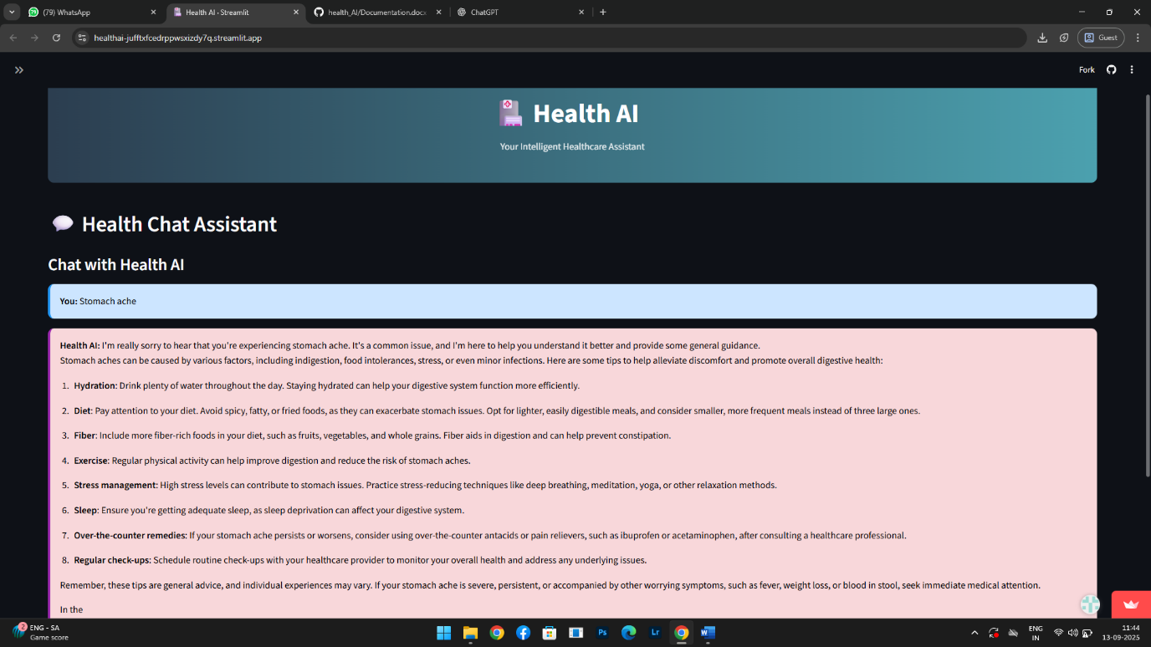

**symptom prediction:**

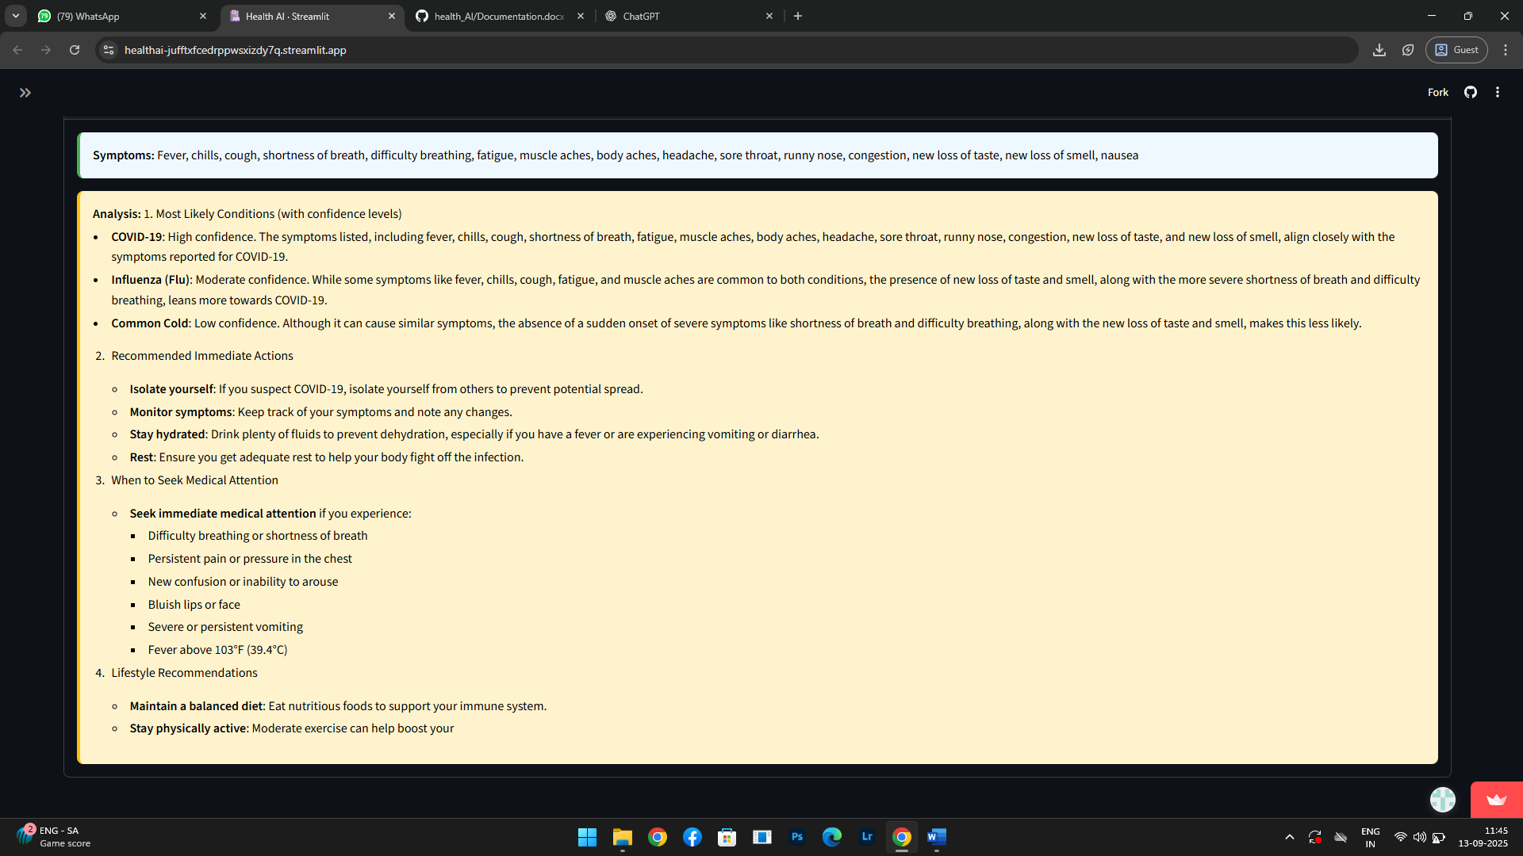

**Conclusion**

Intelligent Healthcare Assistant acts as a compassionate, adaptable companion—much like a caring medical advisor one can consult anytime. It listens to patient concerns, provides instant explanations and guidance for symptoms, and strives to predict health risks, all while carefully safeguarding sensitive health information with secure, respectful communication. The assistant is approachable: engaging users through voice, natural conversation, and clear visualizations, ensuring interactions feel familiar and personalized—not mechanical or cold.