**Pradeep Sharma,** Haldwani- 263139, Uttarakhand, India

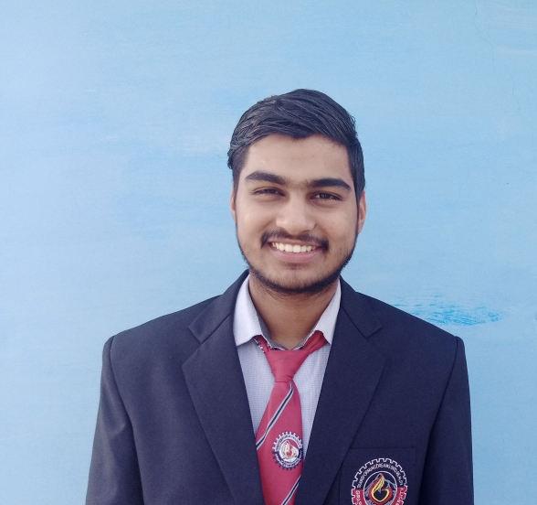

**Open to Relocation:** PAN India

**Email:** [pradeeppssharma829@gmail.com](mailto:harsdhawan188@gmail.com)

**Mobile Number:** +91-8449696679

[https://www.linkedin.com/in/pradeep-sharma-b846a4240](https://www.linkedin.com/in/harsh-dhawan-a3169a196/)

[https://www.hackerrank.com/pradeeppssharma1](https://www.hackerrank.com/harsdhawan188)

https://github.com/pradeep-Sharma2003

**CAREER OBJECTIVE**

As a final-year BCA student with a CGPA of 9.01 . I am seeking a role in the IT industry where I can utilize my technical, analytical, and logical skills to deliver successful projects. My long-term goal is to become a Tech Lead in an organization that values innovation, collaboration, and continuous learning.

**PROJECTS**

As a final project, We prepared an **Ecommerce** website with the functionality of browsing and

buying books utilizing our skills in **HTML5, Bootstrap CSS, PHP & SQL**. My main contribution & responsibility was to develop its **frontend** and **Tester** which received positive feedback from teachers and students and to run website from different platforms.

I have also pushed several projects in web development and android development on my GitHub profile as part of self practice & learning.

**TECHNICAL CERTIFICATIONS**

# HackerRank Coding Certification:

* Problem Solving.
* Sql.
* Python.
* Javascript.

# Great Learning:

* Introduction of **Artificial Intelligence**.

# Android Application Development.

**Internet of Things** Certificate from one day workshop.

**ACADEMIC DETAILS**

|  |  |  |  |
| --- | --- | --- | --- |
| **YEAR** | **QUALIFICATION** | **INSTITUTE** | **CGPA/%** |
| JUL’20 - JUL’23 | Bachelor of Computer Application (BCA) | GRAPHIC ERA HILL UNIVERSITY, HALDWANI | 9.01/10 |
| 2020 | 10+2, Central Board of Secondary Education (CBSE) | VENDY PUBLIC SCHOOL, HALDWANI | 65.4% |
| 2018 | 10, Central Board of Secondary Education (CBSE) | VENDY PUBLIC  SCHOOL, HALDWANI | 50.2% |

**TECHNICAL Knowledge**

**Programming Languages:**, C, C++ & SQL.

**Web Designing:** HTML, CSS , PHP.

**IDE’s:** Visual Studio, Android Studio, & PyCharm.

**Microsoft Tools:** Word, Excel & Powerpoint.

**Operating System:** Windows & Linux.

**STRENGTHS**

* Coding, Logical and Analytical skills.
* Goal Oriented and Strategic Mindset.
* Motivated to have a strong Technical career in IT.

**HOBBIES**

Coding, Photo & Video Editing, Cooking, Travelling & Dancing.

**PERSONAL DETAILS**

**Name:** Pradeep Sharma

**Data of Birth:** 27 Dec 2003 **Nationality:** Indian **Languages:** English and Hindi

**Father’s Name:** Mr. Rajendra Sharma

**Mother’s Name:** Mrs. Champa Sharma

**Date:** 16/April/2023 **Place:** Haldwani, Uttarakhand, India