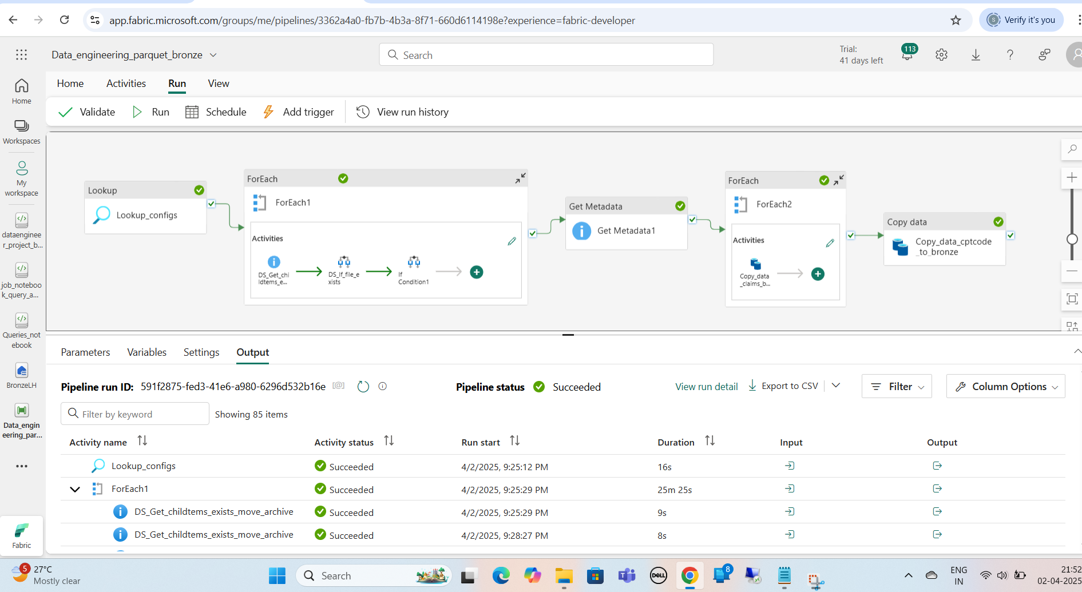

Based on configuration file load type deciding which tables to do full load and incremental load.

After first full load completion, we can configure incremental load for all tables which load data incrementally based in audit logs tables processed date. We can extend same full and incremental load types to claims and cptcodes as well. Currently full loading tables.

**Load config**

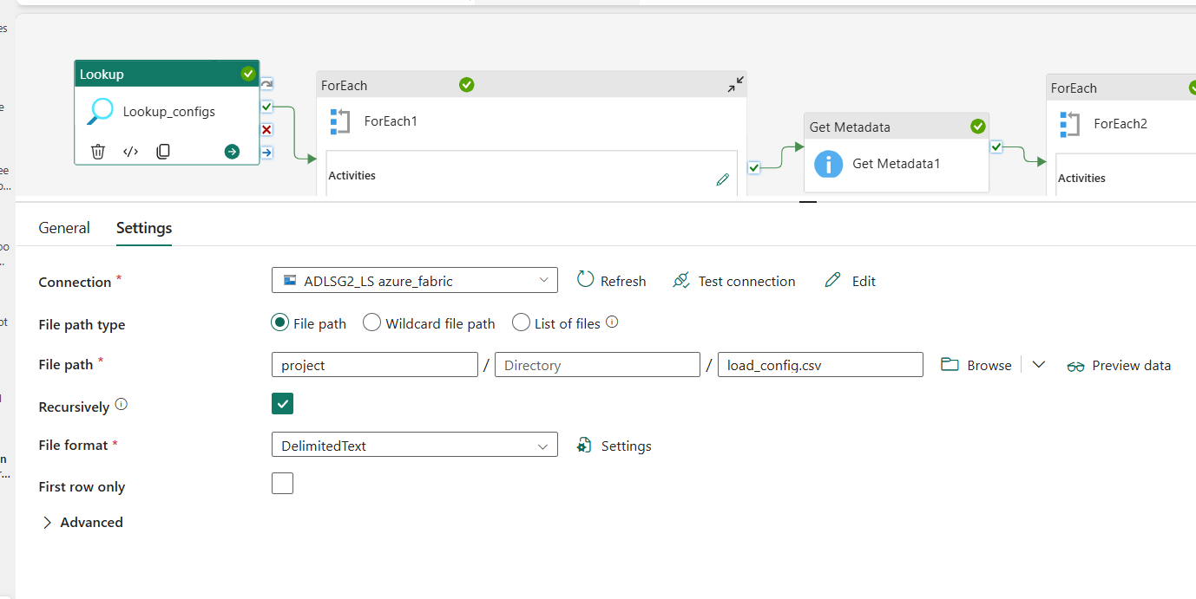

**For Each loop**

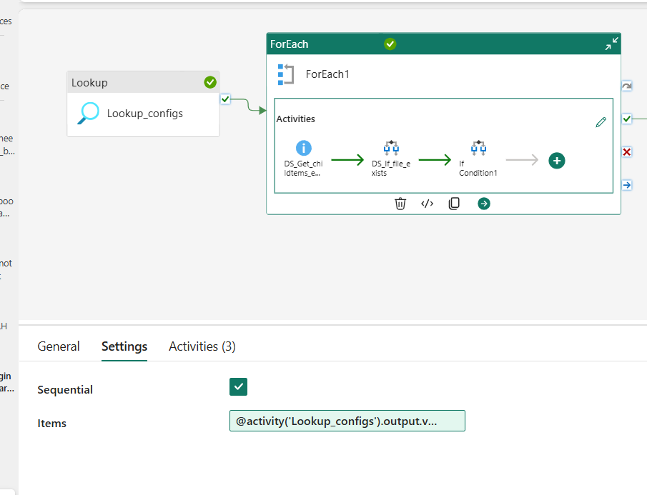

Items:

@activity('Lookup_configs').output.value

**Inside For each loop**

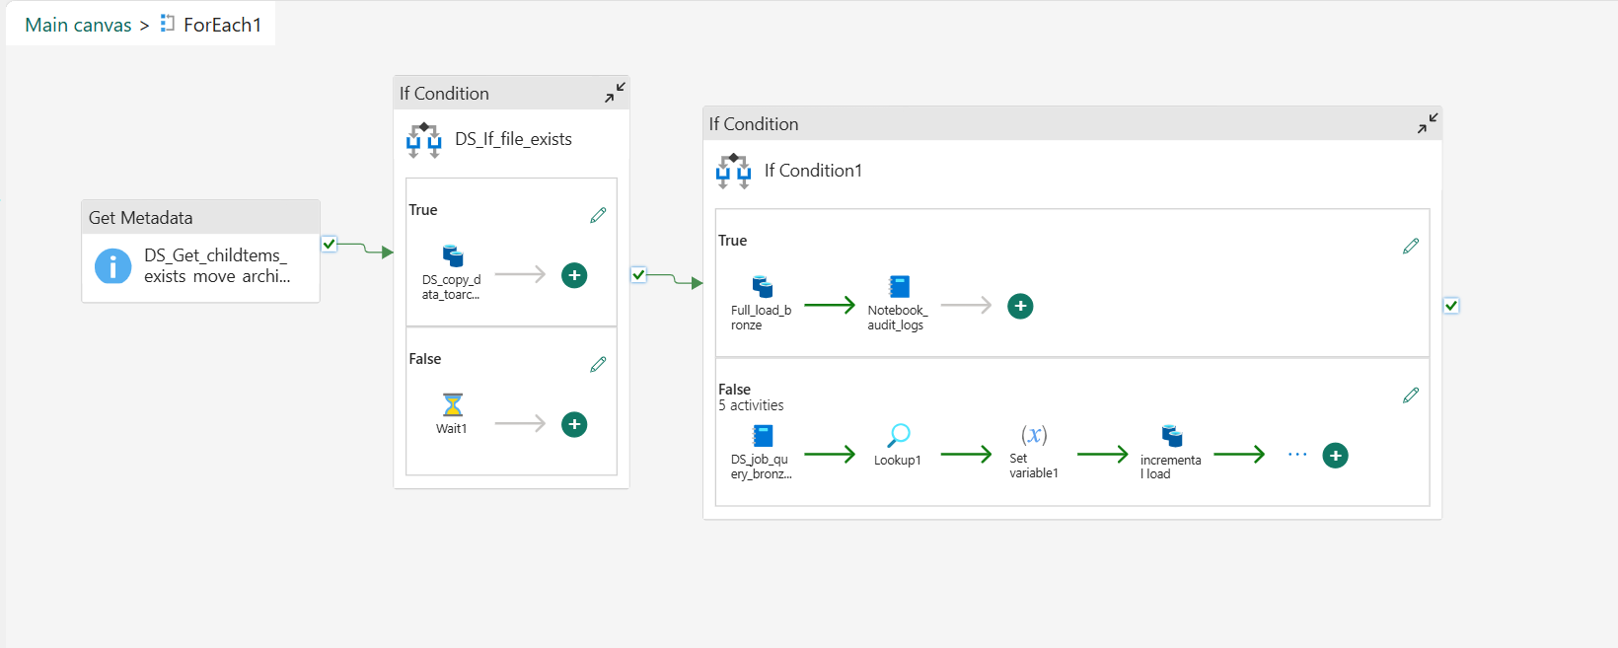

**Get metadata**

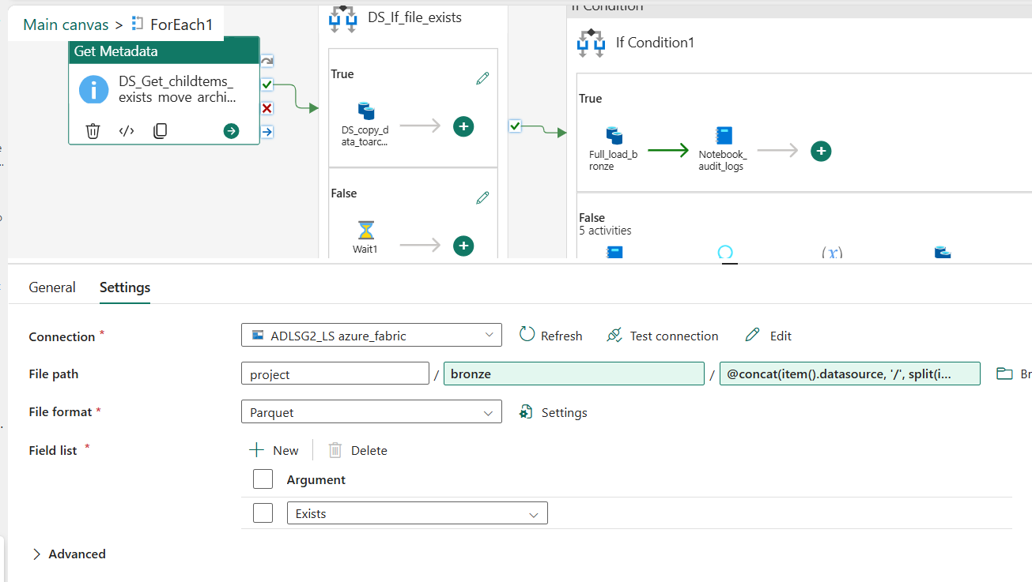

File path:

Project/bronze/@concat(item().datasource, '/', split(item().tablename, '.')[1])

**If condition**

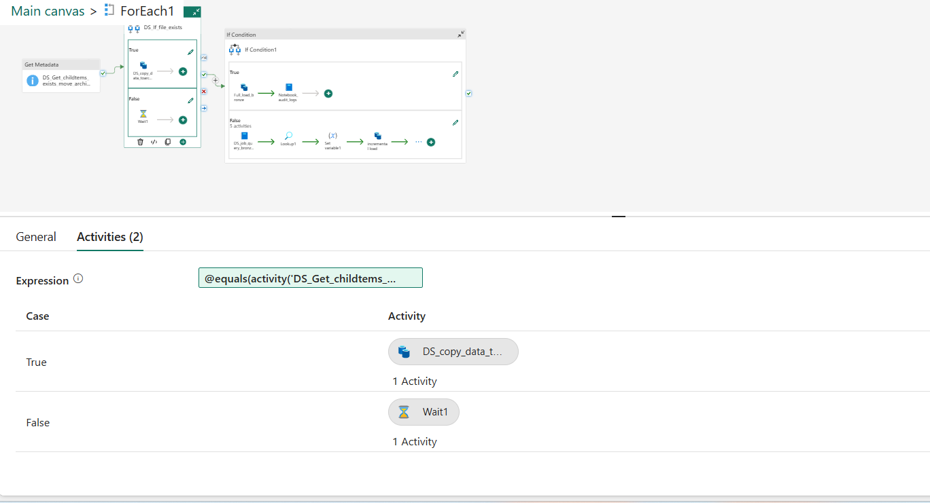

Expression:

@equals(activity('DS_Get_childtems_exists_move_archive').output.exists, true)

**If true condition:**

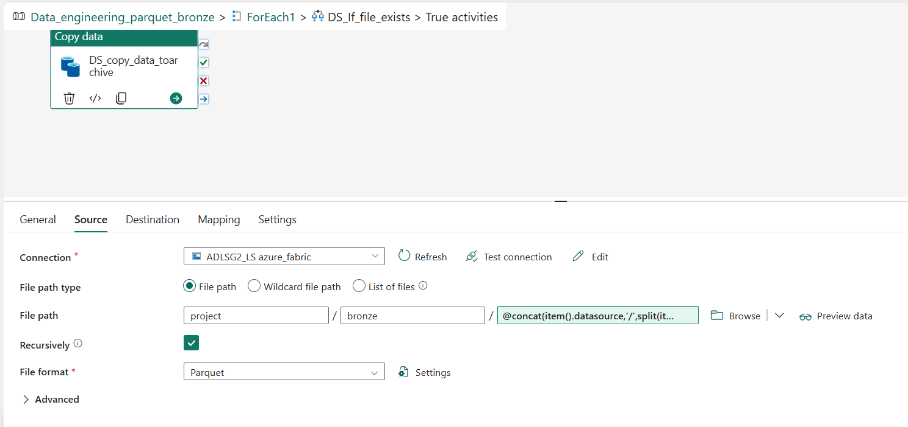

File path:

Project/bronze/@concat(item().datasource,'/',split(item().tablename,'.')[1])

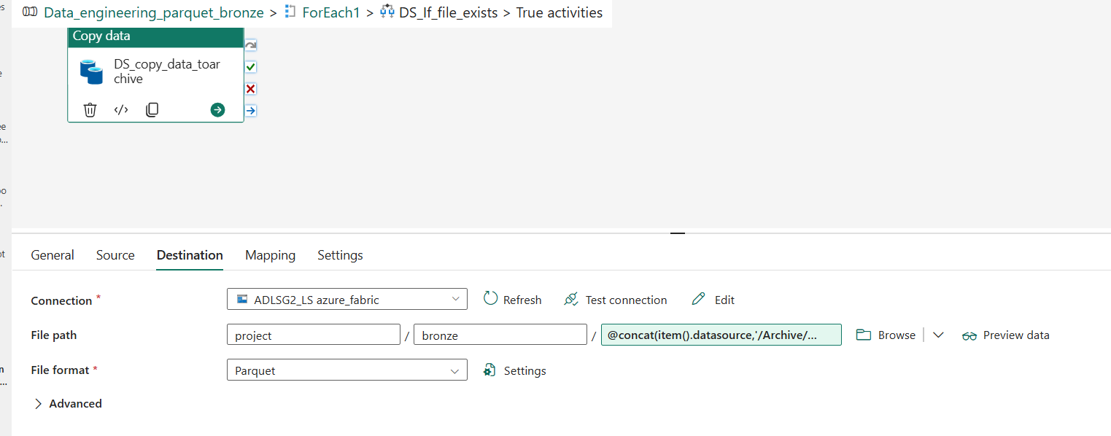

File path:

[Project/bronze/@concat(item().datasource,'/Archive/',formatDateTime(utcNow(),'yyyy'),'/',formatDateTime(utcNow(),'MMMM'),'/',formatDateTime(utcNow(),'%d'),'/',item().tablename)](mailto:Project/bronze/@concat(item().datasource,'/Archive/',formatDateTime(utcNow(),'yyyy'),'/',formatDateTime(utcNow(),'MMMM'),'/',formatDateTime(utcNow(),'%25d'),'/',item().tablename))

**If condition 2**

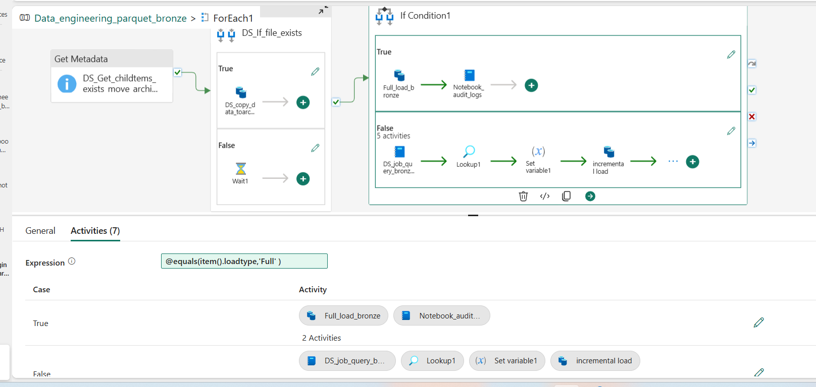

**If condition True:**

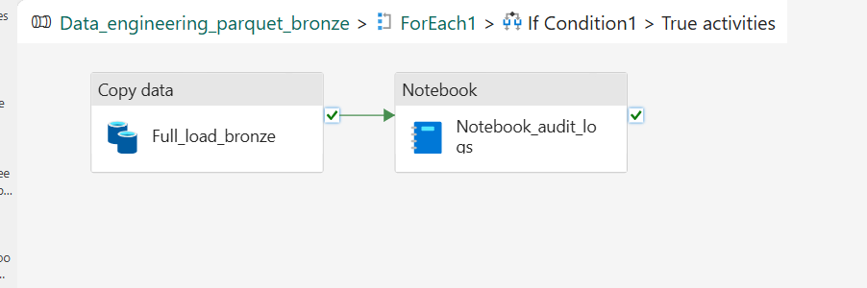

Copy activity :

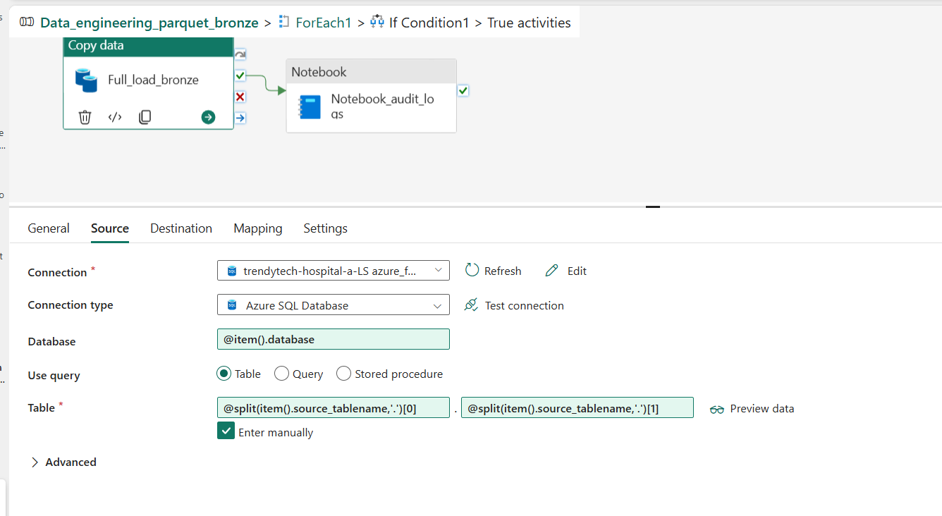

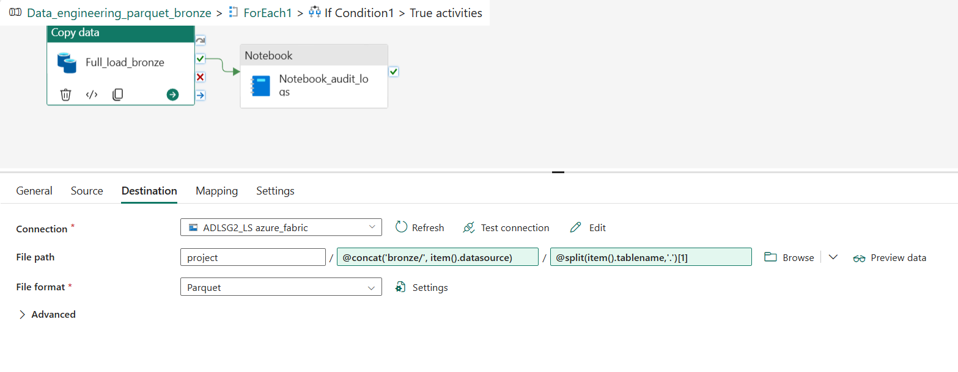

**Note_book_audit_logs:**

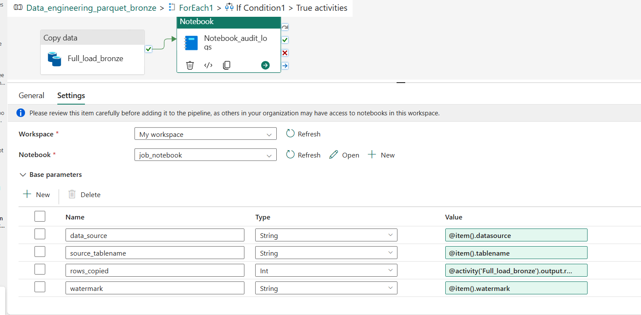

Rows_copied:

@activity('Full_load_bronze').output.rowscopied

**If condition2 False activity:**

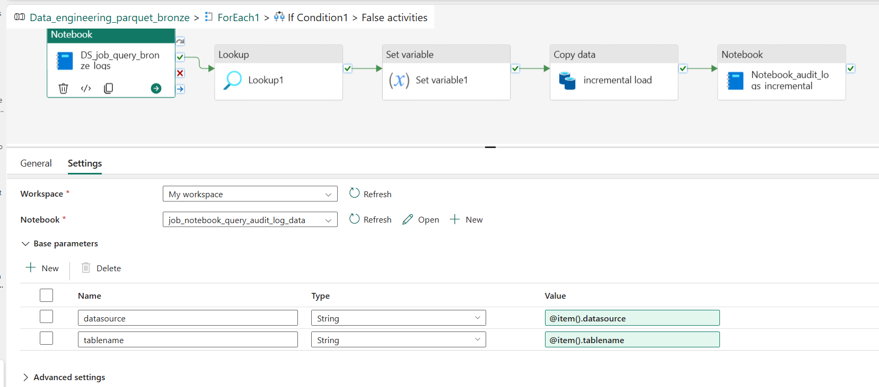

**Loopkup activity:**

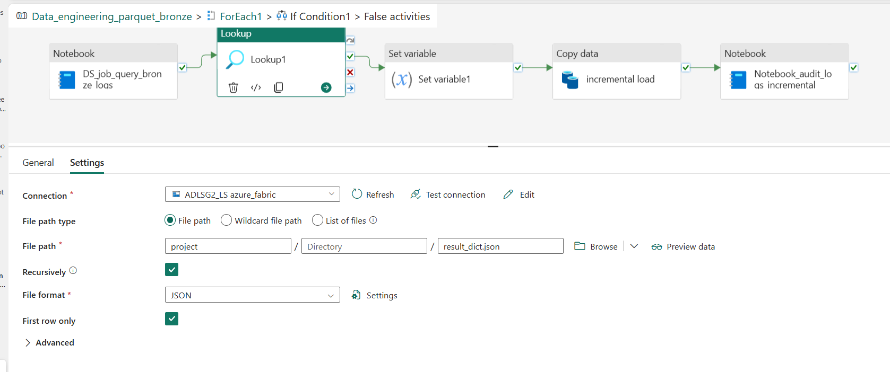

Set variable activity:

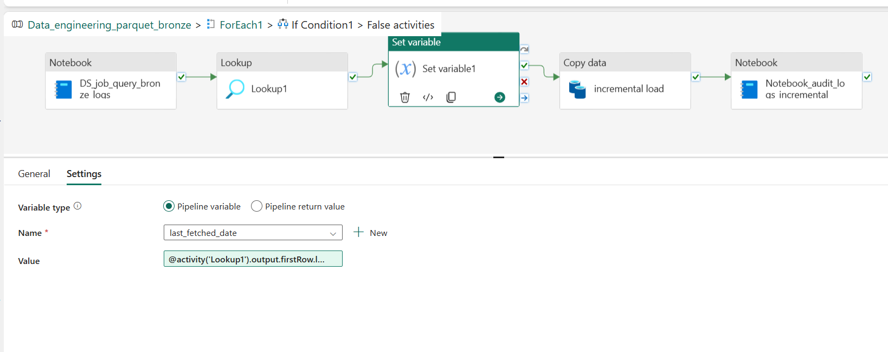

Value:

@activity('Lookup1').output.firstRow.last_fetched_date

**Copy incremental data load:**

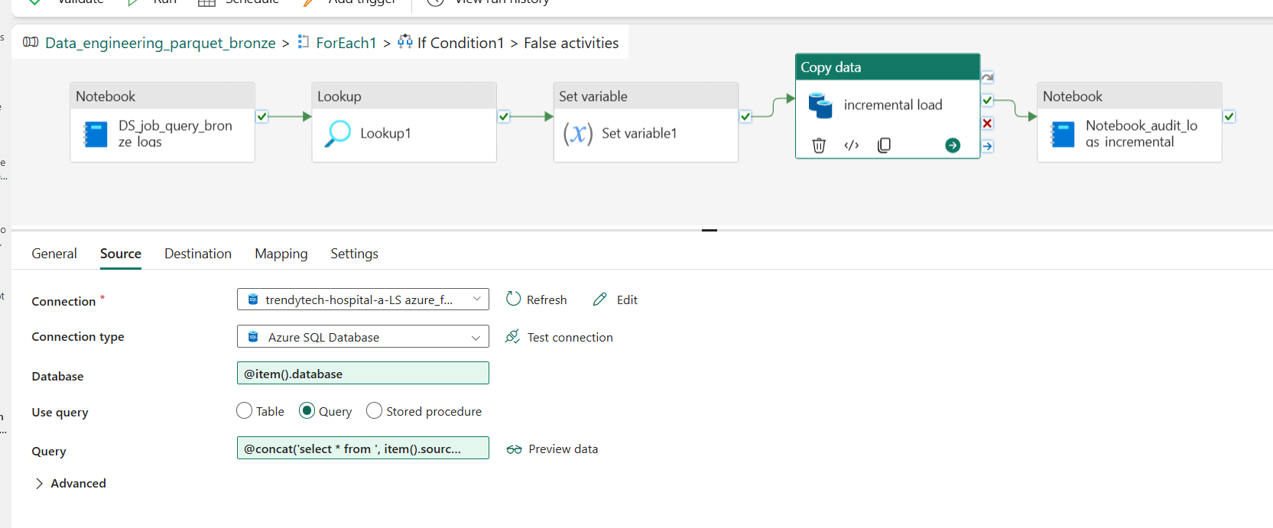

Query:

@concat('select * from ', item().source_tablename, ' where ', item().watermark, ' >= ''',formatDateTime(variables('last_fetched_date'), 'yyyy-MM-dd'),'''')

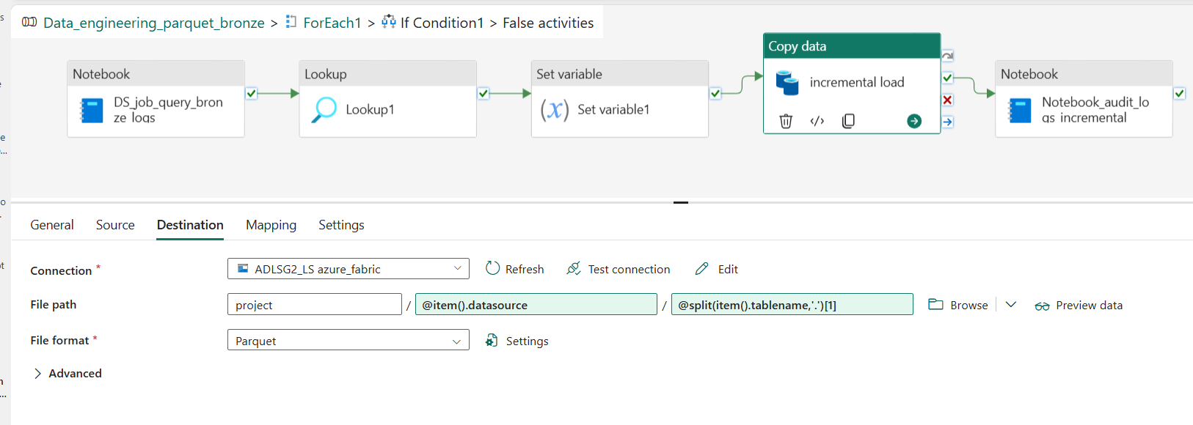

**Note book audit logs:**

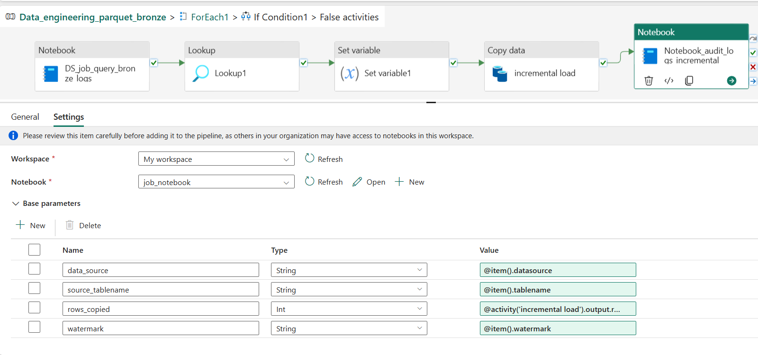

Rows_copied:

@activity('incremental load').output.rowscopied

**Get metadata1**

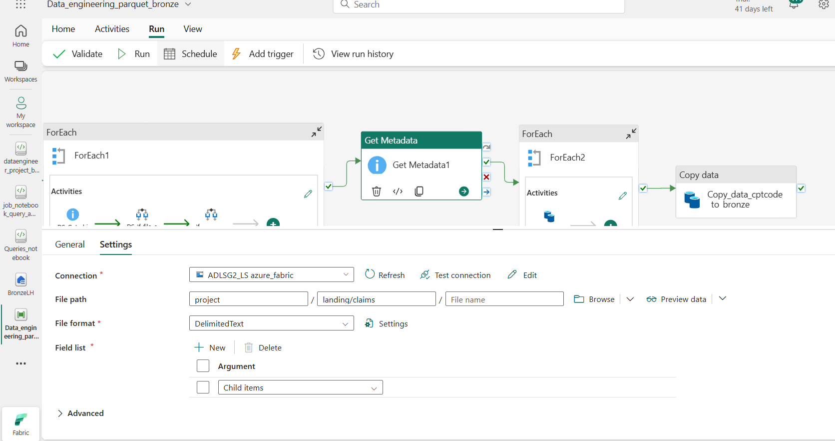

**For each activity 2:**

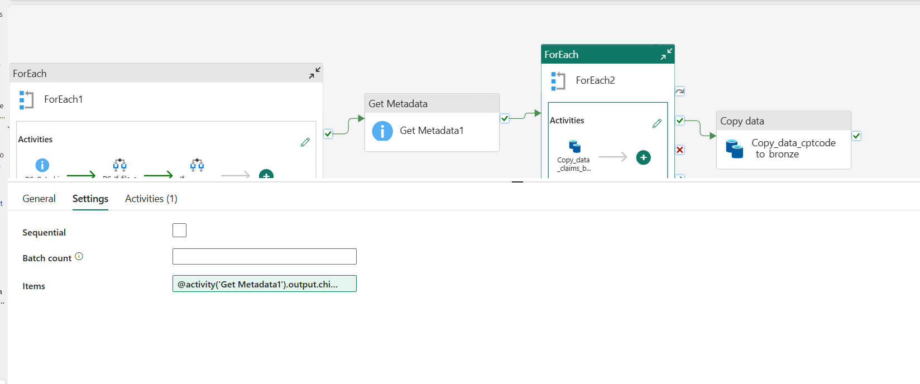

Item:

@activity('Get Metadata1').output.childItems

**Copy data activity:** 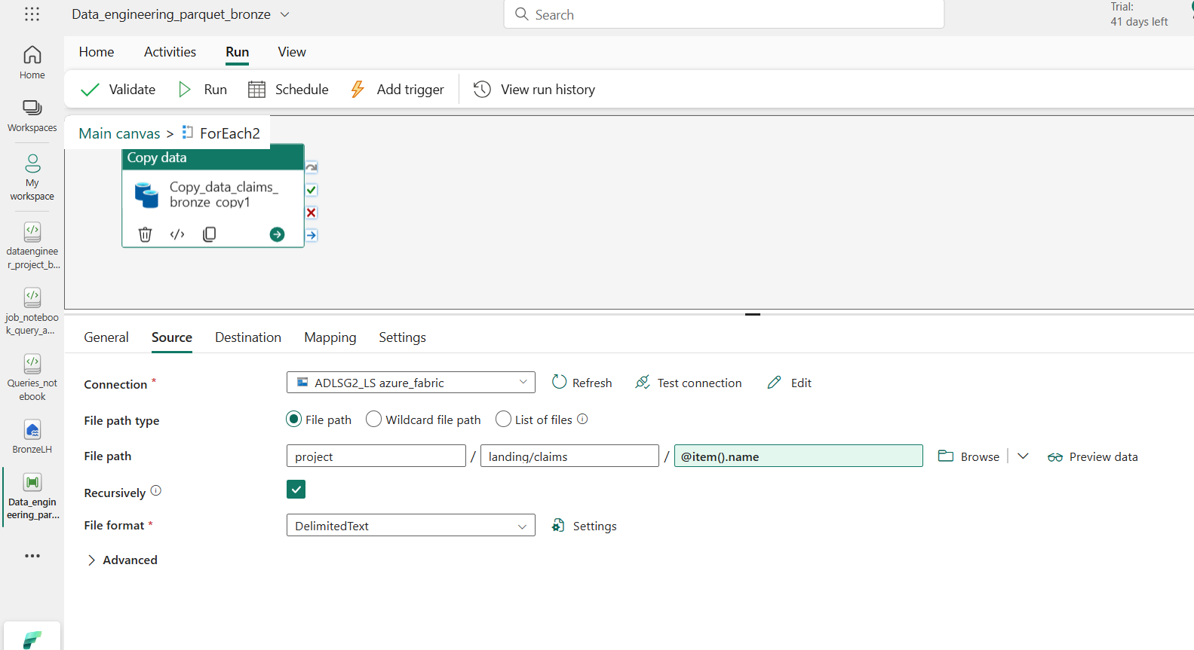

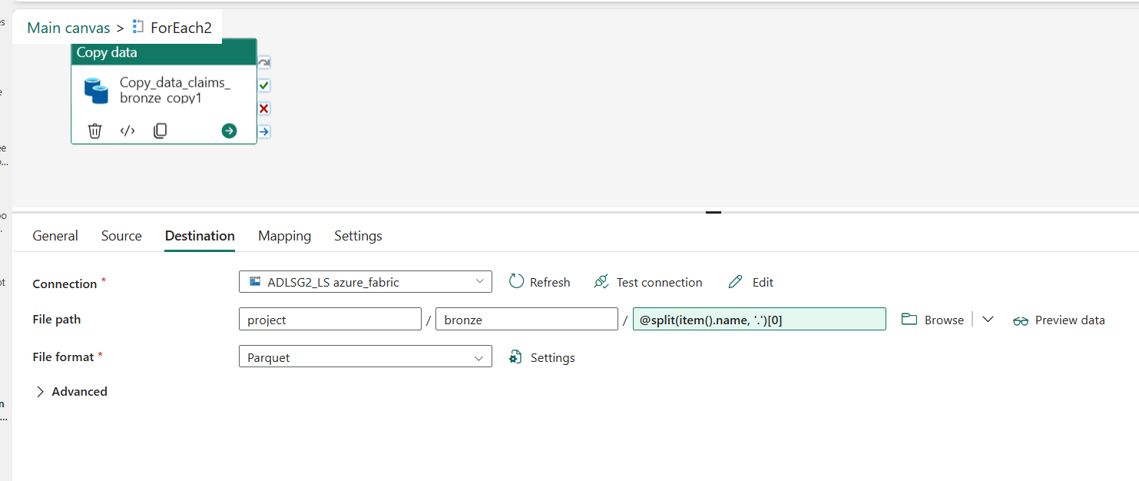

**Copy data activity:**

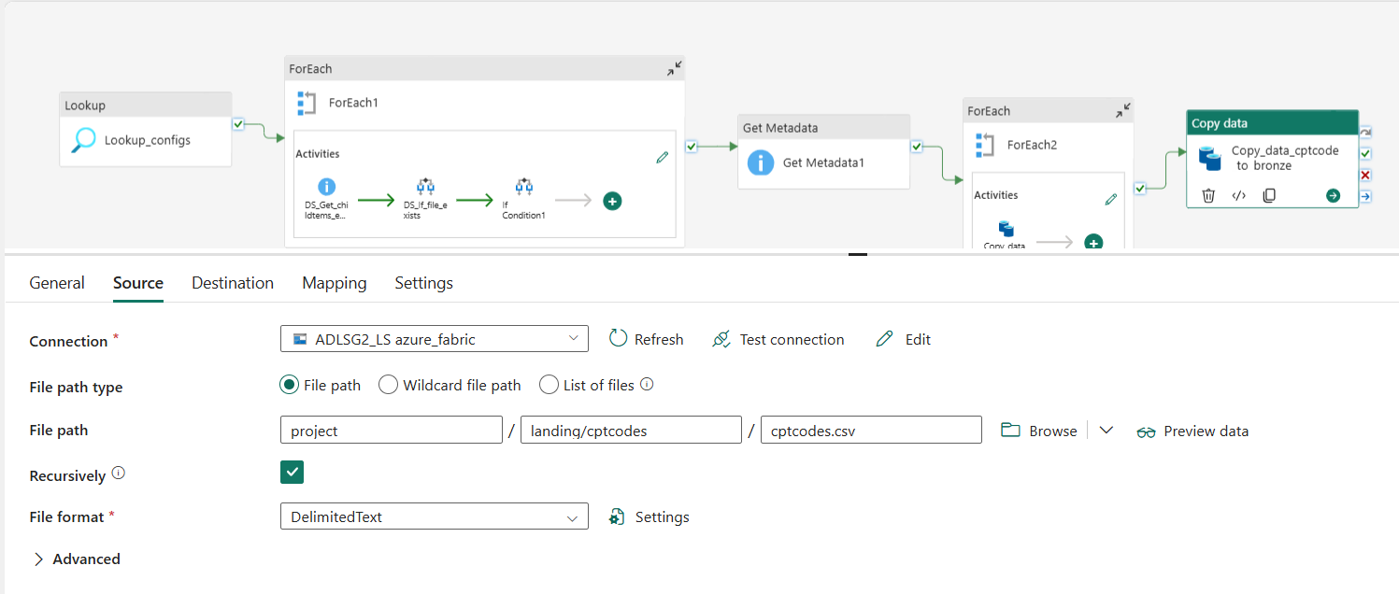

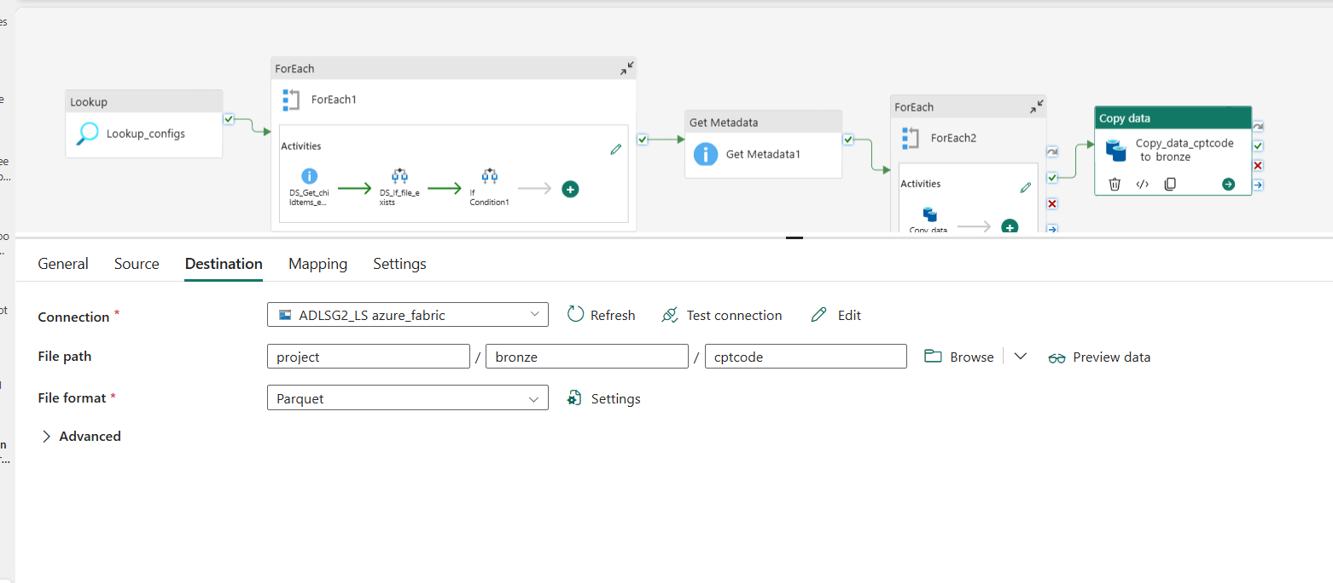

**Azure data lake storage gen2**

**Highlighted are related project**

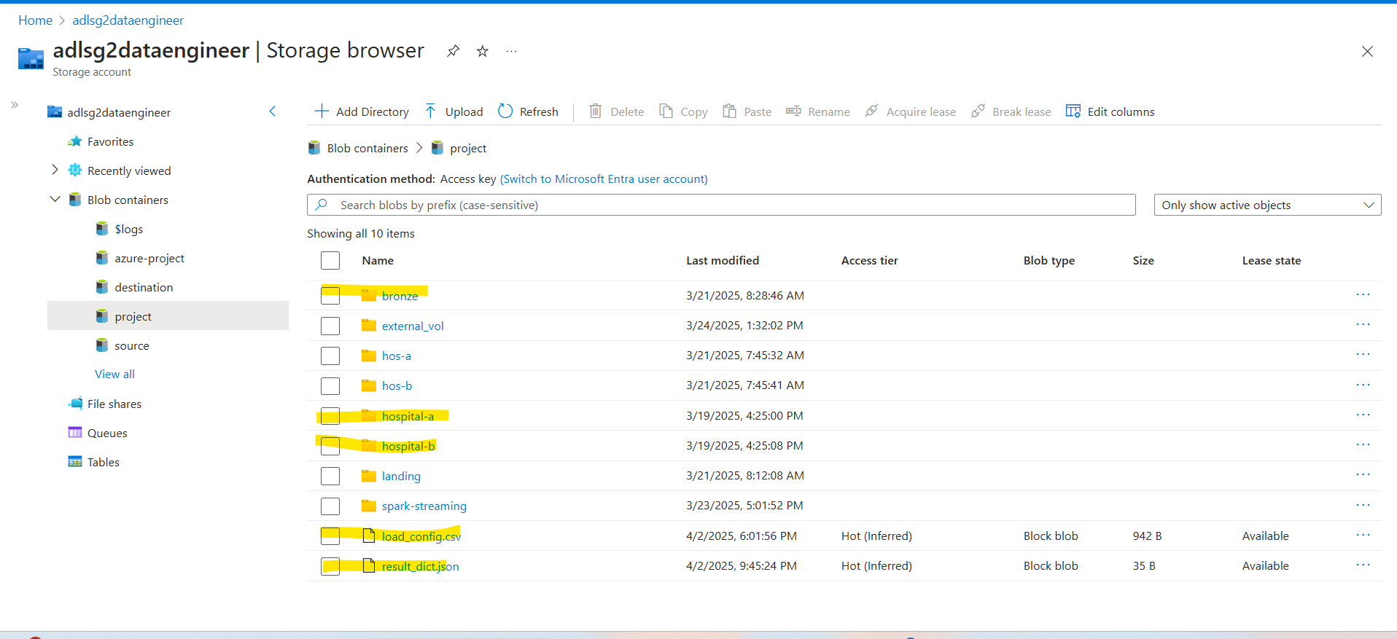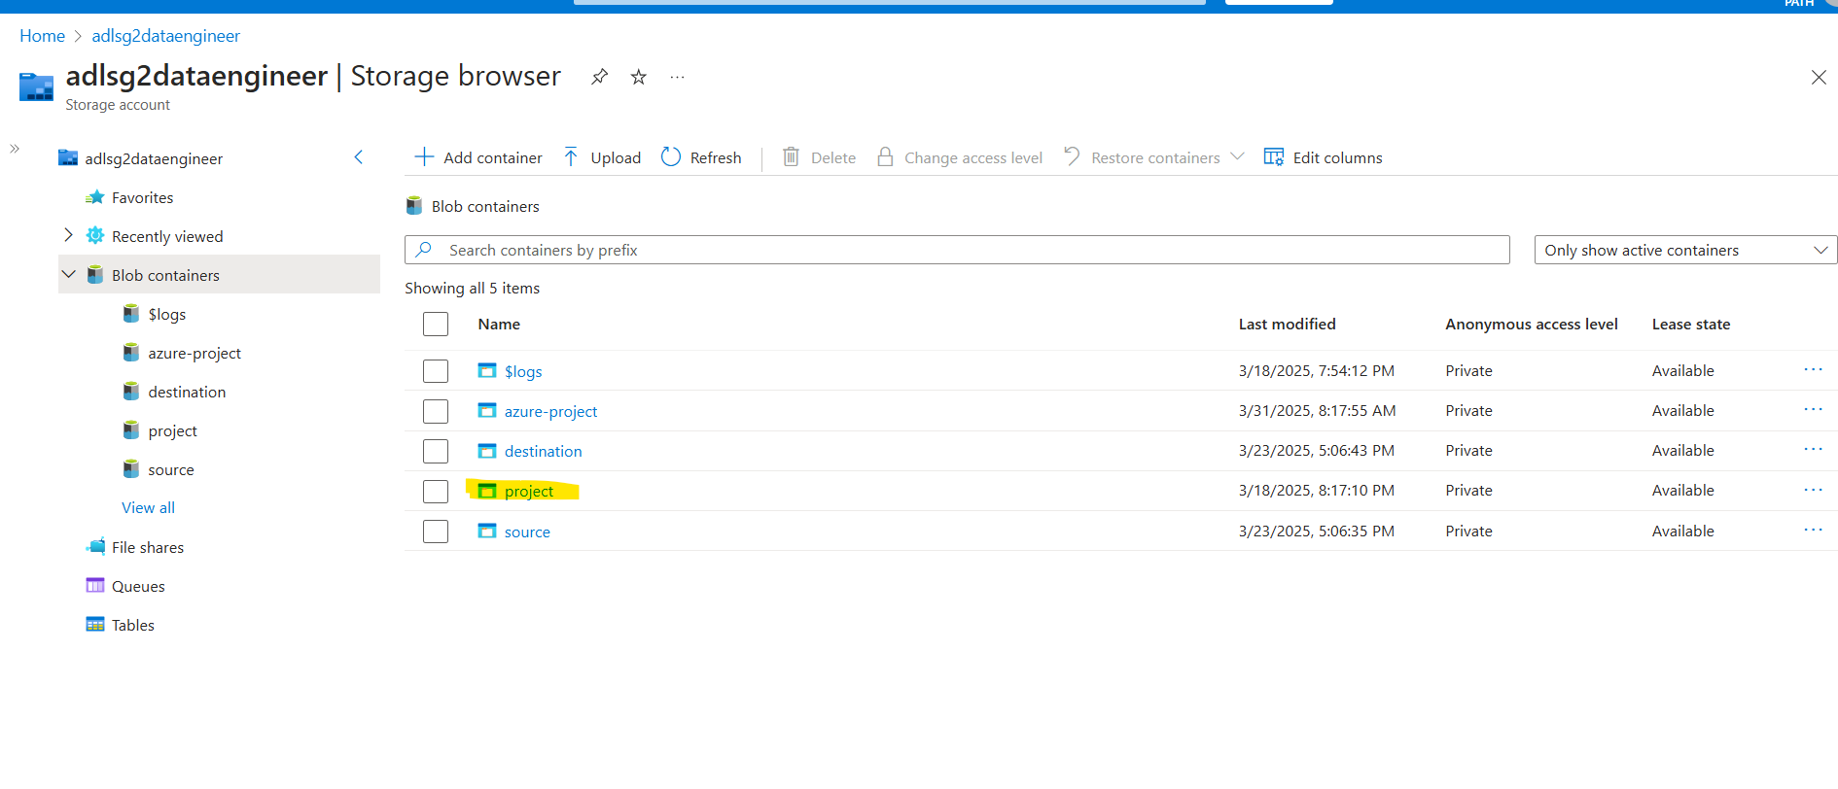

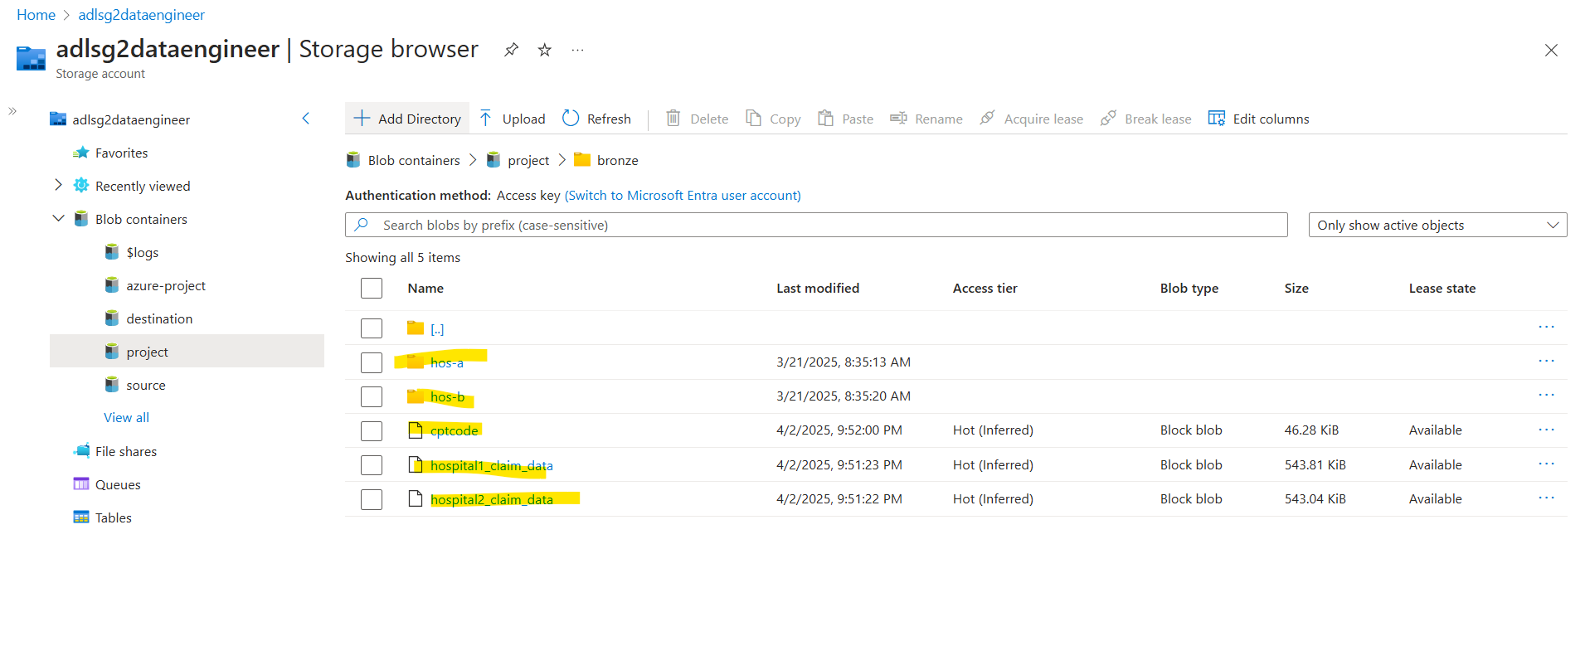

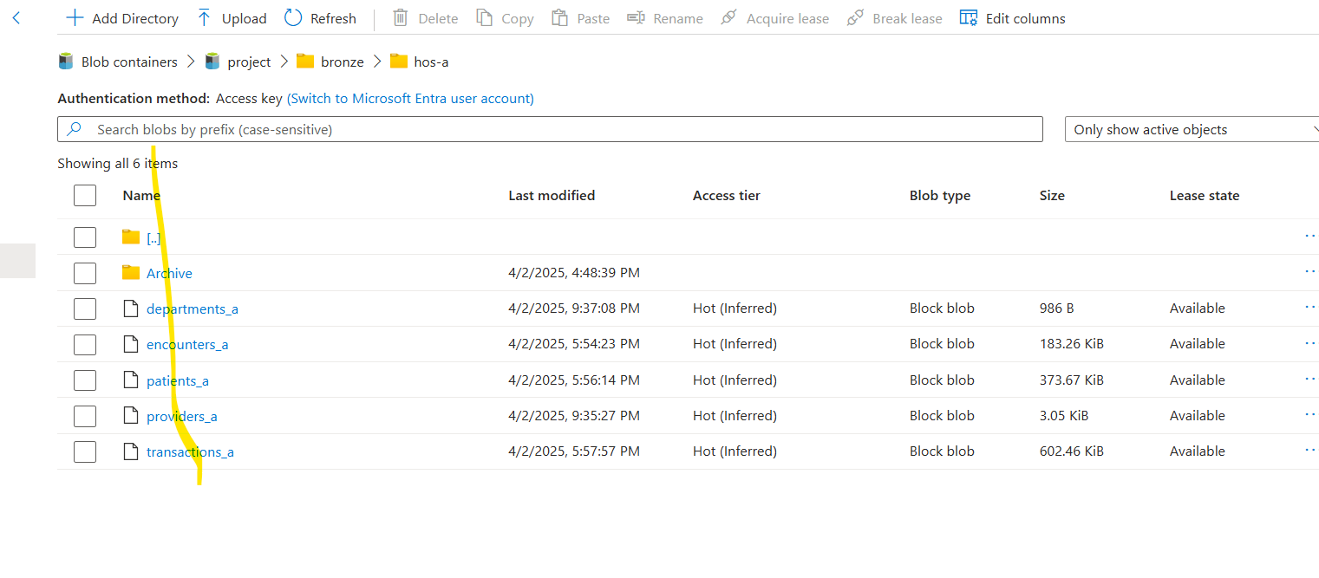

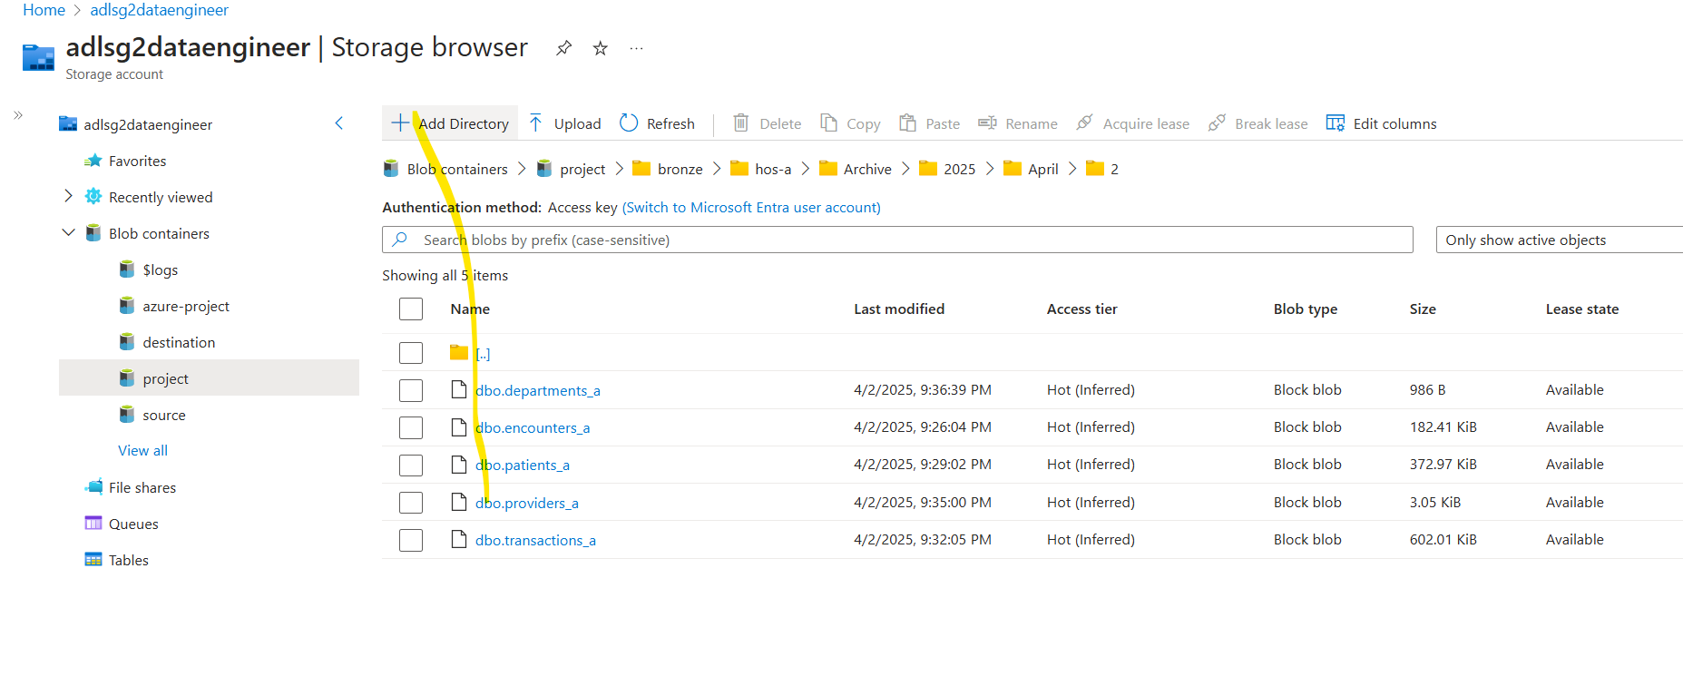

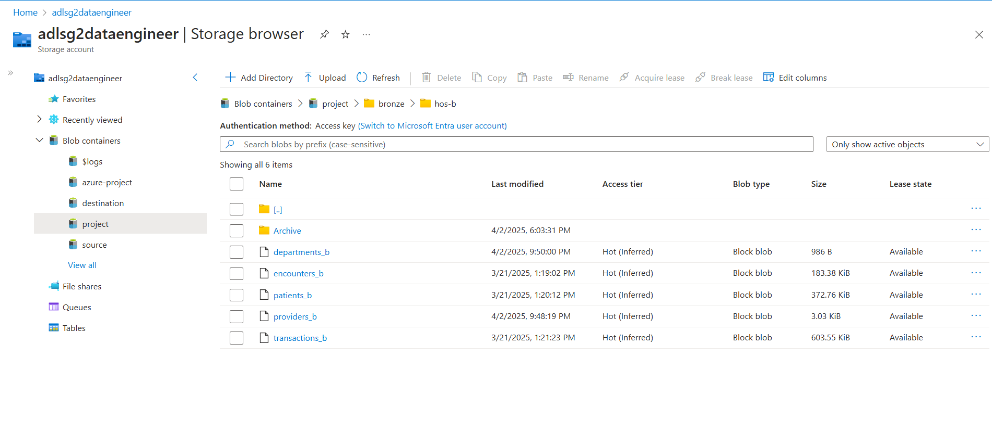

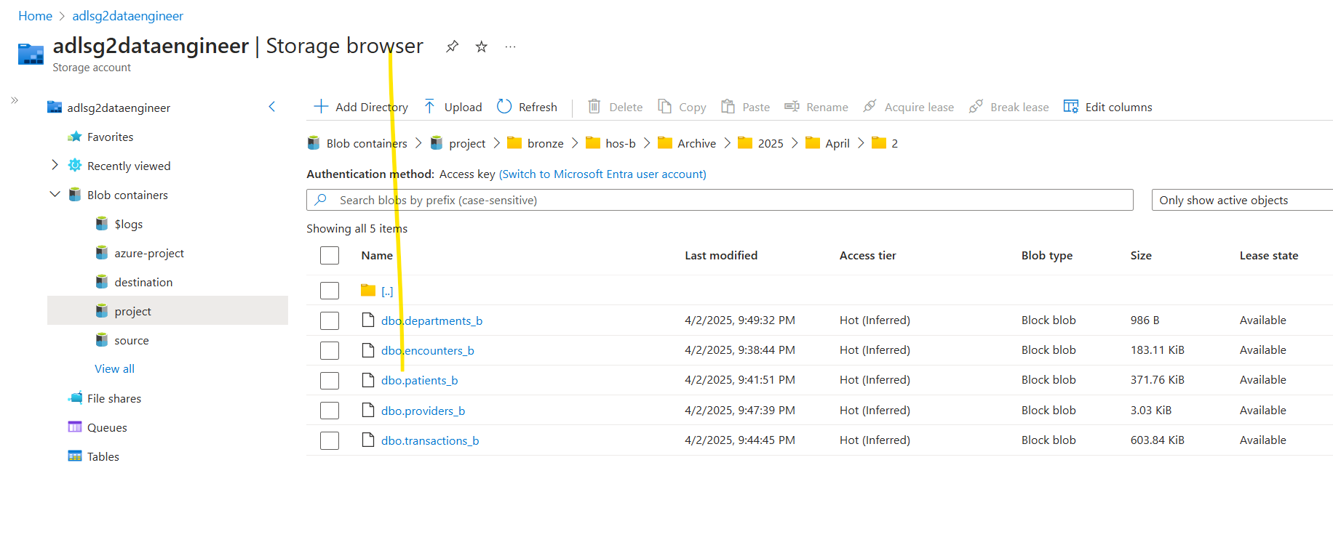

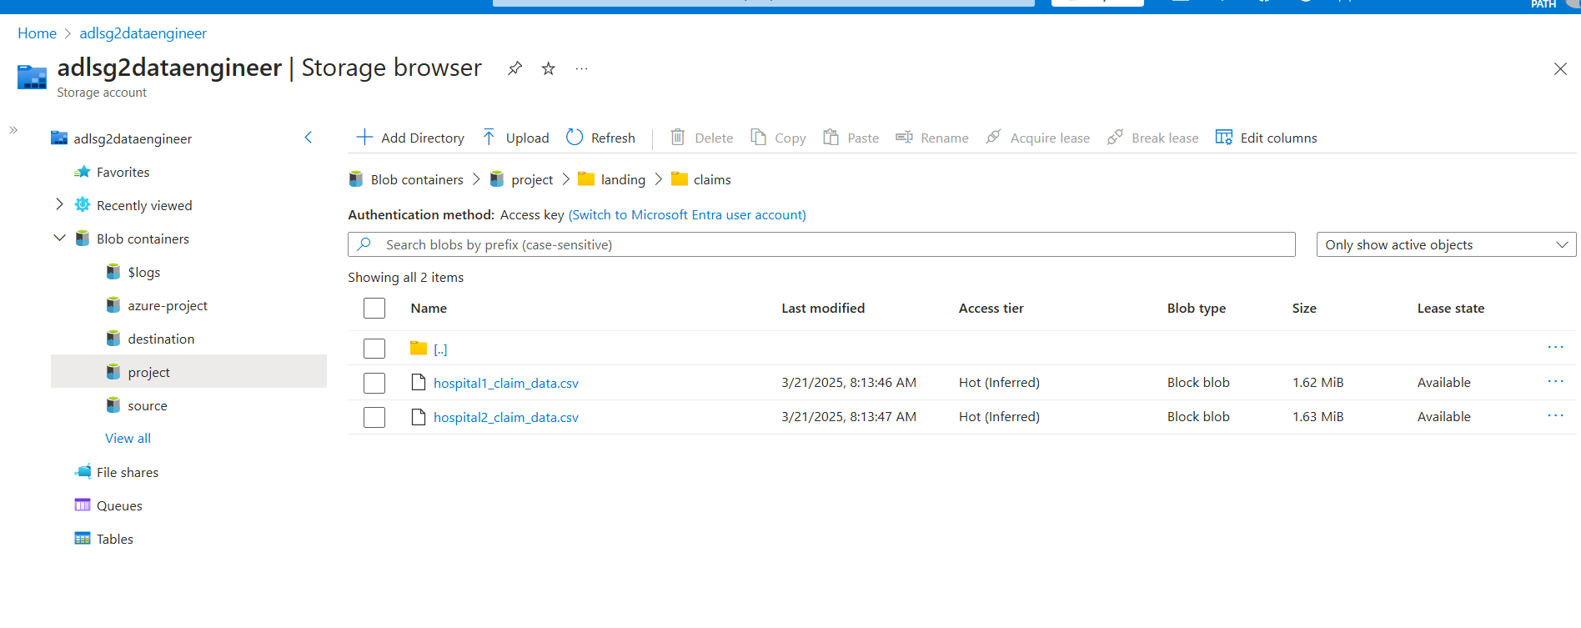

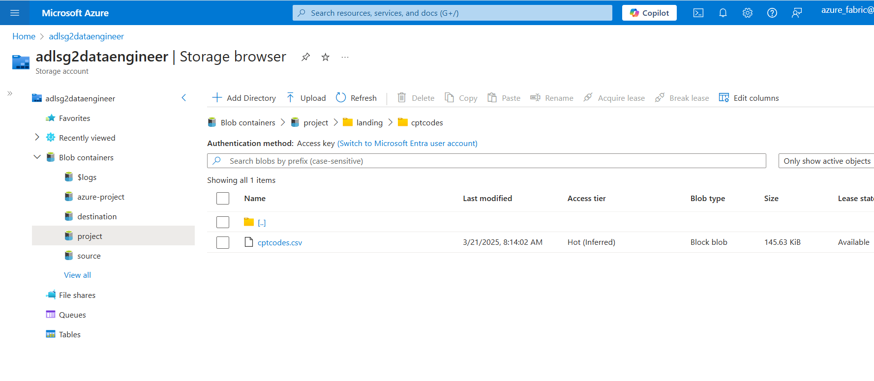

**Lakehouses**

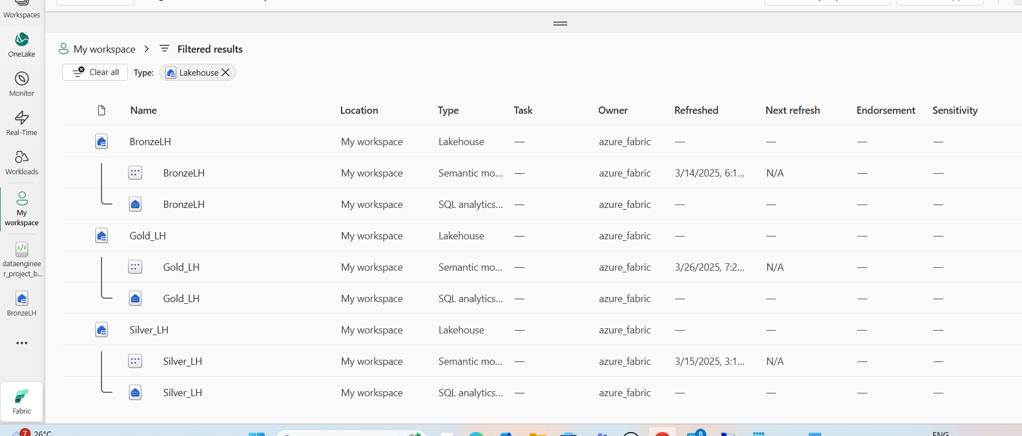

**Bonze**

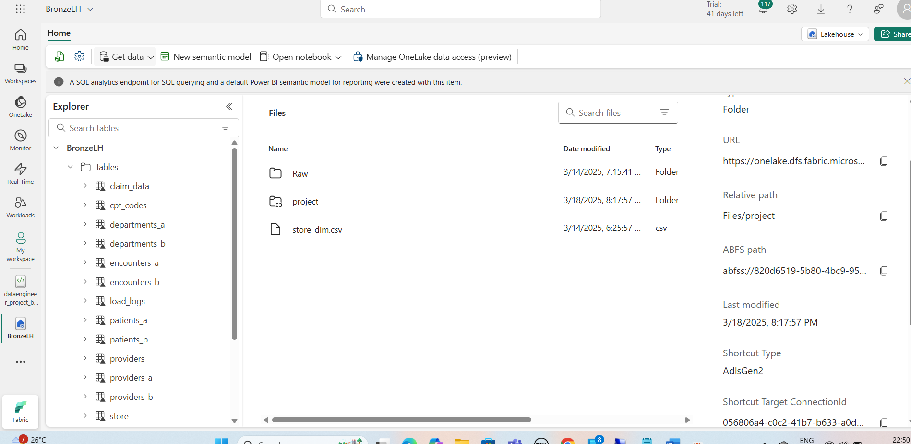

**Silver**

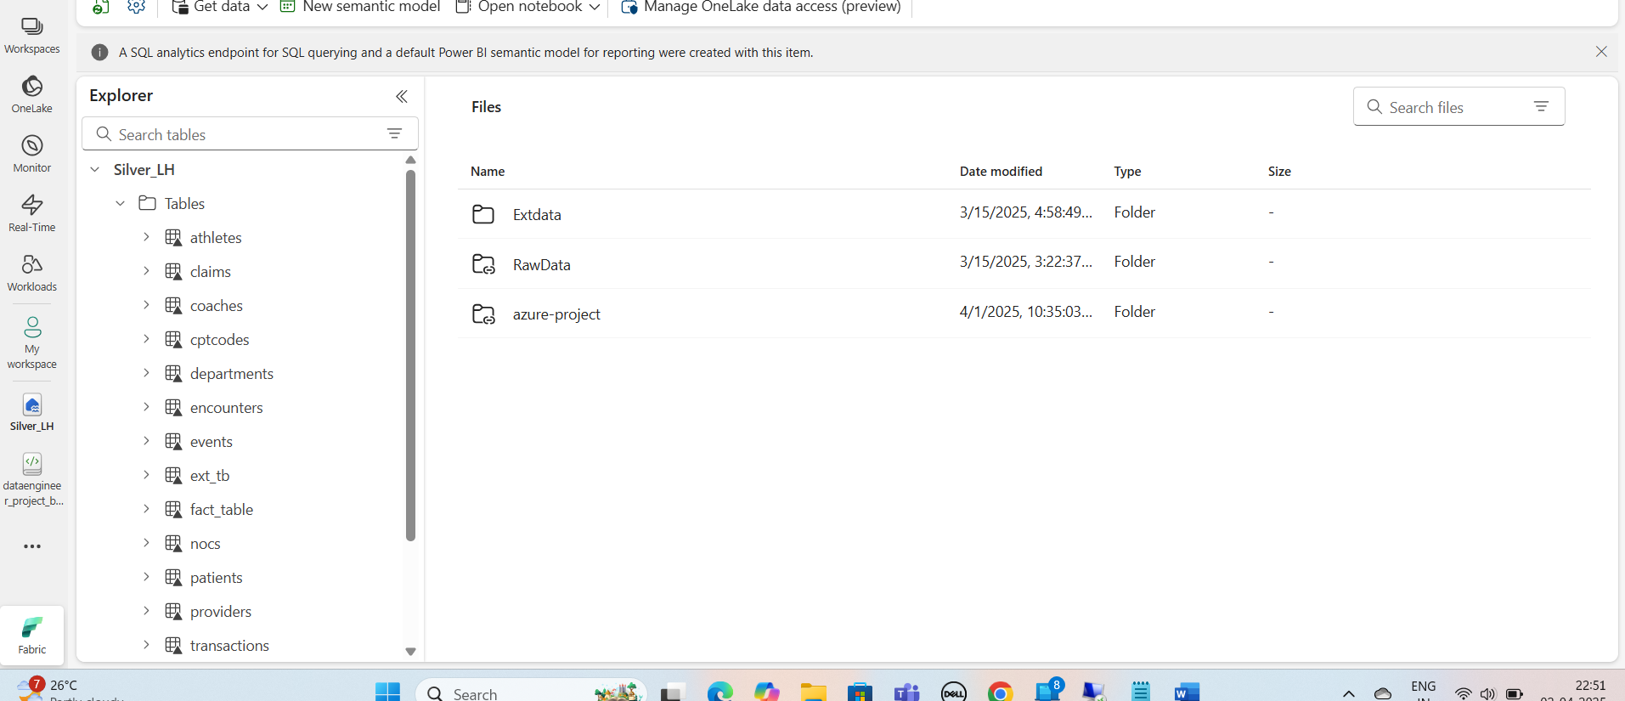

**Gold**

