|  |  |  |
| --- | --- | --- |
| Sentimental Analysis on Reviews of Amazon Fine Food  Pradeep Angadageri, David Williams | |  | | --- | | dbs_logo.png | |

**ABSTRACT**

Sentimental analysis or Opinion Analysis is the machine study of the people’s opinion, sentiments, attitude, emotions expressed in communication[1]. Social Media has given the ample opportunities to online user in terms of gauging the products quality by examining the review posted by other users. The platform such as Amazon.com allows user to express their view about the particular product. This helps both consumer and manufacturer to choosing and improving their product respectively.

* **How the sentimental analysis on reviews of the Amazon fine food, helps the user to choose better products based on the reviews expressed by other users from the same platform users?**
* **How to perform the binary classification using the text feature and machine learning algorithm for these reviews?**

**INTRODUCTION**

Business markets are using the online platform to expand their market and services. The increasing use of social media and the internet has significantly changed the way consumers shop for products. Consumers can judge the quality of the products by reading and examining numerous online reviews available on online public platforms such as Amazon.com. However, if these reviews are not organized or presented properly, can lead the customers to an ambiguous situation.

**OVERVIEW**

It has been estimated that the ‘Helpfulness Voting’ system brings in Amazon.com about $2.7 billion in additional revenue[2]. The study conducted by[3], investigated the effect of sentiment on the helpfulness of online consumer reviews. The study provided insights into the performance of online reviews by investigating the effect of sentiment polarity on the helpfulness.

**Feature extraction :** How the text model converted into classification model.

|  |
| --- |
| Contact :Pradeep Angadageri  e-mail:10554730@mydbs.ie |

**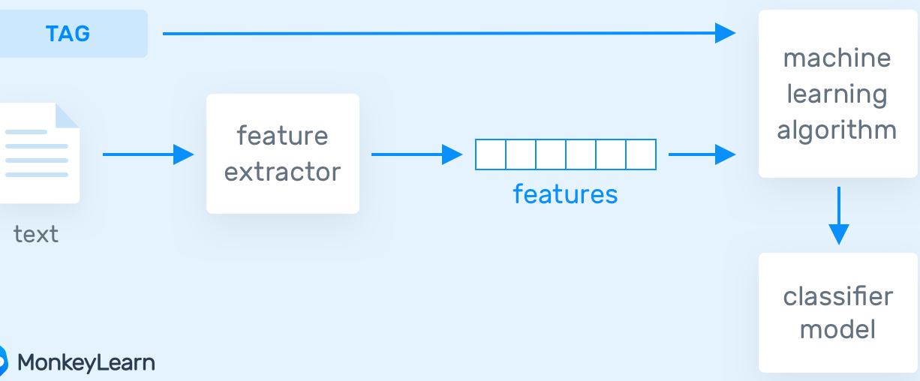**

**METHODOLGY**

* The data set contains 568,454 reviews.
* Number of users are :256,059
* Number of products are:74,258
* Time span : Oct 1999 – Oct 2012

**RESEARCH AND FUTURE PLAN**

|  |
| --- |
| * The dataset includes 10 Columns * Analyzing the data by using standard techniques. * Transforming the raw data into understandable data. Removing the noisy data and Inconsistent. * Converting text data to numeric data using different vectorization techniques. * Naïve Bayes ,KNN, Logistic regression. And finding the best accuracy. * Based on accuracy and precision, the model which is showing highest and precision will be deployed |

**Amazon Fine food reviews (568454 reviews) WILL BE CONidered for sentimental analysis**

**HELPFULNESS**

The distribution of helpfulness for frequent reviewers is similar to that of all reviews. However, frequent reviewers are more likely to have their review voted on and when voted on, more likely to be voted and helpful, and less likely to be unhelpful.

**Graph showing the Helpfulness by reviewer Frequency**

**REFERENCES**

**1).** F. HosseinzadehBendarkheili, R. Mohammadi Baghmolaei and A. Ahmadi, "Product Quality Assessment using Opinion Mining in Persian Online Shopping," 2019 27th Iranian Conference on Electrical Engineering (ICEE), Yazd, Iran, 2019, pp. 1917-1921, doi:10.1109/IranianCEE.2019.8786611.

**2**). Cao, Q., Duan, W. and Gan, Q., 2011. Exploring determinants of voting for the “helpfulness” of online user reviews: A text mining approach. Decision Support Systems, 50(2), pp.511-521.

**3).** Salehan, M. and Kim, D.J., 2016. Predicting the performance of online consumer reviews: A sentiment mining approach to big data analytics. Decision Support Systems, 81, pp.30-40.

**4).** https://www.cs.cornell.edu/home/kleinber/www09-helpfulness.pdf