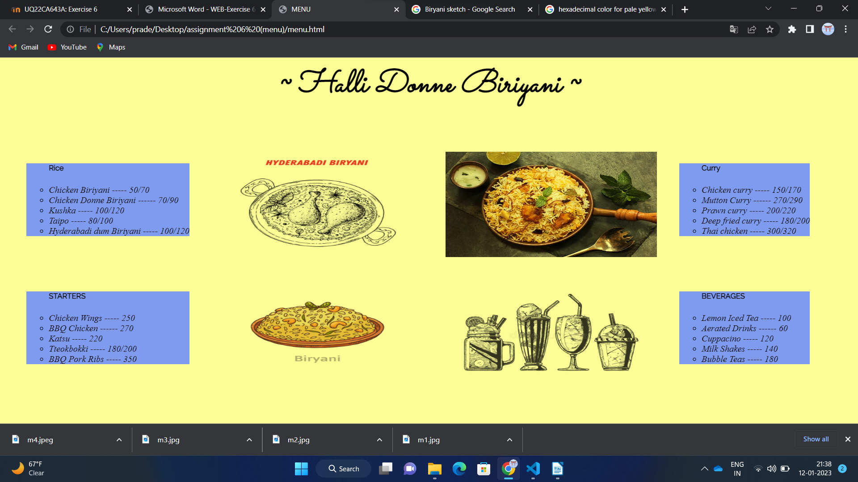
Pradeep PES1202203083 WEB TECH ASSIGNMENT 6

