Project 3: Create a chatbot in Python

**Development Part 2:**

* In this part you will continue building your project.
* Continue building the chatbot by integrating it into a web app using Flask.

* In this part you will continue building your project.
* Continue building the chatbot by integrating it into a web app using Flask.
* We training our Chatbot with help of the below dataset link.

[**https://www.kaggle.com/datasets/grafstor/simple-dialogs-for-chatbot**](https://www.kaggle.com/datasets/grafstor/simple-dialogs-for-chatbot)

**STEP:1**

Creating the app.py file. Then,Run it.

Create the Flask app to serving in main application

**APP.PY CODE:**

from flask import Flask, request

app = Flask(__name__)

@app.route('/')

def index():

return 'Chatbot is running!'

@app.route('/chat', methods=['POST'])

def chat():

message = request.form['message']

# Process the user's message and generate a response from the chatbot

response = process_message(message)

return response

def process_message(message):

# Write your chatbot logic here

# This is just a simple example that echoes back the user's message

return message

if __name__ == '__main__':

app.run()

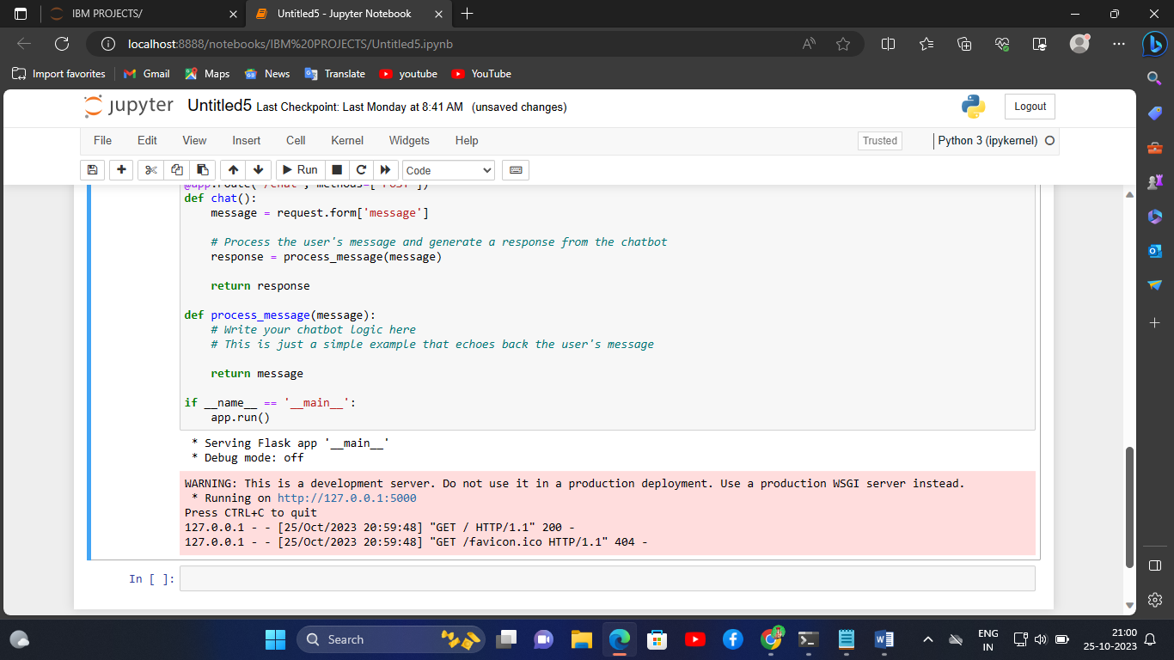

**STEP:2**

Run the app.py code in the jupyter notebook.

Then, the server is running on the website.

In that website, Chatbot is running! is shown on the web application.

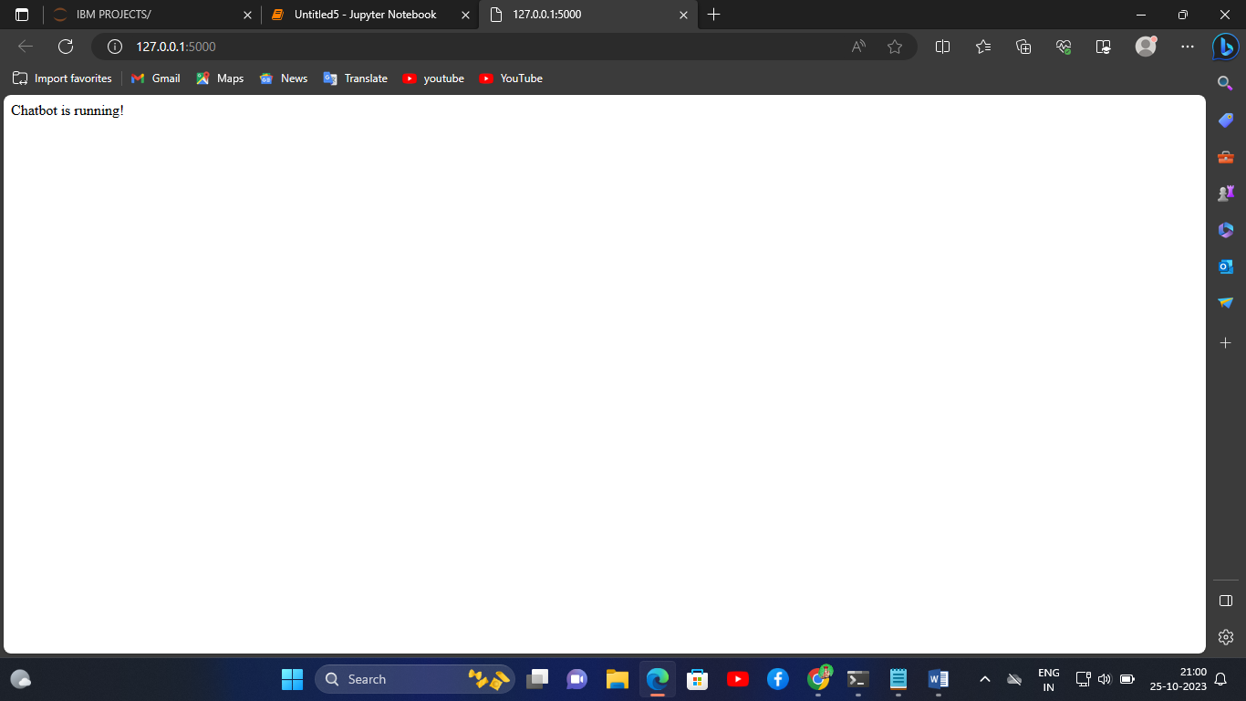

**PROGRAM CODE:**

import random

# define bot responses

bot_responses = {"hi, how are you doing?":["i'm fine. how about yourself?"],

"i'm fine. how about yourself?":["i'm pretty good. thanks for asking."],

"i'm pretty good. thanks for asking.":["no problem. so how have you been?"],

"no problem. so how have you been?":["i've been great. what about you?"],

"i've been great. what about you?":["i've been good. i'm in school right now."],

"i've been good. i'm in school right now.":["what school do you go to?"],

"what school do you go to?":["i go to pcc."]

}

# define function for getting bot response

def get_bot_response(user_input):

"""Get bot response based on user input"""

response = {}

for key in bot_responses.keys():

if key in user_input:

response = random.choice(bot_responses[key])

break

return response if response else "I'm sorry, I didn't understand."

# start chatbot

print("Welcome to Chatbot!")

while True:

user_input = input("You: ")

bot_response = get_bot_response(user_input.lower())

print("Chatbot:", bot_response)

if "bye" in user_input.lower():

break

**OUTPUT:**

