**1.INTRODUCTION:**

In this project, we delve into the educational landscape of India, exploring the disparities in dropout and enrolment rates across various states. Our investigation focuses on the comparative analysis of gender gaps, specifically between girls and boys, and the differences in dropout rates across different educational stages

* Primary (I-V)
* Upper Primary (Vi-Viii)
* Secondary (Ix-X)
* Higher Secondary (Xi-Xii)

By examining these critical factors, we aim to uncover the underlying issues that contribute to the prevalent gaps in the Indian education system. Through meticulous data collection and analysis, we seek to provide insights that could inform policy decisions and educational reforms. This project not only highlights the current state of educational attainment but also serves as a call to action to bridge the gaps and ensure equal opportunities for all students, regardless of gender or socioeconomic status.

**1.1. Analysis:**

**Dropout and enrolment rates**

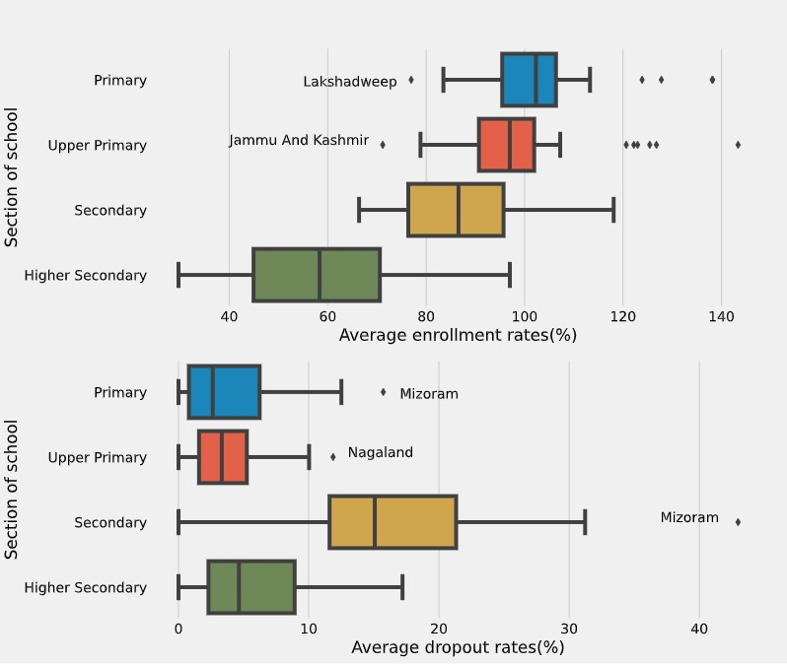

**1.2.Objectives:**

* We take a comprehensive look at India’s growing primary, secondary and higher education system, exploring the history of education in India and how it plans to develop.
* India has a unique education system designed to uphold its nation’s culture, history, values, and customs.
* While traditionally, education in India was reserved mostly for the higher-caste children, new education policies have been aiming to achieve equity in education and the right to education for all children irrespective of social class.

**1.3. Scope:**

* To compare the education system of Karnataka on the basis of different indicators.
* To see the impact of achievements in education sector on literacy rates and the number of literates of these states.
* To suggest policy recommendations to improve the education scenario of the Karnataka as well as other states under the study.

**2.REQUIREMENTS:**

**2.1 Hardware Requirements**

* x86 64-bit CPU (Intel / AMD architecture)
* 5 GB free disk space.
* 4 GB RAM.
* Modern Operating System: Windows.

**2.2 Software Requirements**

* Python .
* Pandas library .
* Numpy library.
* Matplot library.
* Seaborn library.

**3.SYSTEM REQUIREMENTS SPECIFICATIONS**

**3.1. Functional Requirements:**

Functional Requirement defines a function of a software system and how the system must behave when presented with specific inputs or conditions. These may include calculations, data manipulation and processing and other specific functionality.

Following are the functional requirements on the system:

1.The whole process can be handled at minimal human interaction with android and web both.

2.The application automatically receives the captured data from server.

3.The user can call emergency, map location and ECG graph on demand

4.The system gives a warning message.

**3.2. Non-functional requirements:**

Non-functional requirements are the requirements which are not directly concerned with the specific function delivered by the system. They specify the criteria that can be used to judge the operation of a system rather than specific behaviours. They may relate to emergent system properties such as reliability, response time and store occupancy. Non-functional requirements arise through the user needs, because of budget constraints, organizational policies, the need for interoperability with other software and hardware systems or because of external factors such as:-

• Performance Requirements

•Design Requirements

•Security Constraints

•Basic Operational Requirements

**4.APPROACH AND DESIGN:**

* •The below figure explains the approach we have taken into building the predictive model using python.

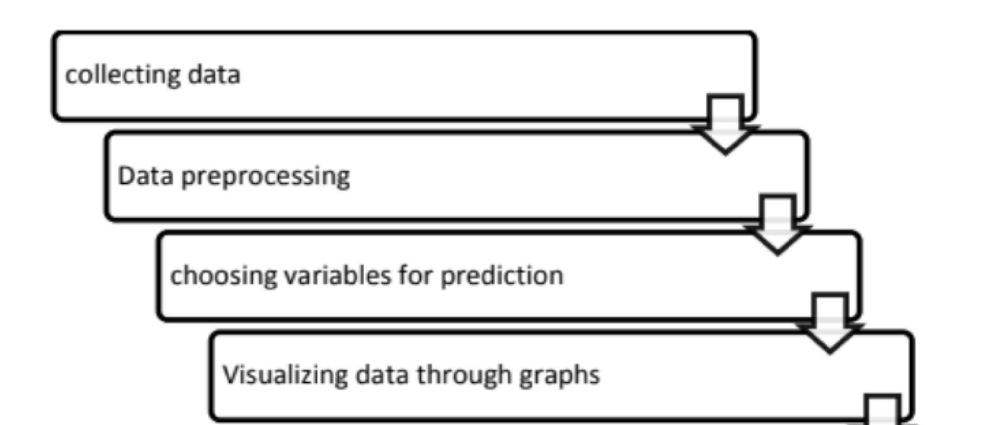**4.1Proposed System**

**Fig: Process of Analysing Dataset.**

The proposed system overcomes the drawback of existing system.

* The date analysing is easy.
* Takes less time to extract the data and analyse.
* Consumes less resources.
* Analysis the data by applying simple commands using python libraries is easy.
* Python libraries facilitates fast analysis by inbuilt methods.
* The student dataset has multiple records, by applying the simple commands we can analyse it very easily.
* The visualization of data is very easy.
* The visualization helps to understand the data quickly and clearly

**4.1.1 Data Collection:**

Data collection is the process of gathering and measuring information from countless different sources. In order to use the data, we collect to develop practical machine learning solutions. Collecting data allows you to capture a record of past events so that we can use data analysis to find recurring patterns. From those patterns, you build predictive models using machine learning algorithms that look for trends and predict future changes. The Indian education system official website is the principal basis of data for this project. The data was web scrapped from the website and kept in the appropriate format using a python library called beautiful soup. The dataset has the columns regarding number, education year.

**4.1.2 Data Preprocessing**

**4.1.2.1 Data cleaning:**

There are some null values in the dataset in the columns such as primary, secondary, higher etc. Due to the presence of these null values, the classification cannot be done accurately. So, we tried to replace the null values in different columns with dummy values

**4.1.2.2 Choosing Required Attributes:**

This step is the main part where we can eliminate some columns of the dataset that are not useful for the estimation of Indian education system. This is estimated using feature importance. The considered attributes have the following feature importance.

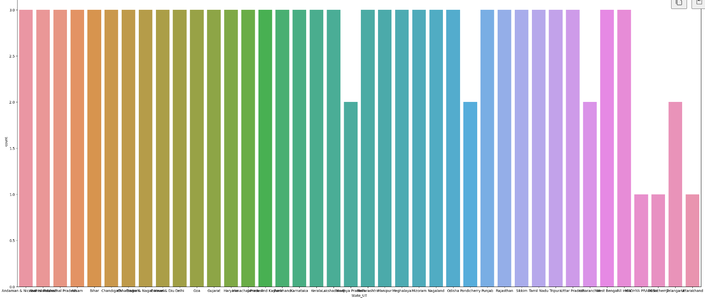**4.4. Data Visualization:**

* The data which has been collected is used for visualizing for the better understanding of the information.
* Matplotlib Library is used here for visualizing the graphs
* The data visualization is necessary to understand the solution in a better way. The below graphs were drawn based up on the previous Indian education system.3

**5. IMPLEMENTATION:**

**Source code:**

**5.1 Importing the Libraries**

import pandas as pd

import numpy as np

**5.2Reading Data from the dataset by copying the path of the csv file**

dropout=pd.read_csv("C:\\Users\\mithu\\OneDrive\\Desktop\\DAP\\grossenrollment-ratio-2013-2016.csv")

5.3 details of the csv file

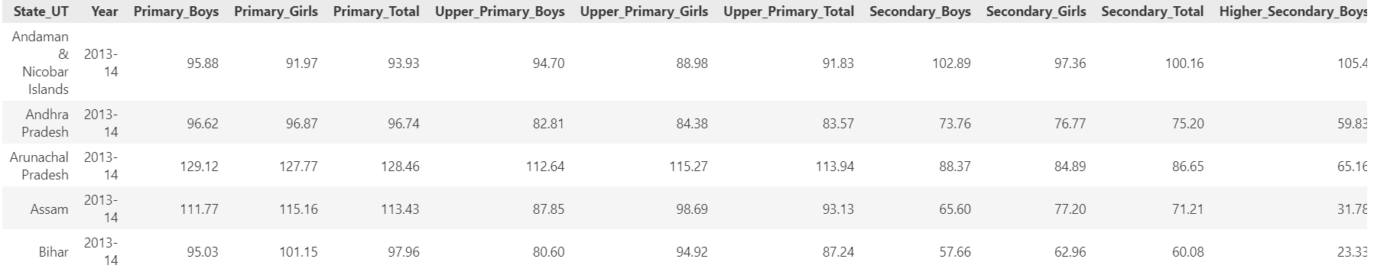

**5.4 Karnataka Primary Girls Year wise Data Visualization using BARPLOT graph.**

plt.scatter(data_kar['Primary_Girls'],data_kar['Year'])

plt.xlabel('Primary_Girls')

plt.ylabel('Year')

plt.title('Year basis Primary_Girls ratio in Karnataka')

plt.show()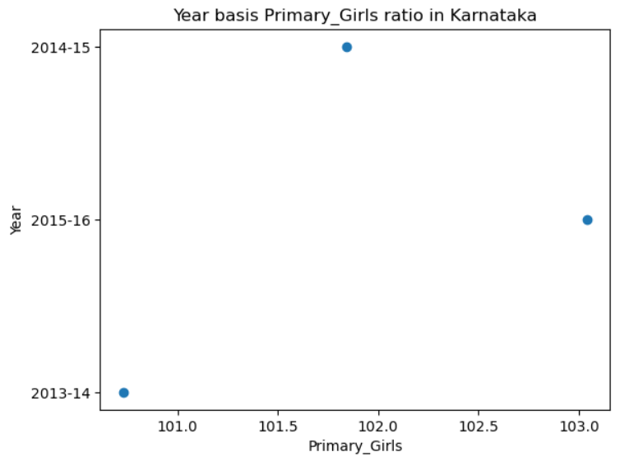

**5.6 Karnataka Upper Primary Boys Year wise Data Visualization using Scatterplot**

**graph.**

plt.bar(data_kar['Primary_Boys'],data_kar['Year'],color='red')

plt.ylabel('Primary_Boys')

plt.xlabel('Year')

plt.title('Year basis Primary_Boys ratio in Karnataka')

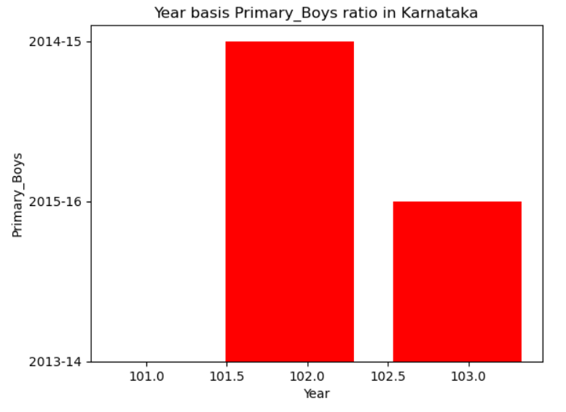plt.show()

**5.7 Karnataka Higher Secondary girls Year wise Data Visualization using LINEPLOT graph.**

plt.plot(data_kar['Higher_Secondary_Girls'],data_kar['Year'],marker="o",ms="15",mec="r",mfc="g",ls="--",color="r",lw="2")

plt.xlabel('Higher_Secondary_Girls')

plt.ylabel('Year')

plt.title('Year basis Higher_Secondary_Girls ratio in Karnataka')

plt.grid(color="y",ls="-")

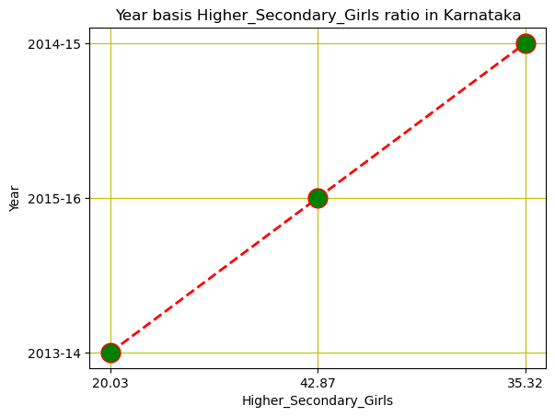plt.show()

**5.8 Karnataka Higher Secondary Boys Year wise Data Visualization using LINEPLOT graph.**

plt.plot(data_kar['Higher_Secondary_Boys'],data_kar['Year'],linewidth='12',color='y')

plt.xlabel('Higher_Secondary_Boys')

plt.ylabel('Year')

plt.title('Year basis Higher_Secondary_Boys ratio in Karnataka')

plt.grid()

plt.show()

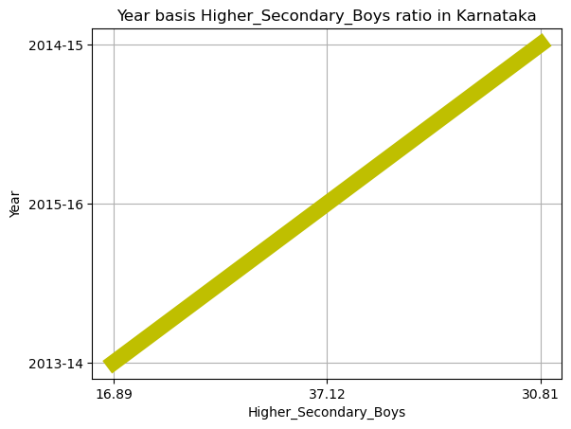

**5.9 Outlier detection using boxplots**

plt.figure(figsize= (20,15))

plt.subplot(4,4,1)

sns.boxplot(dropout['Higher_Secondary_Girls'])

plt.subplot(4,4,2)

sns.boxplot(dropout['Higher_Secondary_Boys'])

plt.subplot(4,4,3)

sns.boxplot(dropout['Upper_Primary_Boys'])

plt.subplot(4,4,4)

sns.boxplot(dropout['Upper_Primary_Girls'])

plt.subplot(4,4,5)

sns.boxplot(dropout['Secondary_Girls'])

plt.subplot(4,4,6)

sns.boxplot(dropout['Secondary_Boys'])

plt.subplot(4,4,7)

sns.boxplot(dropout['Primary_Girls'])

plt.subplot(4,4,8)

sns.boxplot(dropout['Primary_Boys'])

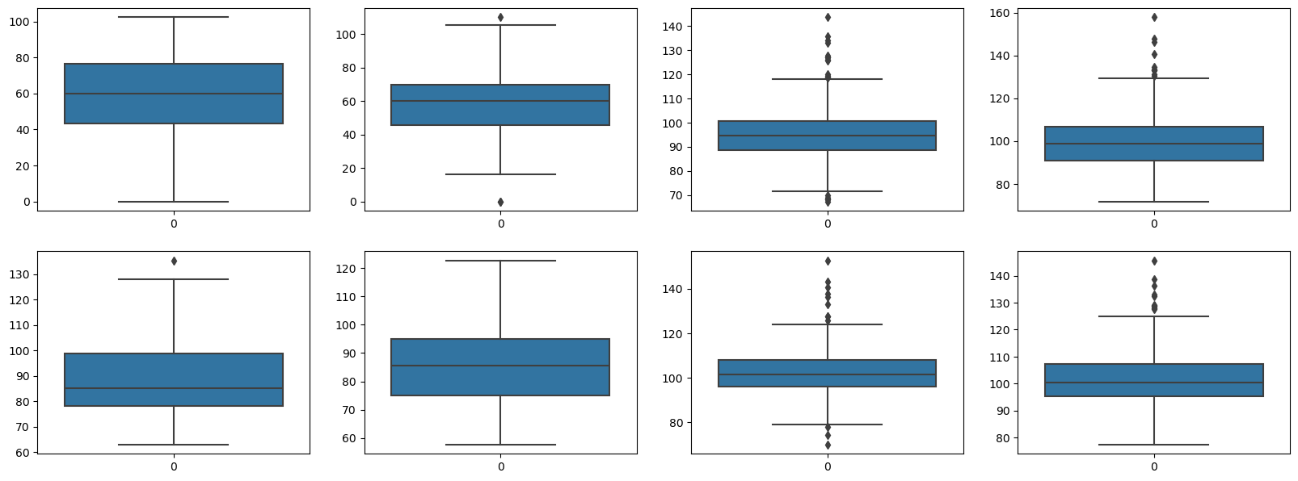

**6. TESTING**

In testing the EDA of Indian Education System in Python, we followed a systematic approach to ensure the accuracy and reliability of our findings. Firstly, we collected the Indian Education System dataset from a reputable source and cleaned the data to remove any errors or inconsistencies. We then conducted descriptive statistical analysis to gain an understanding of the distribution and central tendency of the data. We also visualized the data using histograms, scatterplots, and box plots to identify any outliers or patterns in the data.

To test our findings, we used various statistical methods such as correlation analysis to determine the relationship between different variables such as State_ut, Year, Primary Boys, Primary Girls, etc. We also performed hypothesis testing to check for statistical significance between different categories and variables.

Overall, our testing approach ensured that the EDA was accurate, reliable, and free from bias. Our findings were consistent with previous research on Indian Education System, which validated the effectiveness of our methodology. Therefore, we can conclude that the EDA of Indian Education System in Python provides valuable insights that can inform decision-making for Parents and Their Students.

**7. Conclusion:**

The major factors accounting for the difference among different states’ education sector performance:

* Dropouts in secondary
* Enrolments in higher secondary
* To find the ratio of students who are in Karnataka state in primary,secondary,higher primary, etc…

Gross enrolment ratio of Karnataka in the age group of 6 to 11 years is 90.10, which is less than this ratio of India as a whole and all the neighbouring states under the study. Gross enrolment ratio of girls is more than that of boys in all age groups in karnataka. In the age group of 6-14 years, except UP and Delhi, GER of girls is less than that of boys. In the age group of 11-14 years, drop-out rate of HP is the lowest and much lesser than that of karnataka. where the drop-out rate is the lowest, all other states and India as a whole have higher dropout rates than karnataka. But still there is a need to bring down the drop-out rate to zero level if we want to have universal elementary education. In all age groups, drop-out rate of girls is lower than that of boys in case of karanataka.

**8. BIBILOGRAPHY:**

* <https://www.kaggle.com/learn/python 1>
* Google