SRI JAYACHAMARAJENDRA COLLEGE OF ENGINEERING
(Affiliated to Visvesvaraya Technological University, Belgaum)
MYSORE-570006



A
SEMINAR REPORT ON
Gmailfs Filesystem

In partial fulfillment of requirements for the degree of
Bachelor Of Engineering

Submitted By,
Raghavendra Talur
(USN: 4JC07CS082)
Under the Guidance of
Smt. Manjula S
Senior Scale Lecturer
Department of Computer Science and Engineering
SJCE , Mysore

CERTIFICATE

This is to certify that the seminar entitled “Gmailfs Filesystem” is a bonafied work carried out by Mr.Raghaevndra Talur under the guidance of Smt. Manjula S, Senior Scale Lecturer, Department of Computer Science in partial fulfillment of requirements of the degree B.E. during the academic year 2010-2011.The seminar report has been approved as it satisfies the academic requirements in respect of the seminar work prescribed for the B.E degree.

Seminar Guide External Evaluator Dr. C.N.Ravikumar
Manjula S H.C.Vijayalakshmi Head of Department
Senior Scale Lecturer Senior Scale Lecturer SJCE, Mysore

Department of Computer Science and engineering
SJCE , MYSORE

Abstract

In the era of digital world where every information is being represented in the binary form and people are continuous on the move, it has become essential to provide a means to take evry personal data along with them.
With the easy availability of fast internet access and free services by Google, its now possible to design and develop a simple cloud storage sytem. Gmailfs is a simple hack which uses the email services provided by Google as a storage device and integrates into the user file system using loadable kernel modules. FUSE and IMAP libraries are used to implement the features. Development of a working sytem serves as a proof of concept which can be used to develop more such application which load Internet data into the user file space.

Table of Contents
Abstract 3
1 INTRODUCTION 5
2 FEASIBILITY 5
3 DESIGN 5
4 IMPLEMENTATION 7
5 EVALUATION 8
6 CONCLUSION 9
7 REFERENCES 9

INTRODUCTION
In computer terminology, a Virtual File system is an abstraction layer on top of a more concrete file system. The purpose of a VFS is to allow client applications to access different types of concrete file systems in a uniform way.
Gmail is a free webmail service provided by Google with lots of Data storage capacity(7.5 Gb at the time of writing this report).
Gmailfs is an attempt to make judicious use of the free data storage capacity provided by Google by integrating it into the user filesystem.

FEASIBILITY

The advancement in various sectors of IT technology has now made possible the development of true cloud based services.
Various factors which have lead to these development and the application areas where cloud computing has got potential are as follows.

- Factors
- Homogenization of Computing
- Broadband access
- Economies of Scale

- Application Areas
- Infrastructure as a Service
- Virtualization
- File sharing and collaboration
- Email

Gmailfs was one of the earliest implementaions which established the feasibilty of these services by a simple hack. Adopting a “hacking” way of thinking may actually yield prototypes that help to get to market quicker and learn how customers use products.

DESIGN

It works by building a filesystem with the Filesystem in Userspace loadable kernel module, and manages communication with Gmail through a special purpose Python library called libgmail. The actual GmailFS is also implemented in Python.

Modules required are

- IMAP or libgmail or smtp protocol – To save a File /Send a mail
- IMAP or libgmail -- Get Directory Listing/ Use a file
- FUSE – to implement the filesystem in User Space
FUSE:
Unlike traditional file systems that essentially save data to and retrieve data from disk, virtual filesystems do not actually store data themselves.

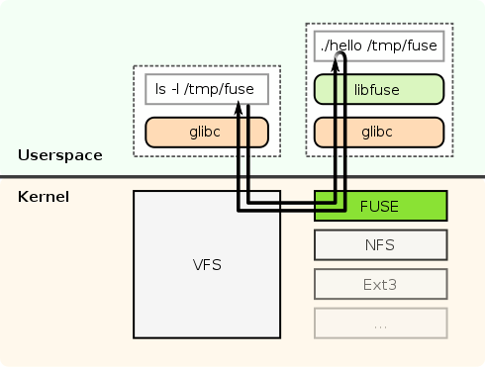
A simple figure explaining the use of file to implement the VFS

IMAP and SMTP libraries are availble for many languages. We will be using the python library.
Advantages and features are as follows

- Internet message application protocol
- Connected and disconnected modes of operation
- Multiple clients simultaneously connected to the same mailbox
- Server-side searches
- Access to MIME message parts and partial fetch
- Multiple mailboxes on the server
- Server-side searches
- IMAP4_SSL(“imap.gmail.com”,993)

- Simple Mail Transfer Protocol
- SMTP is a delivery protocol only.
- Can send with attachments.
- Very Simple when compared to IMAP and POP3
- smtplib.SMTP(“smtp.gmail.com”,587)

FUSE is implemented with thread model which continuously interacts with the IMAP mailbox to get information about the data and keeps the filesystem view updated.

IMPLEMENTATION

Different implementations are available for differenct operating systems.

- Gmailfs – Original implementation for Linux using the method described above.

Provides a complete filesystem to the user.

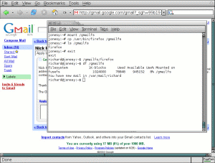

- Gmail Drive for windows

  - Retains the idea of sending and accessing mails the same.
  - But FUSE is not available for Windows and alternatives are not good enough.
  - Hence the filesystem view is provided using a Windows Concept called Name Space Shell Extension
Eg Recycle Bin It just another folder but with Properties as visible to the user different.

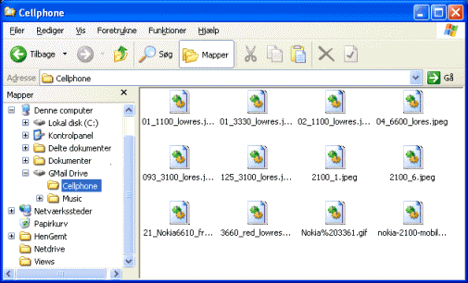
.

My Implementation:

- Implemented for Linux.
- Uses smtp to send mails.
- Uses IMAP to list the directory.
- Provides a minimalist GUI using shell scripting and Zenity.
- Fetch and Delete feature of FUSE not implemented yet. Has to be done only through the gmail web interface.

EVALUATION

Comparision of gmailfs and gmail drive
- Gmailfs provides a true integration as a filesystem.Once mounted, any operation can be performed on it. Gmaildrive doesnot provide a Drive letter, so it cannot be used in scripts.
- Gmailfs is not easy to use as it requires the user to manually mount the file system.
- Gmailfs provides no GUI support.
- Gmail Drive provides a simple installation and configuration

Screenshots

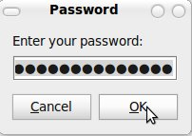

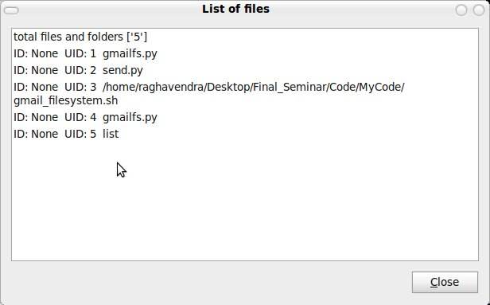

CONCLUSION

- It serves as a proof of concept in two areas
Cloud Computing and Virtual File Systems.

- Cloud services are coming up which provide free Storage space which can be directly integrated into the User File system offering a perfect sync and backup.
Eg: Ubuntu Cloud: Ubuntu One
Rumors say Google will start its services too.

- WikipediaFS : View and edit Wikipedia articles as if they were real files

- s3fs-FuseOverAmazonS3: A FUSE-based file system backed by Amazon S3. Mount a bucket as a local file system read/write. Store files/folders natively and transparently on AWS: Simple Storage Service.

- fuse-zip: Allows to use zip files as a filesystem (supports writing)

- Can be extended in innovative ways to view tweets as files etc.

REFERENCES

- http://richard.jones.name/google-hacks/gmail-filesystem/gmail-filesystem.html
- http://www.viksoe.dk/code/gmail.htm
- http://www.python.org/
- http://sr71.net/projects/gmailfs/
- http://fuse.sourceforge.net/

