1) Under the database “practice”, I have created 3 tables which are related to the Guvi Relational Database System, which are:

a) Students

b) teacher

c) placement_coordinator

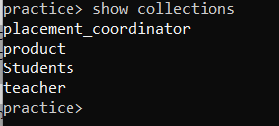

2) Contents of the table “Students” are:

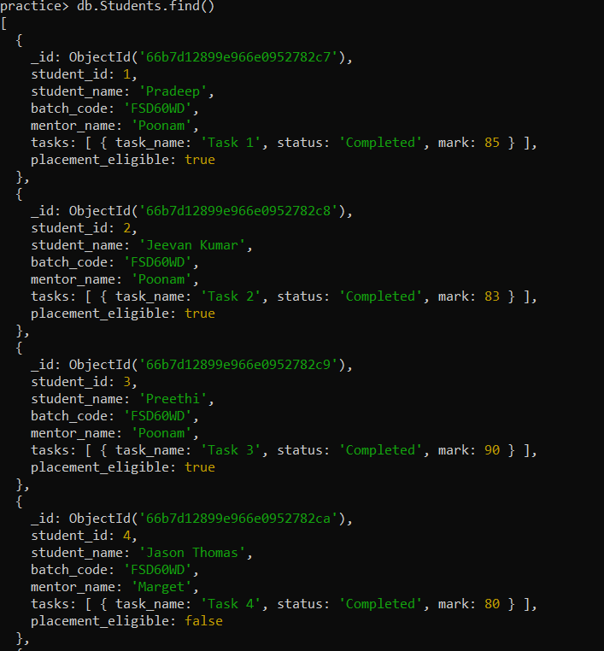

3) Contents of the table “teacher” are:

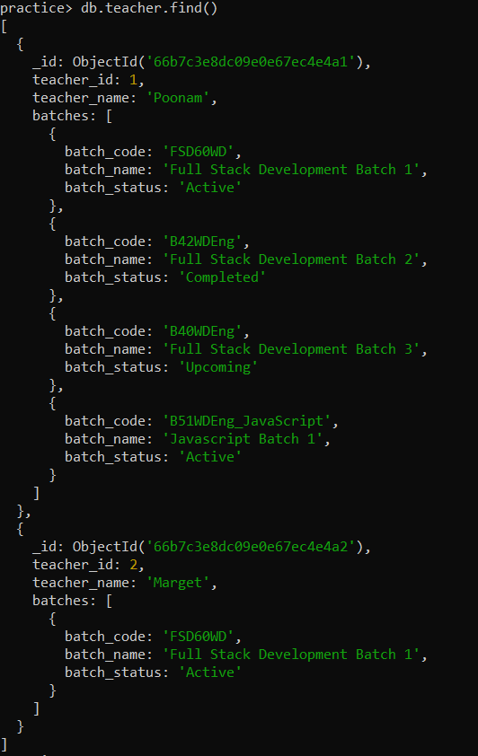

4) Contents of the “placement_coordinator” table :

