1) Find all the information about each product.



2) Find the product price which are between 400 to 800

Totally there are 5 products whose price are between 400 and 800

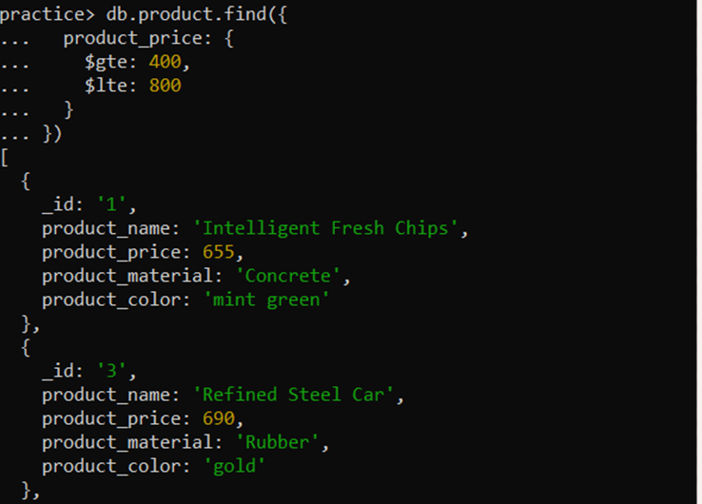

3) Find the product price which are not between 400 to 600:

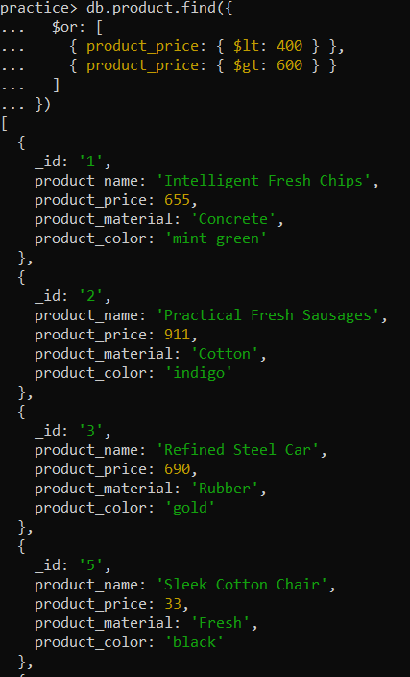

4) List the four product which are greater than 500 in price

Actually, there are only 3 products whose price is greater than $500:

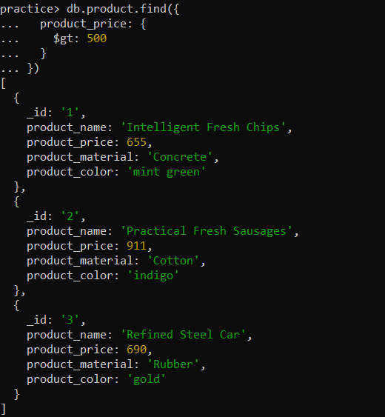

5) Find the product name and product material of each products.

db.product.find({},{product_name : 1,product_material : 1})

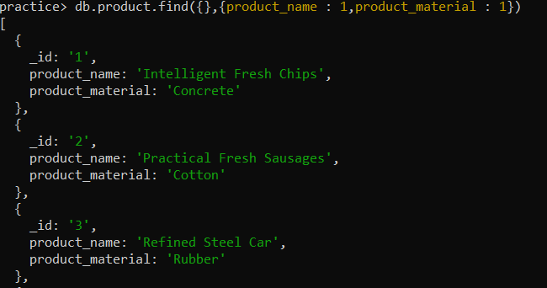

6) Find the product with a row id of 10

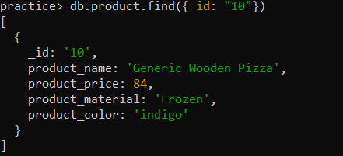

7) Find only the product name and product material

db.product.find({}, {_id: 0, product_name: 1, product_material: 1})

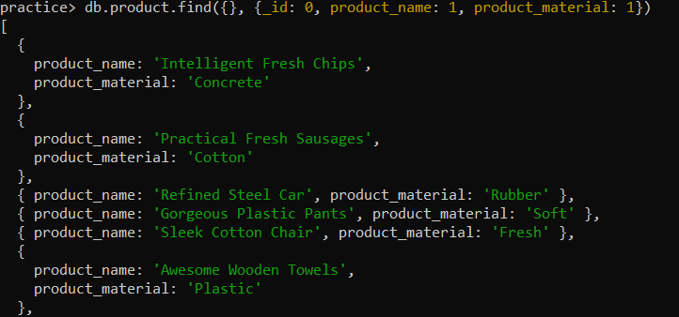

8) Find all products which contain the value of soft in product material

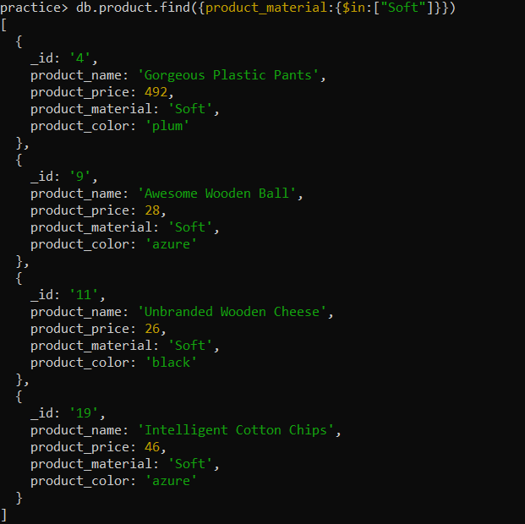

9) Find products which contain product color indigo and product price 492.00

There is no product with both product_price of $492 and product_color as “indigo”



b)

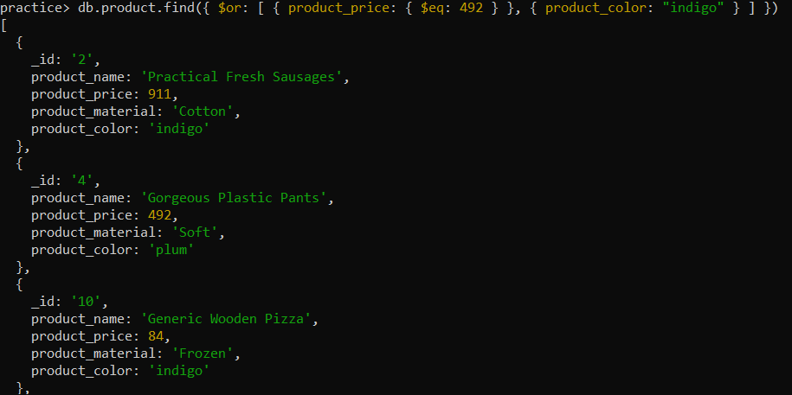

c)Product with product price of $492

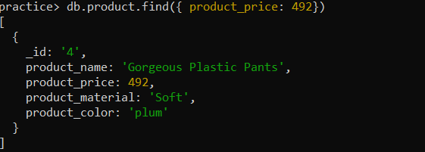

d) Products with color: indigo

There are only 4 products with color indigo

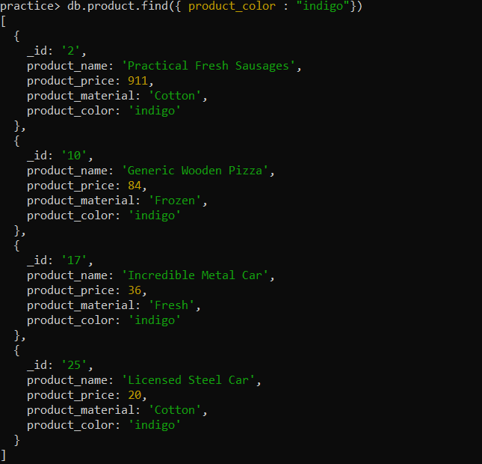

10) Delete the products which product price value are 28

