1. 1st Exercise

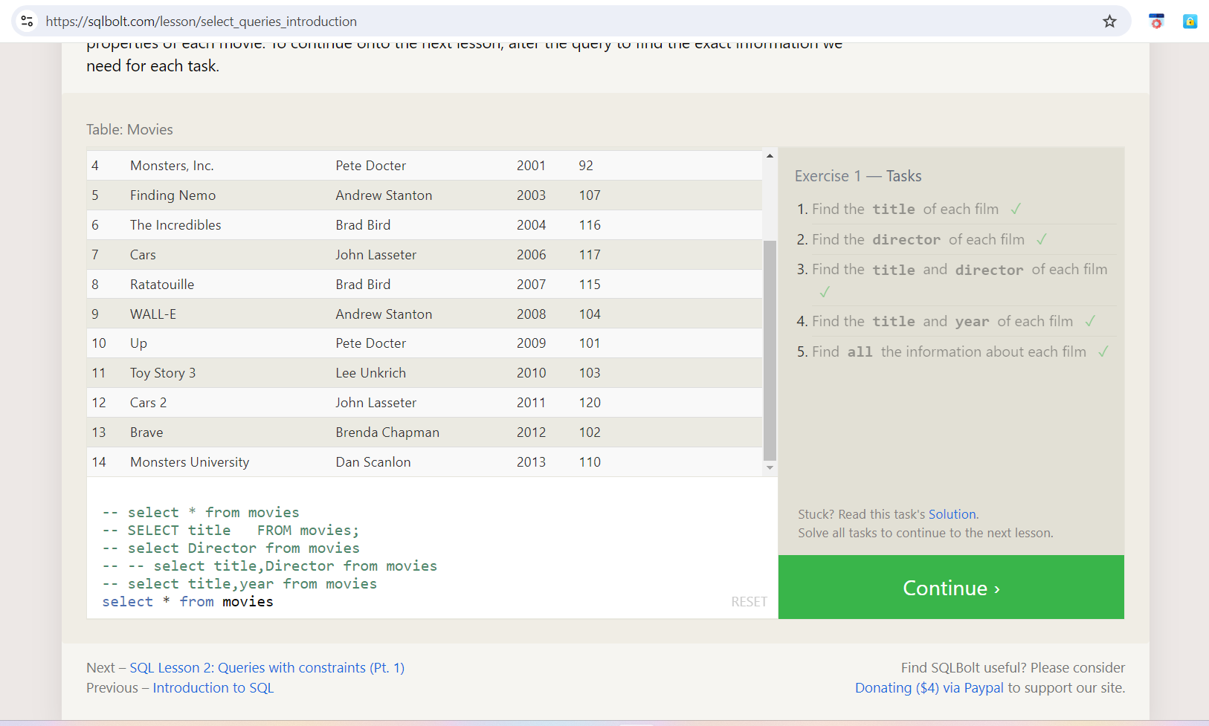

Answer:

i) SELECT title FROM movies;

ii) select Director from movies

iii) select title, Director from movies

iv) select title, year from movies

v) select * from movies

2) 2nd Exercise:

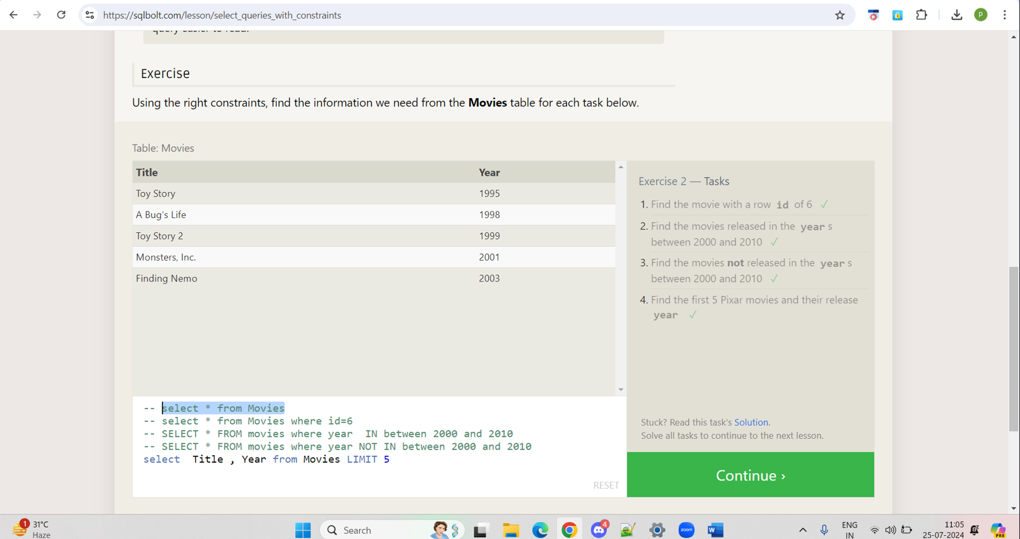

b) Answers:

i) select * from Movies where id=6

ii) SELECT * FROM movies where year IN between 2000 and 2010

iii) SELECT * FROM movies where year NOT IN between 2000 and 2010

iv) select Title, Year from Movies LIMIT 5

3) 3rd Exercise:

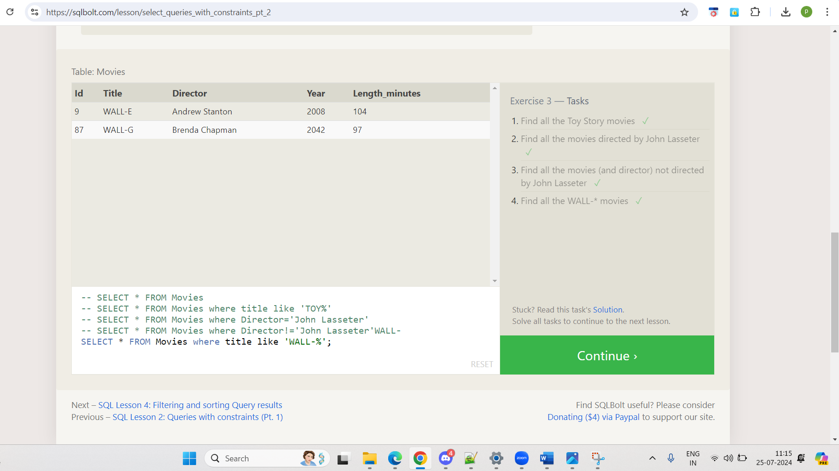

b) Answers:

i) SELECT * FROM Movies where title like 'TOY%'

ii) SELECT * FROM Movies where Director='John Lasseter'

iii) SELECT * FROM Movies where Director !='John Lasseter'

iv) SELECT * FROM Movies where title like 'WALL-%'

4) 4th Exercise:

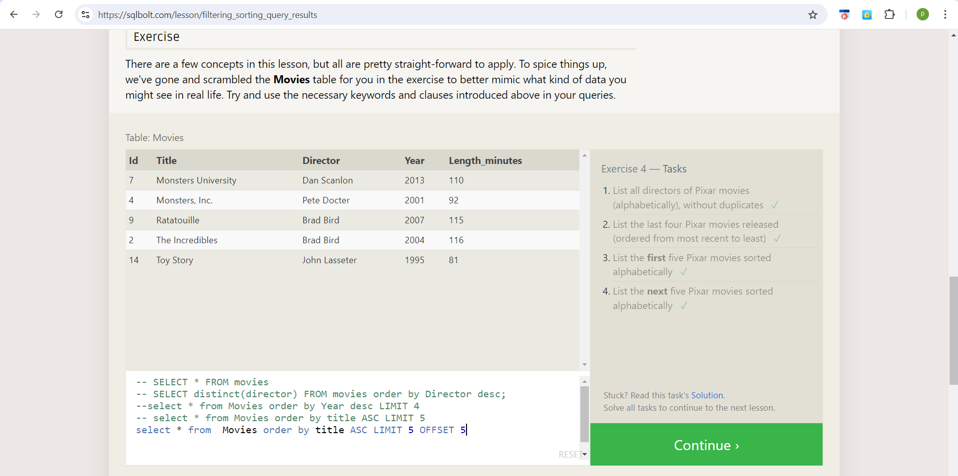

b) Answers:

1. SELECT distinct(director) FROM movies order by Director desc;
2. SELECT * from Movies order by Year desc LIMIT 4
3. select * from Movies order by title ASC LIMIT 5
4. select * from Movies order by title ASC LIMIT 5 OFFSET 5

5)1st Review - Tasks

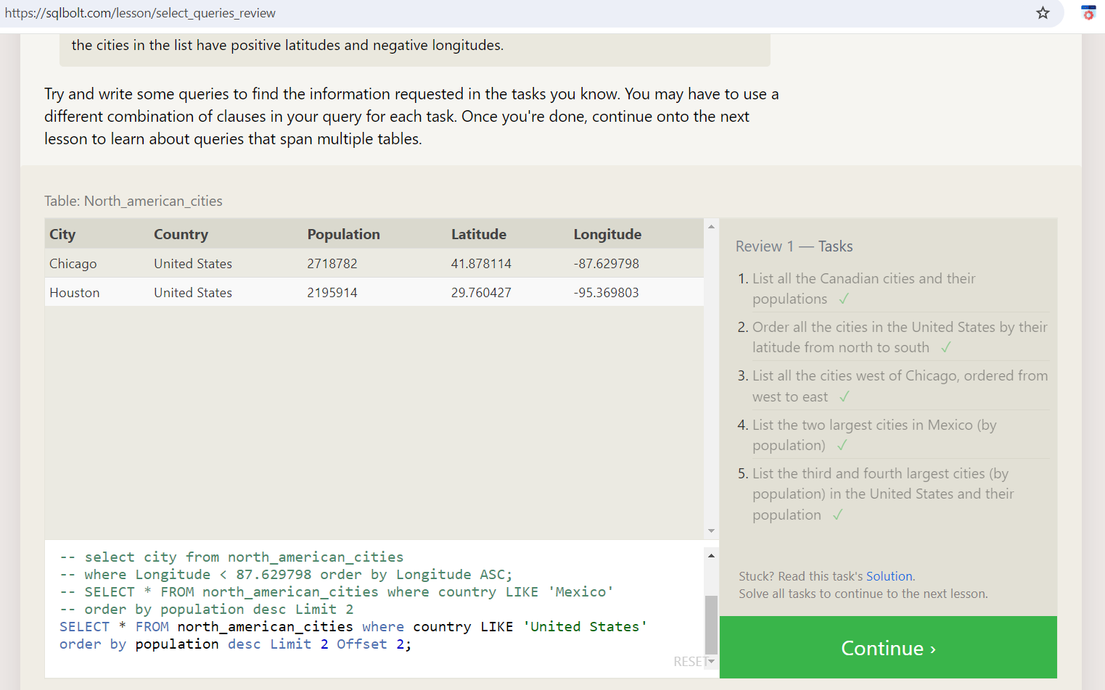

b) Answer:

1)SELECT city, population FROM north_american_cities where Country='Canada'

2)SELECT city FROM north_american_cities where Country='United States' order by Latitude desc

3) select City, Longitude

from north_american_cities where Longitude < -87.629798 order by Longitude ASC;

4)select city, population from north_american_cities where Country like 'Mexico' order by Population desc LIMIT 2;

5) select city, population from north_american_cities where Country like 'United States' order by Population desc LIMIT 2 OFFSET 2;

6) 6th Exercise:

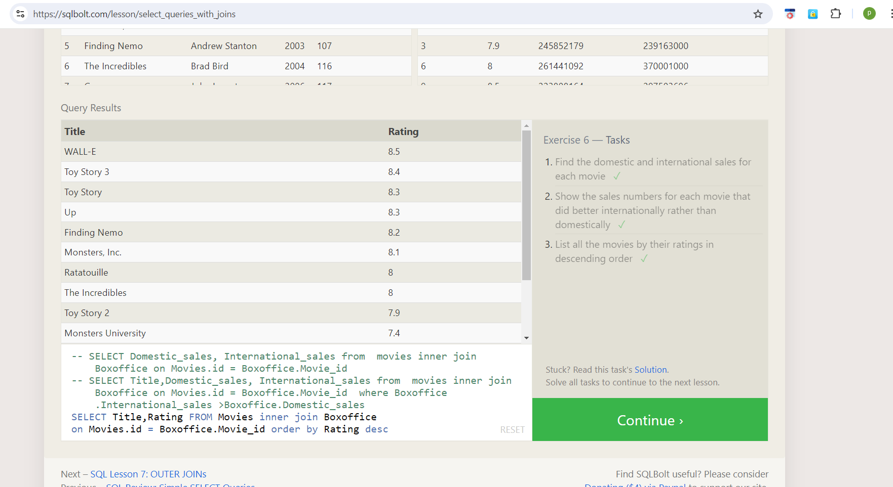

b) Answer:

i) SELECT Domestic_sales, International_sales from movies inner join BoxOffice on Movies.id = BoxOffice.Movie_id

ii) SELECT Title, Domestic_sales, International_sales from movies inner join BoxOffice on Movies.id = BoxOffice.Movie_id where BoxOffice.International_sales > BoxOffice.Domestic_sales

iii) SELECT Title, Rating FROM Movies inner join BoxOffice on Movies.id = BoxOffice.Movie_id order by Rating desc

7) 7th Exercise :

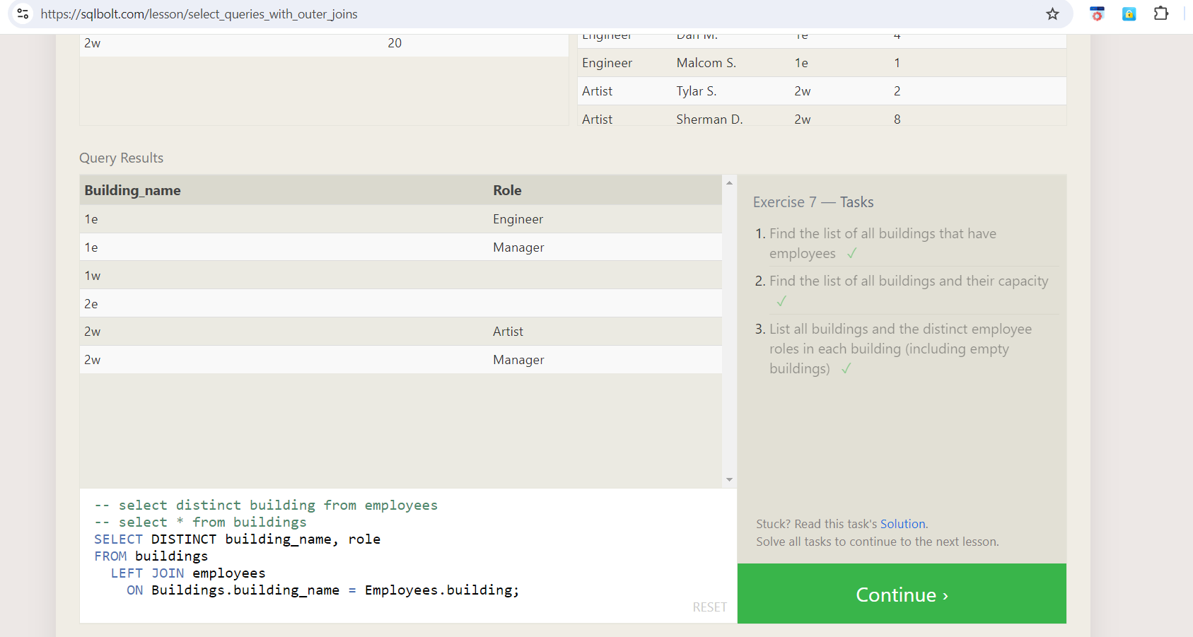

b) Answer:

i) select distinct building from employees

ii) select * from buildings

iii) SELECT DISTINCT building_name, role

FROM buildings

LEFT JOIN employees

ON Buildings.building_name = Employees.building;

8) 8th Exercise:

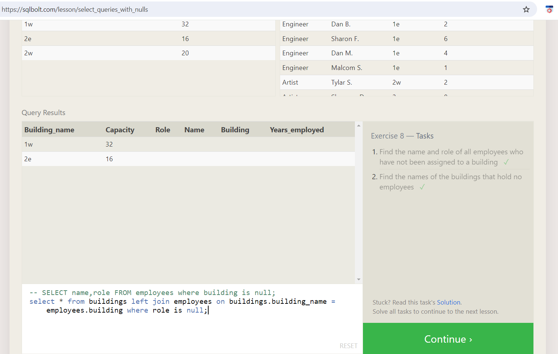

b) Answer:

i) SELECT name, role FROM employees where building is null;

ii) select * from buildings left join employees on buildings.building_name = employees.building where role is null;

9) 9th Exercise

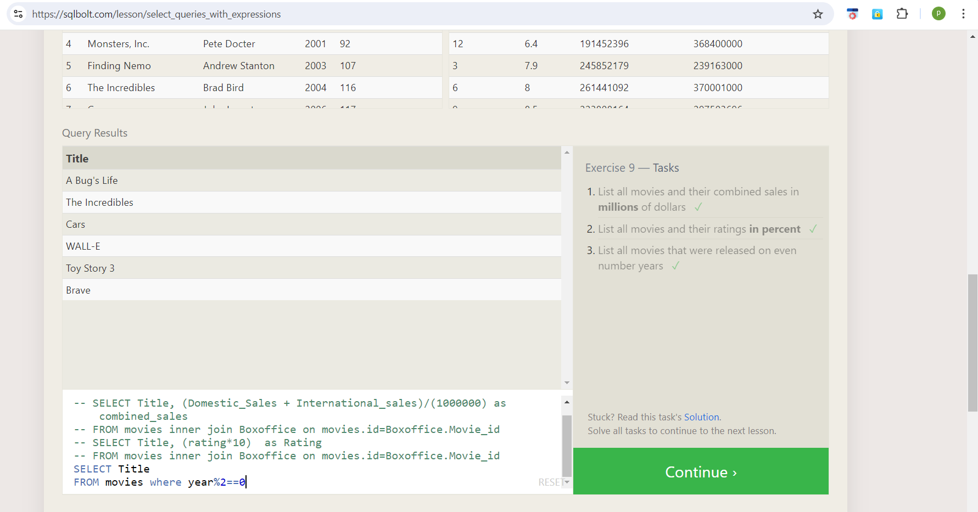

b) Answers:

1) SELECT Title, (Domestic_Sales + International_sales)/(1000000) as combined_sales

FROM movies inner join Boxoffice on movies.id=Boxoffice.Movie_id

2) SELECT Title, (rating*10) as Rating

FROM movies inner join Boxoffice on movies.id=Boxoffice.Movie_id

3) SELECT Title FROM movies where year%2==0

10) 10th Exercise

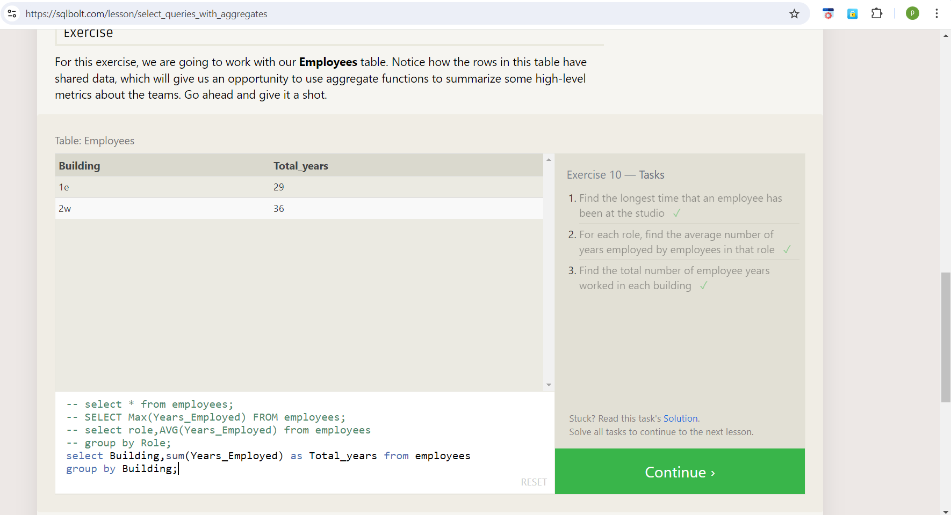

b) Answer:

1) SELECT Max(Years_Employed) FROM employees;

2) select role,AVG(Years_Employed) from employees

group by Role;

3) select Building,sum(Years_Employed) as Total_years from employees

group by Building;

11) 11th Exercise

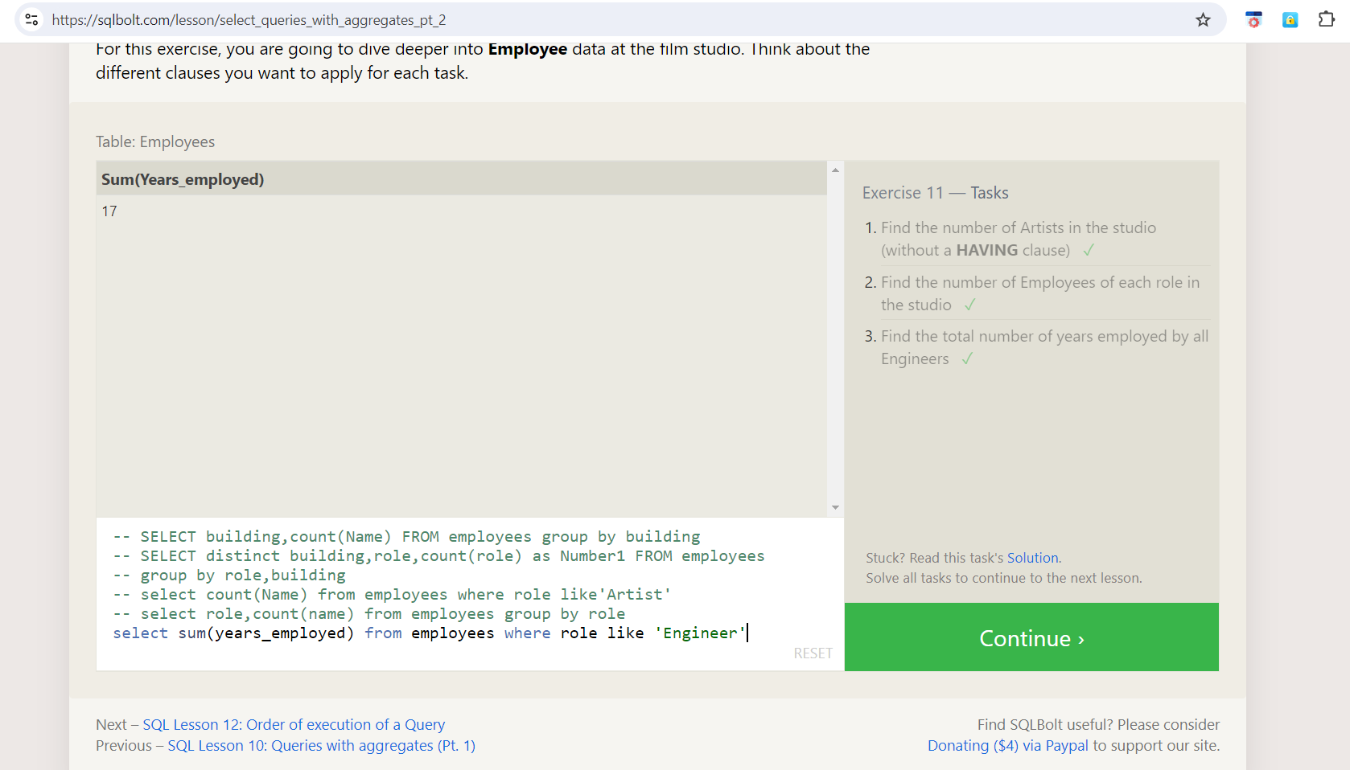

b) Answers:

1) select count(Name) from employees where role like 'Artist'

2) select role,count(name) from employees group by role

3) select sum(years_employed) from employees where role like 'Engineer'

12) 12Th Exercise:

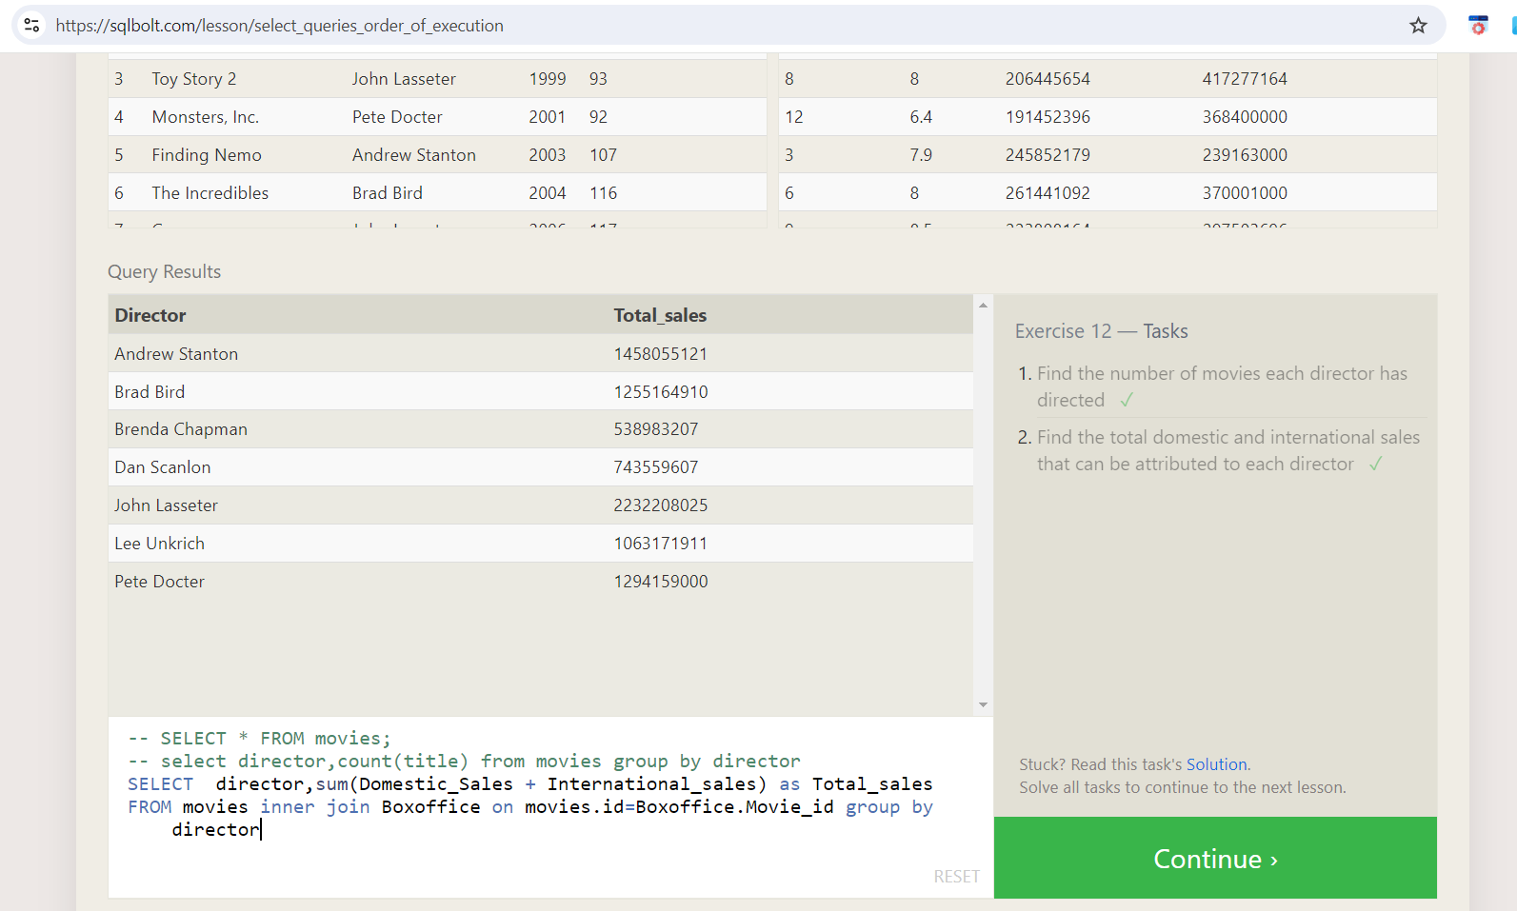

b) Answer:

1) select director,count(title) from movies group by director

2)SELECT director,sum(Domestic_Sales + International_sales) as Total_sales

FROM movies inner join Boxoffice on movies.id=Boxoffice.Movie_id group by director

13) Exercise 13:

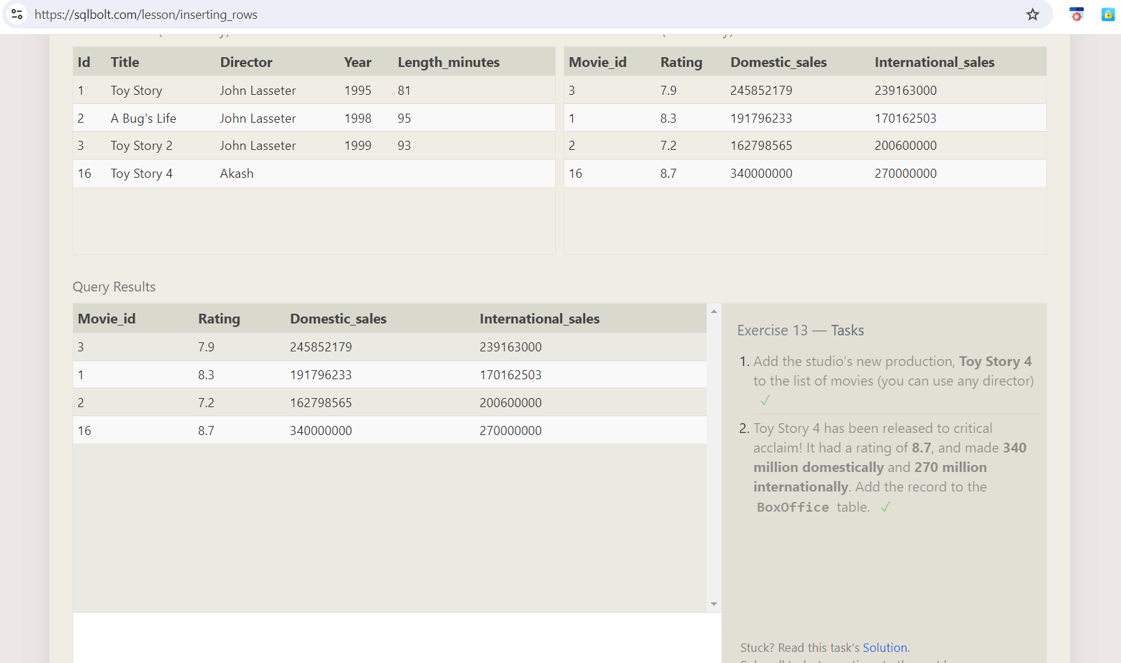

b) Answers

1) Insert into movies (Title,Director) values ('Toy Story 4', 'Akash')

2) Insert into Boxoffice (Movie_id, Rating, Domestic_sales, International_sales) values

(16,8.7,340000000 , 270000000)

14) 14th Exercise:

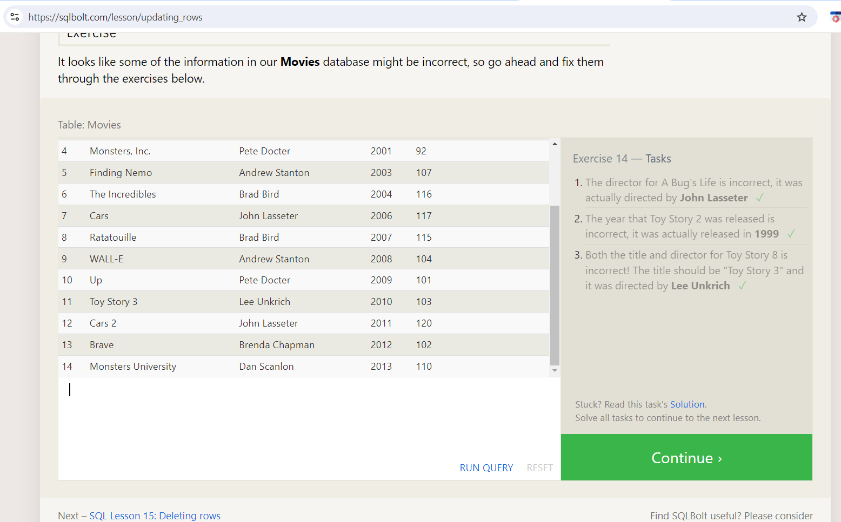

b) Answers:

1)update movies set Director="John Lasseter" where title="A Bug's Life"

2)update movies set Year=1999 where title="Toy Story 2"

3) update movies set Title="Toy Story 3" , director="Lee Unkrich" where Title="Toy Story 8"

15) Exercise 15:

a)

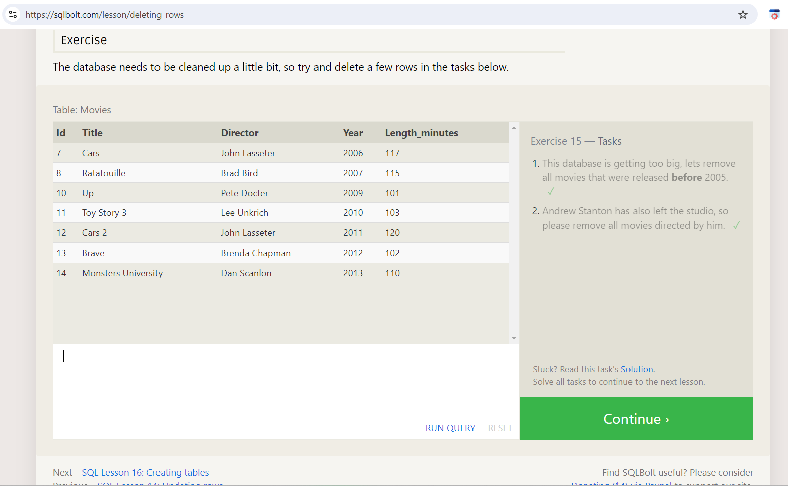

b)

1) delete from movies

where Year<2005;

2) delete from movies where director="Andrew Stanton"

16) 16th Exercise:

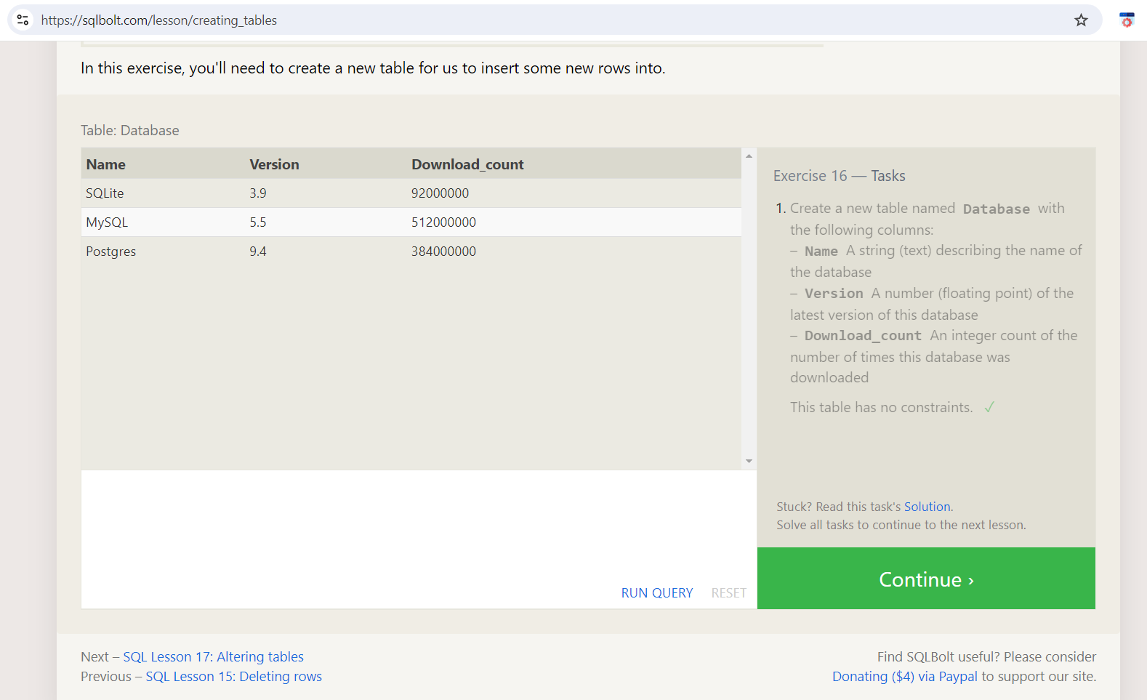

b) Answers:

i) CREATE TABLE database(Name Varchar(10),Version Float, Download_count INTEGER);

17) 17th Exercise :

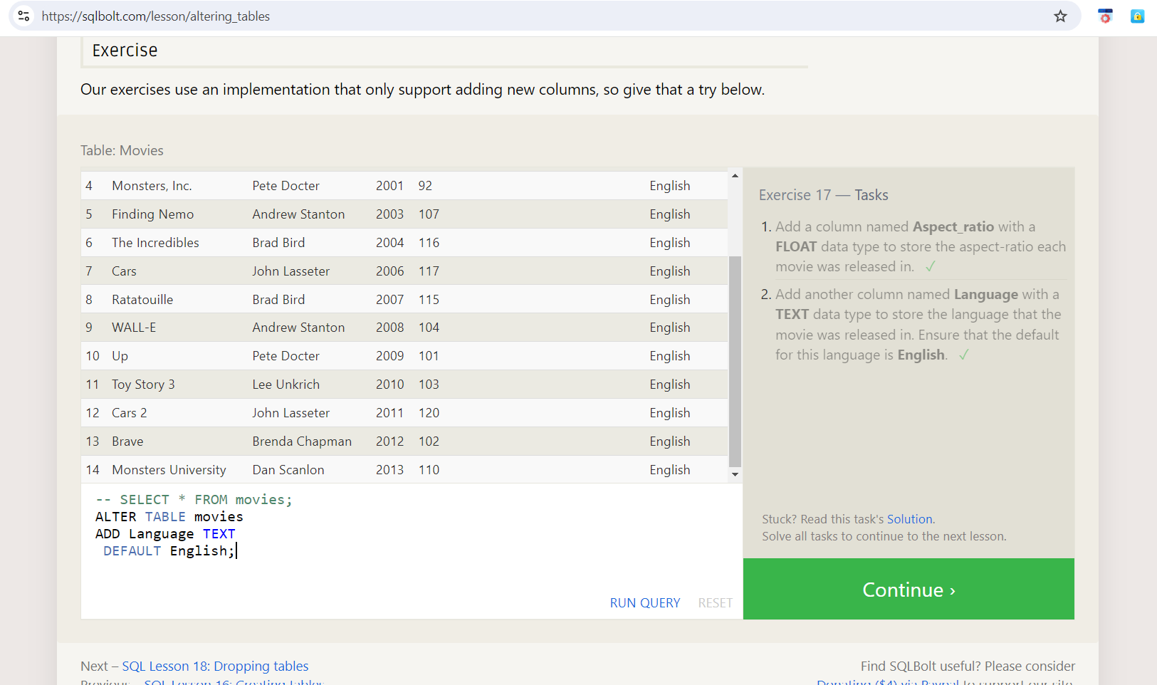

b) **Answers:**

1) ALTER TABLE movies

ADD Aspect_ratio FLOAT ;

2)ALTER TABLE movies

ADD Language TEXT

DEFAULT English;

18) 18th Exercise

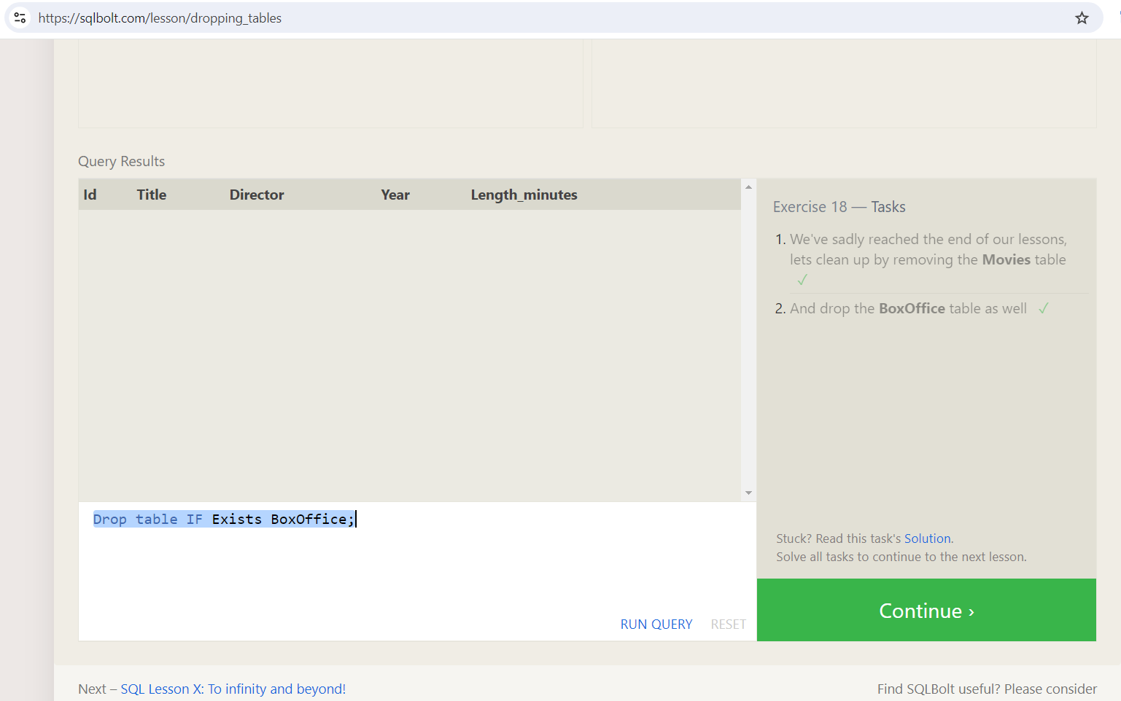

b) Answers:

1) Drop table IF Exists Movies;

2) Drop table IF Exists BoxOffice;