1. Find all the topics and tasks which are Thought (taught) in the month of October:
2. topics that are taught in the month of October – We will be displaying only topic_id , topic_name, topic_date  
   **Answer**:

db.topics.aggregate([

{

$match: {

$expr: {

$eq: [{ $month: "$topic_date" }, 10]

}

}

},

{

$project: {

_id: 0,

topic_id: 1,

topic_name: 1,

topic_date: 1

}

}

])

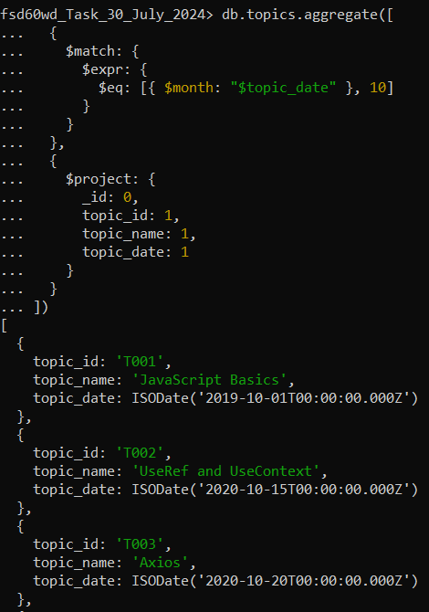

1. tasks that are completed in the month of October – We will be displaying only task_id task_name, task_completion_date  
   **Answer:**

db.tasks.aggregate([

{

$match: {

$expr: {

$eq: [{ $month: "$task_completion_date" }, 10]

}

}

},

{

$project: {

_id: 1,

task_name: 1,

task_completion_date: 1

}

}

])  
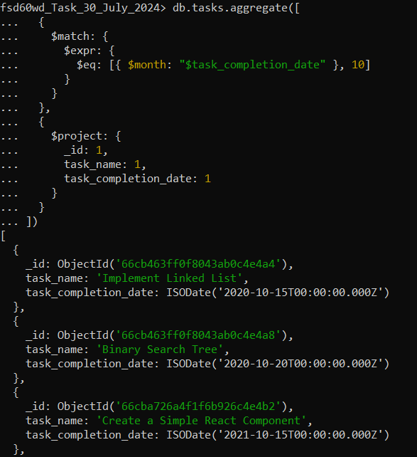

2)

db.company_drives.find({

$and: [

{ drive_date: { $gte: new Date("2020-10-15T00:00:00.000Z") } },

{ drive_date: { $lt: new Date("2020-11-01T00:00:00.000Z") } }

]

}, {

company_name: 1,

drive_date: 1,

_id: 0

})  
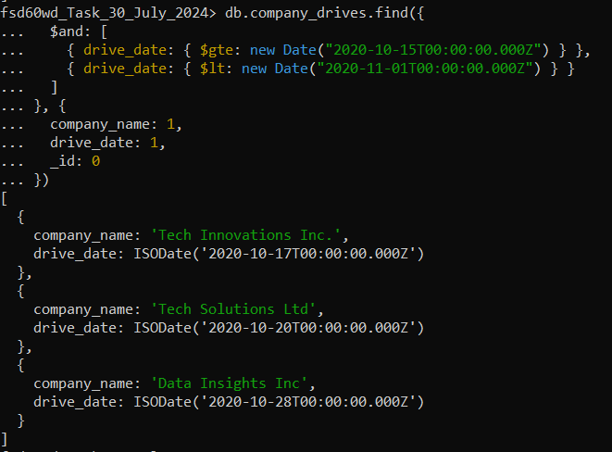

3)Find all the company drives and students who appeared for the placement

Answer:

db.company_drives.aggregate([

{

$group: {

_id: null,

totalStudents: { $sum: "$TotalStudents_Attended" },

totalCompanies: { $sum: 1 }

}

}

])  
In the above MongoDB query, totalCompanies uses $sum: 1 to count the number of documents (each document represents a company).

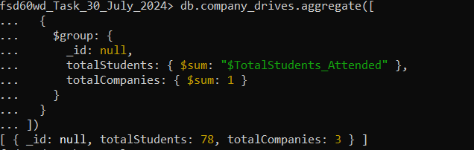  
Total number of students and companies who attended placement is 78 and 3 respectively.

4) Find the number of problems solved by the user

a) Number of questions answered by each user

db.codekata.aggregate([

{

$project: {

user_id: 1,

user_name: 1,

number_of_questions_answered: 1

}

}

])

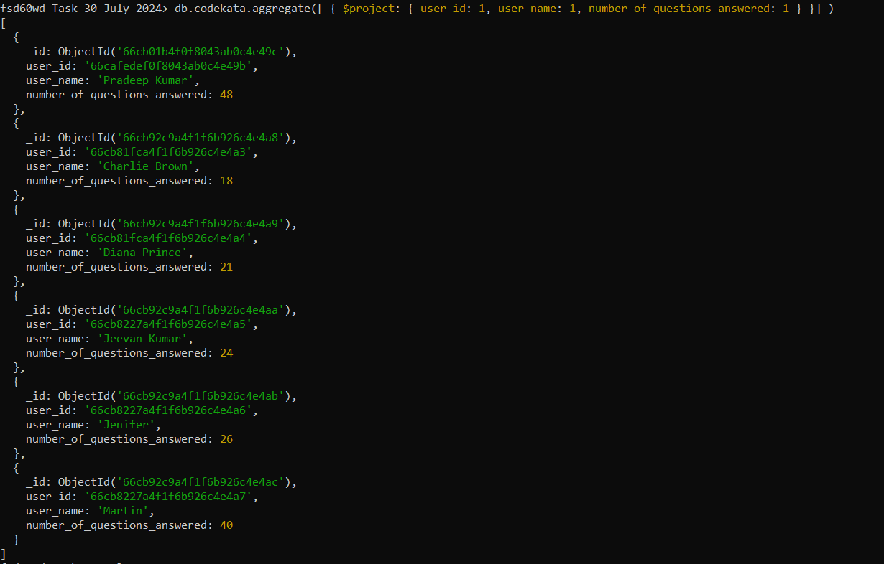

b) Total number of questions solved by all users

db.codekata.aggregate([

{

$group: {

_id: null,

totalQuestions: { $sum: "$number_of_questions_answered" }

}

}

])

5) Find all the mentors with who has mentee’s count more than 15  
Answer:   
db.mentors.find({ Total_Number_of_students: { $gt: 15 } })

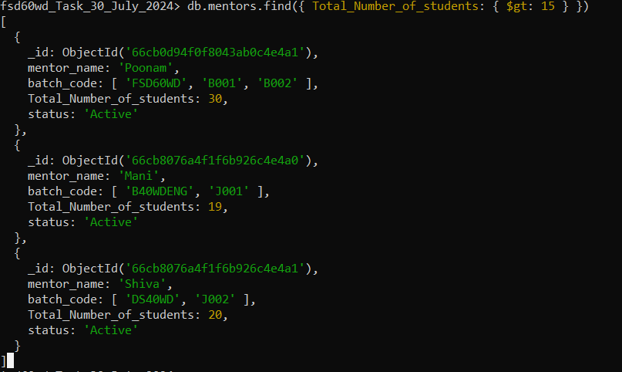

6) Find the number of users who are absent and task is not submitted between 15 oct-2020 and 31-oct-2020:  
Answer:

db.tasks.aggregate([

{

$match: {

status: { $ne: "Completed" },

task_completion_date: {

$gte: ISODate("2020-10-15T00:00:00Z"),

$lte: ISODate("2020-10-31T23:59:59Z")

}

}

},

{

$group: {

_id: null,

count: { $sum: 1 },

tasks: {

$push: {

_id: "$_id",

task_name: "$task_name"

}

}

}

},

{

$project: {

_id: 0,

count: 1,

tasks: 1

}

}

])

Totally, there are 2 tasks that are not submitted between 15-oct-2020 and 31-oct-2020.

