1. Creating a new text file:

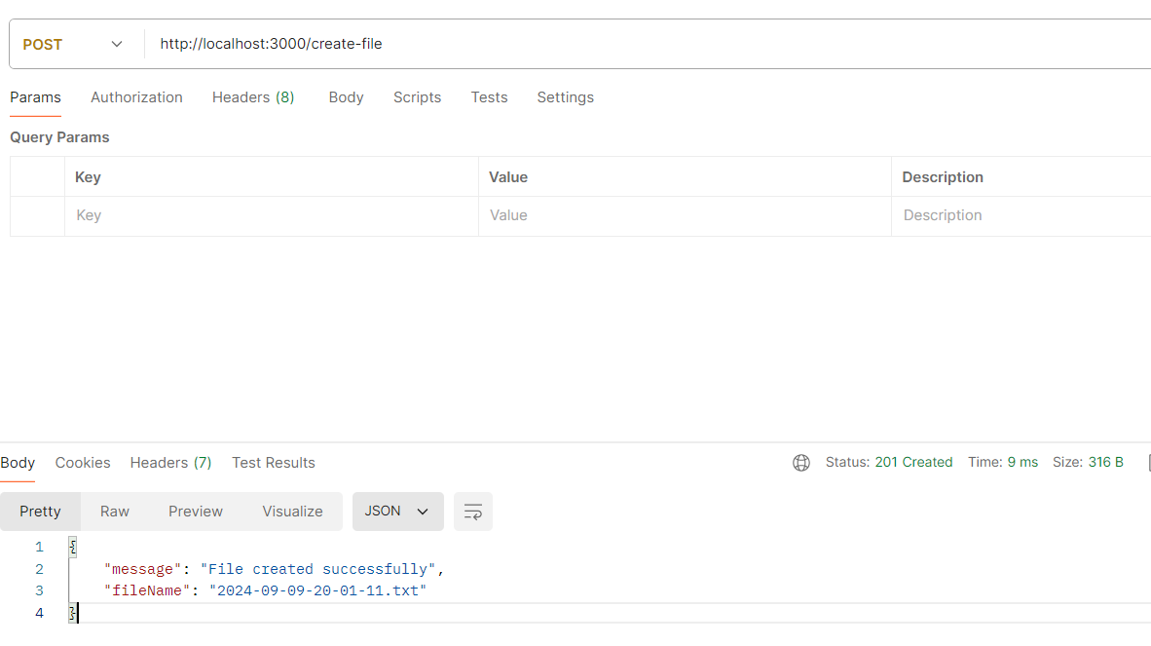

2) Getting the list of text files present in the “files” directory

