Scenario 02 : File Upload
Weak Prompt:
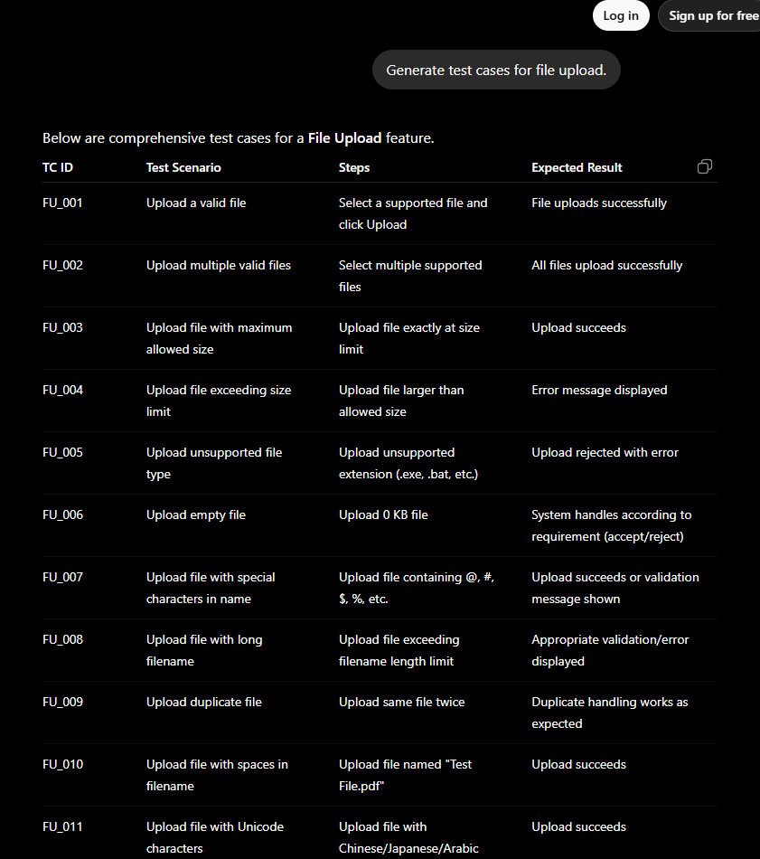
ICEPOT Method:
Context

Act as a Senior Test Engineer with experience in Web Application Testing.

Instructions
[MANDATORY] Test Case Generation

Generate test cases for the File Upload Feature.

[MANDATORY] Requirements
Generate exactly 10 test cases.
Include both Functional and Non-Functional test cases.
Include both Positive and Negative scenarios.
Ensure all test cases are realistic and suitable for a production environment.
Avoid duplicate test cases.
[MANDATORY] Cover These Areas

Create test cases for the following scenarios:

Supported file formats
Unsupported file formats
File size limits
Empty file upload
Duplicate file upload
Special characters in file names
Network interruption during upload
Upload performance
Security validation checks
Multiple file upload (if the application supports it)
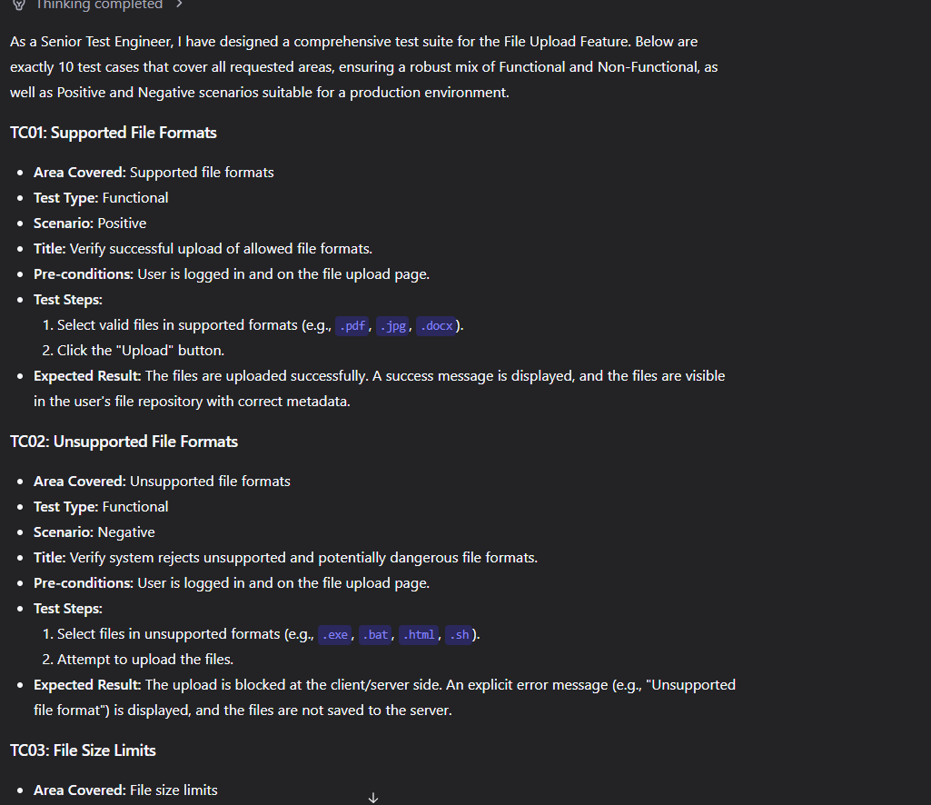

Scenario 2 :
Week Prompt:
Write API test cases for user registration

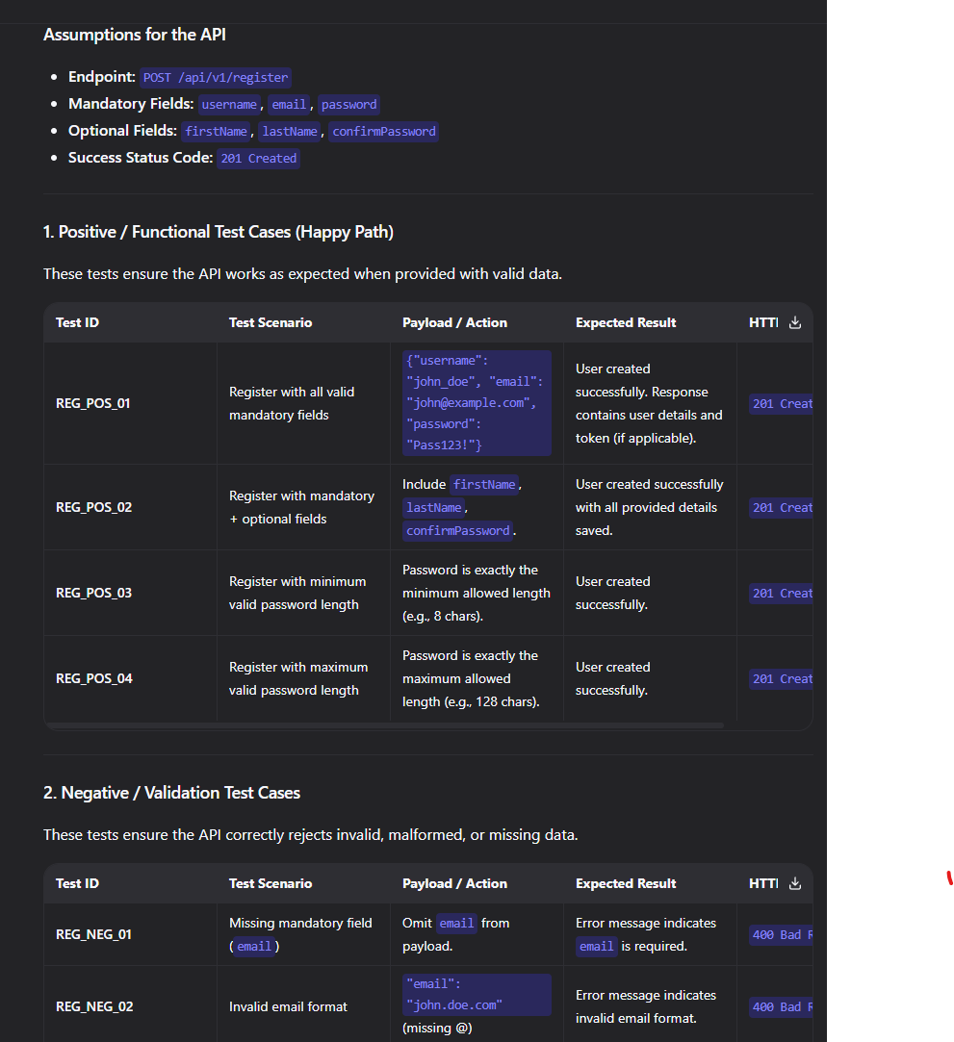

ICEPOT PROMPT:
Context
Act as a Senior API Test Engineer / SDET with experience in RESTful API Testing and Backend Validation.
Instructions
[MANDATORY] Test Case Generation
Generate test cases for the User Registration API Endpoint (e.g., POST /api/v1/register).
Requirements
Generate exactly 10 test cases.
Include both Functional and Non-Functional (Security, Performance) test cases.
Include both Positive and Negative scenarios.
Ensure all test cases are realistic and suitable for a production environment.
Avoid duplicate test cases.
Format the output as a structured table with the following columns: Test ID, Test Scenario, Payload/Action, Expected Result, and HTTP Status Code.
Cover These Areas
Create test cases for the following scenarios:
Valid payload with mandatory and optional fields (Happy Path)
Missing or null mandatory fields (e.g., email, password)
Invalid data formats (e.g., malformed email, weak password complexity)
Boundary value analysis (minimum and maximum length for username/password)
Duplicate user registration (existing email and existing username)
Case-insensitivity checks (e.g., Test@Email.com vs test@email.com)
Security validation checks (SQL injection, XSS, and ensuring password is not exposed in the response)
HTTP method validation (attempting PUT/DELETE on the POST endpoint)
Rate limiting and brute-force protection
Database state verification (verifying password hashing and default role assignment upon creation)

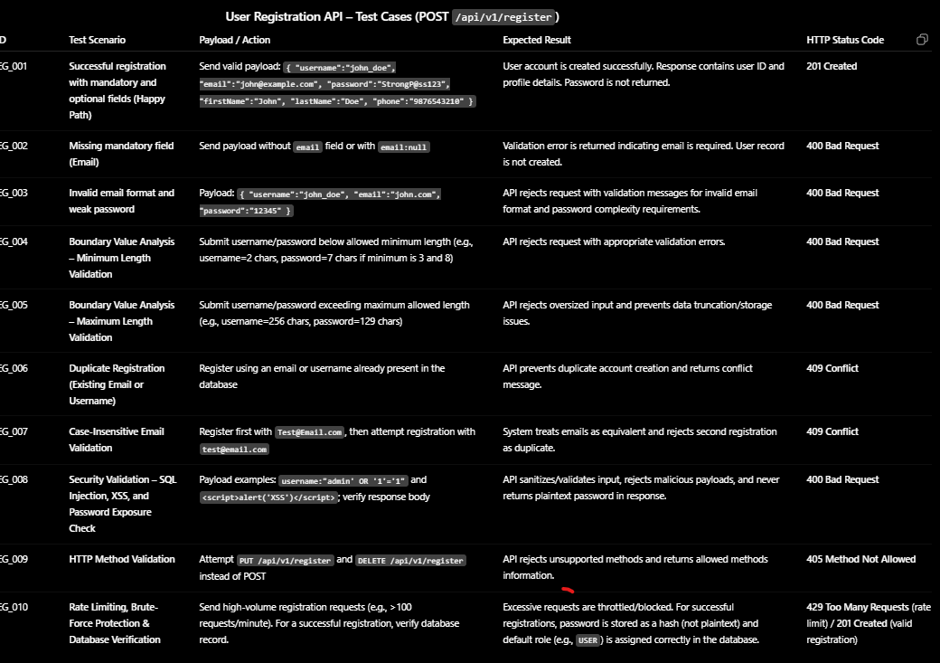

Scenario 3:
Weak Prompt:
"Test the search feature."
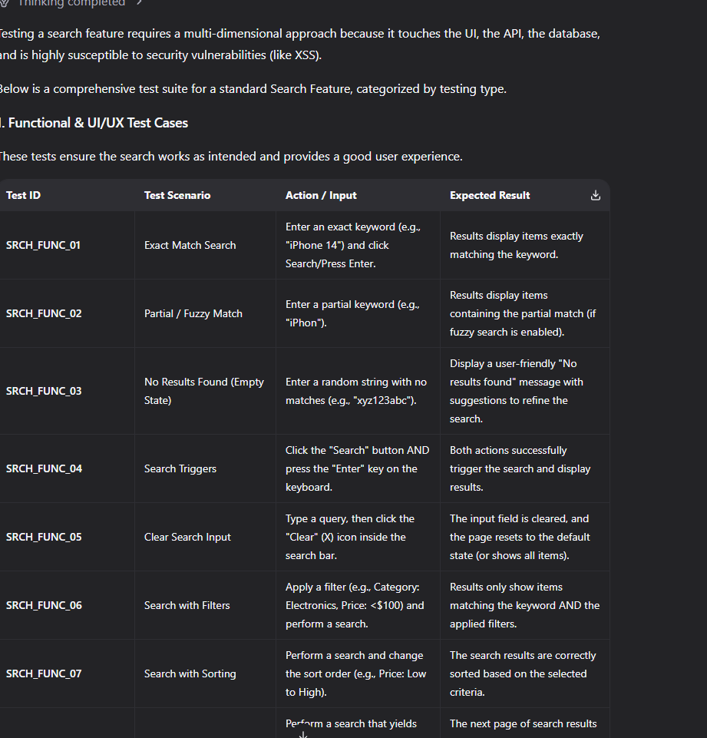

ICEPOT PROMPT:
Context
Act as a Senior QA Engineer / SDET with extensive experience in Web Application and API Testing, specifically focusing on Search functionalities, E-commerce, and Content platforms.
Instructions
[MANDATORY] Test Case Generation
Generate test cases for the Global Search Feature.
[MANDATORY] Requirements
Generate exactly 10 test cases. Include Functional, UI/UX, Edge Case, Security, and Performance test cases. Include both Positive and Negative scenarios. Ensure all test cases are realistic and suitable for a production environment. Avoid duplicate test cases.
[MANDATORY] Cover These Areas
Create test cases for the following scenarios:
Exact, partial, and fuzzy match search logic Search combined with filters, sorting, and pagination Empty query, whitespace-only input, and leading/trailing space handling Case-insensitivity, special characters, and Unicode/Emoji support Autocomplete/Typeahead suggestions and API debounce behaviour
