Rikel Djoko

Pradeep Kumar

MSDS 6372

08/7/19

Introduction

For most of us who follow Basketball, every shot is important and it’s a potential swish. Hence keep us in suspense for a brief moment until we find out if the shot will end up at the bottom of the net. As of today the shot outcome is simply a guessing game, in this paper we going to try a different approach to accurately predict the shot outcome using 20 years of data on Kobe’s swishes and misses and apply machine learning technique.

Data Description

The dataset for this project originates from the Kaggle platform (<https://www.kaggle.com/c/kobe-bryant-shot-selection/data>). The Data consists of 20697 shots with 22 features which describe location and circumstance of every field goal attempted by Kobe Bryant took during his 20-year career. Most of the feature are self-explanatory, see table 1 below and figure 1 for dataset overview/

***Table1: List of features***

|  |  |
| --- | --- |
| recId  action_type  combined_shot_type  game_event_id  game_id  lat – court location identifier (latitude)  loc_x - court location identifier (x/y axis)  loc_y- court location identifier (x / y axis)  lon - court location identifier (longitude)  minutes_remaining – (in period)  period  playoffs  season  seconds_remaining  attendance | avgnoisedb – avg noise in arena (decibels)  shot_distance  shot_made_flag (this is what you are predicting)  shot_type  shot_zone_area  shot_zone_basic  shot_zone_range  team_id  team_name  game_date  matchup  opponent  shot_id  arena_temp (oF) |

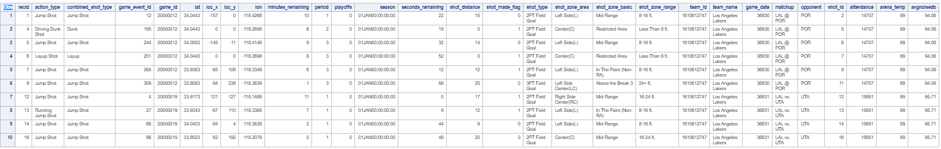

***Figure 1: dataset sample***

 Exploratory Data Analysis

In this section we will use multiple visualization technique to understand each feature and how it relate to the dependent variable, we’re also going to identify outliers address and identify multicollinearity and correlation between variable. And finally check assumption for logical regression.

* Data visualization

Figure2 shows the frequency distribution of the shot across the 20697 shots, the delta between the two categories pretty significant.

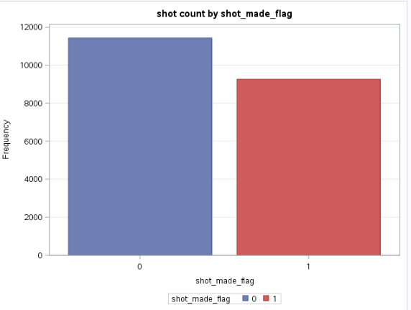

***Figure 2: short frequency distribution***

Figure3 below shows the matrix scatterplot of each of the continue variable, based on the trend of variation we can infer high correlation between lat and loc_y, lon and loc_x.

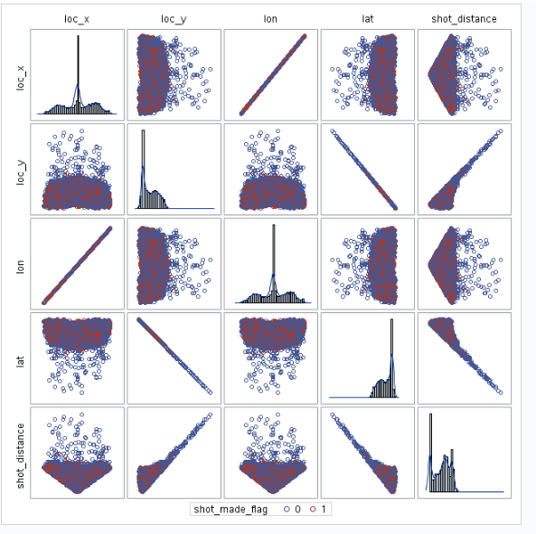

***Figure 3: matrix scatterplot***

Figure 4-8 show the distribution of shot across different categorical, this will identify which of the categorical has less effect on the dependent variable.

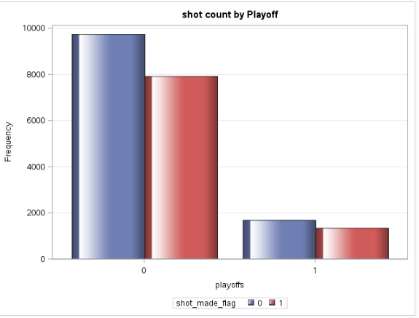

***Figure 4: short distribution based on playoff***

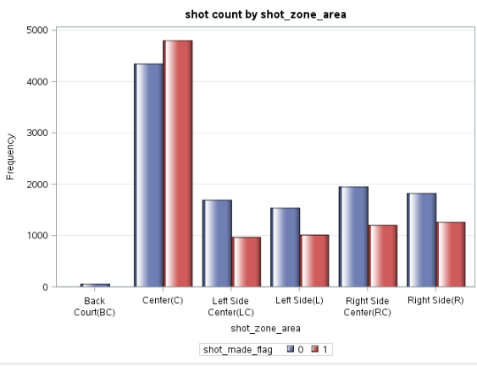

***Figure 5: short distribution based on shot_zone_area***

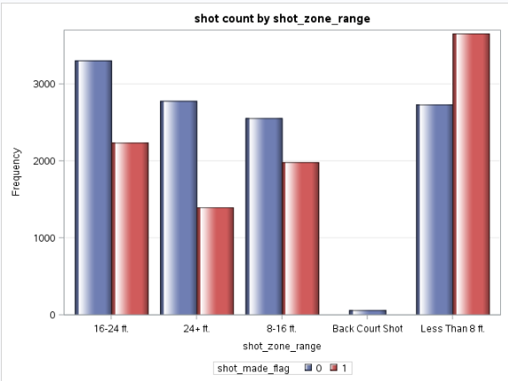

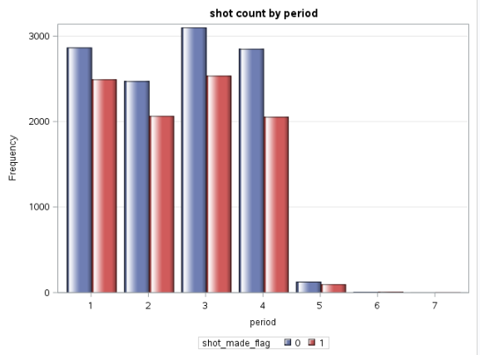

***Figure 6: short distribution based on short_zone_range Figure 7: short distribution based on period***

* Assumption:
* Binary response variable: shot_made_flag is a binary variable where 0 represent missed shot and 1 represent made shot.
* Model fitted correctly, no over fitting nor under fitting: not enough information to validate this assumption we will come back to it the next section using goodness of fit after building the model.
* Independent : each observation are independent from each other
* Linearity of independent variable and log odds: not enough information to validate this assumption we will come back to it the next section using the general test after building the model
* Feature Selection:

Figure 7 shows a Pearson correlation coefficient table across all variables.

Feature selection remove highly correlated feature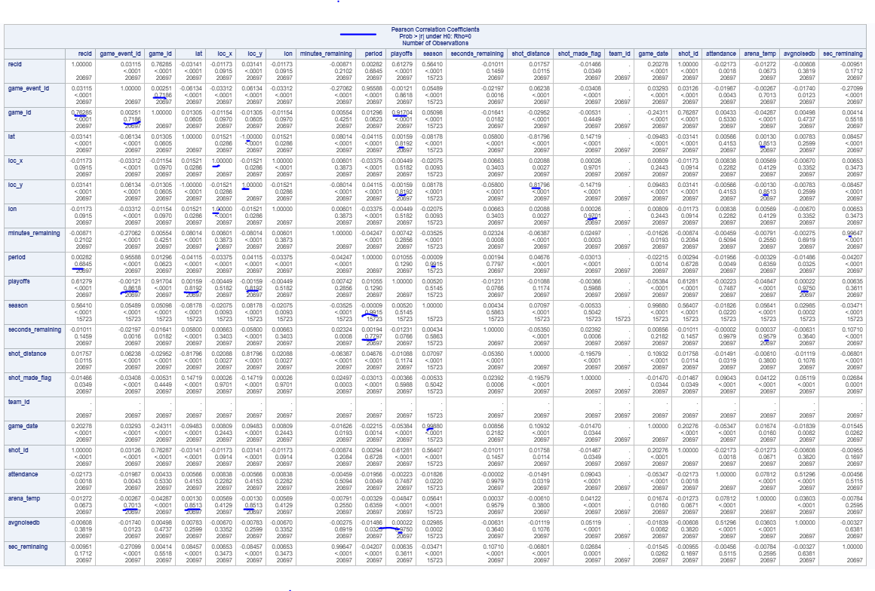 ***Figure6: Pearson Correlation***

Based on the correlation coefficient we can remove some of the high correlated variable, since they are carry the same information.

* game_Id and game_event_Id have a corr coefficient of 0.71 and based on the description it makes logical sense to use either of them in the final model.
* Arena_temp is highly correlated with game_event_Id , lon and loc_y, but logically it doesn’t make sense so we will keep each variable separately
* Game date and season are highly correlated, and it make logical sense since season is defined around the same date , thus we can keep season and remove date
* Avgnoisedb and playoff are highly correlated and it make sense since playoff are very intense. So we can keep playoff and remove avgnoisedb feature.
* Lon and loc_x and lat and loc_y are so highly correlated and make sense so we will keep loc_x and loc_y and remove Lon and Lat feature from the model.
* Since Minute remain and second remaining represent the time value at a different scale, so we add a new variable “sec_reamaining” which is the sum of Minute and second remaining.

Build model

**OUTLIER**

The two figure below use Pearson Residual and Leverage to identify

influential observation, the observations that are furthest away from 0 are the

influential observations, such as observations 2773, 17188 and 20455.

Their absence and presence in the model did not affect the parameters and their values.

So the model will be built without removing these outliers.

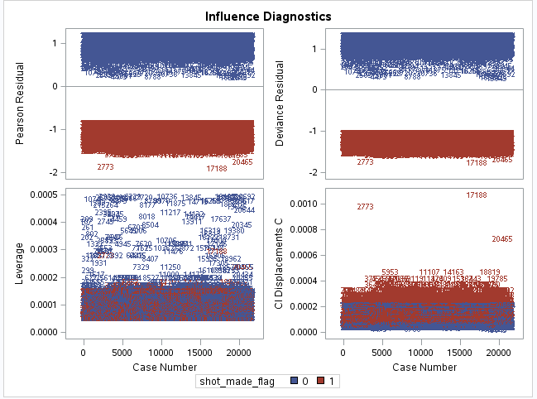

* GOODNESS-OF-FIT TEST

To examine how well your developed model fits the data, the partition below does not show any violation for the requirements of the Hosmer and Lemeshow.

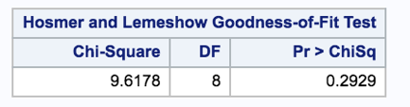

* The odds of Kobe making a shot decrease with respect to the distance he is from the hoop. If there is evidence of this, quantify this relationship. (CIs, plots, etc.)

In the below table find the point estimate and CIs of odds ratio for every shot_zone_range.

The shot_zone_range = “less than 8ft” is the reference.

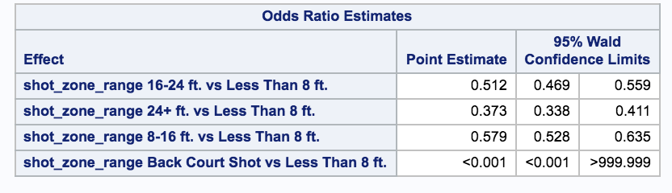

Shot distance is not used here to model since shot distance is not normally distributed and due to which the goodness of fit test (Hosmer and Lemeshow test) indicates that model is not a good fit.

Instead using shot_zone_range which is a similar measure at coarse level.

A sample calculation of odds ratio

W (successful shot) = eb0 + b1 (8-16)ft + b2 (16-24)ft + b3(24+ft)

Odds between “less than 8 ft” and “8-16 ft” is calculated as below

W(successful shot 8-16ft)  / W (successful shot less than 8 ft) = e(0.2899 – 0.5546) / e(0.2899) = 0.57

The confidence interval of the odds of successful shot in zone range 8-16ft to 8 ft is 0.52 to 0.63. This interval does not contain zero as a value so null hypothesis which states that odds of successful shots at range 8-16ft is same as odds of successful shot in range less than 8ft is rejected (p < 0.0001).

From the above model,

1. The odds of kobe making a successful shot if the distance from the hoop is in the range of 8-16ft is estimated to be 0.57 times that of hoop being with in 8ft range (p < 0.0001)
2. The odds of kobe making a successful shot if the distance from the hoop is in the range of 16-24ft is estimated to be 0.54 times that of hoop being with in 8ft range (p < 0.0001)
3. The odds of kobe making a successful shot if the distance from the hoop is in the range of 24+ft is estimated to be 0.37 times that of hoop being with in 8ft range (p < 0.0001)

* The probability of Kobe making a shot decreases linearly with respect to the distance he is from the hoop. If there is evidence of this, quantify this relationship. (CIs, plots, etc.)

The shot made variation w.r.t shot_zone_range coded values as below.

From the below plot we can see that proportions of successful shot made goes down linearly.

|  |
| --- |
|  |

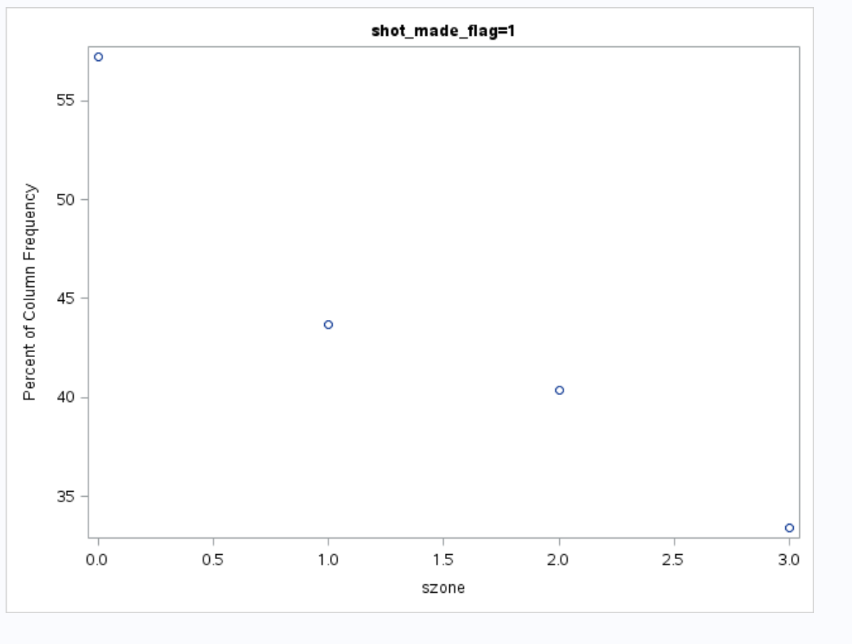

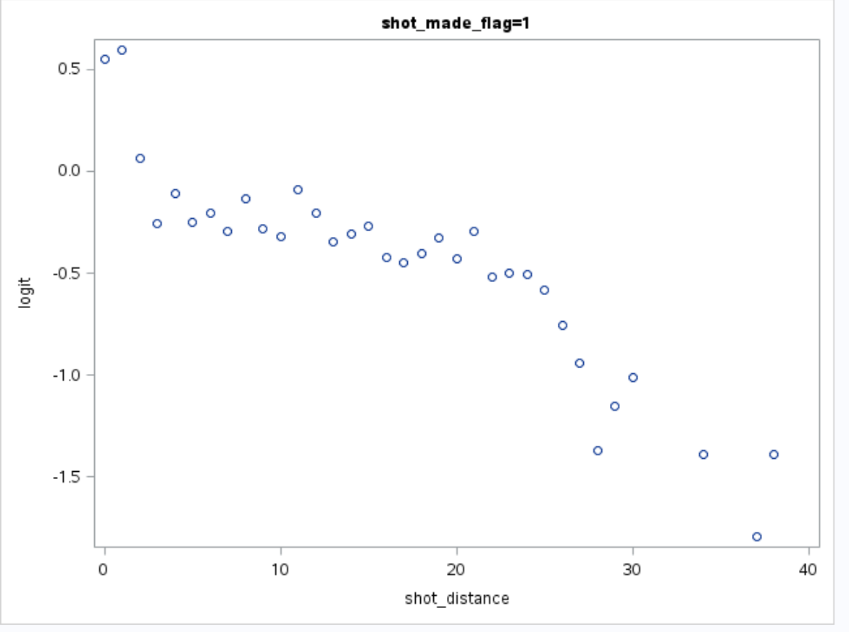

* The relationship between the distance Kobe is from the basket and the odds of him making the shot is different if they are in the playoffs. Quantify your findings with statistical evidence one way or the other. (Tests, CIs, plots, etc.)

With stepwise selection model as shown below, we can see that playoffs gets eliminated at Step 1 since it does not qualify to be part of the model considering 0.05 to be the significance level for entry into the model.

So, playoffs do not have any influence on the odds of making a successful shot.

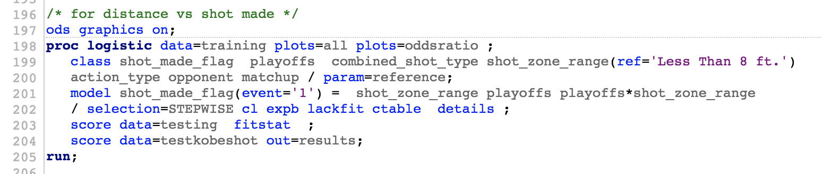

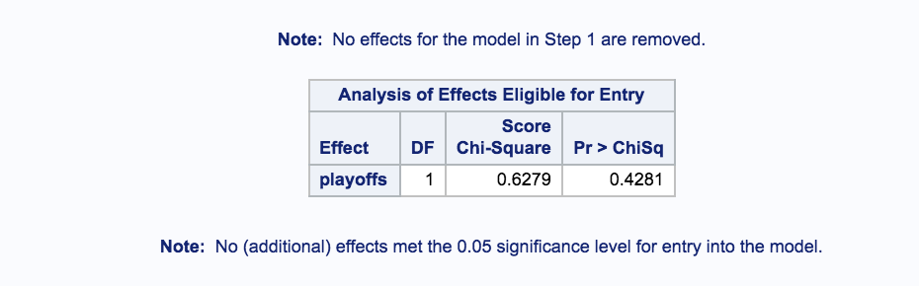

**Logistic Model and its parameter estimates**

Log odds of shot_success = Intercept + B0 Action Type Alley Oop Dunk + B1 “Alley oop layup” + ….. + Bn shot_zone_range(8-16) + Bn+1 shot_zone_range(16-24) + Bn+2 shot_zone_range(24ft) + Bn+3 avgnoise + Bn+4 seconds_remaining

A small snippet of parameters table is as below.

For full table , refer to appendix

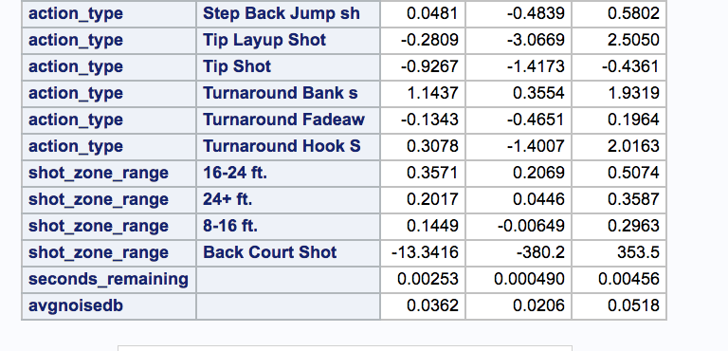

The Parameters of the model are explained in terms of odds ratio.

The complete odds ratio table is in appendix.

A short snippet of odds ratio table is as below

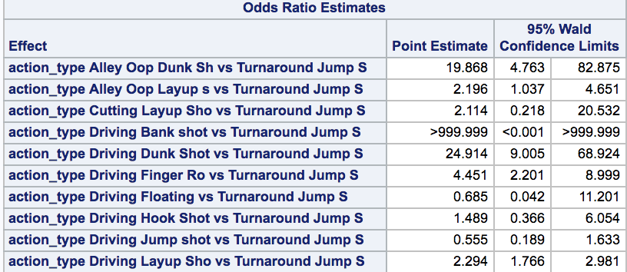

Odds Ratio Estimates and its interpretation

Interpretation of a sample parameter is as below

Parameter: **action_type Alley Oop Dunk Sh vs Turnaround Jump S= 19.86**

This means, when action type is “Alley Oop Dunk” with “Turnaround Jump” as reference action type, the odds of having successful shot gets multiplied by 19.86 times.

| **A** |
| --- |

Evaluating Model Performance

This logistic model is 68% accurate. About 32% of the classifications can be error prone.

The **sensitivity** is the proportion of true positive = 46.7

The **specificity** is the proportion of true negative = 85.8

| **Classification Table** | | | | | | | | | |
| --- | --- | --- | --- | --- | --- | --- | --- | --- | --- |
| **Prob Level** | **Correct** | | **Incorrect** | | **Percentages** | | | | |
| **Event** | **Non- Event** | **Event** | **Non- Event** | **Correct** | **Sensi- tivity** | **Speci- ficity** | **False POS** | **False NEG** |
| **0.450** | 3024 | 6871 | 1134 | 3458 | 68.3 | 46.7 | 85.8 | 27.3 | 33.5 |

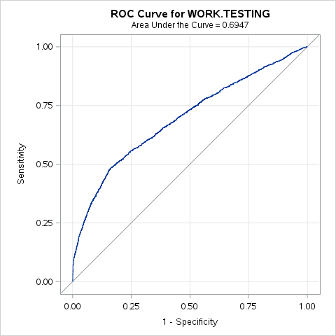

| **Fit Statistics for SCORE Data** | | | | | | | | | | | |
| --- | --- | --- | --- | --- | --- | --- | --- | --- | --- | --- | --- |
| **Data Set** | **Total Frequency** | **Log Likelihood** | **Error Rate** | **AIC** | **AICC** | **BIC** | **SC** | **R-Square** | **Max-Rescaled R-Square** | **AUC** | **Brier Score** |
| **WORK.TESTING** | 6208 | -3871.0 | 0.3215 | 7852.017 | 7853.018 | 8222.365 | 8222.365 | 0.120567 | 0.161335 | 0.694683 | 0.21284 |
| **WORK.TESTING** | 6208 | -3871.0 | 0.3215 | 7852.017 | 7853.018 | 8222.365 | 8222.365 | 0.120567 | 0.161335 | 0.694683 | 0.21284 |

**LINEAR DISCRIMINANT ANALYSIS**

**The table below shows the LDA table and its parameter estimates.**

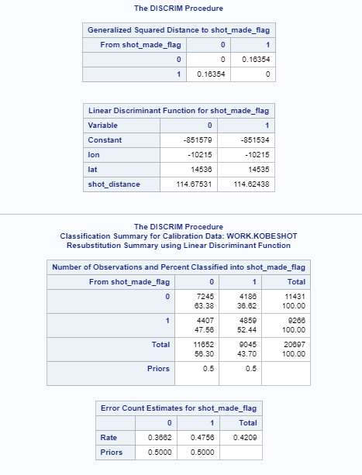

* Comparing LDA and LOGIT

Using accuracy (the proportion of observations for which the test result and actual response agree) and the error rate

|  |  |  |
| --- | --- | --- |
|  | Accuracy | Error rate |
| LDA | 58.7% | 42% |
| LOGIT | 68% | 32% |

From the above table we can see that Logit model is the better model.

Conclusion

Kobe Bryant’s successful shots do have some pattern. The success of shots depends on some of the features in the data set. Some action types like Reverse **Slam Dunk, Slam Dunk Shot have good success rate. These shots do not seem to have any interaction effect with shot_zone_range which means distance to hoops and action type do not have combined effect. The shot_zone_range itself is a significant effect which means all shots are affected by distance to hoops irrespective of type of action.**

**Kobe also gets affected by the average noise in the arena. The more cheering sound seem to make Kobe make successful shots.**

**Suggestion to opposition team**

**Opposition team should create conditions where in Kobe will not be able to take “Hook Bank shot” , “Driving slam dunk” or “Follow up dunk”.**

**The SAS code to this project can be found at**

[**https://github.com/pradeep17j/SMU_MSDS/tree/master/AppliedStats_Proj2**](https://github.com/pradeep17j/SMU_MSDS/tree/master/AppliedStats_Proj2)

APENDIX

| **Parameter Estimates and Wald Confidence Intervals** | | | | |
| --- | --- | --- | --- | --- |
| **Parameter** |  | **Estimate** | **95% Confidence Limits** | |
| **Intercept** |  | -3.4887 | -48.0886 | 41.1112 |
| **shot_zone_range** | **16-24 ft.** | 2.6258 | -24.3720 | 29.6236 |
| **shot_zone_range** | **24+ ft.** | 2.4257 | -24.5722 | 29.4235 |
| **shot_zone_range** | **8-16 ft.** | 2.4737 | -24.5243 | 29.4717 |
| **shot_zone_range** | **Back Court Shot** | -9.7100 | -117.7 | 98.2812 |
| **arena_temp** |  | 0.0367 | 0.0191 | 0.0543 |
| **action_type** | **Alley Oop Dunk Sh** | 2.0173 | -33.4886 | 37.5232 |
| **action_type** | **Alley Oop Layup s** | -0.1940 | -35.6800 | 35.2919 |
| **action_type** | **Cutting Layup Sho** | -0.1162 | -35.6643 | 35.4320 |
| **action_type** | **Driving Bank shot** | 11.0346 | -855.1 | 877.2 |
| **action_type** | **Driving Dunk Shot** | 2.2390 | -33.2533 | 37.7314 |
| **action_type** | **Driving Finger Ro** | 0.4981 | -34.9870 | 35.9831 |
| **action_type** | **Driving Floating** | -1.3081 | -36.8915 | 34.2752 |
| **action_type** | **Driving Hook Shot** | -0.5743 | -36.0793 | 34.9306 |
| **action_type** | **Driving Jump shot** | -1.5651 | -37.0592 | 33.9290 |
| **action_type** | **Driving Layup Sho** | -0.1608 | -35.6400 | 35.3185 |
| **action_type** | **Driving Reverse L** | -0.3402 | -35.8248 | 35.1443 |
| **action_type** | **Driving Slam Dunk** | 10.9754 | -165.6 | 187.6 |
| **action_type** | **Dunk Shot** | 0.0252 | -35.4565 | 35.5069 |
| **action_type** | **Fadeaway Bank sho** | 0.9779 | -34.5583 | 36.5140 |
| **action_type** | **Fadeaway Jump Sho** | -1.1751 | -36.6546 | 34.3044 |
| **action_type** | **Finger Roll Layup** | -0.1282 | -35.6241 | 35.3678 |
| **action_type** | **Finger Roll Shot** | -0.6796 | -36.1748 | 34.8155 |
| **action_type** | **Floating Jump sho** | -0.2162 | -35.7001 | 35.2677 |
| **action_type** | **Follow Up Dunk Sh** | 10.9516 | -318.0 | 339.9 |
| **action_type** | **Hook Bank Shot** | 10.9284 | -423.0 | 444.8 |
| **action_type** | **Hook Shot** | -1.8317 | -37.3155 | 33.6521 |
| **action_type** | **Jump Bank Shot** | -0.0856 | -35.5666 | 35.3954 |
| **action_type** | **Jump Hook Shot** | 0.1889 | -35.3218 | 35.6996 |
| **action_type** | **Jump Shot** | -2.2058 | -37.6849 | 33.2733 |
| **action_type** | **Layup Shot** | -1.7783 | -37.2574 | 33.7009 |
| **action_type** | **Pullup Bank shot** | -1.3296 | -36.8432 | 34.1840 |
| **action_type** | **Pullup Jump shot** | -0.4755 | -35.9558 | 35.0048 |
| **action_type** | **Putback Dunk Shot** | -1.3161 | -36.8988 | 34.2667 |
| **action_type** | **Putback Layup Sho** | -0.5736 | -36.0915 | 34.9443 |
| **action_type** | **Reverse Dunk Shot** | 1.2879 | -34.2097 | 36.7855 |
| **action_type** | **Reverse Layup Sho** | -0.7114 | -36.1917 | 34.7688 |
| **action_type** | **Reverse Slam Dunk** | 10.9190 | -279.5 | 301.3 |
| **action_type** | **Running Bank shot** | 0.6085 | -34.8904 | 36.1074 |
| **action_type** | **Running Dunk Shot** | 0.6817 | -34.8565 | 36.2200 |
| **action_type** | **Running Finger Ro** | -13.4818 | -513.6 | 486.6 |
| **action_type** | **Running Hook Shot** | 0.3914 | -35.1080 | 35.8907 |
| **action_type** | **Running Jump Shot** | -0.1495 | -35.6291 | 35.3302 |
| **action_type** | **Running Layup Sho** | -1.0403 | -36.5271 | 34.4464 |
| **action_type** | **Running Pull-Up J** | -13.6882 | -878.7 | 851.4 |
| **action_type** | **Running Reverse L** | -0.8403 | -36.3626 | 34.6820 |
| **action_type** | **Running Tip Shot** | -13.5541 | -878.6 | 851.5 |
| **action_type** | **Slam Dunk Shot** | 2.5399 | -32.9523 | 38.0322 |
| **action_type** | **Step Back Jump sh** | -0.9213 | -36.4038 | 34.5612 |
| **action_type** | **Tip Layup Shot** | -1.3161 | -36.8990 | 34.2668 |
| **action_type** | **Tip Shot** | -1.9300 | -37.4116 | 33.5516 |
| **action_type** | **Turnaround Bank s** | 0.1889 | -35.2980 | 35.6758 |
| **action_type** | **Turnaround Fadeaw** | -1.1073 | -36.5874 | 34.3729 |
| **action_type** | **Turnaround Hook S** | -0.6863 | -36.2045 | 34.8319 |
| **shot_zone_area** | **Back Court(BC)** | 0.4936 | 0.0523 | 0.9348 |
| **shot_zone_area** | **Center(C)** | -0.00331 | -0.1410 | 0.1344 |
| **shot_zone_area** | **Left Side Center(LC)** | -0.0655 | -0.1953 | 0.0642 |
| **shot_zone_area** | **Left Side(L)** | -0.2714 | -0.4230 | -0.1197 |

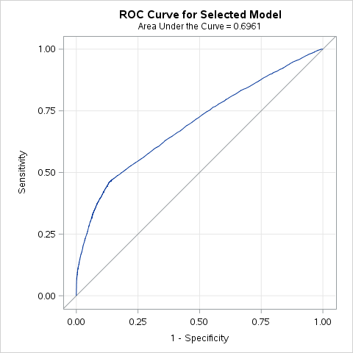

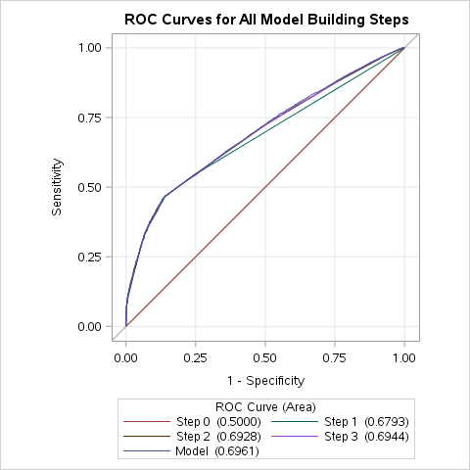

| **Odds Ratio Estimates** | | | |
| --- | --- | --- | --- |
| **Effect** | **Point Estimate** | **95% Wald Confidence Limits** | |
| **shot_zone_range 16-24 ft. vs Less Than 8 ft.** | 1.418 | 1.250 | 1.610 |
| **shot_zone_range 24+ ft. vs Less Than 8 ft.** | 1.224 | 1.072 | 1.397 |
| **shot_zone_range 8-16 ft. vs Less Than 8 ft.** | 1.173 | 1.033 | 1.332 |
| **shot_zone_range Back Court Shot vs Less Than 8 ft.** | <0.001 | <0.001 | >999.999 |
| **arena_temp** | 1.043 | 1.028 | 1.059 |
| **action_type Alley Oop Dunk Sh vs Turnaround Jump S** | 18.133 | 5.634 | 58.362 |
| **action_type Alley Oop Layup s vs Turnaround Jump S** | 1.858 | 1.028 | 3.359 |
| **action_type Cutting Layup Sho vs Turnaround Jump S** | 1.586 | 0.288 | 8.749 |
| **action_type Driving Bank shot vs Turnaround Jump S** | >999.999 | <0.001 | >999.999 |
| **action_type Driving Dunk Shot vs Turnaround Jump S** | 28.579 | 11.546 | 70.740 |
| **action_type Driving Finger Ro vs Turnaround Jump S** | 5.375 | 2.861 | 10.096 |
| **action_type Driving Floating vs Turnaround Jump S** | 0.707 | 0.098 | 5.102 |
| **action_type Driving Hook Shot vs Turnaround Jump S** | 1.197 | 0.385 | 3.717 |
| **action_type Driving Jump shot vs Turnaround Jump S** | 0.516 | 0.204 | 1.304 |
| **action_type Driving Layup Sho vs Turnaround Jump S** | 2.158 | 1.733 | 2.686 |
| **action_type Driving Reverse L vs Turnaround Jump S** | 2.355 | 1.305 | 4.250 |
| **action_type Driving Slam Dunk vs Turnaround Jump S** | 28.429 | 3.868 | 208.953 |
| **action_type Dunk Shot vs Turnaround Jump S** | 2.621 | 1.758 | 3.907 |
| **action_type Fadeaway Bank sho vs Turnaround Jump S** | 6.612 | 1.532 | 28.531 |
| **action_type Fadeaway Jump Sho vs Turnaround Jump S** | 0.787 | 0.637 | 0.973 |
| **action_type Finger Roll Layup vs Turnaround Jump S** | 2.280 | 0.821 | 6.330 |
| **action_type Finger Roll Shot vs Turnaround Jump S** | 0.816 | 0.353 | 1.887 |
| **action_type Floating Jump sho vs Turnaround Jump S** | 1.813 | 1.067 | 3.080 |
| **action_type Follow Up Dunk Sh vs Turnaround Jump S** | 6.590 | 0.828 | 52.458 |
| **action_type Hook Bank Shot vs Turnaround Jump S** | >999.999 | <0.001 | >999.999 |
| **action_type Hook Shot vs Turnaround Jump S** | 0.432 | 0.251 | 0.745 |
| **action_type Jump Bank Shot vs Turnaround Jump S** | 2.414 | 1.692 | 3.445 |
| **action_type Jump Hook Shot vs Turnaround Jump S** | 2.106 | 0.670 | 6.626 |
| **action_type Jump Shot vs Turnaround Jump S** | 0.291 | 0.249 | 0.340 |
| **action_type Layup Shot vs Turnaround Jump S** | 0.446 | 0.363 | 0.548 |
| **action_type Pullup Bank shot vs Turnaround Jump S** | 0.997 | 0.279 | 3.570 |
| **action_type Pullup Jump shot vs Turnaround Jump S** | 1.621 | 1.211 | 2.168 |
| **action_type Putback Dunk Shot vs Turnaround Jump S** | 1.437 | 0.129 | 15.972 |
| **action_type Putback Layup Sho vs Turnaround Jump S** | 1.536 | 0.379 | 6.222 |
| **action_type Putback Slam Dunk vs Turnaround Jump S** | <0.001 | <0.001 | >999.999 |
| **action_type Reverse Dunk Shot vs Turnaround Jump S** | 12.388 | 3.807 | 40.310 |
| **action_type Reverse Layup Sho vs Turnaround Jump S** | 1.272 | 0.938 | 1.724 |
| **action_type Reverse Slam Dunk vs Turnaround Jump S** | >999.999 | <0.001 | >999.999 |
| **action_type Running Bank shot vs Turnaround Jump S** | 3.333 | 1.364 | 8.149 |
| **action_type Running Dunk Shot vs Turnaround Jump S** | 4.577 | 1.012 | 20.688 |
| **action_type Running Finger Ro vs Turnaround Jump S** | 0.575 | 0.152 | 2.168 |
| **action_type Running Hook Shot vs Turnaround Jump S** | 4.226 | 1.446 | 12.353 |
| **action_type Running Jump Shot vs Turnaround Jump S** | 2.044 | 1.610 | 2.596 |
| **action_type Running Layup Sho vs Turnaround Jump S** | 1.682 | 0.853 | 3.318 |
| **action_type Running Pull-Up J vs Turnaround Jump S** | <0.001 | <0.001 | >999.999 |
| **action_type Running Reverse L vs Turnaround Jump S** | 0.782 | 0.156 | 3.921 |
| **action_type Running Tip Shot vs Turnaround Jump S** | <0.001 | <0.001 | >999.999 |
| **action_type Slam Dunk Shot vs Turnaround Jump S** | 38.425 | 15.570 | 94.833 |
| **action_type Step Back Jump sh vs Turnaround Jump S** | 1.041 | 0.662 | 1.636 |
| **action_type Tip Layup Shot vs Turnaround Jump S** | 0.703 | 0.044 | 11.350 |
| **action_type Tip Shot vs Turnaround Jump S** | 0.421 | 0.278 | 0.639 |
| **action_type Turnaround Bank s vs Turnaround Jump S** | 2.661 | 1.308 | 5.413 |
| **action_type Turnaround Fadeaw vs Turnaround Jump S** | 0.840 | 0.639 | 1.106 |
| **action_type Turnaround Finger vs Turnaround Jump S** | >999.999 | <0.001 | >999.999 |
| **action_type Turnaround Hook S vs Turnaround Jump S** | 0.656 | 0.162 | 2.656 |

