To enable faster and better response to changing customer needs, enterprises are increasing their release frequency for applications. This, in turn, demands tighter alignment and collaboration than traditionally has been seen between the line of business, development and IT operations, driving the need for enhanced collaboration, automation and information transparency among these groups. To achieve seamless internal collaboration, many enterprise customers are adopting a DevOps approach.

CI and CD are two acronyms that are often mentioned when people talk about modern development practices. CI is straightforward and stands for continuous integration, a practice that focuses on making preparing a release easier. But CD can either mean continuous delivery or continuous deployment, and while those two practices have a lot in common, they also have a significant difference that can have critical consequences for a business.

**Continuous Integration (CI):**

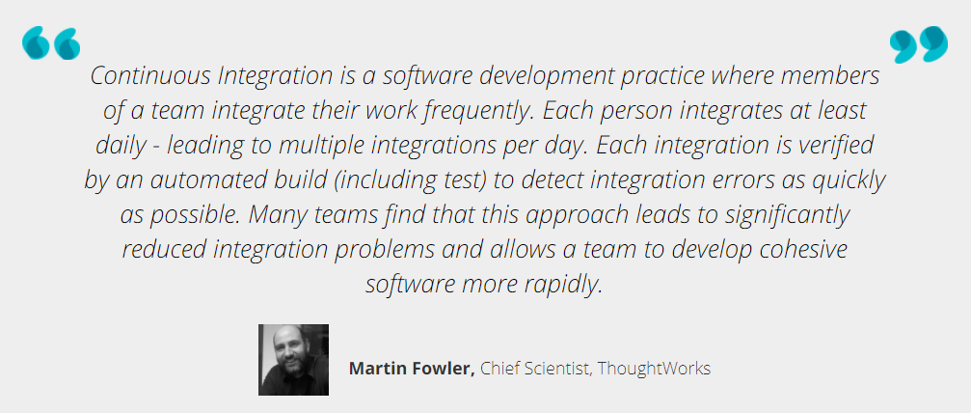

**Continuous delivery (CD):**

It is a DevOps software development practice where code changes are automatically built, tested, and prepared for a release to production. It expands upon continuous integration by deploying all code changes to a testing environment and/or a production environment after the build stage. When continuous delivery is implemented properly, developers will always have a deployment-ready build artifact that has passed through a standardized test process.

Continuous Delivery can help large organizations become as lean, agile and innovative as startups. Through reliable, low-risk releases, Continuous Delivery makes it possible to continuously adapt software in line with user feedback, shifts in the market and changes to business strategy. Test, support, development and operations work together as one delivery team to automate and streamline the build-test-release process.

**CI/CD as a service in Cybage:**

Our CI/CD Service can help you to implement CI/CD Pipeline . As a part of Technology Roadmapping, Cybage offers the following services:

**Continuous Monitoring (CM) as a service in Cybage:**

