|  |  |
| --- | --- |
| Activity | Data Type |
| Number of beatings from Wife | Discrete |
| Results of rolling a dice | Discrete |
| Weight of a person | Continuos |
| Weight of Gold | Continuos |
| Distance between two places | Continuos |
| Length of a leaf | Continuos |
| Dog's weight | Continuos |
| Blue Color | Categorical |
| Number of kids | Discrete |
| Number of tickets in Indian railways | Discrete |
| Number of times married | Discrete |
| Gender (Male or Female) | Categorical |

Q1) Identify the Data type for the Following:

Q2) Identify the Data types, which were among the following

Nominal, Ordinal, Interval, Ratio.

|  |  |
| --- | --- |
| Data | Data Type |
| Gender | Nominal |
| High School Class Ranking | Ordinal |
| Celsius Temperature | Interval |
| Weight | Ratio |
| Hair Color | Nominal |
| Socioeconomic Status | Ordinal |
| Fahrenheit Temperature | Interval |
| Height | Ratio |
| Type of living accommodation | Nominal |
| Level of Agreement | Ordinal |
| IQ(Intelligence Scale) | Ratio |
| Sales Figures | Interval |
| Blood Group | Nominal |
| Time Of Day | Ordinal |
| Time on a Clock with Hands | Ordinal |
| Number of Children | Nominal |
| Religious Preference | Nominal |
| Barometer Pressure | Ratio |
| SAT Scores | Interval |
| Years of Education | Interval |

Q3) Three Coins are tossed, find the probability that two heads and one tail are obtained?

3/8

Q4) Two Dice are rolled, find the probability that sum is

1. Equal to 1 ~> 0
2. Less than or equal to 4 ~> 1/6
3. Sum is divisible by 2 and 3 ~> 1/6

Q5) A bag contains 2 red, 3 green and 2 blue balls. Two balls are drawn at random. What is the probability that none of the balls drawn is blue?

10/21

Q6) Calculate the Expected number of candies for a randomly selected child

Below are the probabilities of count of candies for children (ignoring the nature of the child-Generalized view)

|  |  |  |
| --- | --- | --- |
| CHILD | Candies count | Probability |
| A | 1 | 0.015 |
| B | 4 | 0.20 |
| C | 3 | 0.65 |
| D | 5 | 0.005 |
| E | 6 | 0.01 |
| F | 2 | 0.120 |

Child A – probability of having 1 candy = 0.015.

Child B – probability of having 4/ candies = 0.20

Ans) 3.09

Q7) Calculate Mean, Median, Mode, Variance, Standard Deviation, Range & comment about the values / draw inferences, for the given dataset

* For Points,Score,Weigh>

Find Mean, Median, Mode, Variance, Standard Deviation, and Range and also Comment about the values/ Draw some inferences.

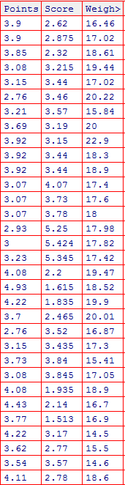

|  |  |  |  |
| --- | --- | --- | --- |
|  | Points | Score | Weigh |
| Mean | 3.596563 | 3.203078 | 17.84906 |
| Mode | 3.92 | 3.44 | 17.02 |
| Median | 3.695 | 3.325 | 17.71 |
| Variance | 0.285881 | 1.010685 | 3.192428 |
| Std Dev | 0.534679 | 1.005328 | 1.786737 |
| Range | 2.17 | 4.2625 | 8.4 |

Q8) Calculate Expected Value for the problem below

1. The weights (X) of patients at a clinic (in pounds), are

108, 110, 123, 134, 135, 145, 167, 187, 199

Assume one of the patients is chosen at random. What is the Expected Value of the Weight of that patient?

Ans) 145.33

**Q9) Calculate Skewness, Kurtosis & draw inferences on the following data**

**Cars speed and distance**

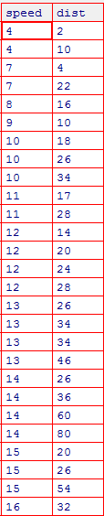

|  |  |  |
| --- | --- | --- |
|  | Car Speed | Distance |
| Skewness | -0.895424912 | 1.290762662 |
| Kurtosis | 0.249560975 | 2.464545503 |
| Inference | moderately skewed right | highly skewed right |

**SP and Weight(WT)**

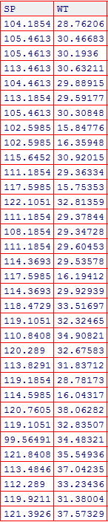

**Left Skewed and Positive Kurtosis for SP**

**Right Skewed and Negative Kurtosis for WT**

**Skewness) -0.4076 for SP and -1.2876 for WT**

**Kurtosis) 2.0867 for SP and 3.8188 for WT**

**Q10) Draw inferences about the following boxplot & histogram**



* **By histogram, we can say that it is rightly skewed.**
* **By box plt, we can say that it is rightly skewed with outliers present in it.**

**Q11)** Suppose we want to estimate the average weight of an adult male in Mexico. We draw a random sample of 2,000 men from a population of 3,000,000 men and weigh them. We find that the average person in our sample weighs 200 pounds, and the standard deviation of the sample is 30 pounds. Calculate 94%,98%,96% confidence interval ?

ANS

**94 => (198.74, 201.25)**

**96 => (198.62, 201.37)**

**98 => (198.43, 201.56)**

**Q12)** Below are the scores obtained by a student in tests

**34,36,36,38,38,39,39,40,40,41,41,41,41,42,42,45,49,56**

1. Find mean, median, variance, standard deviation.
2. What can we say about the student marks?

|  |  |
| --- | --- |
| Mean | 40.94118 |
| Median | 40 |
| Variance | 25.46713 |
| Std Dev | 5.046497 |

We can say that he has performed better than the average score.

Q13) What is the nature of skewness when mean, median of data are equal?

It will not be skewed at all.

Q14) What is the nature of skewness when mean > median ?

Positively skewed

Q15) What is the nature of skewness when median > mean?

Negatively skewed

Q16) What does positive kurtosis value indicates for a data ?

The mean is right to its peak. Most of the data is towards the left of the bell shape. The tail is longer on the right

Q17) What does negative kurtosis value indicates for a data?

The mean is right to its peak. Most of the data is towards the left of the bell shape. The tail is longer on the left.

Q18) Answer the below questions using the below boxplot visualization.



What can we say about the distribution of the data?

It is highly skewed. Most of the values are towards the right side

What is nature of skewness of the data?

Left skewed

What will be the IQR of the data (approximately)?

IQR is in between 10 and 18

Q19) Comment on the below Boxplot visualizations?



Boxplot 1 is highly peaked and most of the data lies in the IQR.

Boxplot 2 is meso kurtic, that is more normally distributed.

Draw an Inference from the distribution of data for Boxplot 1 with respect Boxplot 2.

Both the box plots have same mean. Boxplot 2 is more deviated compared to boxplot 1.

Q 20) Calculate probability from the given dataset for the below cases

Data _set: Cars.csv

Calculate the probability of MPG of Cars for the below cases.

MPG <- Cars$MPG

* 1. P(MPG>38) - 0.407407
  2. P(MPG<40) - 0.753086

c. P (20<MPG<50) - 0.851851

Q 21) Check whether the data follows normal distribution

1. Check whether the MPG of Cars follows Normal Distribution

Dataset: Cars.csv

In Shapiro-Wilk test, p=0.176 which is greater than 0.05. Thus, it is normally distributed.

Also, mean(34.42) and meadian(35.15) are close to each other. Thus, it is normally distributed.

1. Check Whether the Adipose Tissue (AT) and Waist Circumference(Waist) from wc-at data set follows Normal Distribution

Dataset: wc-at.csv

WC – Mean(91.90), Median(90.8). Since mean and median are very close, it is normally distributed.

AT – Mean(101.894), Median(96.54). Since there is a huge difference between two, it is not normally distributed.

Q 22) Calculate the Z scores of 90% confidence interval,94% confidence interval, 60% confidence interval

|  |  |
| --- | --- |
| 90 | 1.65 |
| 96 | 2.05 |
| 60 | 0.84 |

Q 23) Calculate the t scores of 95% confidence interval, 96% confidence interval, 99% confidence interval for sample size of 25

|  |  |
| --- | --- |
| CI | t- score |
| 95 | 2.0639 |
| 96 | 2.1715 |
| 99 | 2.7969 |

Q 24**)** A Government company claims that an average light bulb lasts 270 days. A researcher randomly selects 18 bulbs for testing. The sampled bulbs last an average of 260 days, with a standard deviation of 90 days. If the CEO's claim were true, what is the probability that 18 randomly selected bulbs would have an average life of no more than 260 days

Hint:

rcode 🡪 pt(tscore,df)

df 🡪 degrees of freedom

Ans) 52.86%