Chapter-6
Type coercion madness:
To sporadically add different types of values with the help of + operator.not a single value is the string.
When + operator encounters object of different types it will attempt to coerce the other side of the string and perform the string addition.
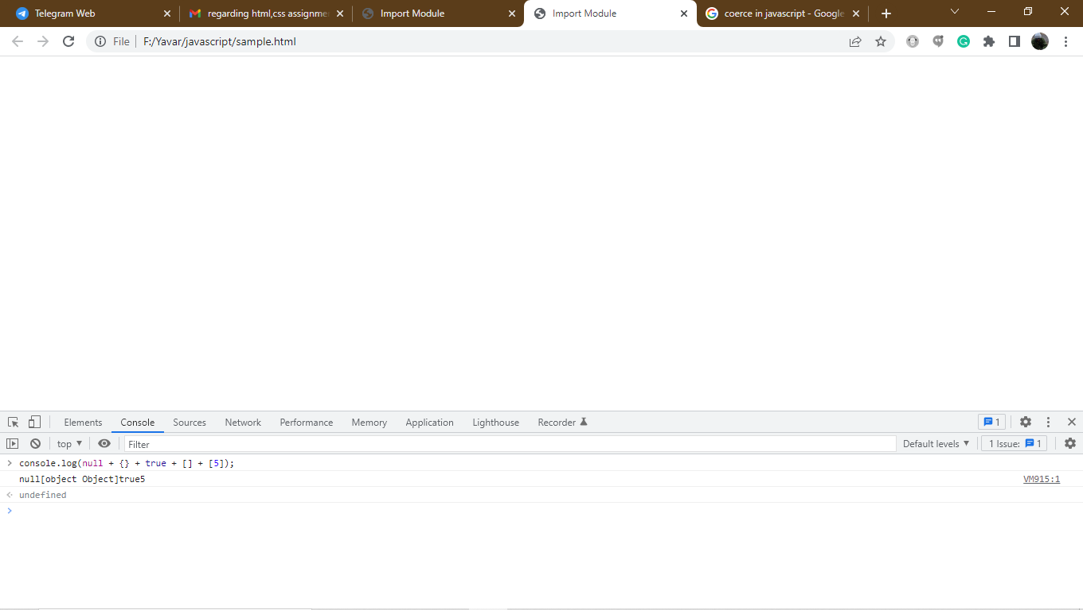
Example of type coercion:
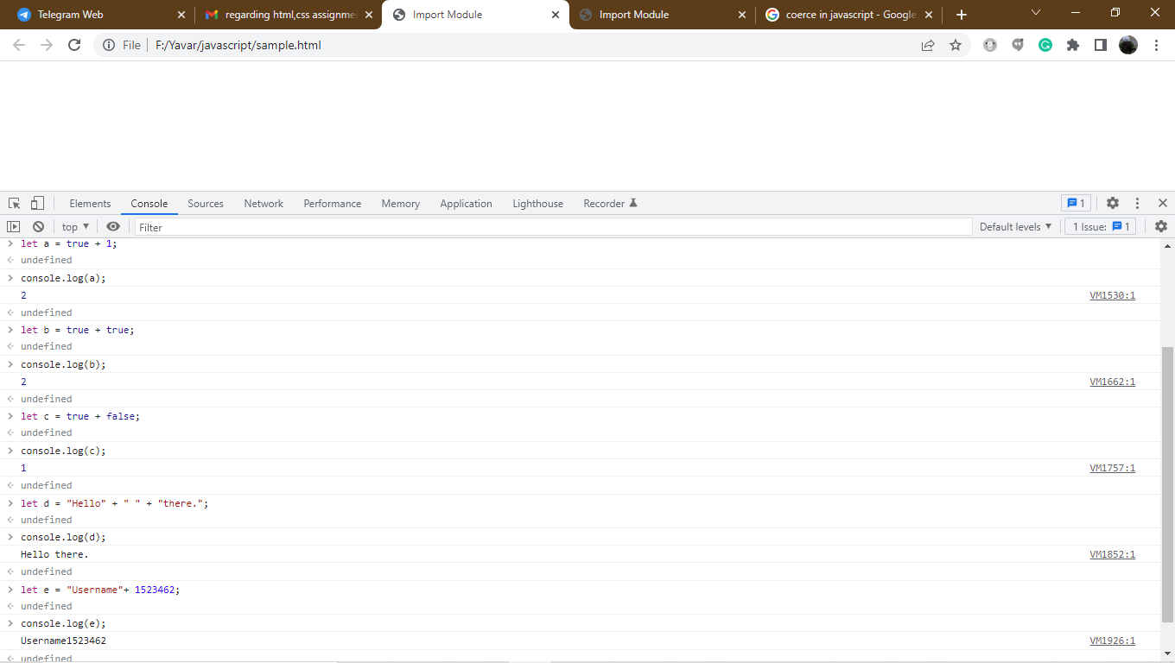
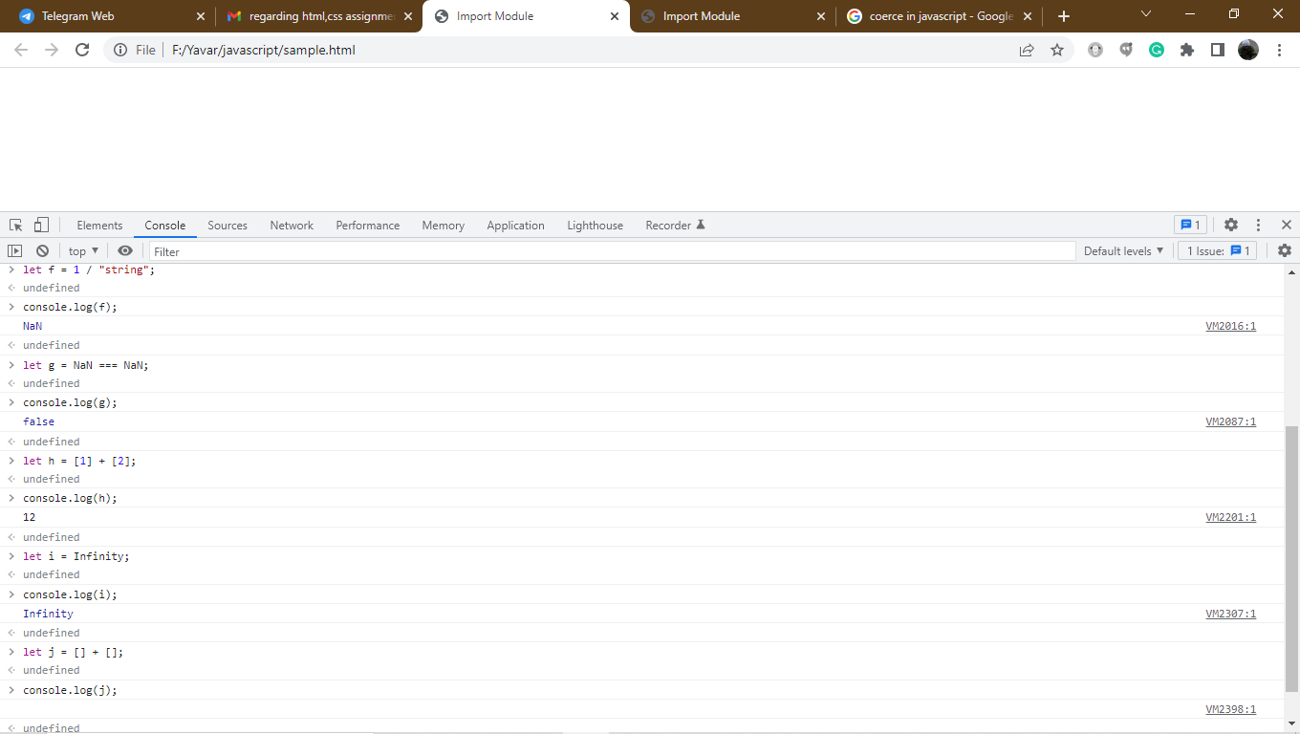
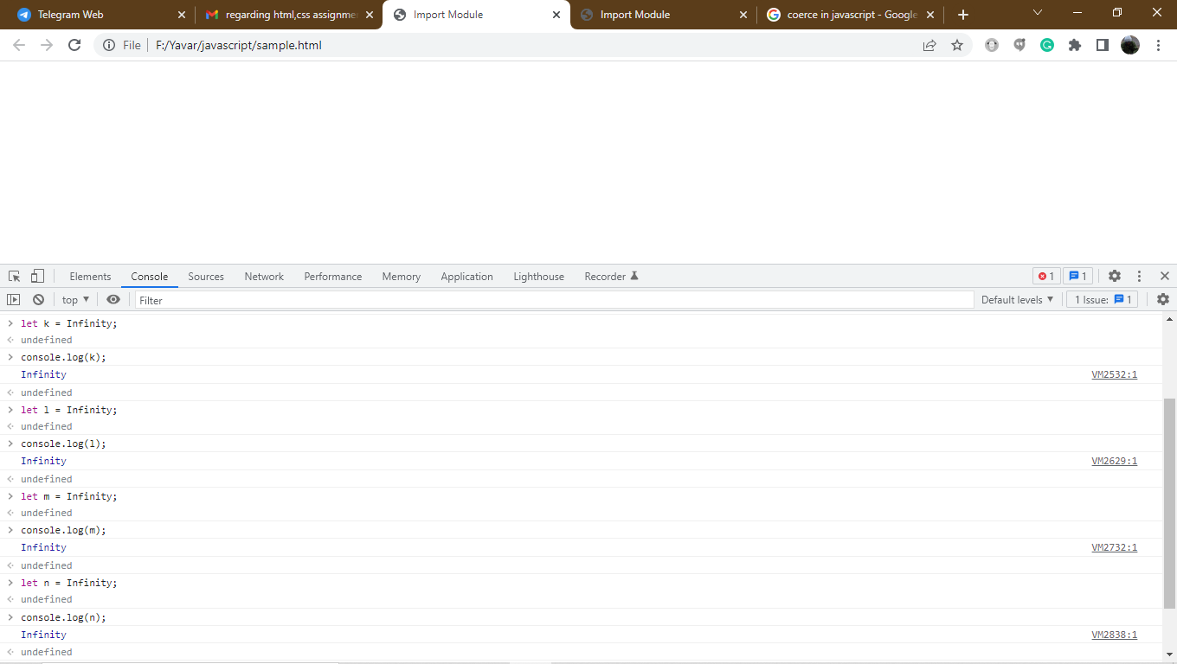

Type of coercion in constructors:
Coercion also provide when we provide an initialization value to a type constructor.
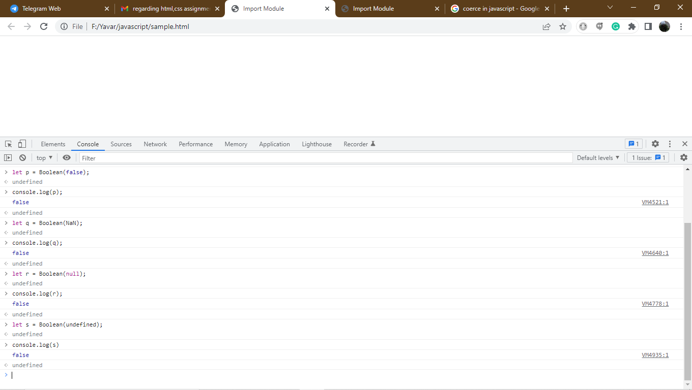
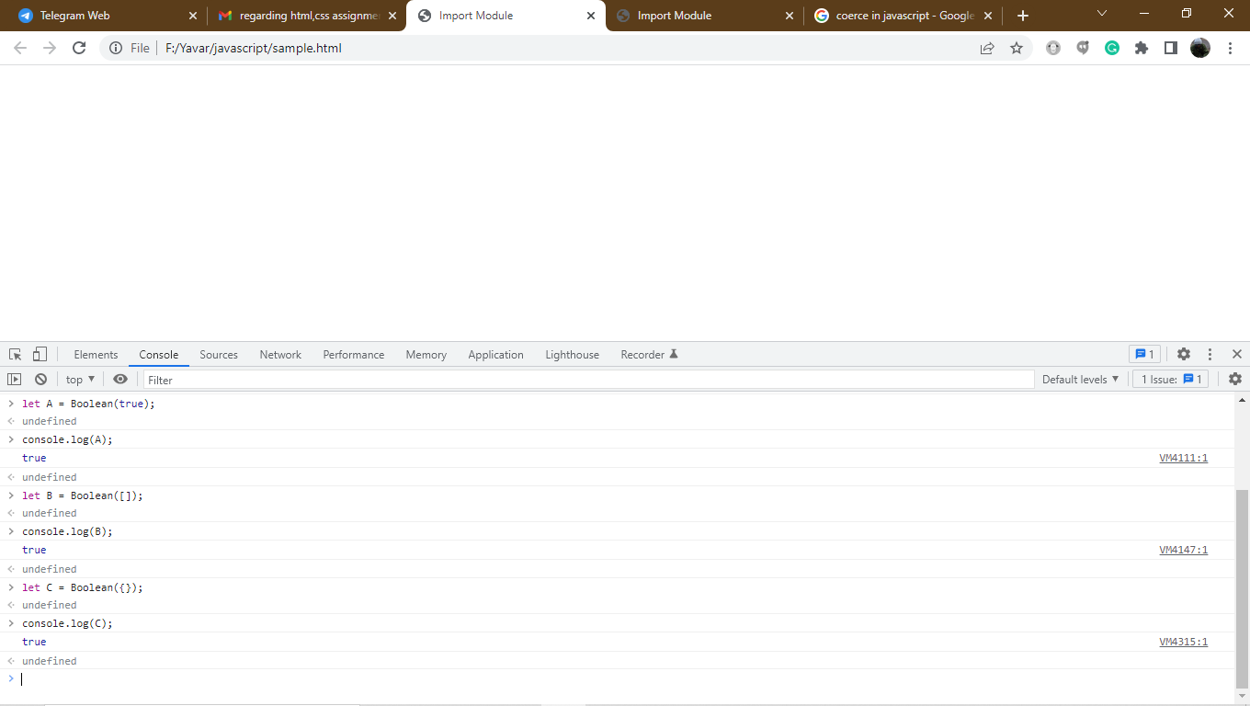

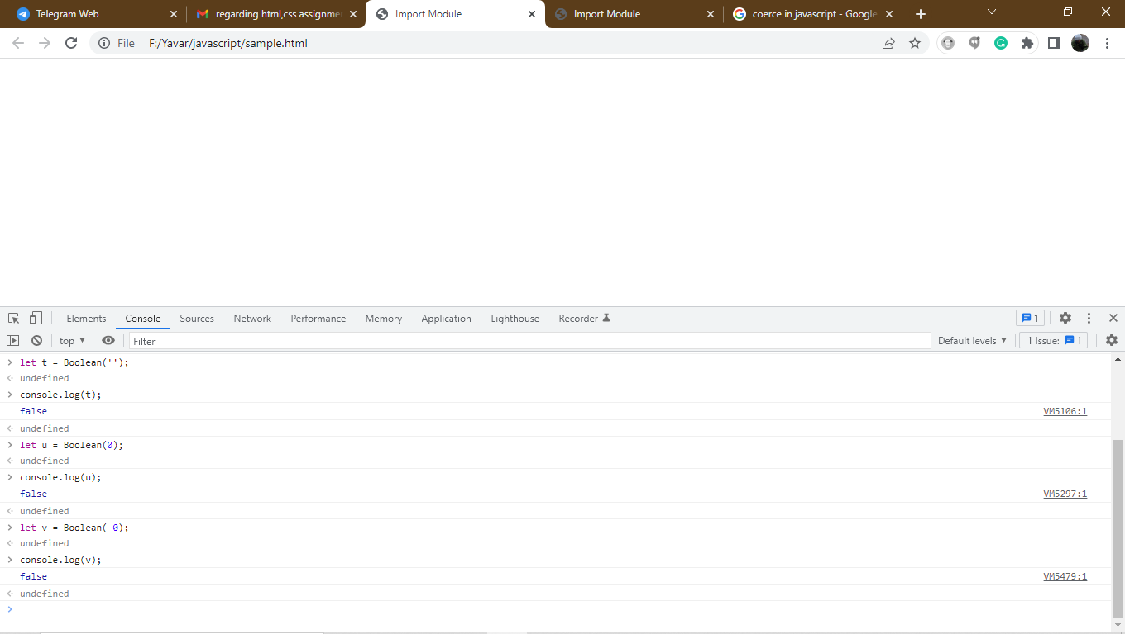
Type coercion:

Lets start simple the unary plus and minus operator force the value to a number the value Is not a number NaN is generated.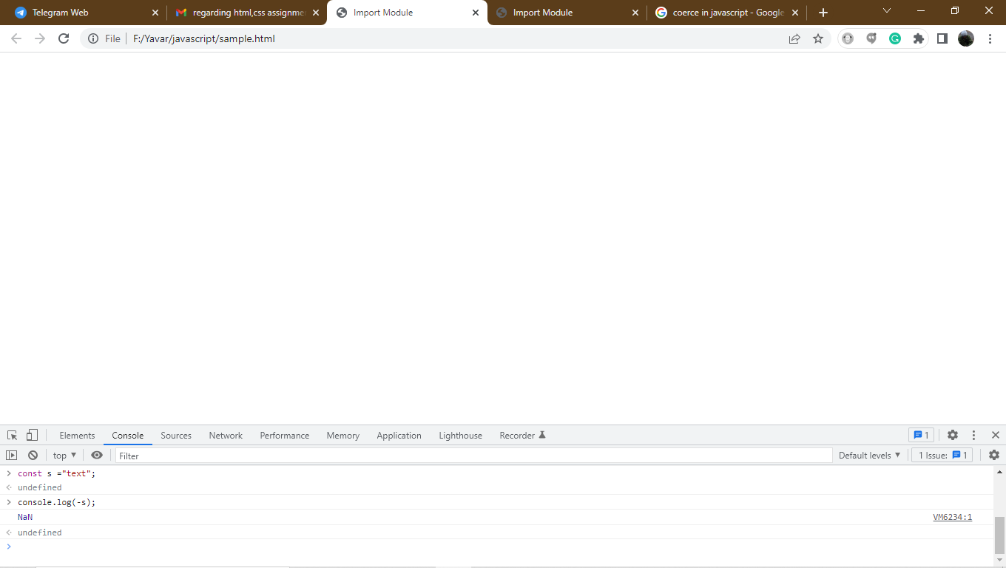
Unary minus can be struggled to convert the string text to a number.so it returns anyway by NaN because text is not a number.
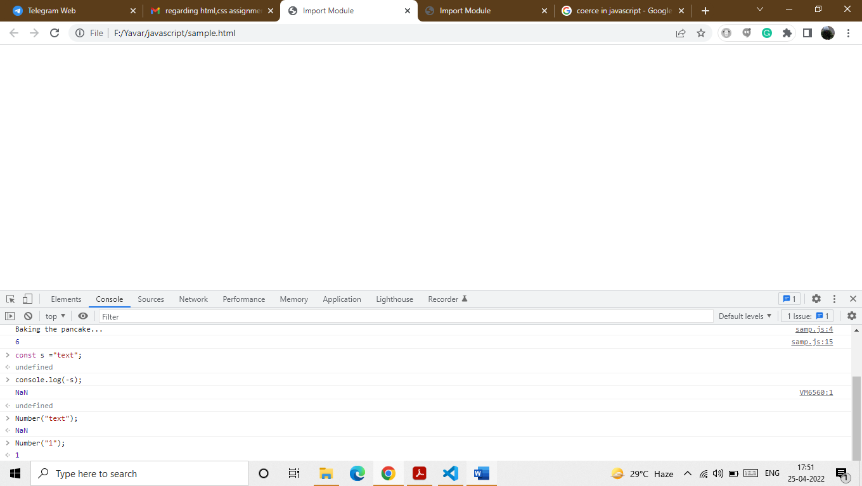
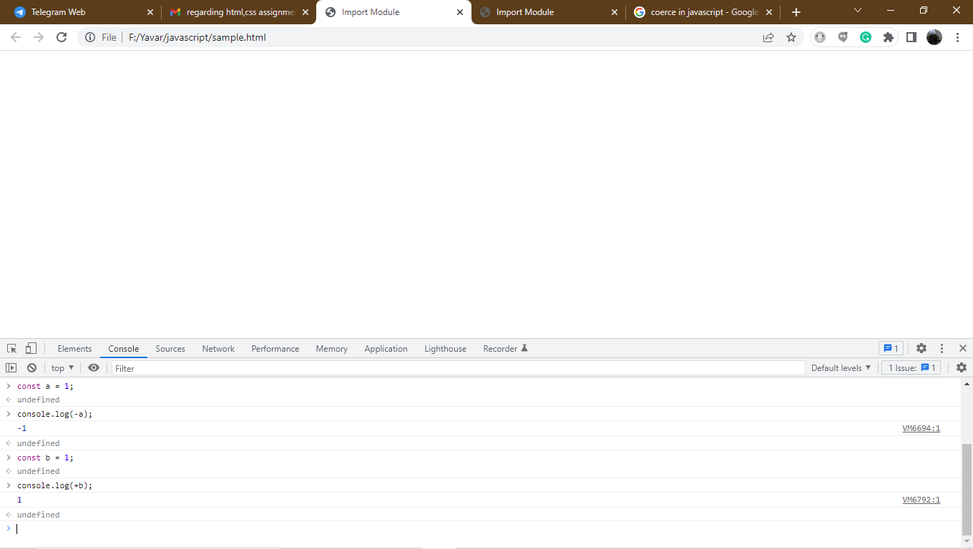
Number and string arithmetics:
Arithmetic value require two values .if both the values are integers arithmetic operation is involved.and the string is performed it the string will invoked.
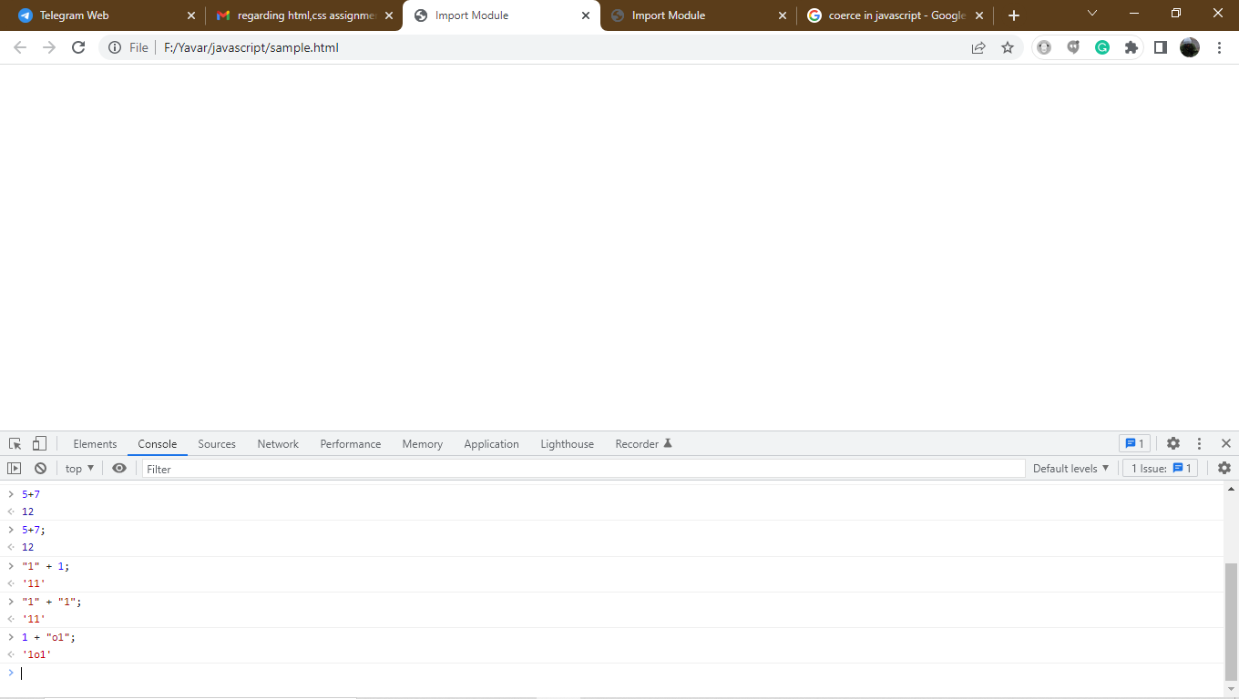
Operators follows the specific associative rules.like + and most other operators the arithmetic addition operator (+) is evaluated from left to right.
1+1; ->2
The assignment operator is evaluated from right to left.
Let n = 2; -> undefined
N is the assigned value of 2 the statement itself evaluates undefined.
N;->2
Adding multiple values:
Adding n umbers and strings numeric value can be taken a precedence.it is a trend in javascript.we will compare numbers to strings using the equality operator.javascript chooses to convert numbers to string and strings to numbers.
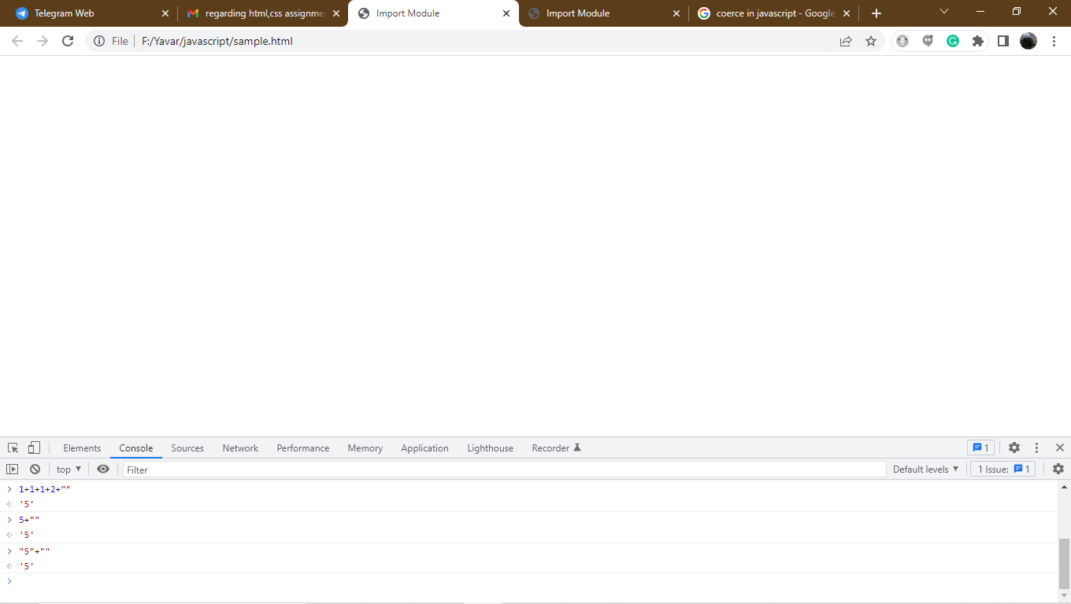
Operator precedence:
Some operators take precedence over others this multiplication will be evaluated before addition.
The string “” will coerce to o and multiply o will get 0 and add the value to get the value.
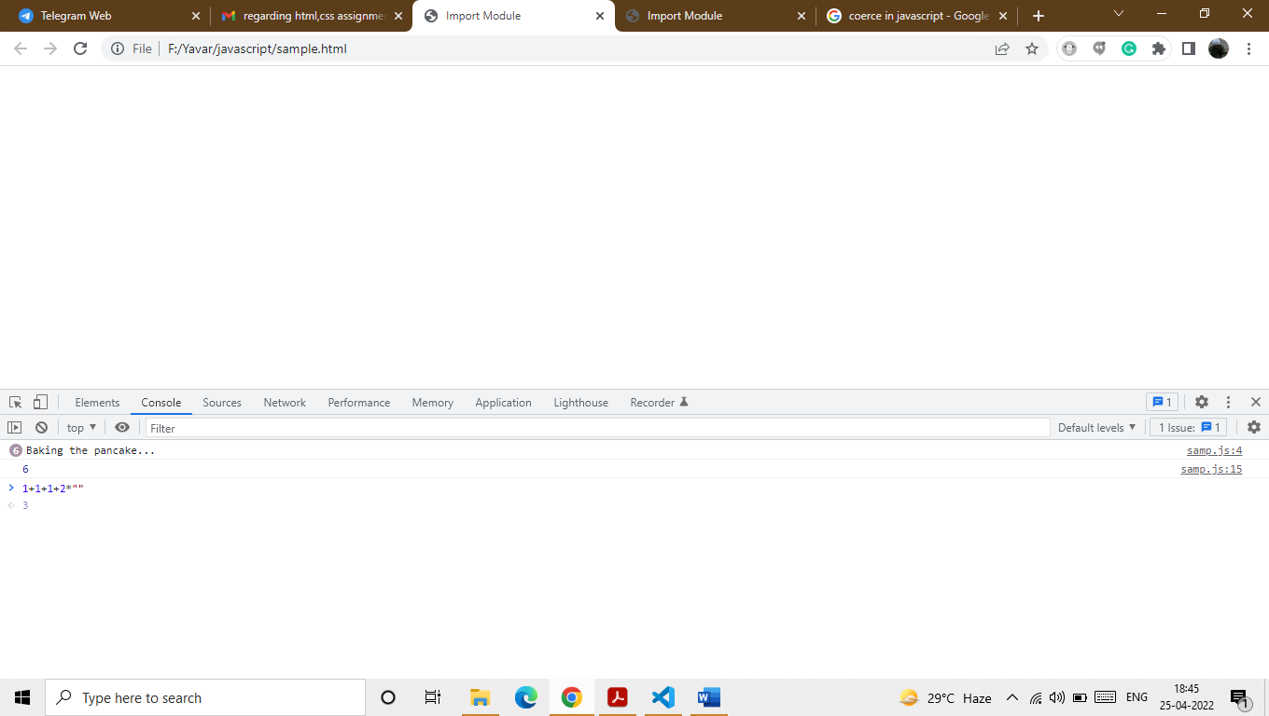
String to number conversion:
When it comes to equality operator == numeric strings are evaluated to numbers in the same way the Number(string) function evaluates to numbers (or NaN).According to EcmaScript speci_cation, coercion between a string and a numeric value on both sides of the == operator can be visualized as follows.
Comparing numeric string to number:
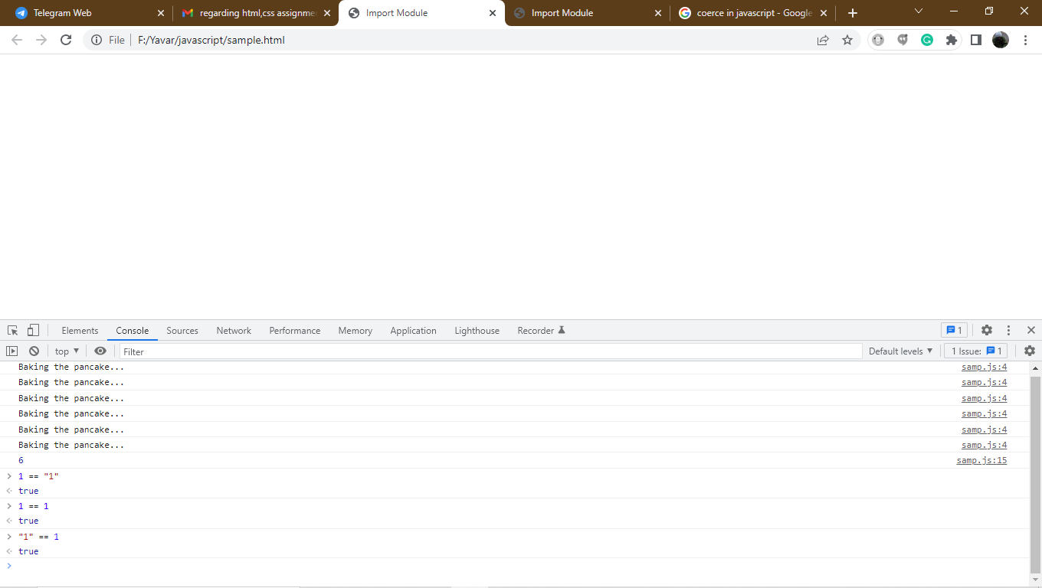
Comparing non numeric string to numbers:
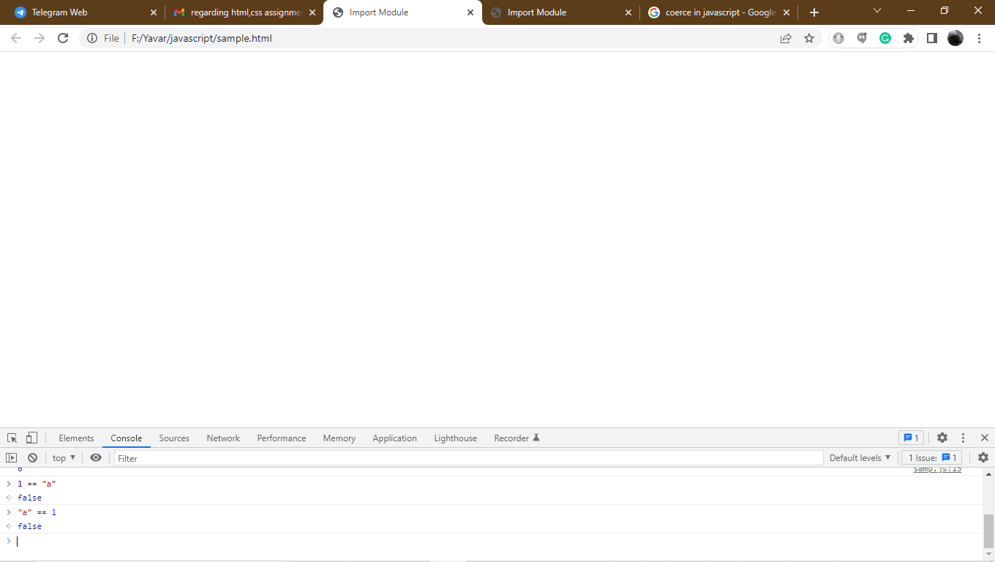
Operator precedence and associativity table:
There are 20 operator precedence level.paranthesis overrides the natural order.Red values are first in associativity order.subtraction operator subtracts blue from red.Assignment operator follows right to left order.

L value and R value:
In many computer languages values on the left and right side of the operator arereffered to as a l- value and r- value.In ecma script they often reffered to as a value of x and y value.
Assignment operator:
The assignment operator takes the r value and transfer it over the l value which is usually a variable identifier name.
Arithmetic addition operator:
The arithmetic addition operator takes the l value and adds r value on it.

Null vs undefined:
The nullprimitive is not an object.so it doesn’t have a built in constructor like some other types we use its literal value null.null is a unique value of empty or nothing value to a variable.if you don’t assign a variable is null.its value will be undefined by a default.value is unknown at the time of the variable definition is always use null instead of undefined.
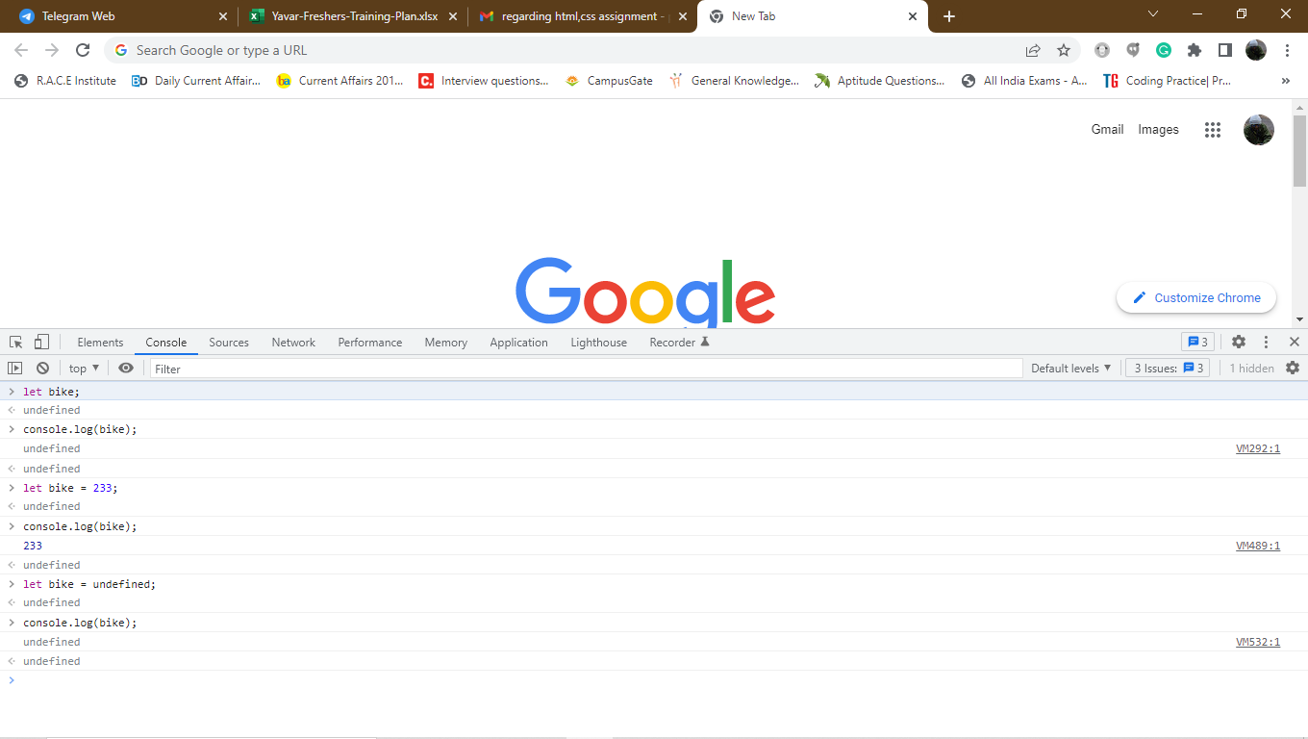
Initialise or update:
In a real case scenario the null value can be help us to determine the data to be initialized for the first time or existing data merely to updated.
