Javascript

Chapter-1&2:

Node-js:-

* It is an open source server environment.
* It allows to run a javscript.

Installation:

Step1: First we check if the node js is installed or not in our system.by using command prompt or terminal.

Step2:If command prompt or terminal window is opened we type “node -v” and get the version it means node is installed in our system if not installed the version is not display.

Step3: we open a chrome and type a nodejs and the page is opened we click the download option and configure the sytem requirements and click download.

Step4:open the download and view the nodejs is download and click on it to install the node js and click the finish button to complete the installation process.

Step5:If we check the nodejs is intalled or not open the cmd and type “node -v“ to view the version of the node.

Source code:

It will be provide the cement of the functionality principle from preceding text.

Color coded diagrams:

They were designed for communicative value,hopefully speed up the learning process in places where hard to grasp the abstract ideas needs to be visually explained.

There are two types.

They are,

* Abstract ideas
* Source code close ins

Abstract Ideas:

There isn’t a way to explain the an abstract idea or its structure without a diagram.

Class.constructor🡪fuctionf

Source code close ins:

Most of the source code is accompanied by source code listing.

Chrome console:

The console is an object which provide an access to the browser debugging console.we can open a console by clicking a ctrl+shift+I

JSON – Javascript Object Notation json is a plain text used for the javascript object notation.It is used to send data between computers

the console object contains several methods are,

* Log()
* Error()
* Warn()
* Clear()
* Time()and timeend()
* Table()
* Count()
* Group() and groupend()
* Custom console logs

Log()

console.log("hi");

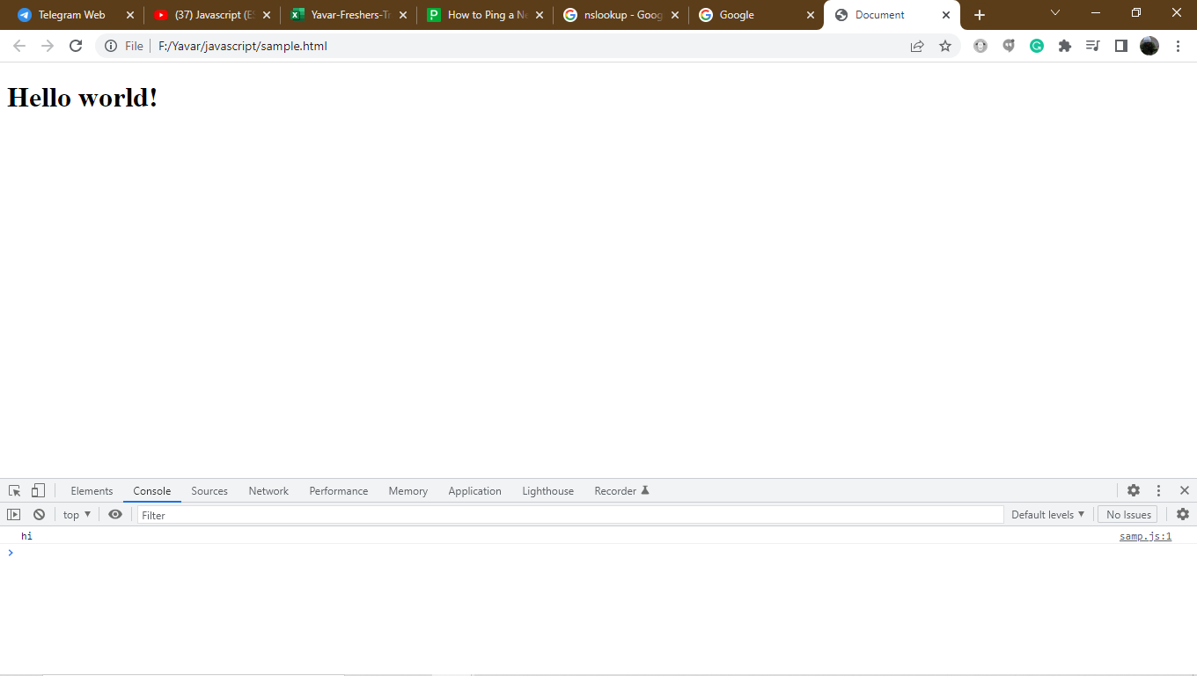

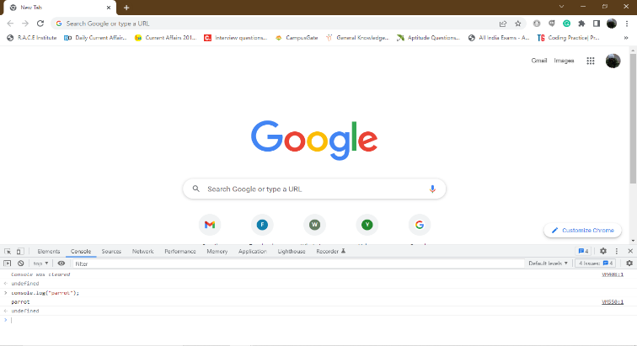Console. log()

Mainly used to print the output of the log()anything inside the log() can be print.It is used to print in the console part of an element. Console log is used to print the standard output.

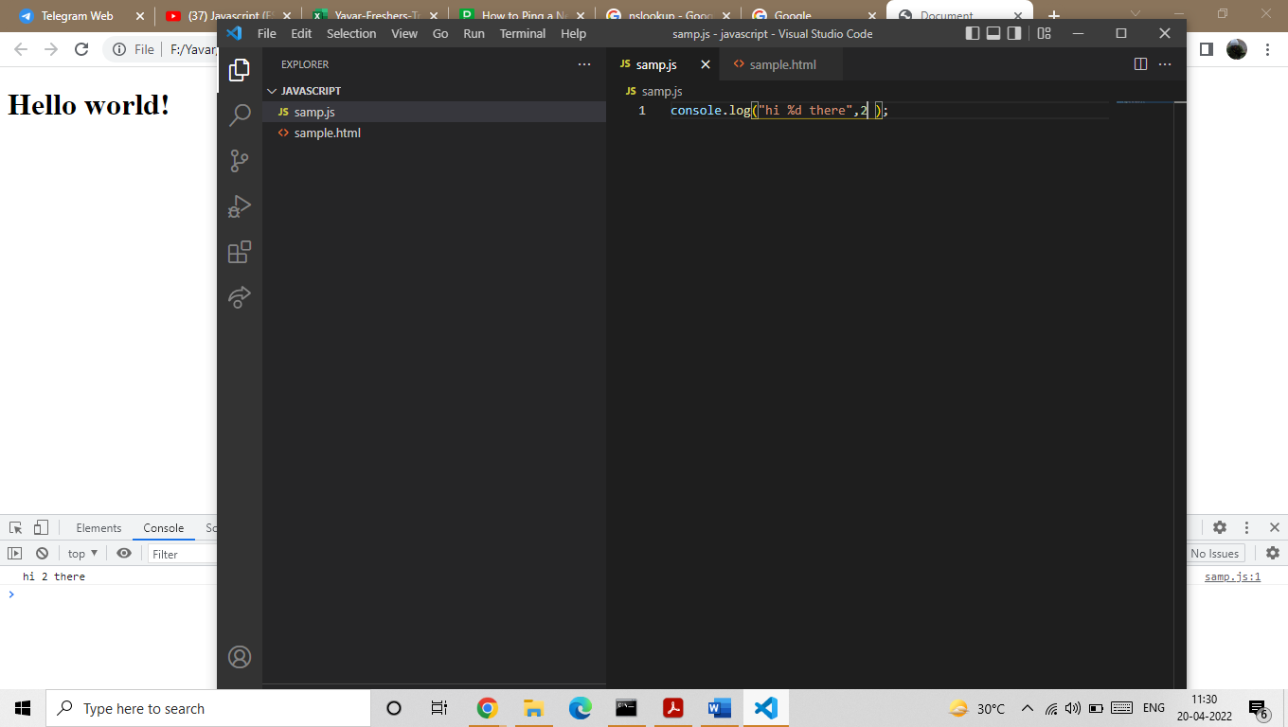

%d can be represent the number

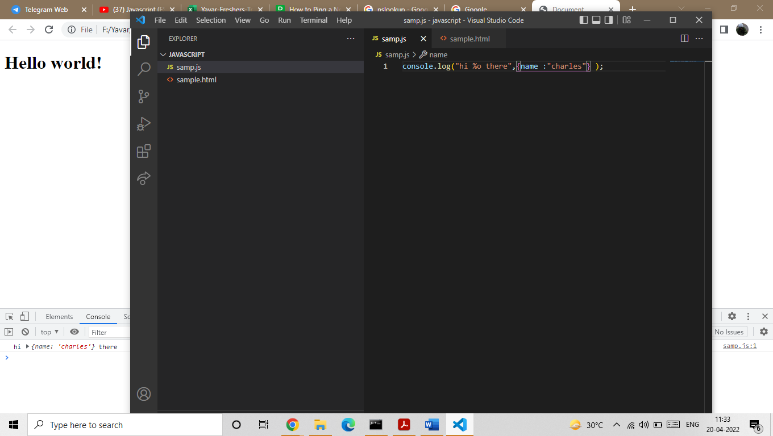

%o can be represent the object

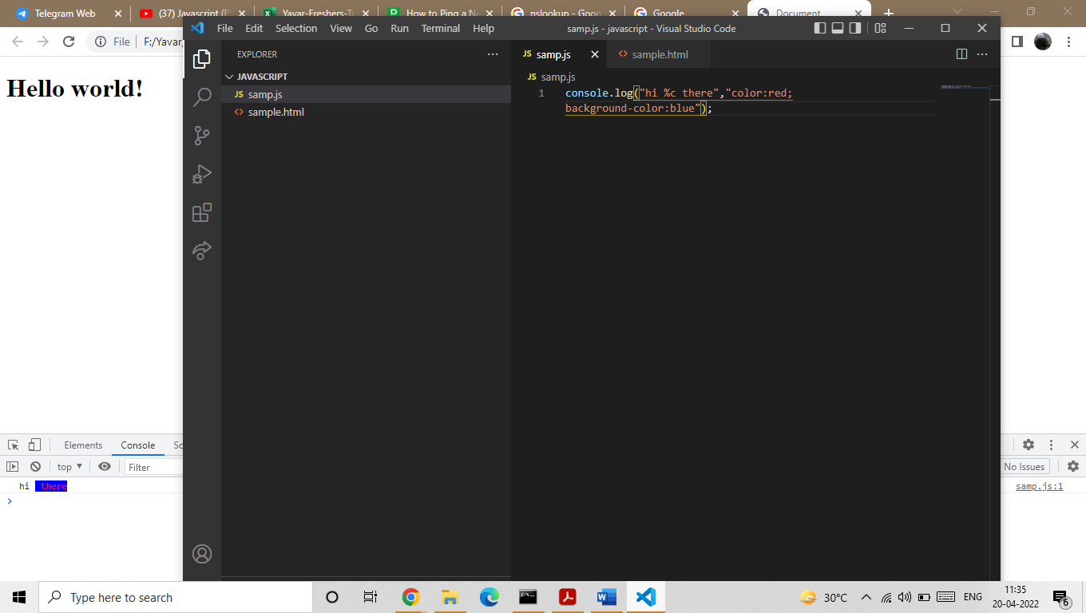

%c can be represent the css style element.

Error()

Console.error()

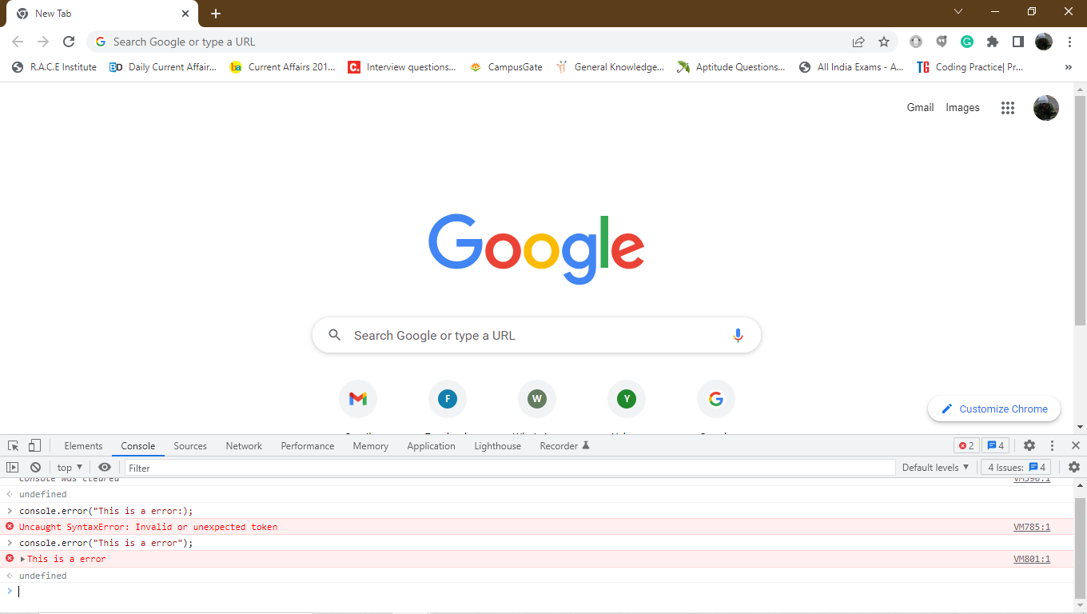  
 this is used to log the error message in the console. By default the error message can be displayed by the red color.console error is used to print the standard error.

Warn()

Console.warn()

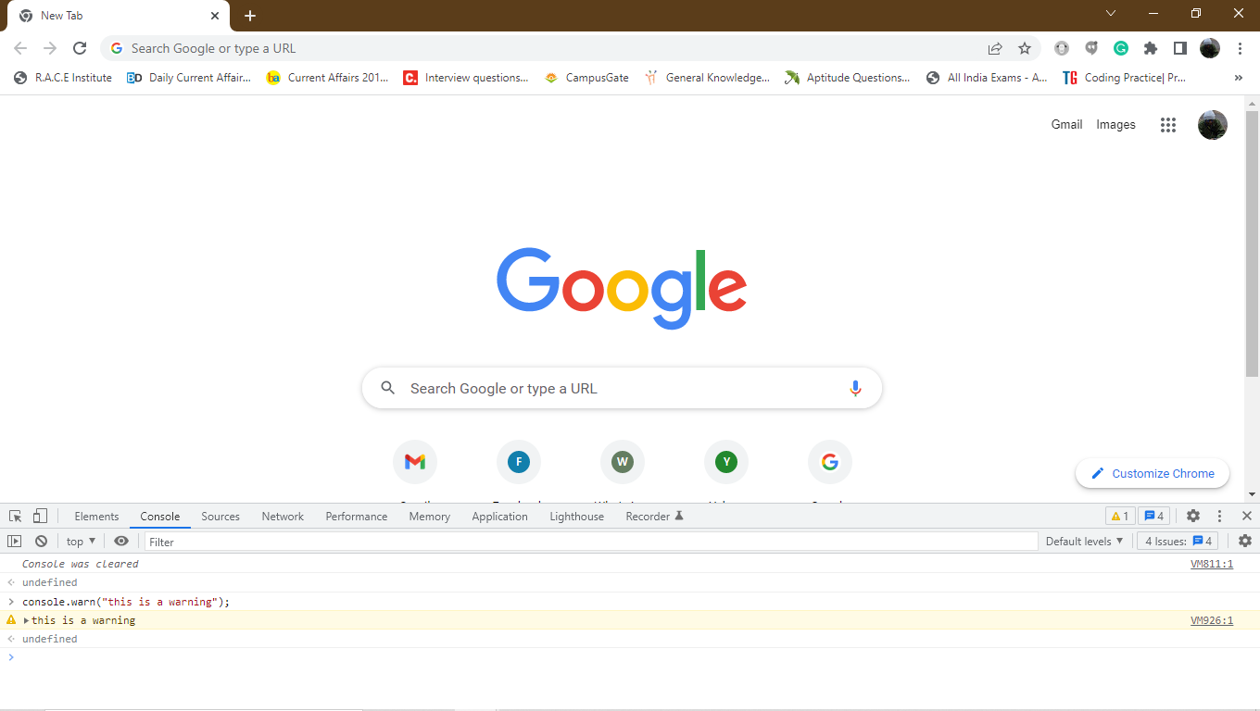

This is used to log the warning message to the console.the warning message can be displayed by the yellow color.

Console.dir()

To look a object properties and method.you can print it out directly into the console.



Console.trace():

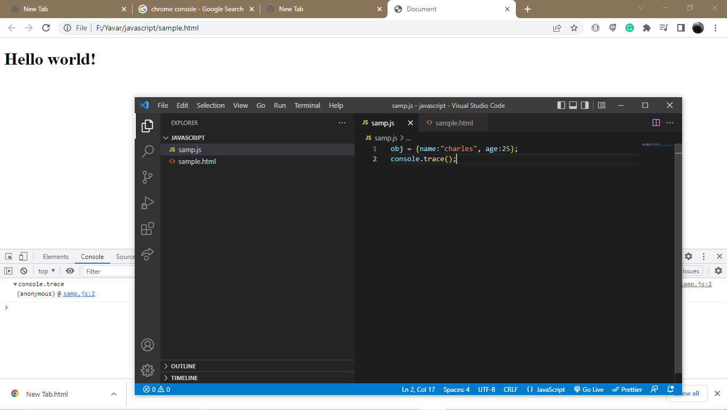

It is used to trace the path and the line number

Clear()

Console.clear()

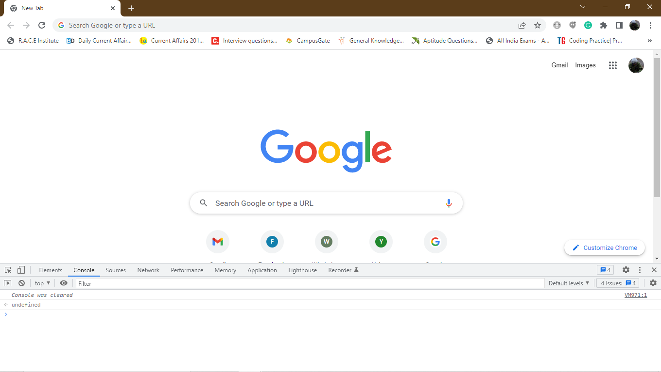

Used to clear the console

Table()

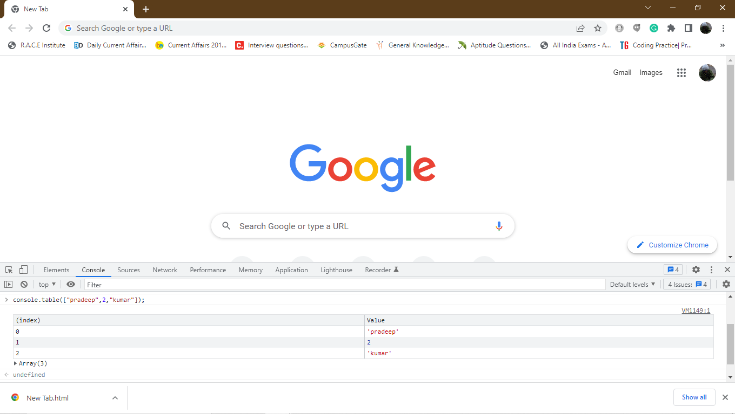

Used to represent the data in the console.

Console.table([“Pradeep”,21,”kumar”]);

Console grouping:

console.group();

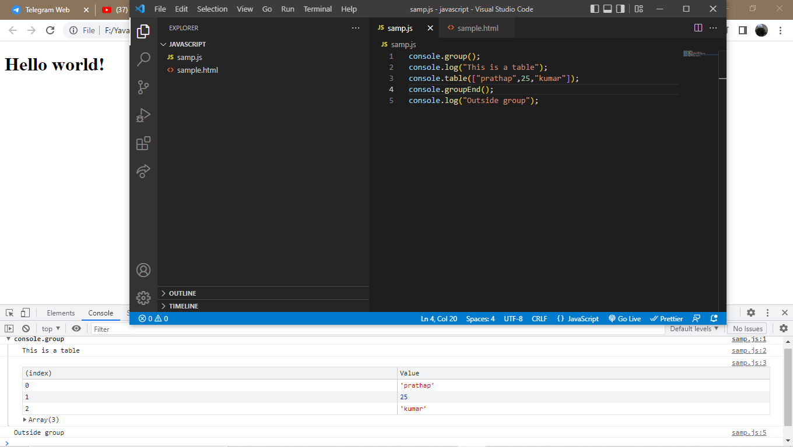

It is used to grouping the data .

Console.time() console.timeEnd():

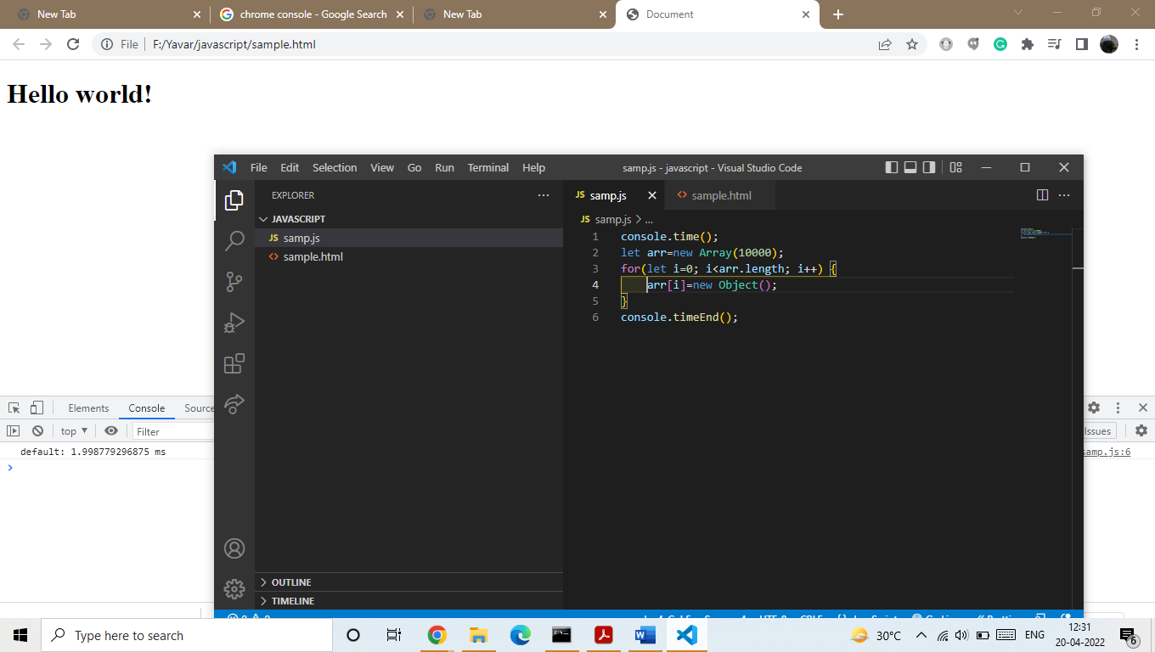

To find the run time of the function

Printing object:

It is used to print the function.we use this console.

Console.log()