Chapter -3

Welcome to Javascript

* It is a single thread synchronous light weight interpreted language.
* Designed for creating a network centric application.
* Easy to implement because it is integrated by html.
* It is open and cross platform.
* If we not known js we are not web developers.
* It is used to write webapps.
* ECMA-European computer Manufacturer Association.
* It is not directly access the memory devices.first js is only used for validation &alert box.

DOM Content loaded:

Dom-Document Object Model the HTML Dom model is constructed as the tree of the object.

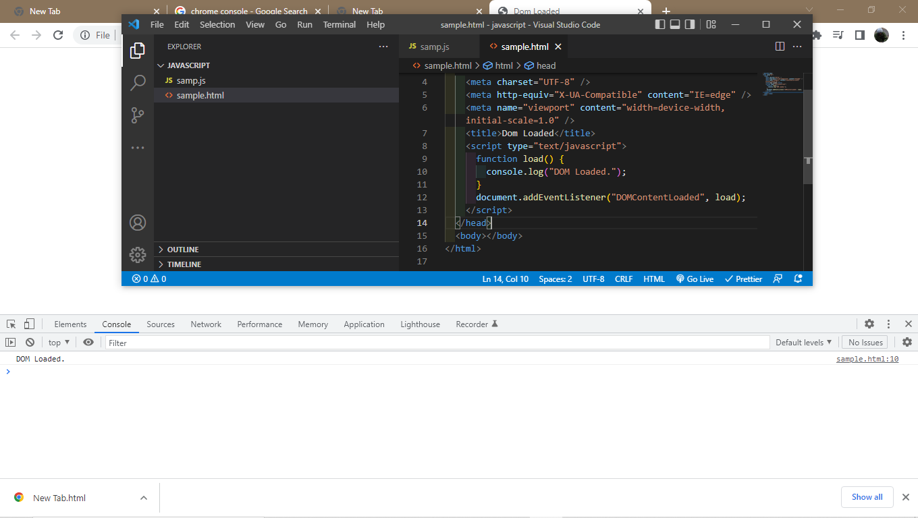

.ready state:

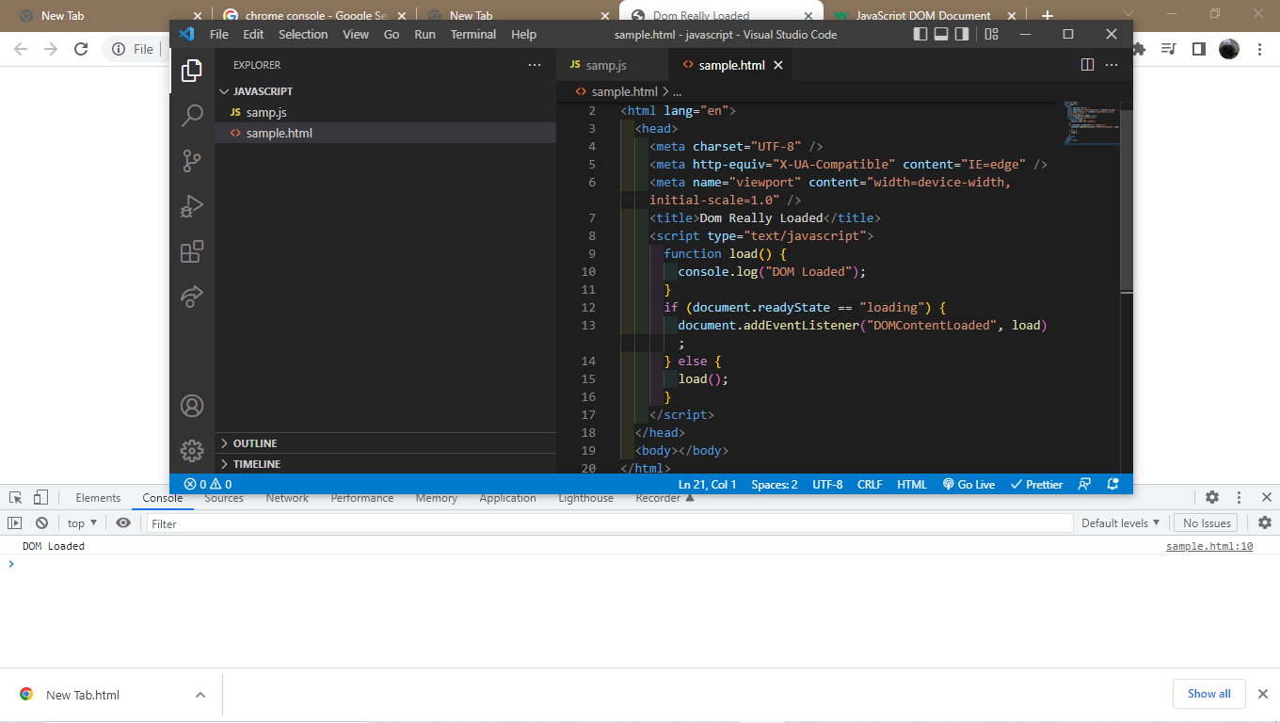

Dom vs media:

Dom is simply a tree like structure of the html element on the webpage.media is used to import the image source in the document.

Windows.onload:

With window.onload method, you can wait until all images and similar media have been fully downloaded: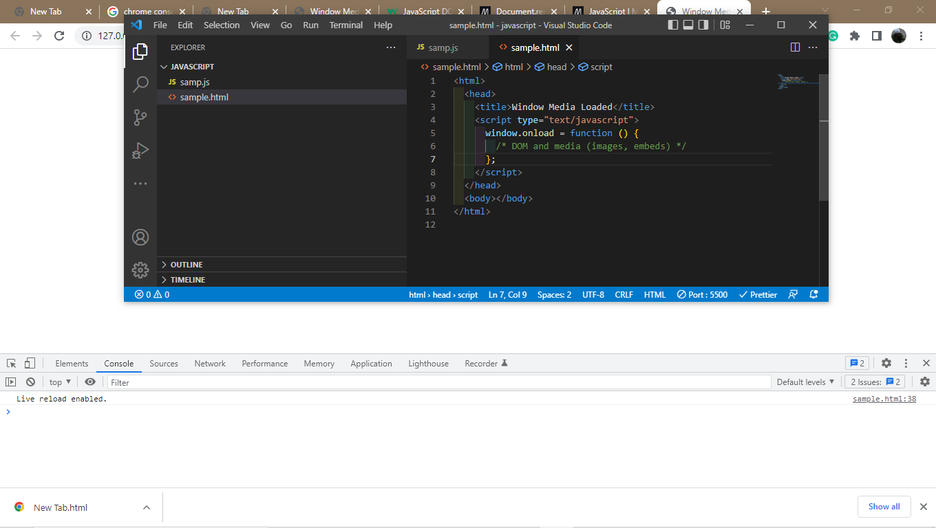

Including External scripts:

It is used to attached the external script to attached by the source code.

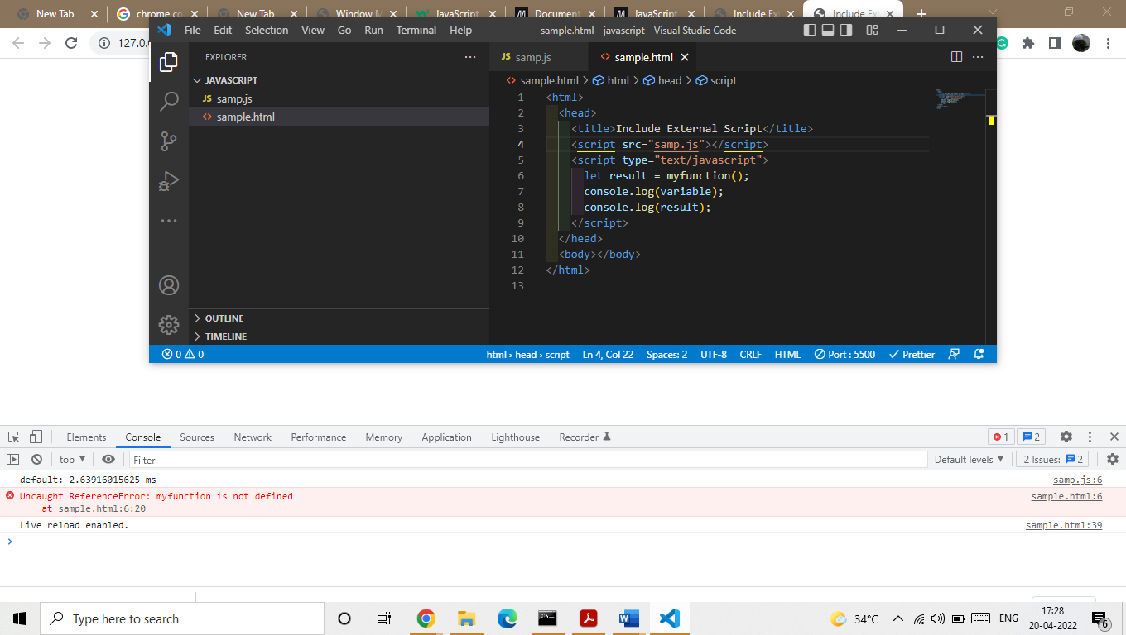

Import: