Chapter-5

Primitive Types:

Primitive is the basic data.Javascript have 7 primitive types.They are

1. Null
2. Undefined
3. Number
4. Bigint
5. String
6. Boolean
7. Symbol

Boolean:

The Boolean can be assigned by the primitive value like true or false.

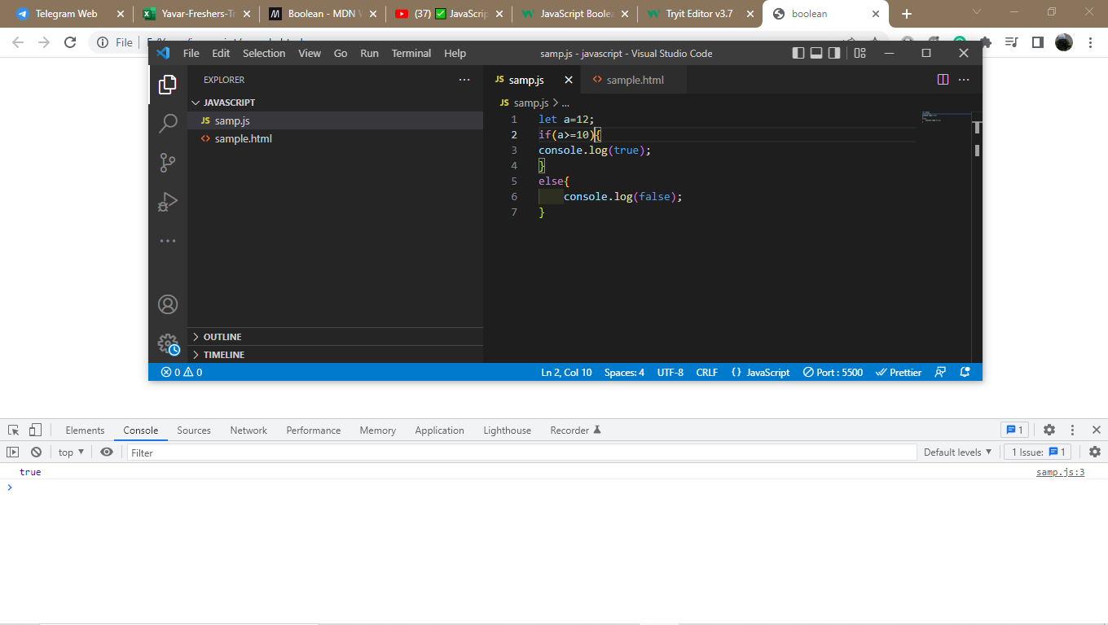

Null:

Null can represent the invalid object or address.

Undefined:

Its not an object.when you named a variable but don’t assign on it is called as undefined.

Number:

Number is a numeric datatype.it can be defined as double,float,integers or bignums.

Bigint:

Bigit was added in ecmascript 10.It allows to specify the number greater than the number MAX_SAFE_INTEGER.

Typeof:

Type of is used to identify the value can be identified by primitive datatype.

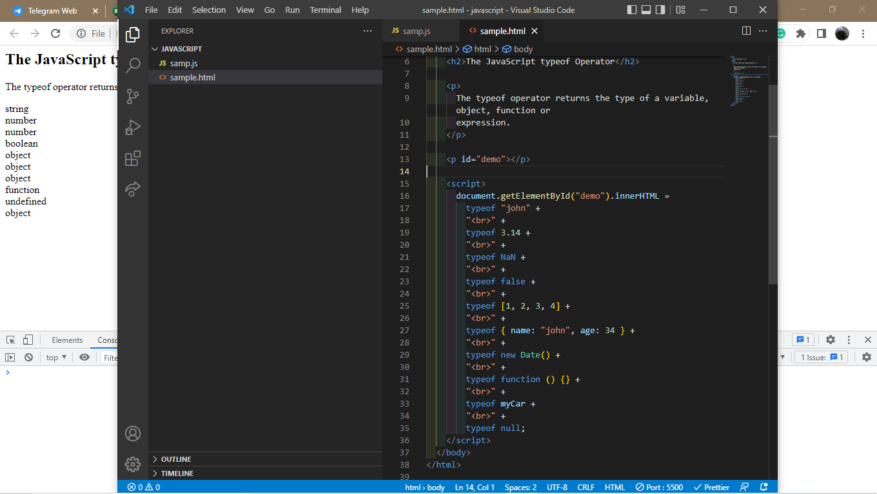

Equality operator:

Equality operator is used to type console and run in the terminal.to print the Boolean values like true or false.

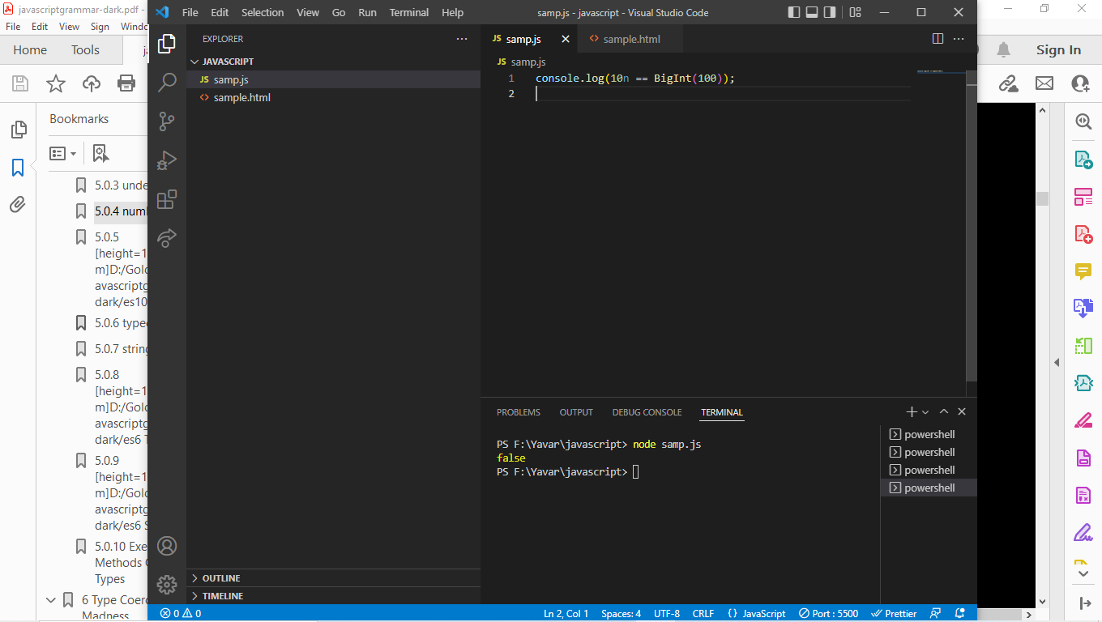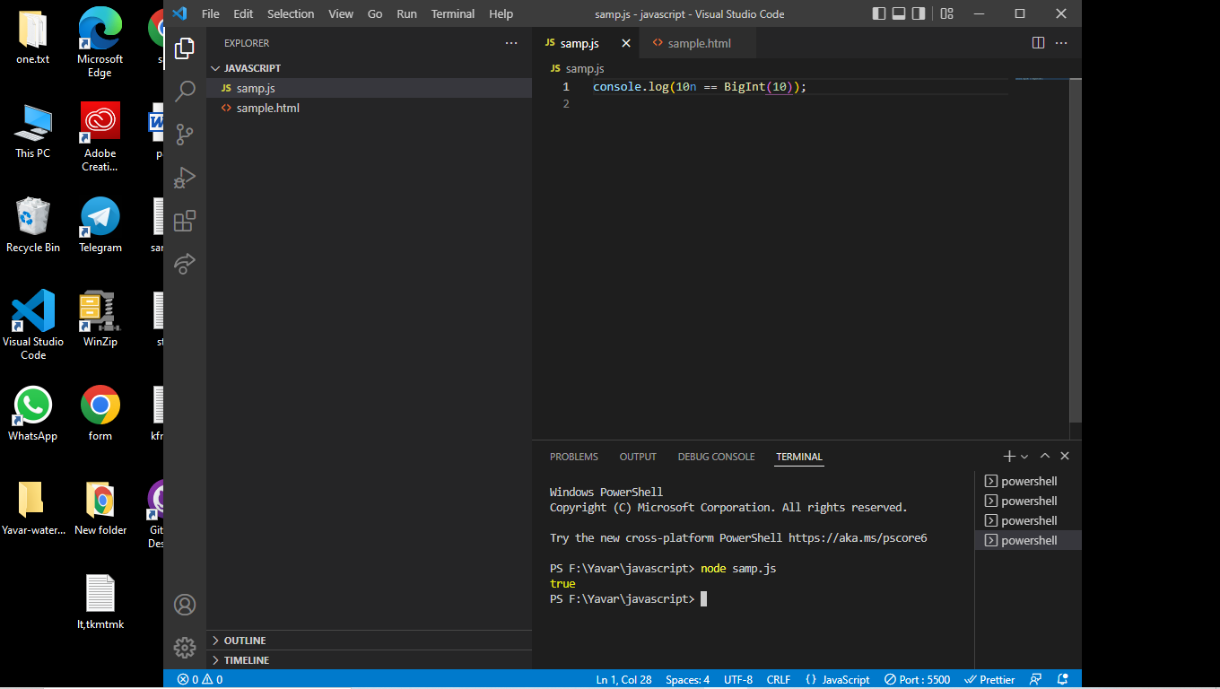

Math operator:

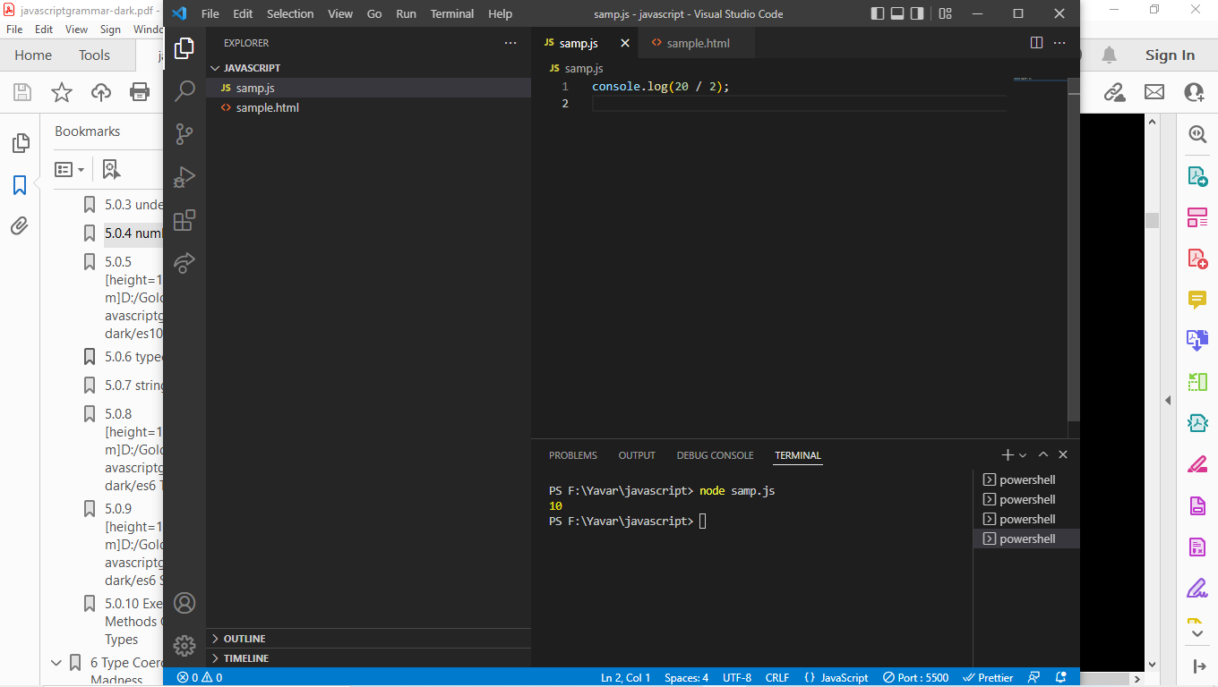

String:

String value is defined as using any of the available quote character.it can be given in the single or double quote.

Tem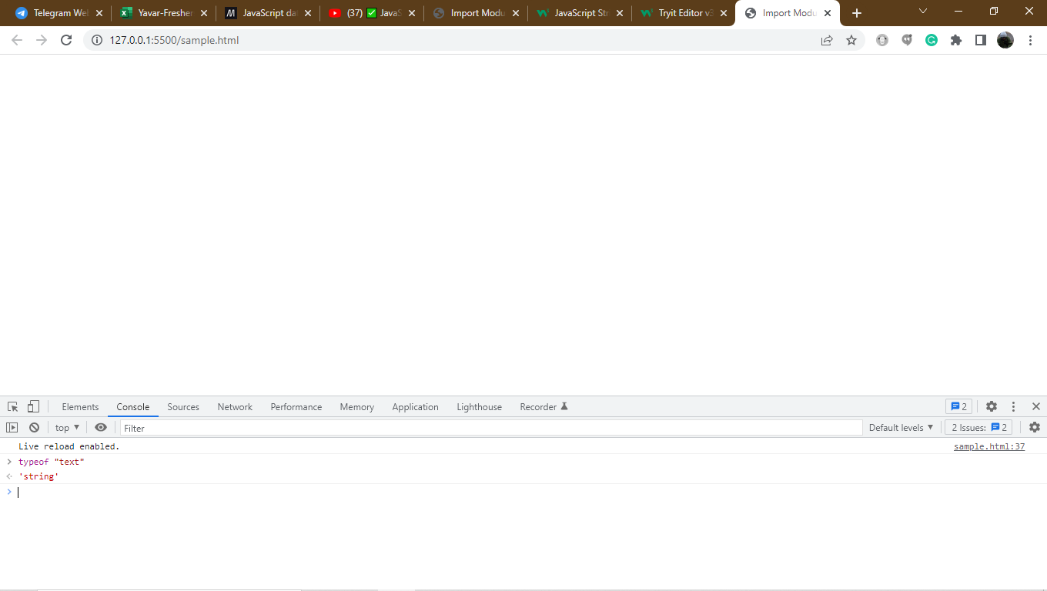

Template Strings:

Strings defined using the backtick quotes have special function.

You can use them to create template strings to embed dynamic variable values inside the string.

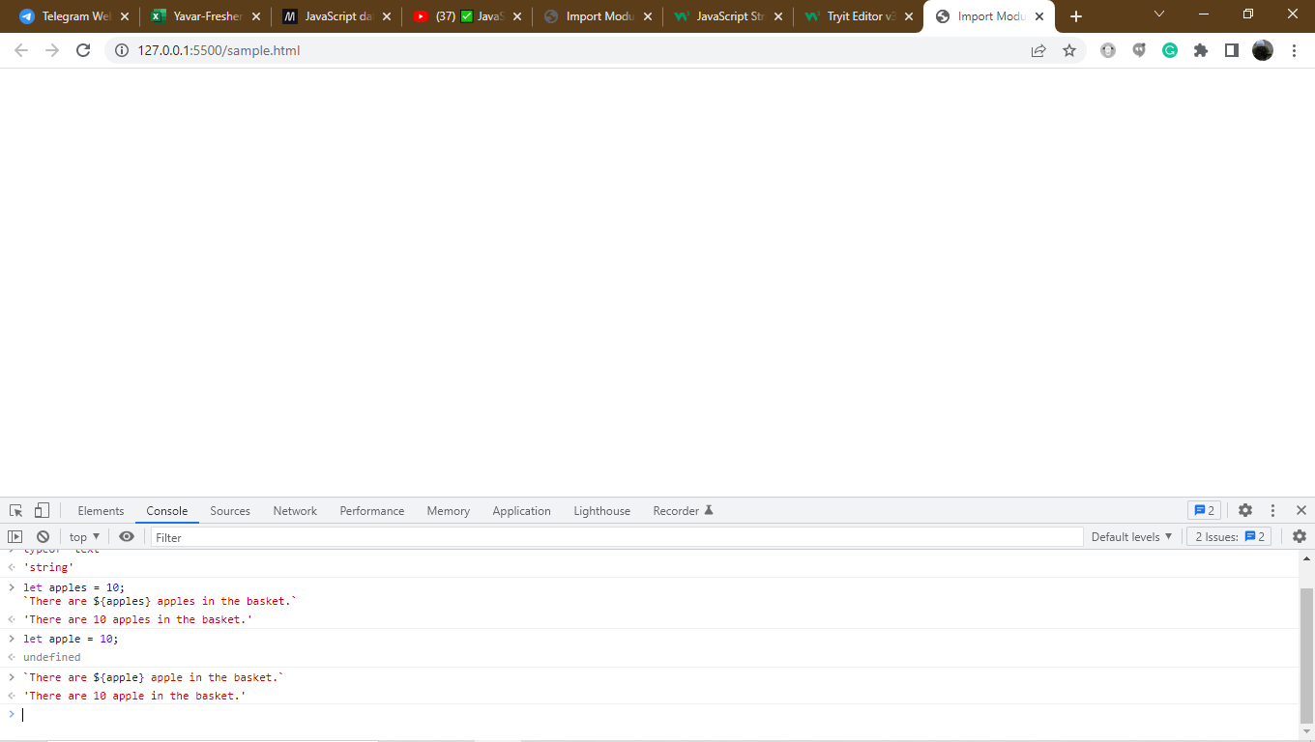

Creative Use case:

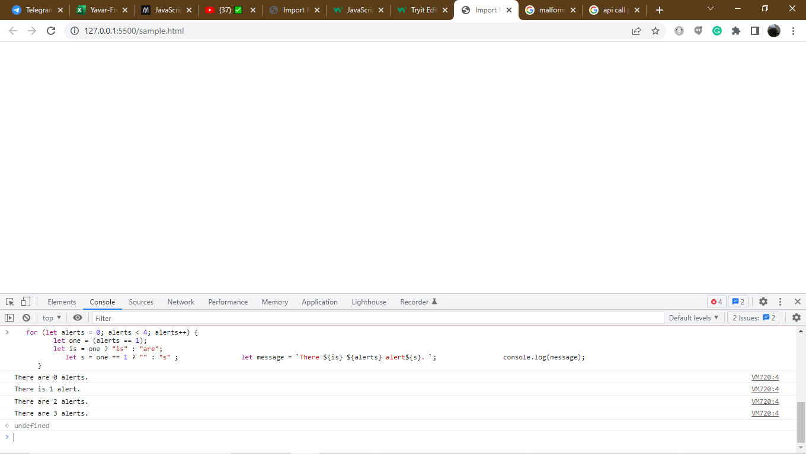

Symbol:

The symbol is a way to create a way to definecompletely unique key.Symbol doesnt have a keyword and cannt be initialized by a constructor.If we declare a same keyword and value on both sides it can be give the value false.

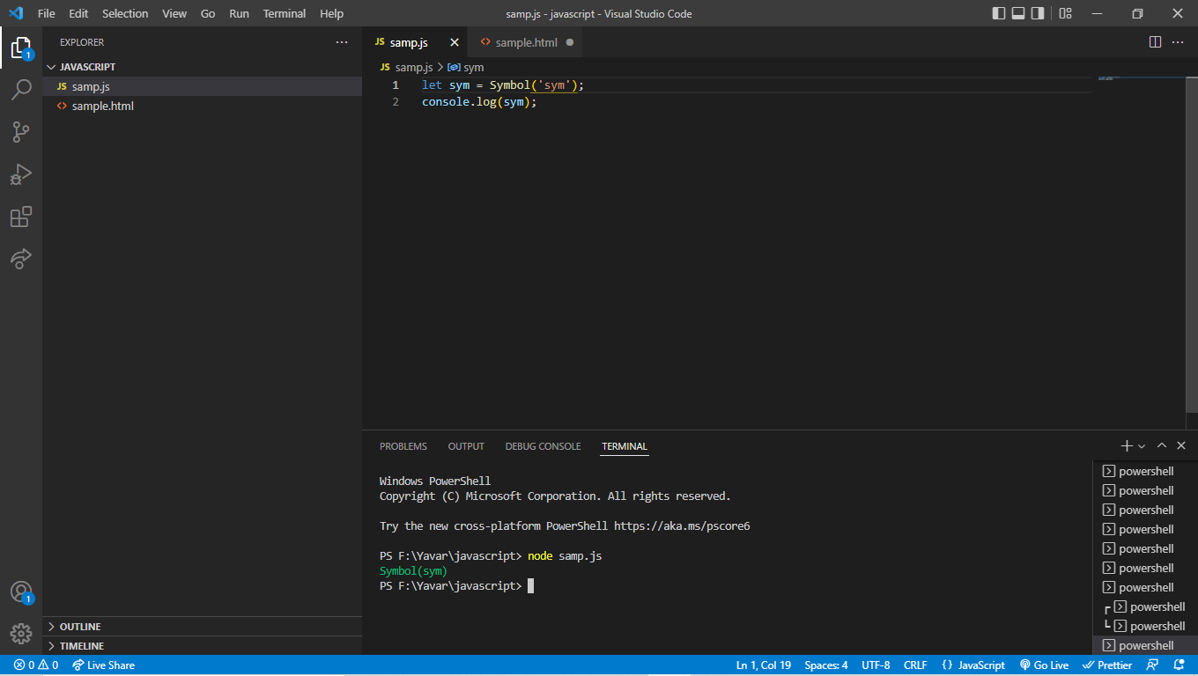

You call a symbol the unique symbol(sym) is created.Symbol can be used in the private object properties.This is not as same as the public object properties.Both private and public object properties can be run on the same object.Symbol properties can behidden from us the string justify method.

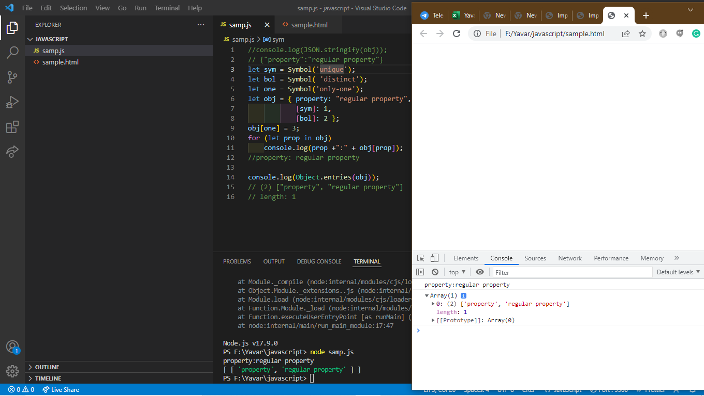

Global Symbol registry:

Symbol(“string”) === Symbol(“string”) is false because two completely unique statement is created.there is a global registry is called symbol that can be accessed by the method Symbol.for,Symbol.keyFor.

Constructor and instance:

There is a distinctinction between the constructor and instance.the constructor is the function definition of the custom object type.The instance is the object that was instantiated by the constructor function using the new operator.

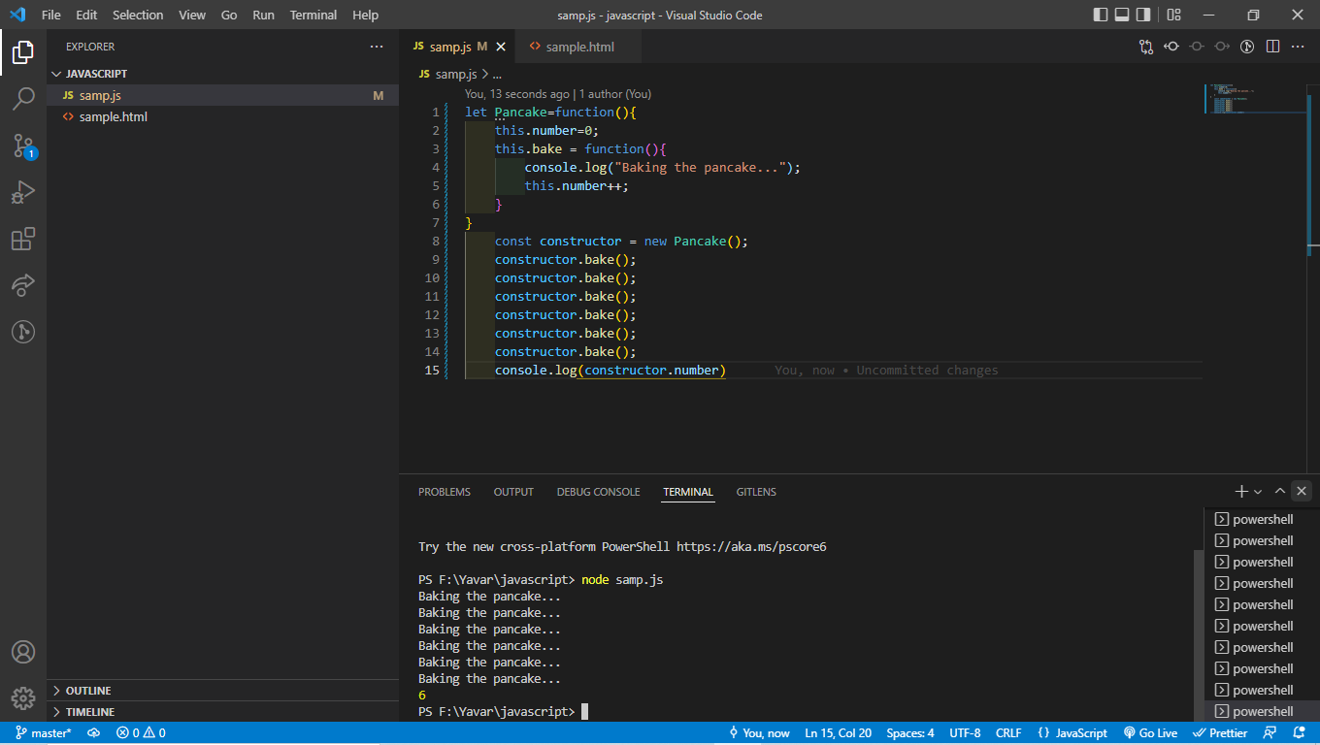

Executing methods on primitive types:

Paranthesis and object property access:

The paranthesis operator gives you control over which statement would evaluate first.

Ex: 5*10+2 is not same as 5*(10+2)

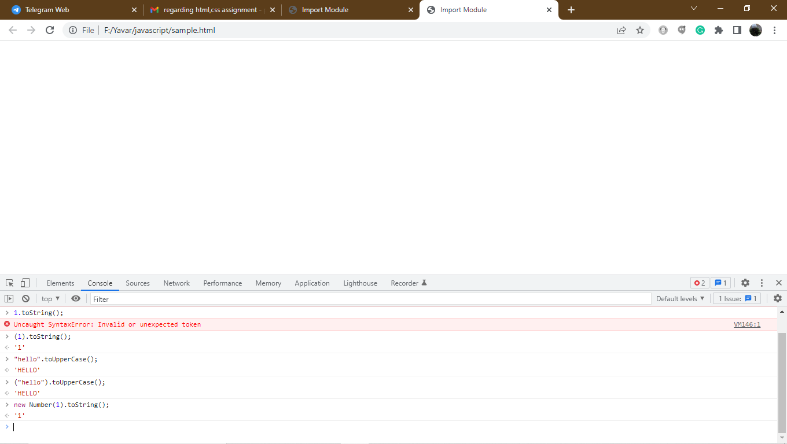

Chaining methods:

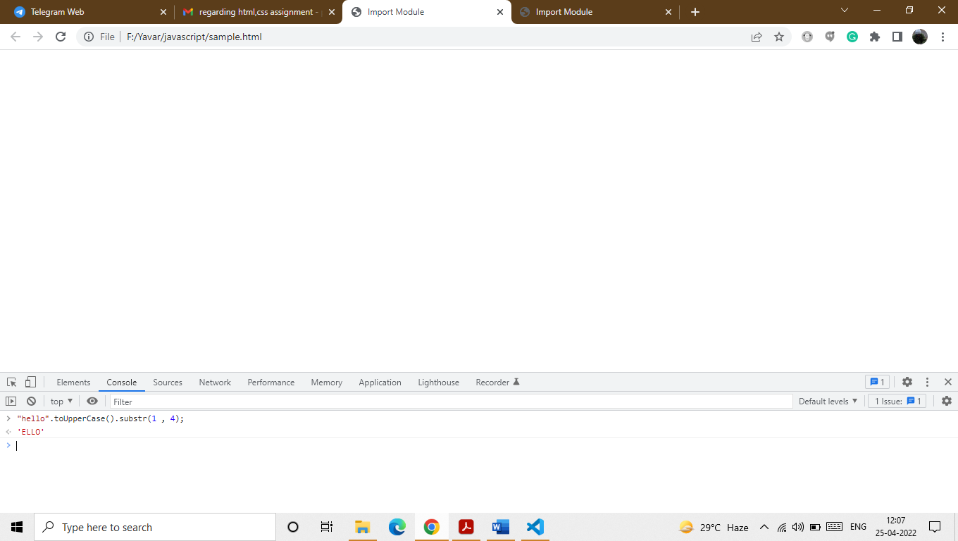

This is used to first value is used to subtract the word and the next value is used to print the number of values given the string.