Chapter-7

Scope

Scope is simply the area enclosed by {} brackets.not to confuse it with the identical empty object literal syntax.

There are 3 unique scope types they are,

1. Global scope
2. Block scope
3. Function scope

Event call back function follows the same rule in function scope.they are just used in slightly a different context.loops can also have their own block scope.

Variable definition:

Variables are case sensitive.This means that a and A are two different variables.

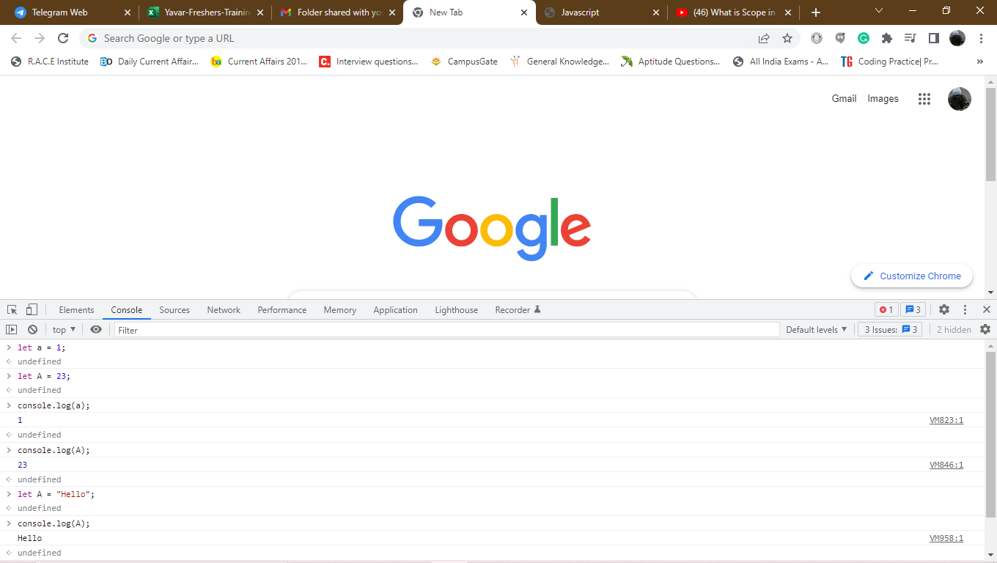

Variables can be defined using var,let,const keyword.If you tried to refer a variable that wasn’t defined anywhere so we would generate a reference error variable name is not defined.

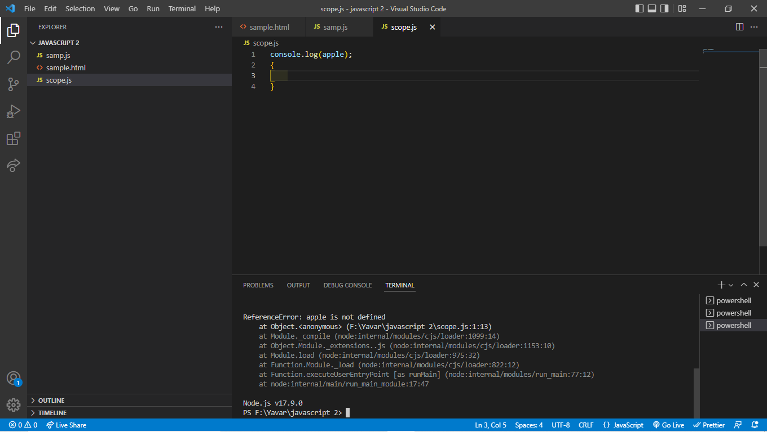

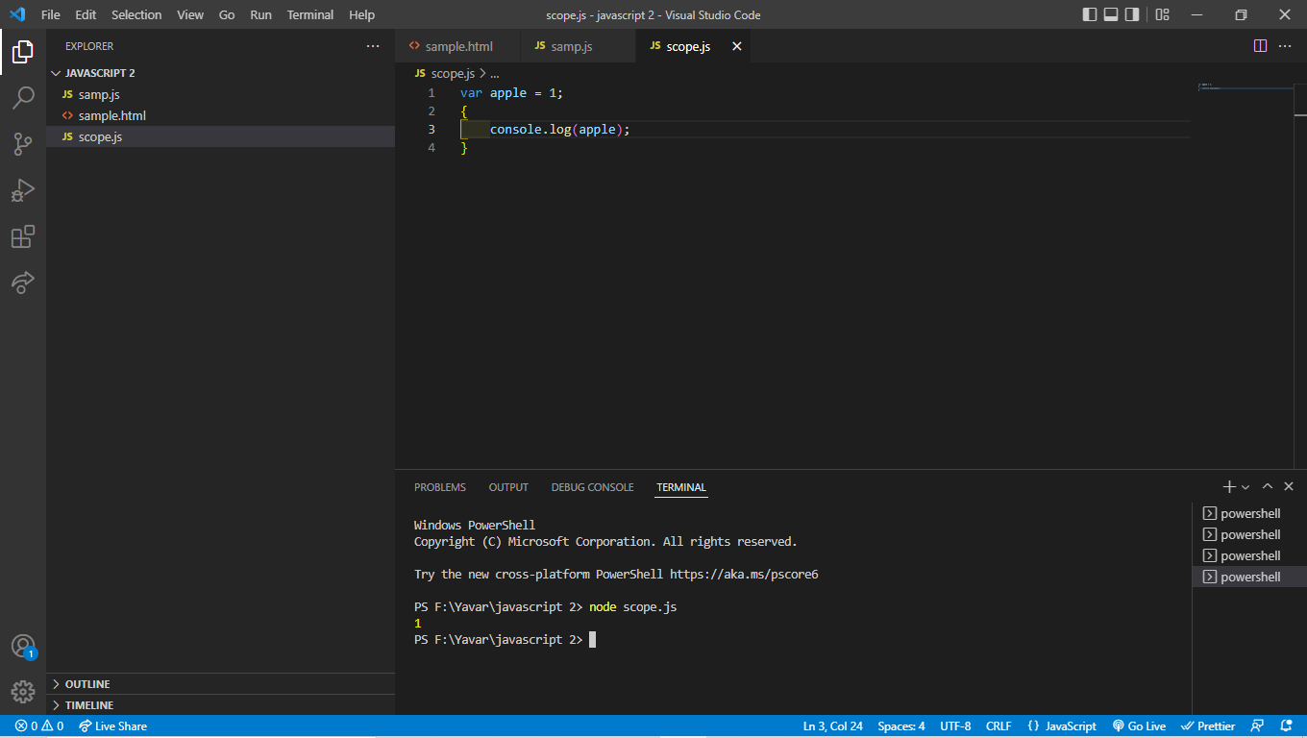

Apple is defined in a global scope and it can be accessed by the block scope.anything defined in a global scope can become available anywhere in a program.the value can be also propogates to the inner scope.When a variables is defined in global scope using a var keyword.

Function name hoisting:

Hoisting also applies the function name but variable hoisting also take precedence.

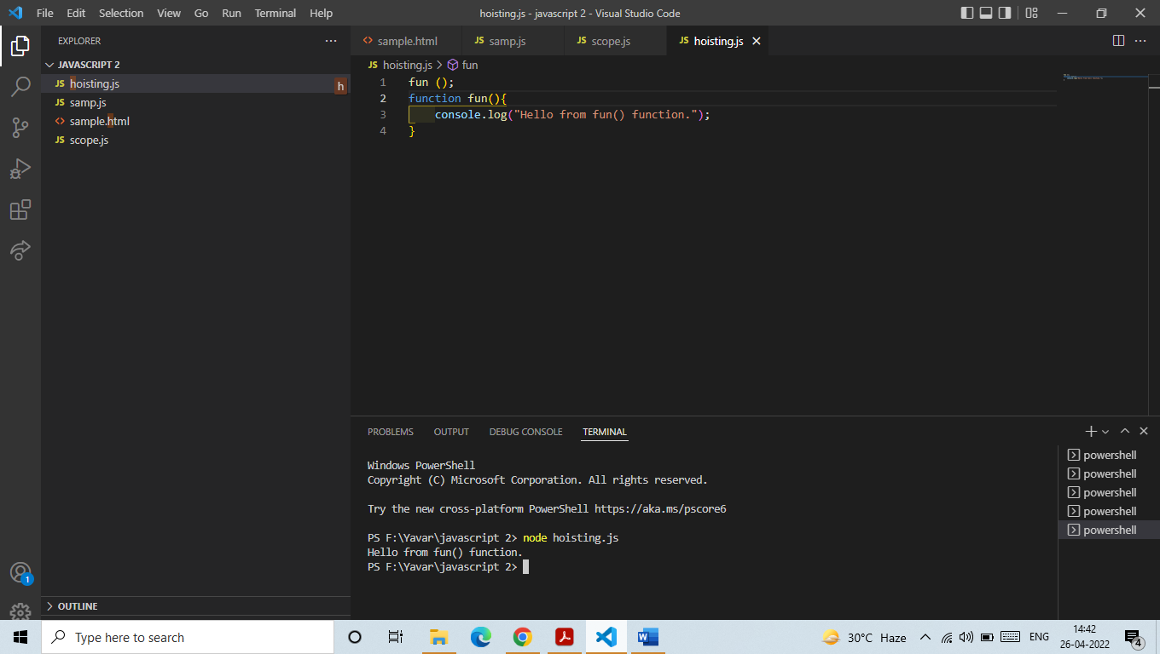

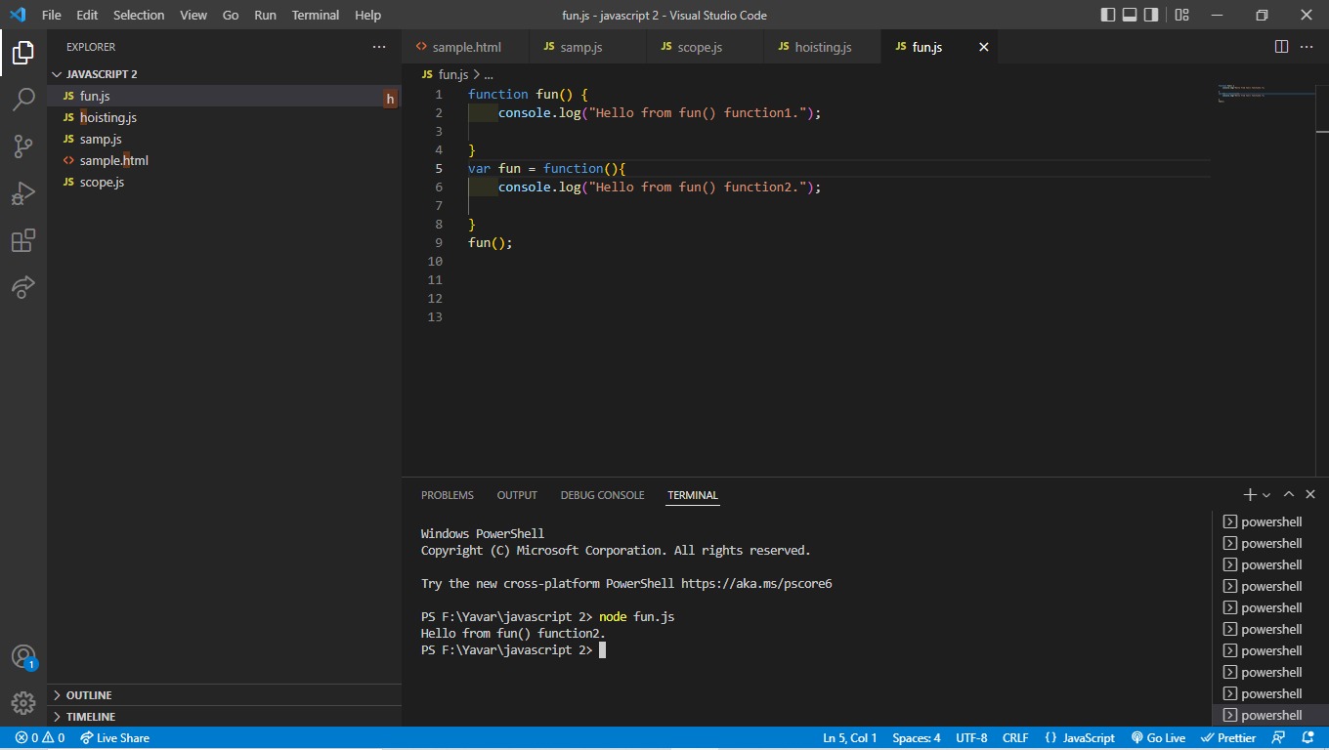

It is possible to assign an anonymous function in a variable name.that anonymous function that were assigned to variable names are not hoisted by unlike named function. We call fun() the function can be written and the var can be overwrite the value .

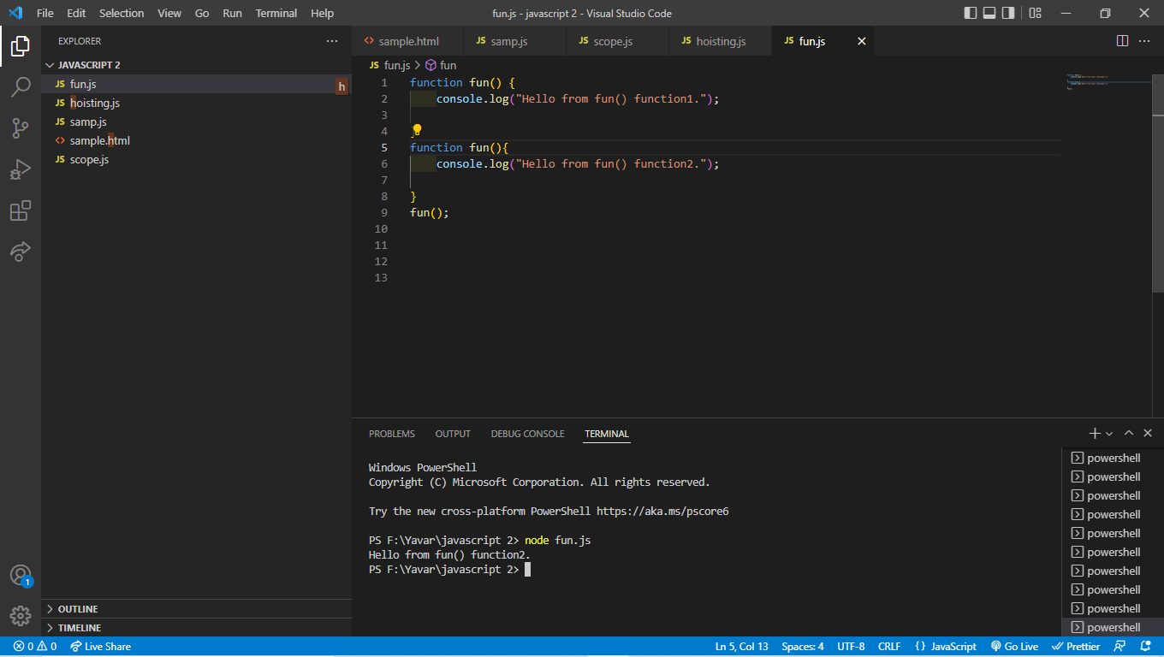

This is a perfect code no error is generated.whenever two fuction created using a same keyword and they happen to share the same name function that was defined last will take the precedence.

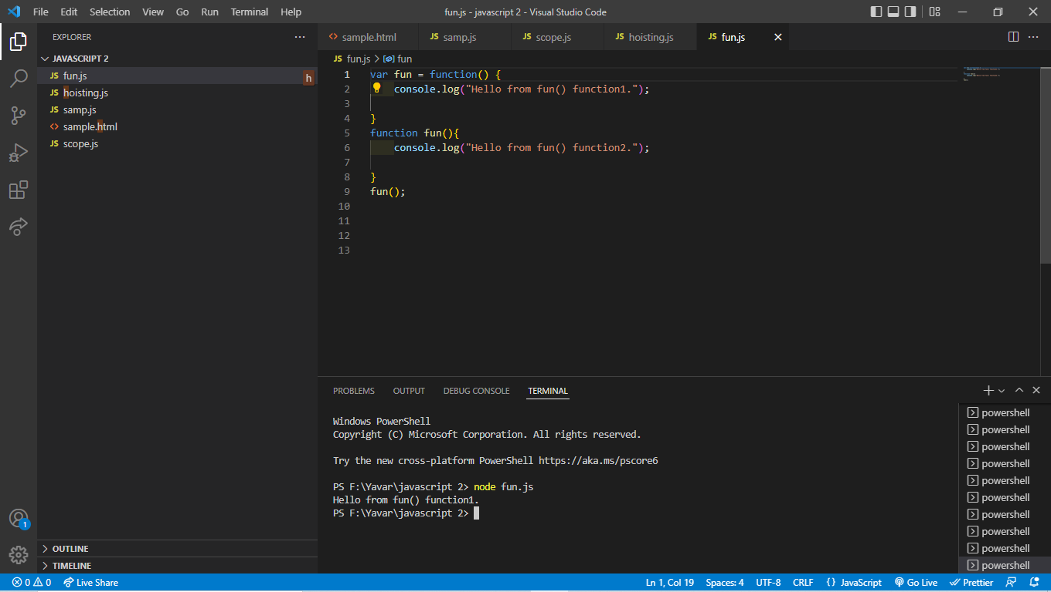

You can see javascript hoists variable and function functions are hoisted first then variable.

Defining variable inside a function scope:

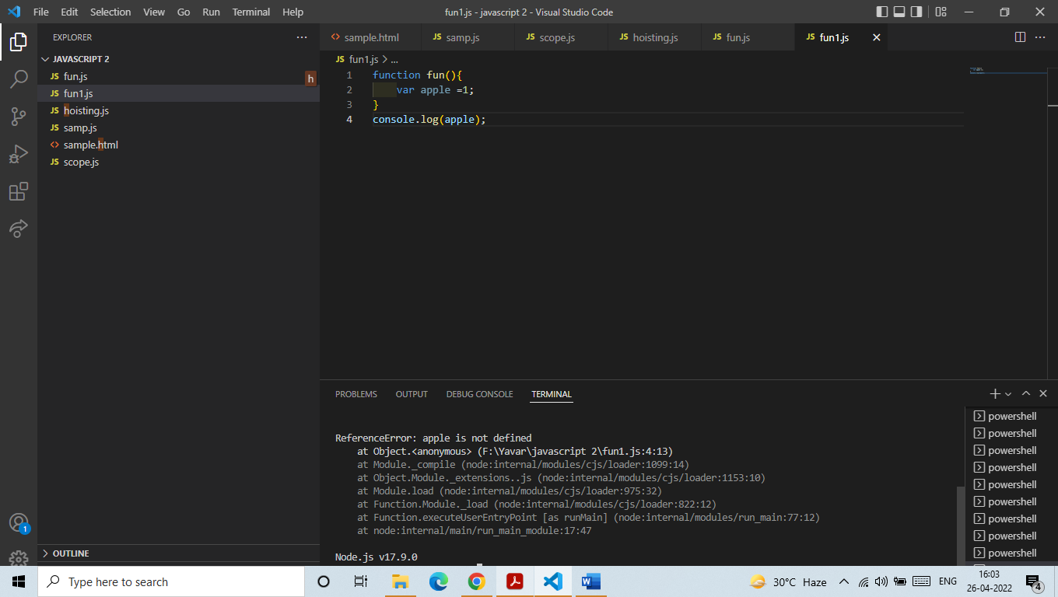

Variable defined inside the function can be a scope of the function.trying to access the outside of the function it will leads to the reference error.