Chapter-9

…Rest and …Spreads

Javascripts uses the (…) for both the rest and spread properties.

The …Rest syntax can help you to a larger number of items by extracting them from a single function parameter name.the single …rest parameter is assumed to contain one or more arguments passed to the function.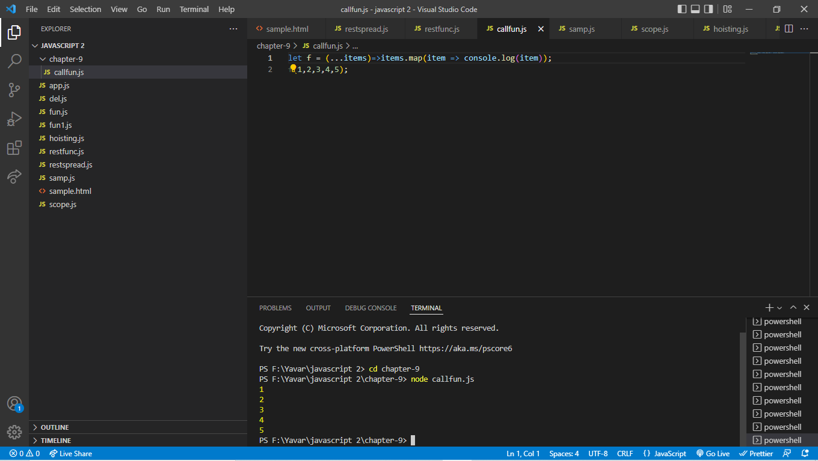

After arrow function were introduced in ecmascript 6 further to shorten code some started their variable name the character.

Spread properties:

You can think of spread of an opposite of rest.It can help you extract parts from an object.

Rest and spread object:

…Spread operator-expand iterable into one or more arguments.

…Rest operator -collect all parameter in to an array.

Spread:

You can think of spread of an opposite of rest.

It can help you extract part from an object.

…rest and …spread:

… spread operator- expands one or more arguments.

… rest operator – collect all remaining parameter into an array.

…rest:

The rest parameter can gather an unknown number of arguments passed to the function and store them in an array.

