**FS extension in Azure Servers:**

**Current Status:**

**Device:**

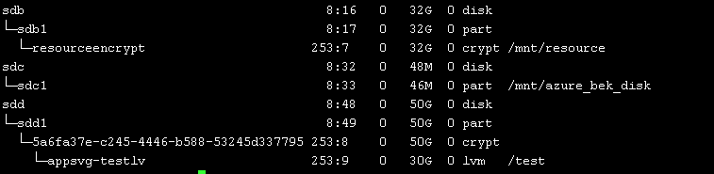

**VG:**

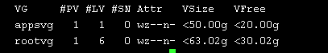

**LV in appsvg:**



**Datadisk:**

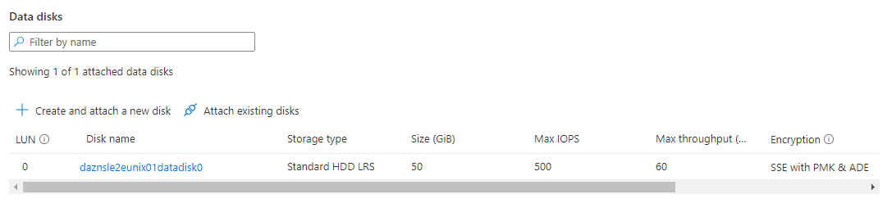

**Case 1: appsvg is already created on encrypted datadisk.**

If appsvg is already created on data disk then we must extend the existing data disk to desired capacity.

1. Stop the Azure VM from portal (Deallocated)

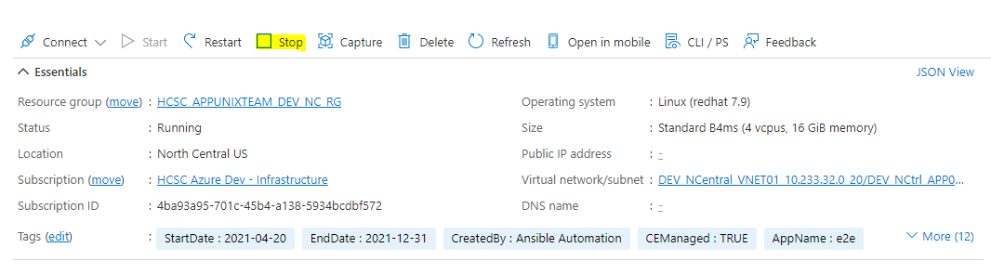

1. Once the VM will be in deallocated state, extend the disk size from azure portal.

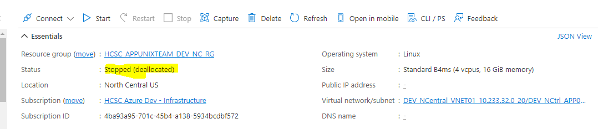

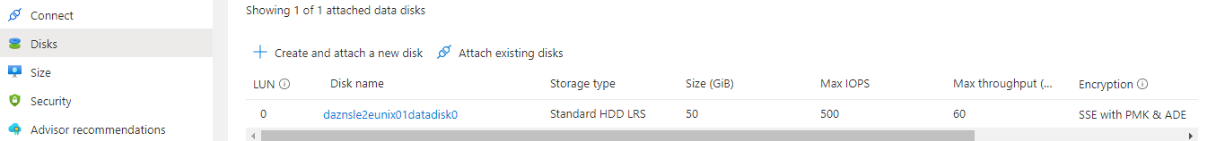

Click on datadisk > “Size + performance” > select size OR custom size > Resize

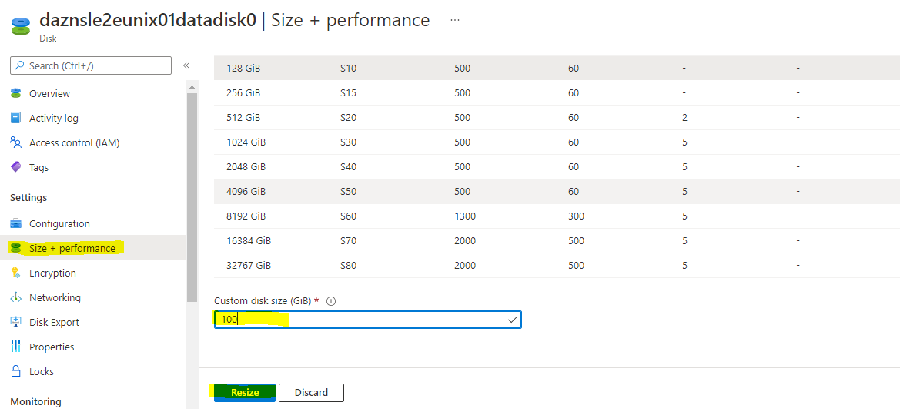

Then It will reflect the new disk size, else refresh the VM to reflect the new size.

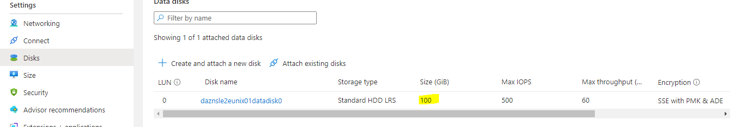

1. Power on the azure VM.
2. Login to server and validate the disk size. Disk size has been extended to 100G.

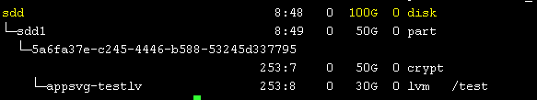

1. Extend the partition

# growpart /dev/sdd 1

** “1” is the partition number in disk (sdd**1**) so use this number according to partition.



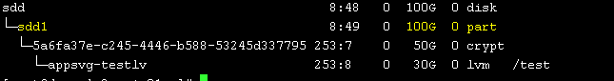

Partition has been extended now but still encrypted device is not extended yet.

1. Extend the encrypted device.

# cryptsetup resize /dev/mapper/5a6fa37e-c245-4446-b588-53245d337795

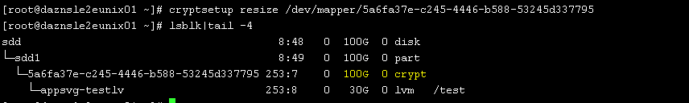

Now encrypted device has been extended.

1. Resize the PV.

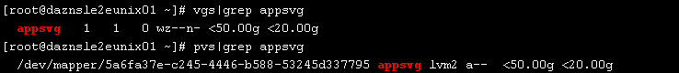

# pvresize /dev/mapper/5a6fa37e-c245-4446-b588-53245d337795

It will reflect the extended size in VG.

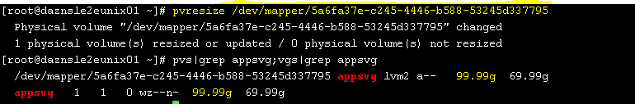

**Case 2: Encrypted datadisk is not assigned on server and appsvg is not created.**

1. If Encypted disk is not added to VM, then “azure-iaas-linux-vm-disk-attach-mount-workflow” ansible job will add the disk to Azure VM. We must provide the below parameters during execution of job.

azure_key_vault_name: APP00046995-109f-prd-sc

azure_storage_account_type: StandardSSD_LRS

azure_vm_rg_name: hcsc_APP00046995_prd_sc_rg

data_disk_size_gb: 2000

num_of_data_disks: 1

As of now We are unable to execute the above job, it seems we don’t have permission to key vault for disk encryption, Discussion is going on with cloud team on this.

**Just ask HCSC cloud team to add encrypted disk on server till we don’t have access.**

Once disk is available create the PV & VG over encrypted disk.

#pvcreate /dev/mapper/5a6fa37e-c245-4446-b588-53245d337795

#vgcreate appsvg /dev/mapper/5a6fa37e-c245-4446-b588-53245d337795