Instructions to run script to extract and plot single-molecule data.

- Script filename : ScriptForDataExtractionAndPlotting_KuRemovalPaper.py
- Packages necessary for running the script are indicated in Block 1. Installation can be done via pip or through Anaconda (https://www.anaconda.com/download).
- Script for extracting raw traces from 'pickle' databases for single-molecule data. Intensity traces from each condition described in the manuscript are deposited as individual zipped files.
- Unzip the files for each condition and the folder should contain the .pkl files containing the collated data for each condition.
- Copy folder path and initialize a variable named 'path' as follows :
- path = r'< path of the folder containing pickle files>'
- I have broken the code into Blocks. Each block is lines of code between two "#%%" symbols. If you use Spyder, these automatically show up as blocks.
- Expected results after successful running of code blocks in the script provided. Wherever apt, some screenshots of the expected results are also shown.

Block 1:
Imports are necessary packages
Block 2:
Changing the directory to the folder of interest
Block 3:
Extracting data from .pkl files in the folder into the workspace. The following variables are loaded on to the workspace.
Variable Name | Remark
greenChTracks | Ku background corrected intensity values
greenTime | Time stamps for Ku traces
stepFitGreen_all | Step-detection results on Ku traces
kuOnTime | A list of Ku lifetimes computed for each molecule
redChTracks | DNA background corrected intensity values
redTime | Time stamps for DNA traces
stepFitRed_all | Step-detection results on DNA traces
dnaOnTime | A list of DNA lifetimes computed for each molecule

Block 4:
Plots all the raw traces with each panel consisting of traces from 16 individual molecules.
Representative results are shown below.

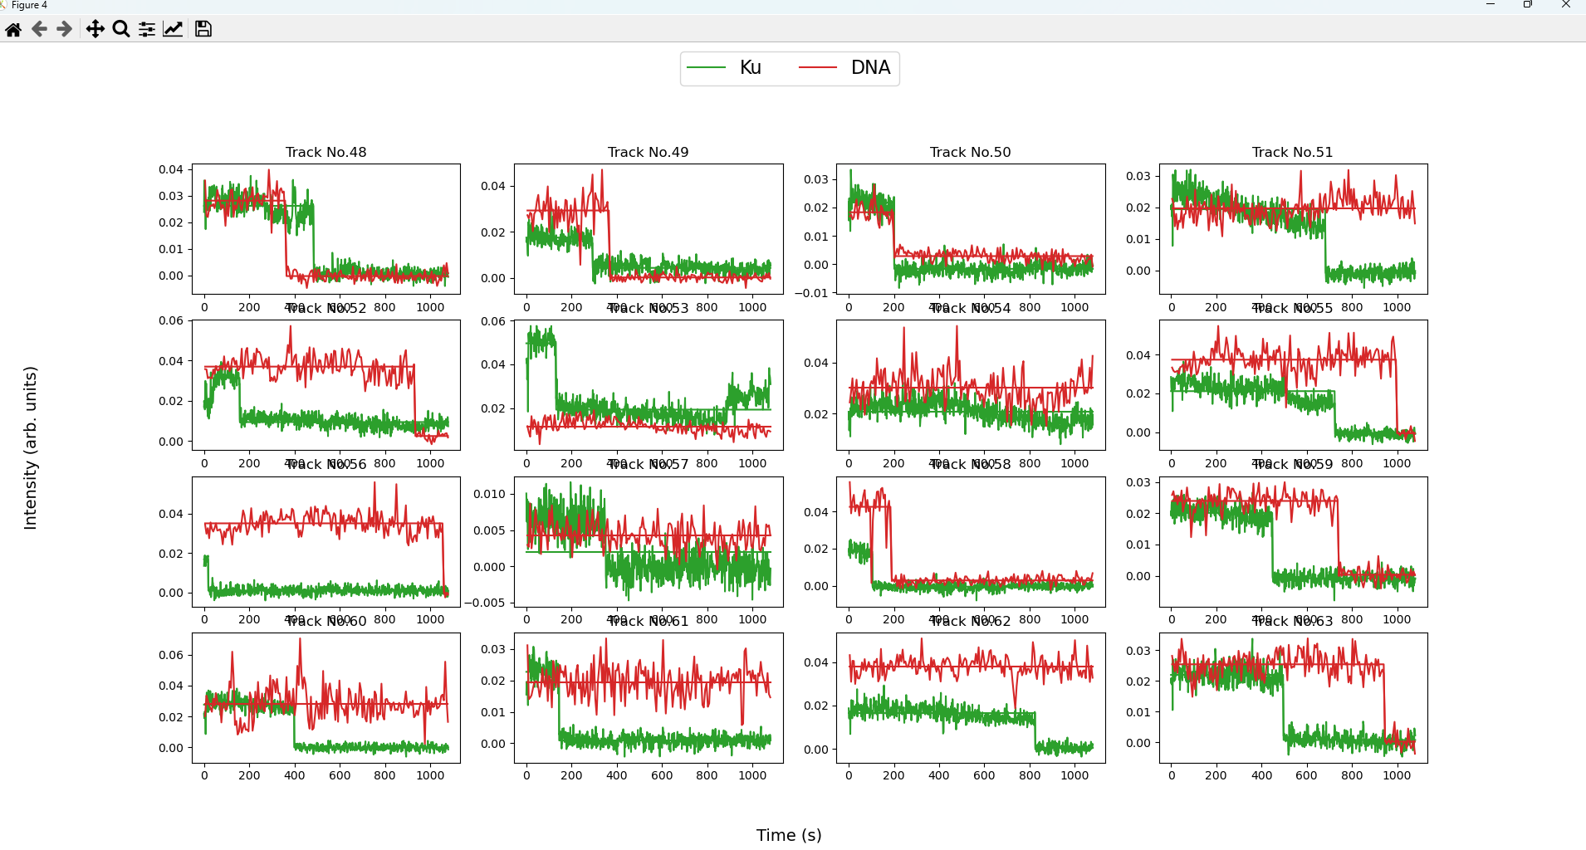

Block 5:
Plotting survival probability curves for all the traces from a single condition (folder).
Representative results are shown below.
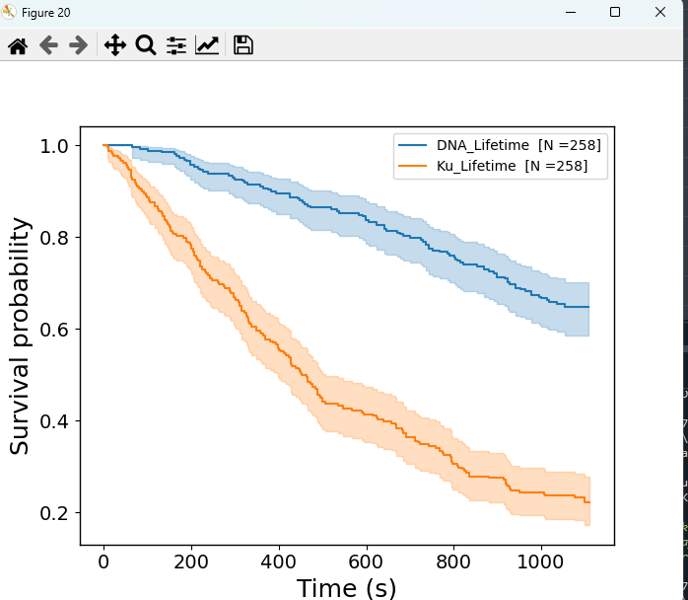

The median Ku and DNA survival probabilities are displayed in the terminal after running this code block. See below.

