Web design assignment

Module (Bootstrap Basic & Advanced) – 6

**(1) What are the advantages of Bootstrap?**

* **Ans.:-** Bootstrap is an open source, sleek, intuitive, and powerful, mobile first

The following are the benefits of using Bootstrap −

* front-end framework for faster and easier web development.
* It is supported by all popular browsers.
* With just the knowledge of HTML and CSS, anyone can get started with Bootstrap.
* Bootstrap's responsive CSS adjusts to Desktops, Tablets, and Mobiles.
* Easy to prevent repetitions among multiple projects
* Maintaining consistency among projects when using multiple developer teams
* Within short time you can develop any web application.
* Bootstrap 3, framework consists of Mobile first styles throughout the entire library instead them of in separate files.

**(2)What is a Bootstrap Container, and how does it work?**

* **Ans.:-** Bootstrap Containers are very essential and basic building blocks of bootstrap that wrap a page’s content. It’s responsible for setting and aligning content within it according to viewport or given device.
* Basically, there are three types of container classes available in bootstrap:

1. Default-Container(container)
2. Responsive-Container(along with sm, md, lg, xl, xxl)
3. Fluid-Container(container-fluid)
4. **Default-Container(container):-** The default container uses ‘.container’ class. It provides a responsive fixed-width container.

* **EXAMPLE:-**
* **Input:-**

<!DOCTYPE html>

<html lang="en">

<!-- ====== HEAD START ====== -->

<head>

<meta charset="UTF-8">

<meta name="viewport" content="width=device-width, initial-scale=1.0">

<title>Document</title>

<!-- ====== BOOTSTRAP LINKS ====== -->

<link href="https://cdn.jsdelivr.net/npm/bootstrap@5.2.3/dist/css/bootstrap.min.css" rel="stylesheet">

<script src="https://cdn.jsdelivr.net/npm/bootstrap@5.2.3/dist/js/bootstrap.bundle.min.js"></script>

</head>

<!-- ====== HEAD END ====== -->

<!-- ====== BODY START ====== -->

<body>

<div class="container" style="background-color: aqua;">

<p>Default-Container</p>

<p>

Default-Container example

</p>

</div>

</body>

<!-- ====== BODY END ====== -->

</html>

* **Output:-**

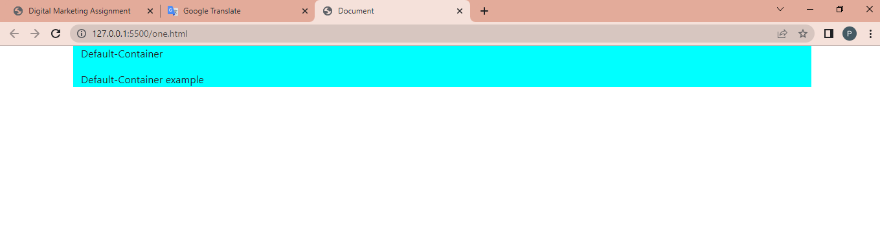

1. **Responsive-Container: -**

Responsive containers are responsive in nature. Responsive containers allow you to specify a class that is wide until the specified breakpoint is reached, after which we apply max-widths for each of the higher breakpoints.

* **EXAMPLE:-**
* **Input:-**

<!DOCTYPE html>

<html lang="en">

<!-- ====== HEAD START ====== -->

<head>

<meta charset="UTF-8">

<meta name="viewport" content="width=device-width, initial-scale=1.0">

<title>Document</title>

<!-- ====== BOOTSTRAP LINKS ====== -->

<link href="https://cdn.jsdelivr.net/npm/bootstrap@5.2.3/dist/css/bootstrap.min.css" rel="stylesheet">

<script src="https://cdn.jsdelivr.net/npm/bootstrap@5.2.3/dist/js/bootstrap.bundle.min.js"></script>

</head>

<!-- ====== HEAD END ====== -->

<!-- ====== BODY START ====== -->

<body>

<div class=" container container-sm"

style="background-color: brown;">

<h1>Responsive-Container</h1>

<h3>wel come to the my webpage</h3>

</div>

<!-- ====== BODY END ====== -->

</body>

</html>

* **Output:-**

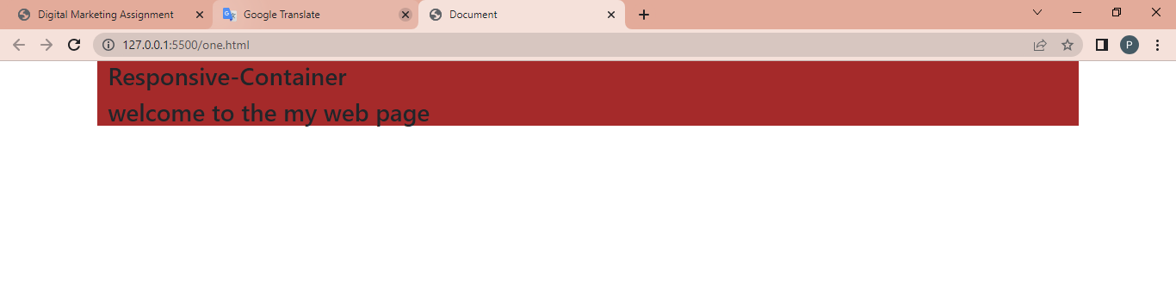

1. **Fluid-Container:**

Fluid-container uses the ‘.container-fluid’ class. It is used for a full-width container, spanning the entire width of the viewport.

* **EXAMPLE:-**
* **Input:-**

<!DOCTYPE html>

<html lang="en">

<!-- ====== HEAD START ====== -->

<head>

<meta charset="UTF-8">

<meta name="viewport" content="width=device-width, initial-scale=1.0">

<title>Document</title>

<!-- ====== BOOTSTRP LINKS ====== -->

<link href="https://cdn.jsdelivr.net/npm/bootstrap@5.2.3/dist/css/bootstrap.min.css" rel="stylesheet">

<script src="https://cdn.jsdelivr.net/npm/bootstrap@5.2.3/dist/js/bootstrap.bundle.min.js"></script>

</head>

<!-- ====== HEAD END ====== -->

<!-- ====== BODY START ====== -->

<body>

<div class=" container-fluid" style="background-color: chartreuse;">

<h1>Fluid-Container</h1>

<p>

example of

container in bootstrap

</p>

</div>

</body>

<!-- ====== BODY END ====== -->

</html>

* **Output:-**

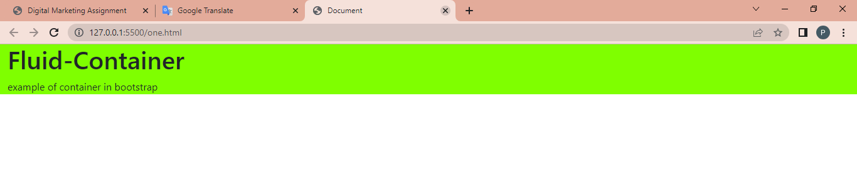

* **Layout:-**
* **Input:-**

<!DOCTYPE html>

<html lang="en">

<head>

<meta charset="UTF-8">

<meta name="viewport" content="width=device-width, initial-scale=1.0">

<title>Document</title>

<!-- ========= bootstrap link ============ -->

<link href="https://cdn.jsdelivr.net/npm/bootstrap@5.2.3/dist/css/bootstrap.min.css" rel="stylesheet">

<script src="https://cdn.jsdelivr.net/npm/bootstrap@5.2.3/dist/js/bootstrap.bundle.min.js"></script>

</head>

<body>

<!-- ======= navbar =========-->

<nav class="navbar navbar-expand-sm navbar-dark bg-dark">

<div class="container-fluid">

<a class="navbar-brand" href="javascript:void(0)">Carousel</a>

<button class="navbar-toggler" type="button" data-bs-toggle="collapse" data-bs-target="#mynavbar">

<span class="navbar-toggler-icon"></span>

</button>

<div class="collapse navbar-collapse" id="mynavbar">

<ul class="navbar-nav me-auto">

<li class="nav-item">

<a class="nav-link" href="javascript:void(0)">Home</a>

</li>

<li class="nav-item">

<a class="nav-link" href="javascript:void(0)">Link</a>

</li>

<li class="nav-item">

<a class="nav-link" href="javascript:void(0)">Disables</a>

</li>

</ul>

<form class="d-flex">

<input class="form-control me-2" type="text" placeholder="Search">

<button class="btn btn-dark border border-success text-success" type="button">Search</button>

</form>

</div>

</div>

</nav>

<!-- ============ main one ==========-->

<!-- Carousel -->

<div id="demo" class="carousel slide" data-bs-ride="carousel">

<!-- Indicators/dots -->

<div class="carousel-indicators">

<button type="button" data-bs-target="#demo" data-bs-slide-to="0" class="active"></button>

<button type="button" data-bs-target="#demo" data-bs-slide-to="1"></button>

<button type="button" data-bs-target="#demo" data-bs-slide-to="2"></button>

</div>

<!-- The slideshow/carousel -->

<div class="carousel-inner bg-secondary p-5">

<div class="carousel-item active p-5 text-end text-white">

<h1>One more for good measure.</h1>

<h5>Cras justo odio, dapibus ac facilisis in, egstas eget quam. Donec id elit non mi ports gravida at

eget metus</h5>

<h5>Nullam id dolor id nibh ultricies vehicula ut id elit.</h5>

<button class="bg-primary p-2 border-0 text-white">Browse gallery</button>

<div class="carousel-caption">

</div>

</div>

<div class="carousel-item p-5 text-end text-white">

<h1>One more for good measure.</h1>

<h5>Cras justo odio, dapibus ac facilisis in, egstas eget quam. Donec id elit non mi ports gravida at

eget metus</h5>

<h5>Nullam id dolor id nibh ultricies vehicula ut id elit.</h5>

<button class="bg-primary p-2 border-0 text-white">Browse gallery</button>

<div class="carousel-caption">

</div>

</div>

<div class="carousel-item p-5 text-end text-white">

<h1>One more for good measure.</h1>

<h5>Cras justo odio, dapibus ac facilisis in, egstas eget quam. Donec id elit non mi ports gravida at

eget metus</h5>

<h5>Nullam id dolor id nibh ultricies vehicula ut id elit.</h5>

<button class="bg-primary p-2 border-0 text-white">Browse gallery</button>

<div class="carousel-caption">

</div>

</div>

</div>

<!-- Left and right controls/icons -->

<button class="carousel-control-prev" type="button" data-bs-target="#demo" data-bs-slide="prev">

<span class="carousel-control-prev-icon"></span>

</button>

<button class="carousel-control-next" type="button" data-bs-target="#demo" data-bs-slide="next">

<span class="carousel-control-next-icon"></span>

</button>

</div>

<!-- ========== main two ============ -->

<div class="container border-bottom p-5 mt-5 justify-content-around">

<div class="row">

<div class="col-sm-4 text-center">

<img src="" class="rounded-circle bg-secondary" alt="" width="195" height="175">

<h3>Heading</h3>

<p>Donec sed odio dui, etiam porta sem <br> malesuda magna euismod. Nullam id <br>

dolor id nibh ultricies vehicula ut id elit. Morbi <br> leo risus, parta ac consectrtur Ac vestibulum <br> at

eros. praesent cornomodo cussus magna.</p>

<button type="button" class="btn bg-secondary text-white">view Details .</button>

</div>

<div class="col-sm-4 text-center">

<img src="" class="rounded-circle bg-secondary" alt="" width="190" height="175">

<h3>Heading</h3>

<p>Donec sed odio dui, etiam porta sem <br> malesuda magna euismod. Nullam id <br>

dolor id nibh ultricies vehicula ut id elit. Morbi <br> leo risus, parta ac consectrtur Ac vestibulum <br> at

eros. praesent cornomodo cussus magna.</p>

<button type="button" class="btn bg-secondary text-white">view Details .</button>

</div>

<div class="col-sm-4 text-center">

<img src="" class="rounded-circle bg-secondary" alt="" width="195" height="175">

<h3>Heading</h3>

<p>Donec sed odio dui, etiam porta sem <br> malesuda magna euismod. Nullam id <br>

dolor id nibh ultricies vehicula ut id elit. Morbi <br> leo risus, parta ac consectrtur Ac vestibulum <br> at

eros. praesent cornomodo cussus magna.</p>

<button type="button" class="btn bg-secondary text-white">view Details .</button>

</div>

</div>

</div>

<!-- ========== main three ============ -->

<div class="container-md d-flex border-bottom p-5">

<div class="main3-one w-75">

<h1 class="mt-5">First featurette heading. It'll <br>blow your mind.</h1>

<p>Donec uliamcorper nulila non metus auctor fringila. vestibulum id ligula <br>ports felis euismod semper.

Praesent commodo cursus magna, vel <br>scelerisque nisl consectetur. Fusce dapibus tellus ac cursus

commodo

</p>

</div>

<div class="main3-two d-flex justify-content-center align-items-center bg-secondary w-25">

<h2>500*500</h2>

</div>

</div>

<!-- ============== main four ============= -->

<div class="container-md d-flex justify-content-center border-bottom p-5">

<div class="main4-one d-flex justify-content-center align-items-center bg-secondary w-25">

<h2>500*500</h2>

</div>

<div class="main4-two ps-5 w-75">

<h1 class="mt-5">Oh yeah, it's that good. See <br>for yourself.</h1>

<p>Donec uliamcorper nulila non metus auctor fringila. vestibulum id ligula <br>ports felis euismod semper.

Praesent commodo cursus magna, vel <br>scelerisque nisl consectetur. Fusce dapibus tellus ac cursus

commodo

</p>

</div>

</div>

<!--=========== main five =============== -->

<div class="container-md d-flex border-bottom p-5">

<div class="main3-one w-75">

<h1 class="mt-5">First featurette heading. It'll <br>blow your mind.</h1>

<p>Donec uliamcorper nulila non metus auctor fringila. vestibulum id ligula <br>ports felis euismod semper.

Praesent commodo cursus magna, vel <br>scelerisque nisl consectetur. Fusce dapibus tellus ac cursus

commodo

</p>

</div>

<div class="main3-two d-flex justify-content-center align-items-center bg-secondary w-25">

<h2>500*500</h2>

</div>

</div>

<!-- =============== main six =============== -->

<div class="container p-5">

<div class="div">&#169; 2017-2018 company Inc <span class="text-primary">privacy-terms</span> <button class="float-end text-primary border-0">back to top</button></div>

</div>

</body>

</html>

* Output:-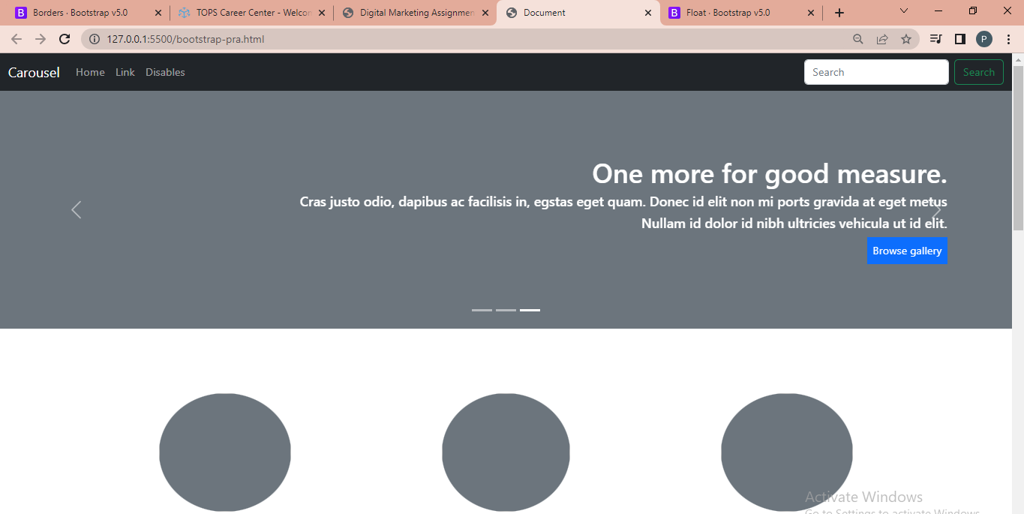

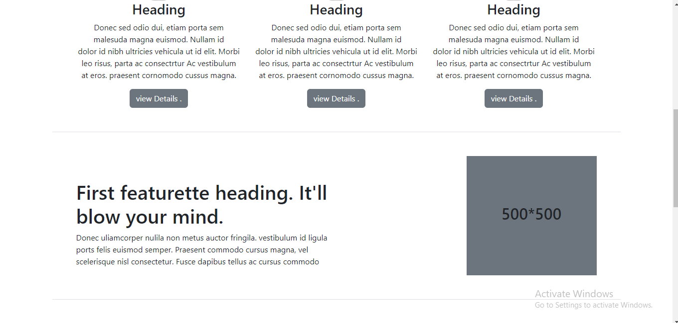

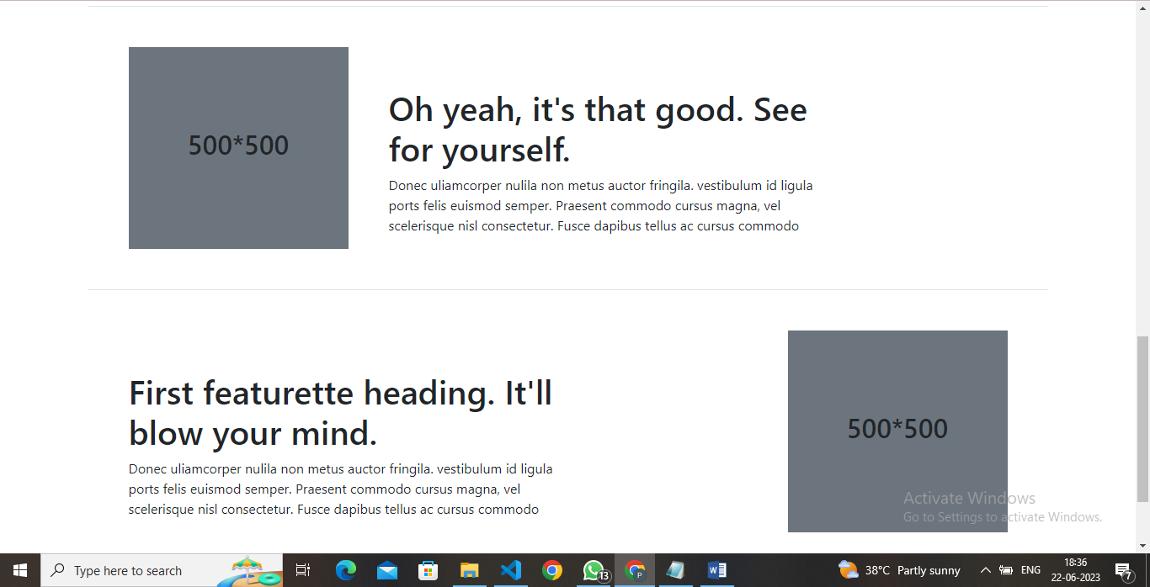

**(3) What are the default Bootstrap text settings?**

* **Ans.:-** Bootstrap 4 uses a default font-size of 16px, and its line-height is 1.5. The default font-family is "Helvetica Neue", Helvetica, Arial, sans-serif. In addition, all <p> elements have margin-top: 0 and margin-bottom: 1rem (16px by default).

**(4) What do you know about the Bootstrap Grid System?**

* **Ans:-** Bootstrap's grid system uses a series of containers, rows, and columns to layout and align content. It's built with flexbox and is fully responsive.

The Bootstrap Grid System allows up to 12 columns across the page. You can use all 12 columns individually or you can groups the columns together to create wider columns.

* **EXAMPLE:-**
* **Input:-**

<!DOCTYPE html>

<html lang="en">

<!-- ====== HEAD START ====== -->

<head>

<meta charset="UTF-8">

<meta name="viewport" content="width=device-width, initial-scale=1.0">

<title>Document</title>

<!-- ====== BOOTSTRP LINKS ====== -->

<link href="https://cdn.jsdelivr.net/npm/bootstrap@5.2.3/dist/css/bootstrap.min.css" rel="stylesheet">

<script src="https://cdn.jsdelivr.net/npm/bootstrap@5.2.3/dist/js/bootstrap.bundle.min.js"></script>

</head>

<!-- ====== HEAD END ====== -->

<!-- ====== BODY START ====== -->

<body>

<div class="row">

<div class="col-md-8">

<div class="pb-3 bg-danger">

.col-md-8

</div>

<div class="row">

<div class="col-md-6 bg-warning">.col-md-6</div>

<div class="col-md-6 bg-success">.col-md-6</div>

</div>

</div>

<div class="col-md-4 bg-info">.col-md-4</div>

</div>

</body>

<!-- ====== BODY END ====== -->

</html>

* **Output:-**

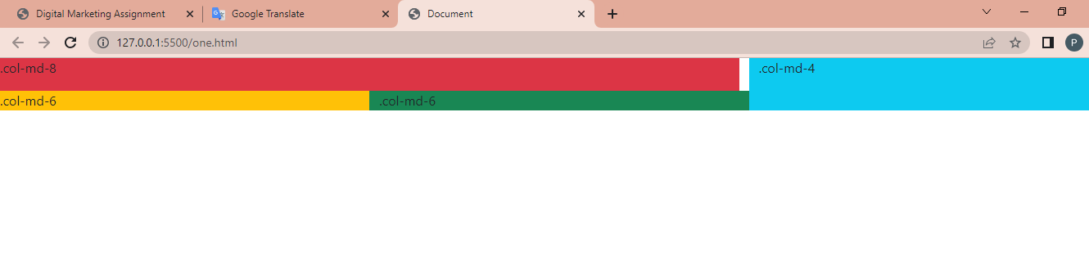

**(5) What is the difference between Bootstrap 4 and Bootstrap 5?**

* **Ans:-**

|  |  |  |
| --- | --- | --- |
| * **Features** | * **Bootstrap 4** | * **Bootstrap 5** |
| **color** | Bootstrap 4 provides a few colors for a web page. | Extra colors insert into the looks, and the card's color palette was upgraded. There are a variety of colors to pick from the Bootstrap 5 framework. |
| **Internet explorer** | Bootstrap 4 is compatible with both Internet Explorer 10 and 11. | Bootstrap 5 does not support Internet Explorer 10 and 11. |
| **Icons for bootstrap** | Bootstrap 4 lacks SVG icons; we must rely on font-awesome for icons. | Bootstrap 5 has its own set of SVG icons. |
| **Grid system** | Bootstrap 4 has five levels: xs, sm, md, lg, and xl. | Bootstrap 5 has six levels: xs, sm, md, lg, xl, and xxl. |
| **Css usability** | Bootstrap 4 uses fewer CSS properties. | Bootstrap 4 uses more CSS properties. |
| **offcanvas**  **component** | There is no off-canvas element. | The offcanvas component is now available. |
| **RTL support** | Languages do not enable RTL (right to the left) switching. | It enables RTL (right to the left) language switching. |

**(6) What is a Button Group, and what is the class for a basic Button Group?**

* **Ans:-** “Button Groups” in Bootstrap is a class of name “btn-group” which is used to create a series of buttons in groups (without spaces) vertically or horizontally.
* Bootstrap allows you to group a series of buttons together (on a single line) in a button group:

<div class="btn-group">

<button type="button" class="btn btn-primary">button 1</button>

<button type="button" class="btn btn-primary">button 2</button>

<button type="button" class="btn btn-primary">button 3</button>

</div>

**(7) How can you use Bootstrap to make thumbnails?**

* **Ans:-** This chapter discusses about Bootstrap thumbnails. A lot of sites need a way to lay out images, videos, text, etc, in a grid, and Bootstrap has an easy way to do this with thumbnails. To create thumbnails using Bootstrap

Add an <a> tag with the class of .thumbnail around an image.

This adds four pixels of padding and a gray border.

On hover, an animated glow outlines the image.

* **EXAMPLE:-**
* **Input:-**

<!DOCTYPE html>

<html lang="en">

<!-- ====== HEAD START ====== -->

<head>

<meta charset="UTF-8">

<meta name="viewport" content="width=device-width, initial-scale=1.0">

<title>Document</title>

<!-- ====== BOOTSTRP LINKS ====== -->

<link href="https://cdn.jsdelivr.net/npm/bootstrap@5.2.3/dist/css/bootstrap.min.css" rel="stylesheet">

<script src="https://cdn.jsdelivr.net/npm/bootstrap@5.2.3/dist/js/bootstrap.bundle.min.js"></script>

</head>

<!-- ====== HEAD END ====== -->

<!-- ====== BODY START ====== -->

<body>

<h3 style="color: red">Bootstrap thumbnails</h3>

<div class="row">

<div class="col-sm-6 col-md-3">

<a href="#" class="thumbnail">

<img src="https://wallpapers.com/images/featured/a5u9zq0a0ymy2dug.jpg"

style="height: 200px; width: 200px" />

</a>

</div>

<div class="col-sm-6 col-md-3">

<a href="#" class="thumbnail">

<img src="https://images3.alphacoders.com/823/thumb-1920-82317.jpg"

style="height: 200px; width: 200px" />

</a>

</div>

<div class="col-sm-6 col-md-3">

<a href="#" class="thumbnail">

<img src="https://cdn.wallpapersafari.com/48/69/y8f9Gt.jpg"

style="height: 200px; width: 200px" />

</a>

</div>

<div class="col-sm-6 col-md-3">

<a href="#" class="thumbnail">

<img src="https://c4.wallpaperflare.com/wallpaper/41/681/303/pc-hd-1080p-nature-1920x1080-wallpaper-preview.jpg"

style="height: 200px; width: 200px" />

</a>

</div>

</div>

</body>

<!-- ====== BODY END ====== -->

</html>

* **Output:-**

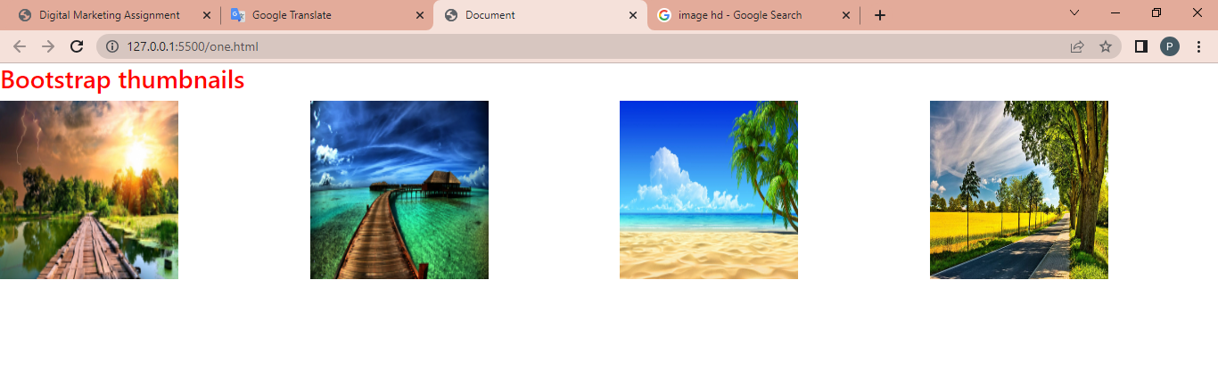

**(8) In Bootstrap 4, what is flexbox?**

* **Ans:-** In Bootstrap 4, flex box is used to control the layout and alignment specification of Bootstrap 4 components. This box makes it easier to design flexible responsive layout structures without using float or positioning attributes.
* **EXAMPLE:-**
* **Input:-**

<!DOCTYPE html>

<html lang="en">

<!-- ====== HEAD START ====== -->

<head>

<meta charset="UTF-8">

<meta name="viewport" content="width=device-width, initial-scale=1.0">

<title>Document</title>

<!-- ====== BOOTSTRP LINKS ====== -->

<link href="https://cdn.jsdelivr.net/npm/bootstrap@5.2.3/dist/css/bootstrap.min.css" rel="stylesheet">

<script src="https://cdn.jsdelivr.net/npm/bootstrap@5.2.3/dist/js/bootstrap.bundle.min.js"></script>

</head>

<!-- ====== HEAD END ====== -->

<!-- ====== BODY START ====== -->

<body>

<div class="container mt-3">

<h2> Bootstrap 4 Flexbox </h2>

<div class="d-flex mb-3 bg-secondary">

<div class="p-2 mr-auto bg-info"> Flexbox box 1</div>

<div class="p-2 bg-warning"> Flex box 2 </div>

<div class="p-2 bg-primary"> Flex box 3 </div>

</div>

</div>

</body>

<!-- ====== BODY END ====== -->

</html>

* **Output:-**

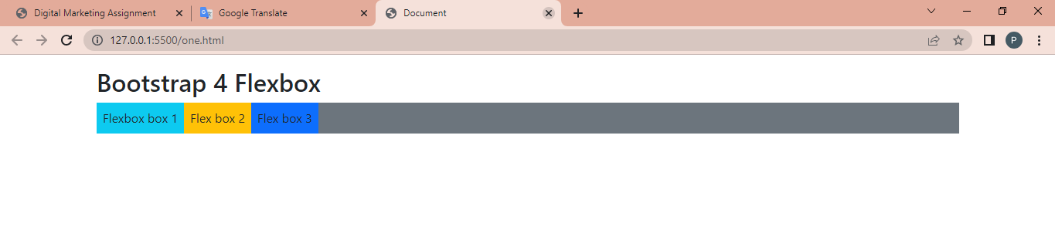

**(9) How can one create an alert in Bootstrap?**

* **Ans:-** Bootstrap Alerts are used to provide an easy way to create predefined alert messages. Alert adds a style to your messages to make it more appealing to the users.

Alerts are created with the .alert class, followed by one of the four contextual classes .alert-success, .alert-info, .alert-warning or .alert-danger

* **EXAMPLE:-**
* **Input:-**

<!DOCTYPE html>

<html lang="en">

<!-- ====== HEAD START ====== -->

<head>

<meta charset="UTF-8">

<meta name="viewport" content="width=device-width, initial-scale=1.0">

<title>Document</title>

<!-- ====== BOOTSTRP LINKS ====== -->

<link href="https://cdn.jsdelivr.net/npm/bootstrap@5.2.3/dist/css/bootstrap.min.css" rel="stylesheet">

<script src="https://cdn.jsdelivr.net/npm/bootstrap@5.2.3/dist/js/bootstrap.bundle.min.js"></script>

</head>

<!-- ====== HEAD END ====== -->

<!-- ====== BODY START ====== -->

<body>

<!-- Success Alert -->

<div class="alert alert-success alert-dismissible fade show">

<strong>Success!</strong> Your message has been sent successfully.

<button type="button" class="btn-close" data-bs-dismiss="alert"></button>

</div>

<!-- Error Alert -->

<div class="alert alert-danger alert-dismissible fade show">

<strong>danger !</strong> A problem has been occurred while submitting your data.

<button type="button" class="btn-close" data-bs-dismiss="alert"></button>

</div>

<!-- Warning Alert -->

<div class="alert alert-warning alert-dismissible fade show">

<strong>Warning!</strong> There was a problem with your network connection.

<button type="button" class="btn-close" data-bs-dismiss="alert"></button>

</div>

<!-- Info Alert -->

<div class="alert alert-info alert-dismissible fade show">

<strong>Info!</strong> Please read the comments carefully.

<button type="button" class="btn-close" data-bs-dismiss="alert"></button>

</div>

</body>

<!-- ====== BODY END ====== -->

</html>

* **Output:-**

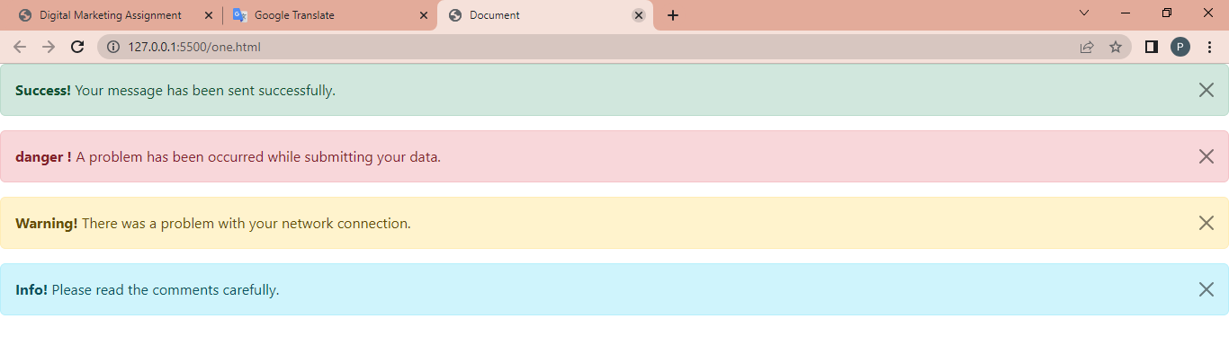

**(10) What is a bootstrap card and how would you create one?**

* **Ans:-** A card in Bootstrap 4 is a bordered box with some padding around its content. It includes options for headers, footers, content, colors, etc.
* EXAMPLE:-
* Input:-

<!DOCTYPE html>

<html lang="en">

<!--=====head start======-->

<head>

<title>Bootstrap Example</title>

<meta charset="utf-8">

<meta name="viewport" content="width=device-width, initial-scale=1">

<!--=======bootstrap link======-->

<link rel="stylesheet" href="https://cdn.jsdelivr.net/npm/bootstrap@4.6.2/dist/css/bootstrap.min.css">

<script src="https://cdn.jsdelivr.net/npm/jquery@3.6.4/dist/jquery.slim.min.js"></script>

<script src="https://cdn.jsdelivr.net/npm/popper.js@1.16.1/dist/umd/popper.min.js"></script>

<script src="https://cdn.jsdelivr.net/npm/bootstrap@4.6.2/dist/js/bootstrap.bundle.min.js"></script>

</head>

<!--====== head end ======-->

<!--======= body start=======-->

<body>

<div class="container">

<h2> Card</h2>

<p></p>

<div class="card" style="width:400px">

<img class="card-img-top" src="card image.jpg" alt="Card image" style="width:100%">

<div class="card-body">

<h4 class="card-title">Richard Taylor</h4>

<p class="card-text">some example</p>

<a href="#" class="btn btn-primary stretched-link">See Profile</a>

</div>

</div>

</div>

</body>

<!--======= body end=======-->

</html>

* Output:-

