(1) What is jQuery?

Ans:

jQuery was introduced in 2006 and quickly gained popularity due to its simplicity and cross-browser compatibility.

jQuery is an open source JavaScript library that simplifies the interactions between an HTML/CSS document, or more precisely the Document Object Model (DOM), and JavaScript.

It abstracts many complex JavaScript operations into simpler functions, allowing developers to write less code and achieve the same results. jQuery's syntax is concise and easy to understand, making it accessible to both beginners and experienced developers.

(2) How to Apply CSS Using JQuery, How to Add Class and Remove Class in Jquery ,JQuery Animation?

Ans:

1. addClass() method: It is used to add specified classes to each of the targeted elements while animating all style changes.

Ex:

    <style>

        .one{

            background-color: purple;

            color: white;

        }

    </style>

<body>

    <p>Lorem, ipsum dolor sit amet consectetur adipisicing elit. Officia, ipsam? Consequatur placeat aliquid, ipsum illum eos impedit quasi dolorum aut.</p>

    <h2>Lorem ipsum dolor sit amet consectetur, adipisicing elit.</h2>

    <h3>Lorem ipsum dolor sit amet consectetur adipisicing elit.</h3>

    <button>Click here</button>

    <script>

        $(document).ready(function () {

            $("button").click(function () {

                // $("p").addClass("one")

                $("p,h2,h3").addClass("one") //multiple classes

            })

        })

    </script>

</body>

Output:

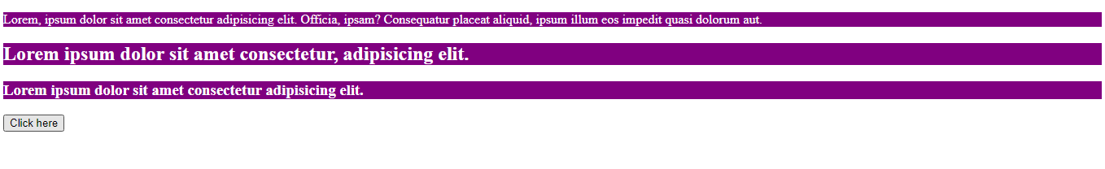

Press ‘click here’ button to applying style.

2. removeClass() method: It is used to remove the classes from the element while animating all style changes.

Ex:

    <style>

        .one{

            background: yellow;

            color: black;

        }

    </style>

</head>

<body>

    <p class="one">Lorem ipsum dolor sit amet consectetur adipisicing elit. Repellat natus necessitatibus sunt corporis cumque deleniti et cupiditate facilis illum ut?</p>

    <h3 class="one">Lorem ipsum dolor sit amet consectetur adipisicing elit.</h3>

    <button>Click here</button>

    <script>

        $(document).ready(function () {

            $("button").click(function () {

                $("p,h3").removeClass("one")

            })

        })

    </script>

</body>

Output:  


Press ‘click here’ button to remove style.

3.jquery animation:

Ex:

    <style>

        #myDiv {

            width: 200px;

            height: 200px;

            background-color: palegoldenrod;

        }

    </style>

</head>

<body>

    <h1>jQuery Animation Example</h1>

    <div id="myDiv"></div>

    <script>

        // jQuery code starts here

        $(document).ready(function () {

            var $myDiv = $("#myDiv");

            // Define the animation

            $myDiv.click(function () {

                $myDiv.animate({

                    width: "400px",

                    height: "400px",

                    backgroundColor: "blue"

                }, 1000, function () {

                    // Animation complete

                    $myDiv.animate({

                        width: "200px",

                        height: "200px",

                        backgroundColor: "red"

                    }, 1000);

                });

            });

        });

    </script>

</body>

Output:

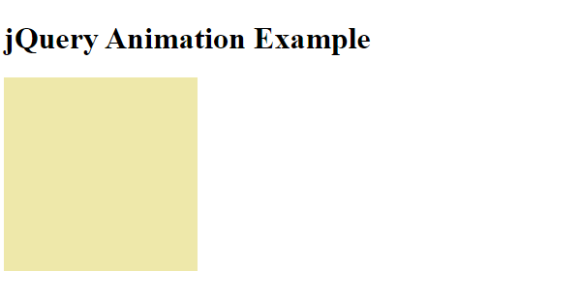

When we click on the box, its height and width will change(animate).

(3) How to create slider with animation?

Ans:

    <style>

        .slide{

            height: 200px;

            width: 200px;

            background: peru;

            margin: 5px;

        }

    </style>

</head>

<body>

    <div id="slider">

        <div class="slide">Slide 1</div>

        <div class="slide">Slide 2</div>

        <div class="slide">Slide 3</div>

    </div>

    <script>

        $(document).ready(function () {

            var slider = $('#slider');

            var slides = $('.slide');

            var currentIndex = 0;

            slides.eq(currentIndex).show();

            function animateSlides() {

                slides.eq(currentIndex).fadeOut();

                currentIndex++;

                if (currentIndex >= slides.length) {

                    currentIndex = 0;

                }

            }

            setInterval(animateSlides, 1000);

        });

    </script>

</body>

</html>

Output:

function every 3 seconds, changing the slides automatically.

