Group Lab Assignment(DHCP)

Project Group 1

**Mahesh Saripalli** :

Configure DHCP server on Mininet (Linux)

**Rahul Rao Kodati** :

Configure DHCP client on Mininet (Linux)

**Gowtham Katari** :

Configure DHCP Relay across different VLANS/Networks and Lab report

**Saloni Kajale** :

Learn to analyze STP (Spanning Tree protocol).

**Overview:**

**Learning Objective :**

1. Build and configure a layer 3 topology in GNS using Cisco 7200 routers

2. Learn to analyze STP (Spanning Tree protocol)

3. Configure DHCP Relay across different VLANS/Networks

4. Configure DHCP server on Mininet (Linux)

5. Configure DHCP client on Mininet (Linux)

A. **Lab setup :**

a. On top of the GNS3 LAB1 topology we added 7200 router R1 and configured .

b. We then connected switch ESW1 FastEthernet1/14 to 7200 router FastEthernet1/0 and switch ESW2 FastEthernet1/14 to 7200 router FastEthernet2/0

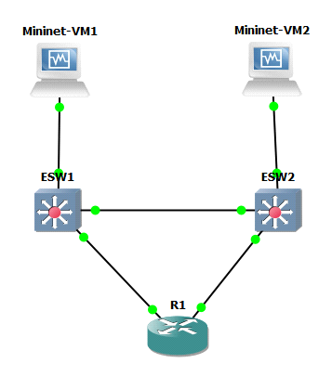

c. Then we started Router R1 and configured using fast ethernet interface by executing following commands:

**interface Fa1/0**

**desc Link to ESW1 VLAN_100**

**ip address 10.10.100.254 255.255.255.0**

**no duplex full**

**no speed 100**

**no shut**

**interface Fa2/0**

**shut**

**desc Link to ESW2 VLAN_200**

**ip address 10.10.200.254 255.255.255.0**

**no duplex full**

**d. In order to setup the switching layer 2 on ESW1 and connect it to fast ethernet 1/14 port on ESW1 to the port fast ethernet 1/0 on router we executed the following command:**

**vlan 100**

**name VLAN_100**

**interface Fa1/14**

**shut**

**switchport access vlan 100**

**desc Link to R1 VLAN_100**

**no duplex full**

**no speed 100**

**no shut**

**interface Fa1/0**

**switchport access vlan 100**

**desc Link to mininet1**

**no duplex full**

**no speed 100**

**no shut**

**end**

**e. Similarly, In order to setup the switching layer 2 on ESW2 and connect it to fast ethernet 1/14 port on ESW2 to the port fast ethernet 1/0 on router we executed the following command:**

**vlan 200**

**name VLAN_200**

**interface Fa1/14**

**shut**

**switchport access vlan 200**

**desc Link to R1 VLAN200**

**no duplex full**

**no speed 100**

**no shut**

**!**

**interface Fa1/0**

**switchport access vlan 200**

**desc Link to mininet2**

**no duplex full**

**no speed 100**

**no shut**

**end**

f. We assigned 10.10.100.1 to mininet VM1 and added the default gateway as 10.10.100.254 on ethernet 0 interface using the following command:

**sudo ifconfig eth0 10.10.100.1 netmask 255.255.255.0 UP**

**sudo route add default gw 10.10.100.254 eth0**

g.In order to see the router output on mininet 1 we exectued the following command:

route -n

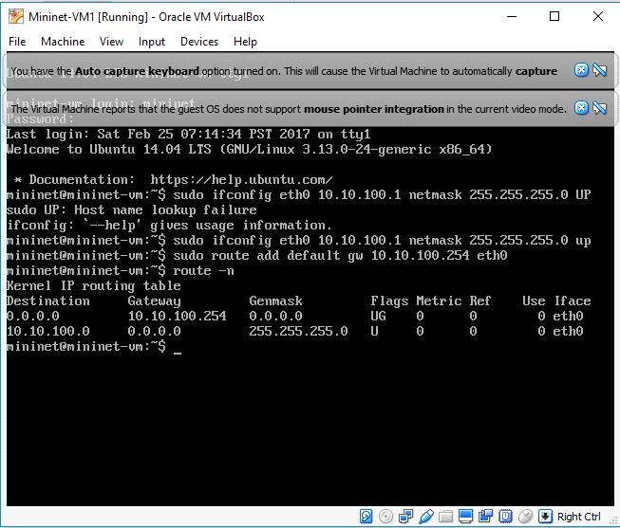

This command specifies the routing table maintained on mininet 1 which in turn gives us the destination port address, the default gateway through which the packet will traverse and the mask as shown in the figure above.

g. Also, we assigned 10.10.200.1 to mininet VM2 and added the default gateway as 10.10.200.254 on ethernet 0 interface using the followig command

**sudo ifconfig eth0 10.10.200.1 netmask 255.255.255.0 UP**

**sudo route add default gw 10.10.200.254 eth0**

h. In order to see the router output on mininet 1 we exectued the following command:

route -n

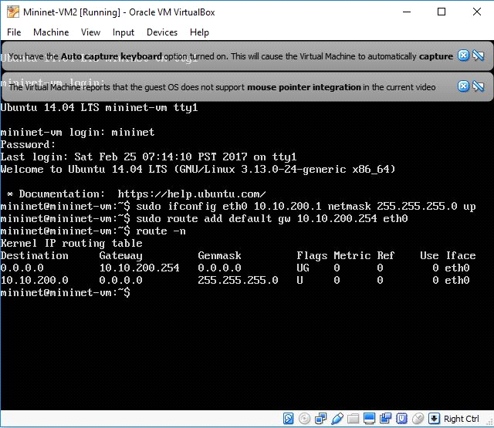

**LAB Setup verification:**

a. In order to see the connectivity from mininet VM1 we ping the following commands:

10.10.100.254 – R1 Vlan 100 router interface

10.10.200.254 – R2 Vlan 200 router interface

10.10.200.1 – Mininet2 eth0 interface on vlan 200

This shows that the connection exits between mininet VM1 to R1 Vlan 100 interface on ESW1 switch and R2 Vlan 200 router interface and connection of mininet VM2 via eth0 interface Vlan 200

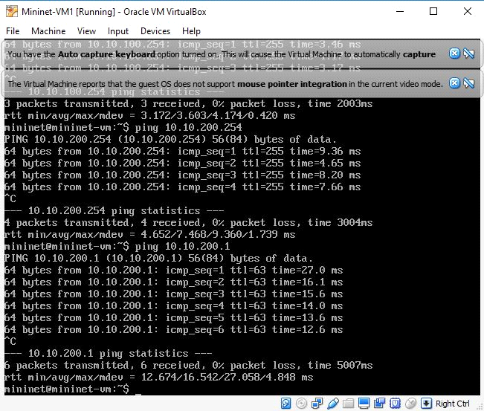

b. Similarly, In order to see the connectivity from mininet VM2 we ping the following commands:

10.10.100.254 – R1 Vlan 100 router interface

10.10.200.254 – R2 Vlan 200 router interface

10.10.100.1 – Mininet2 eth0 interface on vlan 200

This shows that the connection exits between mininet VM1 to R1 Vlan 100 interface on ESW1 switch and R2 Vlan 200 router interface and connection of mininet VM1 via eth0 interface Vlan 200.

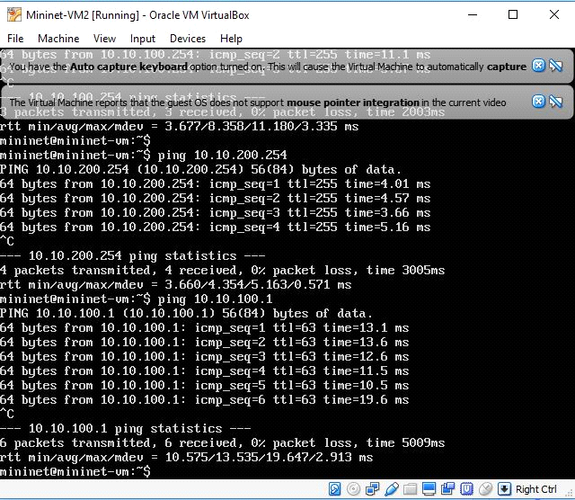

c. In order to check Vlan and MAC addresses on ESW1 we executed the following command:

* show mac-address-table:

ESW1#show mac-address-table

Destination Address Address Type VLAN Destination Port

------------------- ------------ ---- --------------------

c201.3780.0000 Self 1 Vlan1

ca03.3b28.001c Dynamic 100 FastEthernet1/14

0800.27be.dc32 Dynamic 100 FastEthernet1/0

* show spanning-tree vlan 100 brief:

ESW1#show spanning-tree vlan 100 brief

VLAN100

Spanning tree enabled protocol ieee

Root ID Priority 32768

Address c201.3780.0001

This bridge is the root

Hello Time 2 sec Max Age 20 sec Forward Delay 15 sec

Bridge ID Priority 32768

Address c201.3780.0001

Hello Time 2 sec Max Age 20 sec Forward Delay 15 sec

Aging Time 300

Interface Designated

Name Port ID Prio Cost Sts Cost Bridge ID Port ID

-------------------- ------- ---- ----- --- ----- -------------------- -------

FastEthernet1/0 128.41 128 19 FWD 0 32768 c201.3780.0001 128.41

FastEthernet1/14 128.55 128 19 FWD 0 32768 c201.3780.0001 128.55

FastEthernet1/15 128.56 128 19 FWD 0 32768 c201.3780.0001 128.56

* show spanning-tree vlan 200 brief:

ESW1#show spanning-tree vlan 200 brief

Spanning tree instance for VLAN 200 does not exist.

Here Output for Vlan 200 is showing blank because the ESW1 is configured for Vlan 100 only

-------output-------

d. Similarly, In order to check the VLAN and MAC address status on ESW2 we executed the following command:

* show mac-address-table

ESW2#show mac-address-table

Destination Address Address Type VLAN Destination Port

------------------- ------------ ---- --------------------

c202.651c.0000 Self 1 Vlan1

ca03.3b28.0038 Dynamic 200 FastEthernet1/14

0800.2751.5f1d Dynamic 200 FastEthernet1/0

* show spanning-tree vlan 200 brief:

ESW2#show spanning-tree vlan 200 brief

VLAN200

Spanning tree enabled protocol ieee

Root ID Priority 32768

Address c202.651c.0001

This bridge is the root

Hello Time 2 sec Max Age 20 sec Forward Delay 15 sec

Bridge ID Priority 32768

Address c202.651c.0001

Hello Time 2 sec Max Age 20 sec Forward Delay 15 sec

Aging Time 300

Interface Designated

Name Port ID Prio Cost Sts Cost Bridge ID Port ID

-------------------- ------- ---- ----- --- ----- -------------------- -------

FastEthernet1/0 128.41 128 19 FWD 0 32768 c202.651c.0001 128.41

FastEthernet1/14 128.55 128 19 FWD 0 32768 c202.651c.0001 128.55

FastEthernet1/15 128.56 128 19 FWD 0 32768 c202.651c.0001 128.56

* show spanning-tree vlan 100 brief

ESW2#show spanning-tree vlan 100 brief

Spanning tree instance for VLAN 100 does not exist.

Here Output for Vlan 100 is showing blank because the ESW1 is configured for Vlan 100

only

e. Later we run capture on interface using wireshark between ESW1 and mininet 1 and got the following output:

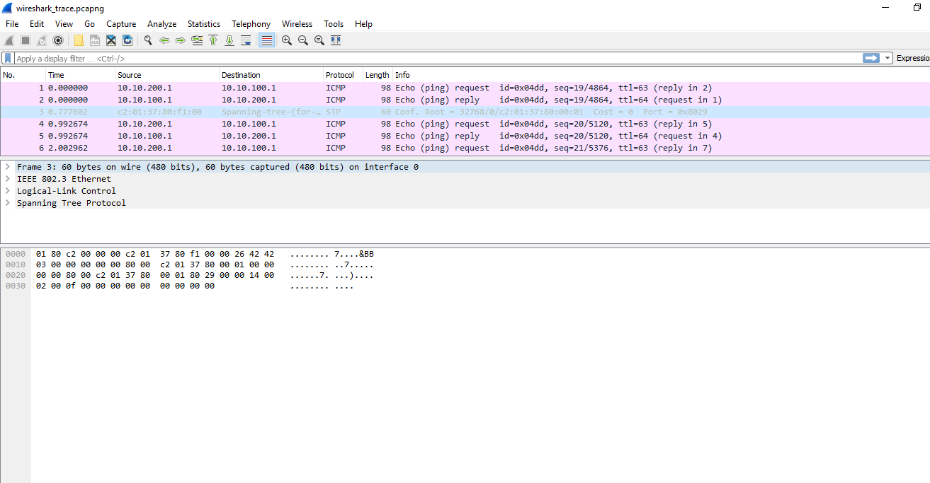

f. In order to assign IP addresses in the range **10.10.100.40 to 10.10.100.60** by the DHCP server we inserted the command into DHCPD.conf file using the VI Editor using:

**subnet 10.10.200.0 netmask 255.255.255.0 {**

**}**

**subnet 10.10.100.0. netmask 255.255.255.0 {**

**range 10.10.100.40 10.10.100.60;**

**option broadcast-address 10.10.100.255;**

**option routers 10.10.100.254;**

**}**

**g. After assigning the Range of IP addresses we started the DHCP server by issuing the following command:**

**sudo service isc-dhcp-server restart**

**h. In order to** configure R1 to forward dhcp requests to mininet2 we ssued the folowing command on Router R1:

**interface FA1/0**

**ip helper-address 10.10.200.1**

**i. In order to configure** mininet 1 as dhcpclient we first need to restart the mininet VM1 by issuing the following command:

**sudo reboot**

**and the executing:**

**sudo ifconfig**

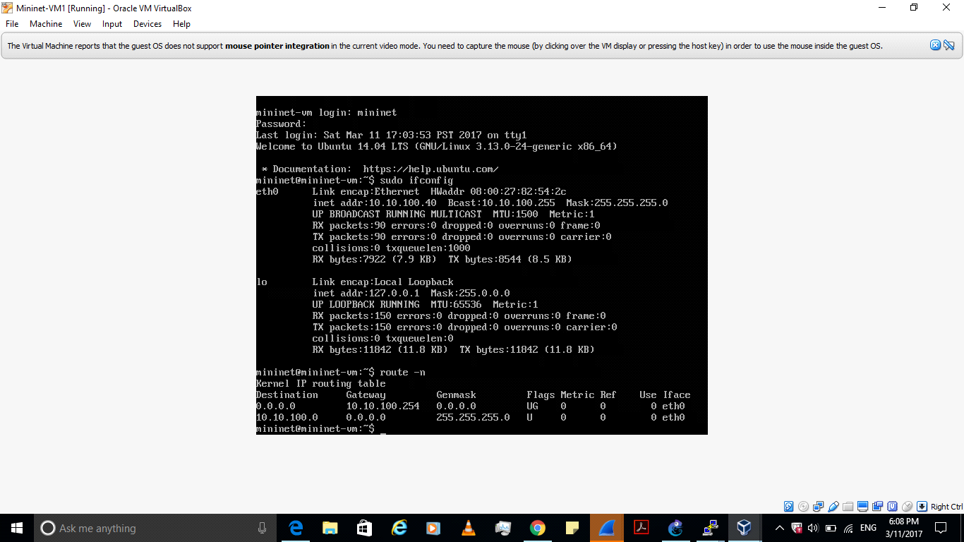

After rebooting mininet ip address 10.10.100.43 is assigned to mininet 1 by dhcp configured sserver mininet 2 .

**Conclusion :**

From this lab, We have learnt how to configure a DHCP server which allocates the ip address whenever the client requests for it. We used a router in between which forwards the DHCP request from the client to the server which in response allocates an ip addess to the client which will be in the range of ip addresses configured in DHCP server.