Configure docker image in product service to create mondo db image

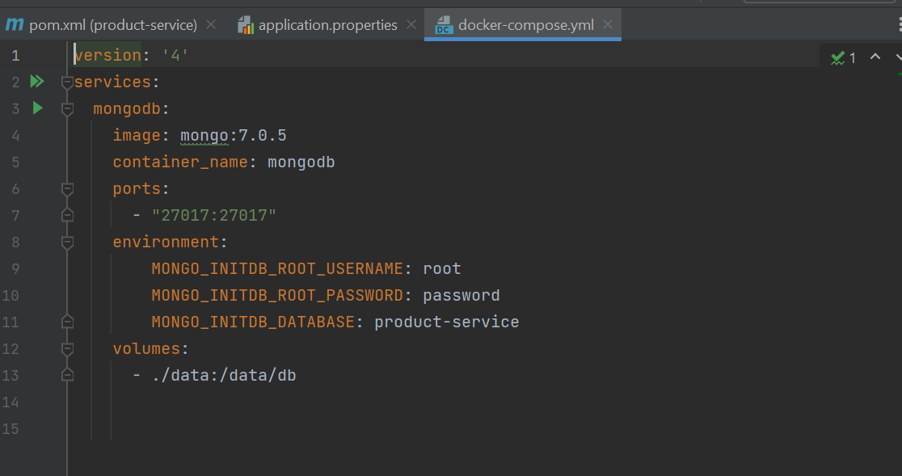

Run below command to make docker up

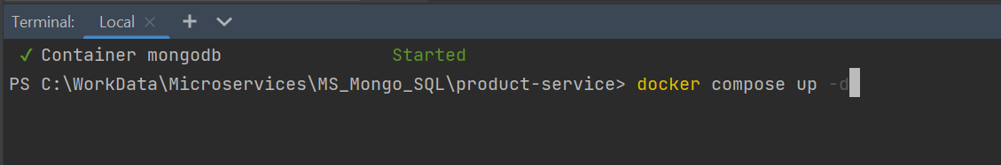

After running successfully

Also in your docker desktop you will see your mongo image as shown below

Order service will run mysql

Command:

docker ps [to see all running images]

docker compose up -d [pull the image to your repository]

docker stop imagename [to stop running image]

docker rm imagename [to remove running image]

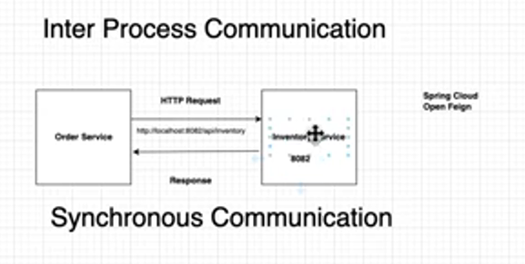

**Scenario**: Order service call Inventory service internally to check the product availability. If product available, then user can place order otherwise order can’t be place.

To run create docker image on docker hub

: mvn spring-boot:build-image -DskipTests -DdockerPassword=

Docker images

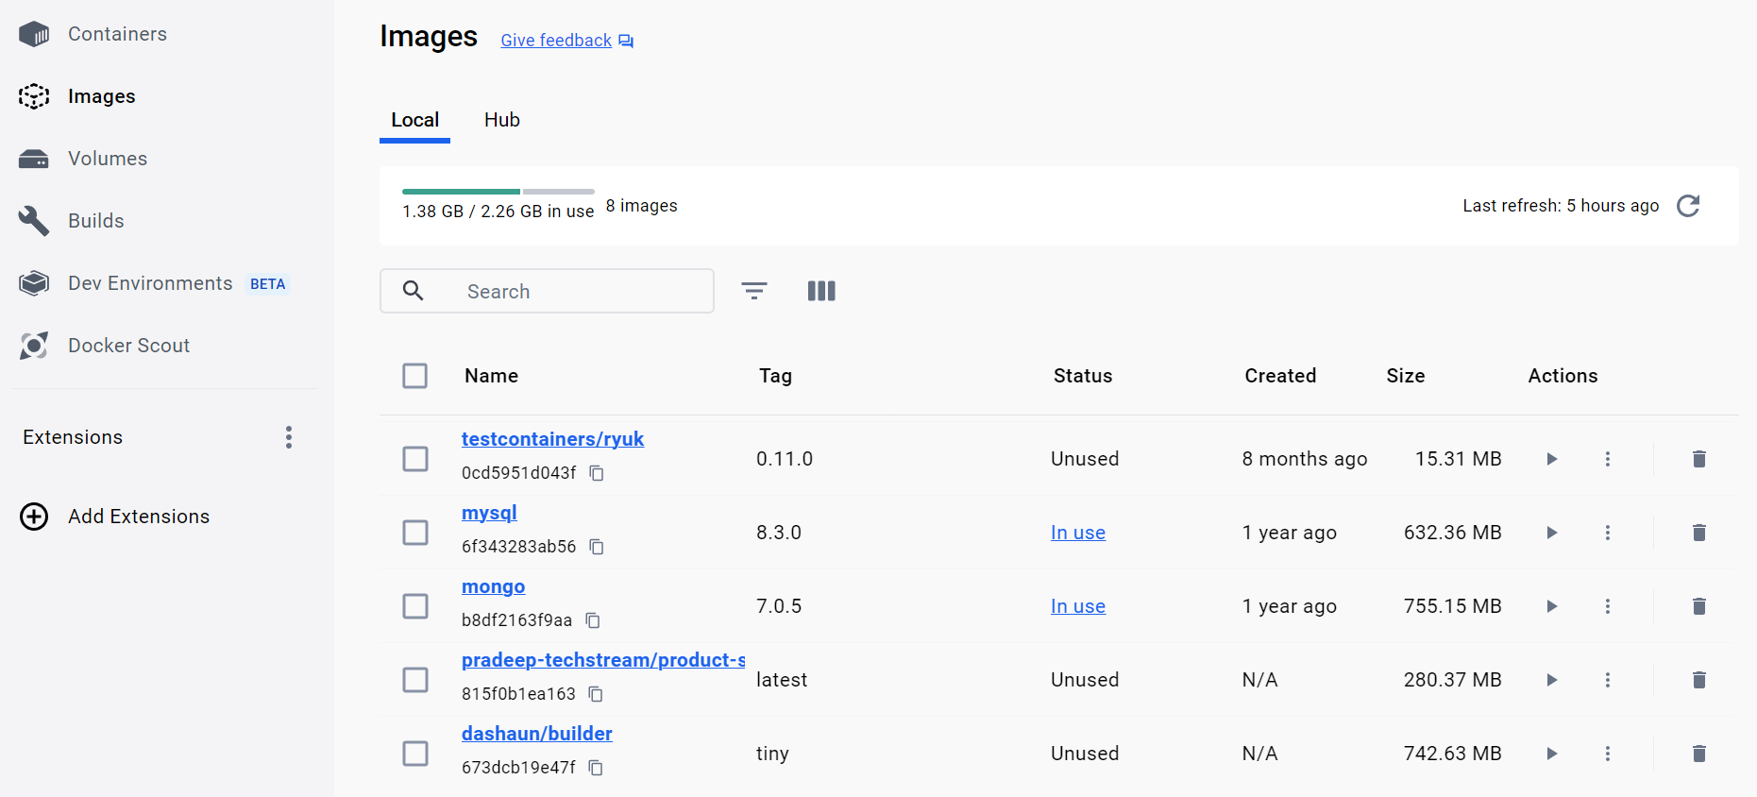

Product Service

Order service

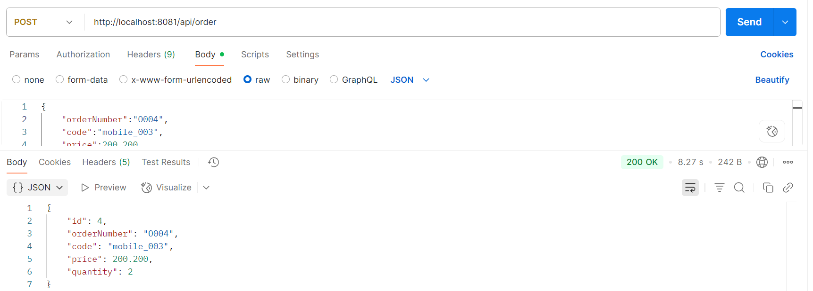

Inventory service

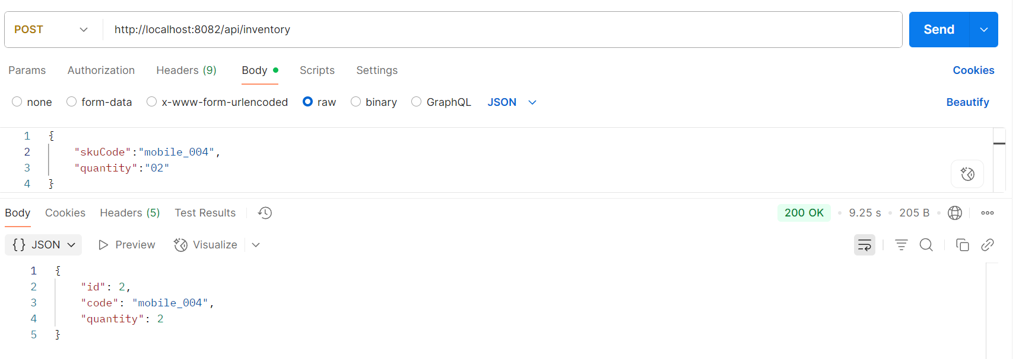

Calling product service with API gateway

