



# Project Report

PROPERTY MANAGEMENT APPLICATION USING SALESFORCE

.

Property Management Application using Salesforce

## 1.Introduction:

Are you new to Salesforce? Not sure exactly what it is, or how to use it? Don’t know where you should start on your learning journey? If you’ve answered yes to any of these questions, then you’re in the right place. This module is for you.

Welcome to Salesforce! Salesforce is game-changing technology, with a host of productivity-boosting features, that will help you sell smarter and faster. As you work toward your badge for this module, we’ll take you through these features and answer the question, “What is Salesforce, anyway?”

## What Is Salesforce?

Salesforce is your customer success platform, designed to help you sell, service, market, analyze, and connect with your customers.

Salesforce has everything you need to run your business from anywhere. Using standard products and features, you can manage relationships with prospects and customers, collaborate and engage with employees and partners, and store your data securely in the cloud.

So what does that really mean? Well, before Salesforce, your contacts, emails, follow-up tasks, and prospective deals might have been organized something like this:

<https://youtu.be/r9EX3lGde5k>

## learning

1. Real Time Salesforce Project
2. Object & Relationship in Salesforc

**2. Problem definition and Design Thinking**

**2.1 Empathy map :**

An empathy map is a collaborative visualization used to articulate what we know about a particular type of user. It externalizes knowledge about users in order to

1) create a shared understanding of user needs, and

2) aid in decision making

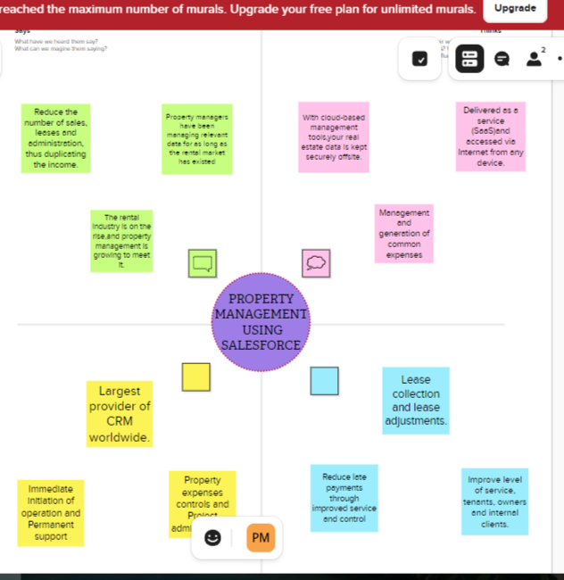

**2.2 Brainstorming :**

Brainstorming is a group problem-solving method that involves

the spontaneous contribution of creative ideas and solutions. This technique requires intensive, freewheeling discussion in which every member of the group is encouraged to think aloud and suggest as many ideas as possible based on their diverse knowledge.

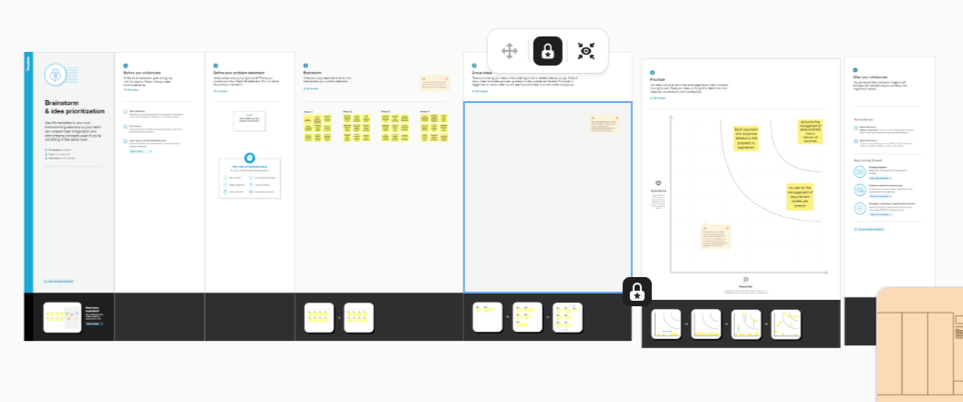

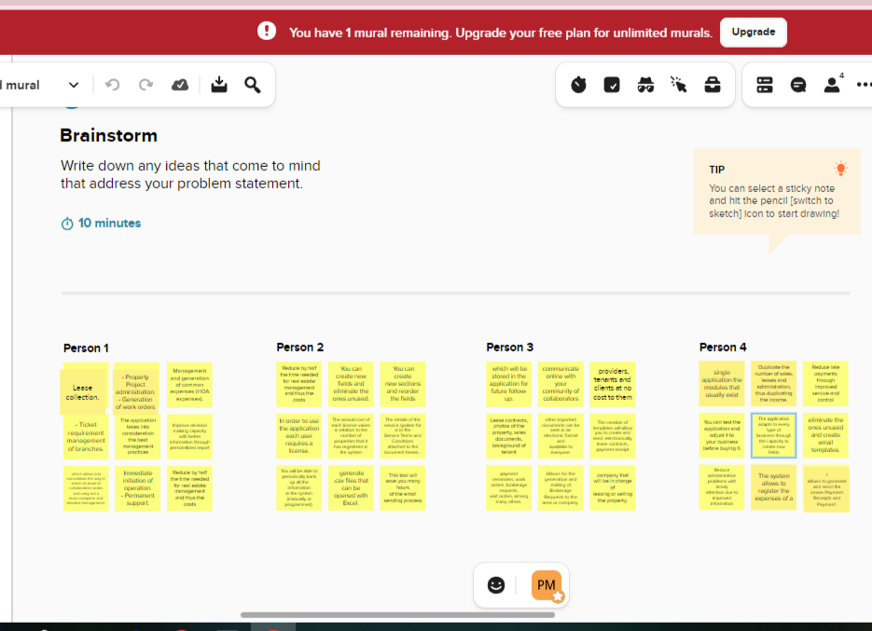

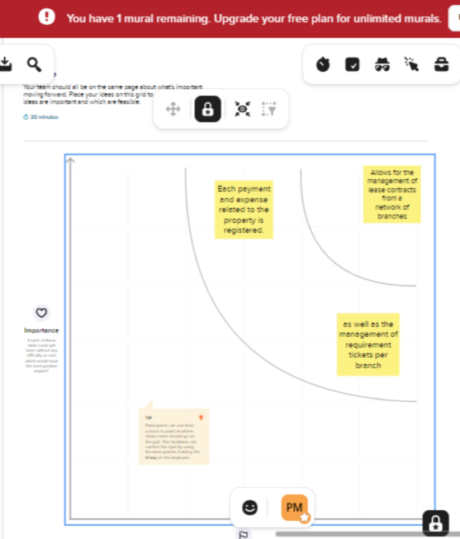

**3.1** **Result:**

|  |  |  |  |
| --- | --- | --- | --- |
| S.no | **Object name** | **Field label** | **Data type** |
| **1** | Buy | Buyers | Percentage |
| **2** | Rent | Rents | Cuddalore |
| **3** | Loan | Loans | Currency |

**3.2 Activity and Screen shorts**

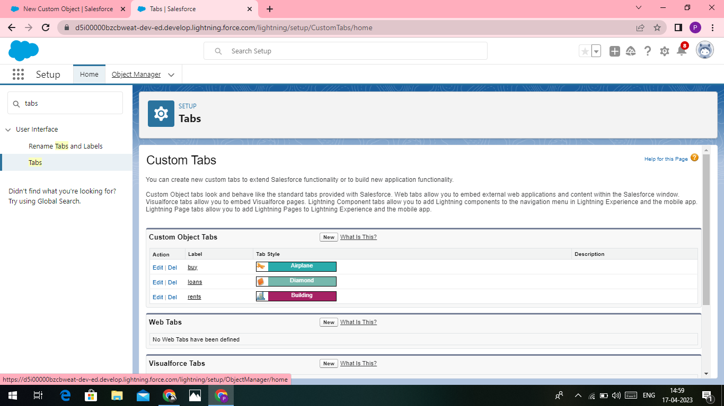

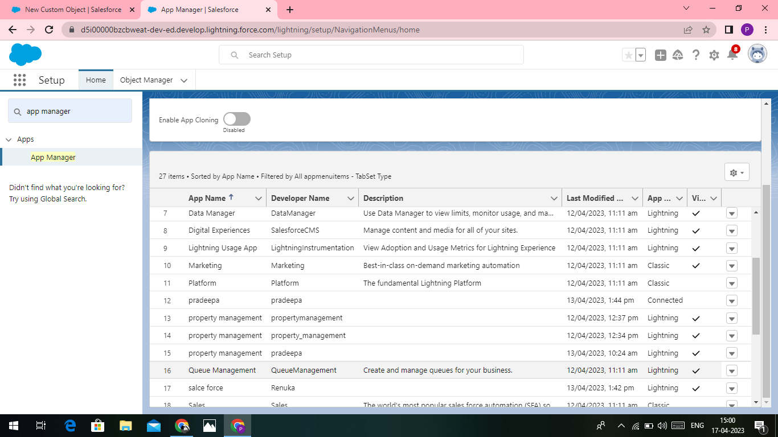

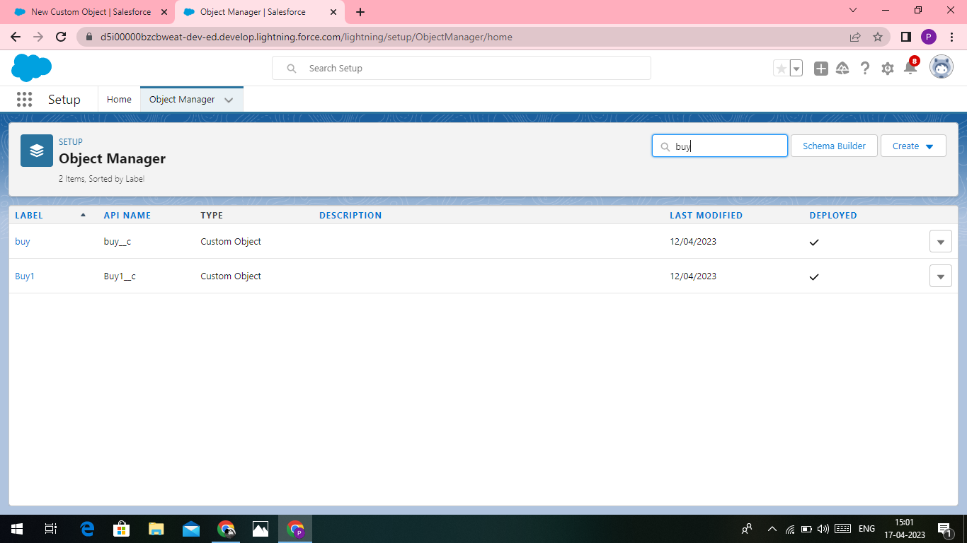

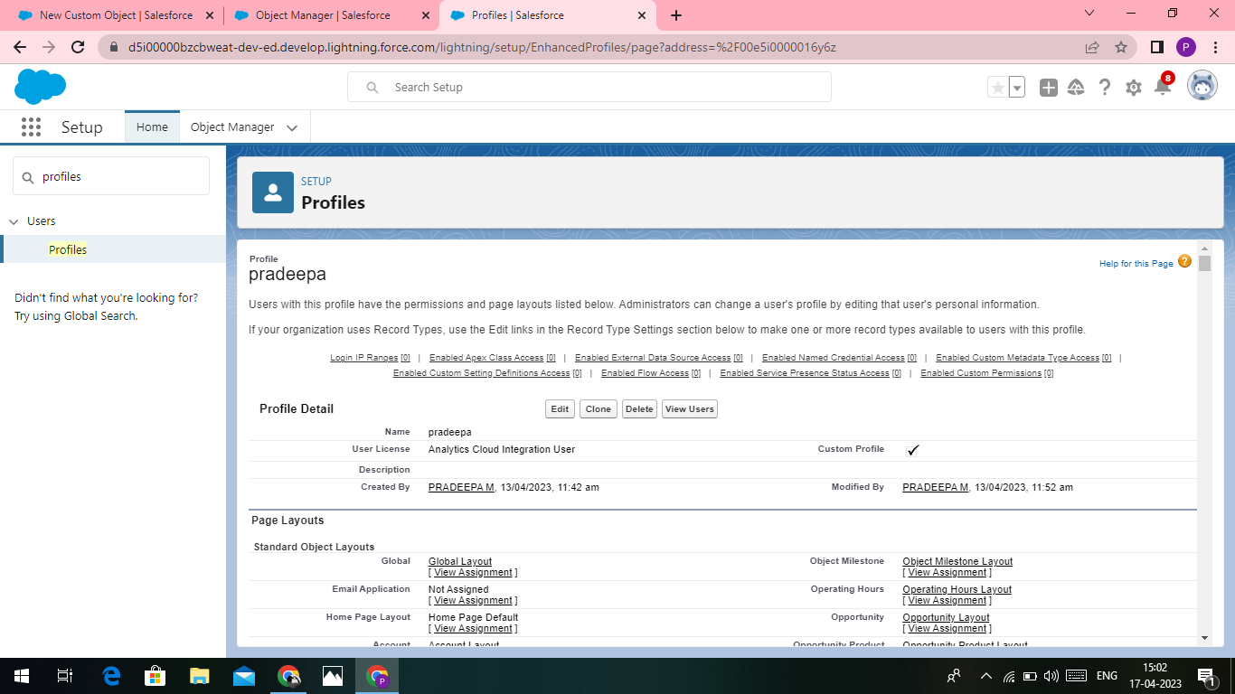

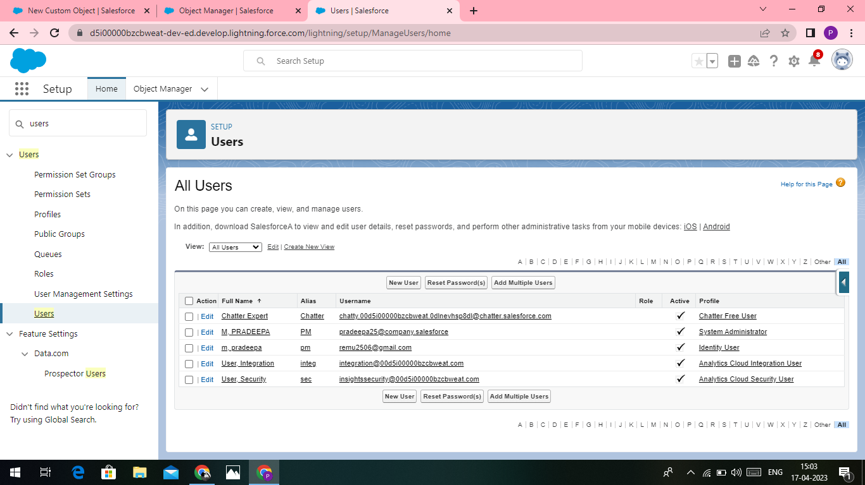

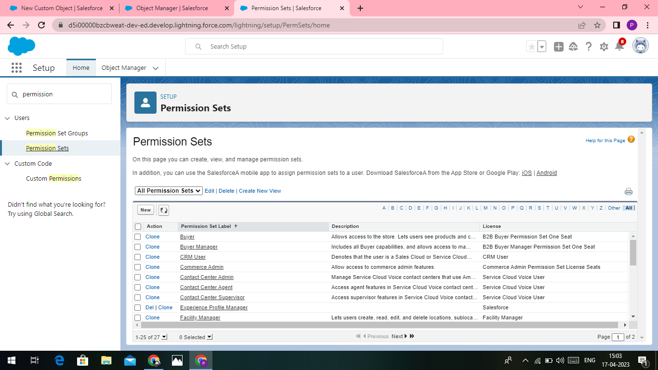

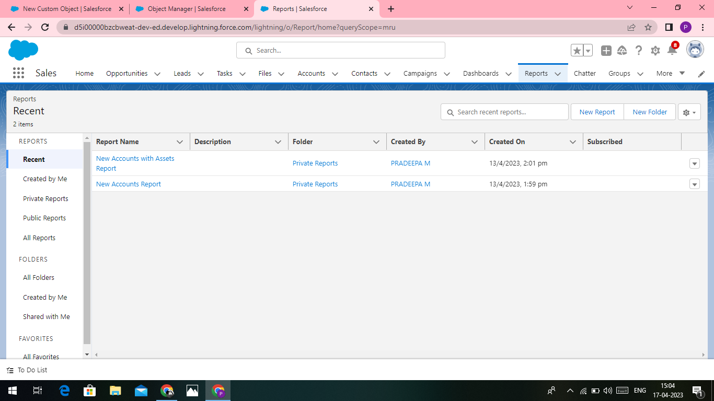

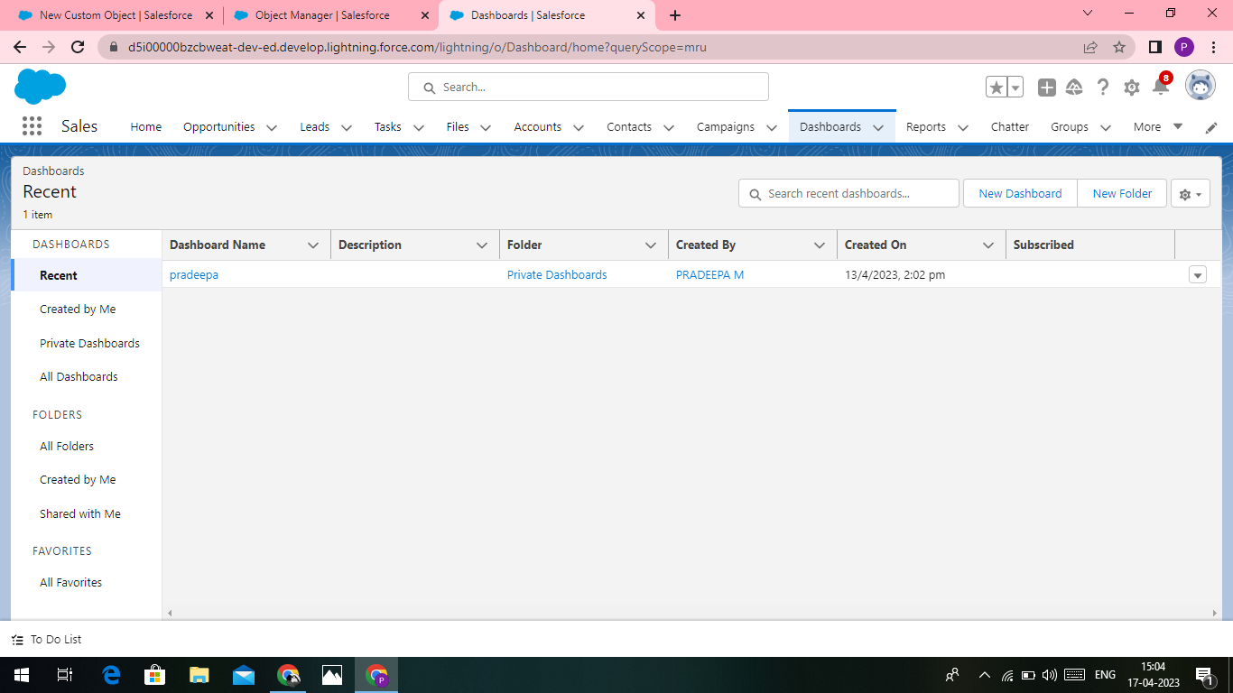

**4.TRAILHEAD PROFILE PUBLIC URL**

**Team leader : https://trailblazer.me/id/remum6**

**Team member 1 : https://trailblazer.me/id/pkalaimani2**

**Team member 2: https://trailblazer.me/id/rraman141**

**Team member 3: trailblazer.me/id/prajan64**

**Advantage:**

1) Having Quality Tenants

2) Avoid Costly Lawsuits and Liabilities

3) Higher Tenant Retention Rate

4) On-Time Rent Payments

5) Lower Maintenance Costs

6) Increased Efficiency and Savings

**Dis advantage:**

1) Time-consuming if you choose the wrong system. ...

2) Might seem expensive for a small business. ...

3) Training (cost and time**).**

**Conclusion**

In conclusion, Property Management System (PMS) software is very crucial for all the Hotels. Especially Opera PMS constitutes the most appropriate PMS software for Hilton Athens. It is user friendly, connects with Central Reservation System (CRS), Point of Sale (POS) etc. and provides all the tools the hotel needs in order to operate effectively