
CO2 - ASSESSMENT 3
 |  | SCENARIO-BASED ASSESSMENT
Course Faculty | : | Dr. K. Anbazhagan
Course Name | : | Ethical Hacking
Course Code | : | ITA1405
Slot | : | Slot A
Total Marks | : | 100

CO2 :
Foot printing Tools: Conducting Competitive Intelligence, DNS Zone Transfers,
Introduction to Social Engineering: Social Engineering Attacks and Countermeasures. (BT3)

Code of Conduct:
I Pradeepa,T (Name / Reg No) certify that this submission is my original work and that I have adhered to the guidelines specified for this assessment.
I understand that any violation of academic integrity rules will result in disciplinary action.

Signature of the student

PRADEEPA.T

Visit https://dnsdumpster.com. Find your assigned website

- under "Enter a Domain to Test" – www.cloudflare.com
- Click Start Test
- Upload complete report as .xlsx Qile which you downloaded after Test
- Upload map generated by DNSDumpster

- 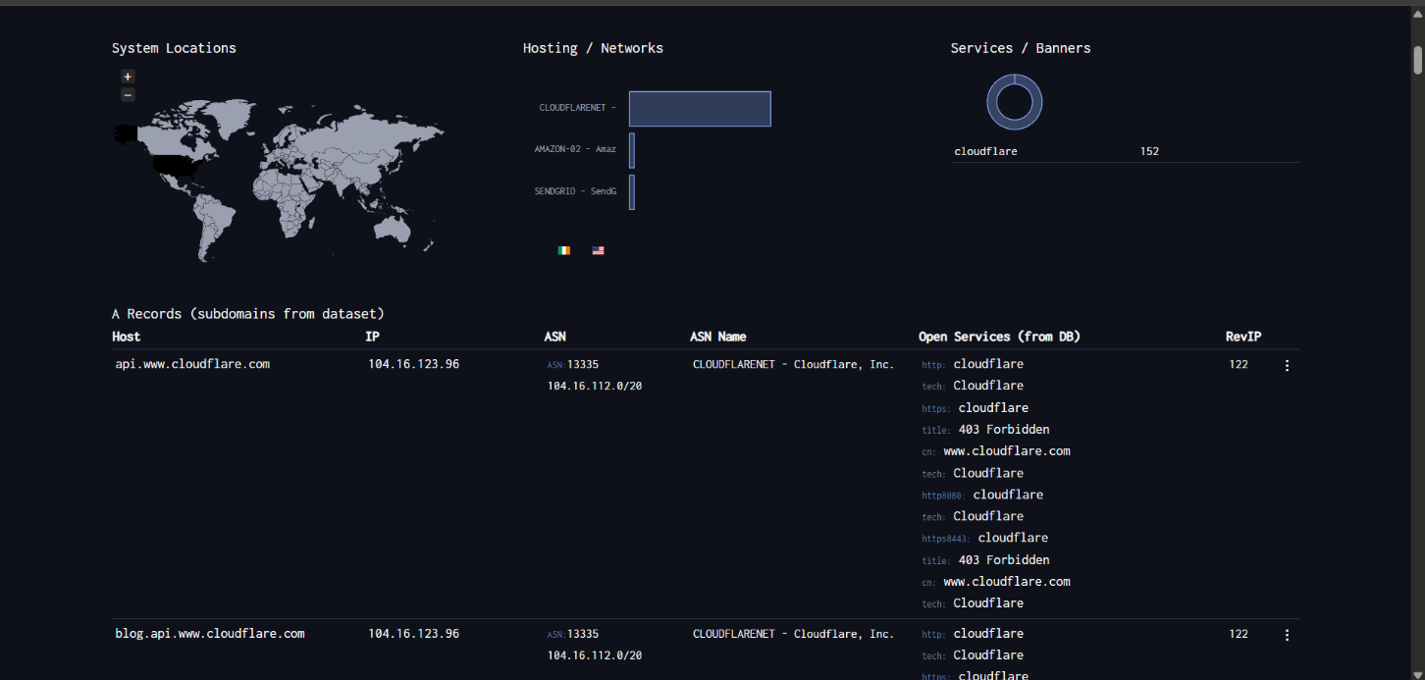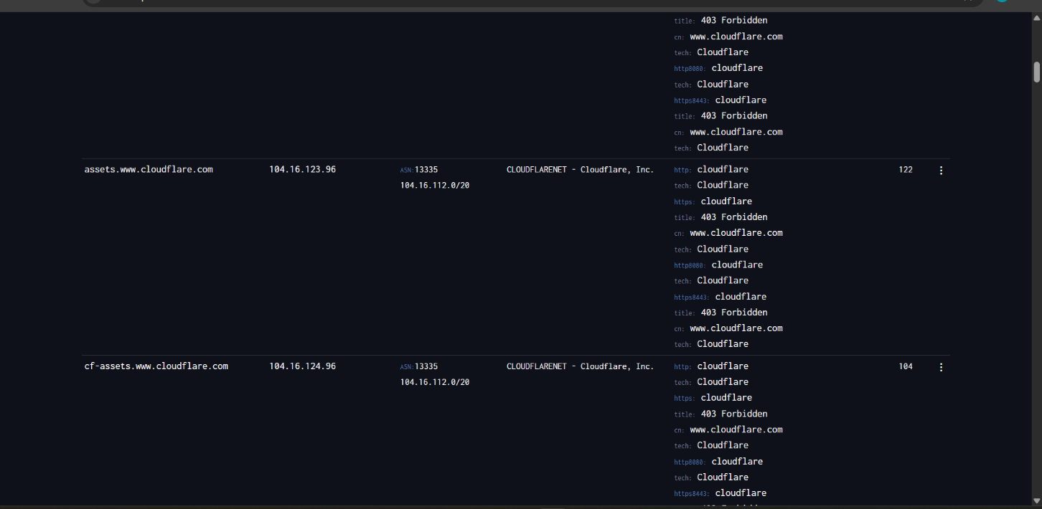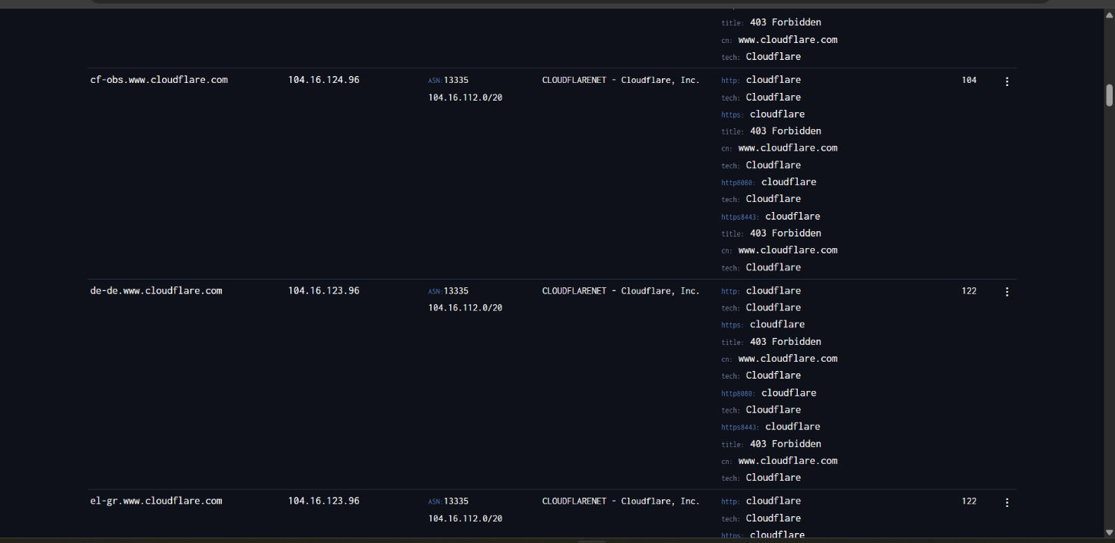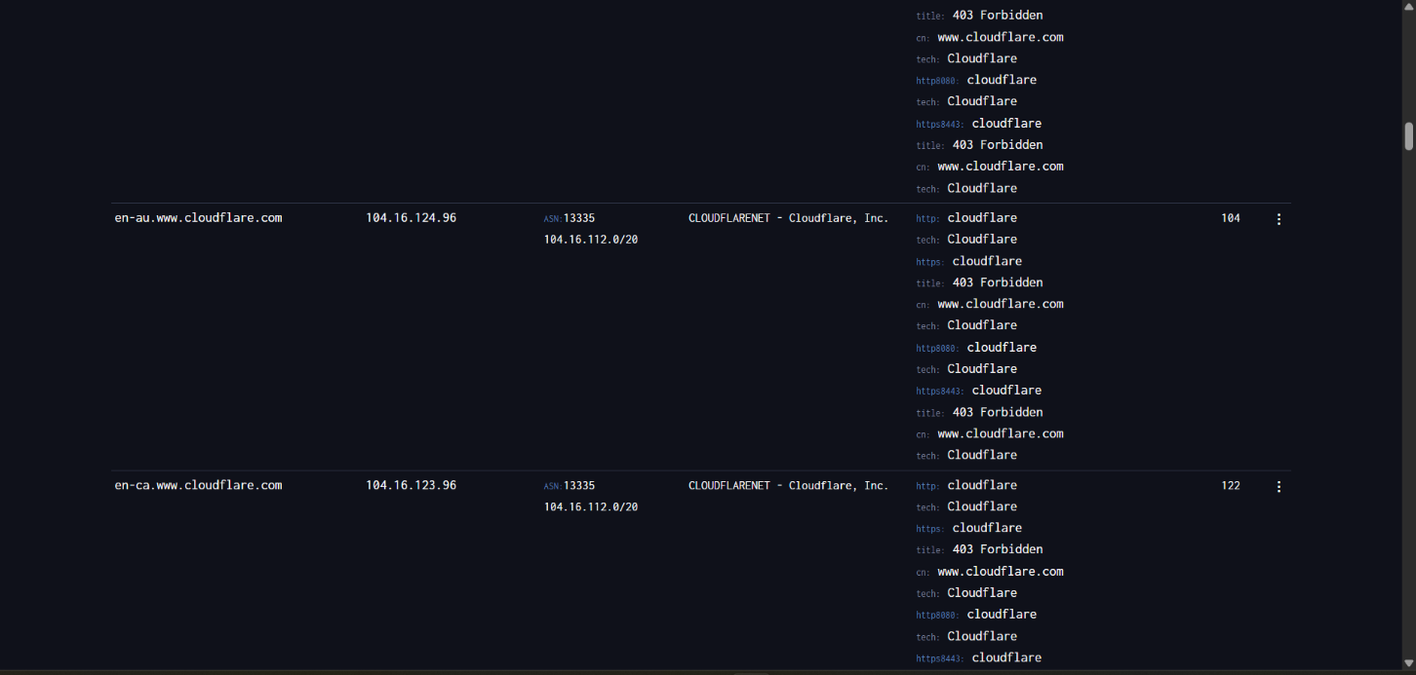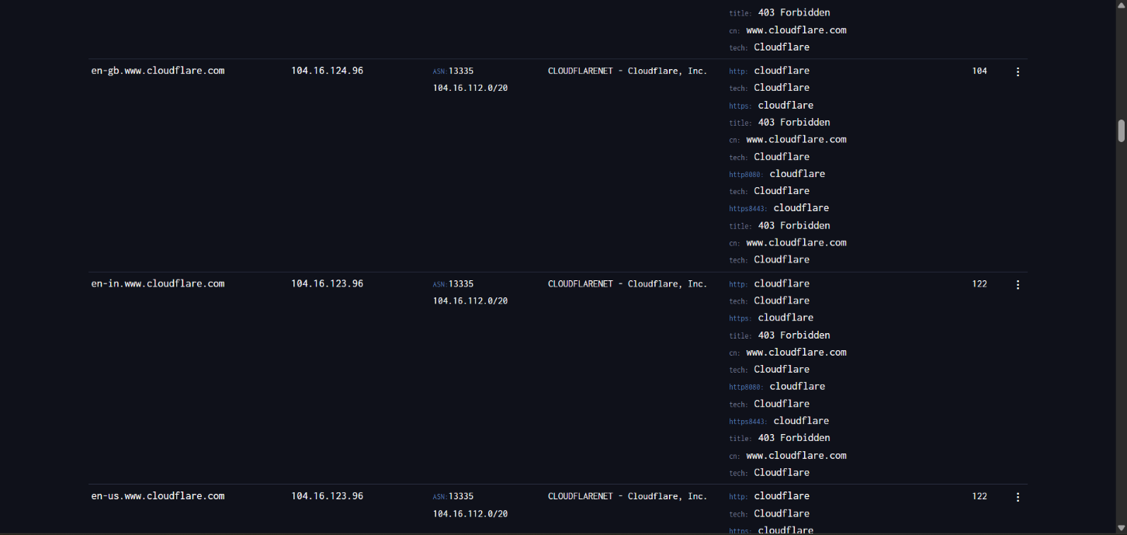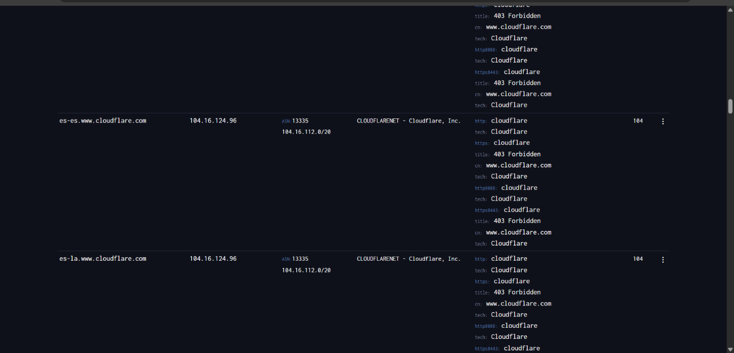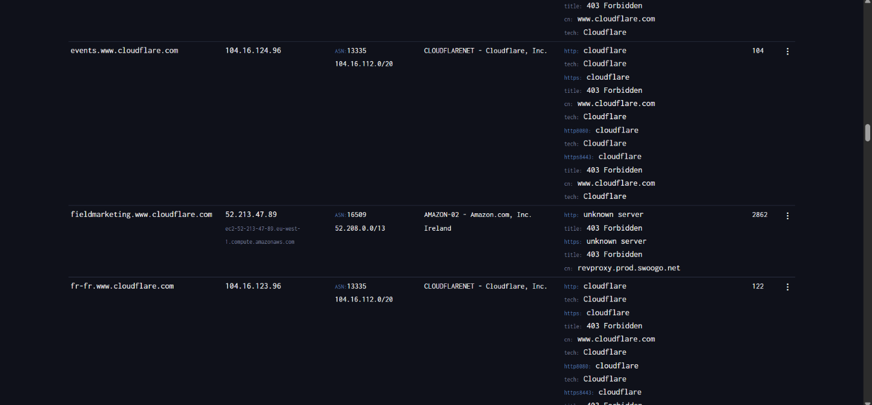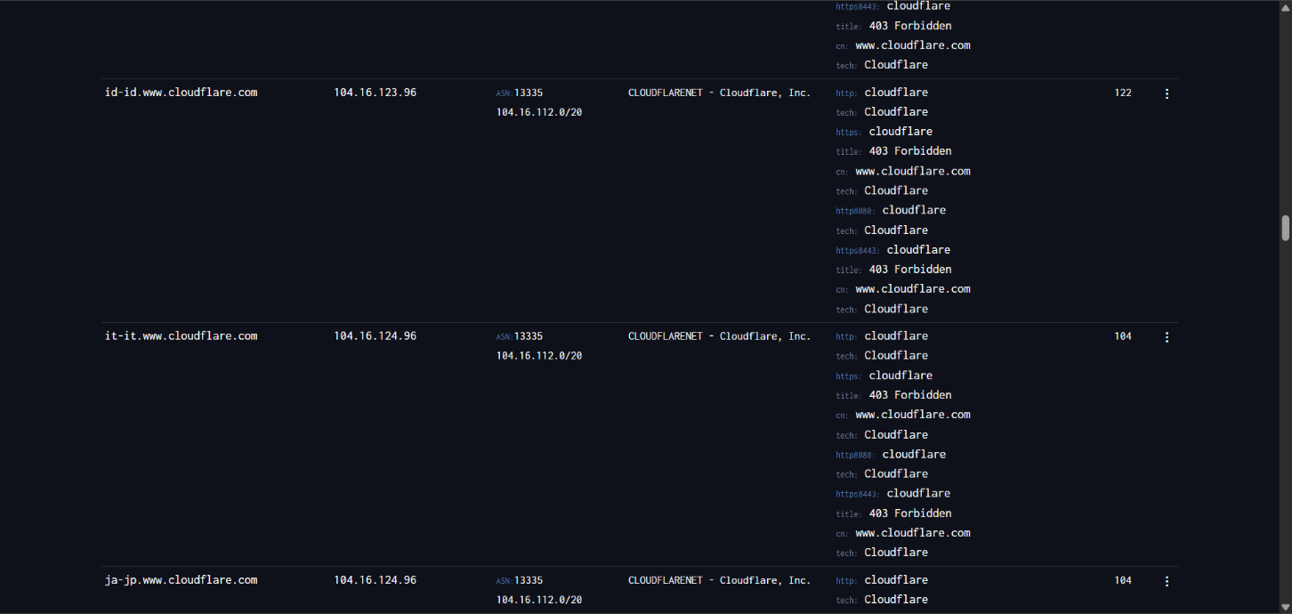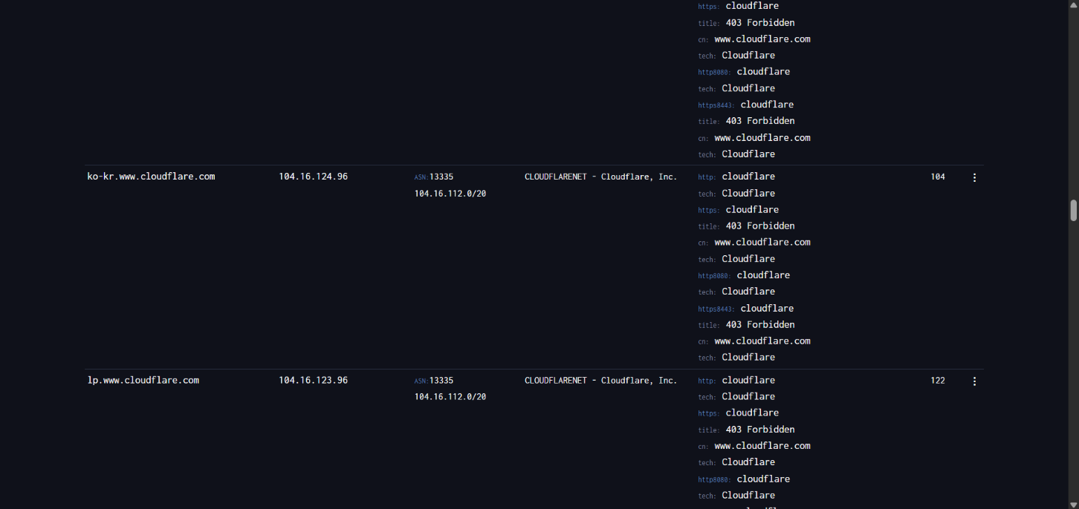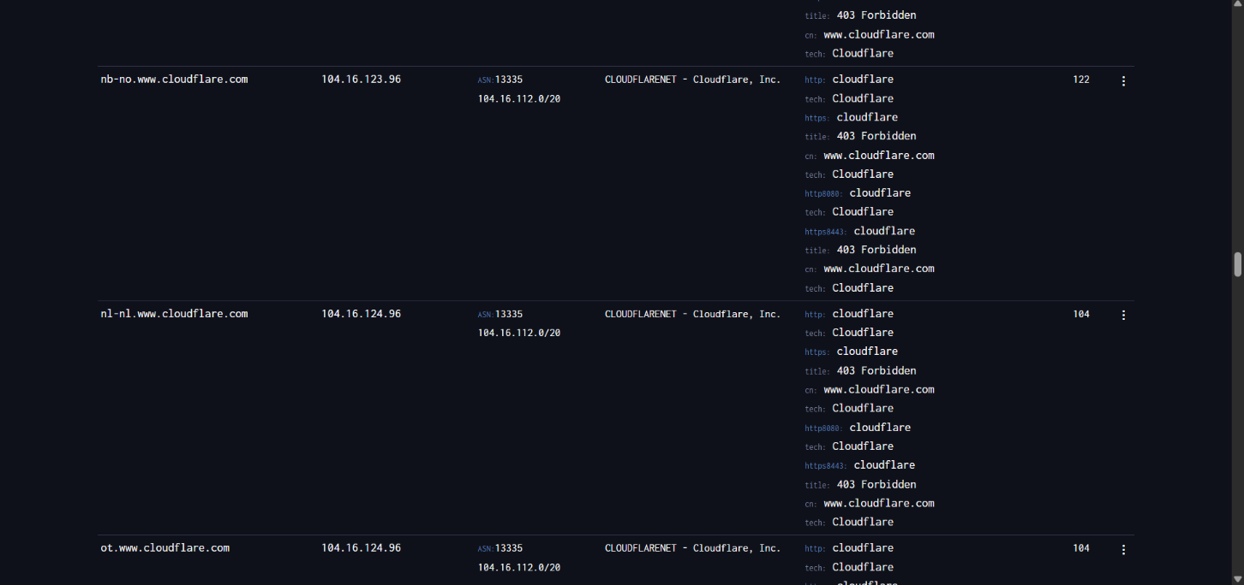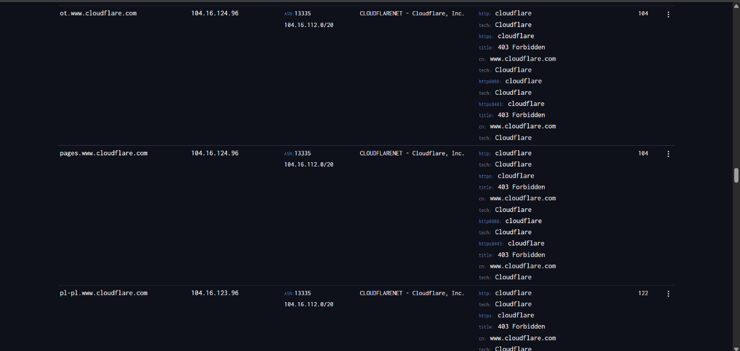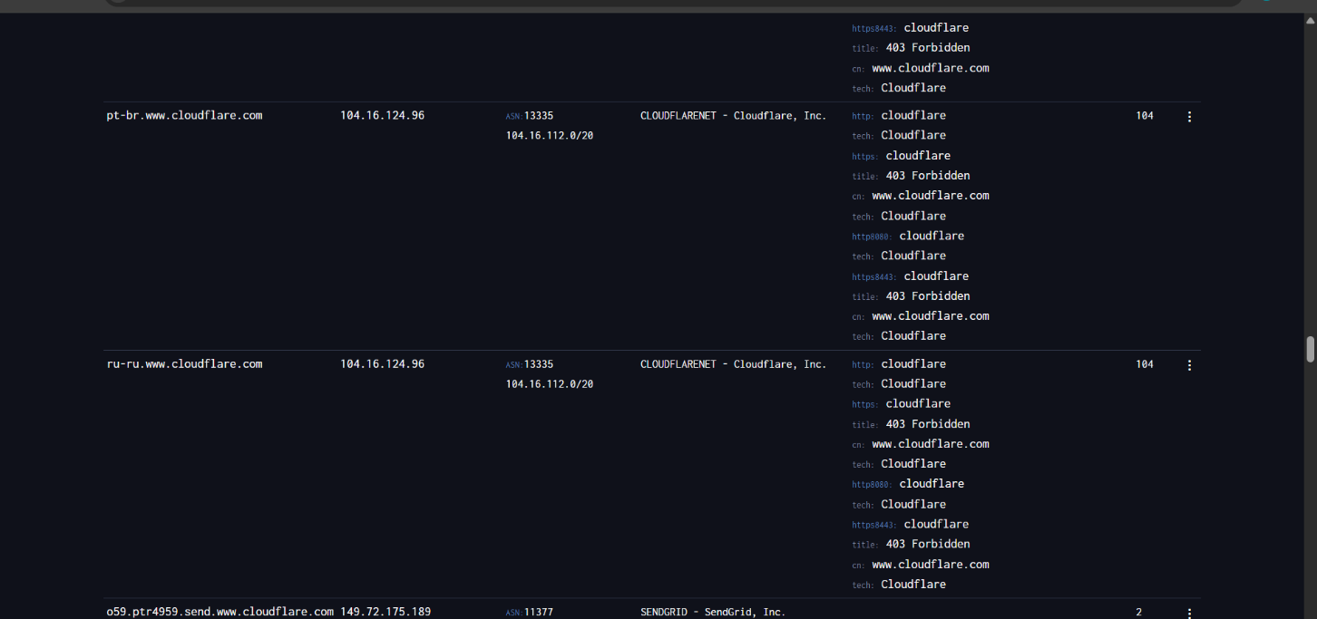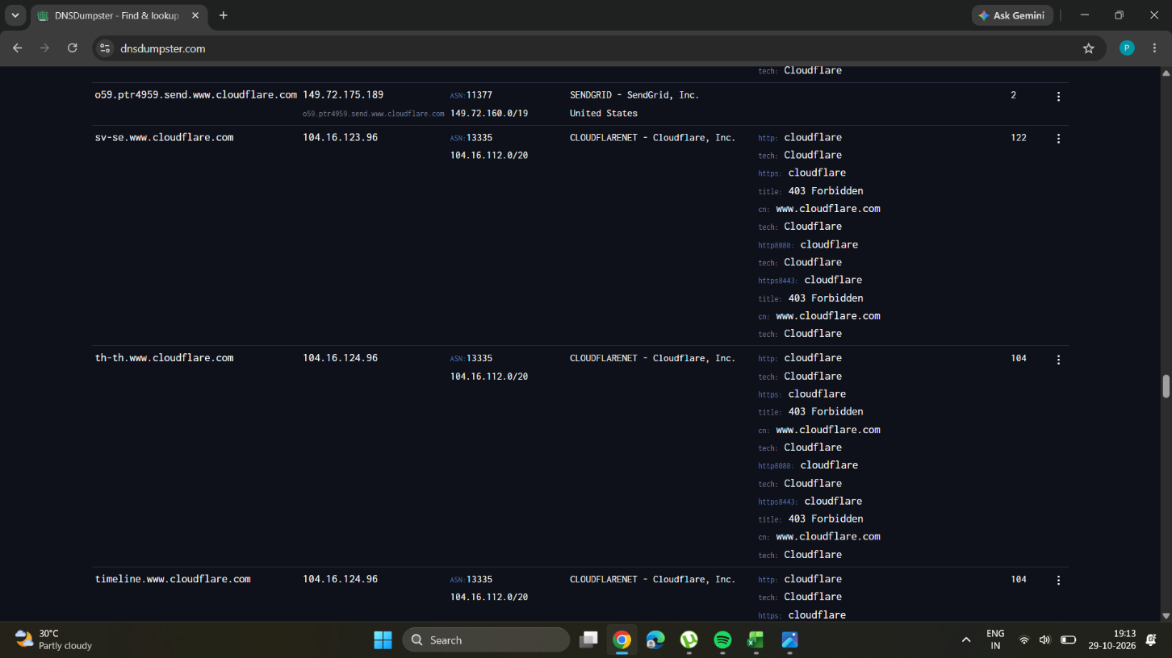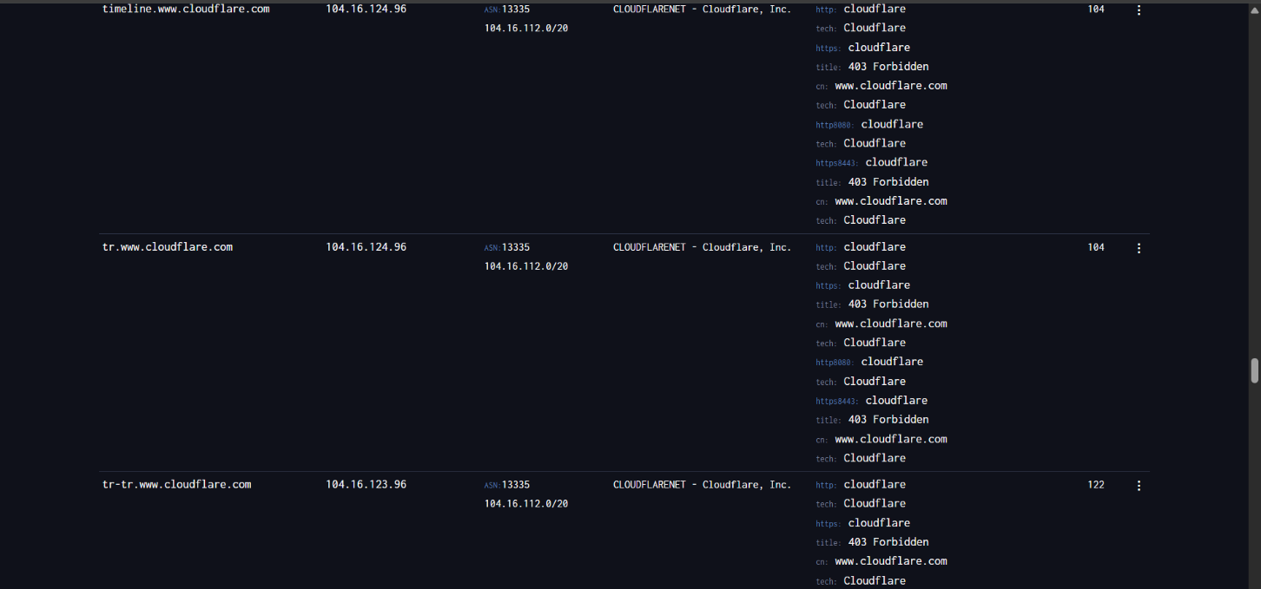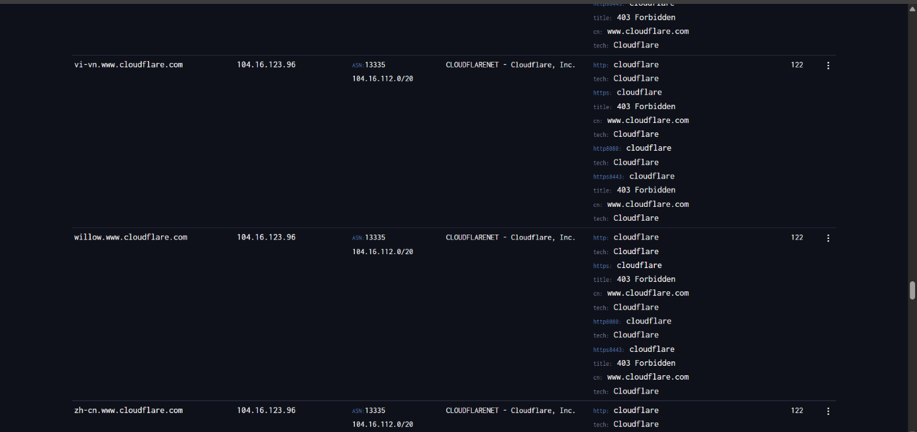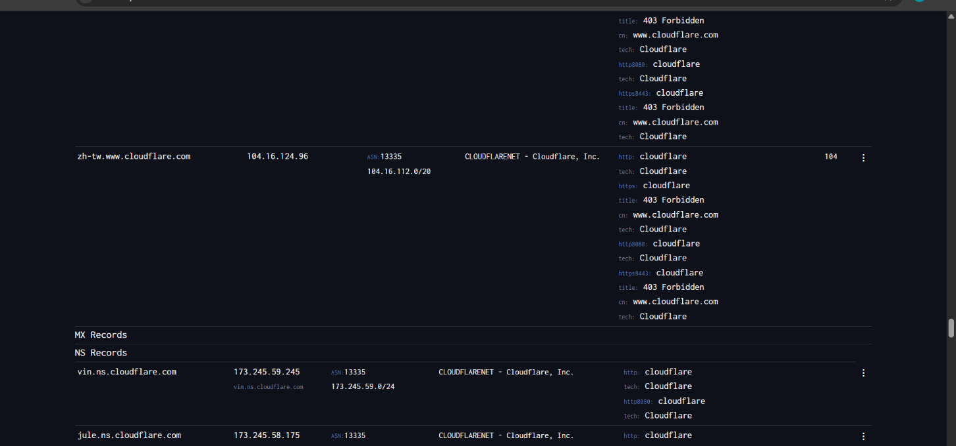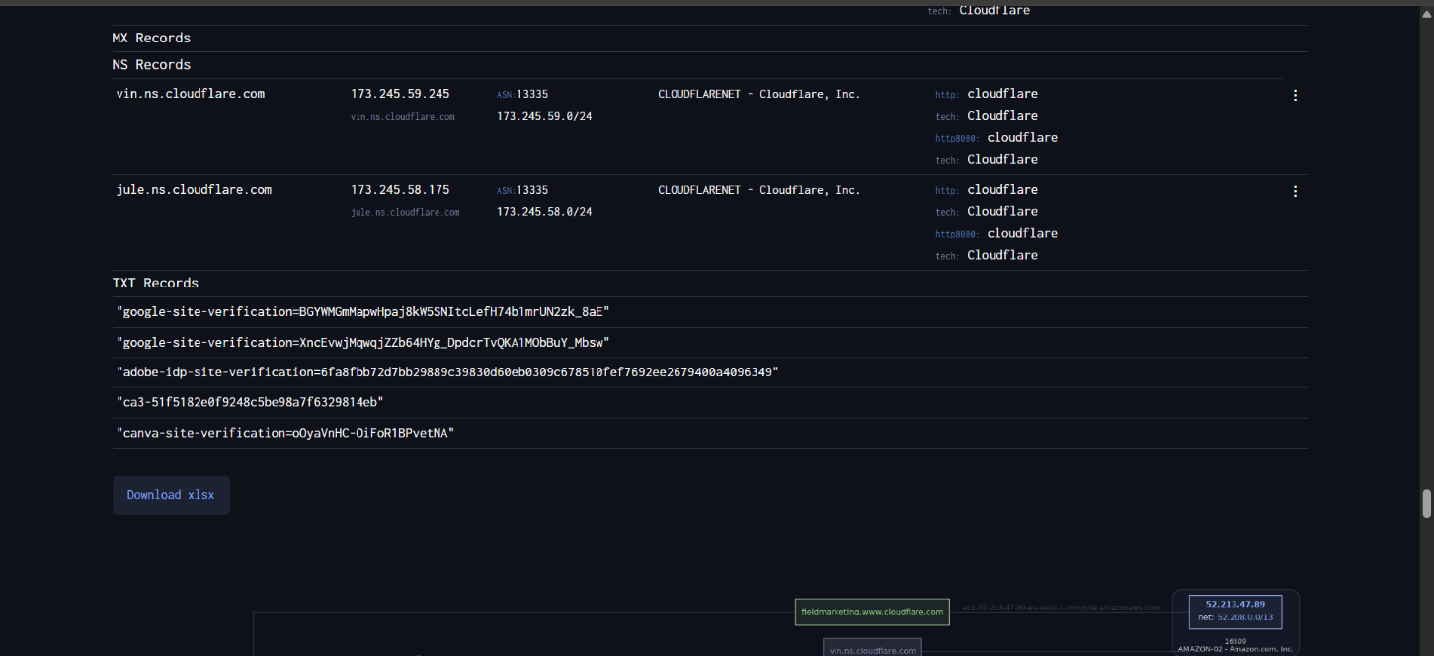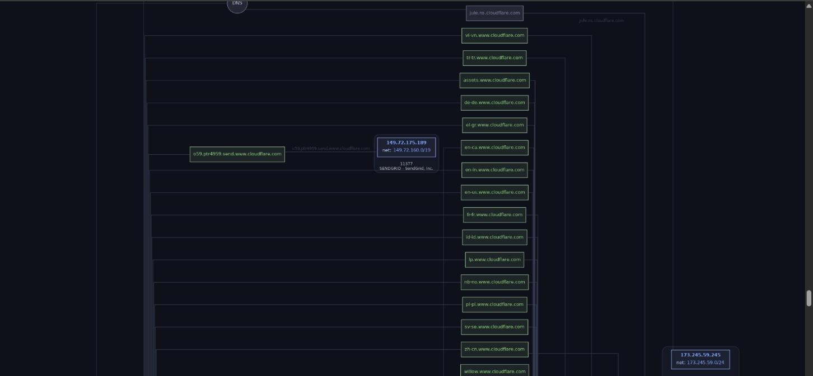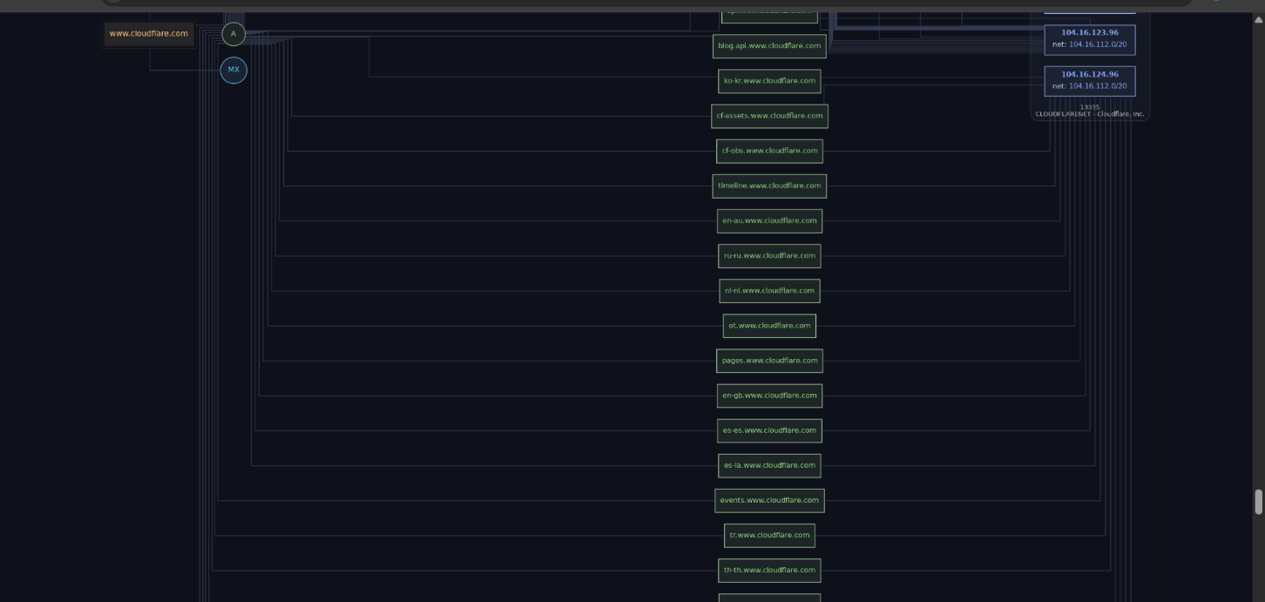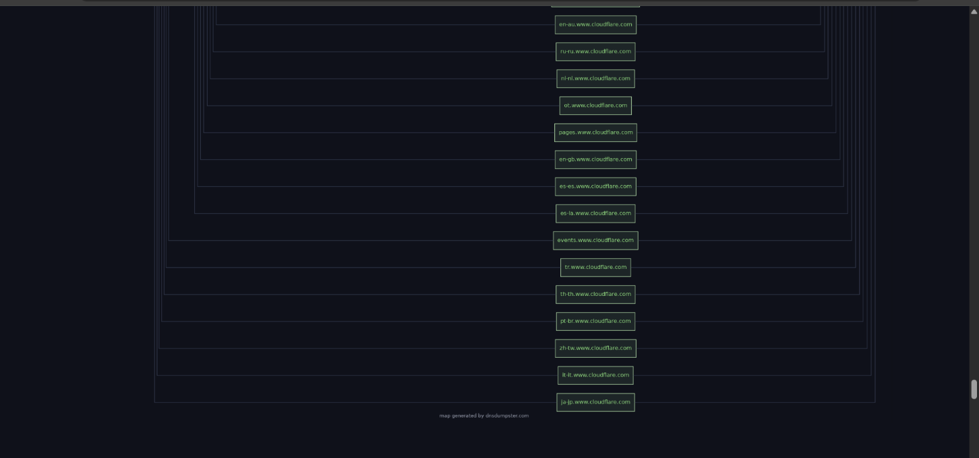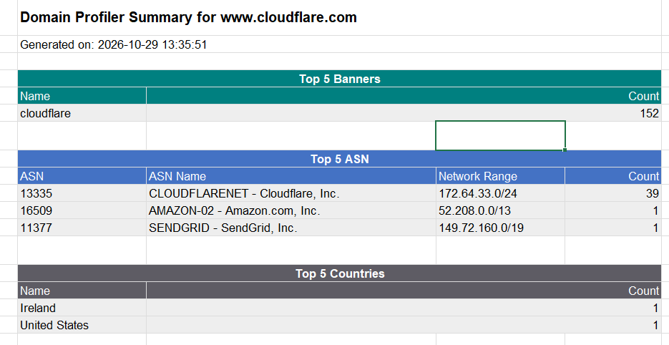
RUBRICS

Criteria | Weightage (%) | Level 4 (Exemplary) | Level 3 (ProVicient) | Level 2 (Developing) | Level 1 (Beginning)
DNS Footprinting  Execution | 25% | Successfully performs DNS  footprinting on the assigned domain  using DNSDumpster and follows the  complete procedure accurately. | Performs DNS footprinting  correctly with  minor procedural errors. | Performs basic DNS footprinting with assistance. | Unable to perform the  required DNS footprinting.
DNS Information IdentiVication | 25% | Accurately identiQies and interprets  relevant DNS, host,  IP, and infrastructure  information from the generated results. | IdentiQies most relevant  information with minor omissions. | IdentiQies some DNS information but  provides limited interpretation. | Fails to identify or interpret  relevant DNS information.
Analysis of DNS  Infrastructure | 30% | Thoroughly analyzes the DNS  map and discovered infrastructure and  explains its security signiQicance clearly. | Correctly analyzes most  infrastructure  information with minor gaps. | Provides basic analysis but misses important  relationships or security implications. | Unable to analyze the  DNS  infrastructure meaningfully.
Report and  Evidence  Presentation | 20% | Submits a complete Excel report and  DNS map with clear, accurate, and wellorganized evidence. | Provides the required report  and map with minor  documentation issues. | Submission is partially complete or poorly organized. | Required report/map is missing,  incomplete, or unusable.

