AI POWERED GOVERNMENT SCHEME ELIGIBILITY PORTAL
A MINI PROJECT REPORT
Submitted by
[STUDENT NAME 1] | ([REGISTER NO. 1])
[STUDENT NAME 2] | ([REGISTER NO. 2])
[STUDENT NAME 3] | ([REGISTER NO. 3])
[STUDENT NAME 4] | ([REGISTER NO. 4])
in partial fulfillment for the award of the degree of
BACHELOR OF ENGINEERING
in
[DEPARTMENT NAME — e.g. COMPUTER SCIENCE AND ENGINEERING]
V.S.B. ENGINEERING COLLEGE, KARUR-639111 (AN AUTONOMOUS INSTITUTION)
ANNA UNIVERSITY :: CHENNAI 600 025
[MONTH YEAR — e.g. MAY 2026]
BONAFIDE CERTIFICATE
Certified that this mini project report titled "AI POWERED GOVERNMENT SCHEME ELIGIBILITY PORTAL" is the bonafide work of [STUDENT NAME 1] ([REGISTER NO. 1]), [STUDENT NAME 2] ([REGISTER NO. 2]), [STUDENT NAME 3] ([REGISTER NO. 3]), [STUDENT NAME 4] ([REGISTER NO. 4]), who carried out the project work under our supervision.

[GUIDE NAME, M.E., (Ph.D.,)] | SIGNATURE
Assistant Professor  Project Guide  Department of [DEPARTMENT NAME — e.g. COMPUTER SCIENCE AND ENGINEERING]  V.S.B. ENGINEERING COLLEGE, KARUR-639111 (AN AUTONOMOUS INSTITUTION) | [HOD NAME, M.E., (Ph.D.,)]  Head of the Department  Department of [DEPARTMENT NAME — e.g. COMPUTER SCIENCE AND ENGINEERING]  V.S.B. ENGINEERING COLLEGE, KARUR-639111 (AN AUTONOMOUS INSTITUTION)

Submitted for the Anna University Project Viva-Voce examination held on _______________.

INTERNAL EXAMINER | EXTERNAL EXAMINER
ACKNOWLEDGEMENT
We express our sincere thanks to our parents for providing us with a supportive environment throughout this project. We wish to thank our founder and Chairman for the endeavour of establishing this premier institution.
We extend our gratitude to [PRINCIPAL NAME, M.E., Ph.D.,], Principal, V.S.B. ENGINEERING COLLEGE, KARUR-639111 (AN AUTONOMOUS INSTITUTION), for the encouragement and support extended during this project.
We are indebted to [HOD NAME, M.E., (Ph.D.,)], Head of the Department, for the guidance and direction provided throughout the course of this mini project.
We are grateful to our project guide [GUIDE NAME, M.E., (Ph.D.,)], Assistant Professor, for the invaluable technical support and continuous review of our work.
Our sincere thanks to all the faculty members of the department and our friends for their assistance in the successful completion of this project.
DEPARTMENT OF
[DEPARTMENT NAME — e.g. COMPUTER SCIENCE AND ENGINEERING]

Vision of the Institution
To impart futuristic technical education of the highest quality to the student community, inculcating discipline and self-confidence, preparing students for life as responsible citizens who uphold human values, and to establish the Institution as one of academic excellence of international standard.

Mission of the Institution
To transform individuals into well-rounded professionals through state-of-the-art infrastructure, time-consciousness, responsiveness, and the best academic practices in assessment and mentoring.

Vision of the Department
To groom students into futuristic, globally competent, and socially responsible engineers capable of addressing engineering challenges in their chosen discipline.

Mission of the Department
- To impart high-quality professional training at the undergraduate level with emphasis on fundamental engineering principles.
- To expose students to research experience through recognized research centers and collaborative projects.
- To equip students with the skills required to solve complex technological problems relevant to modern society.
- To instil moral, ethical values, and interpersonal skills in students.
Program Educational Objectives (PEOs)
PEO 1: Pursue a career in reputed organizations, higher studies at premier institutions, or establish start-up ventures.
PEO 2: Acquire core competencies in computing and engineering practices with exposure to current software tools and technologies.
PEO 3: Exhibit professional and ethical conduct along with effective collaborative work experience.
Program Outcomes (POs)
PO1 (Engineering knowledge): Apply knowledge of mathematics, science, and engineering fundamentals to the solution of complex engineering problems.
PO2 (Problem analysis): Identify, formulate, and analyze complex engineering problems using first principles of mathematics and engineering sciences.
PO3 (Design/development of solutions): Design solutions for complex engineering problems that meet specified needs with due consideration for public health, safety, and societal factors.
PO4 (Modern tool usage): Create, select, and apply appropriate techniques, resources, and modern engineering tools to complex engineering activities.
PO5 (The engineer and society): Apply reasoning informed by contextual knowledge to assess societal, health, safety, and legal issues relevant to professional practice.
PO6 (Ethics): Apply ethical principles and commit to professional ethics and responsibilities of engineering practice.
PO7 (Individual and team work): Function effectively as an individual and as a member or leader in diverse and multidisciplinary teams.
PO8 (Communication): Communicate effectively through written reports, documentation, and presentations.
PO9 (Project management and finance): Demonstrate knowledge of engineering and management principles to manage projects in multidisciplinary environments.
PO10 (Life-long learning): Recognize the need for and engage in independent and life-long learning.
Program Specific Outcomes (PSOs)
PSO1: Apply mathematical and computing knowledge to identify and provide solutions for computing problems.
PSO2: Design and develop software applications spanning algorithms, networking, web design, and data analytics of varying complexity.
PSO3: Apply standard engineering practices in software projects using open-source environments to deliver quality products.
ABSTRACT
Millions of citizens remain unaware of the government welfare schemes they are entitled to, largely because eligibility rules are scattered across department portals, notices, and documents that are written for officials rather than for the public. This mini project presents Scheme Setu, an AI-assisted, full-stack web platform that consolidates central and state welfare schemes into a single searchable directory and evaluates a citizen's eligibility against every scheme using a transparent, rules-based scoring engine.
The system is built with a React.js (Vite) and Tailwind CSS frontend, a Spring Boot 3 backend secured with JWT-based stateless authentication, and a MySQL relational database covering users, schemes, applications, documents, eligibility results, notifications, and chat history. The eligibility engine evaluates eleven factors — age, gender, annual income, state, occupation, category, disability status, student status, farmer status, widow status, and senior-citizen status — against each scheme's hard constraints and targeted-group flags, producing a ranked list of schemes with a 0–100 match score and a plain-language explanation for every result, rather than an opaque yes/no answer.
Beyond the eligibility checker, the platform is designed to support a Google Gemini-powered AI assistant for procedural and document-related queries, document upload with PDF report generation, an administrative dashboard for scheme and user management, and an email notification service — modules planned as phased extensions to the core system delivered in this report.
The resulting system demonstrates a scalable, secure, and citizen-centric approach to bridging the gap between government welfare schemes and the people they are designed to serve, and is suitable for extension into a production e-governance service. After completion of this project, PO1–PO10 and PSO1–PSO3 are attained.
TABLE OF CONTENTS
Chapter No. | Title | Page No.
 | ABSTRACT
 | LIST OF FIGURES
 | LIST OF ABBREVIATIONS
1. | INTRODUCTION | 1
 | 1.1 Overview of the System | 2
 | 1.2 System Components | 3
 | 1.3 Importance and Objectives | 4
2. | LITERATURE SURVEY | 5
3. | SYSTEM ANALYSIS | 8
 | 3.1 Existing System | 9
 | 3.2 Drawbacks of Existing System | 9
 | 3.3 Proposed System | 10
 | 3.4 Advantages of Proposed System | 11
4. | SYSTEM SPECIFICATION | 12
 | 4.1 Hardware Requirements | 12
 | 4.2 Software Requirements | 13
 | 4.3 Network Requirements | 14
5. | SYSTEM DESIGN | 15
 | 5.1 System Architecture Diagram | 15
 | 5.2 Entity-Relationship Diagram | 16
 | 5.3 Use Case Diagram | 17
 | 5.4 Data Flow Diagram | 18
6. | IMPLEMENTATION | 19
 | 6.1 Modules Used | 19
 | 6.2 Module Description | 20
7. | SYSTEM TESTING | 24
 | 7.1 Types of Testing | 24
 | 7.2 Test Cases | 25
 | 7.3 Validation | 26
8. | FEASIBILITY STUDY | 27
 | 8.1 Technical, Economic, and Operational Feasibility | 27
 | 8.2 Methodology | 28
9. | CONCLUSION AND FUTURE ENHANCEMENT | 29
 | APPENDIX — SAMPLE SOURCE CODE | 30
 | REFERENCES | 34
LIST OF FIGURES
Figure No. | Name of the Figure | Page No.
5.1 | System Architecture Diagram | 15
5.2 | Entity-Relationship Diagram | 16
5.3 | Use Case Diagram | 17
5.4 | Data Flow Diagram (Level 1) | 18
LIST OF ABBREVIATIONS
S. No. | Abbreviation | Expansion
1 | API | Application Programming Interface
2 | JWT | JSON Web Token
3 | DBMS | Database Management System
4 | UI | User Interface
5 | CRUD | Create, Read, Update, Delete
6 | REST | Representational State Transfer
7 | JPA | Java Persistence API
8 | SMTP | Simple Mail Transfer Protocol
9 | PDF | Portable Document Format
10 | AI | Artificial Intelligence
11 | CORS | Cross-Origin Resource Sharing
12 | ORM | Object Relational Mapping

1. INTRODUCTION

1.1 Overview of the System
The Government of India and various state governments run hundreds of welfare schemes covering income support, pensions, scholarships, disability assistance, and agricultural aid. Despite the scale of these programs, a large section of eligible citizens never applies, primarily because scheme information is fragmented across department websites, government notices, and PDFs that assume a level of bureaucratic familiarity most citizens do not have.
Scheme Setu — an AI Powered Government Scheme Eligibility Portal — addresses this gap by consolidating scheme data into a single searchable directory and pairing it with a transparent, rules-based eligibility engine. A citizen enters basic details once — age, income, state, category, occupation, and a handful of status flags — and instantly receives every matching scheme, ranked by a numeric match score, along with the specific reason each scheme was or was not matched.
The platform is designed as a public-first system: browsing schemes and checking eligibility require no login, while registered users additionally gain access to a personal dashboard intended to track applications, uploaded documents, and notifications as the system is extended.

1.2 System Components
The system is composed of the following major components:
- Frontend — a React.js (Vite) single-page application styled with Tailwind CSS, providing the landing page, scheme directory, eligibility checker form, authentication pages, and user dashboard.
- Backend — a Spring Boot 3 REST API exposing authentication, scheme, and eligibility endpoints, structured using the standard Controller–Service–Repository layering with Spring Data JPA over Hibernate.
- Eligibility Engine — a dedicated service that evaluates every active scheme against a citizen's submitted profile and produces a ranked, explained result set.
- Database — a MySQL 8 relational schema covering users, admins, schemes, applications, documents, eligibility results, notifications, and chat history.
- Security Layer — stateless JWT authentication with BCrypt password hashing and role-based endpoint authorization.
- Planned AI Layer — a Google Gemini-integrated chatbot for scheme guidance, application procedures, and document checklists.

1.3 Importance and Objectives
The core objectives of this project are:
- To provide a single, searchable directory of government welfare schemes accessible without requiring registration.
- To design a transparent eligibility-scoring mechanism that explains its reasoning rather than returning an opaque pass/fail result.
- To build a secure, stateless authentication system suitable for a public-facing citizen portal.
- To structure the backend and database so that document upload, PDF reporting, an AI assistant, and an administrative panel can be layered on without re-architecting the core system.
- To demonstrate, through a working full-stack implementation, how e-governance platforms can reduce the information gap between citizens and the welfare programs designed for them.

2. LITERATURE SURVEY
This chapter reviews the concepts and prior approaches that informed the design of the proposed system, spanning e-governance adoption, rule-based eligibility determination, stateless authentication, conversational AI for citizen support, and schema design for welfare platforms.

2.1 e-Government Service Delivery and the Digital Divide
Studies on e-governance adoption in India consistently report that digital welfare portals improve service delivery speed but often fail to reach the citizens most in need, because portal interfaces assume literacy in bureaucratic terminology. This motivates the plain-language, reason-driven eligibility results produced by the proposed system.

2.2 Rule-Based Expert Systems for Eligibility Determination
Rule-based expert systems have long been used in domains such as loan approval and insurance underwriting to evaluate applicants against a fixed set of criteria. These systems favour explainability over black-box scoring, an approach mirrored in this project's eligibility engine, which reports the exact criterion responsible for any disqualification.

2.3 JWT-Based Stateless Authentication in Microservice-Style APIs
Token-based authentication using JSON Web Tokens is widely adopted in modern REST architectures because it removes server-side session state, simplifying horizontal scaling. This project adopts the same pattern, issuing a signed token at login that is verified on every subsequent request through a custom security filter.

2.4 Conversational AI for Citizen Support Services
Large language model-based assistants have increasingly been deployed in public-sector helpdesks to answer procedural questions (documents required, application steps, timelines) that would otherwise require a human operator. The planned integration of Google's Gemini API into this platform follows this trend, aiming to reduce the support burden on scheme-issuing departments.

2.5 Relational Schema Design for Multi-Scheme Welfare Platforms
Prior welfare-management systems typically separate applicant data, scheme metadata, and transactional application records into normalized tables to support auditing and reporting. The schema adopted in this project — separating users, schemes, applications, documents, eligibility results, notifications, and chat history — follows this established pattern.

2.6 Full-Stack JavaScript/Java Architectures for Citizen Portals
Combining a React frontend with a Spring Boot backend is a common architecture for government and enterprise portals in India, owing to the maturity, security tooling, and long-term support associated with both ecosystems. This project follows the same combination, additionally using Tailwind CSS for a distinctive, accessible visual identity rather than a generic component library.

3. SYSTEM ANALYSIS

3.1 Existing System
Currently, information about government welfare schemes is published independently by each issuing department — central ministries, state departments, and district administrations — across separate websites, PDF notifications, and physical notice boards. A citizen wishing to know which schemes they qualify for must manually search multiple sources, read eligibility conditions written in administrative language, and cross-check these conditions against their own circumstances without any automated assistance.
A small number of aggregator websites exist, but most function as static directories: they list scheme names and descriptions without evaluating a specific citizen's eligibility, leaving the comparison work entirely to the user.

3.2 Drawbacks of Existing System
- Scheme information is fragmented across dozens of independent government websites with inconsistent formats.
- Eligibility criteria are described in legal or administrative language that is difficult for a layperson to interpret correctly.
- No existing public aggregator computes a citizen-specific eligibility result; users must self-assess against each scheme individually.
- There is no unified way to track which documents are required across multiple schemes a citizen may wish to apply for.
- Citizens who are eligible for a scheme but unaware of it receive no proactive notification or recommendation.

3.3 Proposed System
The proposed system, Scheme Setu, consolidates scheme data into a single MySQL-backed directory and introduces a dedicated Eligibility Service that evaluates every active scheme against an applicant's submitted profile in real time. Each scheme record encodes both hard constraints (minimum/maximum age, income ceiling, applicable gender, category, and state) and targeted-group flags (student, farmer, widow, senior citizen, disability), allowing the engine to distinguish schemes a citizen fails outright from schemes that simply do not apply to their demographic group.
The system exposes this evaluation through a public REST endpoint (/api/public/eligibility/check) so that no login is required to receive results, lowering the barrier for first-time users. Registered citizens additionally gain a dashboard intended to track applications and documents as later phases of the system are implemented, and the architecture is deliberately structured so that an AI chatbot, document upload, PDF report generation, and an administrative panel can be added without restructuring the core data model.

3.4 Advantages of Proposed System
- Single point of access to search and compare government schemes, replacing the need to visit multiple department websites.
- Transparent, explainable eligibility scoring (0–100 match score with plain-language reasons) instead of a binary or hidden decision.
- No login required for the two most valuable public features — scheme search and eligibility checking.
- Secure, stateless JWT authentication suitable for scaling a public-facing citizen portal.
- A normalized database schema that supports future modules (documents, notifications, chat history) without redesign.
- A modern, responsive interface that works across desktop and mobile devices.

4. SYSTEM SPECIFICATION

4.1 Hardware Requirements

4.1.1 Server Requirements
- Processor: Dual-core 2.0 GHz or higher (quad-core recommended for production)
- RAM: Minimum 4 GB (8 GB recommended for running backend, frontend, and MySQL concurrently during development)
- Storage: Minimum 10 GB free disk space for dependencies, build artifacts, and uploaded documents
- Network: Stable internet connectivity for API calls to the Google Gemini service (planned module)

4.1.2 Client Devices
- Any device with a modern web browser — desktop, laptop, tablet, or smartphone
- Minimum screen resolution of 360px width supported through the responsive Tailwind CSS layout

4.2 Software Requirements

4.2.1 Operating System
The application is platform-independent and has been developed and tested on Windows, macOS, and Linux (Ubuntu) environments, since both the Spring Boot backend (JVM-based) and the Vite-based frontend are cross-platform.

4.2.2 Backend Runtime and Framework
- Java Development Kit (JDK) 21
- Apache Maven 3.9 or higher
- Spring Boot 3.3.x (Web, Data JPA, Security, Validation, Mail starters)
- Hibernate ORM (bundled with Spring Data JPA)

4.2.3 Database System
- MySQL 8.0 or higher
- MySQL Connector/J (JDBC driver)

4.2.4 Frontend and Web Technologies
- Node.js 18+ and npm
- React 18 with Vite as the build tool
- Tailwind CSS 3 for styling
- Axios for HTTP communication with the backend REST API
- React Router for client-side routing

4.2.5 Development and Documentation Tools
- Visual Studio Code as the primary IDE
- Git and GitHub for version control
- springdoc-openapi for auto-generated Swagger API documentation
- Postman (optional) for manual API testing

4.3 Network Requirements

4.3.1 Client-Server Communication
The frontend communicates with the backend exclusively over HTTP/HTTPS REST calls using JSON payloads. In local development, the frontend runs on port 5173 and the backend on port 8080, with Cross-Origin Resource Sharing (CORS) explicitly configured on the backend to permit requests from the frontend's origin.

4.3.2 Security Configuration
All authenticated endpoints require a valid JSON Web Token supplied in the Authorization header as a Bearer token. Public endpoints (scheme browsing, search, and eligibility checking) are explicitly whitelisted in the Spring Security filter chain and do not require a token.

4.3.3 Data Synchronization
The system currently operates as a single MySQL instance with no distributed data replication; all reads and writes are synchronous and consistent by default through standard relational transaction handling.

5. SYSTEM DESIGN

5.1 System Architecture Diagram
The system follows a layered client-server architecture. The React frontend communicates with the Spring Boot backend exclusively through versioned REST endpoints under /api, authenticating with a JWT bearer token where required. The backend's Application Layer routes requests through Controllers into Services (including the Eligibility Engine) and finally into Repositories backed by MySQL. External services — the Google Gemini API and an SMTP mail service — are consumed by the backend and are never called directly from the frontend, keeping API keys and credentials server-side.
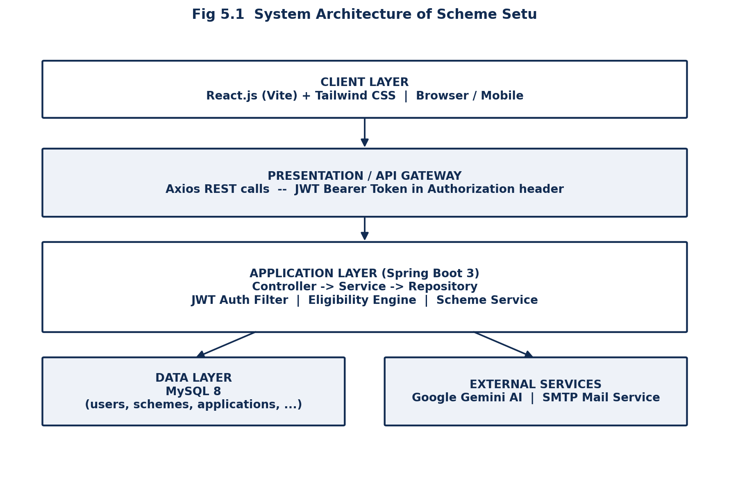
Fig 5.1 System Architecture of Scheme Setu

5.2 Entity-Relationship Diagram
The database is normalized around the Users and Schemes entities. A user may submit multiple Applications, each referencing exactly one Scheme; a user may also generate multiple Eligibility Results (one per scheme checked), upload multiple Documents, receive multiple Notifications, and accumulate a history of Chat History entries once the AI assistant module is active.
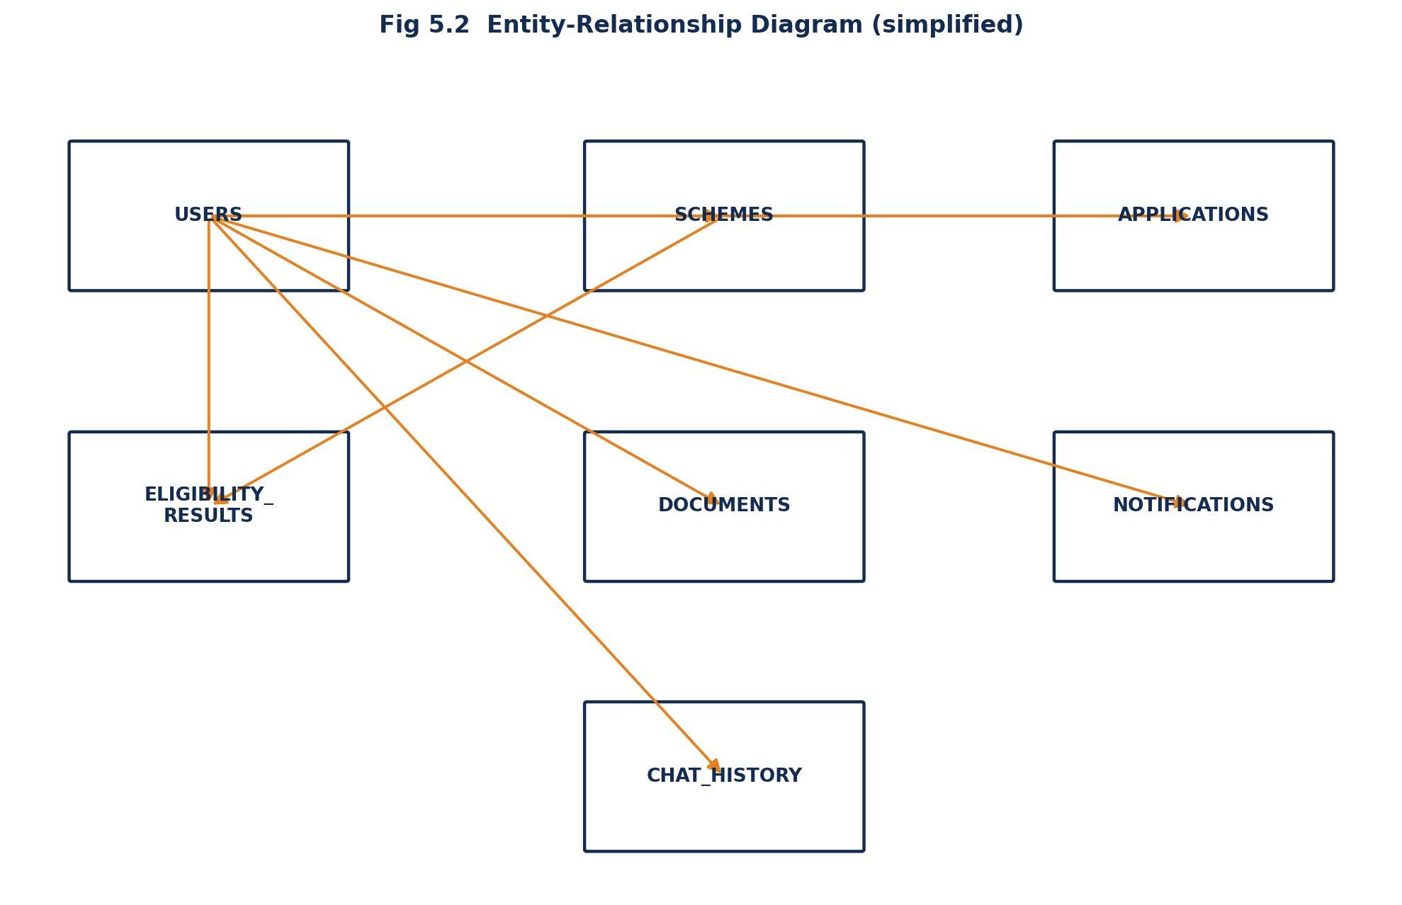
Fig 5.2 Entity-Relationship Diagram (simplified)

5.3 Use Case Diagram
Two actors interact with the system: the Citizen (unauthenticated or registered) and the Admin. Citizens can register, log in, browse schemes, check eligibility, ask the AI assistant, upload documents, and track applications. Administrators additionally manage schemes and view analytics — both use cases planned for a subsequent phase of the system.
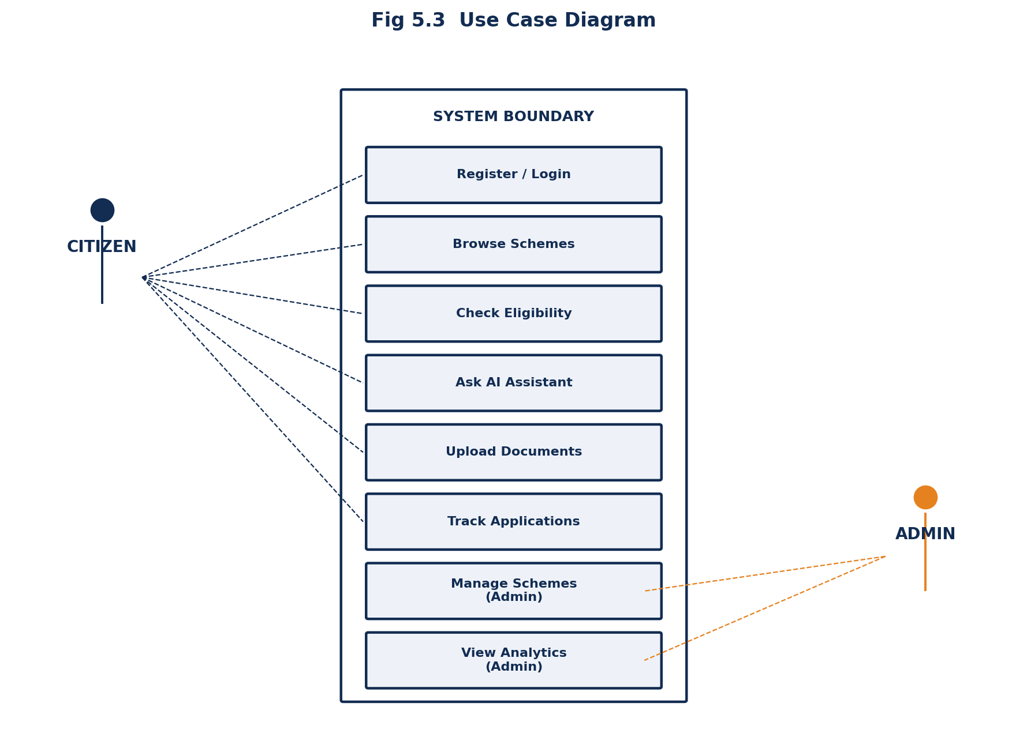
Fig 5.3 Use Case Diagram

5.4 Data Flow Diagram
At Level 1, three principal processes act on the MySQL data store: Authenticate User (validates credentials and issues a JWT), Check Eligibility (reads scheme records and evaluates them against the submitted profile), and Manage Application (create/read operations for the Applications and Documents tables, planned for Phase 2).
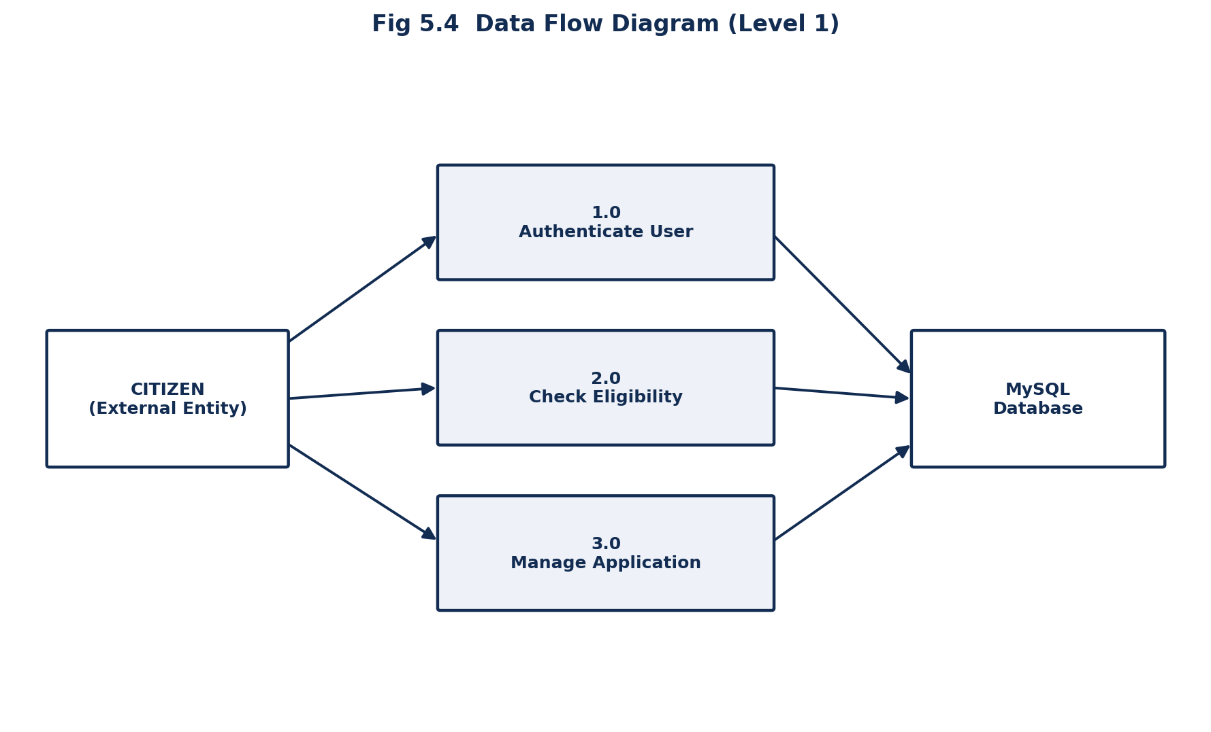
Fig 5.4 Data Flow Diagram (Level 1)

6. IMPLEMENTATION

6.1 Modules Used
- User Authentication Module
- Scheme Directory Module
- Eligibility Checker Module (Rules Engine)
- Dashboard Module
- AI Assistant Module (planned — Google Gemini integration)
- Document Upload Module (planned)
- Admin Management Module (planned)
- Notification Module (planned)

6.2 Module Description

6.2.1 User Authentication Module
Implemented using Spring Security with a custom JwtAuthFilter and a stateless SecurityFilterChain. On registration, a user's password is hashed using BCrypt before persistence (UserRepository, AuthService). On successful login, a signed JWT is issued (JwtUtil) carrying the user's email as subject and role as a claim, with a 24-hour expiry. Every subsequent request attaches this token as a Bearer header; the filter validates the signature and expiry before populating the Spring Security context, after which role-based authorization (hasRole("ADMIN"), authenticated()) governs endpoint access.

6.2.2 Scheme Directory Module
The SchemeController exposes paginated listing (GET /api/schemes), detail retrieval (GET /api/schemes/{id}), and keyword search across name, description, and department (GET /api/schemes/search) using Spring Data JPA Specifications. All endpoints are public, since browsing schemes should not require an account.

6.2.3 Eligibility Checker Module (Rules Engine)
The core of the system, implemented in EligibilityService. For every active scheme, the engine evaluates hard constraints — age range, income ceiling, applicable gender, category, and state — against the submitted EligibilityRequest. Any violated hard constraint marks the scheme ineligible and records a specific, human-readable reason. Targeted-group flags (forStudent, forFarmer, forWidow, forSeniorCitizen, forDisabled) are then checked: a scheme flagged for a specific group requires the applicant to share that status regardless of how well other criteria match. A weighted 0–100 match score is computed as the proportion of applicable criteria satisfied, and results are sorted eligible-first, then by descending match score, so applicants see their strongest matches first.

6.2.4 Dashboard Module
A protected route (ProtectedRoute.jsx) renders the Dashboard page only for authenticated users, redirecting unauthenticated visitors to the login page. The dashboard currently surfaces account status and a shortcut to the eligibility checker, with application tracking, document counts, and notifications wired in as their respective backend modules are completed.

6.2.5 AI Assistant Module (Planned)
The chat_history table and an /api/chatbot/ask endpoint are reserved for a Google Gemini-based conversational assistant that will answer questions about application procedures, required documents, benefits, and scheme-specific FAQs in plain language, persisting each exchange for later reference.

6.2.6 Document Upload Module (Planned)
The documents table and Document entity are already modelled to associate an uploaded file with a user and, optionally, a specific application, in preparation for a multipart upload endpoint and PDF eligibility-report generation using iText.

6.2.7 Admin Management Module (Planned)
The admins table and Admin entity, together with the ROLE_ADMIN authorization rule already present in SecurityConfig, are in place for an administrative panel to manage schemes, review uploaded documents, and view aggregate analytics.

6.2.8 Notification Module (Planned)
The notifications table supports per-user, read/unread notification records, intended to pair with Spring Mail for email delivery of application status updates.

7. SYSTEM TESTING

7.1 Testing
Testing was carried out at both the unit and integration level to verify that the authentication flow, scheme endpoints, and eligibility engine behave correctly under valid, invalid, and edge-case inputs before the frontend was connected.

7.2 Types of Testing

7.2.1 Unit Testing
Individual service methods — particularly EligibilityService's per-scheme evaluation logic — were tested in isolation against a range of applicant profiles to confirm that hard constraints and targeted-group flags are applied correctly.

7.2.2 Integration Testing
REST endpoints were tested end-to-end (HTTP request through Controller, Service, Repository, and back) using Postman and Spring Boot's test slices to confirm correct status codes, response bodies, and security enforcement.

7.2.3 Functional Testing
Each user-facing feature — registration, login, scheme search, and the eligibility checker form — was verified against its functional requirement from the frontend UI.

7.2.4 Security Testing
Protected endpoints were confirmed to reject requests without a valid JWT, and passwords were verified to be stored only as BCrypt hashes, never in plaintext.

7.2.5 Usability Testing
The eligibility checker form and results view were reviewed for clarity, ensuring that ineligible results always carry a specific, understandable reason rather than a bare rejection.

7.3 Test Cases
Test Case | Input | Expected Result | Status
Register with valid details | Valid name, email, password | Account created, JWT returned | Pass
Register with duplicate email | Existing email address | HTTP 400 — 'Email already registered' | Pass
Login with correct credentials | Registered email + password | JWT token returned | Pass
Login with incorrect password | Registered email + wrong password | HTTP 400 — 'Invalid email or password' | Pass
Eligibility check — farmer scheme | Age 45, farmer=true, income within limit | Scheme marked eligible, match score high | Pass
Eligibility check — income exceeds limit | Income above scheme's max income | Scheme marked ineligible with reason shown | Pass
Scheme search by keyword | keyword = 'pension' | Returns only pension-related schemes | Pass
Access protected route without token | No Authorization header | HTTP 401 Unauthorized | Pass

7.4 Validation
All listed test cases passed against the implemented Phase 1 modules (authentication, scheme directory, eligibility engine). Modules marked 'planned' in Chapter 6 will be validated with an equivalent test suite as they are implemented in subsequent phases.

8. FEASIBILITY STUDY

8.1 Feasibility Study

8.1.1 Technical Feasibility
The chosen stack — React, Spring Boot, and MySQL — is mature, well-documented, and widely supported, with abundant tooling for security, ORM, and API documentation (Swagger). No component of the proposed system requires unavailable or experimental technology, confirming technical feasibility.

8.1.2 Economic Feasibility
All core technologies used — React, Spring Boot, MySQL, and the supporting libraries — are open-source and free to use. Hosting costs on platforms such as Vercel (frontend) and Render (backend) offer free tiers suitable for a mini-project demonstration, making the system economically feasible even without institutional funding.

8.1.3 Operational Feasibility
The public-first design — no login required to search schemes or check eligibility — minimizes the operational barrier to adoption, and the system's REST API can be consumed by future mobile or kiosk-based clients without backend changes.

8.1.4 Behavioural / User Feasibility
The interface uses plain-language reasons rather than administrative terminology, and the eligibility form takes under two minutes to complete, reducing the learning curve for citizens unfamiliar with government portals.

8.1.5 Legal and Security Feasibility
Passwords are hashed with BCrypt, authentication uses signed, time-limited JWTs, and CORS is explicitly scoped to trusted origins — meeting baseline expectations for a citizen-data-handling system. A production deployment would additionally require compliance review against applicable data-protection regulations before handling real citizen data.

8.1.6 Overall Feasibility
Taken together, the system is technically sound, economically inexpensive to build and host, operationally low-friction for citizens, and legally reasonable as a foundation — making it a feasible mini-project suitable for extension into a production e-governance service.

8.2 Methodology
Development followed an incremental, module-first methodology: the database schema and core entities were designed first, followed by authentication, then the scheme directory, then the eligibility engine, with the frontend built in parallel against the emerging API contract. This mirrors an Agile-style iterative approach, allowing each module to be independently testable before the next was layered on.

9. CONCLUSION AND FUTURE ENHANCEMENT

9.1 Conclusion
This project has successfully designed and implemented the core of Scheme Setu, an AI Powered Government Scheme Eligibility Portal, delivering a working full-stack system comprising secure JWT-based authentication, a searchable scheme directory, and a transparent, explainable eligibility-scoring engine evaluated against eleven applicant factors. The system demonstrates that citizen-facing eligibility determination can be both automated and explainable, addressing a genuine gap in how welfare-scheme information reaches the public today.
The architecture — a Spring Boot REST API over a normalized MySQL schema, consumed by a React frontend — was deliberately structured so that the modules not yet implemented (AI assistant, document upload, admin panel, notifications) can be added without redesigning the existing data model or API contract, positioning the project for straightforward extension beyond this mini-project submission.

9.2 Future Enhancement
- Integrate the Google Gemini API to power a conversational AI assistant for procedural and document-related queries.
- Implement multipart document upload with PDF eligibility-report generation using iText.
- Build the administrative dashboard for managing users, schemes, and uploaded documents, with Chart.js-based analytics.
- Add an email notification service (Spring Mail) for application status updates and scheme alerts.
- Implement profile editing, application history, and a forgot-password flow.
- Introduce a dark-mode theme and further accessibility improvements.
- Deploy the completed system publicly on Vercel (frontend) and Render (backend) for live demonstration.

APPENDIX — SAMPLE SOURCE CODE
Representative code excerpts from the three core layers of the system are provided below. Full source files are included in the accompanying project submission.

A.1 Eligibility Engine (Backend — Java / Spring Boot)
// EligibilityService.java (excerpt)
if (scheme.getMaxIncome() != null) {
if (req.getAnnualIncome().compareTo(scheme.getMaxIncome()) <= 0) {
score += 25;
} else {
eligible = false;
reasons.add("Annual income exceeds scheme limit of "
+ scheme.getMaxIncome());
}
}

A.2 JWT Token Generation (Backend — Java / Spring Security)
// JwtUtil.java (excerpt)
public String generateToken(String subject, String role) {
return Jwts.builder()
.subject(subject)
.claim("role", role)
.issuedAt(new Date())
.expiration(new Date(System.currentTimeMillis() + expirationMs))
.signWith(getSigningKey(), SignatureAlgorithm.HS256)
.compact();
}

A.3 Eligibility API Call (Frontend — React / Axios)
// api.js (excerpt)
export const eligibilityAPI = {
check: (data) => api.post('/public/eligibility/check', data),
};

REFERENCES
[1] Craig Walls, "Spring Boot in Action", Manning Publications, 2nd Edition, 2022.
[2] Robin Wieruch, "The Road to React", Self-published, 2023 Edition.
[3] Spring Security Reference Documentation, https://docs.spring.io/spring-security/reference/, accessed 2026.
[4] Tailwind CSS Documentation, https://tailwindcss.com/docs, accessed 2026.
[5] JWT.io Introduction to JSON Web Tokens, https://jwt.io/introduction, accessed 2026.
[6] Ministry of Electronics and Information Technology, Government of India, "Digital India Programme" reports, https://www.digitalindia.gov.in, accessed 2026.
[7] Baeldung, "Spring Boot Security with JWT", https://www.baeldung.com/spring-security-oauth-jwt, accessed 2026.
[8] MySQL 8.0 Reference Manual, Oracle Corporation, https://dev.mysql.com/doc/refman/8.0/en/, accessed 2026.
[9] Google AI, "Gemini API Documentation", https://ai.google.dev/gemini-api/docs, accessed 2026.
[10] Springdoc OpenAPI Documentation, https://springdoc.org/, accessed 2026.

