# DATABASE ARCHITECTURE

MySQL Version: 5.6.10

Storage Engine: Innodb

Database Engine: Amazon Aurora

## DataBase Schema Design

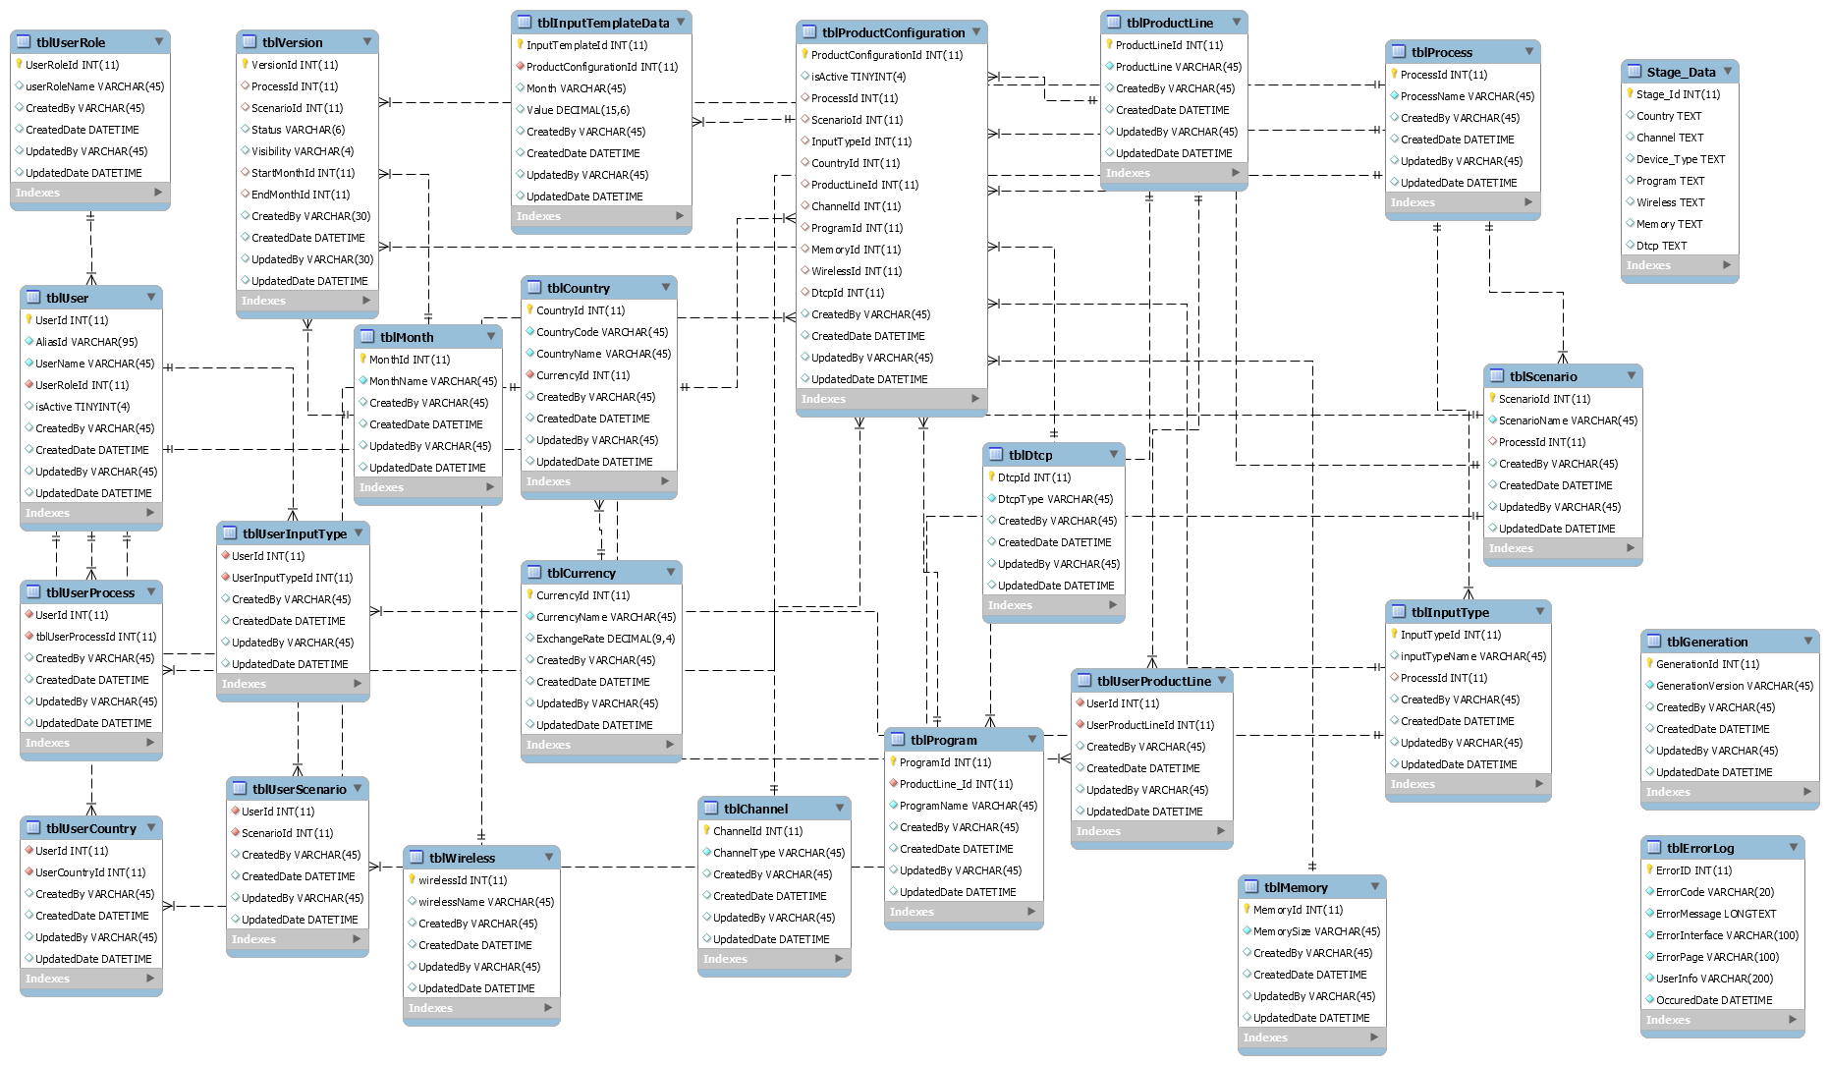

## Database Details

### Database list

* STAGEADFITDB
* DEVADFIT
* UATADFIT

### Database Tables

#### 2.1 Security Tables

These Table are considered as Security Tables. Where all user Access information is stored.

As the Table tblUserRole Comes first because, all the Validations and Security is based on User Role. Roles we are Using currently are,

Role Table Details

|  |  |  |
| --- | --- | --- |
| Sl No | Role | Description |
| 1 | Super Admin | Super Admin is the Root Admin to all other Admins. |
| 2 | Admin | Admin is head of Process, Scenario and Input Type Template. |
| 3 | Manager |  |
| 4 | Normal User |  |

|  |  |
| --- | --- |
| **Table** | **Description** |
| tblUserRole | User Roles Master Table. Which will assign to each User. |
| tblUser | Stores User Information like AliasId, Username and EmailId. |
| tblUserProcess | Stores which Process Can Access by the Specific User. |
| tblUserScenario | Stores which Scenarios Can Access by the Specific User. |
| tblUserInputType | Stores which Input Types Can Access by the Specific User. |
| tblUserProductLine | Stores which Product Lines Can Access by the Specific User. |
| tblUserCountry | Stores which Countries Can Access by the Specific User. |

#### 2.2 Domain Tables

The following Tables are Domain Tables Which Stores Actual Information from Source Database.

|  |  |
| --- | --- |
| **Table** | **Description** |
| tblProcess | Stores Process Information. |
| tblScenario | Stores Scenario information. |
| tblInputType | Stores Input Type Information |
| tblProductLine | Stores Product Line information in this. |
| tblProgram | Stores Program information in this. |
| tblChannel | Stores Channel Information. |
| tblCountry | Stores All Countries Information along with Country Codes. |
| tblCurrency | Stores Currency information for corresponding Countries and Exchange Rate. |
| tblGeneration | Stores Generation Information |
| tblMemory | Contains All Memory Information in this. |
| tblWireless | Stores Wireless Information. |
| tblMonth | Stores Months. |
| tblDtcp | Stores DTCP Information |

#### 2.3 Data Tables

|  |  |
| --- | --- |
| **Table** | **Description** |
| tblProductConfiguration | Stores Product Configuration for Process, Scenario and Input Type. |
| tblInputTemplateData | Stores Values in Decimal format for each Product Configuration according to Month. |
| tblVersion | Stores Scenario Configuration Details like Start Month and End Month and what are all the Months are Opened. |
| tblErrorLog | Stores Error Information for Tracking purpose. |

### Stored Procedures

|  |  |
| --- | --- |
| usp_Admin_CheckAlias | Used for finding User Name for Alias Id. |
| usp_Admin_CreatePopulate | Used for Creating Product Configuration for Generated Combinations from selected Filters in Admin Console. |
| usp_Admin_DeleteUser | Used to Delete the User from Admin Console. |
| usp_Admin_EditUser | Used to get Selected User details for Updating his Access Permissions. |
| usp_Admin_getAllFilters | Used to get all Filters from corresponding Dimension Tables. |
| usp_Admin_getUserDetails | Used to retrieve all Users from Database and Displays in User Tab Admin Console. |
| usp_Admin_InsertUser | Used for inserting New User into the Database. |
| usp_Admin_Populate | Used to Generate the Product Combinations for the Selected Filters in the Product Configuration Tab Admin Console. |
| usp_Admin_UpdatetUser | Used to Update the User Access Permissions from Users Tab in Admin Console. |
| usp_Admin_Version_Create | User to Create a New Scenario Configuration. |
| usp_Admin_Version_Delete | Used to Delete a Scenario Configuration. |
| usp_Admin_Version_Edit | Used to Edit Current Scenario Configuration. |
| usp_Admin_Version_GetAll | Used to Get All Scenarios Configurations from Database. |
| usp_Admin_Version_GetAllFilters | Used to Retrieve all Filters for Scenario Configuration from Database. |
| usp_CreateErrorLog | Used to for Error Reporting Purpose. It stores all Errors raised while using Application. |
| usp_DownloadTemplateData | Used to Download Input Type Template Data fir Selected Filters into the Excel Add-In Input Template Sheet. |
| usp_Excel_ReportGeneration | Used to Compare with Previous Scenarios of that Process to know the Variance and Variance Percentage with highlighted values for Variance of 5% Positive or Negative. |
| usp_getAllFilters | Used for Displaying all Filters after Initializing the Workbook in Excel. |
| usp_getAllFiltersbyType | To populate the menu items dynamically for the initialize workbook dropdown menu |
| usp_UploadTemplateData | Used to Upload the Data after Updating the Input Type Template Data. |