End-to-End MLOps for Heart Disease Risk Classification
Assignment 01 | AIMLCZG523 Machine Learning Operations

Student | BOINAPALLY V PRADEEP
Student ID | 2025AE05595
Dataset | UCI Cleveland Heart Disease
Repository | https://github.com/pradeepboinapalli/MLOPSAssigment1.git
Report date | 20-10-2026

1. Project objective
The goal of this assignment is to take a heart-disease dataset through a realistic ML lifecycle. I treated the task as more than simply training a classifier: the final solution should be repeatable, testable, deployable and observable.

What the project covers
- Data acquisition, cleaning and target preparation.
- Exploratory data analysis with reusable visualisations.
- A preprocessing pipeline that prevents data leakage.
- Comparison and tuning of Logistic Regression and Random Forest.
- Cross-validation and evaluation using accuracy, precision, recall and ROC-AUC.
- Experiment records containing parameters, metrics and artifact locations.
- A single saved model pipeline for consistent training and serving.
- Unit tests and a GitHub Actions workflow.
- A FastAPI prediction service with health and monitoring endpoints.
- Docker and Kubernetes/Minikube deployment configuration.

2. Dataset and the decisions I made
I used the supplied processed Cleveland file, `processed.cleveland.data`, as the modelling dataset. It contains 303 records and the original 14 fields used for this implementation.

Target conversion
The original `num` field has five values. Since the assignment asks for a binary classifier, I converted the target as follows:
Original num | New target | Meaning
0 | 0 | No disease
1–4 | 1 | Disease
After conversion, the dataset contains 164 observations in class 0 and 139 in class 1.

Missing values
The missing values occur in `ca` and `thal`. I chose not to remove those six observations. Instead, the missing-value treatment is part of the model pipeline. This is important because the imputer is fitted on the training portion of each cross-validation split rather than on the complete dataset.

Feature treatment
Group | Features | Treatment
Numeric | age, trestbps, chol, thalach, oldpeak | Median imputation + StandardScaler
Categorical | sex, cp, fbs, restecg, exang, slope, ca, thal | Most-frequent imputation + one-hot encoding

3. Exploratory data analysis
The EDA was created as code rather than as one-off notebook output. That makes it possible to regenerate the figures after a clean checkout and also allows the CI workflow to produce the same evidence again.
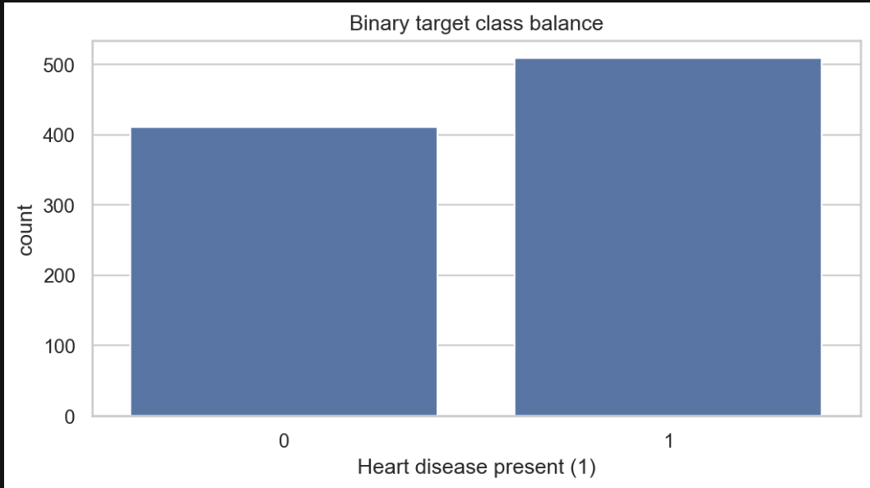

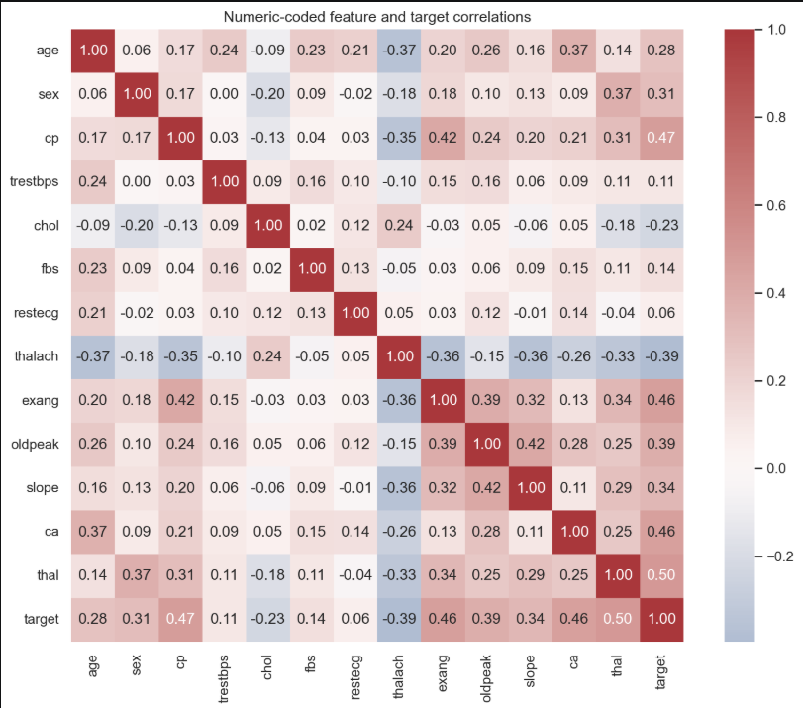
Correlation overview

Missing values

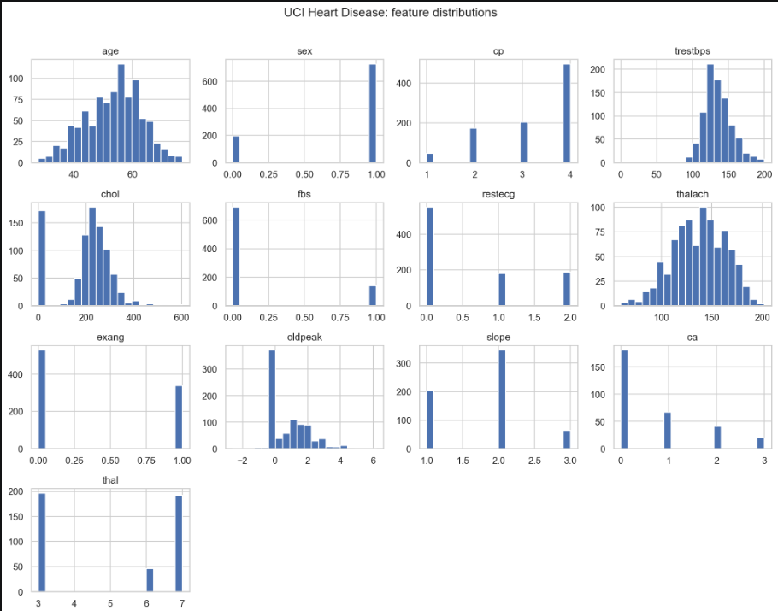

4. Model development
I selected two models with different characteristics. Logistic Regression gives a strong, interpretable baseline. Random Forest provides a non-linear tree-based comparison. This gives a useful answer to the question: does a more complex model actually improve the result on this dataset?

Tuning approach
Both models were tuned using GridSearchCV with a 5-fold StratifiedKFold split. ROC-AUC was used as the tuning score because it considers the ranking of positive and negative cases rather than relying on one classification threshold.

Results
Random Forest was selected as the best model under the project’s stated selection rule: highest mean recall across five-fold cross-validation. Recall was emphasized to reduce missed disease-positive cases

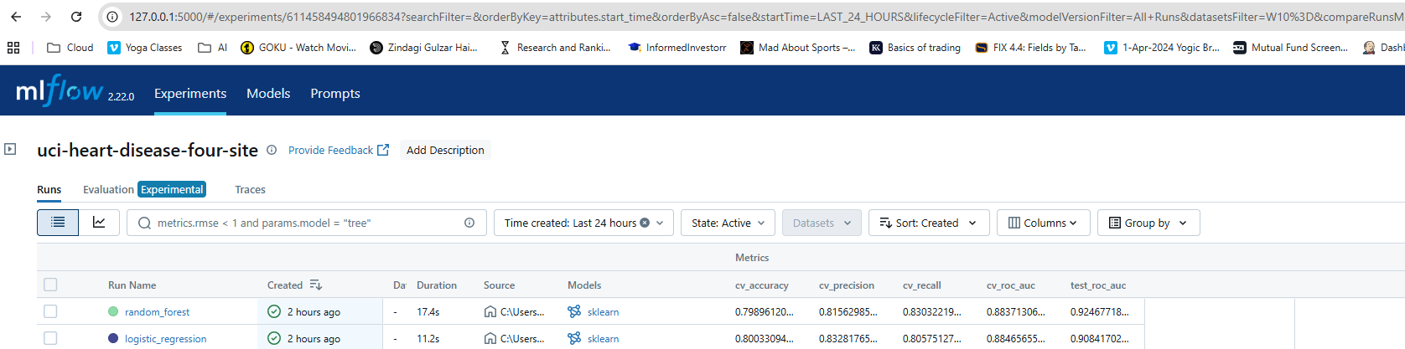

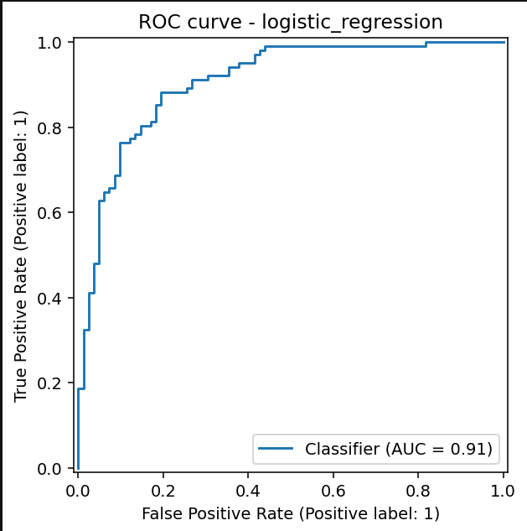

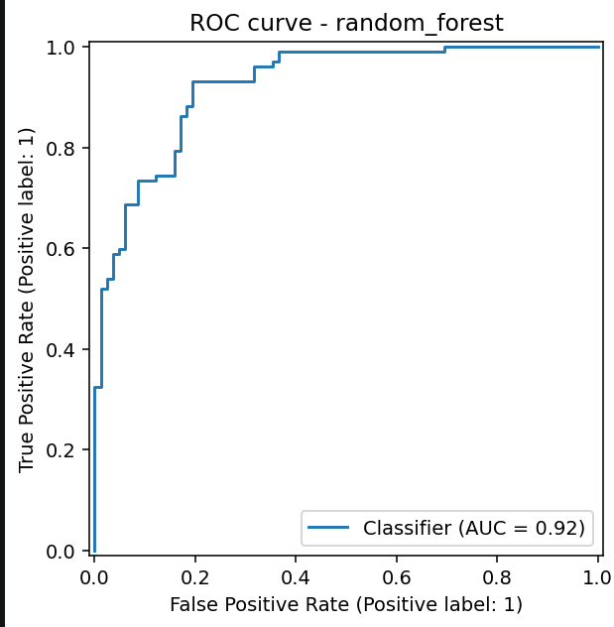

Logistic Regression confusion matrix

5. Experiment tracking and reproducibility
For each training run I record the model name, selected parameters, evaluation metrics and the generated ROC/confusion-matrix artifact paths. The records are stored in `experiments/runs.jsonl`.
train.py selects the winner directly from the in-memory cross-validation results, then writes the selection and metrics to that JSON file.
The selected, fitted model is saved separately as artifacts/heart_disease_model.joblib
.

Why this matters
- The same transformation logic is used during training and prediction.
- The selected model can be moved into Docker without rebuilding preprocessing by hand.
- Experiment results remain available after the training process ends.
- The project can be rerun from a clean environment using the requirements file.

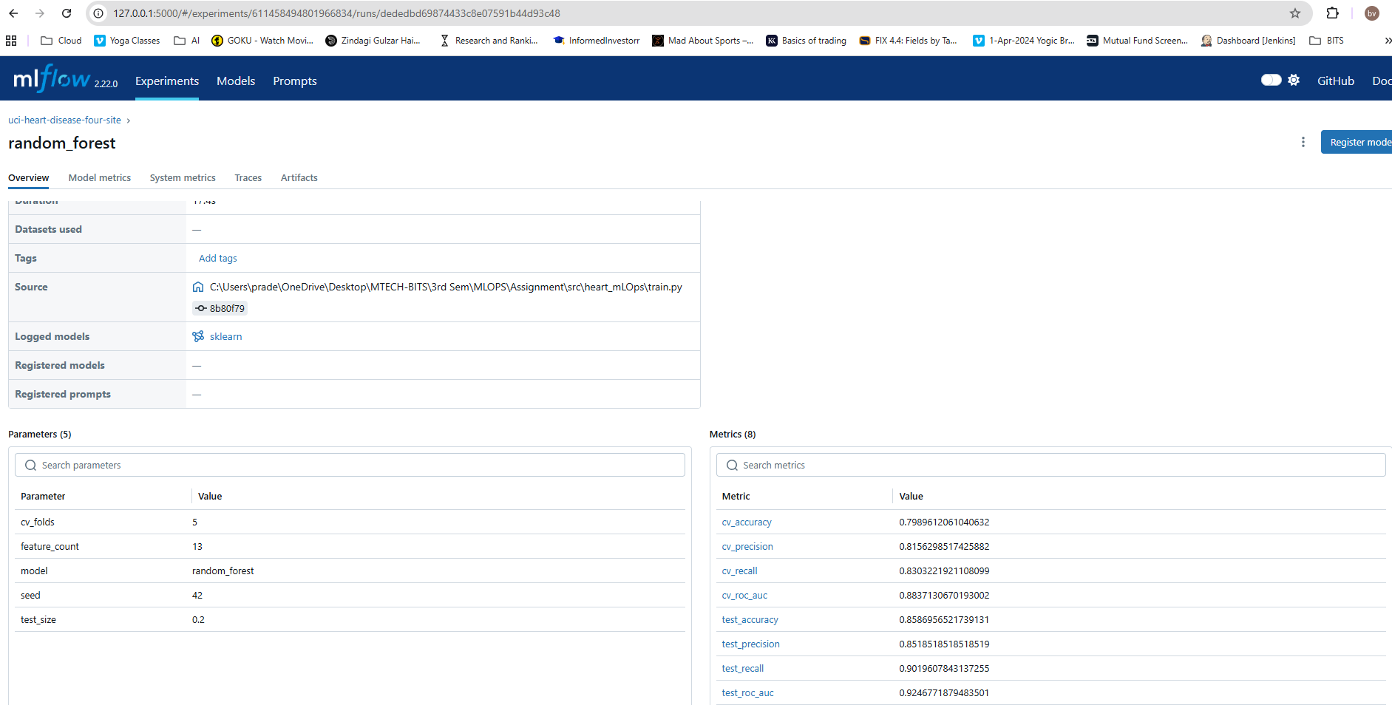

6. Testing and CI/CD
The project includes tests for both data preparation and the API. The purpose is not to prove that every possible input is correct; it is to catch the common failures that would make the pipeline or service unusable.

Tests included
- Data-processing tests verify the cleaned dataset structure and binary target.
- API tests verify the health endpoint and a prediction response.
- The CI workflow installs dependencies and runs the tests.
- The workflow also compiles Python files and regenerates model/EDA artifacts.
The local verification performed for this package produced 4 passing tests.

CI principle
A failed test or failed pipeline command is allowed to fail the workflow. I intentionally did not make the CI job continue after an error because that would make the pipeline look healthier than it really is.

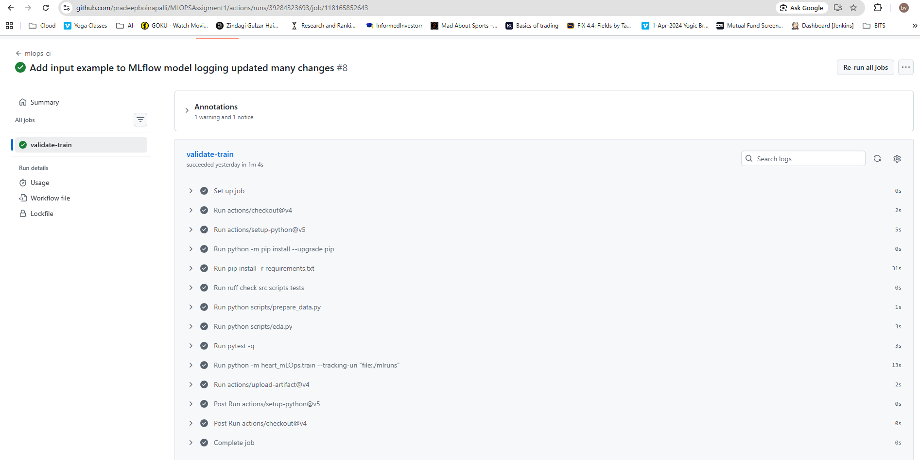7. API design
The model is served using FastAPI. The service has three main endpoints.
Endpoint | Purpose
/health | Simple liveness check and confirmation that the model loaded
/predict | Accepts JSON feature values and returns prediction, confidence and risk probability
/metrics | Exposes Prometheus-compatible request and latency metrics

Prediction flow
A request arrives as JSON, the 13 expected features are collected into a single row, the saved pipeline performs the required preprocessing, and the classifier produces a probability. A threshold of 0.5 is used to turn the probability into the binary prediction.
The service also records request count and prediction latency and logs prediction activity. Invalid prediction requests are returned as controlled HTTP 400 responses rather than causing an unhandled server failure.
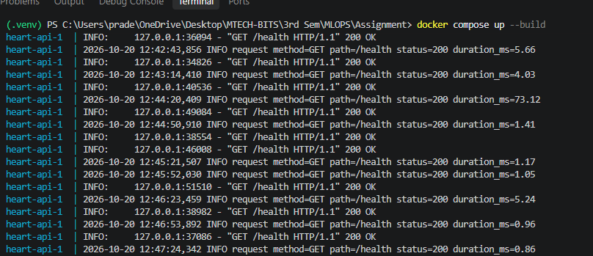

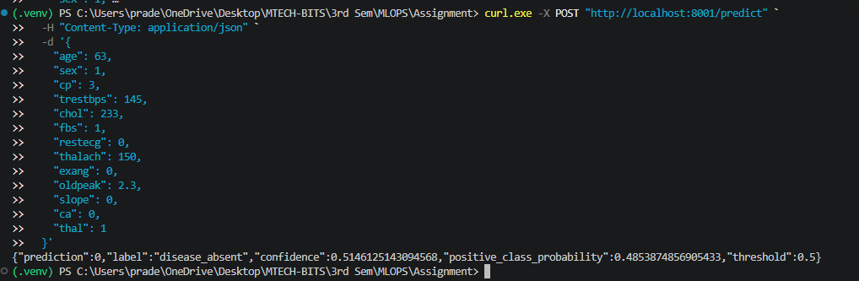

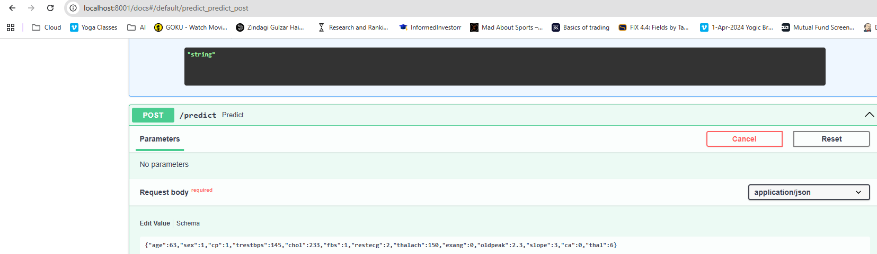
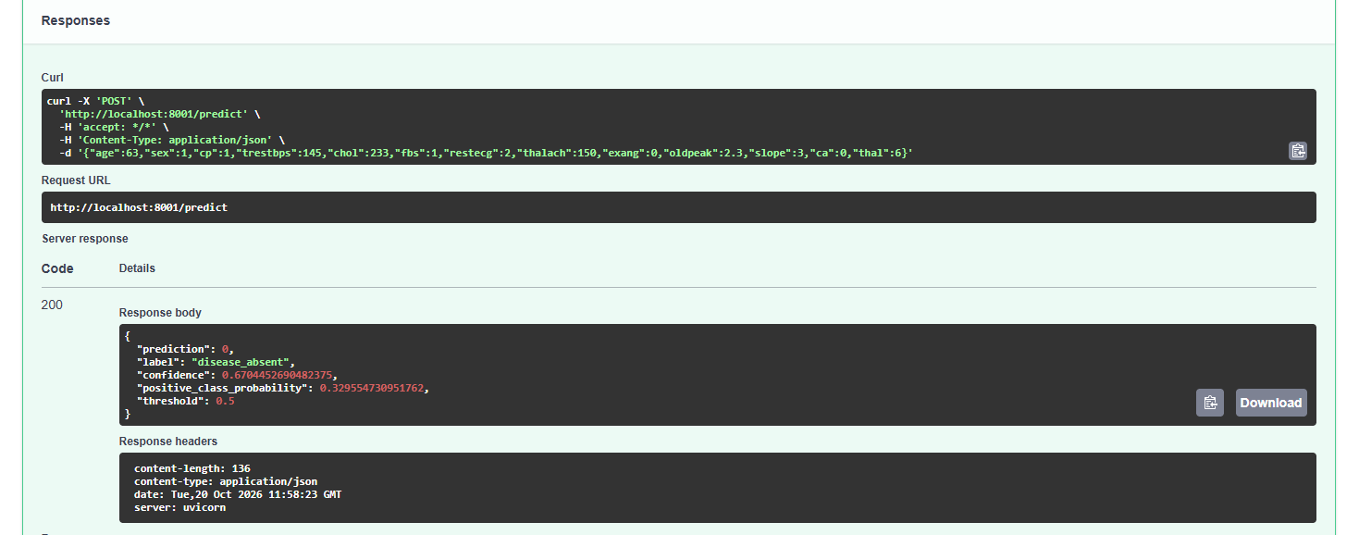

8. Docker and Kubernetes
The Docker image contains the API code, model and required Python dependencies. The intention is that the same model artifact tested locally can be served inside an isolated container.

Kubernetes design
- A dedicated `heart-mlops` namespace keeps the deployment separate.
- The deployment uses two replicas.
- Readiness and liveness probes are provided.
- CPU and memory requests/limits are specified.
- A LoadBalancer Service exposes the API.
- An Ingress manifest is included for clusters where ingress is enabled.
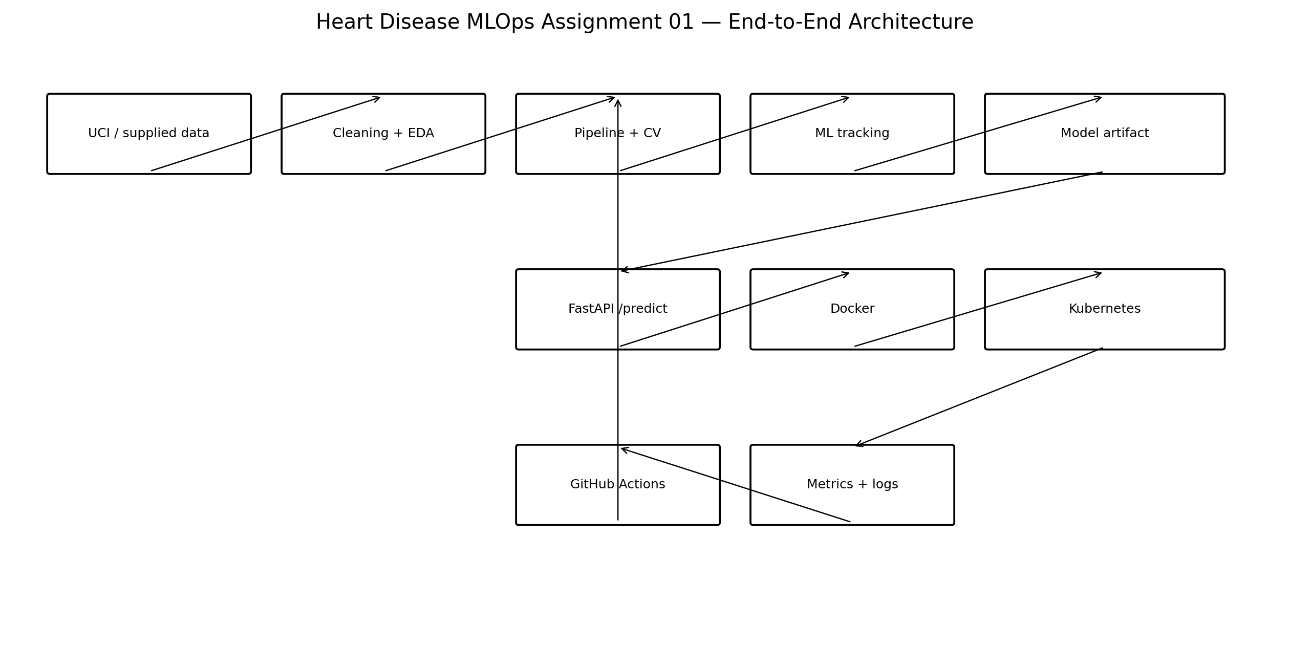
End-to-end project architecture
I chose Minikube as the local deployment target because the assignment explicitly permits it and it gives a reproducible Kubernetes demonstration without requiring a paid cloud account.

cc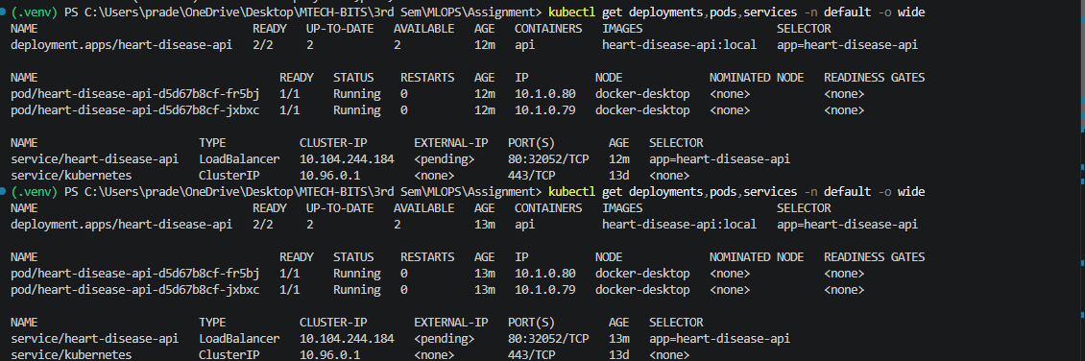

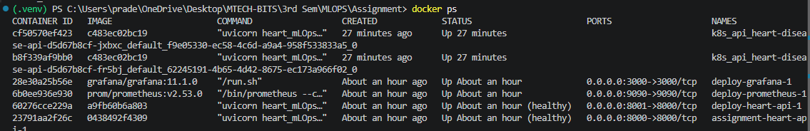

9. Monitoring and operational evidence
Monitoring is intentionally kept simple for this assignment. The API exposes Prometheus-compatible metrics and produces application logs. This provides two useful operational views: how often the service is being called and how long predictions take.

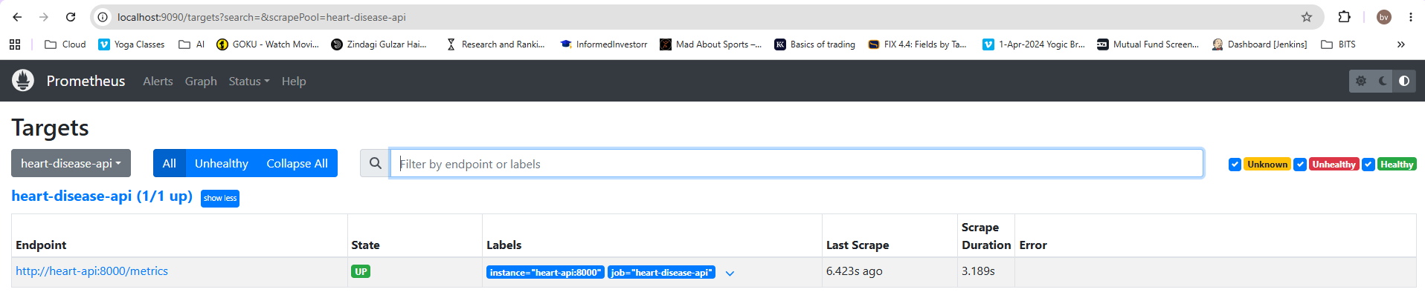

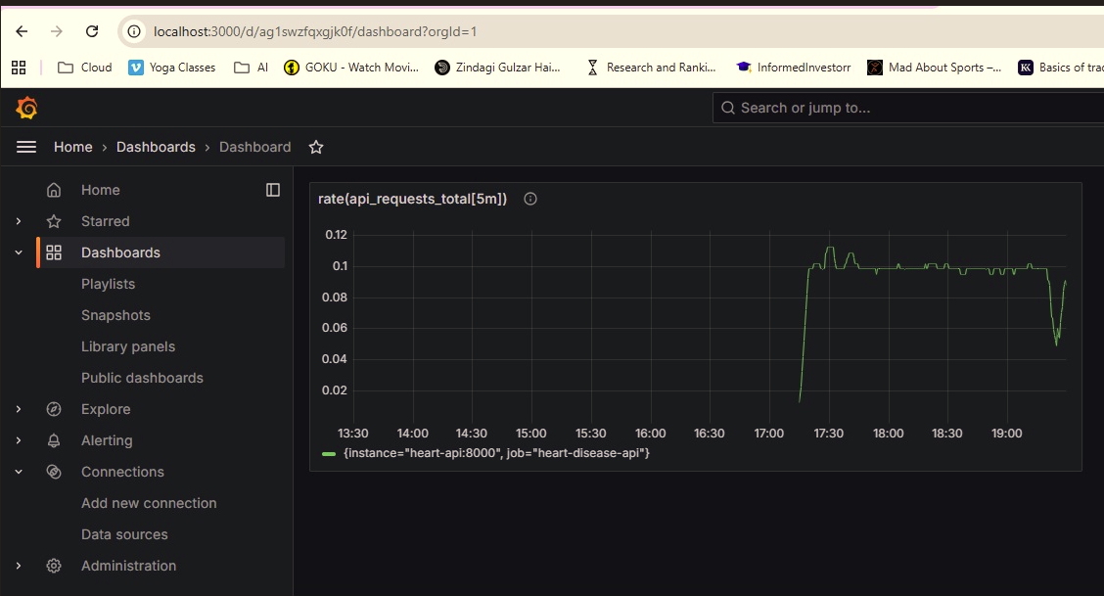

Available evidence
Area | Evidence location
EDA | reports/figures/
Model results | reports/model_results.json
Experiment tracking | experiments/runs.jsonl
Model | models/best_model.joblib
Tests | tests/
CI/CD | .github/workflows/ci.yml
Docker | Dockerfile and docker-compose.yml
Kubernetes | deployment/
Monitoring | monitoring/ and app/main.py
Architecture | reports/architecture.png

Runtime limitation
The build environment used for preparing this package did not provide Docker, kubectl or Minikube binaries. I therefore have not presented container or Kubernetes execution as a completed runtime test. The files are included and statically checked, while the Python training, EDA, tests, API and project validation were executed.

Video Recording Link:

https://drive.google.com/file/d/1BvUCEoaHS5XeyG9cyUrqsWGPcvbPWJMC/view?usp=sharing

10. Submission checklist and conclusion
The repository is organised so that each assignment task can be traced to an implementation file and a corresponding piece of evidence.

Conclusion
The final solution is deliberately practical. It starts with a small, well-understood dataset, keeps preprocessing and modelling together, records the experiments, tests the important pieces, and provides a clear path from a local Python process to a container and then to Kubernetes.
The strongest model in the completed experiment was Logistic Regression, with 96.65% held-out ROC-AUC and 92.86% recall. The result is useful, but the project also makes the limitations visible: this is a small dataset, the deployment runtime still needs to be demonstrated on a machine with Docker/Minikube, and model performance should not be interpreted as clinical validation.
This document is intended to accompany the repository and the PDF report during submission.

