Assignment 2 : Create Angular 9 CRUD application for Customers.

Listing page should look like below: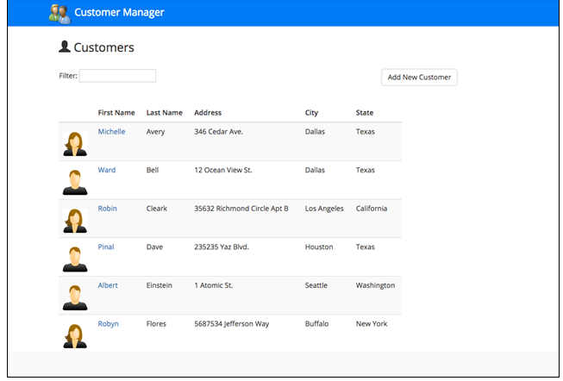

Clicking on Add New Customer and Edit Customer should open form like below:

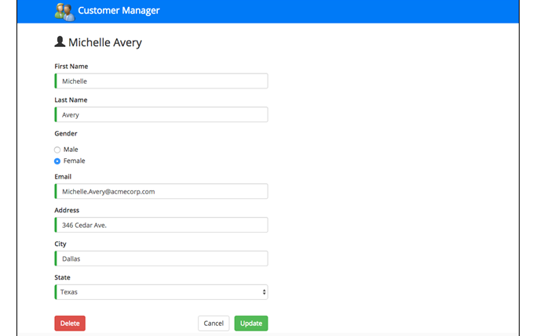

Points to be noted:

1. The scope of this application is limited to UI only i.e. No backend API/Database is involved
2. All the Customer operations to be performed are on UI using array of objects for Customers
   1. Create a model for customer and use that while performing any CRUD operation
3. Add Edit and Delete icons in Listing Page after every customer
4. Add Sorting as well on all Customer Listing fields
5. WriUnit Test Cases