Telco Customer Churn Analysis
1.Preject Overview
This project analyses customer churn patterns in a telecom dataset to identify key factors driving customer attrition. Using SQL, Power BI, and Python, the dashboard highlights churn trends across payment methods, contact types, customer segments, and services, enabling data-driven retention insights.
2.Data Summary
- The dataset contains 7043 observations across 21 parameters
- Key Features
  - Customer Demographics (gender, Senior Citizen, Partner, Dependents)
  - Account & Relationship (Tenure)
  - Service Subscription (Phone Service, Multiple Lines, Internet Services)
  - Value Added Services (Online Security, Online Backup, Device Protection, Tech Support, Streaming TV, Streaming Movies)
  - Contract & Billing Behaviour (Contract, Paperless Billing, Payment Method)
  - Revenue & Pricing (Monthly Charges, Total Charges)
3.Importing the dataset
- Imported the dataset into the jupyter notebook using pandas library
4.Analyse the dataset
- Nulls & Duplicates
  - Verify the null values and duplicated data using df.isna().sum() and df.duplicated().sum()
    - The data does not contain any null values and there are no presence of duplicate entries.
5.Preprocessing
- Remove Identifier to reduce the Noice
- Encoding
  - Categorical data has been encoded using LableEncoder Skikit-learn function

6.EDA (Exploratory Data Analysis)
- Analyse the correlation between the features using Seaborn Heatmap Visuals
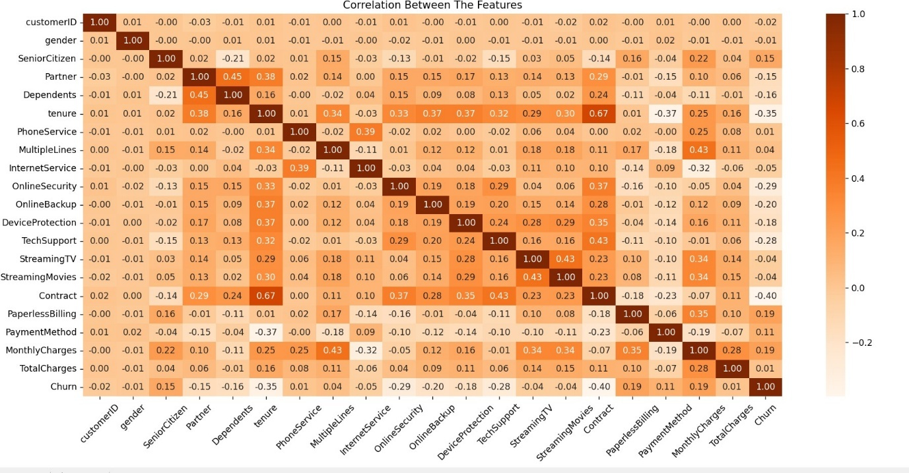

- Analyse the data distribution using subplots
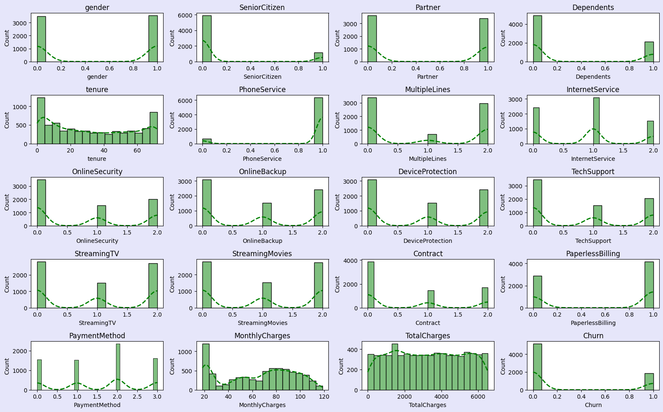
- Find the Outliers using boxplots
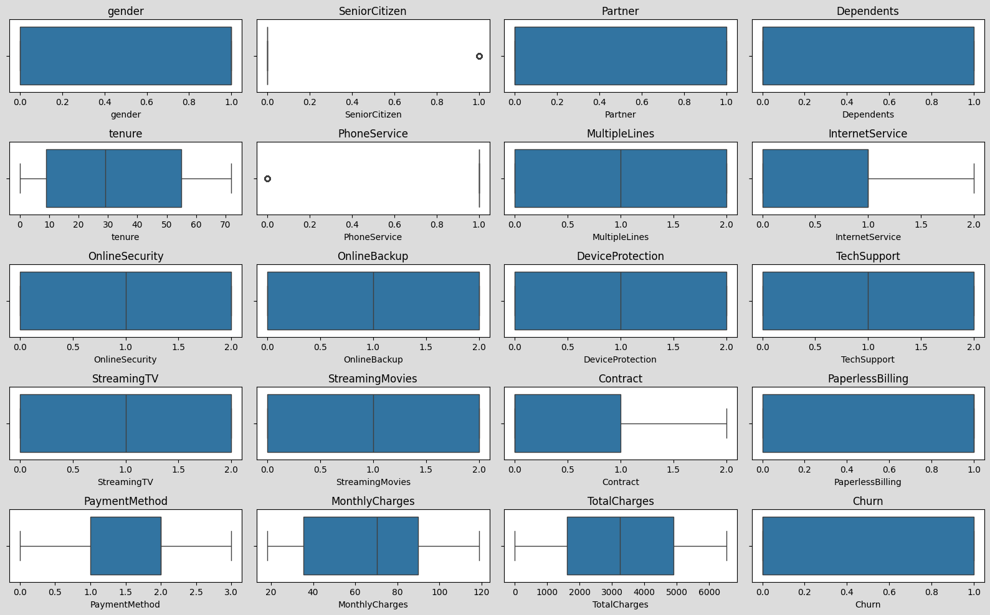
7.Split the data into input features and target variable and training and testing
8.Model Selection
- We used LogisticRegression algorithm to predict the results
- Metrics evaluation
  - Accuracy: 75.16%
  - Precision: 51.95%
  - Recall: 82.31%
  - F1 Score: 63.69%
- Confusion Matrix
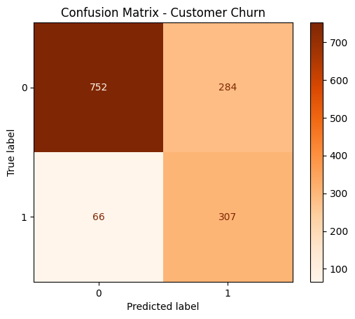
- ROC Curve + AUC (Area Under Curve)
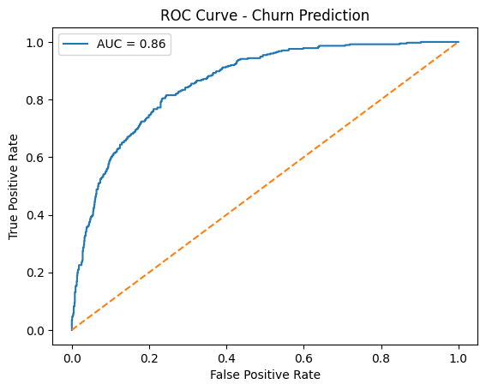
9.Threshold Tuning (Business Focus)
- We set the Threshold as 0.4
10.Top Features Impacting Churn
TOP FEATURES IMPACTING CHURN
Feature | Coefficient
MonthlyCharges | 0.806699
InternetService | 0.171521
PaperlessBilling | 0.16265
TotalCharges | 0.094438
PaymentMethod | 0.068579
SeniorCitizen | 0.063563
MultipleLines | 0.061695
StreamingMovies | 0.046649
Partner | 0.022849
StreamingTV | 0.002148

Data Analyses Using SQL
1.Total Customers: 7043
2.Total Churn Customers: 1869
3.Customer Churn Proportion: 26.54%
4.Total Retain Customer: 5174
5.Ratain Customer Proportion: 73.46%
6.Total Customer churn and retain proportion by gender
gender | Total_Customers | Churn_customers | Total_Churn_Customers | Churn_Proportion
Female | 3488 | 939 | 1869 | 50.24%
Male | 3555 | 930 | 1869 | 49.76%
gender | Total_Customers | Retain_customers | Total_Retain_Customers | Retain_Proportion
Female | 3488 | 2549 | 5174 | 49.27%
Male | 3555 | 2625 | 5174 | 50.73%

7. Total Customer churn and retain proportion by SeniorCitizen
SeniorCitizen |  | Total_Customers |  | Churn_customers |  | Total_Churn_Customers |  | Churn_Proportion
0 |  | 5901 |  | 1393 |  | 1869 |  | 74.53%
1 |  | 1142 |  | 476 |  | 1869 |  | 25.47%
SeniorCitizen | Total_Customers |  | Retain_customers |  | Total_Retain_Customers |  | Retain_Proportion
0 | 5901 |  | 4508 |  | 5174 |  | 87.13%
1 | 1142 |  | 666 |  | 5174 |  | 12.87%

8. Total Customer churn and retain proportion by Partner
Partner | Total_Customers | Churn_customers | Total_Churn_Customers | Churn_Proportion
No | 3641 | 1200 | 1869 | 64.21%
Yes | 3402 | 669 | 1869 | 35.79%
Partner | Total_Customers | Retain_customers | Total_Retain_Customers | Retain_Proportion
No | 3641 | 2441 | 5174 | 47.18%
Yes | 3402 | 2733 | 5174 | 52.82%

9. Total Customer churn and retain proportion by Dependents
Dependents | Total_Customers | Churn_customers | Total_Churn_Customers | Churn_Proportion
No | 4933 | 1543 | 1869 | 82.56%
Yes | 2110 | 326 | 1869 | 17.44%
Dependents | Total_Customers | Retain_customers | Total_Retain_Customers | Retain_Proportion
No | 4933 | 3390 | 5174 | 65.52%
Yes | 2110 | 1784 | 5174 | 34.48%

10. Total Customer churn and retain proportion by PhoneService
PhoneService | Total_Customers | Churn_customers | Total_Churn_Customers | Churn_Proportion
No | 682 | 170 | 1869 | 9.10%
Yes | 6361 | 1699 | 1869 | 90.90%
PhoneService | Total_Customers | Retain_customers | Total_Retain_Customers | Retain_Proportion
No | 682 | 512 | 5174 | 9.90%
Yes | 6361 | 4662 | 5174 | 90.10%

11. Total Customer churn and retain proportion by MultipleLines
MultipleLines | Total_Customers | Churn_customers | Total_Churn_Customers | Churn_Proportion
No | 3390 | 849 | 1869 | 45.43%
No phone service | 682 | 170 | 1869 | 9.10%
Yes | 2971 | 850 | 1869 | 45.48%
MultipleLines | Total_Customers | Retain_customers | Total_Retain_Customers | Retain_Proportion
No | 3390 | 2541 | 5174 | 49.11%
No phone service | 682 | 512 | 5174 | 9.90%
Yes | 2971 | 2121 | 5174 | 40.99%

12. Total Customer churn and retain proportion by InternetService
InternetService | Total_Customers | Churn_customers | Total_Churn_Customers | Churn_Proportion
DSL | 2421 | 459 | 1869 | 24.56%
Fiber optic | 3096 | 1297 | 1869 | 69.40%
No | 1526 | 113 | 1869 | 6.05%
InternetService | Total_Customers | Retain_customers | Total_Retain_Customers | Retain_Proportion
DSL | 2421 | 1962 | 5174 | 37.92%
Fiber optic | 3096 | 1799 | 5174 | 34.77%
No | 1526 | 1413 | 5174 | 27.31%

13. Total Customer churn and retain proportion by OnlineSecurity
OnlineSecurity | Total_Customers | Churn_customers | Total_Churn_Customers | Churn_Proportion
No | 3498 | 1461 | 1869 | 78.17%
No internet service | 1526 | 113 | 1869 | 6.05%
Yes | 2019 | 295 | 1869 | 15.78%
OnlineSecurity | Total_Customers | Retain_customers | Total_Retain_Customers | Retain_Proportion
No | 3498 | 2037 | 5174 | 39.37%
No internet service | 1526 | 1413 | 5174 | 27.31%
Yes | 2019 | 1724 | 5174 | 33.32%

14. Total Customer churn and retain proportion by OnlineBackup
OnlineBackup | Total_Customers | Churn_customers | Total_Churn_Customers | Churn_Proportion
No | 3088 | 1233 | 1869 | 65.97%
No internet service | 1526 | 113 | 1869 | 6.05%
Yes | 2429 | 523 | 1869 | 27.98%
OnlineBackup | Total_Customers | Retain_customers | Total_Retain_Customers | Retain_Proportion
No | 3088 | 1855 | 5174 | 35.85%
No internet service | 1526 | 1413 | 5174 | 27.31%
Yes | 2429 | 1906 | 5174 | 36.84%

15. Total Customer churn and retain proportion by DeviceProtection
DeviceProtection | Total_Customers | Churn_customers | Total_Churn_Customers | Churn_Proportion
No | 3095 | 1211 | 1869 | 64.79%
No internet service | 1526 | 113 | 1869 | 6.05%
Yes | 2422 | 545 | 1869 | 29.16%
DeviceProtection | Total_Customers | Retain_customers | Total_Retain_Customers | Retain_Proportion
No | 3095 | 1884 | 5174 | 36.41%
No internet service | 1526 | 1413 | 5174 | 27.31%
Yes | 2422 | 1877 | 5174 | 36.28%

16. Total Customer churn and retain proportion by TechSupport
TechSupport | Total_Customers | Churn_customers | Total_Churn_Customers | Churn_Proportion
No | 3473 | 1446 | 1869 | 77.37%
No internet service | 1526 | 113 | 1869 | 6.05%
Yes | 2044 | 310 | 1869 | 16.59%
TechSupport | Total_Customers | Retain_customers | Total_Retain_Customers | Retain_Proportion
No | 3473 | 2027 | 5174 | 39.18%
No internet service | 1526 | 1413 | 5174 | 27.31%
Yes | 2044 | 1734 | 5174 | 33.51%

17. Total Customer churn and retain proportion by StreamingTV
StreamingTV | Total_Customers | Churn_customers | Total_Churn_Customers | Churn_Proportion
No | 2810 | 942 | 1869 | 50.40%
No internet service | 1526 | 113 | 1869 | 6.05%
Yes | 2707 | 814 | 1869 | 43.55%
StreamingTV | Total_Customers | Retain_customers | Total_Retain_Customers | Retain_Proportion
No | 2810 | 1868 | 5174 | 36.10%
No internet service | 1526 | 1413 | 5174 | 27.31%
Yes | 2707 | 1893 | 5174 | 36.59%

18. Total Customer churn and retain proportion by StreamingMovies
StreamingMovies | Total_Customers | Churn_customers | Total_Churn_Customers | Churn_Proportion
No | 2785 | 938 | 1869 | 50.19%
No internet service | 1526 | 113 | 1869 | 6.05%
Yes | 2732 | 818 | 1869 | 43.77%
StreamingMovies | Total_Customers | Retain_customers | Total_Retain_Customers | Retain_Proportion
No | 2785 | 1847 | 5174 | 35.70%
No internet service | 1526 | 1413 | 5174 | 27.31%
Yes | 2732 | 1914 | 5174 | 36.99%

19. Total Customer churn and retain proportion by Contract
Contract | Total_Customers | Churn_customers | Total_Churn_Customers | Churn_Proportion
Month-to-month | 3875 | 1655 | 1869 | 88.55%
One year | 1473 | 166 | 1869 | 8.88%
Two year | 1695 | 48 | 1869 | 2.57%
Contract | Total_Customers | Retain_customers | Total_Retain_Customers | Retain_Proportion
Month-to-month | 3875 | 2220 | 5174 | 42.91%
One year | 1473 | 1307 | 5174 | 25.26%
Two year | 1695 | 1647 | 5174 | 31.83%

20. Total Customer churn and retain proportion by PaperlessBilling
PaperlessBilling | Total_Customers | Churn_customers | Total_Churn_Customers | Churn_Proportion
No | 2872 | 469 | 1869 | 25.09%
Yes | 4171 | 1400 | 1869 | 74.91%
PaperlessBilling | Total_Customers | Retain_customers | Total_Retain_Customers | Retain_Proportion
No | 2872 | 2403 | 5174 | 46.44%
Yes | 4171 | 2771 | 5174 | 53.56%

21. Total Customer churn and retain proportion by PaymentMethod
PaymentMethod | Total_Customers | Churn_customers | Total_Churn_Customers | Churn_Proportion
Bank transfer (automatic) | 1544 | 258 | 1869 | 13.80%
Credit card (automatic) | 1522 | 232 | 1869 | 12.41%
Electronic check | 2365 | 1071 | 1869 | 57.30%
Mailed check | 1612 | 308 | 1869 | 16.48%
PaymentMethod | Total_Customers | Retain_customers | Total_Retain_Customers | Retain_Proportion
Bank transfer (automatic) | 1544 | 1286 | 5174 | 24.86%
Credit card (automatic) | 1522 | 1290 | 5174 | 24.93%
Electronic check | 2365 | 1294 | 5174 | 25.01%
Mailed check | 1612 | 1304 | 5174 | 25.20%

Tenure Customer Segmentation
0 to 12 | 1 Year | New Customers
13 to 48 | 4 Years | Established Customers
Above 48 | Above 4 Years | Loyal Customers

Customer_segment | Total_Customers | Total_Churn | Churn_Proportion
New Customers | 1037 | 1869 | 55.48%
Established Customers | 619 | 1869 | 33.12%
Loyal Customers | 213 | 1869 | 11.40%

Monthly Charges
monthlycharges_segmentation | Total_Customers | Churn_customers | Proportion
75 to 100 | 2218 | 828 | 37.33%
Above 100 | 902 | 253 | 28.05%
0 to 75 | 3923 | 788 | 20.09%

Features with Churn Ratio
customerID | Distinct | Tot Customer | Churn Cust | Ratio
gender | Female | 3488 | 939 | 26.92
gender | Male | 3555 | 930 | 26.16
SeniorCitizen | 0 | 5901 | 1393 | 23.61
SeniorCitizen | 1 | 1142 | 476 | 41.68
Partner | No | 3641 | 1200 | 32.96
Partner | Yes | 3402 | 669 | 19.66
Dependents | No | 4933 | 1543 | 31.28
Dependents | Yes | 2110 | 326 | 15.45
tenure | Established Customers | 2618 | 619 | 23.64
tenure | Loyal Customers | 2239 | 213 | 9.51
tenure | New Customers | 2186 | 1037 | 47.44
PhoneService | No | 682 | 170 | 24.93
PhoneService | Yes | 6361 | 1699 | 26.71
MultipleLines | No | 3390 | 849 | 25.04
MultipleLines | No phone service | 682 | 170 | 24.93
MultipleLines | Yes | 2971 | 850 | 28.61
InternetService | DSL | 2421 | 459 | 18.96
InternetService | Fiber optic | 3096 | 1297 | 41.89
InternetService | No | 1526 | 113 | 7.40
OnlineSecurity | No | 3498 | 1461 | 41.77
OnlineSecurity | No internet service | 1526 | 113 | 7.40
OnlineSecurity | Yes | 2019 | 295 | 14.61
OnlineBackup | No | 3088 | 1233 | 39.93
OnlineBackup | No internet service | 1526 | 113 | 7.40
OnlineBackup | Yes | 2429 | 523 | 21.53
DeviceProtection | No | 3095 | 1211 | 39.13
DeviceProtection | No internet service | 1526 | 113 | 7.40
DeviceProtection | Yes | 2422 | 545 | 22.50
TechSupport | No | 3473 | 1446 | 41.64
TechSupport | No internet service | 1526 | 113 | 7.40
TechSupport | Yes | 2044 | 310 | 15.17
StreamingTV | No | 2810 | 942 | 33.52
StreamingTV | No internet service | 1526 | 113 | 7.40
StreamingTV | Yes | 2707 | 814 | 30.07
StreamingMovies | No | 2785 | 938 | 33.68
StreamingMovies | No internet service | 1526 | 113 | 7.40
StreamingMovies | Yes | 2732 | 818 | 29.94
Contract | Month-to-month | 3875 | 1655 | 42.71
Contract | One year | 1473 | 166 | 11.27
Contract | Two year | 1695 | 48 | 2.83
PaperlessBilling | No | 2872 | 469 | 16.33
PaperlessBilling | Yes | 4171 | 1400 | 33.57
PaymentMethod | Bank transfer (automatic) | 1544 | 258 | 16.71
PaymentMethod | Credit card (automatic) | 1522 | 232 | 15.24
PaymentMethod | Electronic check | 2365 | 1071 | 45.29
PaymentMethod | Mailed check | 1612 | 308 | 19.11
MonthlyCharges | 75 to 100 | 2218 | 828 | 37.33
MonthlyCharges | Above 100 | 902 | 253 | 28.05
MonthlyCharges | 0 to 75 | 3923 | 788 | 20.09

Creating Dashboard
With Power BI we created an interactive dashboard to understand visually
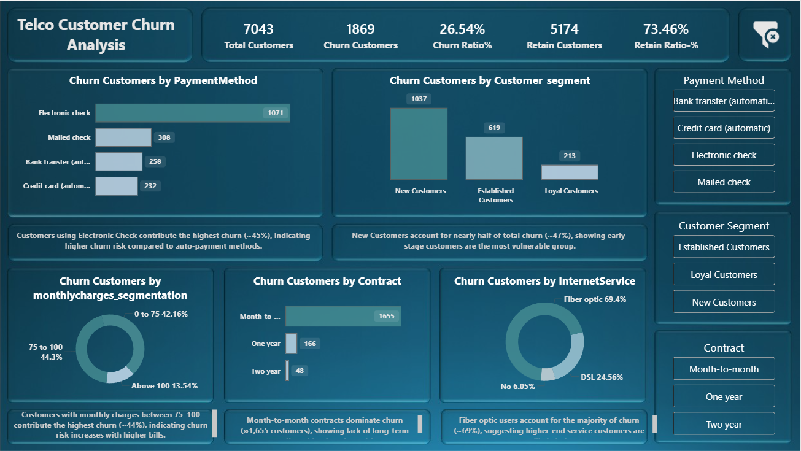
Key Insights
- Payment Method
  - Insights
    - Customers using Electronic Check contribute the highest churn (~45%), indicating higher churn risk compared to auto-payment methods.
  - Action
    - Encourage electronic-check users to switch to auto-payment methods through discounts or cashback incentives.

- Customer Segment
  - Insight
    - New Customers account for nearly half of total churn (~47%), showing early-stage customers are the most vulnerable group.
  - Action
    - Introduce targeted onboarding programs and early-stage engagement offers to improve retention within the first year.

- Monthly Charges Segmentation
  - Insight
    - Customers with monthly charges between 75–100 contribute the highest churn (~44%), indicating churn risk increases with higher bills.
  - Action
    - Offer personalized plans, bill optimization, or loyalty discounts for high-paying customers to reduce price-driven churn.

- Contract
  - Insight
    - Month-to-month contracts dominate churn (≈1,655 customers), showing lack of long-term commitment is a key churn driver.
  - Action
    - Promote long-term contracts using bundled services or reduced pricing to increase customer commitment.

- Internet Services
  - Insight
    - Fiber optic users account for the majority of churn (~69%), suggesting higher-end service customers are more likely to leave.
  - Action
    - Improve service reliability and provide proactive support for fiber optic customers to enhance satisfaction and reduce churn.

