**BCGX – CASE STUDY – CAR CRASH ANALYSIS**

**ANALYTICS REPORT**

**Analytics 1: Find the number of crashes (accidents) in which number of males killed are greater than 2?**

**CONCLUSION: There are no instances in the dataset where more than 2 males got killed in the same crash. However, the maximum number of male fatalities in a crash goes up to 2.**

**Analysis 2: How many two wheelers are booked for crashes?**

**CONCLUSION: A total of 773 two-wheelers are booked for crashes. The different two-wheeler body types considered are motorcycle & police motorcycle.**

**Analysis 3: Determine the Top 5 Vehicle Makes of the cars present in the crashes in which driver died and Airbags did not deploy.**

**CONCLUSION: Below are the top 5 vehicle makes of crashes that fit the required description. Chevrolet tops the list, followed by Ford & Nissan.**

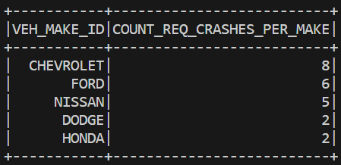

**Analysis 4: Determine number of Vehicles with driver having valid licences involved in hit and run?**

**CONCLUSION: A total of 2569 vehicles were involved in a hit & run where the driver possessed a valid driving license.**

**Analysis 5: Which state has highest number of accidents in which females are not involved?**

**CONCLUSION: Texas tops the list with over 36K reported crashes in which females weren’t involved**

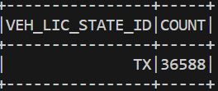

**Analysis 6: Which** **are the Top 3rd to 5th VEH_MAKE_IDs that contribute to a largest number of injuries including death**

**CONCLUSION: Below is the figure consisting of the make of vehicles rated by the number of injuries between the rank of 3 to 5**

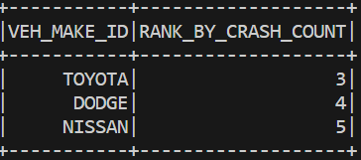

**Analysis 7: For all the body styles involved in crashes, mention the top ethnic user group of each unique body style**

**CONCLUSION: Below is the figure consisting of the relationship between the body type of vehicle and the ethic group that uses them the most.**

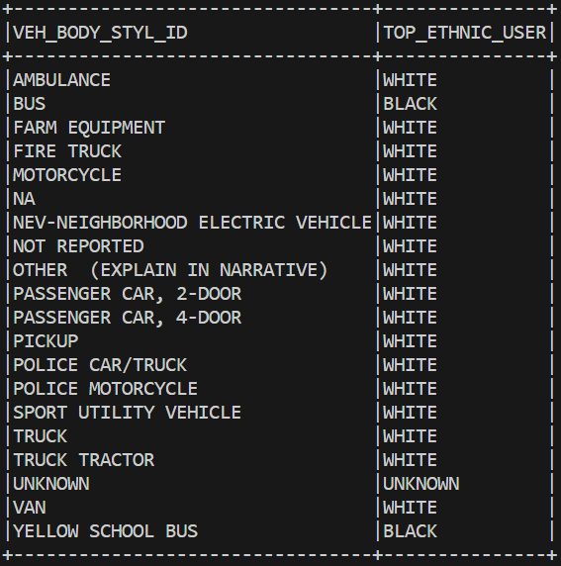

**Analysis 8: Among the crashed cars, what are the Top 5 Zip Codes with highest number crashes with alcohols as the contributing factor to a crash (Use Driver Zip Code)**

**CONCLUSION: Below is the figure consisting of the top 5 zip-codes where the highest number of crashes where alcohol intoxication was a contributing factor.**

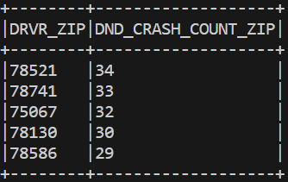

**Analysis 9: Count of Distinct Crash IDs where No Damaged Property was observed and Damage Level (VEH_DMAG_SCL~) is above 4 and car avails Insurance**

**CONCLUSION: There has been a total of 8849 crashes where no property damage was observed and the damage level is above 4 and the parties involved in the crash avail insurance**

**Analysis 10: Determine the Top 5 Vehicle Makes where drivers are charged with speeding related offences, has licensed Drivers, used top 10 used vehicle colours and has car licensed with the Top 25 states with highest number of offences (to be deduced from the data)**

**CONCLUSION: Below are the top 5 vehicle makes that fit the given criterion:**

