BUILD LLM
Research-Based Assessment | Training a GPT-style language model from scratch | November 2026
One-page summary
A decoder-only Transformer was trained on a 10-book Project Gutenberg text collection. Training duration and learning rate have the clearest effect on validation loss; architectural changes help more modestly over the short ten-epoch comparison window, while removing residual connections substantially impairs optimization.
Question | Observed result | Practical inference
Baseline | 10 epochs: train 3.907, validation 3.937. | Loss falls steadily; extend training with validation-based stopping.
Epochs / learning rate | Best saved validation: 4.001 at epoch 37, lr=0.001. | Validation rises as training loss falls: select checkpoints, not the last epoch.
Transformer depth | 7 layers: validation 4.423; 12 layers: 4.448 after 5 epochs. | More depth helps up to 7 layers in this run; 12 layers did not improve the endpoint.
Attention heads | 8 heads: validation 4.462; 1 head: 4.529 after 5 epochs. | More heads give a small endpoint improvement at fixed width.
Component ablations | No residual: validation 6.796; no norm 4.202; no FFN 4.263. | Residual paths matter most here; loss does not substitute for a generation-quality test.

Key findings
1. Early stopping is essential. At lr=1e-4, validation bottoms at 3.675 at epoch 37; the 200-epoch run ends at train 0.113 / validation 6.536, strong evidence of overfitting.
2. Moderate depth is a short-run trade-off. Seven layers reached the lowest five-epoch validation loss; 12 layers were slightly worse and took longer.
3. Residual connections matter most. Without shortcuts, training plateaus near 6.95 and validation near 6.80, unlike the normalization and FFN ablations.
1. Dataset, method, and baseline
The corpus Project_Gutenberg_10_New_Releases.txt contains ten Gutenberg titles (4,425,452 raw characters); the notebook reports 4,278,693 characters after loading and preprocessing. Titles include Riders of the Wind and Lady Bell, Volume 3. Text uses GPT-2 BPE. The character stream is split 90%/10% into training and validation partitions, then chunked into overlapping 256-token windows with stride 64.
Setting | Baseline value
Architecture | Decoder-only GPT-style Transformer; 12 blocks
Embedding width / heads | 768 / 12
Context / batch | 256 tokens / 16 sequences
Dropout | 0.1
Optimizer | AdamW; learning rate 4e-4; weight decay 0.1
Training controls | Seed 123; gradient norm clipped at 1.0; 5 epochs
Loss logging | Mean of up to 100 training-batch losses; validation mean over first 10 batches

Baseline loss by epoch
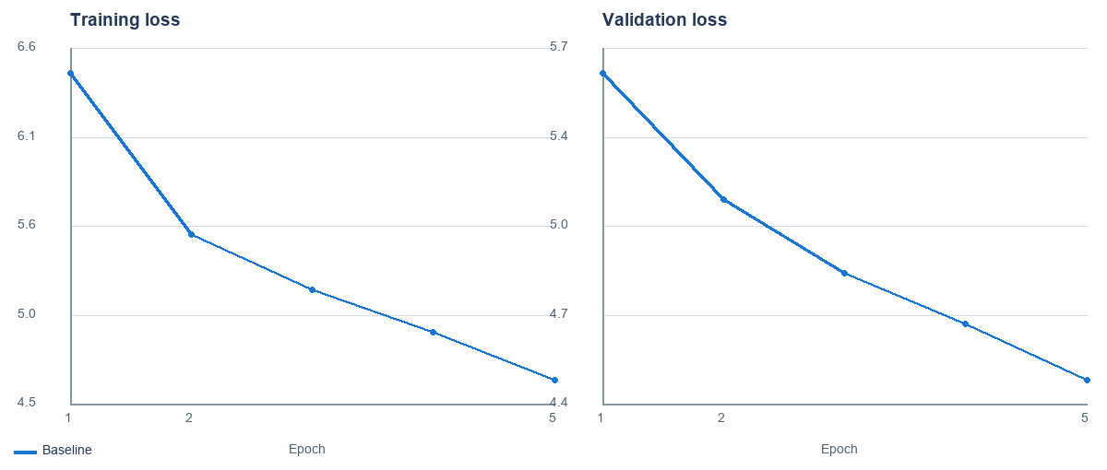
Epoch | Train loss | Validation loss
1 | 6.4777 | 5.6504
2 | 5.5249 | 5.1563
3 | 5.2003 | 4.8658
4 | 4.9467 | 4.6681
5 | 4.6671 | 4.4481

Both losses decrease across the five logged epochs, with validation loss below training loss at the endpoint. This is an early training snapshot, not evidence of convergence; longer runs show why checkpoint selection matters.

2. Experiment 1: epochs and learning rate
The saved grid contains epoch budgets of 5, 10, 20, 50, 100, and 200 for lr=1e-4, and 5, 10, 20, 50, and 100 for lr=1e-3. The figure plots the longest exported history for each learning rate; the table gives its best validation checkpoint and final logged loss.
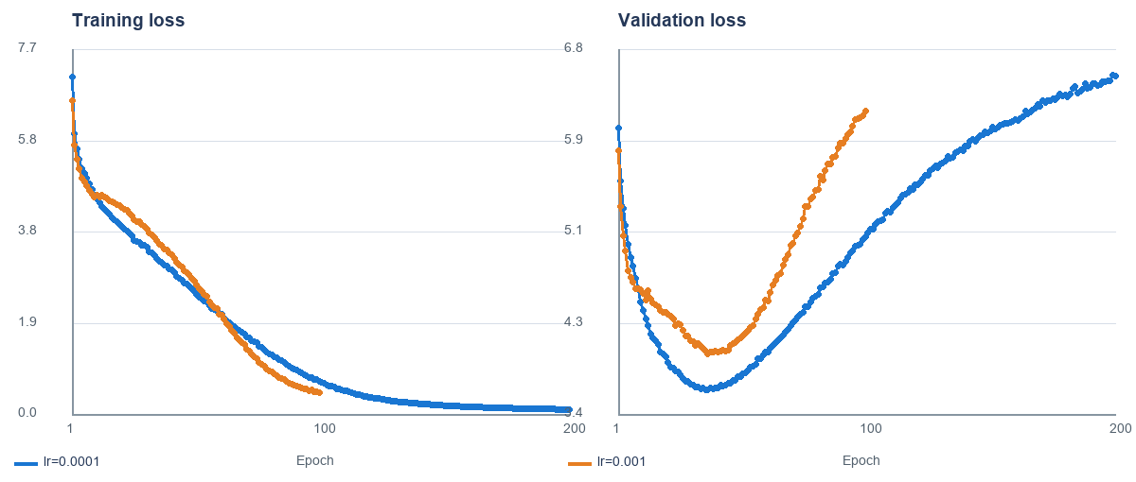
Learning rate | Longest run | Best validation (epoch) | Endpoint train / val
0.0001 | 200 | 3.675 (ep 37) | 0.113 / 6.536
0.001 | 100 | 4.002 (ep 37) | 0.465 / 6.219

Interpretation
The lower learning rate generalizes better in the saved runs: its best validation loss is 3.675 at epoch 37, compared with 4.002 at epoch 37 for lr=1e-3. At lr=1e-4, validation rises to 3.793 at epoch 50, 5.070 at epoch 100, and 6.536 at epoch 200 while training falls to 0.113. The lr=1e-3 history shows the same divergence (endpoint 0.465 / 6.219 at epoch 100). This supports early stopping; the smaller rate delays, but does not prevent, overfitting.

3. Experiment 2: transformer depth
Depths 1, 3, 5, 7, and 12 were trained for five epochs at learning rate 4e-4, with embedding width 768 and 12 attention heads held fixed. The panels show the complete training and validation histories.
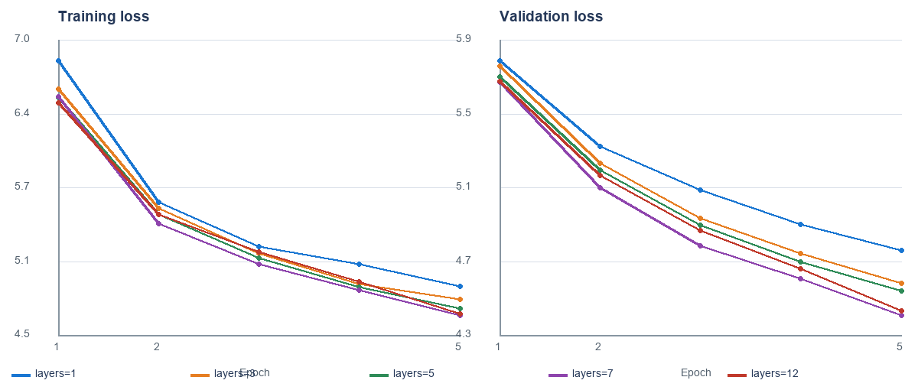
Layers | Epoch 5 train | Epoch 5 validation | Elapsed seconds
1 | 4.906 | 4.765 | 94.2
3 | 4.797 | 4.591 | 136.2
5 | 4.719 | 4.552 | 177.1
7 | 4.658 | 4.423 | 216.0
12 | 4.667 | 4.448 | 318.2

Interpretation
Five-epoch validation improves from 4.765 at one layer to 4.423 at seven layers. Twelve layers finish at 4.448, slightly worse than seven. This supports a capacity benefit through moderate depth in this short run, but not a monotonic benefit from adding layers. The seven-layer run takes about 216 seconds versus 318 seconds for 12 layers, the strongest loss/runtime trade-off among these single runs.
These are equal-epoch, single-seed comparisons, not equal-compute or repeated-seed trials. More layers add capacity and computation; loss alone cannot identify what features individual layers learned.

4. Experiment 3: attention heads
The number of heads was varied across 1, 2, 4, and 8 while holding embedding width at 768, depth at 12 layers, learning rate at 4e-4, and training length at five epochs. Increasing head count reduces each head's width from 768 to 96.
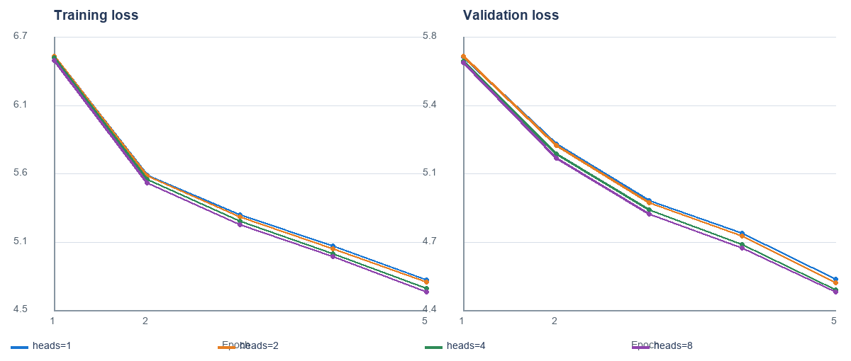
Attention heads | Head width | Epoch 5 train | Epoch 5 validation
1 | 768 | 4.782 | 4.529
2 | 384 | 4.765 | 4.509
4 | 192 | 4.718 | 4.472
8 | 96 | 4.690 | 4.462

Interpretation
Validation loss falls modestly across the tested values: 4.529 with one head, 4.509 with two, 4.472 with four, and 4.462 with eight. Multiple heads can attend through different learned projections; the slight improvement is consistent with that flexibility. The total endpoint spread is only 0.067, so the data do not support a strong claim that more heads are always better.

5. Experiment 4: component ablations
Each component was disabled throughout all 12 Transformer blocks. The no-normalization variant also replaces the final normalization with an identity operation. Ablation runs last ten epochs at learning rate 4e-4.
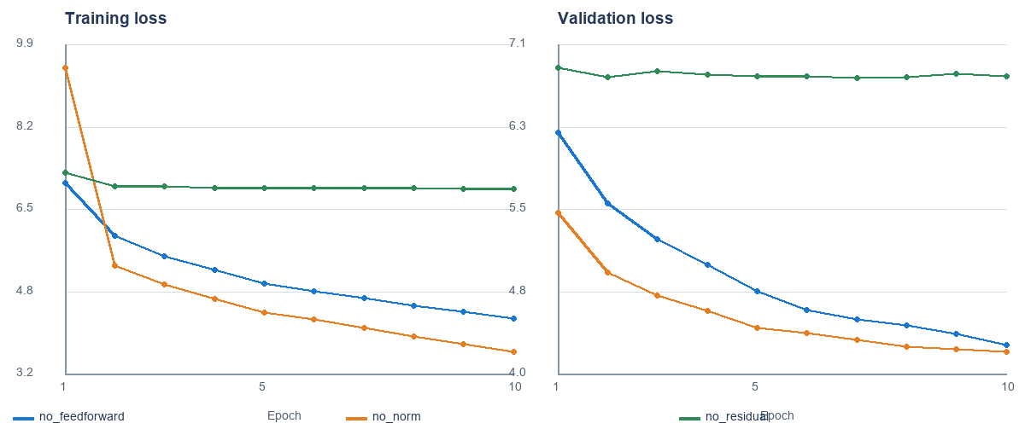
Configuration | Epochs | Final train | Final validation
no feedforward | 10 | 4.308 | 4.263
no norm | 10 | 3.637 | 4.202
no residual | 10 | 6.945 | 6.796

What the ablations suggest
No normalization: optimization proceeds and reaches train 3.637 / validation 4.202, but the train-validation gap is wider near the end. Normalization controls activation scale and can improve optimization stability; this run does not show training failure without it.
No residual connections: training stalls near 6.95 and validation near 6.80, far worse than other variants despite ten epochs. This is consistent with shortcut paths supporting signal and gradient flow through a deep stack.
No feedforward network: the model still learns (train 4.308 / validation 4.263), but lacks the block's position-wise nonlinear transformation and channel mixing. Attention alone is not enough to conclude that the FFN is dispensable.

6. Conclusions, limitations, and reproducibility
Conclusions
Within the recorded experiments, the best next-step training recipe is the smaller tested learning rate (1e-4) with checkpoint selection around the observed validation minimum, not an arbitrary long epoch budget. Seven layers are a promising efficiency candidate under the five-epoch depth study; the head-count advantage is marginal. Residual connections should be retained. Normalization and feedforward ablations still learn, but their effects need matched baselines and direct generation evaluation.
Code and data appendix
The complete training and experiment code is provided in LLM_Research_Assessment_Reference_Code_Extended_Proj_Gutenberg.ipynb. The saved CSV histories in the submission folder are the numerical source for this report's plots and tables.
Project Gutenberg corpus file: Project_Gutenberg_10_New_Releases.txt. The selected compilation includes ten titles

