1. Get Product reviews with Product ID which exists on both external Site and Product –Review-Service eg.https://www.adidas.co.uk/api/products/M20324



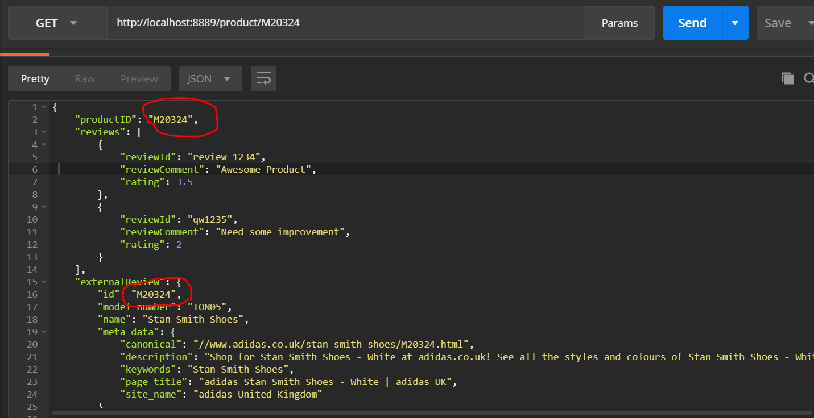

1. Get Product reviews with Product ID which doesn’t exist on external Site :

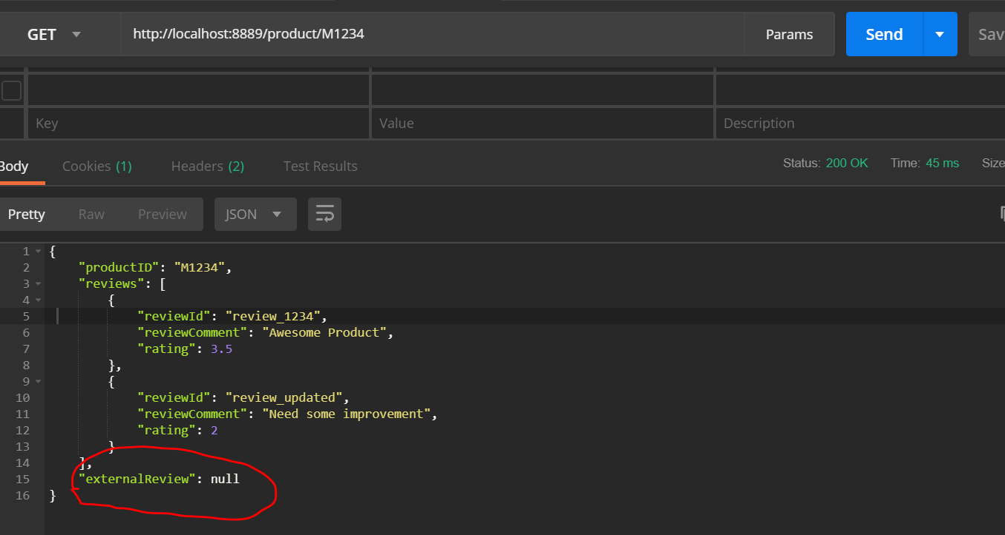

1. Negative Scenarios, Invalid Product ID passed :

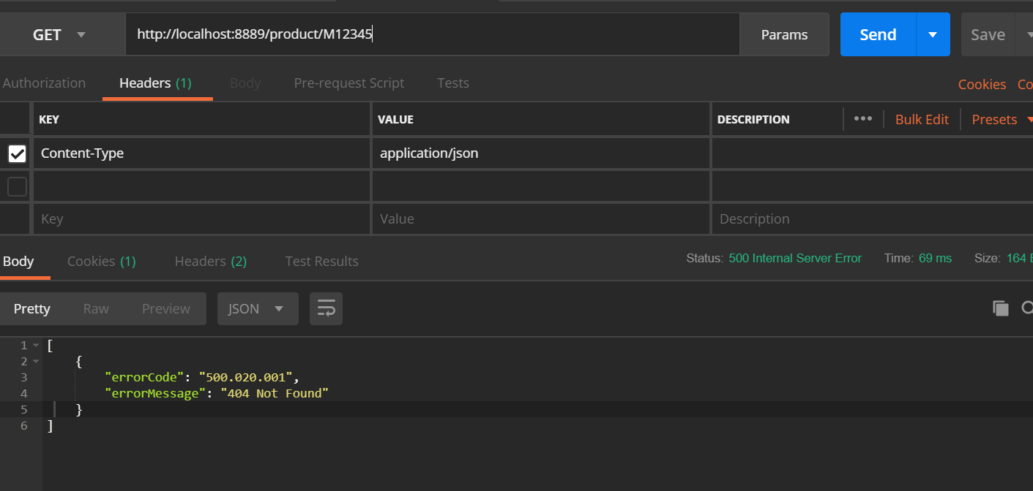

1. Invalid URL passed :

