**AI ASSISTED CODING LAB 15.3**

__________________________________________________________________________________

PRADEEP GUPTHA

2403A510C7

BATCH 05

**Task Description #1 – Basic REST API Setup**

Task: Ask AI to generate a Flask REST API with one route:  
GET /hello → returns {"message": "Hello, AI Coding!"}

**PROMPT :** to generate a Flask REST API with one route:  
GET /hello → returns {"message": "Hello, AI Coding!"}

**CODE :**

from flask import Flask, jsonify

# Create a Flask app

app = Flask(__name__)

# Define a route

@app.route('/hello', methods=['GET'])

def hello():

    return jsonify({"message": "Hello, AI Coding!"})

# Run the server

if __name__ == '__main__':

    app.run(debug=True)

OUTPUT :

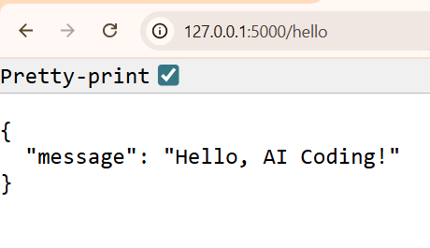

**OBSERVATION :**

The jsonify() function is used to convert the data into proper JSON. When the program runs, it starts a local server on port 5000, and the message can be viewed using a web browser, Postman, or Curl. This code demonstrates the basic working of a RESTful API using Flask in a clear and easy way.

**Task Description #2 – CRUD Operations (Students API)**Task:  
Use AI to build REST endpoints for a Student API:  
• GET /students → List all students.  
• POST /students → Add a new student.  
• PUT /students/<id> → Update student details.  
• DELETE /students/<id> → Delete a student.  
Expected Output:  
• Flask API with dictionary/list storage.  
• JSON responses for each operation.

**PROMPT :** build REST endpoints for a Student API:

**CODE :**

from flask import Flask, jsonify, request

app = Flask(__name__)

# Sample data (acts as a simple in-memory database)

students = [

    {"id": 1, "name": "Alice", "age": 20, "course": "Computer Science"},

    {"id": 2, "name": "Bob", "age": 22, "course": "Data Science"}

]

next_id = 3

# -------------------------

# 1️⃣ GET all students

# -------------------------

@app.route('/students', methods=['GET'])

def get_students():

    """Returns a list of all students."""

    return jsonify(students)

# -------------------------

# 2️⃣ GET a student by ID

# -------------------------

@app.route('/students/<int:id>', methods=['GET'])

def get_student(id):

    """Returns a single student by their ID."""

    student = next((s for s in students if s["id"] == id), None)

    if student:

        return jsonify(student)

    return jsonify({"message": "Student not found"}), 404

# -------------------------

# 3️⃣ POST (Add new student)

# -------------------------

@app.route('/students', methods=['POST'])

def add_student():

    """Adds a new student to the list."""

    global next_id

    if not request.json or not 'name' in request.json or not 'course' in request.json:

        return jsonify({"message": "Bad request, 'name' and 'course' are required"}), 400

    new_student = {

        "id": next_id,

        "name": request.json['name'],

        "age": request.json.get('age', None),

        "course": request.json['course']

    }

    students.append(new_student)

    next_id += 1

    return jsonify(new_student), 201

# -------------------------

# 4️⃣ PUT (Update student)

# -------------------------

@app.route('/students/<int:id>', methods=['PUT'])

def update_student(id):

    """Updates an existing student's details."""

    student = next((s for s in students if s["id"] == id), None)

    if not student:

        return jsonify({"message": "Student not found"}), 404

    if not request.json:

        return jsonify({"message": "Bad request"}), 400

    student['name'] = request.json.get('name', student['name'])

    student['age'] = request.json.get('age', student['age'])

    student['course'] = request.json.get('course', student['course'])

    return jsonify(student)

# -------------------------

# 5️⃣ DELETE (Remove student)

# -------------------------

@app.route('/students/<int:id>', methods=['DELETE'])

def delete_student(id):

    """Deletes a student from the list."""

    global students

    student = next((s for s in students if s["id"] == id), None)

    if not student:

        return jsonify({"message": "Student not found"}), 404

    students = [s for s in students if s["id"] != id]

    return jsonify({"message": "Student deleted successfully"})

# -------------------------

# Run the app

# -------------------------

if __name__ == '__main__':

    app.run(debug=True)

**OUTPUT :**

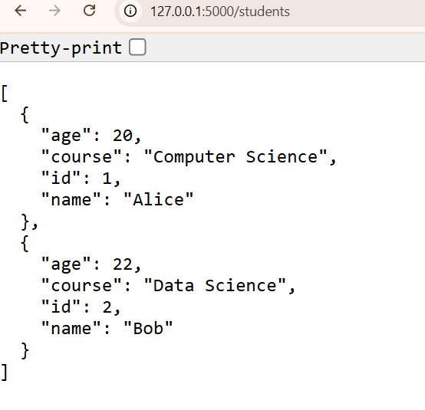

**OBSERVATION :**

The API returns data in JSON format, which can be tested using a browser or Postman. When the code is run, a local server starts on port 5000, allowing users to interact with student data easily. This program demonstrates the basic concept of backend API development

**Task Description #3** – API with Query Parameters  
Task: Ask AI to generate a REST API endpoint  
Expected Output:  
Working search function with query param handling.

**PROMPT :** generate a REST API endpoint

**CODE :**

from flask import Flask, jsonify, request

app = Flask(__name__)

# Sample data: A list of books to search through

books = [

    {"id": 1, "title": "The Great Gatsby", "author": "F. Scott Fitzgerald", "genre": "Fiction"},

    {"id": 2, "title": "To Kill a Mockingbird", "author": "Harper Lee", "genre": "Fiction"},

    {"id": 3, "title": "1984", "author": "George Orwell", "genre": "Dystopian"},

    {"id": 4, "title": "A Brief History of Time", "author": "Stephen Hawking", "genre": "Science"},

    {"id": 5, "title": "Sapiens: A Brief History of Humankind", "author": "Yuval Noah Harari", "genre": "History"},

    {"id": 6, "title": "Brave New World", "author": "Aldous Huxley", "genre": "Dystopian"}

]

@app.route('/search', methods=['GET'])

def search_books():

    """

    Searches for books based on query parameters.

    Example Usage:

    - /search?author=George Orwell

    - /search?genre=Fiction

    - /search?title=History

    - /search?genre=Dystopian&author=Aldous Huxley

    """

    # Get query parameters from the request URL

    query_author = request.args.get('author')

    query_genre = request.args.get('genre')

    query_title = request.args.get('title')

    # Start with the full list of books

    results = books

    # Filter by author if the parameter is provided

    if query_author:

        results = [book for book in results if book['author'].lower() == query_author.lower()]

    # Filter by genre if the parameter is provided

    if query_genre:

        results = [book for book in results if book['genre'].lower() == query_genre.lower()]

    # Filter by title (contains) if the parameter is provided

    if query_title:

        results = [book for book in results if query_title.lower() in book['title'].lower()]

    # Return the filtered list as JSON

    return jsonify(results)

if __name__ == '__main__':

    # To run:

    # 1. pip install Flask

    # 2. python ai_lab_15_3.py

    # 3. Open your browser and go to an address like:

    #    http://127.0.0.1:5000/search?genre=Dystopian

    app.run(debug=True)

**OUTPUT :**

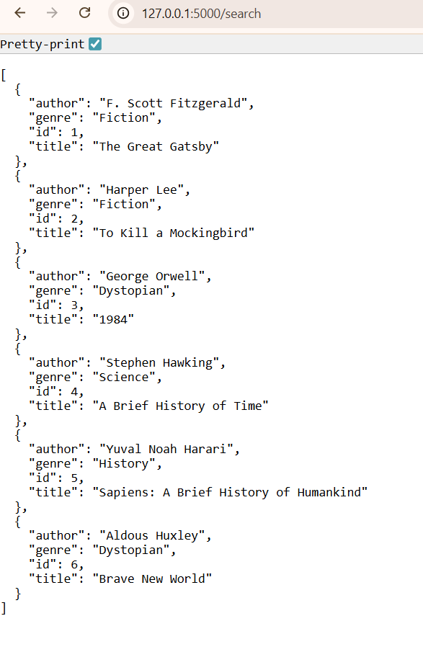  
**OBSERVATION :**

**The code efficiently handles these optional parameters by starting with the full list of books and progressively filtering it down if a parameter is present. The final list of matching books is then returned in JSON format, a standard for web APIs. The script includes sample data and comments explaining how to run the server and test the search functionality.**

**Task Description #4 – Integration & Testing**

Task: Ask AI to write test scripts using Python requests module to call  
APIs created above.

**PROMPT :** write test scripts using Python requests module to call  
APIs created above.

**CODE :**

import requests

import json

# The base URL of your running Flask application

BASE_URL = "http://127.0.0.1:5000"

def test_student_api():

    """

    Tests the CRUD operations for the /students endpoint.

    """

    print("--- 🧪 Testing Student API ---")

    # 1. GET all students

    print("\n1. GET /students (Initial List)")

    try:

        response = requests.get(f"{BASE_URL}/students")

        print(f"Status Code: {response.status_code}")

        print("Response JSON:", response.json())

    except requests.exceptions.ConnectionError as e:

        print(f"Connection Error: Please ensure the Flask API server is running. Details: {e}")

        return # Stop testing if the server is not running

    # 2. POST a new student

    print("\n2. POST /students (Add a new student)")

    new_student_data = {"name": "Charlie", "age": 21, "course": "Physics"}

    response = requests.post(f"{BASE_URL}/students", json=new_student_data)

    print(f"Status Code: {response.status_code}")

    added_student = response.json()

    print("Response JSON:", added_student)

    student_id = added_student.get("id")

    # 3. PUT (update) the new student's details

    print(f"\n3. PUT /students/{student_id} (Update student's course)")

    update_data = {"course": "Astrophysics"}

    response = requests.put(f"{BASE_URL}/students/{student_id}", json=update_data)

    print(f"Status Code: {response.status_code}")

    print("Response JSON:", response.json())

    # 4. GET the updated student to verify the change

    print(f"\n4. GET /students/{student_id} (Verify update)")

    response = requests.get(f"{BASE_URL}/students/{student_id}")

    print(f"Status Code: {response.status_code}")

    print("Response JSON:", response.json())

    # 5. DELETE the student

    print(f"\n5. DELETE /students/{student_id} (Remove student)")

    response = requests.delete(f"{BASE_URL}/students/{student_id}")

    print(f"Status Code: {response.status_code}")

    print("Response JSON:", response.json())

    # 6. GET all students again to confirm deletion

    print("\n6. GET /students (Final List)")

    response = requests.get(f"{BASE_URL}/students")

    print(f"Status Code: {response.status_code}")

    print("Response JSON:", response.json())

    print("-" * 30)

def test_book_search_api():

    """

    Tests the query parameter functionality of the /search endpoint.

    """

    print("\n--- 🧪 Testing Book Search API ---")

    # 1. Search by genre

    print("\n1. GET /search?genre=Dystopian")

    try:

        response = requests.get(f"{BASE_URL}/search", params={"genre": "Dystopian"})

        print(f"Status Code: {response.status_code}")

        print("Response JSON:", response.json())

    except requests.exceptions.ConnectionError as e:

        print(f"Connection Error: Please ensure the Flask API server is running. Details: {e}")

        return

    # 2. Search by author

    print("\n2. GET /search?author=Harper Lee")

    response = requests.get(f"{BASE_URL}/search", params={"author": "Harper Lee"})

    print(f"Status Code: {response.status_code}")

    print("Response JSON:", response.json())

    # 3. Search with no results

    print("\n3. GET /search?genre=Comedy (No results expected)")

    response = requests.get(f"{BASE_URL}/search", params={"genre": "Comedy"})

    print(f"Status Code: {response.status_code}")

    print("Response JSON:", response.json())

    print("-" * 30)

if __name__ == "__main__":

    # --- How to Run ---

    # 1. Make sure your Flask API (e.g., ai_lab_15_2.py or ai_lab_15_3.py) is running in a separate terminal.

    # 2. Run this script in another terminal: python ai_lab_15_4.py

    # 3. You will need to install the 'requests' library first: pip install requests

    test_student_api()

    test_book_search_api()

**OUTPUT :**



**OBSERVATION :**

**his Python script is a simple web API built using the Flask framework. It combines two separate functionalities into a single server:**

**A Student API: Provides full CRUD (Create, Read, Update, Delete) operations for managing a list of students.**

**The script uses simple Python lists to store book data, acting as an in-memory database. When run, starts a local web server, making these API endpoints accessible.**