Our Proposal: Automating the Product Lifecycle with AI — Human in the Loop
A TechSur GenAI proposal, designed to work with TT Electronics’ Product Lifecycle Process (ENG 001 v4.1)
Prepared by TechSur Solutions for Sanjeev Sachan, Director — Engineering & Program Management (North America), TT Electronics
1. What We Propose
TechSur proposes to automate TT Electronics’ product lifecycle using Generative AI (GenAI), with a human always in the loop. We would deliver an internal-only, multi-agent “TT Engineering Copilot” that drafts, checks and packages work at every phase — while your engineers keep every decision. Our two priorities are: (1) automate the lifecycle end-to-end wherever it adds value, and (2) lead with validating designs against standards for manufacturability — the highest-payoff, easiest-to-demonstrate capability.
Human-in-the-loop is a design principle, not a feature. The AI proposes; the engineer disposes. Every consequential output — a gate pass/fail, a design-change suggestion, a PPAP approval — requires human review and sign-off. Nothing is grounded in guesswork: retrieval-augmented generation ties every answer to a cited source, and no TT data leaves your tenant. TT-specific baselines and targets would be sized in a short discovery sprint.
2. Why Our Approach Fits TT From Day One
Rather than change how TT works, we layer AI onto the gated process you already run in Cora. Three things already true in your environment make our automation low-risk and fast to land — we simply build on them:
- We plug into your single source of truth. Because the process runs in Cora — which the policy itself calls “a critical enabler for increased use of GenAI business intelligence” — our Copilot reads from and writes back to Cora without disrupting the gated flow.
- We automate rules that already exist. Your gates have defined exit criteria and Pass / Conditional Pass / Fail outcomes. We turn those written rules into automated first-checks, so the AI does the reading and drafting and the engineer does the judging.
- We turn static checklists into active, signed-off checks. Where a gate checklist is stored today as evidence, our agents pre-populate it with cited findings that an engineer reviews and signs — strengthening your audit trail, not replacing it.
3. The Copilot We Propose — One Platform, Delivered in Three Waves
We propose an internal-only, multi-agent Copilot alongside Cora (and CAD, PLM, ERP and the standards library) that adds three capability groups, each keeping a human decision-maker:
- Automated first-checks on proposals, requirements, designs, manufacturability, production readiness and lessons learned — for the engineer to confirm.
- Pre-review intelligence that drafts the gate-review pack from Cora artifacts and flags likely Conditional-Pass / Fail risks before the review — so reviewers focus on judgment.
- Design-validation agents that check CAD and BOM data against external standards, TT internal rules and TT historical defect/yield data — with findings the engineer signs off.
One platform, not two — manufacturability validation is a gate agent, not a separate app.
Manufacturability & standards validation is not a second product. It is the DFM/DFA + Compliance agent that runs at Gate 3 (light screen) and Gate 4 (deep audit) — one of the ten phase agents in the same Copilot. “Leading with it” is purely a delivery-sequencing choice: we build that agent first (the Wave 2 flagship) because it has the clearest ROI and is the easiest to demo. It shares the same architecture, knowledge graph, connectors, RAG grounding, Gate Cockpit UI and governance as every other agent. After Wave 3 it is simply a mature member of the same crew — one application, one codebase.
We would sequence delivery in three waves so value lands early and risk stays low:
Wave | What we automate | Why now
Wave 1 — Foundational Months 0–6 | Cora natural-language Q&A; gate-checklist auto-fill; proposal / business-case draft generator; requirements decomposition & traceability. Gate Cockpit v1. | Highest ease; directly cuts review-prep and proposal effort. Builds trust fast.
Wave 2 — Advanced Months 6–14 | Standards & DFM/DFA compliance agent (flagship); historical defect & yield predictor; V&V test-plan generator; production-readiness (PPAP-style / MRL) assembly. | Where late, costly manufacturability failures get collapsed — the headline ROI.
Wave 3 — Agentic Months 14–24 | Autonomous gate-prep orchestrator (matures the Gate Cockpit); design-optimization advisor; cross-project reuse; portfolio “chief engineer” analytics — all with human approval. | Compounding advantage once data and trust are established.
4. How We Automate the Full Lifecycle — Phase by Phase
For each phase we propose a specific AI agent that drafts, checks and packages the work — mapped to that gate’s exit criteria — while the engineer keeps the decision. The manufacturability agent (★ Phase 4) is one of these, not a separate track.
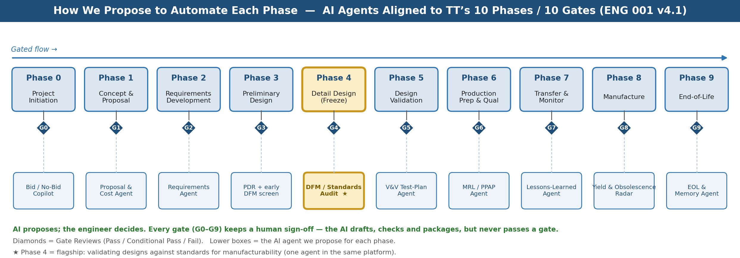
Figure 1 — The AI agent we propose for each phase, all within one platform. AI drafts and checks; the engineer signs every gate (G0–G9). Phase 4 manufacturability validation is the flagship.
Phase → Gate | What we propose to automate (human keeps the decision)
Phase 0 → Gate 0 Project Initiation / Bid–No-Bid | We automate: opportunity triage and Salesforce enrichment; capability match against TT history; information-sufficiency check on customer drawings/specs; strategy-fit and export-control screening; a drafted one-page Bid/No-Bid brief. Human decides the bid.
Phase 1 → Gate 1 Concept & Proposal | We automate: a drafted costed proposal / business case from historical projects and parametric estimation; a concept-level DFM sanity check; feasibility Q&A over design libraries; NTI starting-TRL assessment; auto-creation of the Cora baseline and Executive Summary. Engineer approves the proposal.
Phase 2 → Gate 2 Requirements Development | We automate: requirements decomposition (direct vs. derived); a traceability-matrix draft into Cora; a testability audit; suggested mandatory requirements drawn from applicable standards. Engineer confirms the requirement set.
Phase 3 → Gate 3 Preliminary Design (PDR) | We automate: concept trade-off support; early DFM/DFA screening (flagship agent, light pass); a proposed Cora Risk & Issues register; a drafted PDR pack; a check that prior-gate actions are closed. Reviewers own the Gate 3 decision.
Phase 4 → Gate 4 Detail Design / Design Freeze (CDR) | FLAGSHIP — we automate: deep DFM/DFA + standards audit on the frozen design (see §5); BOM health check (obsolescence, single-source, preferred-parts); a drafted CDR pack; drafted provisional production docs (BOMs, routes, SOPs, work instructions). Engineer signs the freeze.
Phase 5 → Gate 5 Design Validation | We automate: a V&V test-plan draft derived from requirements; a test-failure diagnostic against historical failures; pre-compliance environmental prediction (thermal, vibration, humidity) before costly chamber time; a Gate 5 evidence pack. Engineer validates results.
Phase 6 → Gate 6 Production Prep & Qualification | We automate: manufacturing-readiness (MRL) scoring; PPAP-precursor and control-plan / PFMEA drafts; a Gate 6 pack with financials, schedule vs. baseline, risks and business-case update. Ops/quality approve full-rate production.
Phase 7 → Gate 7 Transfer & Monitor | We automate: lessons-learned capture from Cora, gate minutes and action registers; early production anomaly detection; a transfer-completeness audit; candidate Continuous Improvement (PDCA/DMAIC) items. Engineer confirms transfer.
Phase 8 → Gate 8 Manufacture | We automate: natural-language yield & quality interrogation; an obsolescence radar over supplier PCN/PDN feeds (18–36 months out); Change Review Board support; financial-anomaly detection. Board owns the change decision.
Phase 9 → Gate 9 End-of-Life | We automate: drafted EOL customer notifications and last-time-buy packs; a redevelopment business-case advisor; a retention & disposal / ERP-update audit; institutional-memory extraction before knowledge is lost. Engineer approves EOL actions.
5. Flagship — We Propose to Validate Designs Against Standards for Manufacturability
This is the agent we recommend building first. It targets a problem every engineering leader recognizes: designs that look fine on screen but fail to manufacture — and are discovered too late. It runs at Gate 3 (light screen) and Gate 4 (deep audit) inside the same platform, and the engineer always confirms the findings.
The gap we would close
Today, gate-exit criteria are answered by people reading checklists. A hidden tolerance stack-up or non-manufacturable feature can pass Preliminary Design, survive the Gate 4 “freeze,” and only bite in Phase 6 — when tooling is being commissioned and change is most expensive. We propose to move that discovery to Gate 3/Gate 4.
How our proposed agent works
On CAD upload, the agent extracts features, runs three sub-checks in parallel, and returns one consolidated, risk-scored, source-cited report that auto-fills the Cora gate checklist — surfaced in the Gate Cockpit for the engineer to review and sign:
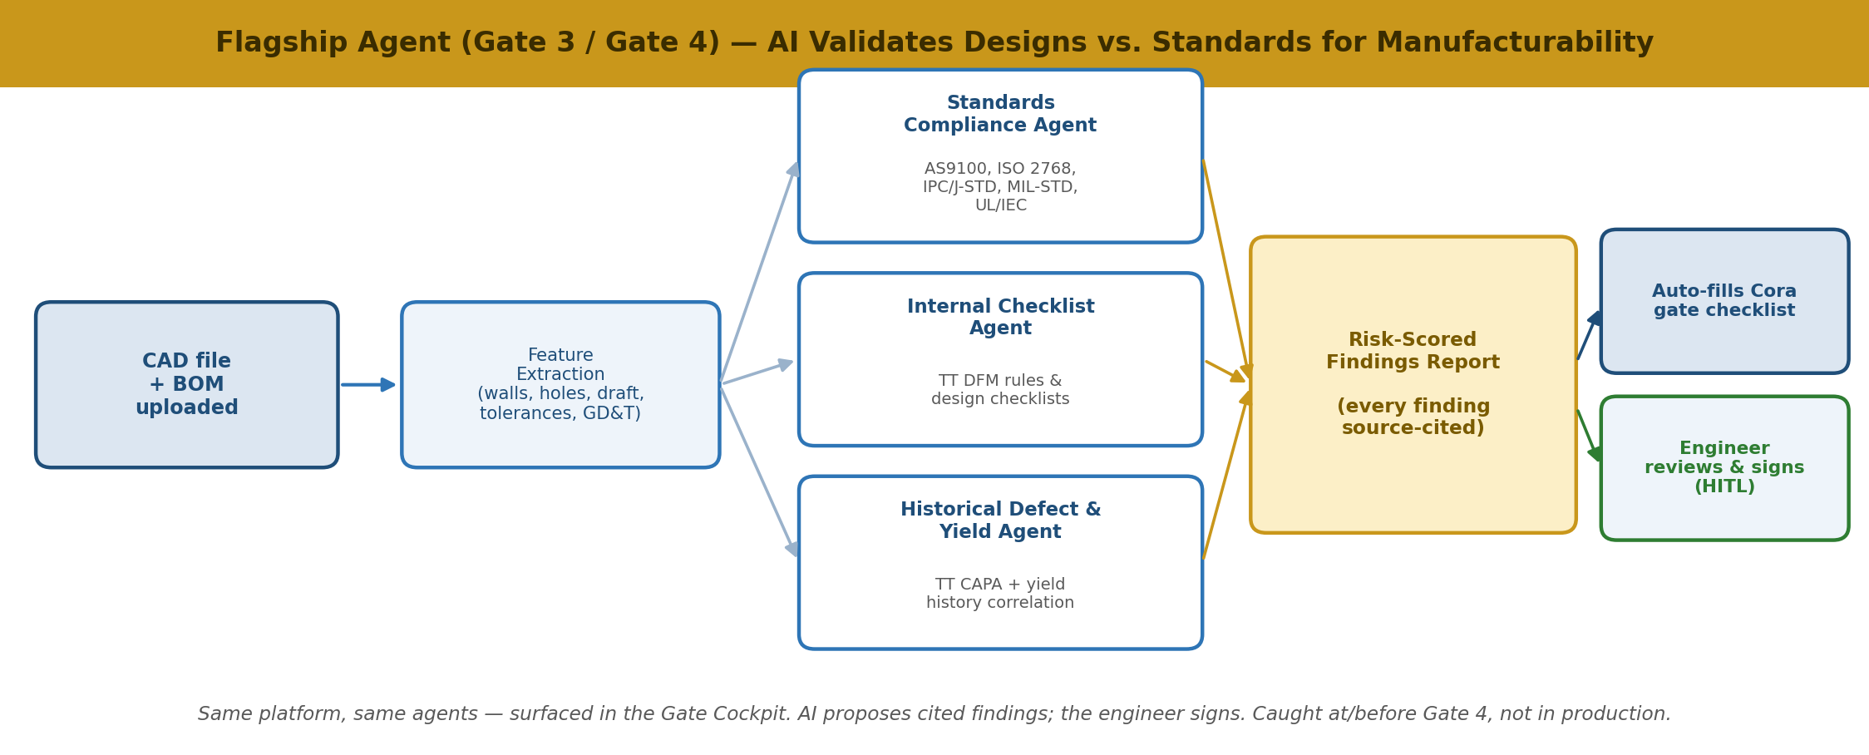
Figure 2 — The flagship Gate 3/Gate 4 agent (part of the same platform). The AI produces cited findings; the engineer reviews and signs in the Gate Cockpit (human-in-the-loop).
- Standards Compliance check — against applicable external standards (e.g., AS9100, ISO 2768 tolerances, IPC / J-STD, MIL-STD, UL/IEC), as relevant to the product.
- Internal Checklist check — against TT’s own DFM rules and design checklists.
- Historical Defect & Yield check — correlates the design signature against TT’s CAPA and yield history to predict likely failure modes and yield ranges.
For make-to-print work, the same agent drafts the customer manufacturability-advisory report. Every engineer override trains the rules over time. Net effect: non-manufacturable designs are caught at or before Gate 4 — not in production — with a human signing every finding.
Why we recommend leading here
- Tangible and measurable — fewer late ECOs, less scrap/rework, fewer requalifications; a clean before/after story on a real pilot part.
- Rides on the existing process — it fills the Gate 3/Gate 4 checklist already mandated, strengthening compliance rather than adding overhead.
- Universally understood — “the design can’t be built” is a pain every stakeholder feels, so the value needs no translation.
6. How We Would Build It — One Architecture, With a Web Gate Cockpit
We propose a single six-layer platform with governance — including human-in-the-loop — running vertically through every layer. The engineer’s primary surface is a purpose-built Web Gate Cockpit: a UI with workflow and RBAC to navigate gates G0–G9, review the AI-drafted packs and checklists, and confirm/sign each gate. Cora remains the system of record and approval engine — the Cockpit federates with Cora and writes approvals, checklists and the RAIL back to it, so we never build a second workflow engine.
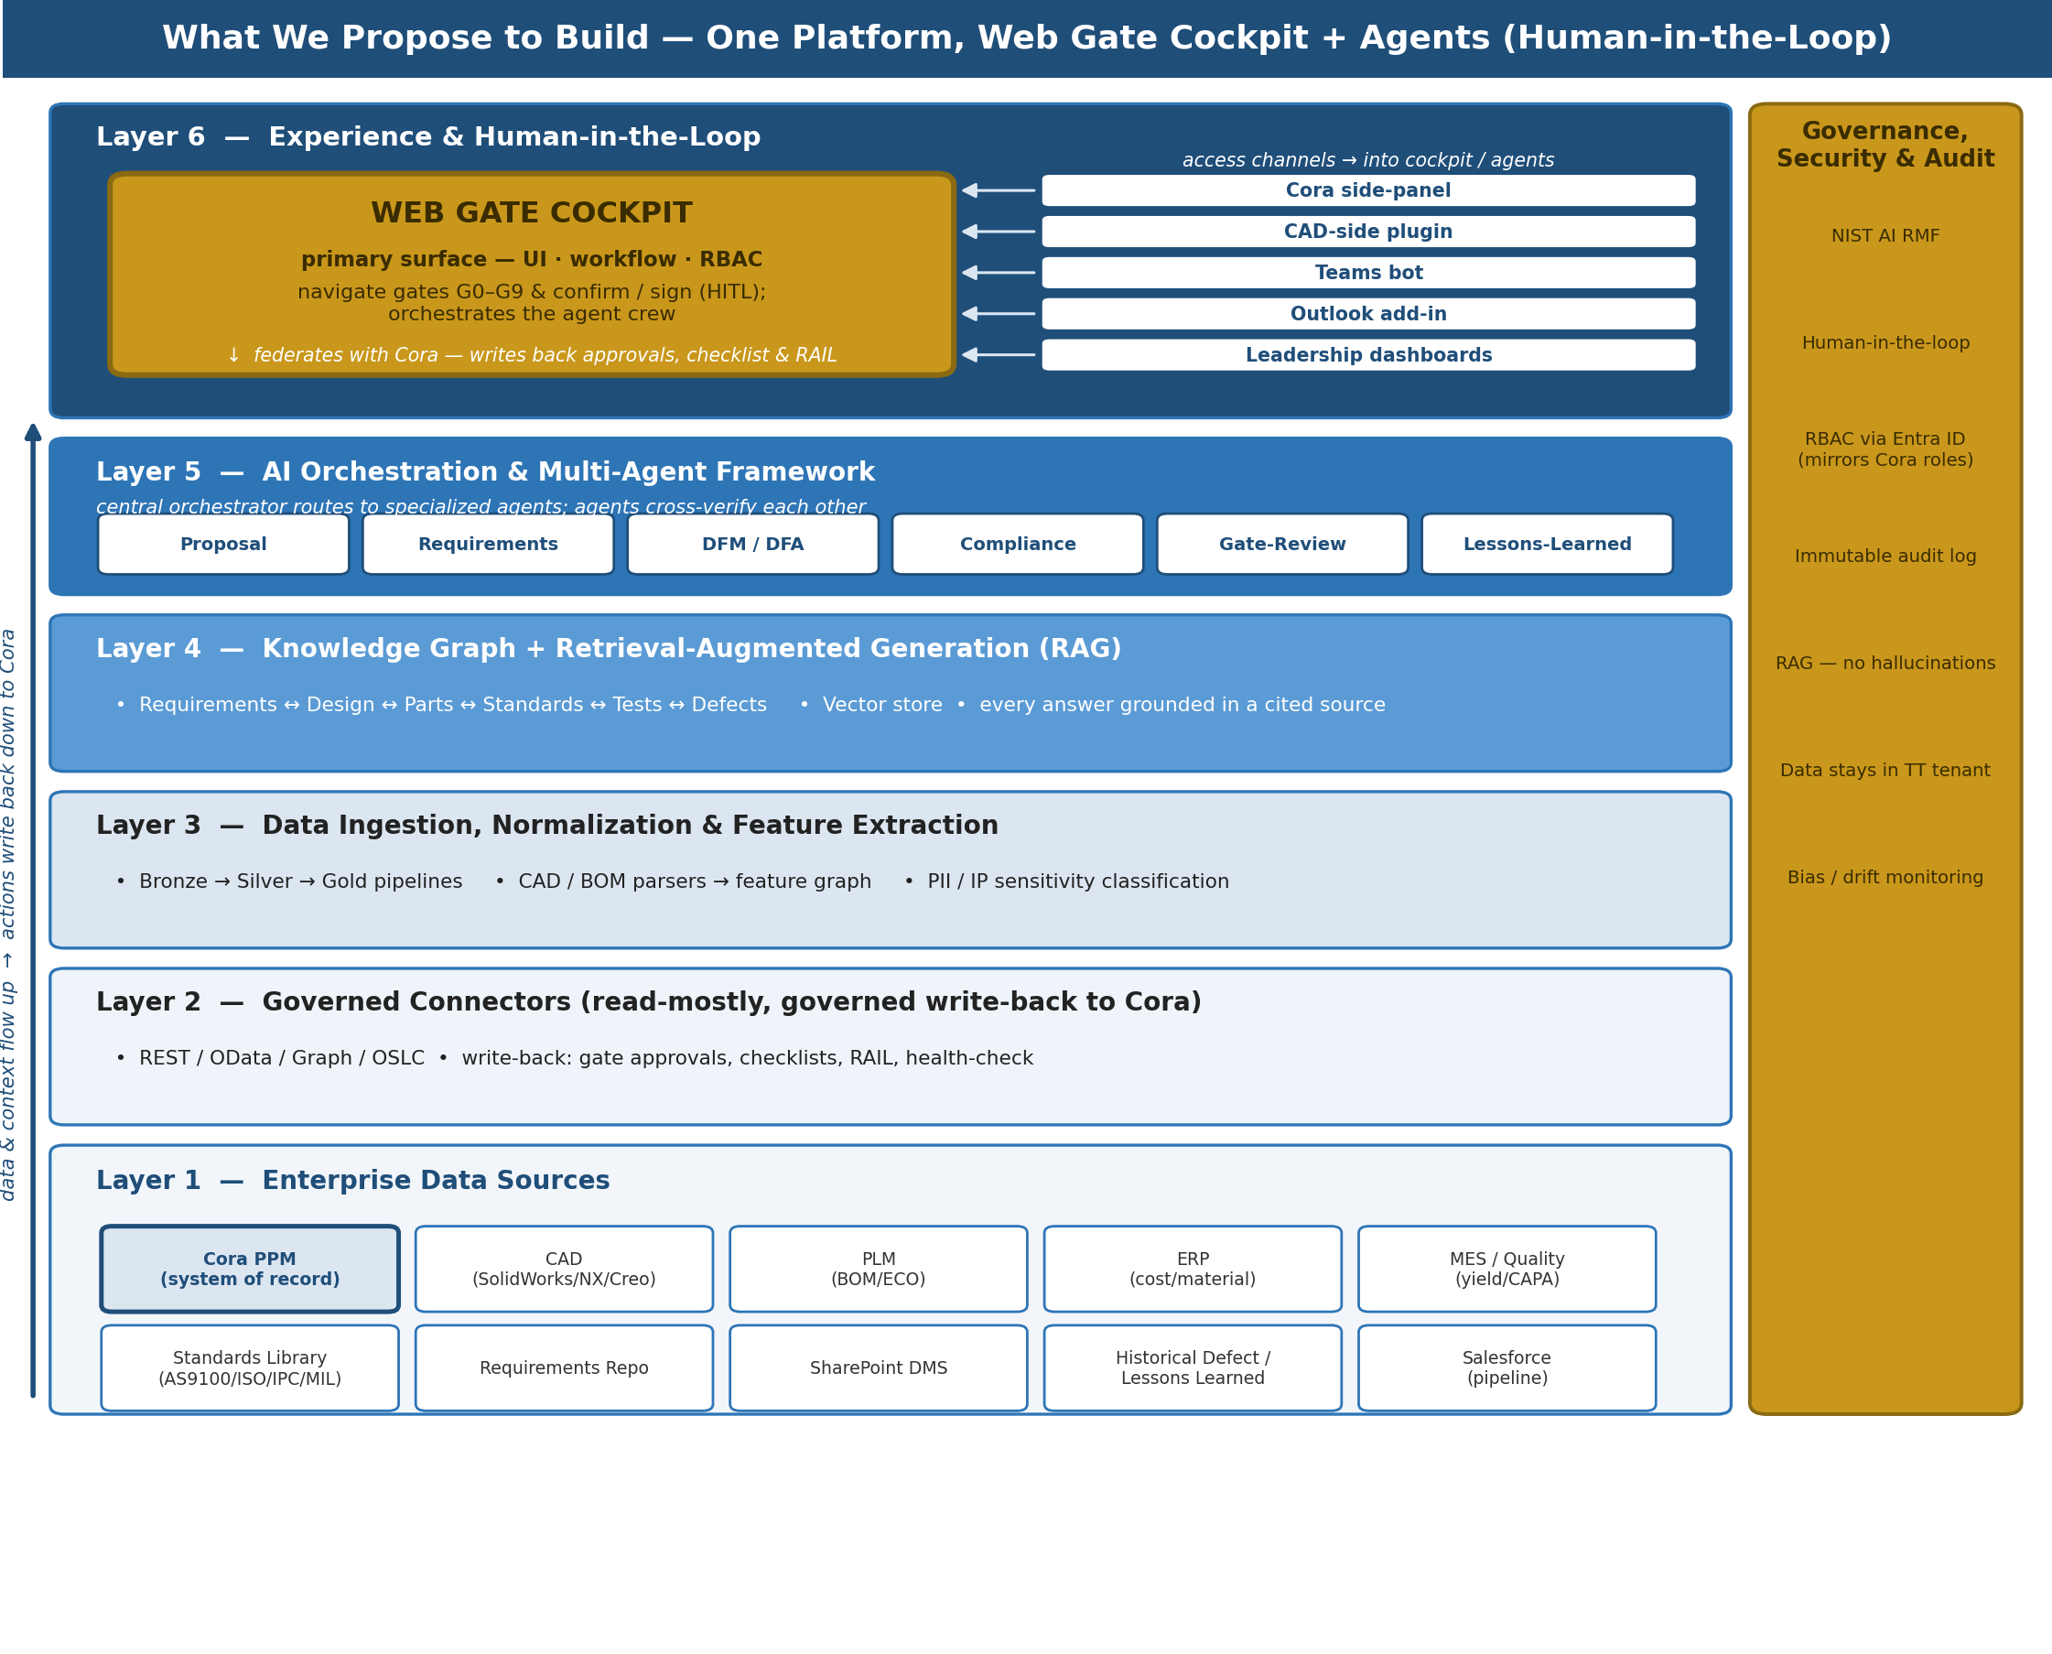
Figure 3 — One platform: data sources → governed connectors → ingestion → knowledge graph + RAG → multi-agent orchestration → the Web Gate Cockpit (primary human-in-the-loop surface), with other channels feeding into it and governance spanning every layer.
Why a Web Gate Cockpit — and not “everything in the Cora side-panel”
You raised the right concern: driving a multi-agent gate workflow entirely from the Cora side-panel is limiting — it’s constrained by Cora’s screen real estate and extensibility. Our recommendation is a dedicated Web Gate Cockpit as the primary surface, with the other Layer 6 items as lightweight channels into the same cockpit and agents. This keeps one platform while giving engineers a proper cockpit, and it lets us evolve the UX (Wave 1 basic → Wave 3 autonomous gate-prep) without touching the architecture.
Layer 6 component | Purpose — where/when it is used
Web Gate Cockpit (primary surface) | The main human-in-the-loop surface. UI + workflow + RBAC to move through gates G0–G9, review AI-drafted packs/checklists and confirm/sign. Orchestrates the agent crew; federates with Cora for the actual approval and record.
Cora side-panel | A channel for engineers who prefer to stay in Cora — shows the same drafted pack/checklist and routes the sign-off through Cora’s native approval + RBAC.
CAD-side plugin | Where the design engineer actually works. Surfaces DFM/standards findings live as they model — so issues are caught before they ever reach a gate.
Teams bot | Conversational, on-the-go access: “What’s blocking Gate 4 on Project X?”, quick Q&A, and approval nudges/notifications.
Outlook add-in | Gate-review action reminders and executive summaries pushed to the inbox.
Leadership dashboards | Portfolio view for the Technology Director / Steering Group: TRL/MRL roll-ups, gate-outcome analytics, portfolio health.
Division of labor (so there is no duplication): the Cockpit owns the experience, agent orchestration and gate navigation; Cora stays the workflow engine and system of record for gate approvals and the RAIL; RBAC is inherited from Entra ID / Active Directory and mirrors Cora’s existing approver roles — one identity model, not a new one.
- Data & connectors (Layers 1–2) — governed read access to Cora, CAD, PLM, ERP, MES/quality, requirements, standards and Salesforce, with controlled write-back to Cora (gate approvals, checklists, RAIL, health-check).
- Knowledge & agents (Layers 3–5) — a medallion data pipeline and CAD/BOM feature extraction feed a knowledge graph and vector store; RAG grounds every answer in a cited source; specialized agents cross-verify each other.
7. How We Keep It Defensible — Governance & Human Control
- Human-in-the-loop by default on all consequential decisions (gate pass/fail, design-change proposals, PPAP approvals). The Copilot augments your engineers; it never overrides them and never passes a gate on its own.
- Grounded, no hallucinations — retrieval-augmented generation ensures every answer is drawn from TT’s own documents and data, and every finding cites its source clause, rule or record.
- Data stays in TT’s tenancy — no TT design or IP data leaves your environment; models fine-tuned in-tenant if required, with UK/EU/US residency as needed.
- Aligned to NIST AI RMF (Govern–Map–Measure–Manage), with RBAC via Entra ID/SSO, an immutable audit log, and continuous monitoring for bias, drift and hallucination — the posture TechSur operationalizes in regulated federal work.
8. What We Recommend Next
- Endorse a charter for an internal-only, human-in-the-loop TT Engineering Copilot with a Web Gate Cockpit, integrated with Cora, CAD, PLM, ERP/MES and the standards library.
- Nominate an executive sponsor in Engineering / Technology (the Technology Director owns ENG 001).
- Run a focused discovery sprint with us to confirm the CAD/PLM/ERP/MES stack, the Cora federation approach for the Cockpit, and digitize a first slice of TT DFM rules and standards.
- Pilot the manufacturability wedge first — 2–3 representative projects (one Cat 1 NPI A, one Cat 2 NPI B, one make-to-print) and one part for a live Gate 3/Gate 4 DFM/standards demo with baseline vs. post-deployment metrics.
- Confirm site scope (we recommend Plano North America plus one European site to prove global-parity from the start).
Bottom line: one platform, not two. We layer a governed, human-in-the-loop Copilot — fronted by a Web Gate Cockpit that federates with Cora — onto the lifecycle TT already runs, lead with manufacturability validation as the first agent, and expand wave by wave. The AI does the heavy lifting; your engineers stay in control at every gate.

Appendix A — Agent Inputs & Outputs by Gate
Representative (not exhaustive) inputs each agent relies on to generate its artifacts, tuned to TT Electronics’ product mix (sensors, power management, magnetics, mil-spec connectors, optoelectronics, PCBAs and electromechanical box-builds). Standards are applied as relevant to the product — e.g., a mil-spec connector pulls MIL-DTL/DO-160, a medical sensor pulls ISO 13485, a PCBA pulls IPC.
Agent / Gate | External sources (inputs) | Internal artifacts (inputs) | Outputs (artifacts generated)
Bid/No-Bid Copilot Phase 0 / Gate 0 | Customer RFQ/RFP/SOW; customer drawings & specs; ITAR/EAR & UK export-control lists; DFARS / customer flow-downs | Salesforce opportunity record; TT capability & skills library; historical project & win/loss data; site capacity / loading | Opportunity summary; capability-match & spec-gap assessment; export/security screen; drafted 1-page Bid/No-Bid brief
Proposal & Cost Agent Phase 1 / Gate 1 | Customer requirements/spec; supplier budgetary quotes & distributor lead-times (Mouser/TTI/DigiKey); market / target-price data | Historical proposals of similar NPI type; parametric cost models; preliminary BOM; labor / rate cards; Cora templates | Costed proposal / business case; resource & schedule plan; auto-created Cora baseline & Executive Summary; NTI starting-TRL note
Requirements Agent Phase 2 / Gate 2 | Customer system/interface specs; applicable standards (AS9100D, DO-160, MIL-STD-810/461, UL/IEC); regulatory reqs (medical: ISO 13485 / FDA) | Draft requirements set; prior requirement libraries; interface control documents; Cora / requirements repository | Decomposed direct & derived requirements; requirements-traceability matrix; testability audit; standards-driven mandatory requirements
PDR + Early DFM Agent Phase 3 / Gate 3 | ASME Y14.5 (GD&T); ISO 2768 general tolerances; IPC-2221 (PCB design); plant / process-capability references | Concept CAD (SolidWorks/NX/Creo); preliminary BOM; prior-gate RAIL / actions; historical yield for similar parts | Design trade-off analysis; early DFM/DFA screen; seeded Risk & Issues register; drafted PDR pack; action-closure check
DFM / Standards Audit Agent (flagship) Phase 4 / Gate 4 | AS9100D; ASME Y14.5; ISO 2768; IPC-A-610 & IPC-J-STD-001 (assembly); MIL-STD / UL / IEC as applicable; RoHS / REACH / conflict-minerals; supplier PCN/PDN feeds | Frozen CAD + GD&T; released BOM & PLM (ECN/ECO); TT internal DFM rules / checklists; tolerance stack-ups; CAPA & yield history (MES/quality); preferred-parts library | Risk-scored, source-cited DFM/DFA & standards audit; BOM health check; drafted CDR pack; provisional production docs (routes, SOPs, WIs); make-to-print manufacturability advisory
V&V Test-Plan Agent Phase 5 / Gate 5 | Test-method standards (MIL-STD-810 methods, DO-160 sections, IEC 61000 EMC); customer acceptance criteria | Requirements / traceability matrix; DFMEA; historical test-failure database; material selections | V&V test matrix (analysis/inspection/demo/test); pre-compliance environmental prediction; test-failure diagnostics; Gate 5 evidence pack
MRL / PPAP Agent Phase 6 / Gate 6 | PPAP / APQP & control-plan conventions; first-article standard (AS9102); customer PPAP requirements | Process flow & routings; PFMEA; first-article / FAI data; equipment qualification & Cpk data; cost / baseline in Cora | MRL score; PPAP-precursor package; control plan / PFMEA draft; Gate 6 pack (financials, schedule vs. baseline, risks)
Lessons-Learned Agent Phase 7 / Gate 7 | Customer field / acceptance feedback | Cora gate minutes & RAIL; early-production MES yield/scrap data; defect / CAPA reports; meeting transcripts | Structured lessons-learned (tagged by type/category); production anomaly flags; transfer-completeness audit; CI (PDCA/DMAIC) candidates
Yield & Obsolescence Radar Phase 8 / Gate 8 | Supplier PCN/PDN & EOL notices; distributor stock / lead-time; obsolescence databases (SiliconExpert / IHS) | MES / ERP yield, scrap & cost data; BOM & preferred-parts library; Change Review Board records | Yield / quality Q&A; 18–36-month obsolescence risk forecast; CRB support pack; financial-anomaly alerts
EOL & Memory Agent Phase 9 / Gate 9 | Customer EOL / last-time-buy requirements; EHS / disposal & records-retention regs; contractual data-retention terms | ERP material status; final BOM & demand history; fixtures / tooling records; full project archive | Drafted EOL notices & last-time-buy packs; redevelopment business-case advisory; retention/disposal & ERP-update audit; institutional-memory knowledge asset
Note: the Gate 4 flagship row is deliberately the richest — it is where CAD + GD&T, IPC/AS9100 standards, TT internal DFM rules and CAPA/yield history converge to validate manufacturability before design freeze.

