## Introduction

With the growing abundance of online courses covering a wide range of subjects, finding courses that align with one's interests and needs has become increasingly challenging. Traditional recommender systems have relied on machine learning techniques such as content-based filtering and collaborative filtering. Larger platforms like Coursera have even incorporated deep learning algorithms to analyze user behavior and provide course recommendations. However, these systems have shown limitations when it comes to assisting beginners who are not yet certain about the specific topics they wish to explore.

To address this issue, we aim to develop a recommendation system that caters to individuals who are unsure about the kind of topics they want to delve into. This system would go beyond the traditional approaches by leveraging innovative techniques and strategies. By considering a holistic understanding of the user, the system would be able to provide personalized recommendations that align with their general interests and learning goals.

## Problem Statement

* Usually, for a course recommendation, a user enters the topic he is interested in and the system recommends courses which are relevant to the topic entered by the user.
* This is fine when the user is sure about the topic he wants to learn but for the users who are unsure of the topic they want to choose, this method become inefficient.
* The user should be able to give a detailed description/his profile (usually a bio/resume) to the system to get recommendations.

## Proposed Solution

* To tackle the discussed problem, We suggest using a recommendation system where the user can come in and type his interest and what type of course he is looking for and his expected outcomes from the course.
* Based on the detailed Description, we Intent to analyze the likeliness between the user’s description and the Course Descriptions and other parameters of the available courses to suggest the most relevant course to the user.

## Literature Survey

|  |  |  |  |
| --- | --- | --- | --- |
| **Name of the paper** | **Year of Publication** | **Medium of Publication** | **Links** |
| A recommendation system for online courses | 2017 | World conference on Information Systems and Technologies | [Here](https://www.researchgate.net/publication/315848045_A_Recommendation_System_for_Online_Courses) |
| Online course recommendation using deep convolutional neural network with negative sequence mining | 2022 | Wireless communications and mobile computing | [Here](https://www.hindawi.com/journals/wcmc/2022/9054149/) |
| Methods for building course recommendation system | 2016 | KSE | [Here](https://www.researchgate.net/publication/311313309_Methods_for_building_course_recommendation_systems) |
| A collaborative recommendation system for online course recommendations | 2019 | IEEE | [Here](https://ieeexplore.ieee.org/document/8876926) |
| Online course recommendation system | 2019 | IRJET | [Here](https://www.irjet.net/archives/V6/i4/IRJET-V6I41117.pdf) |

## Proposed Methodology

To gain insights into the industry's approach to user experience and improve our recommendation system, we propose exploring the Coursera website. By studying their recommendation methods, we can understand how they cater to end-users and enhance their learning journey. We will collect essential data such as Course Description, Skills Taught, Course Name, Course Rating, Course Duration, and University to train our models effectively.

To begin, we will employ traditional machine learning methods such as Content-based filtering and Collaborative Filtering. By implementing these techniques, we can evaluate their efficiency in providing accurate course recommendations based on user preferences and historical data.

Next, we will develop a Deep Learning model using Recurrent Neural Networks (RNN). This model will be trained on the collected data, enabling us to make course recommendations based on the description provided by the user. RNNs are well-suited for processing sequential data, making them a suitable choice for capturing the context and nuances of course descriptions and user input.

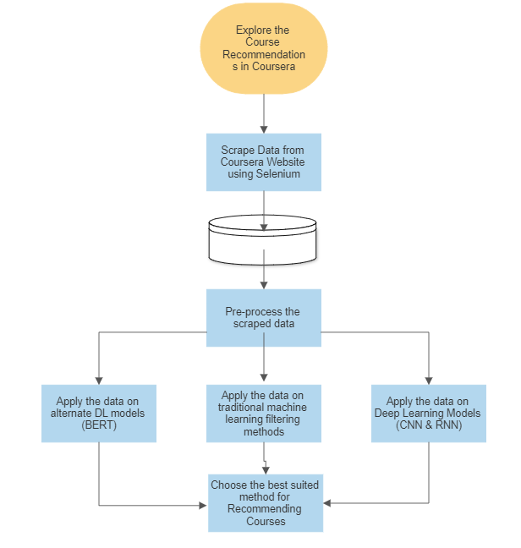Additionally, we will build a Deep Learning model using Convolutional Neural Networks (CNNs) to assess their efficiency in course recommendation. CNNs excel at analyzing structured data and can potentially uncover patterns and relationships within course descriptions, leading to accurate and relevant recommendations.

Lastly, we will explore the use of BERT (Bidirectional Encoder Representations from Transformers), a powerful language model, to generate word embeddings for existing course descriptions and the user's description. By calculating the similarity between these embeddings, we can recommend the most relevant courses to the user. BERT's contextual understanding of language allows us to capture semantic relationships effectively and improve the precision of our recommendations.

By implementing and comparing these different deep learning approaches, we aim to enhance the accuracy and effectiveness of our recommendation system. Through this comprehensive exploration, we can leverage the industry's best practices while striving to deliver an exceptional user experience to beginners and users looking to explore new subjects on our platform.

## Conclusion

After thoroughly experimenting with various traditional machine learning methods and deep learning models, we have drawn several conclusions. Traditional machine learning models excel at recommending similar courses when user activity data is available. However, they face limitations when it comes to providing recommendations for new users who lack prior data within the system.

Our findings indicate that Recurrent Neural Network (RNN) models perform exceptionally well when processing long sequential data. By training them on extensive datasets of natural language processing (NLP) data, RNN models prove to be highly effective in course recommendation systems. Their ability to capture contextual information and understand the sequential nature of course descriptions enable accurate and personalized recommendations.

Convolutional Neural Network (CNN) models, on the other hand, demonstrate great proficiency in feature extraction. They can extract relevant keywords from the user's description and utilize them to recommend courses that possess similar keywords within their descriptions. This feature-based approach enhances the precision of course recommendations and enables users to find courses aligned with their specific interests.

Moreover, our exploration of BERT (Bidirectional Encoder Representations from Transformers) reveals its remarkable capabilities in embedding and grouping similar words together. By leveraging BERT's training on extensive NLP datasets, we can process course descriptions and user input, allowing us to measure the similarity between descriptions and recommend the most relevant courses. BERT's contextual understanding of language contributes significantly to the accuracy and relevance of the recommendations provided.

Overall, our analysis underscores the strengths and advantages of different models. Traditional machine learning methods are well-suited for leveraging user activity data, while RNN models excel in processing sequential data. CNN models excel in extracting meaningful features, and BERT models excel in capturing semantic relationships between words. By combining these models intelligently, we can create a robust recommendation system that enhances the user experience and assists beginners in finding courses tailored to their needs and interests.

## References

* <https://www.researchgate.net/publication/315848045_A_Recommendation_System_for_Online_Courses>
* [https://Wikipedia.com](https://wikipedia.com/)
* <https://www.researchgate.net/publication/311313309_Methods_for_building_course_recommendation_systems>
* <https://www.hindawi.com/journals/wcmc/2022/9054149/>