Microservices Patterns
with Spring Boot and Spring Cloud
Project guide, pattern flows with diagrams, interview questions and production incident playbook
Contents
1. Project overview
2. How to run the code (with and without Docker)
3. Pattern flows explained with diagrams
4. Interview questions and answers (scenario based, 25 questions)
5. Real-time incident scenarios and how to handle them (8 incidents)
6. Pattern-to-service guide with architecture images and summary table
Based on the pattern catalog at microservices.io/patterns.

1. Project overview
This project is a runnable Spring Boot 3.3 / Spring Cloud 2023.0 system that demonstrates the patterns from the microservices.io pattern language. The business domain is deliberately small - placing an order - so that every pattern has a visible job to do.
A client logs in, places an order through the API gateway, and a saga coordinates stock reservation and payment across independent services that each own their own database. Services talk to each other through Kafka events and commands, and a separate read model answers queries.
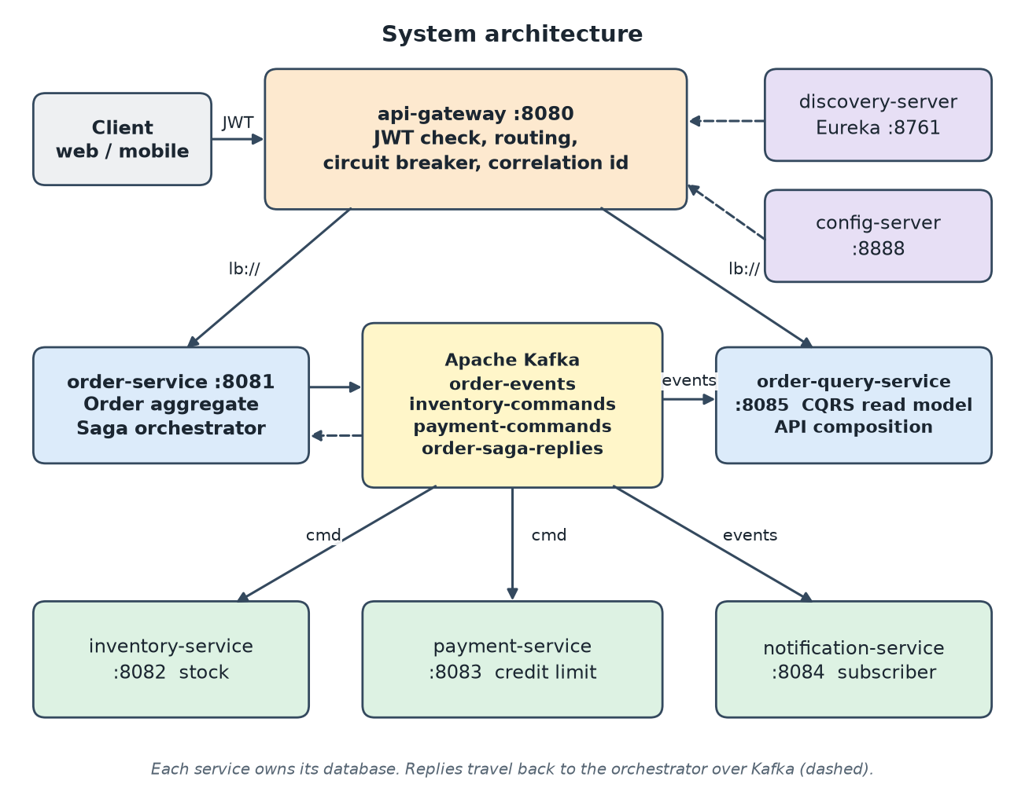
Figure 1 - System architecture

Modules
Module | Port | Responsibility | Main patterns
common | - | Shared chassis: outbox, idempotent consumer, correlation id, error handler, audit log, shared config | Microservice chassis, Transactional outbox, Idempotent consumer
discovery-server | 8761 | Eureka service registry | Service registry, Self registration
config-server | 8888 | Serves configuration files to services | Externalized configuration
api-gateway | 8080 | Single entry point: JWT check, routing, fallbacks, correlation id | API gateway, Access token, Circuit breaker, BFF-style routes
order-service | 8081 | Order aggregate and saga orchestrator | Saga, Aggregate, Domain event, Database per service
inventory-service | 8082 | Stock levels and reservations | Saga participant, Idempotent consumer
payment-service | 8083 | Payments with a configurable credit limit | Saga participant, Externalized configuration
notification-service | 8084 | Reacts to order events | Domain event subscriber, Messaging
order-query-service | 8085 | Read model and composed order details | CQRS, API composition, Circuit breaker
local-kafka | 9092* | Kafka inside one JVM for running without Docker (dev only) | -

Technology stack
- Java 17, Spring Boot 3.3.5, Spring Cloud 2023.0.3 (Gateway, Eureka, Config, LoadBalancer, Resilience4j)
- Spring Data JPA with one in-memory H2 database per service (swap for PostgreSQL in production)
- Apache Kafka for messaging (embedded single-node Kafka provided for local runs, Docker image provided for compose)
- Micrometer, Prometheus registry and Zipkin for metrics and tracing; Spring Security OAuth2 resource server for JWT
- Maven multi-module build, one Dockerfile for all services, docker-compose for infrastructure
Scope note. The code is a teaching reference, not a production system. Known simplifications: in-memory databases, a single-partition Kafka topic, no dead-letter topic, a demo-only token endpoint, and no gateway rate limiting (see the last section of the README).

2. How to run the code

2.1 Prerequisites
- JDK 17 on the path used to start the services. Check with java -version; on machines where an older Java is first on the PATH, call the JDK 17 binary explicitly.
- Maven 3.9+ (mvn -v must report Java 17).
- Docker is optional. Section 2.3 runs everything without it.
- Free ports: 8761, 8888, 8080 (or set SERVER_PORT for the gateway), 8081-8085, and the Kafka port.

2.2 Build and test
mvn -B verify # compiles all modules and runs the tests (no Kafka needed)
mvn -B -DskipTests package # faster: only build the jars
The tests are a service component test (OrderSagaComponentTest: happy path, compensation, out-of-stock) and a consumer contract test (ReserveStockContractTest: message shape and duplicate delivery). They run with Kafka switched off.

2.3 Run without Docker
Open one terminal per process from the project root. Start them in this order. The embedded Kafka prints the port it chose (for example LOCAL KAFKA READY on localhost:63088); the services read it from the KAFKA_BOOTSTRAP environment variable.
- Kafka: mvn -pl local-kafka exec:java and note the printed port.
- Registry: java -jar discovery-server/target/discovery-server-1.0.0.jar
- Config: java -jar config-server/target/config-server-1.0.0.jar
- Business services (each in its own terminal, with KAFKA_BOOTSTRAP set): order, inventory, payment, notification and order-query service jars.
- Gateway: java -jar api-gateway/target/api-gateway-1.0.0.jar (set SERVER_PORT=8090 if 8080 is already used on your machine).
Example for one service in Windows PowerShell and in a bash shell:
# PowerShell
$env:KAFKA_BOOTSTRAP = "localhost:63088"
java -jar order-service/target/order-service-1.0.0.jar

# bash / Git Bash
KAFKA_BOOTSTRAP=localhost:63088 java -jar order-service/target/order-service-1.0.0.jar
Each service needs about 20-60 seconds to start when many JVMs share one machine. Check http://localhost:8761 to see all instances registered in Eureka.

2.4 Run with Docker (optional)
docker compose up -d # Kafka + Zipkin only; run the services from your IDE or jars
docker compose --profile apps up -d --build # everything in containers

2.5 Try it
Replace 8080 with your gateway port. The first call obtains a JWT from the demo endpoint; all other gateway calls need it.
TOKEN=$(curl -s -X POST localhost:8080/auth/token -H 'Content-Type: application/json' \
-d '{"username":"demo","password":"demo"}' | sed 's/.*"access_token":"\([^"]*\)".*/\1/')

# 1) happy path -> status becomes APPROVED
curl -s -X POST localhost:8080/api/orders -H "Authorization: Bearer $TOKEN" -H 'Content-Type: application/json' \
-d '{"customerId":"c1","sku":"BOOK-1","quantity":2,"amount":40.00}'

# 2) payment over the 1000 credit limit -> stock released, status REJECTED
curl -s -X POST localhost:8080/api/orders -H "Authorization: Bearer $TOKEN" -H 'Content-Type: application/json' \
-d '{"customerId":"c1","sku":"LAPTOP-1","quantity":1,"amount":1500.00}'

curl -s "localhost:8080/api/query/orders?customerId=c1" -H "Authorization: Bearer $TOKEN" # CQRS read side
curl -s localhost:8080/api/query/orders/<id>/details -H "Authorization: Bearer $TOKEN" # API composition
curl -s localhost:8080/mobile/orders/<id> -H "Authorization: Bearer $TOKEN" # BFF-style route

What you should see (verified run)
Check | Result observed
Order 1: BOOK-1, 2 x 40.00 | Created as PENDING (HTTP 202), then APPROVED; inventory shows available 98, reserved 2
Order 2: LAPTOP-1, 1500.00 | REJECTED, reason "Credit limit exceeded"; stock compensated back to available 5, reserved 0
Gateway without token | HTTP 401
Query service | Both orders listed with their final status; payment of order 2 shown as DECLINED in the composed details
payment-service stopped | Details endpoint still answers 200 with "payment": {"status": "UNAVAILABLE"}; order and stock data intact

2.6 Troubleshooting
Symptom | Cause | Fix
Orders stay PENDING; logs show "Connection to node -1 could not be established" | Services point at a Kafka port that is not the one the broker uses | Start services with the exact KAFKA_BOOTSTRAP printed by local-kafka
UnsupportedClassVersionError or class not found when starting a jar | An old Java (for example 8) is first on the PATH | Use the JDK 17 java executable
Gateway fails with "Port 8080 was already in use" | Another program uses 8080 | Set SERVER_PORT=8090
Gateway returns 503 "Service temporarily unavailable" | Circuit breaker fallback: target service down, still registering, or slower than the gateway time limit (5 s) | Wait for the registry to list the instance; check the service log
Services log Eureka connection warnings | discovery-server not running | Start it first, or ignore; services retry

3. Pattern flows explained with diagrams
Each flow below shows what happens at runtime, which classes are involved, and why the pattern exists. A complete pattern-by-pattern catalog (including the patterns that are deployment or organisational choices) is in the project README.

3.1 Saga (orchestration) - happy path
Problem. Creating an order touches three databases (orders, inventory, payments). A single ACID transaction across services is not available, so consistency is achieved with a sequence of local transactions.
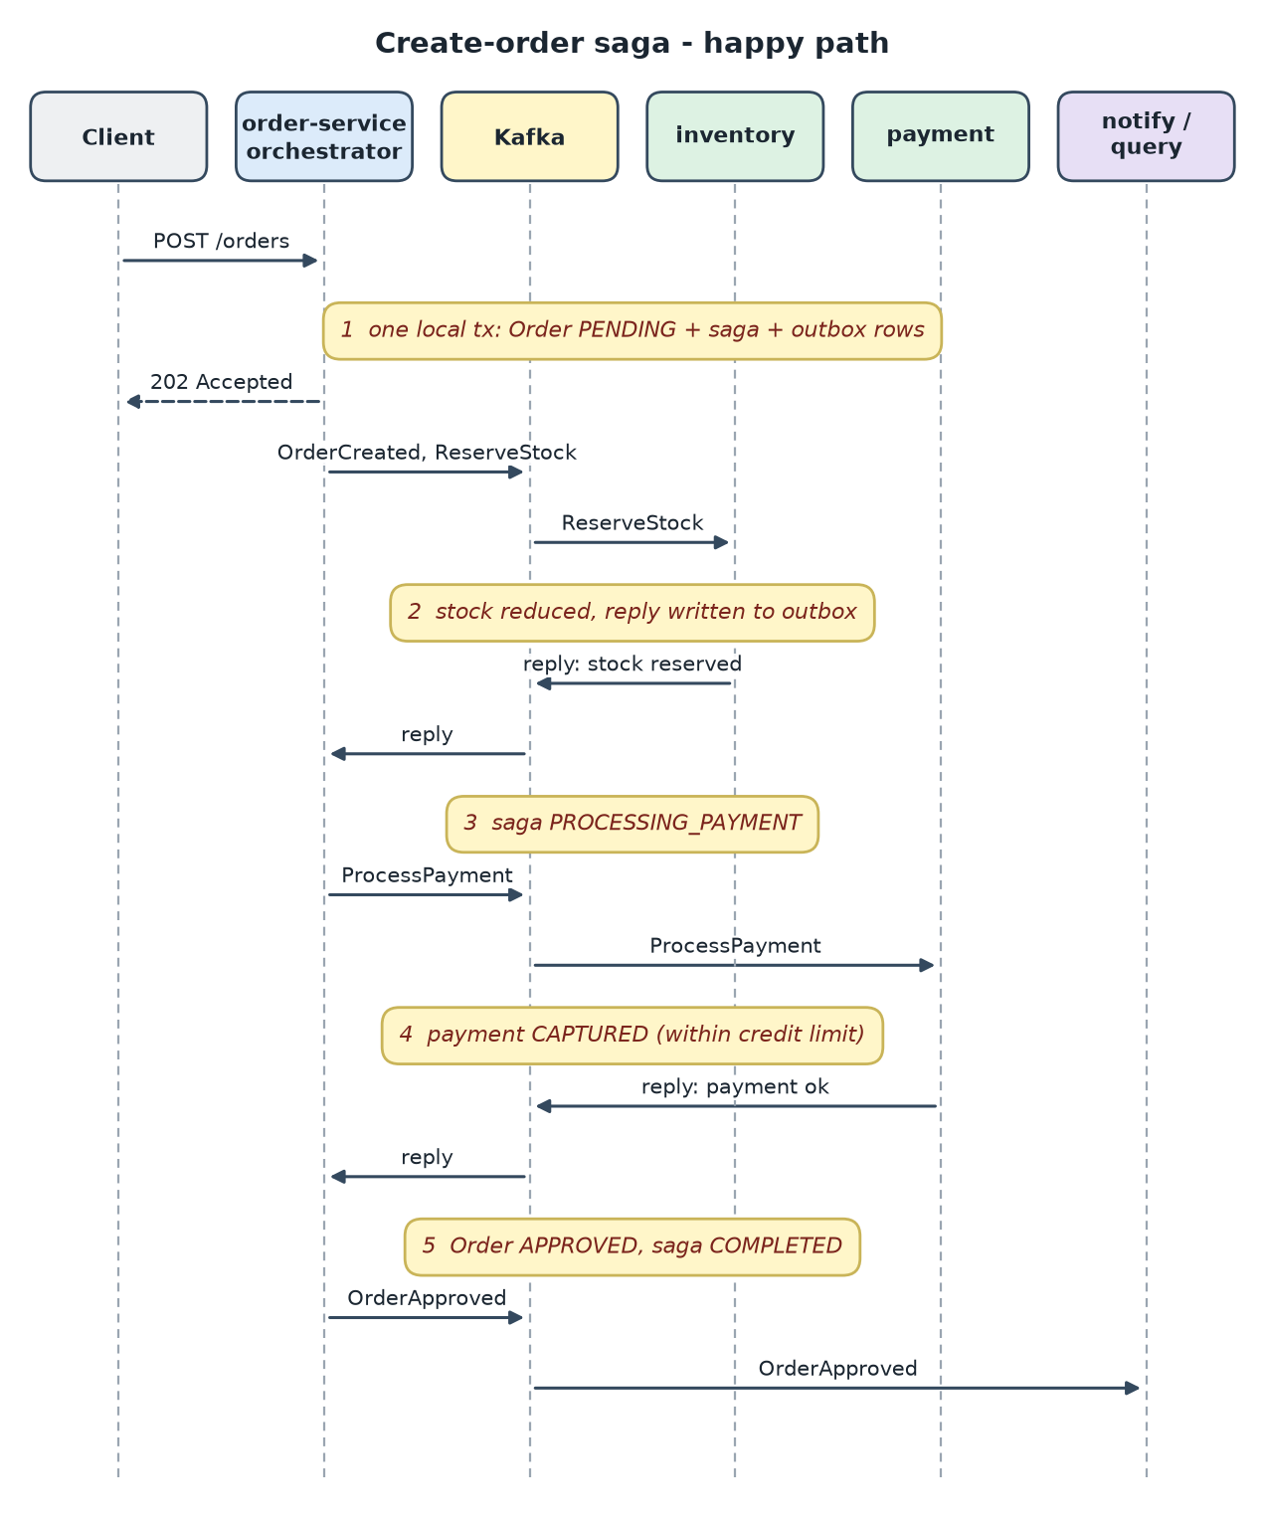
Figure 2 - Create-order saga, happy path
- CreateOrderSaga.start saves the order as PENDING, creates a saga_instance row and writes outbox rows - all in one local transaction - and returns HTTP 202.
- Each participant (InventoryCommandListener, PaymentCommandListener) performs its local transaction and answers with a SagaReply through its own outbox.
- SagaReplyListener hands each reply to CreateOrderSaga.onReply, a small state machine: RESERVING_STOCK -> PROCESSING_PAYMENT -> COMPLETED.
- The saga state is persisted, so the orchestrator survives restarts and can be inspected with one SQL query.

3.2 Saga - compensation
When a later step fails, earlier steps must be undone with compensating transactions. A payment above the credit limit (configured in the config server) is declined, and the stock reserved in step 1 is released.
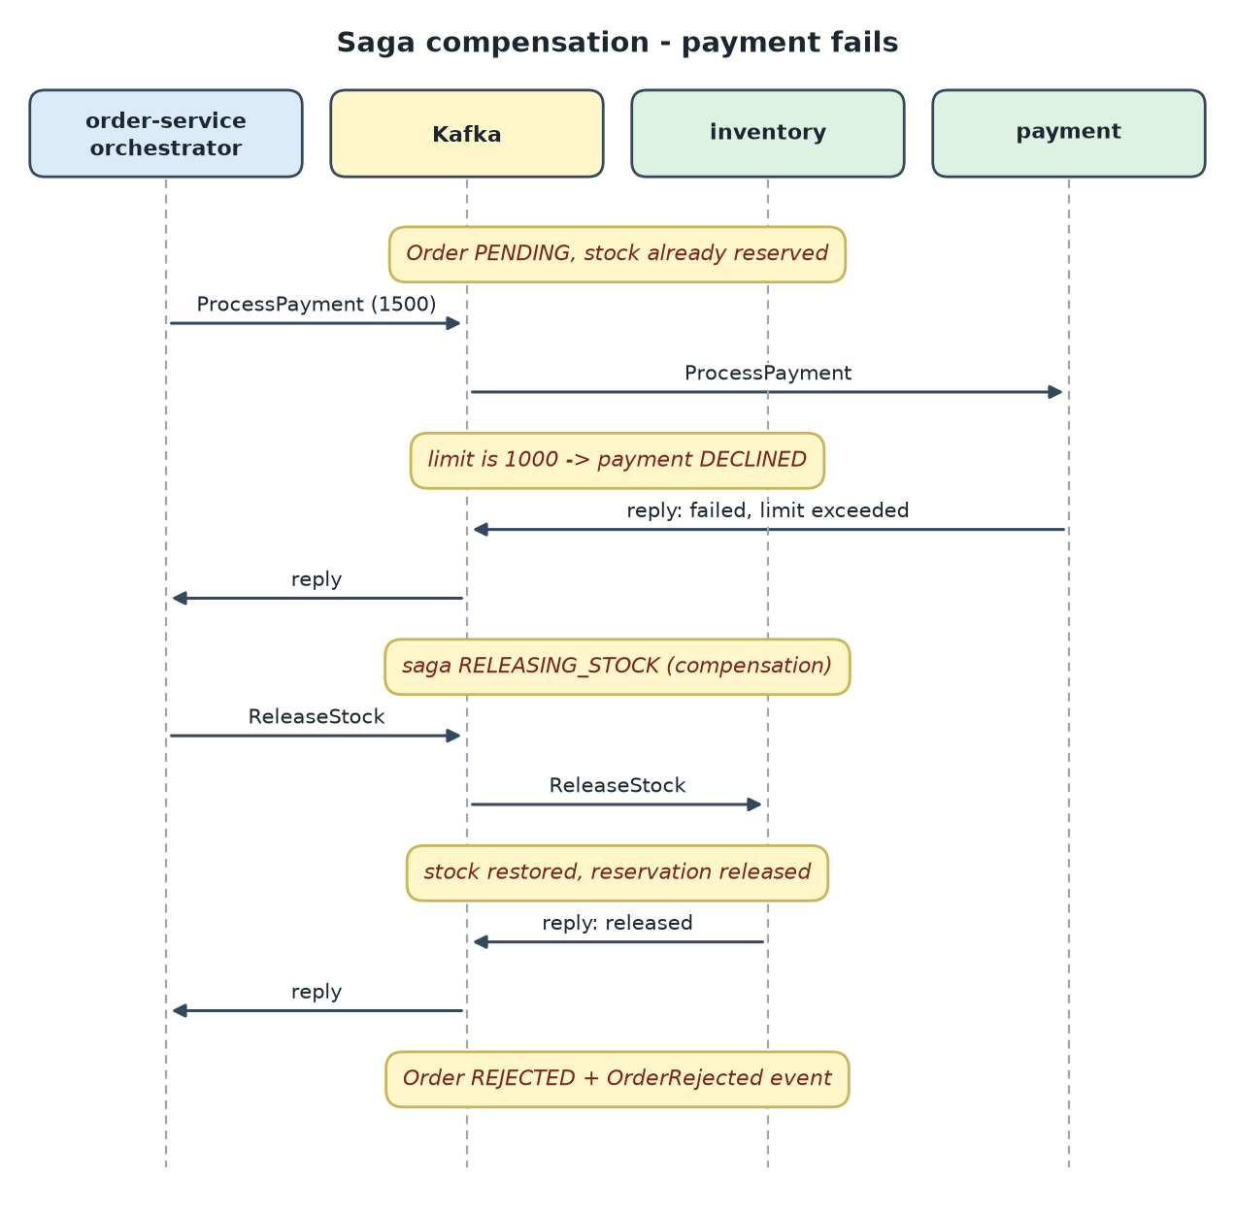
Figure 3 - Compensation when payment fails
- Reservation and release are both idempotent, so a repeated command cannot double-count stock.
- The order keeps the failure reason (Credit limit exceeded) and the final domain event OrderRejected is published.
- If the first step fails (out of stock) there is nothing to compensate and the order is rejected immediately.

3.3 Transactional outbox, polling publisher and idempotent consumer
Problem (dual write). Saving to the database and sending to Kafka are two systems; one can succeed while the other fails. The outbox stores the message in the same database transaction as the business data, and a relay sends it later.
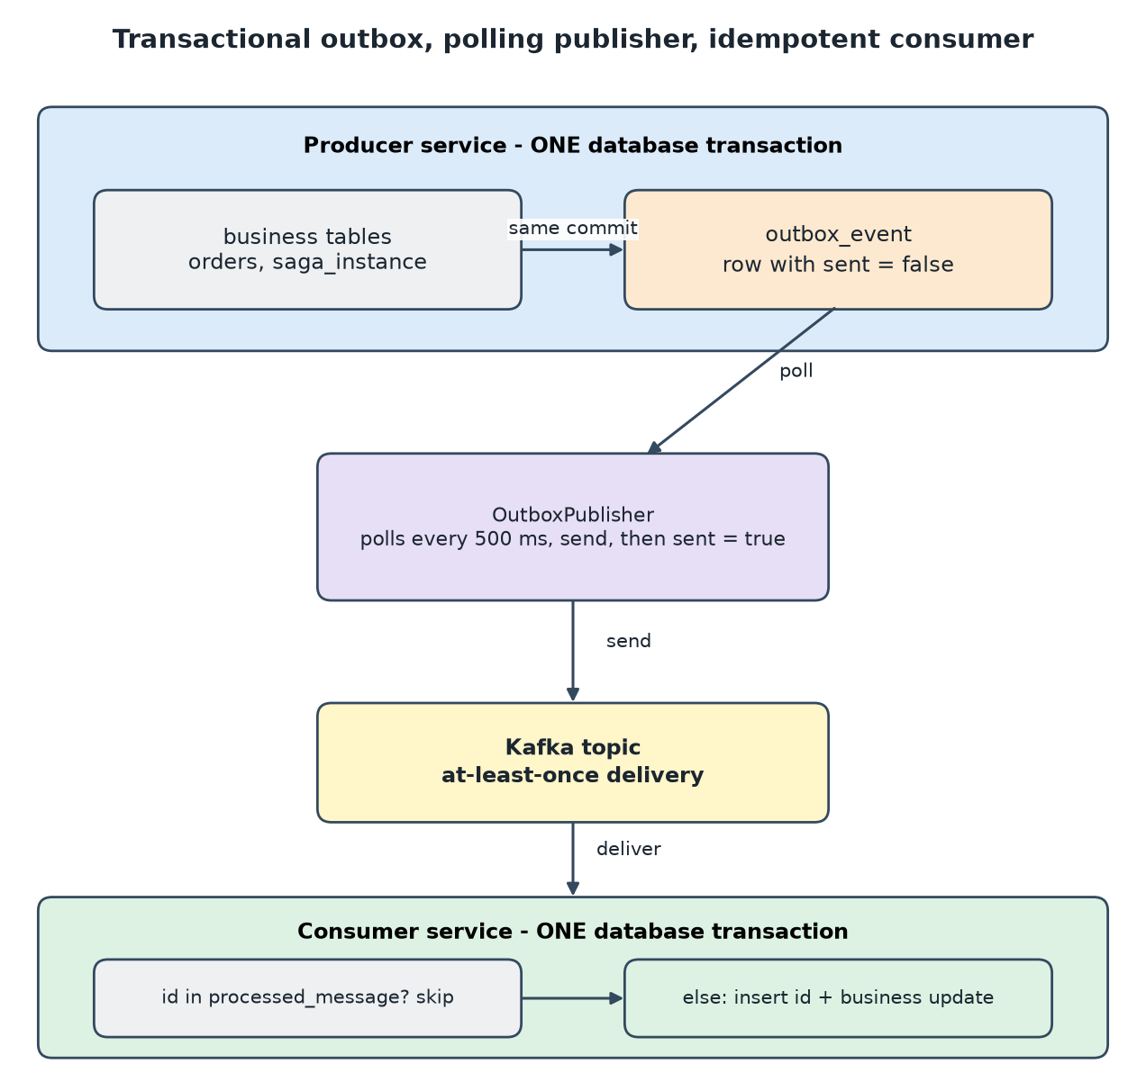
Figure 4 - Reliable messaging
- OutboxService.publish uses propagation MANDATORY: calling it outside a transaction fails fast.
- OutboxPublisher polls every 500 ms, sends each row with a messageId header, then marks it sent. Delivery is at-least-once.
- IdempotentConsumer.runOnce inserts the messageId into processed_message in the same transaction as the business change, so a duplicate is skipped.
- Alternative to polling: Debezium reading the database log (transaction log tailing) - consumers stay the same.

3.4 Domain events and CQRS
Writes go through the order service. Reads are served by order-query-service, which keeps a denormalised order_summary table fed only by order-events. Notification is a second independent subscriber.
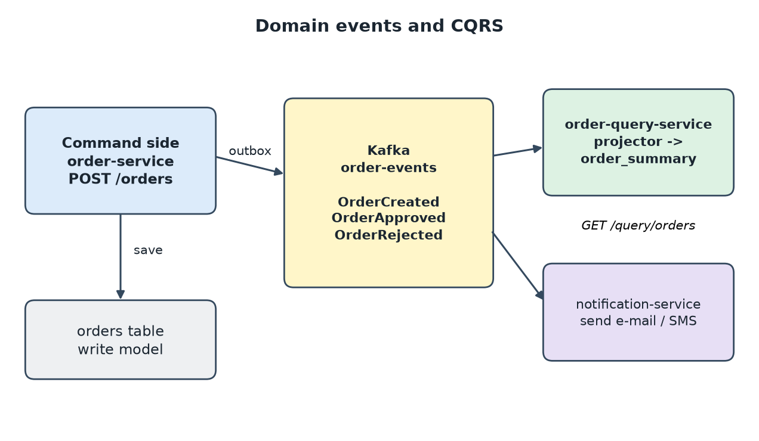
Figure 5 - Domain events feeding the read model
- Queries never call other services, so they stay fast and available when the command side is busy or down.
- The read model is eventually consistent: a few hundred milliseconds behind the write.
- A new view can be built by replaying the topic into a new projector.

3.5 API gateway and access token
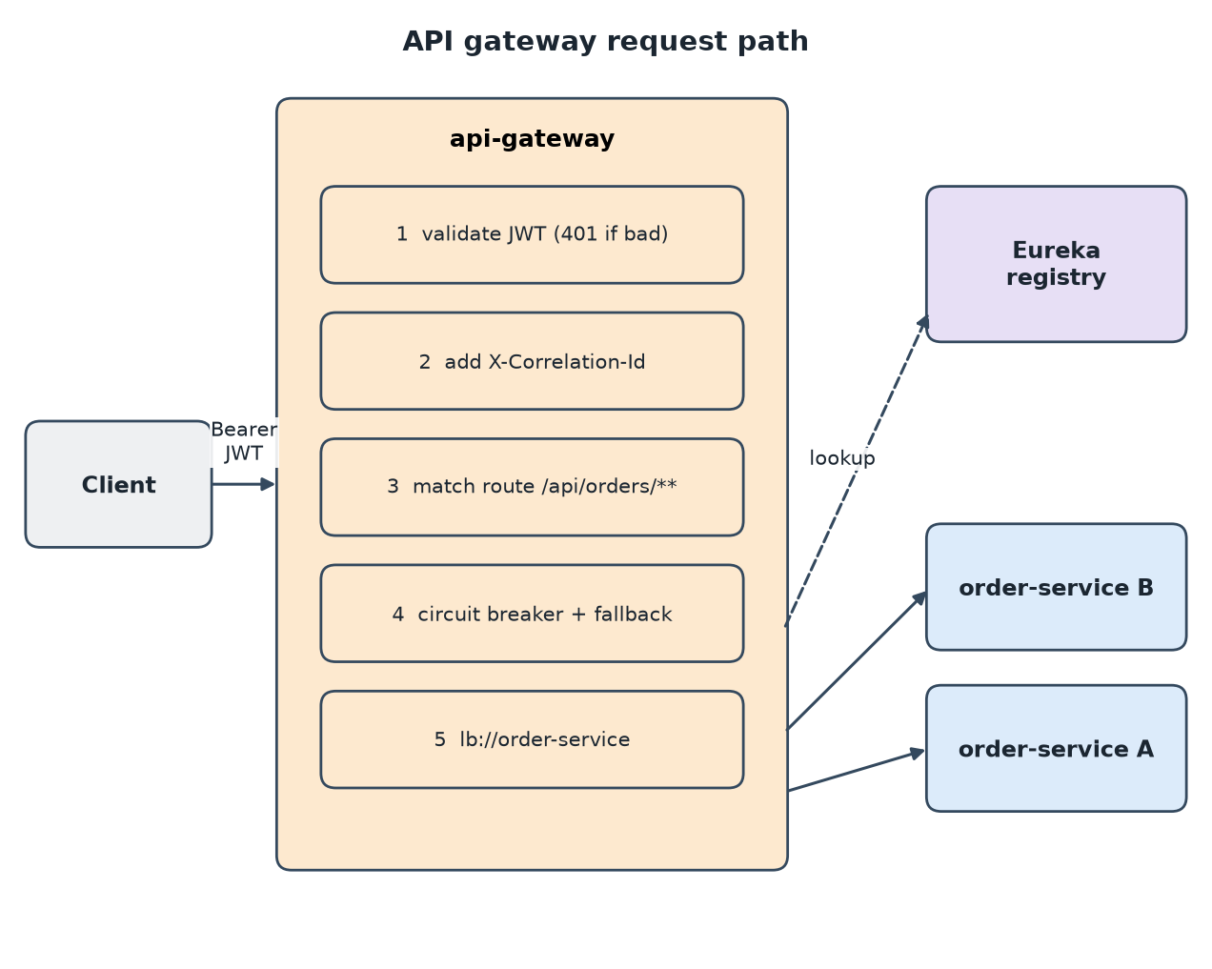
Figure 6 - Gateway request path
- Every route except /auth/token, /actuator/** and /fallback/** requires a valid JWT (HS256 here, validated by Spring Security as an OAuth2 resource server).
- CorrelationIdGlobalFilter creates X-Correlation-Id when the client did not send one; services copy it to the logging context and into Kafka headers.
- Routes use lb://service-name, resolved through Eureka (client-side discovery). /mobile/orders/** is rewritten to the query service to show a client-specific (BFF-style) API.
- The /auth/token endpoint is a demo issuer. A real deployment uses Keycloak, Okta or Entra ID.

3.6 Service registry and externalized configuration
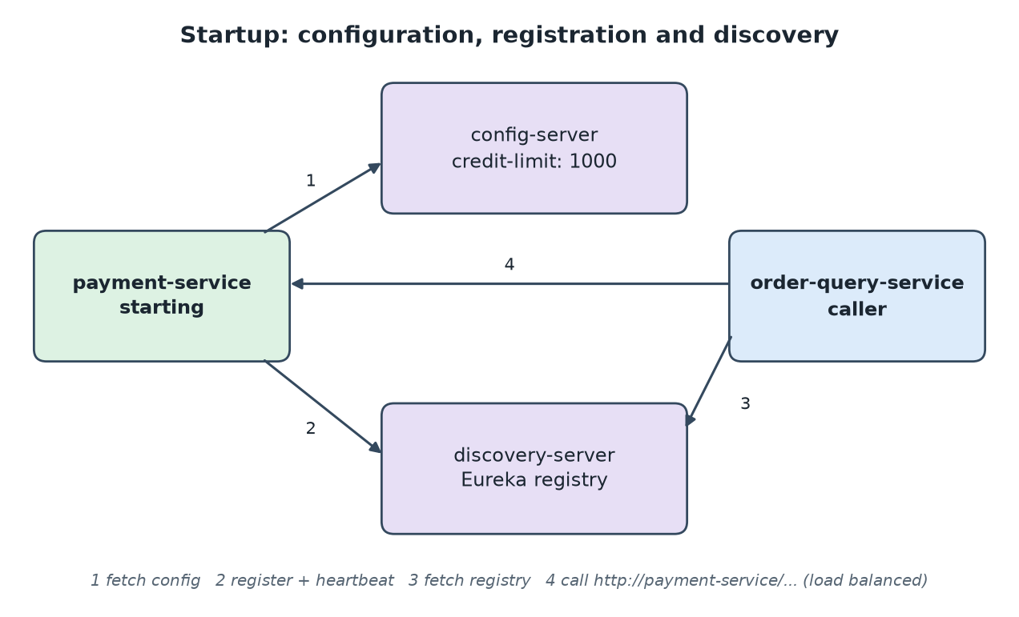
Figure 7 - Startup sequence
- On startup each service imports optional:configserver: and chassis.yml; the payment credit limit lives in config-server/.../payment-service.yml.
- The service registers itself with Eureka and sends heartbeats (self registration); callers fetch the registry and load balance (client-side discovery).
- On Kubernetes the platform provides discovery (server-side discovery) and ConfigMaps/Secrets, and Eureka/config-server can be dropped.

3.7 Circuit breaker and API composition
OrderDetailsComposer joins data from order, payment and inventory services. Each call goes through a Resilience4j circuit breaker with a 2 s time limit. When a dependency fails repeatedly the breaker opens and the answer contains a degraded part instead of failing the whole request.
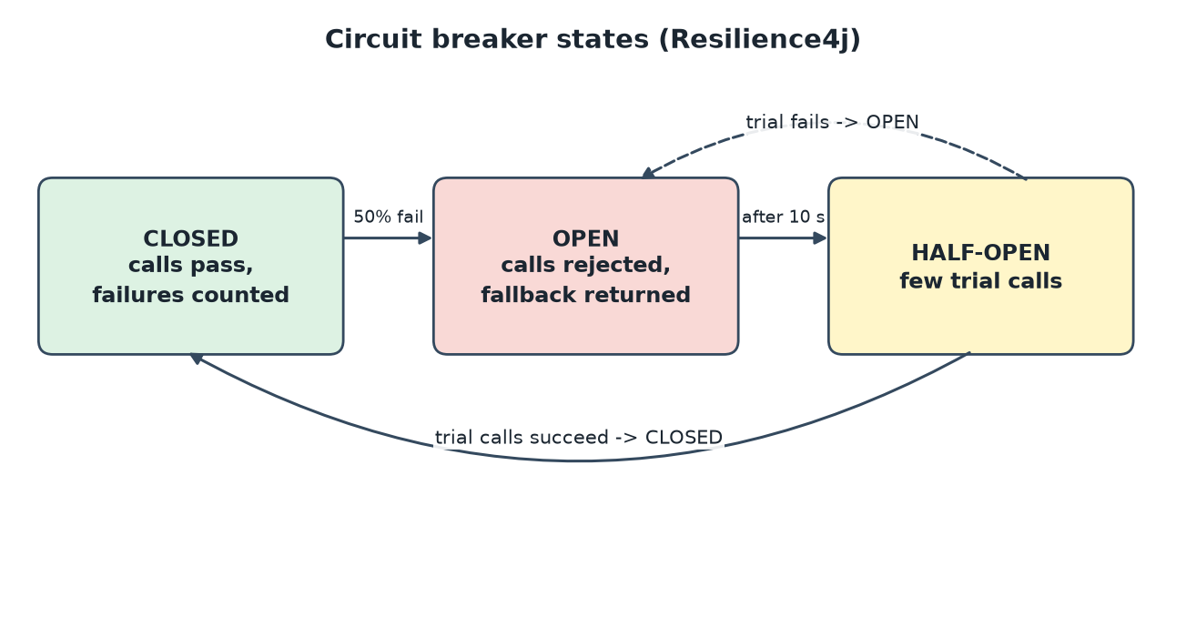
Figure 8 - Circuit breaker states
{ "order": { ... "status": "REJECTED" },
"payment": { "status": "UNAVAILABLE", "service": "payment-service" }, <- breaker fallback
"stock": { "sku": "LAPTOP-1", "available": 5, "reserved": 0 } }
Lesson from the verified run. The gateway has its own circuit breaker and Resilience4j time limiter whose default is 1 second. The first composed call after payment-service was stopped took just over one second and the gateway answered with its own 503 fallback even though the query service itself would have answered correctly. The gateway time limit is now set to 5 s (resilience4j.timelimiter.configs.default.timeout-duration). Always align timeouts layer by layer: client > gateway > service > downstream.

3.8 Observability
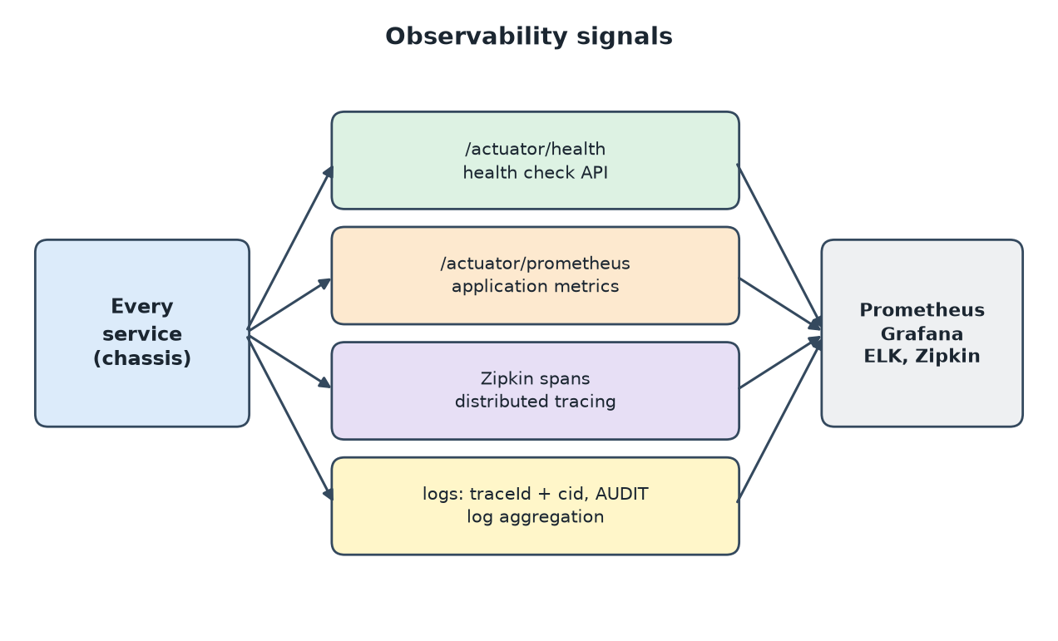
Figure 9 - Observability signals
- Health check API: /actuator/health with liveness and readiness probes.
- Application metrics: /actuator/prometheus (Micrometer).
- Distributed tracing: Micrometer Tracing (Brave) to Zipkin on port 9411; traceId appears in every log line.
- Log aggregation / audit / exception tracking: logs carry service name, traceId and correlation id; AuditLog writes business actions to an AUDIT logger; GlobalExceptionHandler is the single place that logs unexpected errors.

3.9 Pattern quick index
Pattern | Where in the project
Microservice architecture, Decompose by business capability / subdomain | Module layout; one service per capability
Database per service | Each service has its own datasource URL (orderdb, inventorydb, ...)
Saga, Aggregate, Domain event | CreateOrderSaga, Order, OrderEvent
Transactional outbox, Polling publisher, Idempotent consumer | OutboxService, OutboxPublisher, IdempotentConsumer in common
CQRS, API composition | order-query-service: OrderSummaryProjector, OrderDetailsComposer
API gateway, Access token, BFF, Circuit breaker | api-gateway and OrderDetailsComposer
Service registry, Self registration, Client-side discovery | discovery-server, Eureka client in the chassis, lb:// routes
Externalized configuration, Microservice chassis, Service template | config-server, common module, identical module structure and Dockerfile
Service component test, Consumer-driven contract test | OrderSagaComponentTest, ReserveStockContractTest
Health check, Metrics, Tracing, Audit logging, Log aggregation, Exception tracking | Actuator, Micrometer, Zipkin, AuditLog, MDC correlation id, GlobalExceptionHandler
Service instance per container | Dockerfile, docker-compose.yml
Documented only (not coded) | Event sourcing, Transaction log tailing, Strangler, Anti-corruption layer, Server-side discovery, Serverless, Service mesh, UI composition

4. Interview questions and answers (experienced Java developer)
Questions are written as real situations, in the way a senior interviewer would ask them. Answers are what a strong candidate should cover; several refer to this project so you can show working knowledge. Use the project README for the pattern background.

A. Architecture and decomposition
Q1. How do you decide the service boundaries when breaking up a monolith?
Scenario: A 40-developer team owns a monolith for orders, stock, payments and notifications. Releases happen once a month and every release is risky.
Answer
Start from the business, not from technical layers: use decompose by business capability and bounded contexts (DDD). Run event storming with the business to find where the language changes (an order means something different to inventory than to payment).
Good boundaries have high cohesion, own their data, and change for the same reason. A service that needs another service database or changes in lockstep with it is a wrong cut.
Do not rewrite. Use the strangler approach: put a gateway in front, extract the capability with the highest change rate or scaling need first, move traffic route by route, and keep an anti-corruption layer so legacy concepts do not leak.
Warning signs of a distributed monolith: shared database, long synchronous call chains, services deployed together, shared domain libraries that force coordinated releases.
Q2. Order service needs the customer credit status owned by another service. Call it synchronously or keep a copy?
Scenario: The credit service is slow at month end. Orders must still be accepted.
Answer
A synchronous call couples availability and latency: order availability becomes the product of both services. It is simple and always fresh, so fine for non-critical, low-volume reads.
For the critical path keep a local replica (command-side replica) updated from credit events. Orders are accepted from local data and the replica is eventually consistent; you must accept occasionally stale decisions and add a re-check (for example in the payment step).
Middle ground: synchronous call wrapped in timeout, circuit breaker and a cached or default fallback, with the business agreeing what happens when credit is unknown.
Q3. When would you advise against microservices?
Scenario: A startup with 6 developers wants 25 microservices from day one.
Answer
Microservices trade code complexity for operational and consistency complexity (deployment, tracing, eventual consistency, versioning). That is worth it when many teams need independent delivery or parts of the system scale differently.
For a small team with an unclear domain, a modular monolith with strict module boundaries gives most of the benefit; extract services later when a boundary proves stable. Wrong early boundaries are far more expensive across network calls and databases.

B. Data consistency and messaging
Q4. Why not use a distributed transaction (2PC / XA) for the order flow?
Scenario: A colleague proposes JTA with XA so stock, payment and order commit atomically.
Answer
2PC holds locks in every participant while the coordinator decides, reducing throughput and availability; a coordinator failure leaves participants blocked in doubt. Many modern resources (Kafka, REST services, most NoSQL stores) do not support XA at all.
It also couples services at deployment and runtime. A saga replaces one atomic transaction by local transactions plus compensations and accepts temporary inconsistency (an order is PENDING for a moment).
Q5. Explain orchestration versus choreography and why this project uses orchestration.
Scenario: A new joiner asks why CreateOrderSaga is one class instead of services reacting to each other events.
Answer
Choreography: each service publishes events and others react. No central point, but the flow is implicit, hard to see and easy to create cyclic dependencies as steps grow.
Orchestration: one orchestrator holds the state machine and sends commands. The flow is explicit, testable and observable (one table shows every order saga state). The cost is a component that knows all steps; keep it a coordinator with no business rules of the participants.
Rule of thumb: choreography for 2-3 simple steps; orchestration when there are compensations, branches or timeouts.
Q6. What if the compensating step (ReleaseStock) itself fails or never gets a reply?
Scenario: Payment declined, ReleaseStock was sent, but inventory-service was down for 30 minutes.
Answer
Compensations must be retryable, idempotent and eventually succeed: the command stays in the outbox and Kafka retains it, so it is delivered when inventory returns. The saga stays in RELEASING_STOCK, which is visible and alertable.
Add a saga timeout / watchdog that finds sagas stuck longer than N minutes, re-sends the command, and escalates to a human with a dead-letter or ticket. Never design compensation that can only fail permanently; if it can, you need a manual remediation process.
Semantic locks (a reservation row, a PENDING state) prevent other flows from using half-finished data meanwhile.
Q7. What is the dual-write problem and how does the outbox solve it?
Scenario: A developer saves the order and then calls kafkaTemplate.send in the same method. Occasionally orders exist with no event.
Answer
Two systems cannot be updated atomically. If the app crashes between the DB commit and the send (or the send fails), the database says one thing and the event stream another. Reversing the order just creates ghost events.
The transactional outbox writes the event into an outbox table in the same local transaction as the business data. A relay (polling publisher, or CDC such as Debezium) publishes unsent rows. Result: the event is sent at least once if and only if the transaction committed.
Details to mention: Propagation.MANDATORY on the outbox write, ordering by creation time and keying by aggregate id, purge of old rows, and with several app instances use SELECT ... FOR UPDATE SKIP LOCKED or CDC so two relays do not send the same row.
Q8. Can you get exactly-once processing with Kafka?
Scenario: The business says a payment must never be taken twice.
Answer
End to end exactly-once does not exist across arbitrary systems. Kafka offers idempotent producers and transactions that give exactly-once within Kafka (read-process-write between topics).
In practice use at-least-once delivery plus an idempotent consumer, which gives effectively-once outcomes: store the messageId in the same transaction as the side effect, or make the operation naturally idempotent (unique key on orderId, upsert). For calls to an external payment provider pass an idempotency key as well.
Q9. How do you make the idempotent consumer safe under concurrency, and how does it grow over time?
Scenario: Two consumer instances receive the same message after a rebalance at nearly the same moment.
Answer
The message id is the primary key of processed_message. Both transactions try to insert it; one fails with a constraint violation and rolls back its business change, so the effect happens once. Treat that exception as "duplicate" and acknowledge.
The table grows forever, so purge entries older than the maximum redelivery window (for example retention of the topic plus a margin), or partition the table by date.
Q10. The client posts an order and immediately reads it. How do you design for eventual consistency?
Scenario: Users complain that the order list does not show their new order for a second.
Answer
Make the asynchrony explicit: return 202 Accepted with the order id and a PENDING status, and give a way to follow progress (GET by id on the command side, polling, server-sent events or webhook).
Read-your-writes for the creator: return the created resource from the command response, or have the UI merge it into the list optimistically. Show a status badge instead of hiding in-progress orders.
Q11. How do you evolve event schemas without breaking consumers?
Scenario: Order service wants to rename amount to totalAmount and add currency.
Answer
Prefer additive, backward-compatible changes: add optional fields, never rename or change meaning in place. Consumers must be tolerant readers (ignore unknown fields; Jackson FAIL_ON_UNKNOWN_PROPERTIES off).
For a breaking change publish a new version (new type or topic), run both during migration (expand/contract), and retire the old one when consumer-driven contract tests show nobody uses it. Use a schema registry (Avro / Protobuf) with compatibility rules in CI for larger organisations.
Q12. The read model is wrong or must get a new column. How do you rebuild it?
Scenario: Product wants the customer name shown in the order list, which the read model never stored.
Answer
Because the read model is derived only from events, deploy a new projector version that writes to a new table or a new service version, replay the topic from the beginning (new consumer group with earliest offset), switch queries when it has caught up, then delete the old table.
This needs events with enough data (or enrichment from a replica), idempotent projections, and retention long enough; otherwise keep a compacted topic or an event store.

C. Resilience
Q13. A downstream service becomes slow. What exactly protects your service?
Scenario: payment-service latency rises from 50 ms to 20 s. Within minutes the order-query service stops answering everything.
Answer
Slow is worse than down: callers hold threads and connections until they run out (cascading failure). Layers of defence: timeouts on every remote call, circuit breaker (fail fast when failure or slow-call rate is high), bulkhead (separate bounded pools so one dependency cannot take all threads), limited retries with backoff and jitter only for idempotent calls, and a sensible fallback.
Order matters: time limiter and bulkhead inside, circuit breaker around, retry outermost with care so retries do not multiply load on a struggling service (retry storm).
In this project OrderDetailsComposer wraps each downstream call in a Resilience4j breaker with a 2 s time limit and returns UNAVAILABLE for just that part.
Q14. How do you tune a circuit breaker and decide the fallback?
Scenario: The breaker opens during a short blip and users see degraded data for long.
Answer
Key settings: sliding window size and type, failure-rate threshold, slow-call threshold, minimum number of calls, wait duration in open state, permitted calls in half-open. Too small a window makes it flap; too large reacts late. Tune from real latency percentiles, not guesses.
A fallback must be a business decision: cached or stale data, default value, partial response, or an explicit error. Never fake success for writes (for example pretending a payment worked). Monitor breaker state and fallback rate as metrics.
Q15. Users get 503 from the gateway although the service is healthy. What do you check?
Scenario: After stopping payment-service, the first call to order details returned the gateway fallback although the query service answers correctly when called directly.
Answer
This happened during development of this project. Compare the timeout of each layer: the gateway circuit breaker has a time limiter (default 1 s) shorter than the time the composed call can legitimately take (load balancer retries plus the 2 s downstream limit).
Fix: align timeouts so outer layers are longer than inner ones (client > gateway > service > downstream), set the gateway limit explicitly, and test with a dependency down, not only with everything up.

D. Security
Q16. Is validating the JWT only at the gateway enough?
Scenario: Security review finds that any pod inside the cluster network can call order-service directly.
Answer
No - it is perimeter-only security. Apply defence in depth (zero trust): each service validates the token (resource server, issuer and audience checks, scopes/roles) or the mesh enforces mTLS and authorisation, and network policies restrict who can call what.
Forward the user token (or exchange it for a narrower one) so the service can authorise by subject; for service-to-service calls without a user use the OAuth2 client-credentials grant or mTLS identities.
Operational points: short token lifetime with refresh, revocation strategy, and asymmetric signing with a JWKS endpoint and key ids so keys can rotate without an outage. The project uses HS256 with a shared secret for simplicity and says so.

E. Spring, JPA and Kafka specifics
Q17. What are the common @Transactional mistakes in a service like this?
Scenario: A developer annotates a private method, calls it from the same class, and rollbacks do not happen. Another calls a REST service inside the transaction.
Answer
Self-invocation and private/final methods bypass the proxy so the annotation is ignored; move the logic to another bean or use TransactionTemplate.
By default only unchecked exceptions roll back; use rollbackFor for checked ones.
Never hold a transaction while doing remote calls or sending to Kafka: it keeps a DB connection busy (pool exhaustion) and cannot be rolled back. This is exactly why the outbox exists.
Know propagation: REQUIRED default, REQUIRES_NEW for independent commits (audit), MANDATORY to enforce a surrounding transaction (used by OutboxService).
Q18. Two orders for the last item arrive at the same time. Is the inventory service safe?
Scenario: Both reserve 1 unit of a SKU with stock 1.
Answer
In this project commands go through one single-partition topic, so they are processed one at a time, which hides the problem. With more partitions or several instances two transactions can read available=1 and both decrement - a lost update and overselling.
Fixes: optimistic locking (@Version on StockItem, retry on OptimisticLockException), a conditional update (UPDATE stock SET available = available - :q WHERE sku = :s AND available >= :q), or pessimistic locking for hot rows; also key messages by SKU so one SKU is handled in order.
Q19. Why is spring.jpa.open-in-view set to false, and how do you avoid N+1 queries?
Scenario: A list endpoint becomes slow after adding a relationship.
Answer
Open-in-view keeps the EntityManager (and a DB connection) open for the whole web request, hides lazy-loading problems and can exhaust the pool; disable it and load what the use case needs in the service layer.
N+1: fetch joins or @EntityGraph, batch fetching (hibernate.default_batch_fetch_size), or projections/DTOs for read endpoints. Verify with SQL logging or Hibernate statistics in tests.
Q20. A Kafka consumer keeps rebalancing and a message is processed repeatedly.
Scenario: Lag grows and the same orderId appears again and again in the logs.
Answer
Likely causes: processing slower than max.poll.interval.ms (consumer kicked out, then the offset was not committed), or a poison message that always throws (the default error handler retries, then skips or loops depending on configuration).
Actions: measure processing time, reduce max.poll.records or move heavy work off the poll thread, raise the interval, configure DefaultErrorHandler with backoff and a dead-letter topic, and keep handlers idempotent. Remember: parallelism is limited by partition count, and order is guaranteed only per partition (key by aggregate id).
Q21. Eureka versus Kubernetes service discovery, and what can go wrong with Eureka?
Scenario: A pod was killed but callers kept sending requests to it for a minute and got errors.
Answer
Eureka is client-side discovery with an AP registry: clients cache the registry and instances are removed after missed heartbeats (default about 90 s), and self-preservation mode can keep dead instances. Mitigate with shorter lease and cache intervals, graceful shutdown (deregister first), client retries on idempotent calls, and circuit breakers.
On Kubernetes a Service plus readiness probes does server-side discovery, so Eureka is usually unnecessary. Keep Spring Cloud LoadBalancer only if you need client-side balancing.
Q22. How do you manage configuration and secrets across environments?
Scenario: A credit limit must change without a redeploy, and database passwords must not be in Git.
Answer
Externalize everything environment-specific: Config Server (git-backed, profiles per environment) or Kubernetes ConfigMaps; refresh via @RefreshScope plus actuator refresh or Spring Cloud Bus, or a rolling restart.
Secrets belong in Vault, cloud secret managers or Kubernetes Secrets (encrypted at rest), injected as environment variables or mounted files - never in config repos in clear text. Review and audit config changes like code, and record them next to deployments.

F. Testing, delivery and operations
Q23. What is your testing strategy for a system of many services?
Scenario: End-to-end tests take 40 minutes and fail randomly.
Answer
Shift to the test pyramid for microservices: many unit tests; service component tests (the service with real DB, external collaborators stubbed - see OrderSagaComponentTest); consumer-driven contract tests (Spring Cloud Contract or Pact) so producer builds fail when they break a consumer; a handful of end-to-end journeys against a deployed environment.
Use Testcontainers for real Kafka/PostgreSQL in CI, test failure modes (broker down, duplicate message, slow dependency), and run synthetic checks after each deployment.
Q24. How do you deploy a change that alters the database and the message format without downtime?
Scenario: Order service v2 needs a new non-null column and a new event field.
Answer
Use expand / contract: release 1 adds the column as nullable and writes both; backfill; release 2 reads the new column; release 3 removes the old one. Same idea for messages: add fields first, switch consumers, then remove.
Rolling or canary deployment with readiness probes, backward-compatible APIs, schema migrations with Flyway/Liquibase run before the new version, and automatic rollback on error-rate increase.
Q25. A support agent reports one order is stuck. How do you follow it across six services?
Scenario: No error is visible; the customer only has the order number.
Answer
Search logs by correlation id (created at the gateway, copied to MDC and Kafka headers) and by traceId in Zipkin to see each hop and its latency. Read the saga state (saga_instance), check unsent outbox_event rows, and consumer group lag for the topic where the flow stopped.
Audit logs show business decisions (payment declined), metrics show where rates changed. This is why correlation ids and structured logs are part of the chassis rather than something each team invents.
Q26. Traffic grows ten times for a sale. What do you change?
Scenario: Black Friday; the order flow must process 10x orders per second.
Answer
Find the bottleneck with load tests first. Typical steps: more topic partitions keyed by orderId/SKU and matching consumer instances; connection pool and DB indexes sized from measurements; batch the outbox relay or switch to CDC; scale stateless services horizontally and keep reads on the CQRS model (cache hot queries).
Protect the system: rate limit at the gateway, bulkheads, backpressure, graceful degradation (accept orders asynchronously), and autoscaling on lag rather than CPU for consumers.

5. Real-time incident scenarios and how to handle them
These are the incidents that typically occur in a Spring Boot / Kafka microservice landscape like this one. Each follows the same shape: detect -> diagnose -> mitigate -> fix and prevent. Two of them (incidents 1 and 3) and one more (incident 8) actually occurred while this project was being built and run, and are marked as such.
General incident routine.
1) Acknowledge and declare severity. 2) Check what changed (deploys, config, traffic). 3) Stabilise first (rollback, scale, disable), investigate second. 4) Communicate status regularly. 5) Write a blameless post-mortem with actions and owners.

Incident 1: Orders stuck in PENDING
Severity | Impact | Affected pattern
SEV-2 | Customers see no confirmation; stock and payment may be half processed. | Saga, Transactional outbox, Messaging

Scenario. Support reports that new orders never leave PENDING. The API returns 202, but no order becomes APPROVED or REJECTED. This happened for real when the services were started with the wrong Kafka port: every send failed, the outbox rows stayed unsent and the saga never advanced.
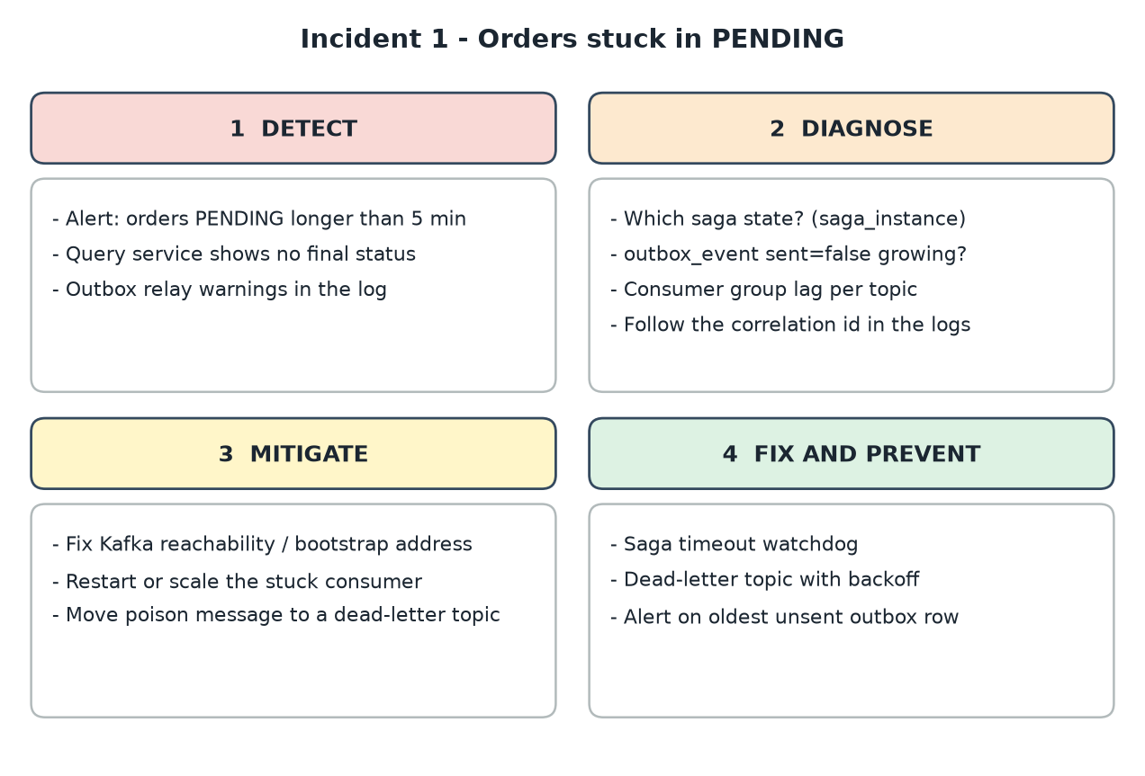
Triage flow - incident 1

How to detect it
- Business alert: number of orders PENDING longer than 5 minutes greater than zero.
- Metric/alert on the oldest unsent outbox_event and on consumer group lag.
- Logs: OutboxPublisher warnings ("Outbox relay failed ... will retry") and Kafka client warnings such as "Connection to node -1 could not be established".

How to diagnose it
- Find where the flow stopped by reading the saga state: stuck in RESERVING_STOCK means the command never reached or was never answered by inventory; PROCESSING_PAYMENT points at payment.
- If unsent outbox rows keep growing, the problem is between the service and the broker (network, wrong bootstrap address, broker down). If outbox is empty but lag grows, a consumer is stuck.
- Search all logs with the order correlation id to see the last service that touched it.
-- order-service database
select state, count(*) from saga_instance group by state;
select count(*), min(created_at) from outbox_event where sent = false;

# Kafka
kafka-consumer-groups.sh --bootstrap-server <host:port> --describe --group inventory-service

Immediate mitigation (stop the bleeding)
- Restore connectivity (correct KAFKA_BOOTSTRAP, restart broker, fix security group). The outbox relays the backlog automatically in order.
- If a consumer is stuck, restart or scale it; if one poison message blocks a partition, move it to a dead-letter topic and continue.
- After recovery verify that the PENDING count falls to zero; reply to affected customers if needed.

Permanent fix and prevention
- Add a saga timeout watchdog: sagas older than N minutes are retried or compensated and raise an alert.
- Alert on the age of the oldest unsent outbox row (should be seconds).
- Dead-letter topic with backoff for failing messages; startup check that fails fast when Kafka is unreachable.

Incident 2: Customer charged twice (duplicate message)
Severity | Impact | Affected pattern
SEV-1 (money) | Wrong charges, refunds, trust and compliance exposure. | Idempotent consumer, Messaging

Scenario. A consumer rebalance happens while payment-service is processing ProcessPayment. Kafka redelivers the same message to another instance. Without protection a second charge is created for the same order.
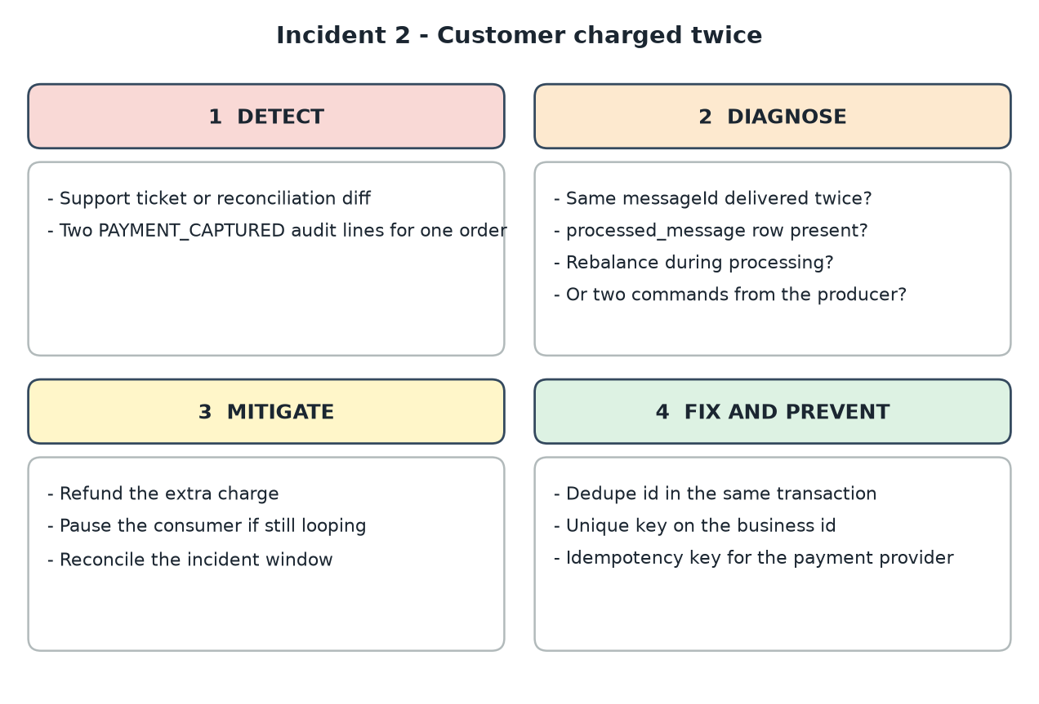
Triage flow - incident 2

How to detect it
- Customer complaint or reconciliation job: two captured payments for one order id.
- Audit log shows two PAYMENT_CAPTURED lines with the same orderId.
- Logs show Duplicate message ... ignored should have appeared but did not.

How to diagnose it
- Look at the Kafka headers: same messageId twice? Then deduplication failed. Different ids for the same business operation means the producer emitted two commands (for example a retried HTTP request creating two orders).
- Check that the dedupe insert and the business update are in the same transaction; a dedupe row written in a separate transaction is lost on crash.
- Check rebalances and processing time versus max.poll.interval.ms.
select order_id, count(*) from payment group by order_id having count(*) > 1;
select * from processed_message where id like 'payment-service:%' order by processed_at desc;

Immediate mitigation (stop the bleeding)
- Refund the duplicate charge through the payment provider; record the correction in the audit log.
- Pause the consumer if duplicates are still being created, then fix and resume.
- Run a reconciliation query for the incident window to find all affected orders.

Permanent fix and prevention
- Idempotent consumer with the message id stored in the same transaction as the business update (already implemented in IdempotentConsumer).
- Database unique constraint on the business key (payment.order_id is the primary key here), so a second insert fails.
- Pass an idempotency key to the external payment provider; make client POSTs idempotent with an Idempotency-Key header.
- Chaos test: kill the consumer mid-processing and verify a single effect.

Incident 3: Slow payment-service causes cascading failure
Severity | Impact | Affected pattern
SEV-1 | Increasing 5xx and timeouts across several services; order details unavailable. | Circuit breaker, API gateway, Timeouts

Scenario. payment-service latency rises from milliseconds to many seconds after a slow database query. Callers keep waiting, exhaust their thread and connection pools, and healthy services start failing too. A smaller real example from this project: with payment-service stopped, the first composed call exceeded the gateway default time limit of 1 s and the gateway answered 503 although the query service itself was fine.
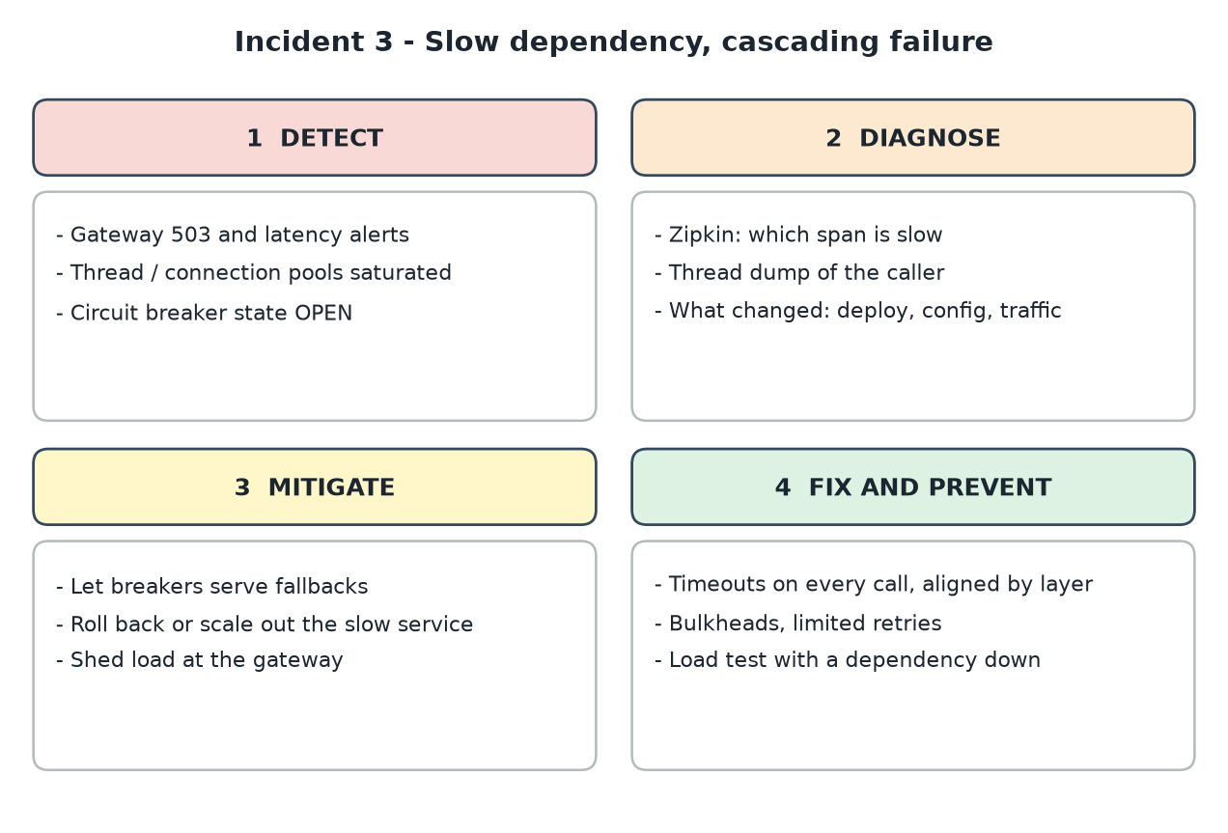
Triage flow - incident 3

How to detect it
- Gateway latency and 5xx alerts; circuit breaker metrics show OPEN.
- Thread pool, Tomcat and Hikari pool saturation graphs; GC pauses.
- Zipkin traces where almost all time is spent in the payment span.

How to diagnose it
- Open a slow trace in Zipkin to find the slow hop, then look at that service metrics and database.
- Take a thread dump of a caller: many threads waiting on the same remote call confirm exhaustion.
- Ask what changed in the last hour: deploy, config, new index missing, traffic spike.
curl -s localhost:8083/actuator/metrics/http.server.requests
curl -s localhost:8085/actuator/health
jcmd <pid> Thread.print > threads.txt

Immediate mitigation (stop the bleeding)
- Let breakers fail fast and serve fallbacks; do not add retries.
- Roll back the last deploy or scale the slow service out; if it is a database problem, kill the long queries.
- Shed load at the gateway (reduce traffic, disable optional features) until latency recovers.

Permanent fix and prevention
- Timeouts on every remote call and aligned layer by layer (client > gateway > service > downstream); the gateway limit is now 5 s.
- Bulkheads per dependency, retries only for idempotent calls with backoff and jitter.
- Load and chaos tests with a dependency slowed down, and alerts on p95/p99 latency, not only errors.

Incident 4: Wrong configuration pushed to the config server
Severity | Impact | Affected pattern
SEV-2 | Legitimate payments declined; revenue loss. | Externalized configuration, Saga compensation

Scenario. An engineer changes payment.credit-limit from 1000 to 100 in the config repository by mistake. After instances restart, most orders are rejected with "Credit limit exceeded" and stock is released again and again.
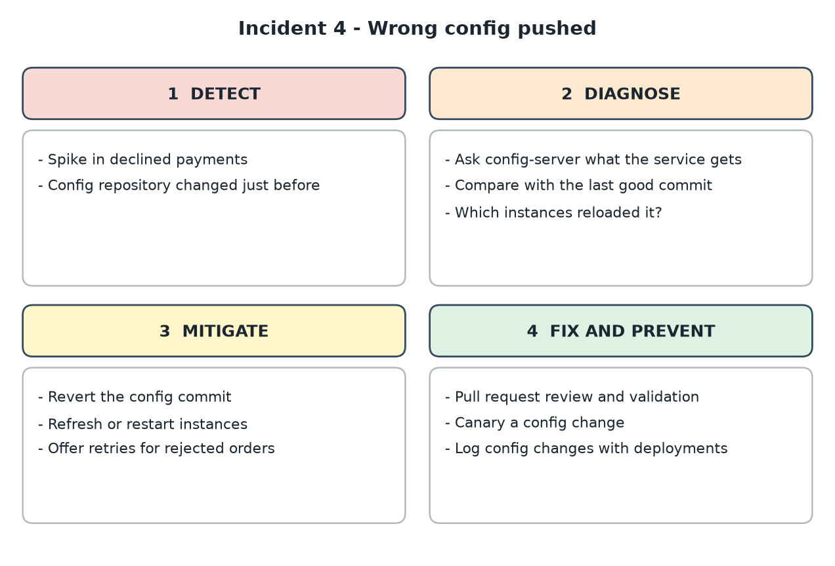
Triage flow - incident 4

How to detect it
- Spike in PAYMENT_DECLINED audit events and in REJECTED orders.
- Change history of the config repository shows a commit shortly before the spike.

How to diagnose it
- Ask the config server what a service actually receives, then compare with the previous commit.
- Check which instances loaded the new value (instances that did not restart still have the old one).
curl -s localhost:8888/payment-service/default
git -C <config-repo> log -p -3 -- payment-service.yml

Immediate mitigation (stop the bleeding)
- Revert the config commit and restart or refresh the instances.
- Identify the orders rejected during the window and offer customers a retry (the saga compensated correctly, so there are no stuck reservations).

Permanent fix and prevention
- Review config changes through pull requests with validation (schema, sane ranges), like code.
- Roll out config to one instance first (canary) and watch decline rate before the rest.
- Log every config change together with deployments so the cause is found in minutes.

Incident 5: 401 storm after JWT key rotation
Severity | Impact | Affected pattern
SEV-2 | All authenticated traffic is rejected; backend services see no requests. | Access token, API gateway

Scenario. Security rotates the JWT signing secret. The token issuer starts signing with the new key while the gateway still validates with the old one (or the reverse). Every request returns 401 although users are logged in.
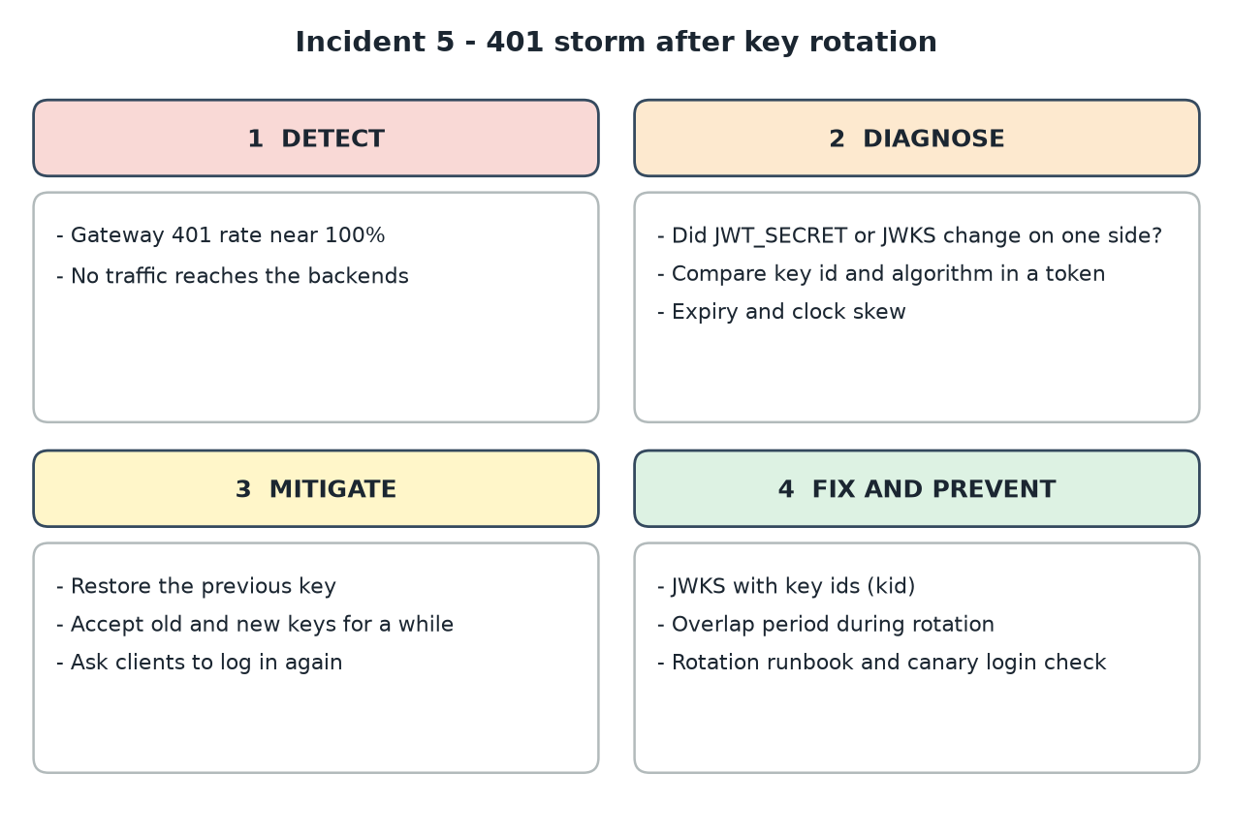
Triage flow - incident 5

How to detect it
- Gateway 401 rate jumps to nearly 100% while backend request rate drops to zero.
- Gateway log: JWT signature validation failures.

How to diagnose it
- Did JWT_SECRET (or the JWKS content) change on one side only? Decode a token header and compare the key id and algorithm.
- Check expiry and clock skew between issuer and gateway if only some tokens fail.

Immediate mitigation (stop the bleeding)
- Restore the previous key on the side that changed (fastest) or make the gateway accept both keys for a while.
- Ask clients to log in again if tokens were signed with a key that is no longer trusted.

Permanent fix and prevention
- Use asymmetric keys with a JWKS endpoint and kid: publish the new key before signing with it, keep the old key until old tokens expire.
- Rotation runbook, a canary check that logs in and calls an API after every rotation, and monitoring of 401 rate.

Incident 6: Database connection pool exhausted
Severity | Impact | Affected pattern
SEV-2 | Requests wait and time out; messages are processed slowly. | Transactions, Database per service

Scenario. A new feature calls an external REST service inside a @Transactional method. When that service slows down, transactions stay open, the Hikari pool of 10 connections is used up, and every other request waits for a connection.
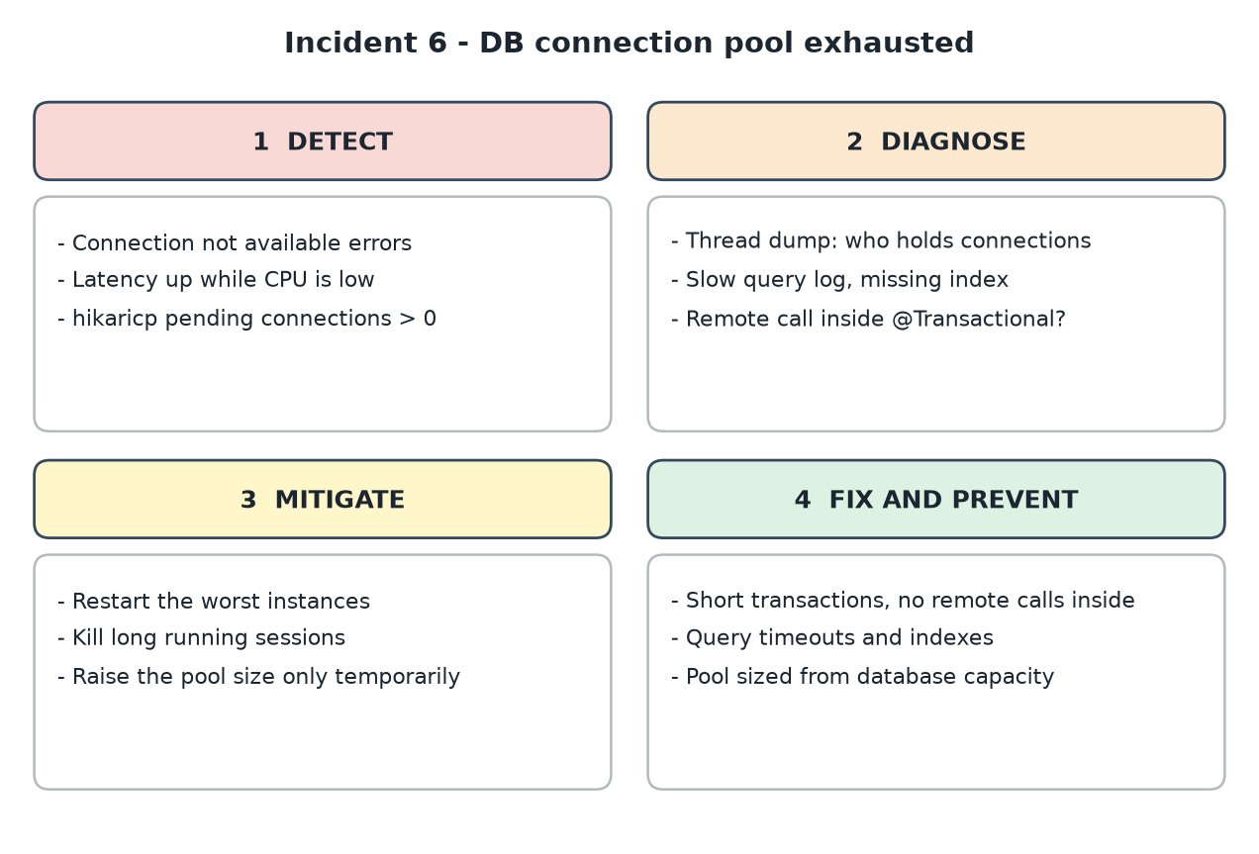
Triage flow - incident 6

How to detect it
- Errors: "Connection is not available, request timed out"; latency up while CPU is low.
- Metrics hikaricp.connections.active at max and hikaricp.connections.pending greater than zero.

How to diagnose it
- Thread dump: many threads inside the same service method holding a connection while waiting for I/O.
- Database side: long-running or idle-in-transaction sessions, missing index on a hot query.
curl -s localhost:8081/actuator/metrics/hikaricp.connections.pending
select * from pg_stat_activity where state like 'idle in transaction%'; -- PostgreSQL

Immediate mitigation (stop the bleeding)
- Restart the worst instances to release connections; kill the long sessions.
- Temporarily raise the pool size only if the database can take it - this hides the cause and can move the problem to the database.

Permanent fix and prevention
- Keep transactions short: no REST calls, no Kafka sends, no file I/O inside them (use the outbox for messages).
- Query and transaction timeouts, correct indexes, and a pool size derived from database capacity divided by instance count.
- Alert on pending connections before the pool is empty.

Incident 7: Kafka consumer lag keeps growing
Severity | Impact | Affected pattern
SEV-3 to SEV-2 | Read model and notifications are minutes behind; downstream saga steps are delayed. | Messaging, CQRS, Domain events

Scenario. After a marketing campaign order volume triples. The projector in order-query-service processes each event in 20 ms and cannot keep up; queries show old statuses and notification e-mails arrive late. A poison message also causes repeated retries on one partition.
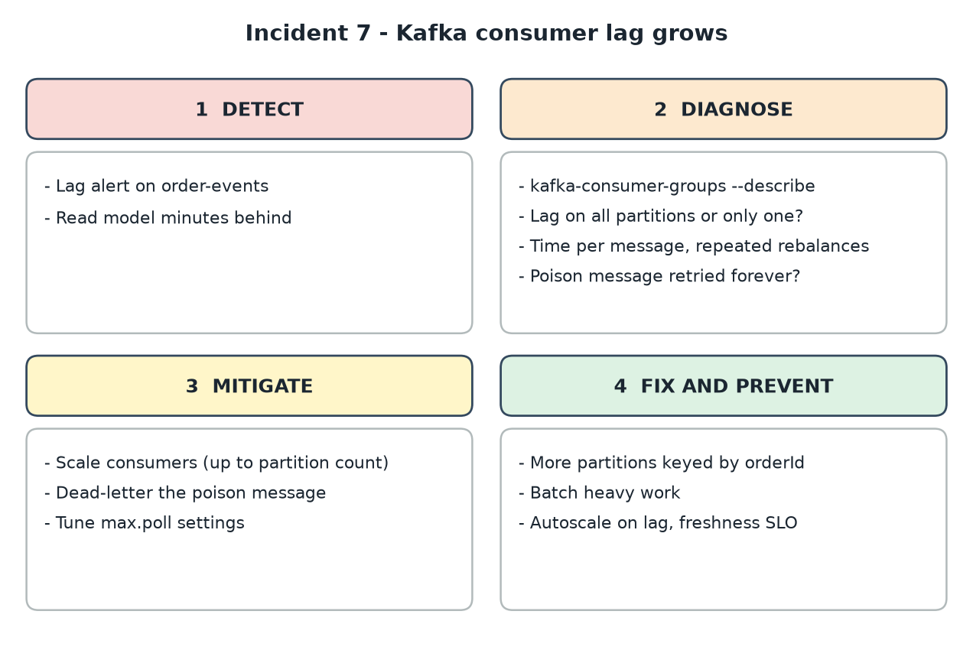
Triage flow - incident 7

How to detect it
- Lag alert per consumer group and topic; "data freshness" metric of the read model.
- Growing end-to-end time between OrderCreated and its appearance in the query API.

How to diagnose it
- Describe the consumer group: is lag on all partitions or one? One partition suggests a stuck or poison message or a hot key.
- Measure processing time per record and look for repeated rebalances (max.poll.interval exceeded).
kafka-consumer-groups.sh --bootstrap-server <host:port> --describe --group order-query-service
kafka-topics.sh --bootstrap-server <host:port> --describe --topic order-events

Immediate mitigation (stop the bleeding)
- Add consumer instances (no more useful than the number of partitions).
- Send the poison message to a dead-letter topic and let the partition continue.
- Increase max.poll.interval.ms or reduce max.poll.records if rebalances are the cause.

Permanent fix and prevention
- Create the topic with enough partitions keyed by orderId so consumers can scale; batch database writes in the projector.
- Dead-letter topic and error handler with backoff; autoscale consumers on lag.
- Define a freshness SLO for read models and test with load.

Incident 8: A release breaks every authenticated gateway route
Severity | Impact | Affected pattern
SEV-1 | All API calls through the gateway return HTTP 500 right after the release; login still works. | API gateway, Release management

Scenario. This happened while running this project. A filter that adds X-Correlation-Id tried to write a header on the incoming request headers, which are read-only in this Spring version, and threw UnsupportedOperationException on every routed request. The build and unit tests were green because nothing tested the gateway end to end.
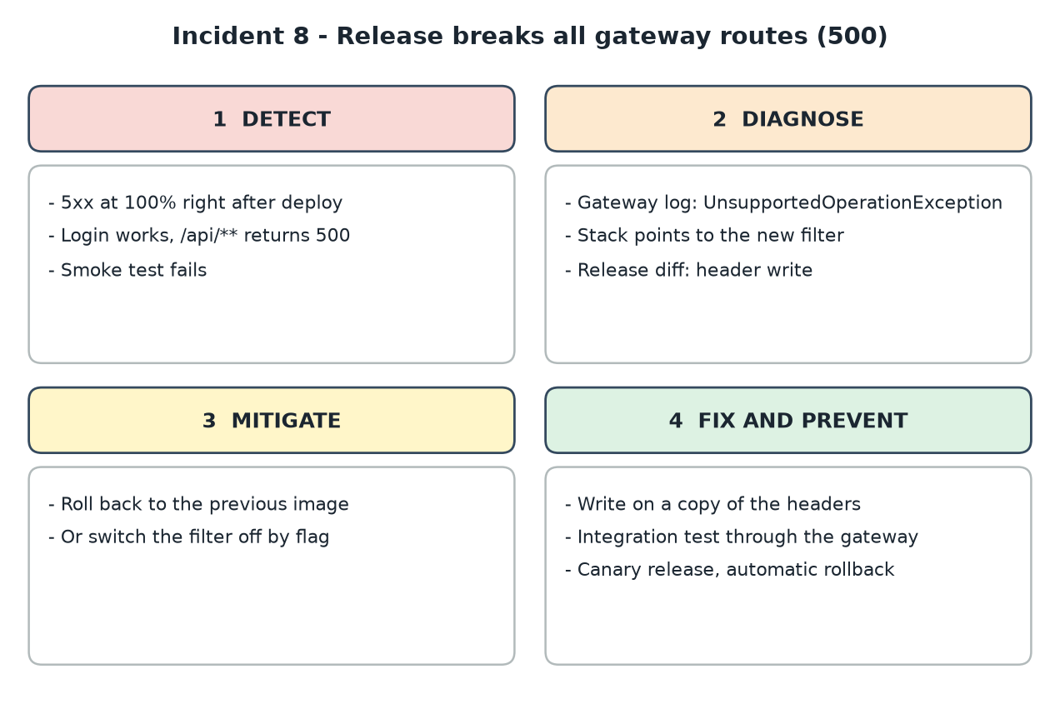
Triage flow - incident 8

How to detect it
- 5xx rate 100% for routed paths immediately after deployment; /auth/token and /actuator/health still succeed.
- Synthetic check (login, then GET an order) fails.

How to diagnose it
- Gateway log shows ReadOnlyHttpHeaders.put / set with the stack pointing to the new filter class and line.
- Diff of the release confirms the only gateway change.

Immediate mitigation (stop the bleeding)
- Roll back to the previous image (fastest) or disable the filter with a feature flag.
- Communicate recovery and confirm with the synthetic check.

Permanent fix and prevention
- Copy the headers to a writable HttpHeaders and decorate the request (fixed in CorrelationIdGlobalFilter); add the response header in beforeCommit.
- Add an integration test that sends a request through the gateway to a stub backend and asserts the status and header.
- Canary releases with automatic rollback on error rate; post-deploy smoke tests in the pipeline.

Lesson. Green unit tests do not prove that cross-cutting infrastructure works. Test the gateway path, test with a dependency down, and make rollback a one-click action.

Incident handling cheat sheet
Symptom | First place to look | Typical first action
Orders stay PENDING | saga_instance state, unsent outbox_event, consumer lag | Restore Kafka connectivity or restart the stuck consumer
Duplicate side effects | processed_message, messageId headers, rebalances | Pause consumer, refund, verify dedupe in same transaction
5xx / timeouts across services | Zipkin slow span, breaker state, thread dump | Fail fast, roll back, scale the slow dependency
Business rule suddenly different | Config server value and its git history | Revert the config commit and refresh
All requests 401 | JWT secret or JWKS on issuer vs gateway | Restore previous key or accept both
Latency high, CPU low | Hikari pending connections, transactions with remote calls | Restart worst instances, shorten transactions
Read model or e-mails late | Consumer group lag per partition | Scale consumers, dead-letter the poison message
Errors right after a release | Diff, logs with stack trace, error rate by version | Roll back first, analyse second

6. Pattern-to-service guide
This section shows, for each pattern, which services take part, what each one must contain, and how they connect. The final table repeats this in one place.
Service ports in this project. order-service 8081, inventory-service 8082, payment-service 8083, notification-service 8084, order-query-service 8085, api-gateway 8080, config-server 8888, discovery-server 8761.

6.1 Database per service
Every business service owns a private database and exposes its data only through APIs or events. In this project each one has its own in-memory H2 schema; in production, give each its own schema or instance.
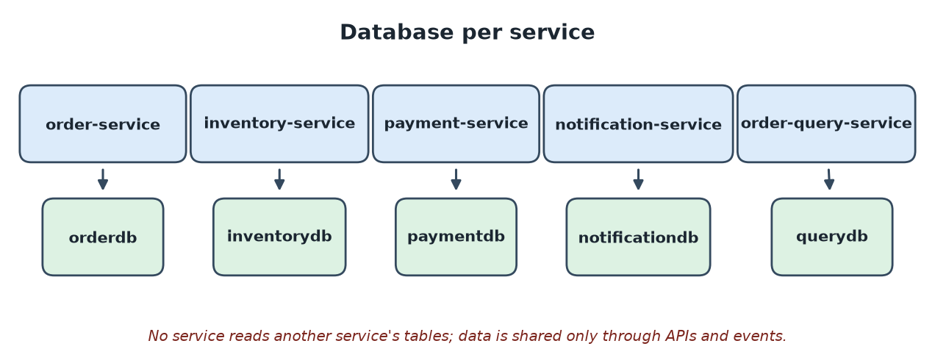
Services involved: Database per service
Service | What it needs for this pattern
order-service | orderdb with orders, saga_instance, outbox_event; spring.datasource.url of its own.
inventory-service | inventorydb with stock_item (seeded BOOK-1, LAPTOP-1) and reservation.
payment-service | paymentdb with payment records; credit-limit rule kept in code and config.
notification-service | notificationdb that holds the idempotency table only.
order-query-service | querydb with the denormalised order_summary read model.

Rule. No foreign keys or joins across services. Cross-service consistency comes from the saga, not from a shared transaction.

6.2 Saga (orchestration) with compensation
order-service runs the saga as a state machine: RESERVING_STOCK, PROCESSING_PAYMENT, then COMPLETED. If payment is declined it sends ReleaseStock and ends FAILED.
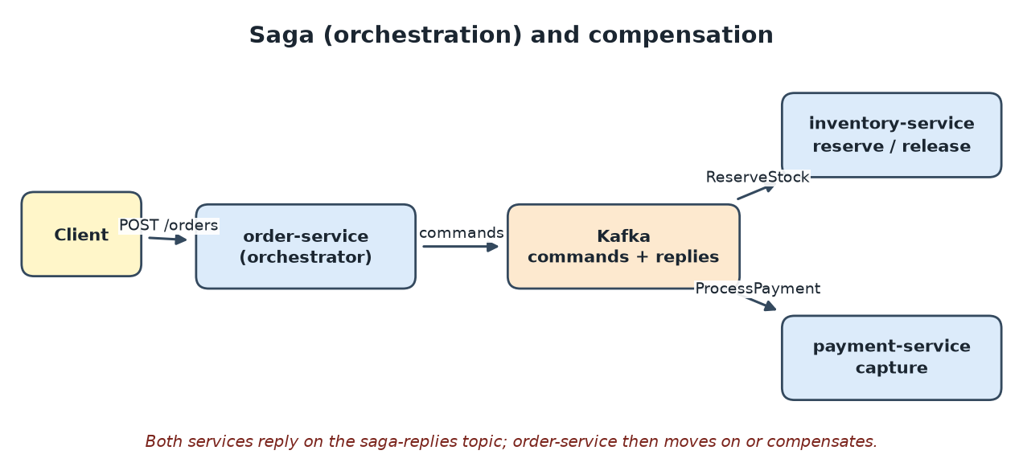
Services involved: Saga (orchestration) with compensation
Service | What it needs for this pattern
order-service | CreateOrderSaga (state machine), SagaInstance entity, SagaReplyListener for replies, OrderController that returns 202 Accepted.
inventory-service | InventoryCommandListener handling ReserveStock and ReleaseStock; replies with SagaReply.
payment-service | PaymentCommandListener handling ProcessPayment; checks payment.credit-limit; replies with SagaReply.
common / Kafka | Contracts records and Topics constants; topics for commands and replies.

Rule. Every step that changes data needs a compensating action, and every handler must be idempotent.

6.3 Transactional outbox and polling publisher
A service writes the business change and an outbox_event row in one local transaction. A scheduled publisher reads unsent rows, sends them to Kafka and marks them sent. A crash between the two steps only delays delivery.
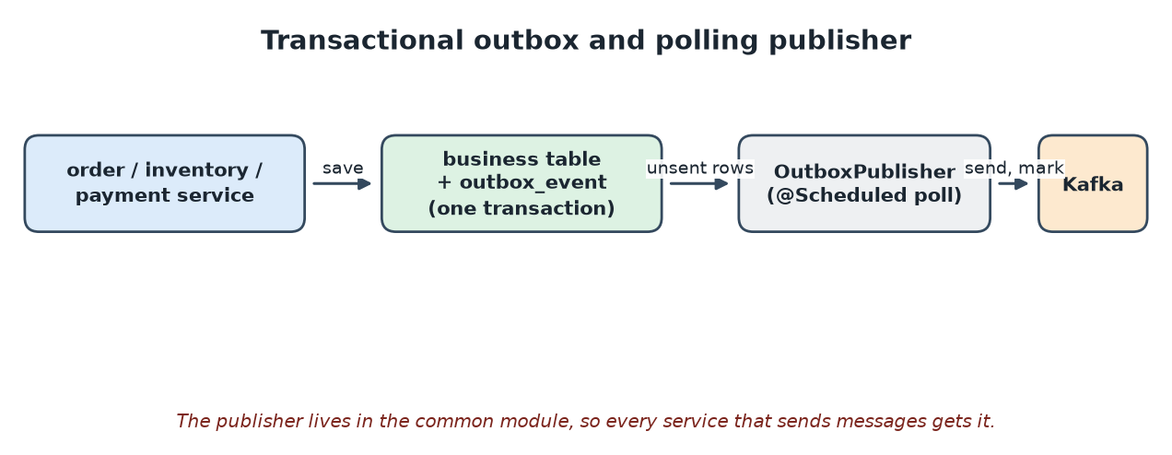
Services involved: Transactional outbox and polling publisher
Service | What it needs for this pattern
common | OutboxEvent, OutboxRepository, OutboxService (enqueue) and OutboxPublisher (poll and send).
order / inventory / payment | Call OutboxService inside the same @Transactional method that changes business data; each has an outbox_event table.
Kafka | Topic for each destination; delivery is at-least-once, so consumers must de-duplicate.

Rule. Never call kafkaTemplate.send directly inside business code; always write to the outbox.

6.4 Idempotent consumer
Each message carries a messageId header. The consumer inserts that id into processed_message in the same transaction as its business change. A repeat finds the id and is skipped.
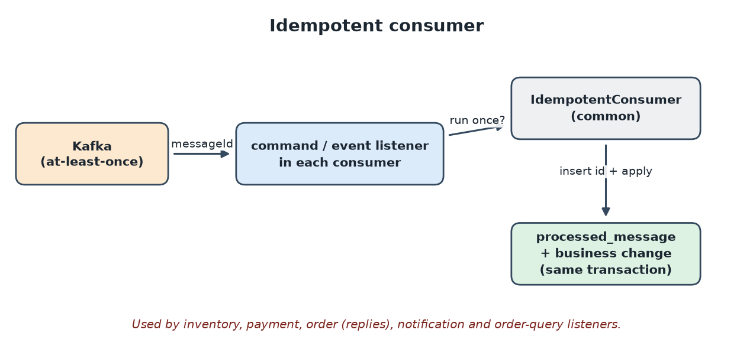
Services involved: Idempotent consumer
Service | What it needs for this pattern
common | IdempotentConsumer, ProcessedMessage entity and repository, Msg and MessageReader for headers and payload.
Every listener | Wrap the handler in IdempotentConsumer so the id insert and business update commit together.
Publishers | Set a stable messageId (the outbox event id) so retries carry the same id.

Rule. The dedupe check and the business change must be in one transaction, or a crash can still cause a double effect.

6.5 CQRS and domain events
order-service handles commands and publishes an OrderEvent through the outbox whenever the order changes state. order-query-service consumes the events and maintains a read model that serves queries.
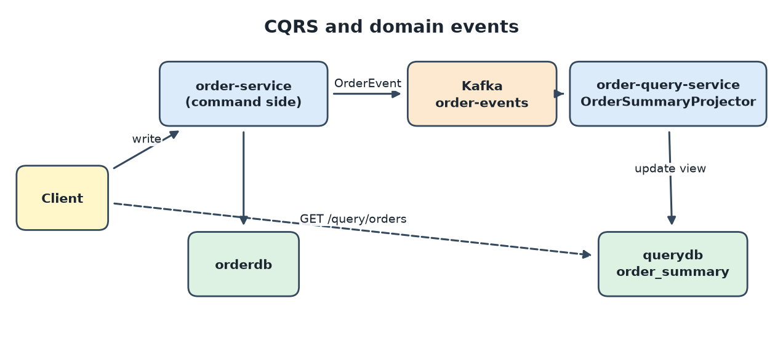
Services involved: CQRS and domain events
Service | What it needs for this pattern
order-service | Publishes OrderEvent for each state change via the outbox.
order-query-service | OrderSummaryProjector (event listener), OrderSummary read entity, OrderQueryController for GET /query/orders.
notification-service | A second subscriber of the same events (OrderEventNotifier), showing that events are reusable.
Kafka | The order-events topic.

Rule. The read model is eventually consistent; a just-created order can take a moment to appear.

6.6 API composition
GET /query/orders/{id}/details calls order, payment and inventory and merges the results into one response.
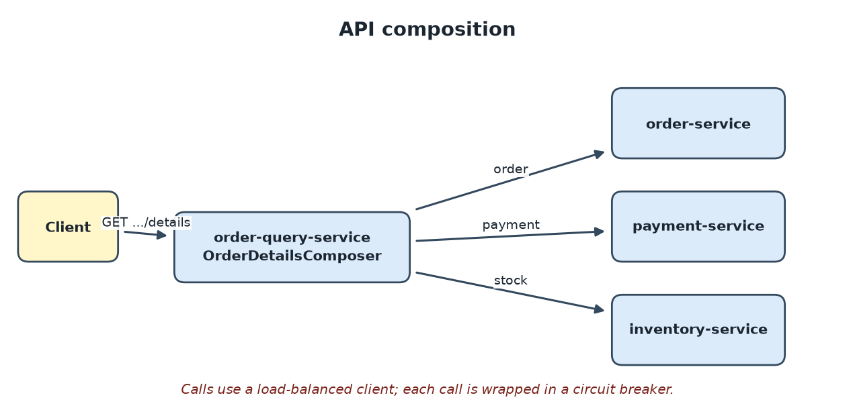
Services involved: API composition
Service | What it needs for this pattern
order-query-service | OrderDetailsComposer; a @LoadBalanced RestClient.Builder; a circuit breaker around each call.
order-service | GET /orders/{id}.
payment-service | GET /payments/{orderId}.
inventory-service | GET /inventory/{sku}.

Rule. Call providers in parallel where possible and return partial data when one is down.

6.7 API gateway
Spring Cloud Gateway on port 8080 routes /api/** to the services, removing the leading /api (StripPrefix=1). It also adds the correlation id, validates tokens and applies circuit breakers.
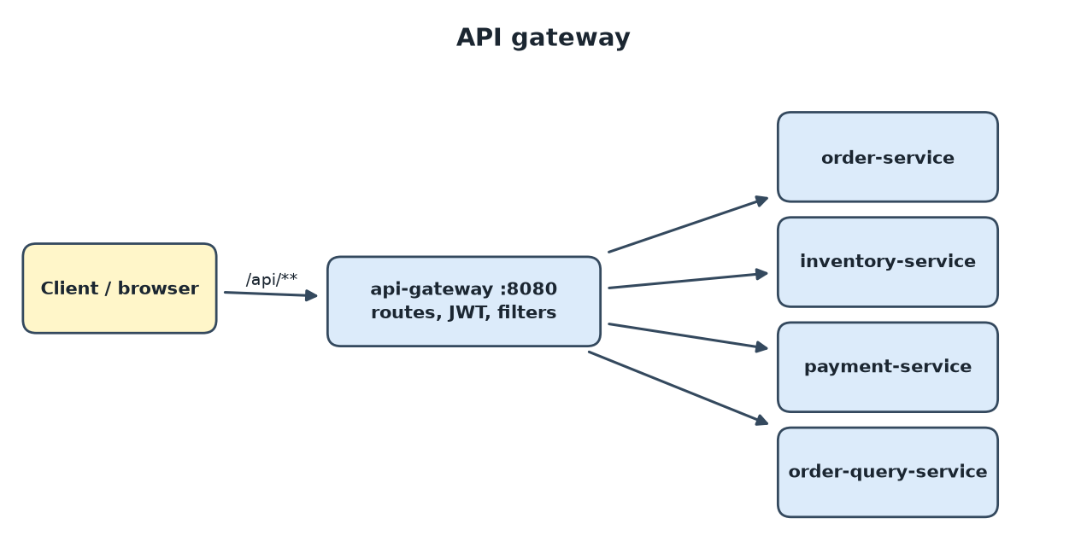
Services involved: API gateway
Service | What it needs for this pattern
api-gateway | application.yml routes (lb://service), SecurityConfig, CorrelationIdGlobalFilter, FallbackController, /mobile/orders/** rewrite route.
Downstream services | Plain REST controllers; they need no knowledge of the gateway and should not be exposed publicly.

Rule. Keep the gateway free of business logic; it only routes and applies cross-cutting policies.

6.8 Access token (JWT)
POST /auth/token (demo / demo) returns a signed HS256 JWT. The gateway validates the Bearer token on all other routes and returns 401 when it is missing or invalid.
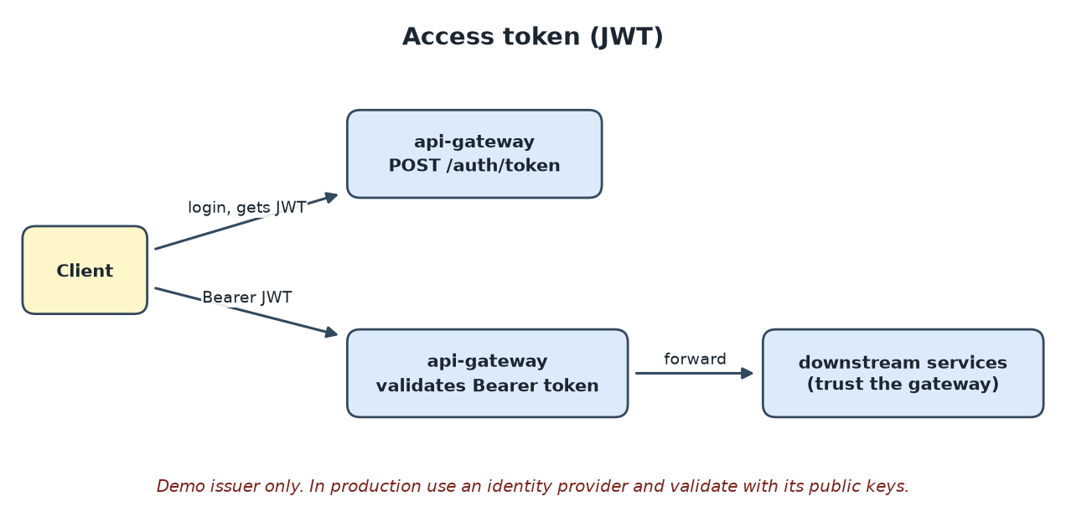
Services involved: Access token (JWT)
Service | What it needs for this pattern
api-gateway | TokenController (demo issuer), SecurityConfig as OAuth2 resource server, shared secret from JWT_SECRET.
Clients | Send Authorization: Bearer <token> on every call.
Downstream services | Trust requests from the gateway; protect them with network rules.

Rule. The built-in issuer and secret are for demos. Use a real identity provider in production.

6.9 Circuit breaker
After repeated failures or timeouts the breaker opens and calls fail fast. The gateway forwards to a fallback; the composer returns partial data.
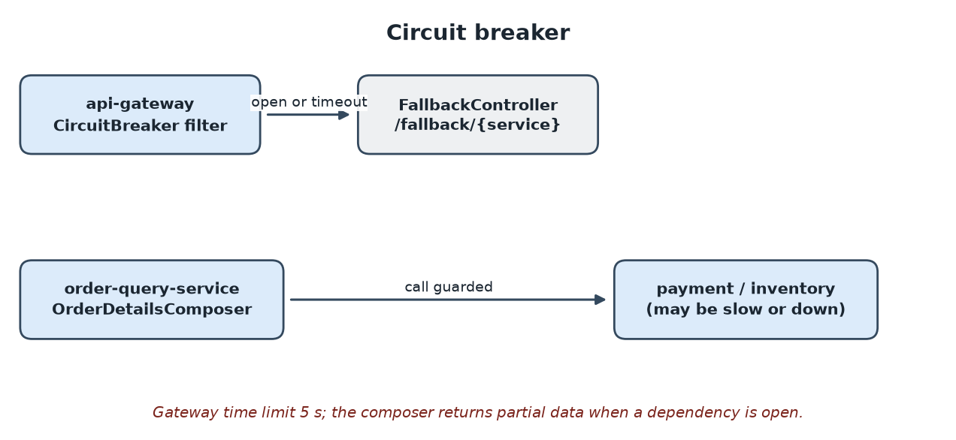
Services involved: Circuit breaker
Service | What it needs for this pattern
api-gateway | CircuitBreaker filter on each route with fallbackUri; time limiter of 5 s; FallbackController.
order-query-service | Resilience4JCircuitBreakerFactory customiser and CircuitBreakerFactory used in OrderDetailsComposer.

Rule. Always define a timeout and a fallback; a breaker without them only moves the failure.

6.10 Service registry, self registration and client-side discovery
Each service registers itself with Eureka at startup and sends heartbeats. Callers look up lb://service-name and the client chooses a healthy instance.
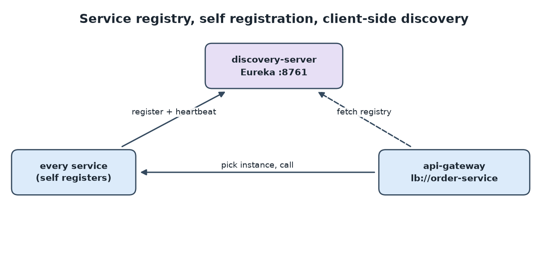
Services involved: Service registry, self registration and client-side discovery
Service | What it needs for this pattern
discovery-server | @EnableEurekaServer on port 8761.
Every service | Eureka client dependency and spring.application.name (self registration).
api-gateway / order-query | lb:// routes, and @LoadBalanced clients (client-side discovery).

Rule. Start the registry first; give each service a unique, stable application name.

6.11 Externalized configuration
config-server on port 8888 serves files from config-repo/. Each service imports them with spring.config.import=optional:configserver:. payment-service reads payment.credit-limit (1000) from it.
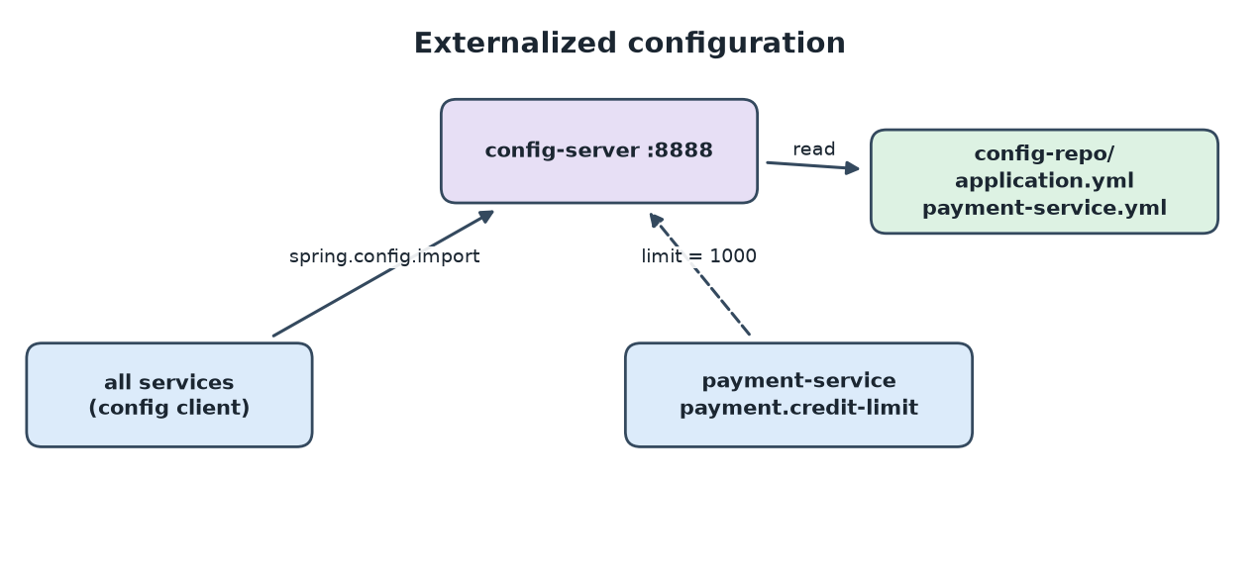
Services involved: Externalized configuration
Service | What it needs for this pattern
config-server | @EnableConfigServer, native config-repo/application.yml and payment-service.yml.
Every service | spring.config.import pointing to CONFIG_SERVER_URL; optional: lets them start without it.
payment-service | payment.credit-limit property bound to the approval rule.

Rule. Keep secrets out of the repository; use environment variables or a secrets manager.

6.12 Microservice chassis
The common module is an auto-configuration library. Adding it as a dependency brings the Kafka, JPA and actuator defaults, the correlation-id filter, the error handler, outbox, idempotency and audit logging.
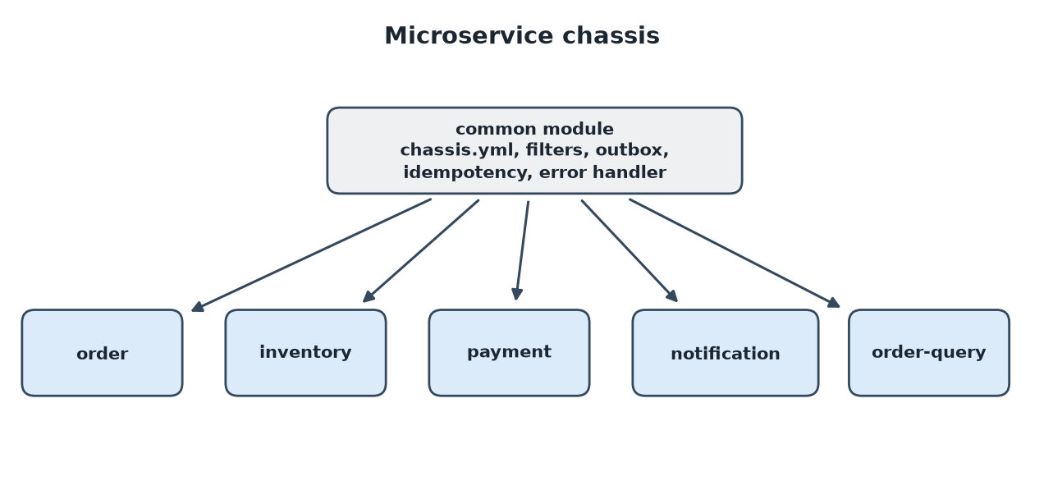
Services involved: Microservice chassis
Service | What it needs for this pattern
common | ChassisAutoConfiguration, chassis.yml, CorrelationIdFilter, GlobalExceptionHandler, AuditLog, outbox and idempotency classes.
Every service | Dependency on common and spring.config.import: classpath:chassis.yml.

Rule. Keep the chassis infrastructure-only; adding business rules to it couples every service.

6.13 Observability
Each service exposes health and metrics, sends traces to Zipkin, and writes logs that carry the trace id and correlation id. AuditLog records key business events.
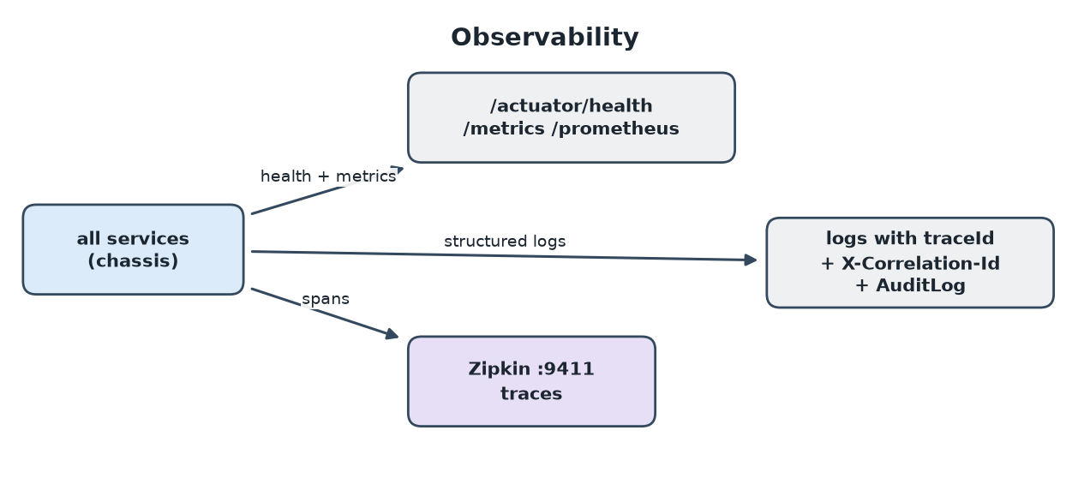
Services involved: Observability
Service | What it needs for this pattern
Every service | Actuator (health, metrics, prometheus), Micrometer tracing with the Zipkin reporter, ZIPKIN_URL.
order / payment / notification | AuditLog.record(...) calls for order created, payment captured or declined, notification sent.
Zipkin | Started from docker-compose.yml on port 9411 (optional when running locally).

Rule. Always log the trace id and correlation id so one request can be followed across services.

6.14 Messaging and remote procedure invocation
Clients call the system with REST through the gateway. Services talk to each other with Kafka commands, replies and events, so they are not blocked by each other.
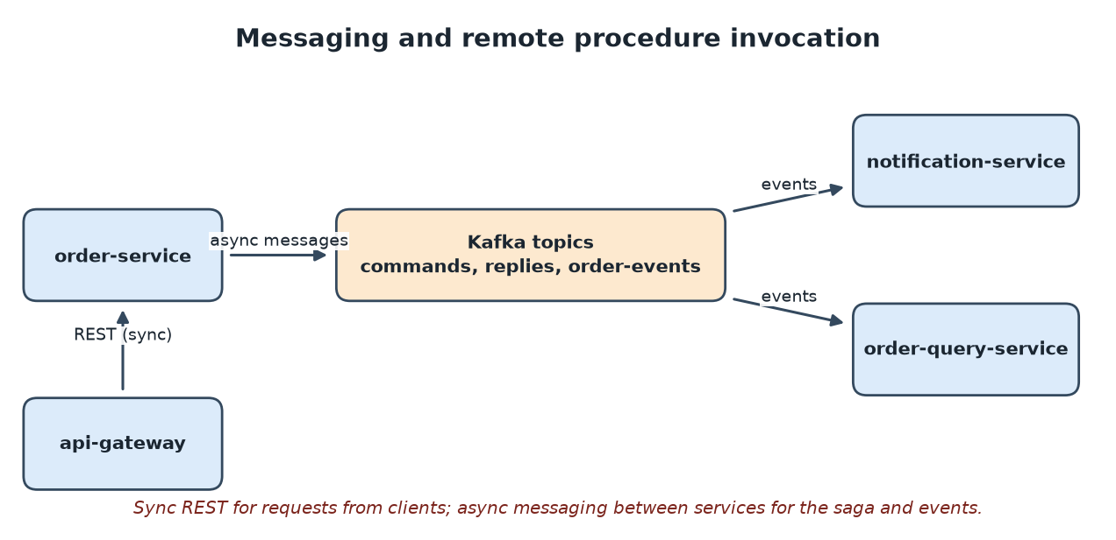
Services involved: Messaging and remote procedure invocation
Service | What it needs for this pattern
Kafka | Run local-kafka (embedded, port 9092) or the Docker broker.
Producers | Publish through the outbox to Topics constants.
Consumers | @KafkaListener methods wrapped in the idempotent consumer.
REST controllers | OrderController, InventoryController, PaymentController, OrderQueryController.

Rule. Use messaging for state changes that cross services, and REST for queries and client requests.

6.15 Q&A: What is chassis.yml and how do the other services use it?
Answer. chassis.yml is a shared settings file inside the common module (common/src/main/resources/chassis.yml). It holds the defaults every business service needs, so they are written once instead of in each service.
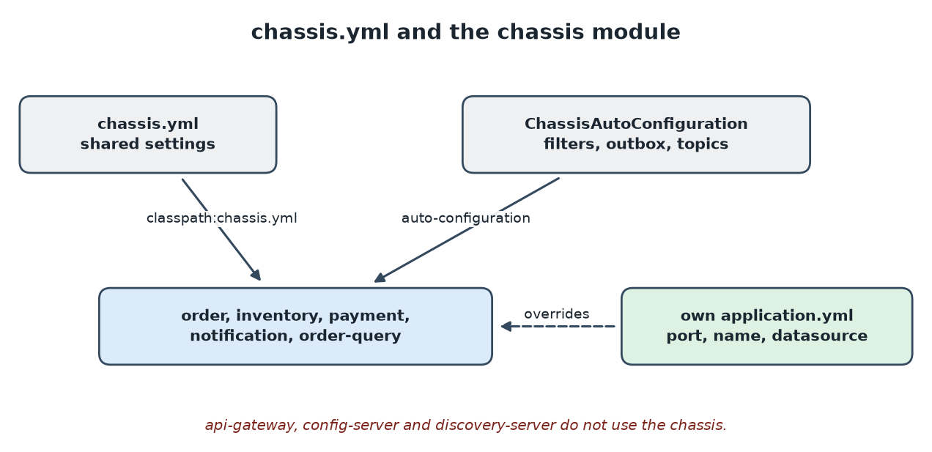
chassis.yml reaches each service through the common jar
Section | What it sets
JPA | ddl-auto: update, open-in-view: false.
Kafka | Broker from KAFKA_BOOTSTRAP (default localhost:9092), string serializers, acks: all, consumers start from earliest.
Eureka | Registry URL from EUREKA_URL, prefer-ip-address.
Actuator and tracing | Exposes health, info, metrics, prometheus; samples all traces to ZIPKIN_URL.
Logging | Pattern with app name, traceId, spanId and correlationId.

- How it is linked. Each service depends on common and imports it with spring.config.import: ...,classpath:chassis.yml.
- Overrides. The service's own application.yml sets port, application name, datasource and consumer group, and wins over the shared defaults.
- Java part. ChassisAutoConfiguration is loaded automatically. It adds the correlation filter, error handler, outbox, idempotent consumer and the four Kafka topics.
- Not used by api-gateway (reactive app), config-server and discovery-server.
Chassis vs config server. The chassis ships inside the jar (fixed defaults, change means rebuild). The config server serves values you can change without rebuilding the service.

6.16 Q&A: What is config-repo in config-server and how do the other services use it?
Answer. config-repo is the folder of configuration files that config-server serves (config-server/src/main/resources/config-repo/). It is the "repository" of the externalized configuration pattern. The server runs with the native profile, so it reads these files from the classpath instead of Git.
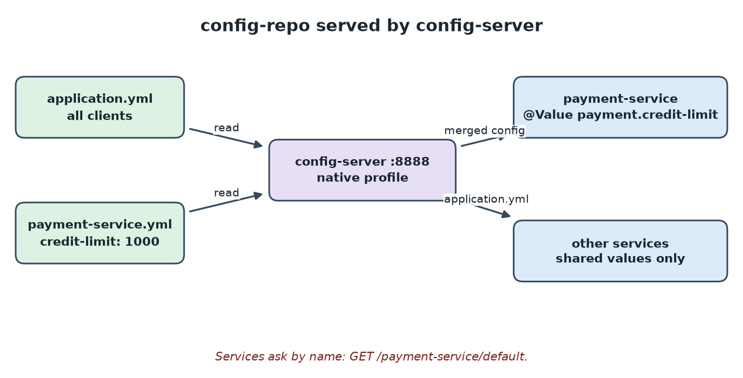
config-repo files served to the services
File | Served to | Content
application.yml | Every service | patterns.environment: local-dev
payment-service.yml | Only payment-service | payment.credit-limit: 1000

- At startup a service reads spring.config.import: optional:configserver:http://localhost:8888.
- It asks the server for its application name, for example GET /payment-service/default.
- The server merges application.yml with payment-service.yml and returns the result.
- PaymentCommandListener reads it with @Value("${payment.credit-limit:1000}") and approves a payment when amount <= creditLimit.
Changing a value. Edit the file, restart config-server (the files are in its jar), then restart payment-service. /actuator/refresh is not exposed here.
Fallback. optional: lets a service start when the server is down; it then uses the default after the colon (1000).
Production. Point the server at a Git repository so config is versioned and reviewed like code.

6.17 Summary table
One row per pattern: the services that take part, the purpose, and the architecture.
Pattern | Services included | Purpose | Architecture
Database per service | order, inventory, payment, notification, order-query | Each service owns its data, so services can change and scale independently.
Saga (orchestration) with compensation | order (orchestrator), inventory, payment, Kafka | Keeps data consistent across services without a distributed transaction; undoes work when a step fails.
Transactional outbox and polling publisher | order, inventory, payment (publishers), common, Kafka | Guarantees a message is sent if and only if the database change committed.
Idempotent consumer | inventory, payment, order, notification, order-query, common | Makes duplicate message deliveries harmless.
CQRS and domain events | order (command), order-query (query), Kafka, notification | Separates writes from reads so each can be modelled and scaled independently.
API composition | order-query, order, payment, inventory | Answers a query that needs data from several services without a shared database.
API gateway | api-gateway, order, inventory, payment, order-query | One entry point for clients that handles routing and cross-cutting concerns.
Access token (JWT) | api-gateway, all downstream services | Authenticates a caller once and passes proof of identity to every request.
Circuit breaker | api-gateway, order-query | Stops a failing dependency from exhausting threads and failing the whole system.
Service registry, self registration and client-side discovery | discovery-server, every service, api-gateway | Services find each other by name instead of fixed addresses.
Externalized configuration | config-server, all services (payment-service uses it) | Changes settings without rebuilding services.
Microservice chassis | common module, then all business services | Gives every service the same cross-cutting features without copy and paste.
Observability | all services (via chassis), Zipkin | Lets you see health, metrics, traces and a business audit trail across services.
Messaging and remote procedure invocation | Kafka, order, inventory, payment, notification, order-query, api-gateway | Uses REST for client requests and asynchronous messaging between services.

