API Gateway - application.yml
A brief explanation of the Spring Cloud Gateway configuration, section by section.

1. Basics & Config Server
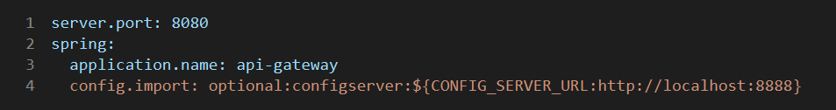
- Runs on port 8080 with the application name api-gateway.
- config.import loads extra configuration from the Config Server. The URL comes from the CONFIG_SERVER_URL env var, defaulting to http://localhost:8888.
- The optional: prefix lets the gateway start even if the Config Server is unavailable.

2. Gateway Routes (orders, inventory, payments, query)
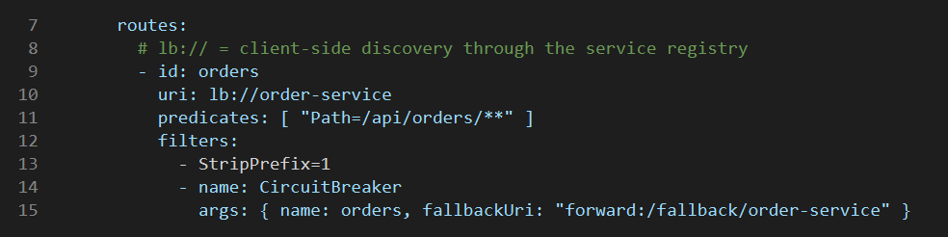
- Each route maps a Path predicate to a service. lb:// means client-side load balancing via the Eureka registry.
- /api/orders/** -> order-service, /api/inventory/** -> inventory-service, /api/payments/** -> payment-service, /api/query/** -> order-query-service.
- StripPrefix=1 removes the leading /api segment before forwarding.
- CircuitBreaker filter forwards to a /fallback/<service> endpoint when the service fails. The orders route is shown; the others follow the same pattern.

3. Mobile BFF Route
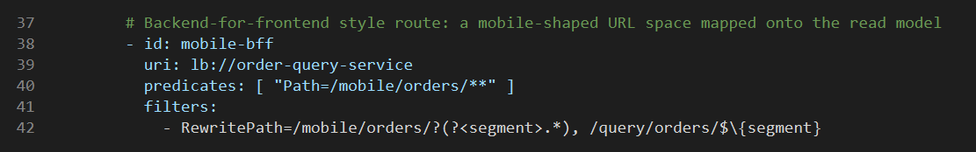
- Backend-for-frontend style route: /mobile/orders/** is rewritten to /query/orders/** on order-query-service (the read model).
- RewritePath captures the remainder of the path as 'segment'. The $\{segment} escape stops Spring treating it as a property placeholder.

4. Security
- security.jwt.secret is the JWT signing key, read from JWT_SECRET.
- The default value is for development only and must be overridden in production.

5. Resilience4j
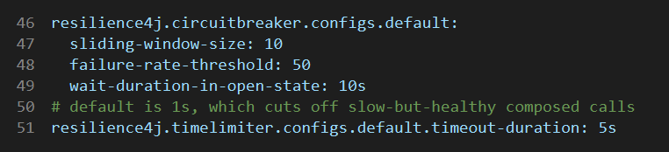
- Default circuit breaker: sliding window of 10 calls, opens at a 50% failure rate, stays open for 10 seconds.
- Time limiter timeout is raised from the 1s default to 5s so slow-but-healthy calls are not cut off.

6. Service Discovery (Eureka)
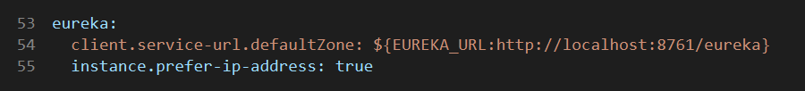
- Registers with the Eureka server at EUREKA_URL (default http://localhost:8761/eureka).
- prefer-ip-address registers the instance by IP rather than hostname.

7. Observability & Logging
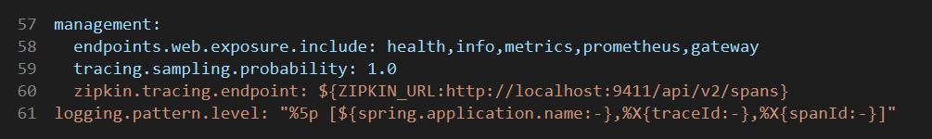
- Actuator exposes health, info, metrics, prometheus and gateway endpoints.
- Tracing samples 100% of requests and sends spans to Zipkin at ZIPKIN_URL.
- The log level pattern includes application name, traceId and spanId for correlation.

