chassis.yml

What is chassis.yml?
chassis.yml lives in the common module and implements the Microservice Chassis and Externalized Configuration patterns. It holds shared defaults (database, Kafka, service discovery, observability, logging) that every business service imports, so each service's own application.yml only needs service-specific settings. Changing a default here changes it for all services.

1. JPA / Hibernate Defaults
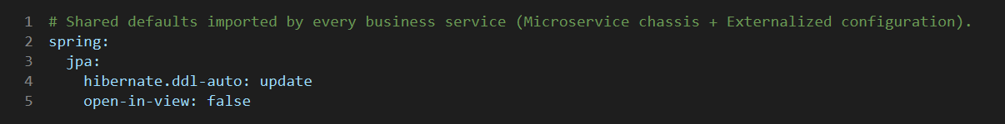
- ddl-auto: update lets Hibernate create or alter tables automatically (convenient for dev; use migrations in production).
- open-in-view: false stops the DB session staying open during view rendering, avoiding lazy-loading in controllers and leaked connections.

2. Kafka Defaults
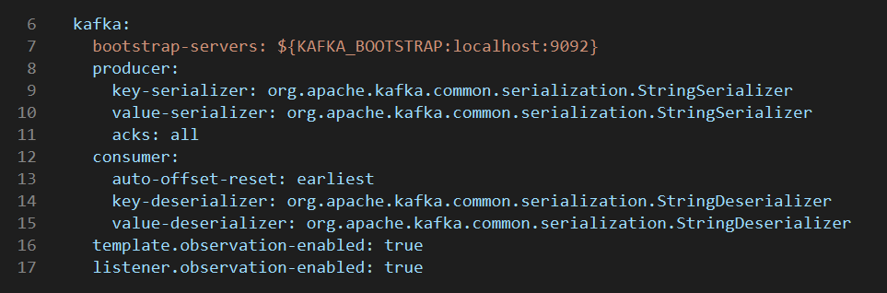
- bootstrap-servers comes from KAFKA_BOOTSTRAP, defaulting to localhost:9092.
- Producer: String key/value serializers and acks=all, so a write is confirmed by all in-sync replicas (durability).
- Consumer: String deserializers and auto-offset-reset=earliest, so a new consumer group reads from the beginning.
- Observation is enabled on KafkaTemplate and listeners, so traces and metrics cover Kafka messages.

3. Service Registry (Eureka)
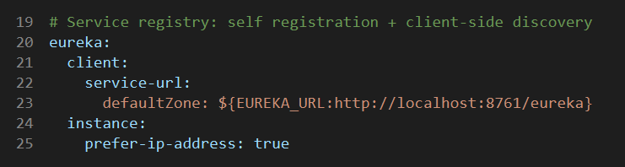
- Each service registers itself with Eureka at EUREKA_URL (default http://localhost:8761/eureka) and uses it for client-side discovery.
- prefer-ip-address registers the instance by IP instead of hostname.

4. Observability: Health, Metrics, Tracing
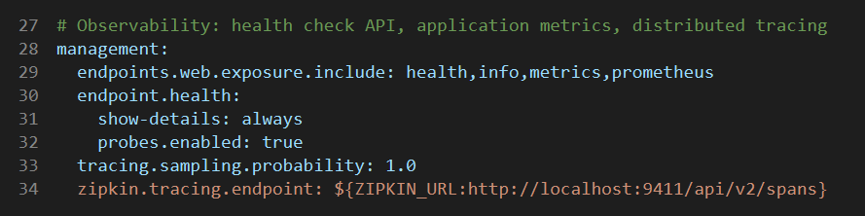
- Actuator exposes health, info, metrics and prometheus endpoints.
- Health shows full details and enables liveness/readiness probes (useful for Kubernetes).
- Tracing samples 100% of requests and sends spans to Zipkin at ZIPKIN_URL.

5. Log Format
- Every log line carries the application name, traceId, spanId and a business correlationId (cid).
- This makes logs easy to aggregate and follow across services.

