config-server - application.yml
Configuration for the Spring Cloud Config Server, which serves centralized configuration to the other services.
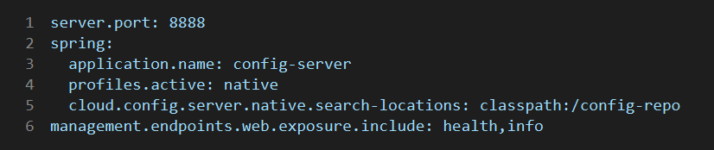

Explanation
- server.port: 8888 - the port clients use as CONFIG_SERVER_URL.
- spring.application.name: config-server - service name.
- spring.profiles.active: native - serves config from local files instead of Git.
- spring.cloud.config.server.native.search-locations: classpath:/config-repo - the folder holding the served config files.
- management.endpoints.web.exposure.include: health,info - only these Actuator endpoints are exposed.

