config-repo/application.yml
A config file served by the Config Server. Because it is named application.yml, it applies to every client application.
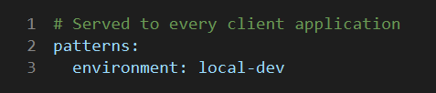

Explanation
- patterns.environment: local-dev - a shared property every service receives from the Config Server, here marking the environment as local development.

